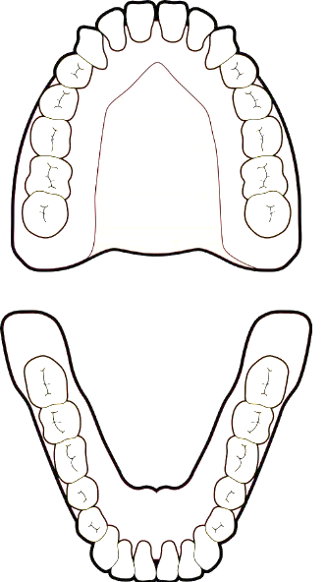
Additional File 1: Questionnaire
x
x
QUESTIONNAIRE (PART 1)
Think about your first adult molar tooth, marked with an x in the picture.
You normally have one on each side of your lower and upper jaw at the back of your mouth. Imagine that this tooth is weak and needs treatment.
The dentist discusses the following treatment options with you.
 | Treatment Option
A | White filling on the tooth. This will need replacement over time.
B | Silver cap on the tooth. This will need replacement over time.
C | Root canal filling of the tooth and a cap which covers the tooth.
D | Removal of tooth and a gap remains.
E | Removal of tooth and gap closes naturally.
F | Removal of the tooth and a bridge to fill the gap.  Bridge = fake tooth which is fixed to the neighbouring tooth.
G | Removal of the tooth and an implant to fill the gap.  Implant = fake tooth which is screwed into the bone.
H | Removal of the tooth and a denture to fill the gap.  Denture = a removable fake tooth.
x
x
x
x

Rank each of these treatment options.
Place the corresponding letter beside your preferred option.
Example: My most preferred option is A (white filling), so I write the letter A beside 1 below.
Most preferred option
1
2
3
4
5
6
7
8

Least preferred option
QUESTIONNAIRE (PART 2)
In the next part of the questionnaire we want you to think about the different treatments you might have on this tooth. This might involve filling a cavity in the tooth, covering the tooth with a cap, or even removing it.
We will ask you to rate each of the treatments on a scale from zero which represents the worst possible outcome to 100 which represents the best possible outcome. Please think about the long term impacts of these treatments rather than any pain or discomfort that might only last a few days. Feel free to use any part of the scale and do not worry if you give different treatments the same rating.
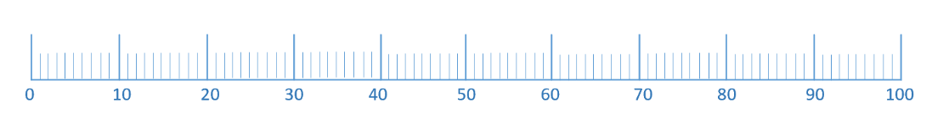
Perfect outcome

Worst outcome

Example:
The dentist offers me a white filling to fix the tooth. I think a white filling would be almost the same as having a perfect tooth, so I mark 95 on the scale.

Imagine this weak first adult molar tooth.
Indicate with a mark on the scale where you would rate these treatment options.

- White filling on the tooth which will need replacement over time.
Perfect outcome

Worst outcome

- Silver cap/crown on the tooth which will need replacement over time.
Perfect outcome

Worst outcome

- The tooth receives a root canal filling and a permanent cap/crown.
Perfect outcome

Worst outcome

- The tooth is removed and a gap remains.
Worst outcome

Perfect outcome

- The tooth is removed and the gap closes naturally.
Worst outcome

Perfect outcome

- The tooth is removed and a bridge is placed to fill the gap.
Bridge = fake tooth which is fixed to the neighbouring tooth.
Worst outcome

Perfect outcome

- The tooth is removed and an implant is placed to fill the gap.
Implant = fake tooth which is screwed into the bone.
Worst outcome

Perfect outcome

- The tooth is removed and a denture is placed to fill the gap.
Denture = a removable fake tooth
Worst outcome

Perfect outcome

QUESTIONNAIRE (PART 3)
In the last part of the questionnaire we want you to value the treatments again, but in a different way. We want you to imagine that you need a type of treatment on your first adult molar tooth.
You could have the traditional treatment (the options we have mentioned to you already) and it will last for 10 years. After 10 years, your tooth would need to be removed and you would be left with a gap.
Or, your dentist offers you a perfect tooth. But the perfect tooth will not last 10 years. At some point before 10 years, the tooth will have to be removed and you will be left with a gap.
Example: I would want a perfect tooth for 8.5 out of 10 years before I would pick it over having a white filling. This means that I would accept having a gap (no tooth) for 1.5 years longer if it meant that I could have a perfect tooth. This is what I would mark below.
Traditional Treatment | Number of years
White filling on the tooth. | _8.5_ / 10 years

Question:
How many years of a perfect tooth would you need before you would choose it over the traditional treatment? Please think only about the next 10 years.
Number of years that you would want the ‘perfect tooth’ for before you would pick it over the Traditional Treatment
Remember: Traditional Treatment will last 10 years

Traditional Treatment | Number of years
White filling on the tooth. | ___ / 10 years
Silver cap on the tooth. | ___ / 10 years
Root canal filling of the tooth and a cap which covers the tooth. | ___ / 10 years
Removal of tooth and a gap remains. | ___ / 10 years
Removal of tooth and gap closes naturally. | ___ / 10 years
Removal of the tooth and a bridge to fill the gap.  Bridge = fake tooth which is fixed to the neighbouring tooth. | ___ / 10 years
Removal of the tooth and an implant to fill the gap.  Implant = fake tooth which is screwed into the bone | ___ / 10 years
Removal of the tooth and a denture to fill the gap.  Denture = a removable fake tooth. | ___ / 10 years

Please tick the most appropriate box.

What age are you?
16-24 |  | 25-34 |  | 35-44 |  | 45-54 |  | 55-64 |  | 65-74 |  | 75-84 |  | 85+

Male |  | Female

What is your ethnic background?
White British
White Irish
Other White
Indian
Pakistani
Bangladeshi
Other Asian
Black Caribbean
Black African
Other Black Background
Chinese
White and Black Caribbean
White and Black African
Other Mixed Background
Other
Prefer not to say

Employment
Currently working |  | Not currently working

Please write down the first four characters of your postcode

Additional file 2
This table reports the relationship between demographic characteristics and responses for each health state.
Outcome Variable | Age | Gender | Employment | Ethnicity *
VAS A | 0.9206 | 0.6427 | 0.0702 | 0.5808
VAS B | 0.6173 | 0.2329 | 0.8016 | 0.1154
VAS C | 0.2909 | 0.2877 | 0.2748 | 0.0382
VAS D | 0.2434 | 0.5475 | 0.4514 | 0.5343
VAS E | 0.9871 | 0.6032 | 0.6427 | 0.8413
VAS F | 0.9528 | 0.9816 | 0.8311 | 0.2454
VAS G | 0.6433 | 0.8171 | 0.5895 | 0.4525
VAS H | 0.0862 | 0.563 | 0.6067 | 0.976
TTO A | 0.4631 | 0.6324 | 0.1967 | 0.6566
TTO B | 0.8916 | 0.9533 | 0.6747 | 0.1336
TTO C | 0.4731 | 0.775 | 0.2084 | 0.3678
TTO D | 0.3869 | 0.0888 | 0.5956 | 0.0154
TTO E | 0.1198 | 0.5146 | 0.3128 | 0.1334
TTO F | 0.9508 | 0.442 | 0.8991 | 0.4073
TTO G | 0.5156 | 0.2206 | 0.8195 | 0.3783
TTO H | 0.8415 | 0.13 | 0.4702 | 0.1126
*Ethnicity was grouped as Group 1(White British) and Group 2 (other Ethnicity)
A: White filling B: Silver crown C: RCT and crown D: Gap E: Gap Closes F: Bridge G: Implant H: Denture

This indicates a higher preference for the root treated tooth with crown state amongst non-white respondents according to median VAS scores (p=0.038). Non-white respondents appeared to have a lower preference for an open gap according to median TTO values (p=0.015). However, given the number of relationships examined, these may be chance findings.

White Filling | Ranking VAS TTO
Silver Crown
RCT and Crown
Extraction and Gap
Gap Closes
Bridge
Implant
Denture

Additional file 3: Distribution of responses for each health state across three methods (Blue: Ranking Exercise [Rank 1-8]; Green: VAS method [Range 0-100]; Orange: TTO method [Range 1-10 years])

