S1：The effect of RANKL on the viability of renal cancer cells (786-O and A498) was determined by the CCK-8 assay.

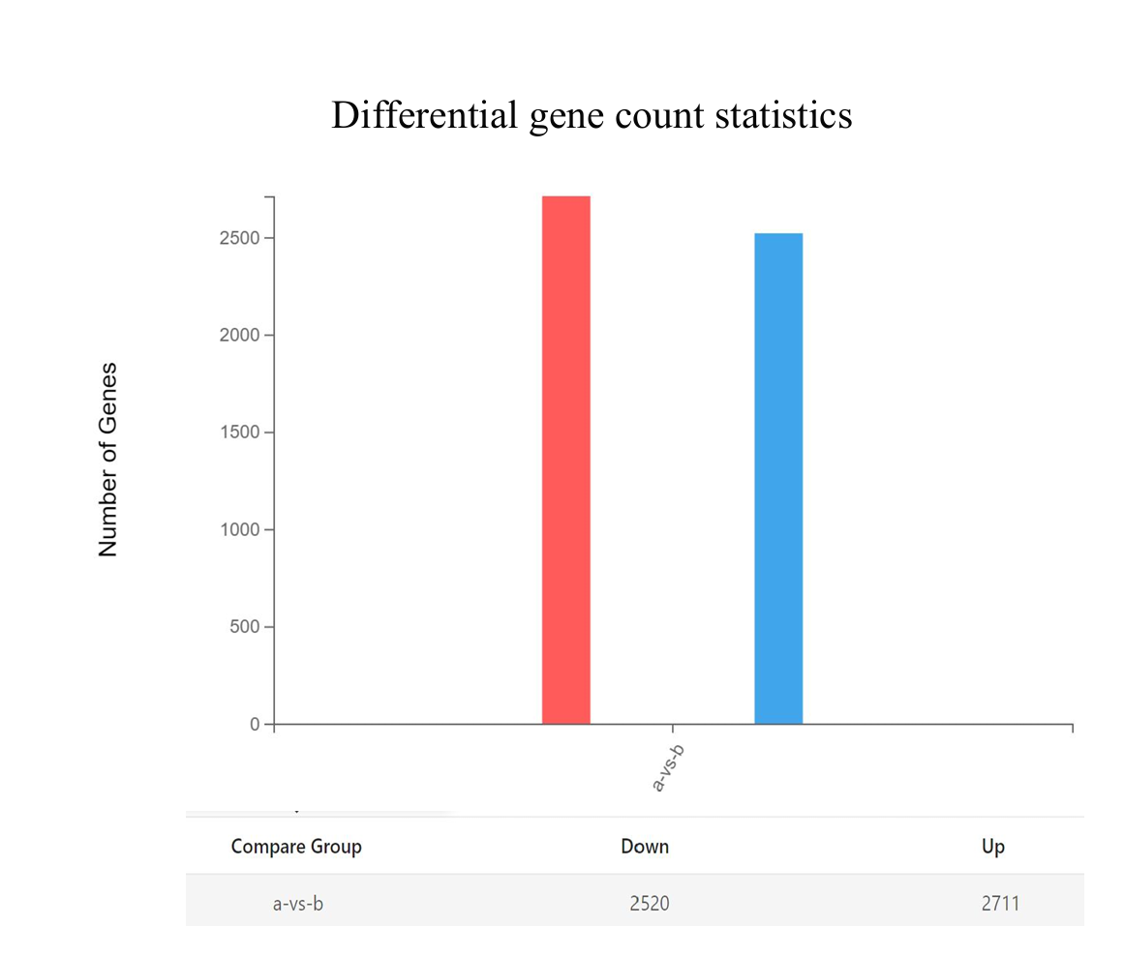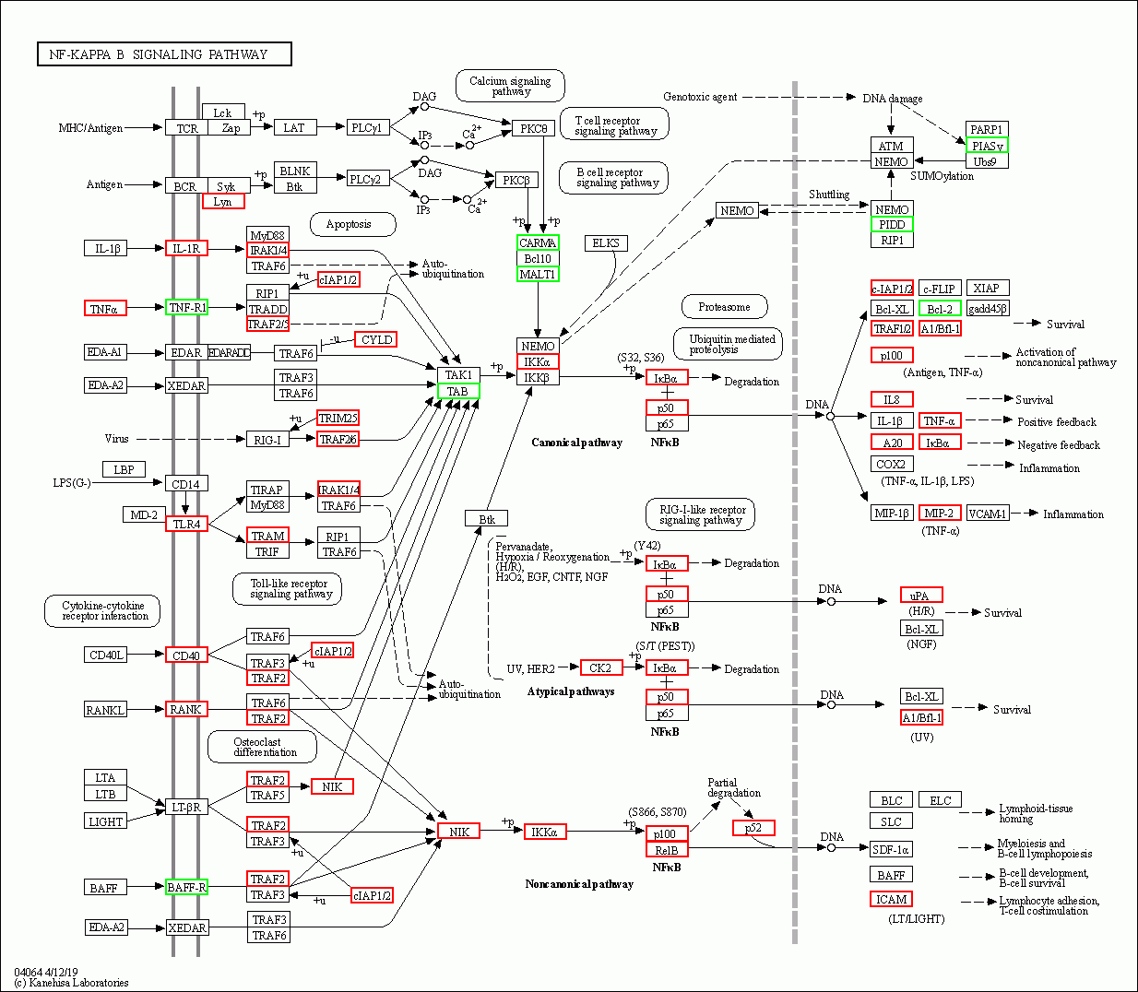

S2: The figures obtained from RNA - seq are as follows: The first figure is a bar chart of differentially expressed genes obtained by | Log2FC | >= 1, Qvalue <= 0.01, where a vs represents 0 vs 1uM JS - K; The second figure shows the differentially expressed genes in the NF-κB signaling pathway, where red indicates up - regulation and green indicates down - regulation. All the above results were provided by BGI Genomics.

