Supplementary Information

Photothermal skyrmion tweezer: Programmable manipulation of topological quasiparticles

Jaeyu Kim¹†, Seungmo Yang²†, Dongha Kim¹, Kyoung-Woong Moon², Changsoo Kim², Chanyong Hwang^{2§}, and Min-Kyo Seo¹*

¹Department of Physics, KAIST, 291 Daehak-ro, Daejeon, 34141, Republic of Korea
²Quantum Technology Institute, Korea Research Institute of Standards and Science, 267 Gajeong-ro, Daejeon 34113, Republic of Korea
†These authors contributed equally to this work.
§cyhwang@kriss.re.kr
*minkyo_seo@kaist.ac.kr

Contents:
S1 Temperature-dependent magnetic anisotropy energy
S2 Skyrmion Hall effect
S3 Photothermal tweezer for half skyrmion manipulation
S4 Arrhenius equation-based interpretation of photothermal skyrmion transport
References for Supplementary Information

Supplementary Information S1. Temperature-dependent magnetic anisotropy energy
To investigate the photothermal potential well for a chiral domain wall (DW), we measured the effective perpendicular magnetic anisotropy (PMA) energy density per unit volume ($K_{eff}$) and the saturation magnetization ($M_{s}$) as functions of temperature. Our results show that $K_{eff}$ plays a key role in determining the temperature-dependent change in the DW energy density, which decreases as the temperature rises. This decrease forms a potential well in response to localized photothermal heating.
First, we evaluated the saturation magnetization ($M_{S}$) by measuring the magneto-optic Kerr effect (MOKE) signal intensity (𝐼), averaged over the sample, and the zero-field stripe domain width ($λ_{0}$). In the stripe domain state, the areal ratio of domains magnetized in the +z and −z directions changes approximately linearly with a weak external perpendicular field ($H_{z}$), and is given by^{R1}:
$$R=\frac{A_{+}-A_{-}}{A_{+}+A_{-}}=\frac{2λ_{0}}{πd}\frac{1}{M_{S}}H_{z}$$
where d is the thickness of magnetic film, and $A_{±}$ represents the area of domains magnetized in the ±z-direction. The MOKE signal intensity averaged across the sample reflects this areal ratio and is expressed as $R=\frac{2I-I_{+}-I_{-}}{I_{+}-I_{-}}$, where $I_{±}$ represents the MOKE intensity when the sample is fully saturated in the ±z-directions, respectively. As shown in Fig. S1a, we measured the linear proportionality constant between R and H_{z} at various temperatures. We then extracted λ₀ from the two-dimensional fast Fourier transform (FFT) of the MOKE images of the stripe domains at the corresponding temperatures (Fig. S1b).
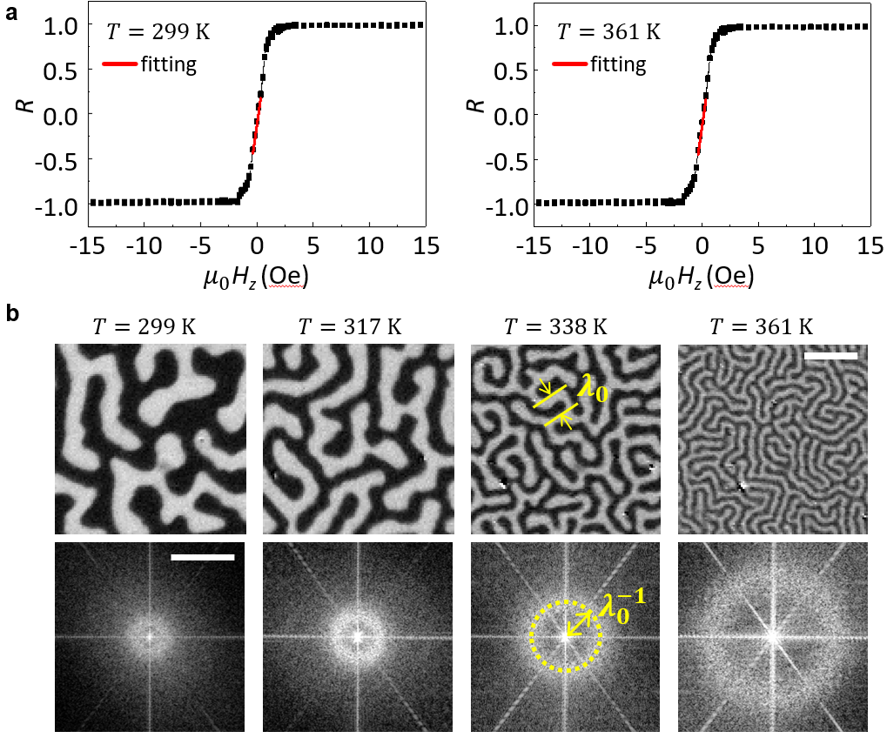
Figure S1 Temperature-dependent MOKE signal and stripe domain width (a) Normalized MOKE intensity as a function of the perpendicular magnetic field. (b) MOKE microscopy image of stripe domains (top) and the corresponding FFT distribution (bottom) at different temperatures. Scale bar: 10 μm (top) and 0.5 μm⁻¹ (bottom).
Figure S2 shows the saturation magnetization ($M_{S})$ extracted from the data in Fig. S1a across the temperature range of 299 K to 370 K. The saturation magnetization decreases with increasing temperature in accordance with Bloch’s law: $M_{s}\left(T\right) =M_{s}\left(0\right)\left(1-{\left(T/T_{c}\right)}^{3/2}\right)$, where $T_{c}$ is the Curie temperature. The Curie temperature of CoFeB varies from several hundred kelvin to approximately 750-1000 K, depending on its composition and fabrication process^{R2, R3}. Since the temperatures used in this study are well below this upper limit, the saturation magnetization remains nearly constant over the range measured.
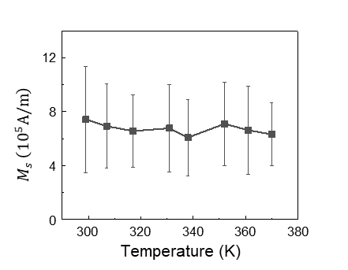
Figure S2 Temperature dependence of the saturation magnetization. The saturation magnetization was extracted from the data in Fig. S1a over the temperature range from 299 K to 370 K.

Second, we evaluate the PMA energy density $K_{eff}$ by measuring the MOKE signal intensity as a function of the in-plane magnetic field. The effective PMA energy density is given as^{R4, R5}
$$K_{eff}=\frac{1}{2}μ_{0}H_{k}M_{s}$$
where $μ_{0}H_{k}$ is the PMA field. In the presence of an external magnetic field $H_{x}\hat{x}+H_{z}\hat{z}$, the total magnetic field is given by $μ_{0}H_{x}\hat{x}+\left(μ_{0}H_{z}+μ_{0}H_{k}m_{z}\right)\hat{z}$. Here, $μ_{0}H_{k}m_{z}$ is the contribution of the PMA field, and $m_{z}$ is the normalized magnetization component along the z-axis, ranging from −1 to +1. A value of $m_{z}=±1$ corresponds to full magnetization saturation in the ±z-direction. In our sample, since the magnetization aligns parallel to the total magnetic field^{R4, R5}, $m_{z}$ is formulated recursively as
$$m_{z}=\frac{H_{z}+H_{k}m_{z}}{\sqrt{{\left(H_{z}+H_{k}m_{z}\right)}^{2}+H_{x}^{2}}}.$$
We measured$m_{z}$ from the normalized MOKE signal R as a function of the in-plane external magnetic field component at different temperatures, as shown in Fig. S3a. A constant perpendicular magnetic field $H_{z}$ of +36 Oe was applied during the measurement to initially saturate the magnetization of the sample in the +z-direction, thereby preventing the formation of a stripe domain state. In our MOKE microscopy setup, the signal R corresponds to $m_{z}$, allowing us to fit the experimental data using the recursive model equation to extract $μ_{0}H_{k}$. We observed that R decreases more steeply at higher temperatures, implying a weakening of the PMA strength. From these fits, we extracted the temperature-dependent PMA field, as shown in Fig. S3b, which shows a monotonic decrease with increasing temperature. Using the extracted values of $H_{k}$ and $M_{s}$, we determined the temperature dependence of $K_{eff}$ in Fig. S3c. These results clearly demonstrate that $K_{eff}$ decreases with increasing temperature, supporting the formation of the photothermal potential well and its spatial profile, as illustrated in Fig. 1a of the main manuscript.
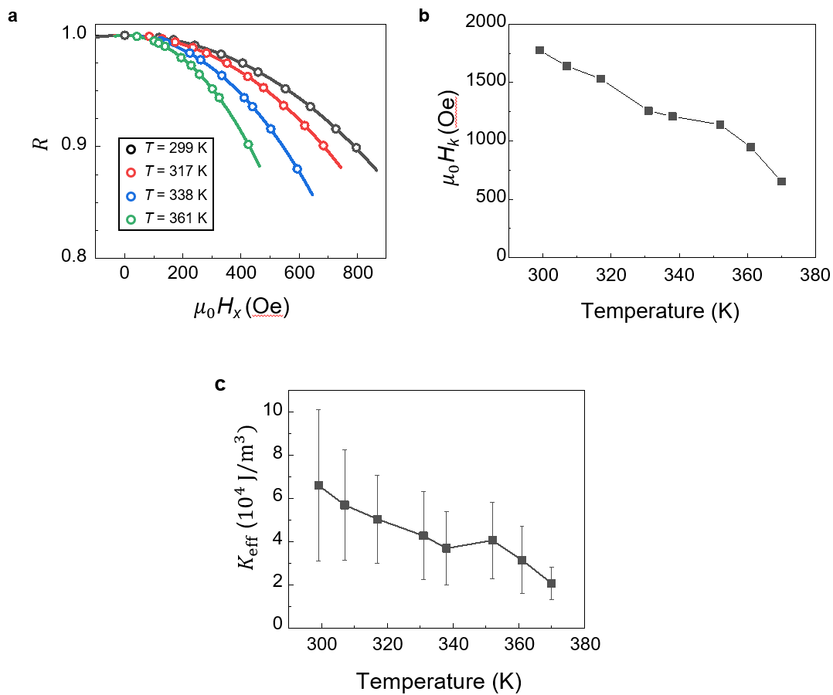
Figure S3 Temperature-dependent analysis of the PMA field and energy density. (a) Normalized MOKE signal as a function of the in-plane magnetic field component at different temperatures. (b, c) Temperature dependence of the PMA field and energy density.

In this study, we prepared two identical samples grown under the same fabrication conditions (see Materials and Methods). Sample #1 was used for the experiments shown in Figs. 2a and 2c, as well as Figs. 3a and 3b. Sample #2 was used for the experiments in Fig. 2b, Fig. 3c, and Fig. 4. This division was made to prevent potential inaccuracies due to sample degradation from repeated experiments for statistical analysis. We verified that the magnetic properties of the two samples were consistent. In Fig. S4, we compared the $M_{s}$ and $K_{eff}$ of Samples #1 and #2. The magnetic constants and their temperature-dependent behavior show a clear match between the two samples.

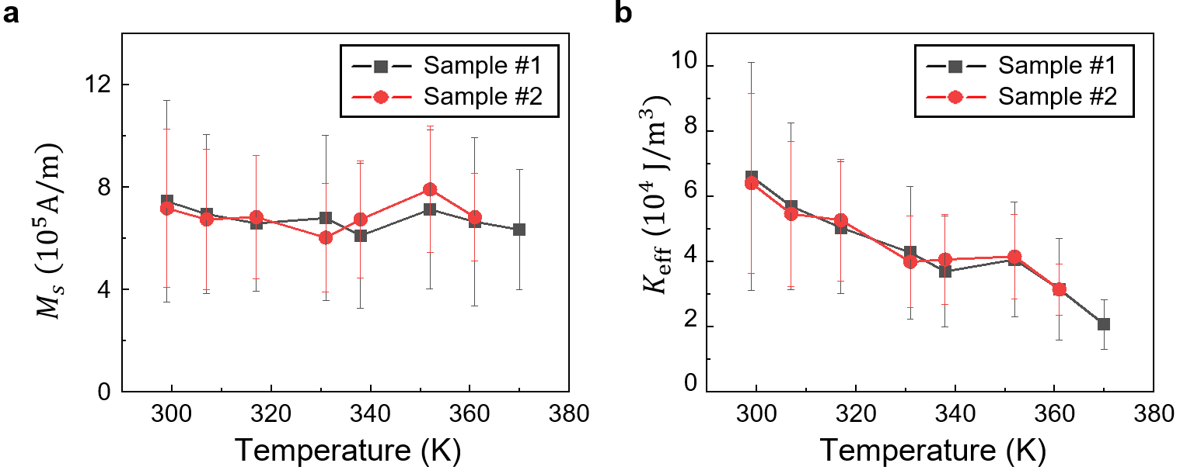
Figure S4 Comparison of the magnetic properties of Sample #1 and #2. (a) Saturation magnetization $M_{s}$ and (b) effective PMA energy density $K_{eff}$ as functions of temperature for both samples.

Supplementary Information S2. Skyrmion Hall effect
Polar MOKE microscopy alone cannot distinguish between skyrmions and non-topological magnetic bubbles. To verify that the spin textures in this study are indeed skyrmions, we measured their Hall effects under electrical current pulses (Fig. S5). We examined both photothermally created and magnetic field-induced skyrmions. As shown in Fig. S5a, the photothermally created skyrmions exhibit transverse motion relative to the direction of the applied current pulse, with the skyrmion Hall angles ($θ$) showing opposite sign for topological charges Q = +1 and Q = −1. We applied an electrical current pulse with a duration of 100 ms and a current density of 3.46×10⁹ A/m². Figure S5b presents the statistical distribution of the skyrmion Hall angle, based on 215 measurements for Q = −1 and 169 measurements for Q = +1. The measured difference in the median skyrmion Hall angle between Q = +1 and Q = −1 is approximately 17$°$, consistent with the previous reported values on the MgO/CoFeB/W multilayer system^{R5,R6,R7}. Figure S5c shows the results for magnetic field-induced skyrmions (Q = −1), based on 299 measurements under electric pulses with a current density of 4.09×10⁹ A/m². These results confirm that both photothermally created and magnetic field-induced skyrmions exhibit the same Hall effect, validating their topological nature.
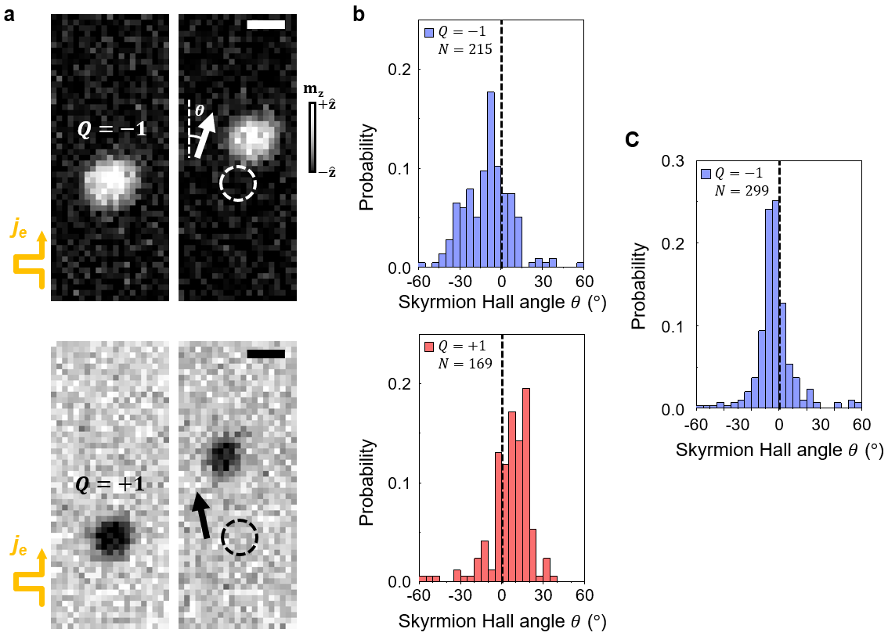
Figure S5 Skyrmion Hall effect (a) Trajectories of photothermally created skyrmions for Q = −1 (top panel) and Q = +1 (bottom panel) under an applied electrical current pulse, showing deflection from the current direction. Scale bar, 2 μm. (b) Statistical distribution of the skyrmion Hall angle for Q = −1 (top panel) and Q = +1 (bottom panel). N denotes the number of measurements. (c) Statistical distribution of the skyrmion Hall angle for magnetic field-induced skyrmions (Q = −1).
Supplementary Information S3. Photothermal tweezer for half skyrmion manipulation
The potential well landscape induced by the temperature gradient is universal for any spin texture regardless of its detailed distribution, since the anisotropy energy is the dominant factor. Therefore, the photothermal tweezer technique enables not only the manipulation of skyrmions but also the control of chiral domain walls. Similar to skyrmion transport, the DW texture is trapped by the photothermal potential well and dragged in the direction of sweeping the laser beam, reversing the magnetizations along its path and leaving a flipped trail behind (Fig. S6a). From a topological perspective, a chiral domain wall with a semicircular shape carries a topological charge of ±1/2, often referred to as a "half-skyrmion."
Half-skyrmions can be generated not only by dragging pre-existing DWs but also by pulling one side of a single skyrmion as shown Fig. S6b. This process occurs at lower laser power and higher sweeping speeds compared to the manipulation of an entire skyrmion. We measured the probability of half-skyrmion formation as a function of the laser power and sweeping speed, based on 20 trials per condition (Fig. S6c). At a laser power of 1.9 mW, the photothermal potential is insufficient to overcome local pinning forces and manipulate the target skyrmion. At an intermediate power of 2.5 mW, a slow beam sweep moves the entire skyrmion, while a fast sweep results in no motion. Under these conditions, optimal sweeping speed of 360 nm/s enables the formation of half-skyrmions from single skyrmions. At higher powers (above 3.7 mW), the probability of half-skyrmion formation increases with sweeping speed. This trend is consistent with the thermally activated behavior predicted by the Arrhenius equation.
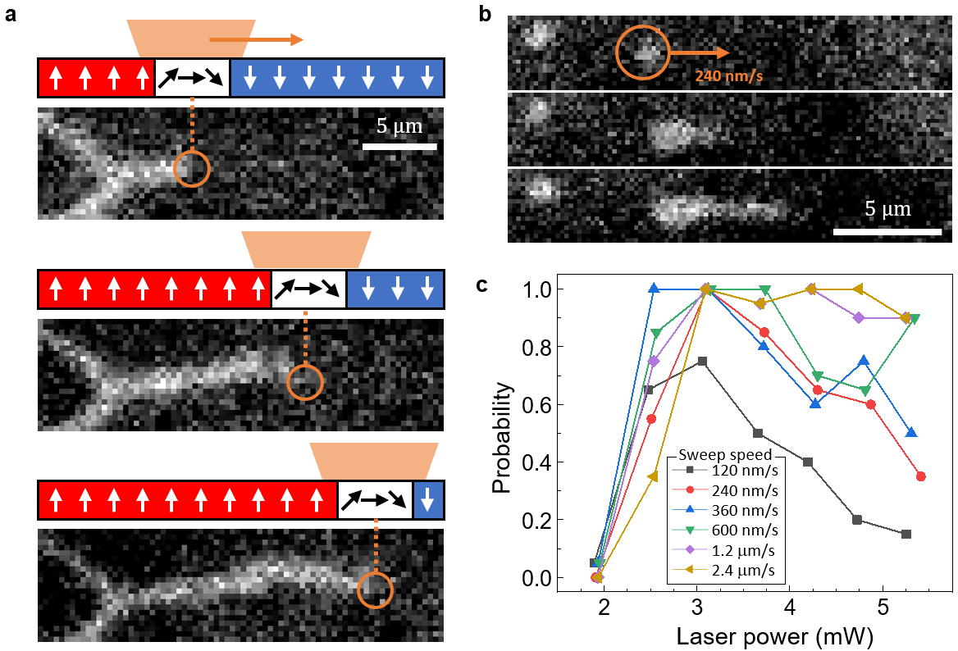
Figure S6 Optical formation of half-skyrmions. (a) Photothermal dragging of a chiral DW. (b) Creation of half-skyrmions by pulling one side of an individual skyrmion. (c) Probability of half-skyrmion formation from a single skyrmion as a function of laser power and sweeping speed, based on 20 trials per condition.
Supplementary Information S4. Arrhenius equation-based interpretation of photothermal skyrmion transport
The thermally activated nature of skyrmion transport under a photothermal potential can be effectively described by the Arrhenius equation. The rate at which a skyrmion overcomes an energy barrier to jump between intrinsic local pinning sites, as a function of temperature and incident laser power, is given by
$$k=A\exp\left(-\frac{E_{b}}{k_{B}T_{local}}\right)=A\exp\left(-\frac{E_{b}}{k_{B}\left(T_{0}+αP\right)}\right)$$
Here, $T_{local}$ is the local temperature effectively determined by the room temperature T₀, the pre-exponential factor A, the incident laser power P, and the heating coefficient α. E_{b} and k_{B} are the activation energy barrier and the Boltzmann constant, respectively. A higher transition rate corresponds to a shorter time required to achieve a given skyrmion transport probability, allowing for faster laser spot sweeping. From the experimental results in Fig. 2c of the main manuscript (see the magnified view in the top panel in Fig. S7), we estimated the laser power necessary to achieve a transport probability of p = 0.1 at various sweeping speeds varying from 120 nm/s to 2.4 μm/s. As shown in the bottom panel of Fig. S7, the relationship between the sweeping speed $v_{sw}$ and the incident laser power $P$ follows an exponential dependence, consistent with the thermally activated behavior described by the Arrhenius equation: $v_{sw}=v_{0}\exp\left(-\frac{E_{b}}{k_{B}\left(T_{0}+αP\right)}\right)$.
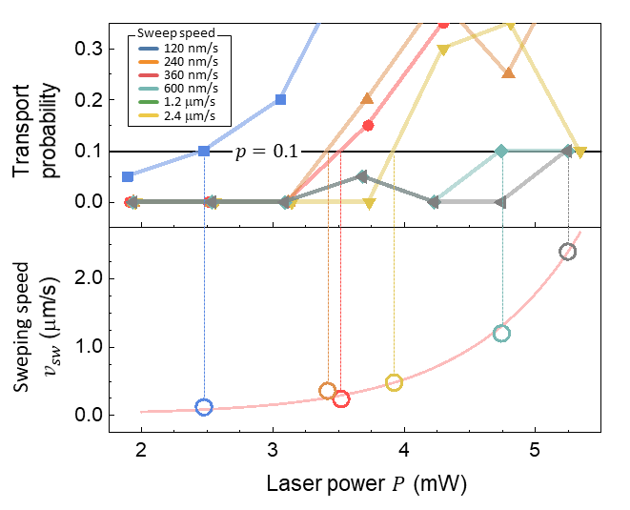
Figure S7 Arrhenius equation-based analysis of photothermal skyrmion transport. (Top panel) Magnified plot of the experimental data from Fig. 2c in the main manuscript. The probability of successfully transporting a single skyrmion over a 10 μm distance as a function of the incident laser power and sweeping speed, based on 20 trials per condition. (Bottom panel) Exponential dependence of the sweeping speed on incident laser power. The laser power required to achieve a skyrmion transport probability of 𝑝 = 0.1 is estimated for different sweeping speeds, varying from 120 nm/s to 2.4 μm/s.
References for Supplementary Information
[R1] Moon, K.-W et al. Measuring the Magnetization from the Image of the Stripe Magnetic Domain. Phys. Rev. Appl. 12, 034030 (2019)
[R2] Lee, K-M., Choi, J.W., Sok, J. & Min, B-C. Temperature dependence of the interfacial magnetic anisotropy in W/CoFeB/MgO. AIP Adv. 7, 065107 (2017)
[R3] Yamanouchi, M. et al. Domain Structure in CoFeB Thin Films With Perpendicular Magnetic Anisotropy. IEEE Magn. Lett. 2, 3000304 (2011)
[R4] Yang, S. et al. Magnetic Skyrmion Transistor Gated with Voltage-Controlled Magnetic Anisotropy. Adv. Mater. 35, 2208881 (2023)
[R5] Yang, S. et al. Hwang, Magnetic Field Magnitudes Needed for Skyrmion Generation in a General Perpendicular Magnetized Film. Nano Lett. 22, 8430-8436 (2022)
[R6] Song, M. et al. Universal Hopping Motion Protected by Structural Topology. Adv. Mater. 34, 2203275 (2022)
[R7] Yang, S. et al. Electrical Generation and Deletion of Magnetic Skyrmion-Bubbles via Vertical Current Injection. Adv. Mater. 33, 2104406 (2021)

