Supporting information for:

Cross-reactivity of antibodies from non-hospitalized COVID-19 positive individuals against the native and B.1.351 SARS-CoV-2 spike proteins

Maryam Hojjat Jodaylami^{[a] ⊥}, Abdelhadi Djaileb^{[b]⊥}, Pierre Ricard^{[a]⊥}, Julien Coutu^{[a]}, Étienne Lavallée^{[b]}, Matthew Stuible^{[c]}, Christian Gervais^{[c]}, Yves Durocher^{[c]}, Marie-Pierre Cayer^{[d]}, Marie Joëlle de Grandmont^{[d]}, Samuel Rochette^{[d]}, Danny Brouard^{[d]}, Sylvie Trottier^{[e]}, Denis Boudreau^{[f]}, Joelle N. Pelletier*^{[b]} and Jean-Francois Masson*^{[a]}

[a] Department of Chemistry, Quebec Centre for Advanced Materials (QCAM), Regroupement Québécois sur les Matériaux de Pointe (RQMP), and Centre interdisciplinaire de recherche sur le cerveau et l’apprentissage (CIRCA), Université de Montréal, CP 6128 Succ. Centre-Ville, Montreal, Québec, Canada, H3C 3J7
[b] Department of Chemistry, Department of Biochemistry and PROTEO, The Québec Network for Research on Protein Function, Engineering and Applications, Université de Montréal, CP 6128 Succ. Centre-Ville, Montreal, Québec, Canada, H3C 3J7
[c] Mammalian Cell Expression, Human Health Therapeutics Research Centre, National Research Council Canada, Montréal, Québec, Canada.
[d] Héma‐Québec, Affaires médicales et innovation, 1070, avenue des Sciences‐de‐la‐Vie, Québec City, Québec, Canada, G1V 5C3
[e] Centre de recherche du Centre hospitalier universitaire de Québec and Département de microbiologie-infectiologie et d’immunologie, Université Laval 2705, boulevard Laurier, Québec City, Québec, Canada G1V 4G2
[f] Department of Chemistry and Centre for Optics, Photonics and Lasers (COPL), Université Laval, 1045, av. de la Médecine, Québec City, Québec, Canada, G1V 0A6

* Corresponding authors: joelle.pelletier@umontreal.ca; tel: +1-514-343-2124
jf.masson@umontreal.ca; tel: +1-514-343-7342
⊥ Authors that contributed equally to the work.

Table of contents:

- RBD SPR and ELISA assays
- Optimization of the ACE-2:spike inhibition assay
- Supporting Tables
- Supporting Figures

1) RBD SPR and ELISA assays

A decrease in the ELISA OD₄₅₀ (generally > 1 for spike and <0.5 for RBD, Table S3) and in the SPR shifts (generally >1000 RU for spike and < 400 RU for RBD, Table S4) compared to spike proteins led to lower sensitivity (Tables S5 and S6) and specificity (Tables S5 and S6), in addition to poorer AUC for ROC curves (0.57 to 0.99 for ELISA and 0.58 to 0.89 for SPR, Figure S5 and S6). These poorer performance metrics were obtained for the native RBD as well as for the RBD for the VOCs.

2) Optimization of the ACE-2:spike inhibition assay

Human recombinant ACE-2 immobilization

We initially tried to immobilize human recombinant ACE-2 to the surface of the SPR sensor and expose the surface to a spike protein solution to the chip for binding. In that scheme, spike would be added to the clinical sera to measure the inhibition of the human recombinant ACE-2−spike protein interaction in the presence of neutralizing antibodies (Scheme S1). The immobilization of human recombinant ACE-2 (conditions: 10 µg/mL, buffer: 10 mM acetate pH 4.5) led to shifts on the order of 1000 RU and the detection of the 2.5 µg/mL native spike protein showed shifts on the order of 200-300 RU, revealing that a functional human recombinant ACE-2 SPR chip could be produced. Regeneration of the chip was possible in 0.1% SDS. However, attempts to perform an inhibition assay were suboptimal with 10 µg/mL spike protein, as we did not see strong inhibition (10%) of the ACE-2−spike protein interaction. In this assay, the spike protein was added to a COVID-positive serum diluted 1:5 in the running buffer, such that neutralizing antibodies should prevent the spike protein from binding to the human recombinant ACE-2-functionalized SPR chip. Decreasing the concentration of spike protein to 2.5 µg/mL led to slightly better performance, obtaining 34% inhibition of the response from the COVID-positive serum. The improvement of the inhibition was to be expected as a decreased concentration of spike should lead to larger inhibition, as a larger proportion of the spike protein should be bound to the antibodies. However, the range, or contrast, of the inhibition assay with human recombinant ACE-2 on the SPR chip was insufficient and further decreasing the concentration of spike would lead to weak SPR signals. As such, the design of the assay was modified to immobilize spike on the surface.

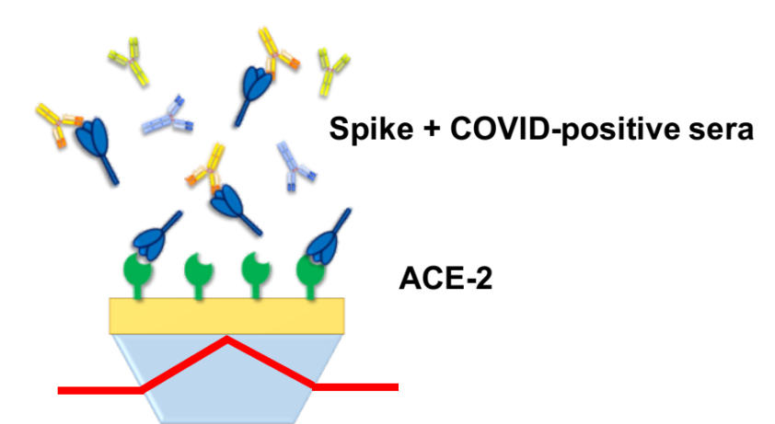
Scheme S1. Human recombinant ACE-2 was immobilized on the SPR sensor. Then, a concentration of spike protein was added to a 1:5 diluted sera and pre-incubated for 2 hours. This solution was injected on the SPR sensor and free spike protein could bind to recombinant human ACE-2. In the presence of neutralizing antibodies, the concentration of free spike available to bind to recombinant human ACE-2 decreased and led to a lower response of the SPR sensor. The response was then compared to that obtained in a control serum having no anti-spike antibodies.

Spike immobilization
Immobilizing spike on the SPR surface led to improved performance of the inhibition assay. In this case, the spike-functionalized SPR surface (immobilized at 20 µg/mL, buffer: 10 mM acetate pH 4.5 buffer) was first exposed to the COVID-positive sera (diluted 1:5) to bind the spike protein with neutralizing antibodies. Then, a 2.5 µg/mL solution of human recombinant ACE-2 was injected to the surface where it bound to the spike proteins that were not bound to neutralizing antibodies. The reference channel was exposed to a commercial serum exempt of anti-spike antibodies at the same dilution factor and then, exposed to the same concentration of human recombinant ACE-2, providing a positive control (Scheme S2). In those conditions, a decrease of 450 RU of the human recombinant ACE-2 / spike interaction was observed for the COVID-positive serum diluted 1:5, a significant improvement from the 100 RU signal observed with ACE-2 immobilized on the surface.
We then sought to find the optimal dilution factor for the interaction of human recombinant ACE-2. As previously observed with the affinity curves and shown here in Figure S10, the SPR response from anti-spike antibodies in serum (response subtracted from a blank serum) led to a relatively linear increase of the SPR response with dilution. Similarly, a smaller serum dilution, implying a larger anti-spike antibody concentration, led to a relatively linear increase of the inhibition of human recombinant ACE-2 binding to the spike-coated SPR chip. Note that the data in Figure S10 – right panel is presented as a decrease in human recombinant ACE-2 binding, resulting from inhibition of binding to spike protein by the antibodies. A 1:5 dilution was selected with consideration of the volume of serum available and to maximize signal from ACE-2 inhibition. To increase the contrast, human recombinant ACE-2 concentration was increased to 5 µg/mL.

Measurement of human recombinant ACE-2 interaction with spike
We ensured that the SPR sensor was functional with the estimation of the K_{D} at 38 and 33 nM with the native and B.1.351 spike proteins respectively (Figure S11 and Table S7). The difference in K_{D} between the results presented here and the ones of ref (1) (<10 nM) may be explained by the difference in protein source, protein structure (RBD (1) vs trimeric spike here) and orientation of the protein immobilized on the SPR surface. Analysis of the association (k_{on}) and dissociation (k_{off}) rates revealed that they were slightly slower for B.1.351 in comparison to the native spike protein (Table S7). Hence, SPR can actively detect the interaction of human recombinant ACE-2 with the various spike proteins immobilized on the SPR sensor.

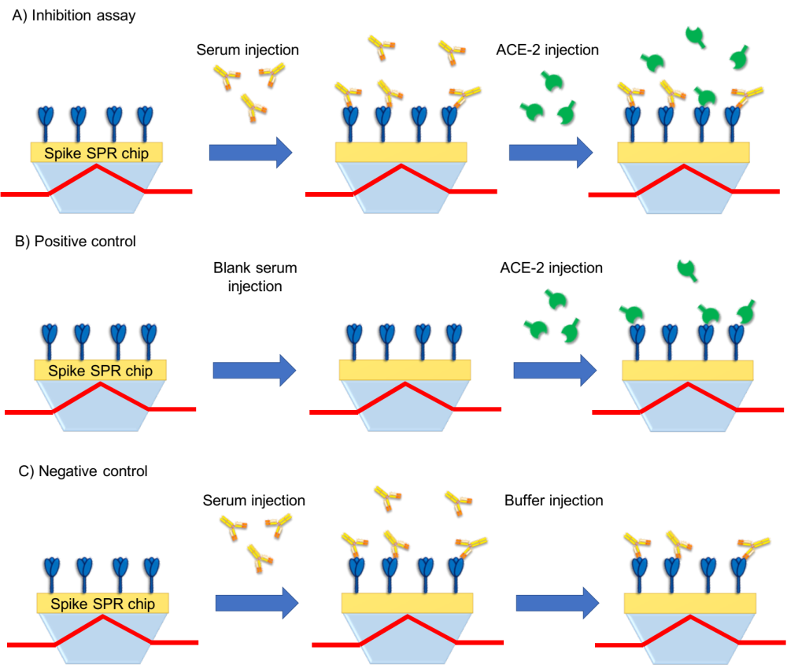
Scheme S2. A) Scheme of the inhibition measurement. The COVID-positive sera (diluted 1:5) are injected on the SPR chip functionalized with the spike protein (native or VOCs). Following a rapid wash in running buffer, the surface was then exposed to 5 µg/mL ACE-2. The SPR signal in RU is expected to range between the positive control (high ACE-2 signal, panel B) and above the negative control signal (low ACE-2 signal, panel C). B) The positive control channel is first exposed to a blank serum at the same dilution factor as the pseudo-neutralization channel and then exposed to ACE-2 in otherwise identical conditions. C) The negative control consist in the injection of the same COVID-positive serum as in A), but running buffer is injected in the second step instead of ACE-2. This provides the background SPR signal and accounts for partial desorption of the antibodies on the SPR sensor.

Calculation of an inhibition percentage
As antibodies binding to spike protein can dissociate from the surface of the SPR chip in running buffer, we added a negative control to the inhibition assay protocol. In one of the four channels, the serum from a COVID-positive individual is first injected in identical conditions to the measurement channels, but running buffer is then injected instead of ACE-2 to measure the drop in SPR response from washing away loosely bound antibodies. The drop in SPR signal from loosely bound antibodies is approximately 50 to 100 RU on average, or about 5% to 10% of the immobilized antibodies (Figure S13). As such, the inhibition protocol required the measurement of the serum samples in duplicate, a positive control and a negative control, as shown in Table S8.
Equation S1 led to the calculation of percent inhibition (%I). As the serum was diluted for the inhibition assay, it should not be interpreted as an absolute value.

(S1) %I = (SPR_{COVID+} – SPR_{pos}) / (SPR_{pos} – SPR_{neg}) * 100%

Where SPR_{COVID+} is the SPR response (all in RU) of human recombinant ACE-2 following the injection of a sera from a COVID-positive individual, SPR_{pos}) corresponds to the SPR response for the human recombinant ACE-2−spike protein interaction in a control serum (devoid of anti-spike antibodies) and SPR_{neg} is the SPR response for the injection of the immune serum and a blank (no human recombinant ACE-2). A percentage change of the inhibition (Δ%I) was calculated from the inhibition with the VOC spike proteins (%I_{VOC}) and the inhibition with the native spike protein (%I_{native}) (equation 2).

(S2) Δ%I = %I_{VOC} / %I_{native} * 100%

Table S1. Compilation of the ELISA OD₄₅₀ for the detection of anti-spike antibodies to the spike protein of native SARS-CoV-2 and of the B.1.351 VOC.
 |  |  | Native Spike |  | B.1.351 (SA) Spike
Sample ID | Sex | PCR test result | Week 4 | Week 16 | Week 4 | Week 16
4908 | F | Positive | 1.985 | 1.077 | 1.160 | 0.706
4910 | M | Positive | 2.376 | 1.952 | 1.566 | 1.473
4913 | F | Positive | 1.628 | 1.261 | 1.123 | 0.694
4914 | M | Positive | 1.191 | 0.997 | 0.420 | 0.562
4915 | M | Positive | 1.711 | 1.367 | 1.077 | 0.643
4916 | F | Positive | 1.718 | 1.044 | 1.243 | 0.729
4917 | F | Positive | 0.745 | 0.756 | 0.333 | 0.383
4918 | F | Positive | 1.494 | 1.061 | 0.791 | 0.784
5902 | F | Positive | 1.981 | 1.262 | 1.450 | 1.283
5903 | M | Positive | 2.845 | 1.556 | 1.953 | 1.135
5908 | M | Positive | 3.341 | 2.728 | 2.283 | 2.179
5909 | M | Positive | 0.960 | 0.887 | 0.590 | 0.576
5911 | F | Positive | 2.537 | 1.739 | 1.935 | 1.061
5912 | M | Positive | 2.899 | 2.042 | 2.249 | 1.393
5914 | F | Positive | 0.752 | 1.663 | 0.525 | 1.061
5915 | F | Positive | 1.189 | 0.738 | 0.900 | 0.756
6903 | M | Positive | 2.880 | N/A | 2.059 | N/A
6905 | F | Positive | 3.413 | 2.002 | 2.305 | 3.061
6906 | F | Positive | 1.409 | 1.134 | 0.870 | 1.351
6907 | F | Positive | 2.800 | 2.417 | 1.508 | 2.286
6908 | F | Positive | 1.944 | 1.526 | 1.117 | 0.810
6909 | M | Positive | 1.821 | 1.080 | 0.690 | 0.743
6910 | M | Positive | 1.713 | 1.288 | 1.019 | 1.701
6911 | M | Positive | 2.091 | 1.139 | 0.968 | 2.089
7003 | F | Positive | 2.342 | 1.844 | 2.735 | 2.782
7004 | M | Positive | 2.779 | 2.249 | 2.289 | 2.973
7005 | F | Positive | 2.341 | 2.049 | 1.751 | 2.022
7006 | M | Positive | 2.313 | 2.408 | 2.270 | 2.360
7007 | M | Positive | 2.058 | 2.386 | 2.292 | 2.920
7008 | F | Positive | 2.049 | 2.438 | 2.249 | 2.173
7009 | F | Positive | 1.853 | 2.024 | 1.475 | 2.407
7010 | F | Positive | 1.354 | 1.460 | 1.311 | 2.549
C001 | F | Negative | 0.155 | 0.33 | 0.125 | 0.133
C002 | F | Negative | 0.170 | 0.300 | 0.126 | 0.162
C003 | F | Negative | 0.228 | 0.329 | 0.236 | 0.154
C004 | M | Negative | 0.268 | 0.281 | 0.147 | 0.185
C005 | F | Negative | 0.140 | 0.381 | 0.128 | 0.152
C007 | F | Negative | 0.149 | 0.171 | 0.139 | 0.300
C008 | F | Negative | 0.162 | 0.247 | 0.167 | 0.139
C009 | F | Negative | 0.194 | 0.549 | 0.176 | 0.139

N/A: sample not available

Table S2. Compilation of the SPR binding shift for the detection of anti-spike antibodies to the spike protein of native SARS-CoV-2 and of the B.1.351 VOC. All shifts are reported in RU for the secondary detection step.
 |  |  | Native Spike |  | B.1.351 (SA) Spike
Sample ID | Sex | PCR test result | Week 4 | Week 16 | Week 4 | Week 16
4908 | F | Positive | 1181 | 1075 | 880 | 360
4910 | M | Positive | 1862 | 1572 | 797 | 104
4913 | F | Positive | 1278 | 933 | 803 | 1807
4914 | M | Positive | 1124 | 1475 | 717 | 400
4915 | M | Positive | 1885 | 1844 | 785 | 1807
4916 | F | Positive | 313 | 1113 | 1036 | 875
4917 | F | Positive | 1436 | 601 | 453 | 1212
4918 | F | Positive | 1539 | 773 | 846 | 792
5902 | F | Positive | 2341 | 1726 | 422 | 1132
5903 | M | Positive | 1968 | 1990 | 1725 | 1205
5908 | M | Positive | 1978 | 1977 | 691 | 1742
5909 | M | Positive | 1342 | 775 | 1061 | 517
5911 | F | Positive | 1531 | 2177 | 1722 | 1617
5912 | M | Positive | 2024 | 2283 | 933 | 1704
5914 | F | Positive | 1298 | 1858 | 1608 | 1071
5915 | F | Positive | 1621 | 121 | 1070 | 1063
6903 | M | Positive | 1996 | N/A | 1513 | N/A
6905 | F | Positive | 897 | 2188 | 1013 | 1566
6906 | F | Positive | 910 | 733 | 1825 | 331
6907 | F | Positive | 687 | 1202 | 438 | 915
6908 | F | Positive | 1545 | 1310 | 79 | 1108
6909 | M | Positive | 1047 | 444 | 1039 | 593
6910 | M | Positive | 713 | 1304 | 1087 | 779
6911 | M | Positive | 1686 | 1579 | 1558 | 726
7003 | F | Positive | 2662 | 1974 | 2089 | 1110
7004 | M | Positive | 1988 | 1534 | 2118 | 937
7005 | F | Positive | 1101 | 1661 | 1275 | 160
7006 | M | Positive | 1095 | 1773 | 462 | 1362
7007 | M | Positive | 908 | 1891 | 1868 | 1092
7008 | F | Positive | 1603 | 1312 | 1593 | 42
7009 | F | Positive | 1744 | 1836 | 1445 | 1210
7010 | F | Positive | 1346 | 1424 | 870 | 757
C001 | F | Negative | 280 | -47 | 386 | 98
C002 | F | Negative | 3 | 240 | 412 | 183
C003 | F | Negative | 349 | 108 | 454 | 158
C004 | M | Negative | 261 | 94 | 672 | 158
C005 | F | Negative | 271 | 24 | 677 | 343
C007 | F | Negative | 441 | 127 | 622 | 119
C008 | F | Negative | 582 | 6 | 1276 | 51
C009 | F | Negative | 217 | 307 | 622 | 277

N/A: sample not available

Table S3. Compilation of the ELISA OD₄₅₀ for the detection of anti-RBD antibodies to the spike protein of native SARS-CoV-2 and of the B.1.351 VOC.
 |  |  | Native RBD |  | B.1.351 (SA) RBD
Sample ID | Sex | PCR test result | Week 4 | Week 16 | Week 4 | Week 16
4908 | F | Positive | 0.155 | 0.136 | 0.769 | 0.168
4910 | M | Positive | 0.165 | 0.341 | 1.220 | 0.672
4913 | F | Positive | 0.213 | 0.157 | 0.785 | 0.153
4914 | M | Positive | 0.130 | 0.108 | 0.435 | 0.183
4915 | M | Positive | 0.203 | 0.218 | 0.890 | 0.364
4916 | F | Positive | 0.172 | 0.212 | 0.937 | 0.355
4917 | F | Positive | 0.112 | 0.120 | 0.303 | 0.109
4918 | F | Positive | 0.143 | 0.145 | 0.687 | 0.152
5902 | F | Positive | 0.208 | 0.327 | 0.775 | 0.263
5903 | M | Positive | 0.334 | 0.384 | 1.369 | 0.364
5908 | M | Positive | 0.564 | 0.592 | 1.554 | 1.121
5909 | M | Positive | 0.122 | 0.113 | 0.465 | 0.132
5911 | F | Positive | 0.397 | 0.486 | 1.470 | 0.482
5912 | M | Positive | 0.537 | 0.369 | 1.487 | 0.771
5914 | F | Positive | 0.116 | 0.356 | 0.308 | 0.327
5915 | F | Positive | 0.182 | 0.180 | 0.361 | 0.201
6903 | M | Positive | 0.348 | N/A | 1.101 | N/A
6905 | F | Positive | 0.268 | 0.474 | 1.022 | 0.204
6906 | F | Positive | 0.125 | 0.192 | 0.410 | 0.258
6907 | F | Positive | 0.159 | 0.235 | 0.787 | 0.243
6908 | F | Positive | 0.218 | 0.148 | 0.617 | 0.144
6909 | M | Positive | 0.185 | 0.116 | 0.260 | 0.137
6910 | M | Positive | 0.200 | 0.128 | 0.638 | 0.263
6911 | M | Positive | 0.144 | 0.145 | 0.588 | 0.139
7003 | F | Positive | 0.978 | 0.199 | 1.444 | 0.593
7004 | M | Positive | 0.365 | 0.170 | 1.050 | 0.271
7005 | F | Positive | 0.373 | 0.161 | 1.019 | 0.276
7006 | M | Positive | 0.610 | 0.154 | 1.237 | 0.539
7007 | M | Positive | 0.616 | 0.207 | 1.411 | 0.440
7008 | F | Positive | 0.555 | 0.237 | 1.216 | 0.388
7009 | F | Positive | 0.373 | 0.180 | 0.755 | 0.281
7010 | F | Positive | 0.302 | 0.194 | 0.636 | 0.569
C001 | F | Negative | 0.130 | 0.108 | 0.240 | 0.107
C002 | F | Negative | 0.103 | 0.101 | 0.115 | 0.105
C003 | F | Negative | 0.194 | 0.104 | 0.352 | 0.104
C004 | M | Negative | 0.116 | 0.107 | 0.101 | 0.104
C005 | F | Negative | 0.114 | 0.111 | 0.114 | 0.100
C007 | F | Negative | 0.101 | 0.104 | 0.137 | 0.099
C008 | F | Negative | 0.111 | 0.109 | 0.199 | 0.105
C009 | F | Negative | 0.117 | 0.110 | 0.162 | 0.113

N/A: sample not available

Table S4. Compilation of the SPR binding shift for the detection of anti-RBD antibodies for the native SARS-CoV-2 RBD and for the B.1.351 VOCs. All shifts are reported in RU for the secondary detection step.
 |  |  | Native RBD |  | B.1.351 (SA) RBD
Sample ID | Sex | PCR test result | Week 4 | Week 16 | Week 4 | Week 16
4908 | F | Positive | 268 | 173 | -16 | 474
4910 | M | Positive | 186 | 593 | 32 | 267
4913 | F | Positive | 101 | 136 | -132 | -63
4914 | M | Positive | 257 | 417 | 36 | -134
4915 | M | Positive | 331 | 226 | -2 | 22
4916 | F | Positive | 338 | 446 | -52 | 16
4917 | F | Positive | 79 | 266 | -79 | -50
4918 | F | Positive | 183 | 255 | -127 | -61
5902 | F | Positive | 558 | 583 | 71 | 5
5903 | M | Positive | 615 | 474 | 128 | 83
5908 | M | Positive | 475 | 817 | 711 | -11
5909 | M | Positive | 235 | 401 | -26 | -72
5911 | F | Positive | 656 | 622 | 136 | -33
5912 | M | Positive | 759 | 716 | 224 | 151
5914 | F | Positive | 87 | 612 | -5 | 32
5915 | F | Positive | 405 | 494 | 124 | -24
6903 | M | Positive | 452 | N/A | 47 | N/A
6905 | F | Positive | 228 | 277 | 110 | -198
6906 | F | Positive | 334 | 502 | 47 | -139
6907 | F | Positive | 601 | 407 | -79 | -95
6908 | F | Positive | 88 | 446 | 48 | -148
6909 | M | Positive | 181 | 530 | -10 | -63
6910 | M | Positive | 327 | 435 | -33 | -177
6911 | M | Positive | 444 | 610 | -102 | -17
7003 | F | Positive | 184 | 810 | 267 | -22
7004 | M | Positive | 512 | 1040 | 151 | 262
7005 | F | Positive | 527 | 1144 | 87 | 30
7006 | M | Positive | 562 | 910 | 108 | 190
7007 | M | Positive | 933 | 777 | 379 | 209
7008 | F | Positive | 592 | 657 | 80 | 68
7009 | F | Positive | 719 | 685 | -5 | -28
7010 | F | Positive | 797 | 397 | 99 | 241
C001 | F | Negative | 187 | 257 | 22 | -31
C002 | F | Negative | 268 | 222 | -43 | 70
C003 | F | Negative | 36 | 337 | -22 | -52
C004 | M | Negative | 252 | 273 | -99 | -81
C005 | F | Negative | 216 | 314 | 45 | 11
C007 | F | Negative | 310 | 351 | -45 | 75
C008 | F | Negative | 127 | 304 | -43 | -52
C009 | F | Negative | 177 | 273 | -97 | -162

N/A: sample not available

Table S5. ELISA for the detection of IgG targeting the native and B.1.351 RBD proteins
 |  | Native RBD |  | B.1.351 RBD
ELISA |  | Week 4 | Week 16 | Week 4 | Week 16
OD₄₅₀ (A.U) | Pos. | 0.3 ± 0.2 | 0.23 ± 0.12 | 0.9 ± 0.4 | 0.3 ± 0.2
OD₄₅₀ (A.U) | Neg. | 0.12 ± 0.03 | 0.107 ± 0.003 | 0.18 ± 0.08 | 0.105 ± 0.004
Threshold (A.U) |  | 0.13 | 0.125 | 0.25 | 0.125
COVID+ sera | # Pos. | 27 | 27 | 32 | 30
COVID+ sera | # Neg. | 5 | 4 | 0 | 1
Control sera | # Pos. | 1 | 0 | 1 | 0
Control sera | # Neg. | 7 | 8 | 8 | 8
AUC |  | 0.91 | 0.99 | 0.99 | 0.99
p value |  | <0.05 | <0.01 | <0.0001 | <0.01
Sensitivity |  | 84 | 87 | 100 | 97
Specificity |  | 87 | 100 | 88 | 100

Table S6. SPR assay for the detection of IgG targeting the native and B.1.351 RBD proteins
 |  | Native RBD |  | B.1.351 RBD
 |  | Week 4 | Week 16 | Week 4 | Week 16
Shift (kRU) | Pos. | 0.4 ± 0.2 | 0.5 ± 0.2 | 0.07 ± 0.16 | 0.02 ± 0.15
Shift (kRU) | Neg. | 0.18 ± 0.08 | 0.29 ± 0.04 | -0.04 ± 0.05 | -0.03 ± 0.08
Threshold (kRU) |  | 0.3 | 0.4 | 0.05 | 0.1
COVID+ sera | # Pos. | 20 | 24 | 13 | 7
COVID+ sera | # Neg. | 12 | 7 | 19 | 24
Control sera | # Pos. | 1 | 0 | 0 | 0
Control sera | # Neg. | 7 | 8 | 8 | 8
AUC |  | 0.77 | 0.84 | 0.77 | 0.58
p value |  | <0.05 | <0.01 | 0.08 | 0.37
Sensitivity |  | 62 | 77 | 41 | 23
Specificity |  | 88 | 100 | 100 | 100

Table S7. Spike protein / ACE-2 binding kinetics and affinity

SARS-CoV-2 strain | k_{on} (M^{-1.}s⁻¹) x 10⁴ | k_{off} (s⁻¹) x 10⁻⁴ | K_{D} (nM)
native | 6.68 ± 0.96 | 25.2 ± 4.4 | 37.6 ± 1.2
B.1.351 | 3.6 ± 0.5 | 11.9 ± 1.6 | 32.9 ± 1.6

Table S8. Protocol / injection sequence for the SPR inhibition assay
 | Channel A | Channel B | Channel C | Channel D
Step time (min) | Measurement | Measurement | Positive control | Negative control
10 | COVID+ serum | COVID+ serum | Negative serum | COVID+ serum
Few seconds | Running buffer | Running buffer | Running buffer | Running buffer
10 | 5 µg/mL ACE-2 | 5 µg/mL ACE-2 | 5 µg/mL ACE-2 | Running buffer
Few seconds | Regeneration | Regeneration | Regeneration | Regeneration

Table S9. Compilation of the SPR inhibition data for the native SARS-CoV-2 spike protein and for the B.1.351 VOC using serum from SARS-CoV-2-positive individuals at week 4 and 16 post-diagnosis.
 |  | Native |  | B.1.351
Sample ID | Sex | Week 4 | Week 16 | Week 4 | Week 16
4908 | F | 57 | 31 | 23 | 25
4910 | M | 47 | 51 | 25 | 48
4913 | F | 23 | 73 | 28 | 26
4914 | M | 34 | 34 | 18 | 32
4915 | M | 33 | 78 | 28 | 30
4916 | F | 38 | 15 | 16 | 16
4917 | F | 36 | 35 | 23 | 36
4918 | F | 38 | 56 | 27 | 39
5902 | F | 56 | 42 | 41 | 47
5903 | M | 82 | 76 | 57 | 32
5908 | M | 92 | 97 | 92 | 52
5909 | M | 40 | 31 | 55 | 46
5911 | F | 69 | 65 | 52 | 33
5912 | M | 90 | 78 | 89 | 42
5914 | F | 46 | 52 | 14 | 23
5915 | F | 54 | 48 | 10 | 15
6903 | M | 56 | N/A | 19 | N/A
6905 | F | 70 | 68 | 86 | 78
6906 | F | 31 | 42 | 8 | 35
6907 | F | 81 | 107 | 37 | 27
6908 | F | 51 | 16 | 33 | 57
6909 | M | 8 | 19 | 3 | 16
6910 | M | 5 | 48 | 34 | 41
6911 | M | 73 | 68 | 54 | 33
7003 | F | 87 | 68 | 74 | 24
7004 | M | 90 | 92 | 78 | 56
7005 | F | 41 | 82 | 31 | 10
7006 | M | 91 | 77 | 40 | 37
7007 | M | 120 | 42 | 64 | 58
7008 | F | 103 | 53 | 64 | 45
7009 | F | 67 | 96 | 46 | 14
7010 | F | 72 | 13 | 53 | 41
Mean |  | 59 ± 28 | 57 ± 26 | 59 ± 28 | 59 ± 28

N/A: sample not available

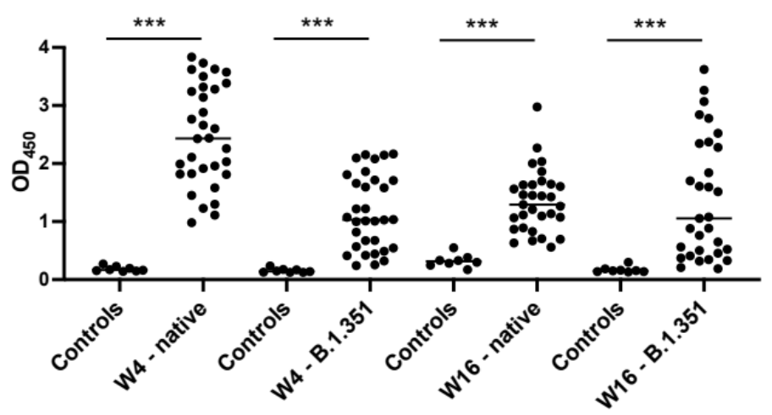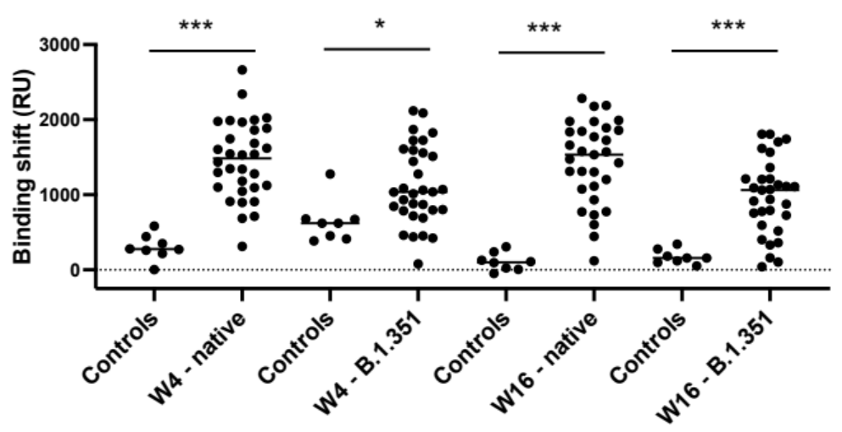

Figure S1. ELISA OD₄₅₀ (top) and SPR binding shifts (bottom) for the detection of anti-spike IgG in each positive serum (n=32) and negative controls (n=8) at week 4 (W4) and week 16 (W16) post-infection for the native and B.1.351 spike proteins. As shown in Figure 1, the average ELISA OD and the SPR binding shift was generally lower for the two VOCs, with the B.1.351 leading to the lowest cross-reactivity of the IgG antibodies elicited to the native SARS-CoV-2. In all cases, the controls associated to an experiment are represented to the left of the data for the positive sera. * p< 0.05, *** p < 0.001

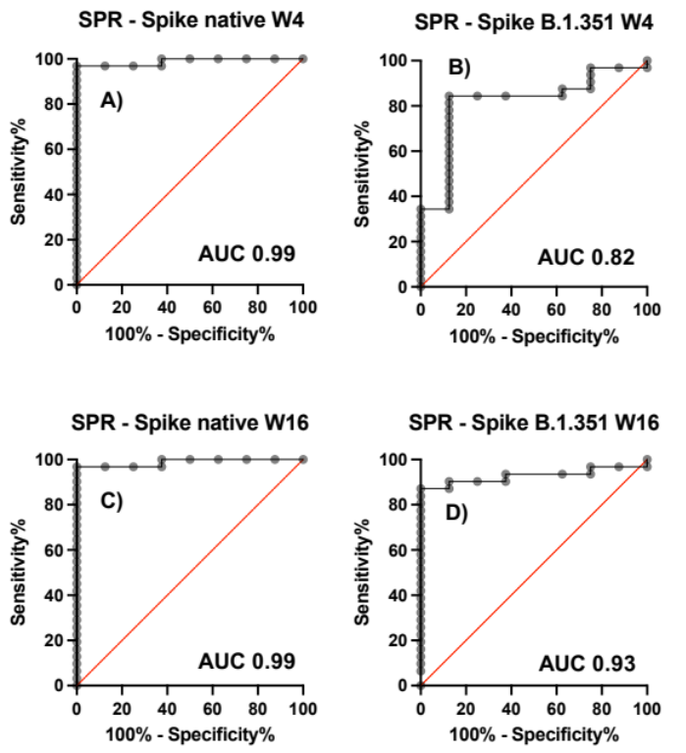
Figure S2. Receiver-operator characteristic curves (ROC) for the SPR detection of anti-IgG targeting the spike proteins (native and B.1.351) in serum samples of SARS-CoV-2 positive (n=32) and negative (n=8) individuals at weeks 4 and 16 post-infection.

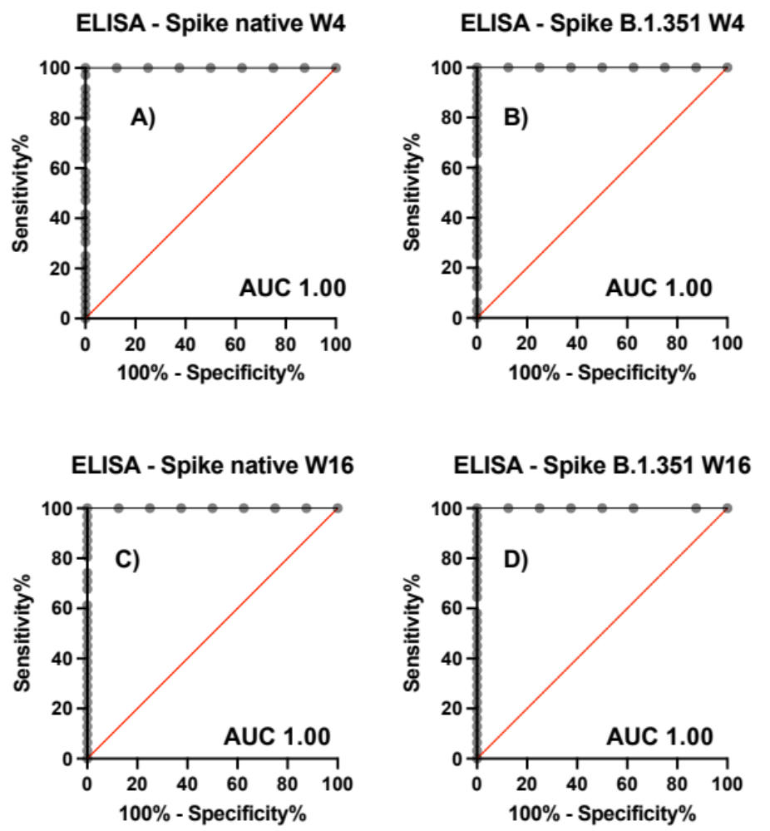
Figure S3. Receiver-operator characteristic curves (ROC) for the ELISA detection of anti-IgG targeting the spike proteins (native and B.1.351) in serum samples of SARS-CoV-2 positive (n=32) and negative (n=8) individuals at weeks 4 and 16 post-infection.

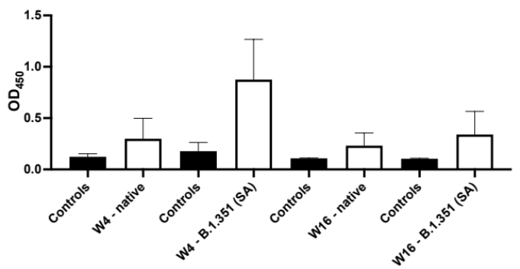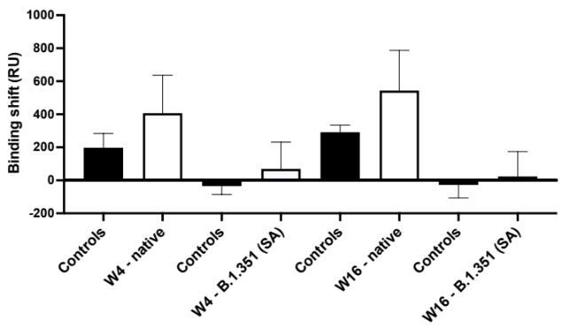
Figure S4. Average ELISA OD₄₅₀ (left) and SPR binding shifts (right) for the detection of anti-RBD IgG in positive sera at week 4 (W4, n = 32) and week 16 (W16, n = 31), and negative controls (n=8) post-infection for the native and B.1.351 RBD proteins. In general, poorer contrast was observed with RBD compared to the spike proteins (Figure 1). In all cases, the controls associated to an experiment are represented to the left of the data for the positive sera. ELISA was performed at 1:50 dilution of sera, while SPR required sera to be diluted 1:5.

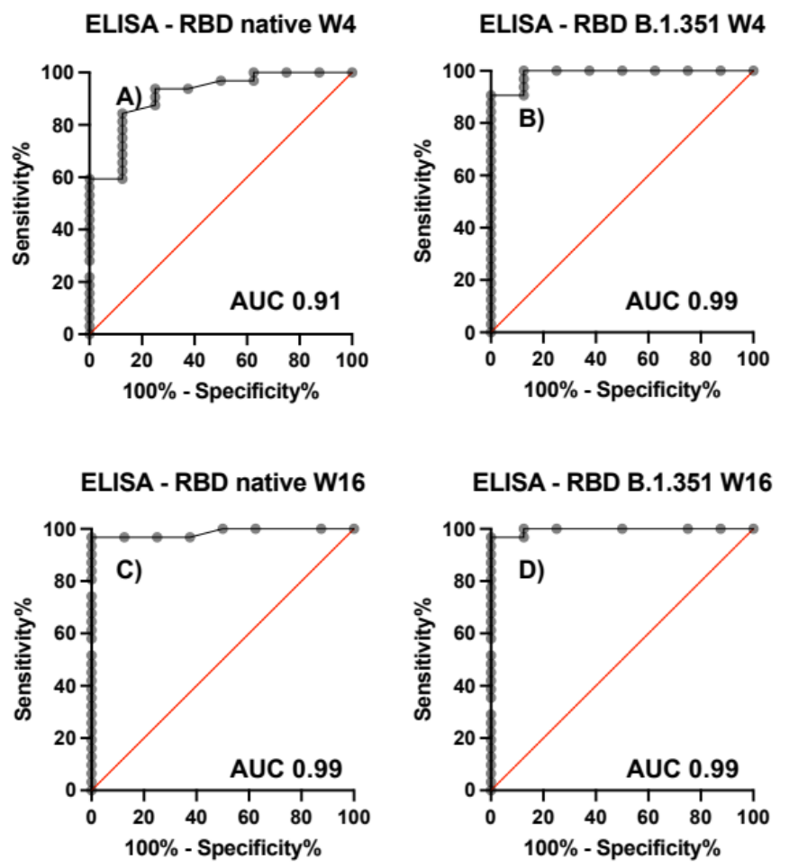
Figure S5. Receiver-operator characteristic curves (ROC) for the SPR detection of anti-IgG targeting the RBD proteins (native and B.1.351) in serum samples of SARS-CoV-2 positive (n=32 for week 4 and n=31 for week 16) and negative (n=8) individuals at weeks 4 and 16 post-infection.

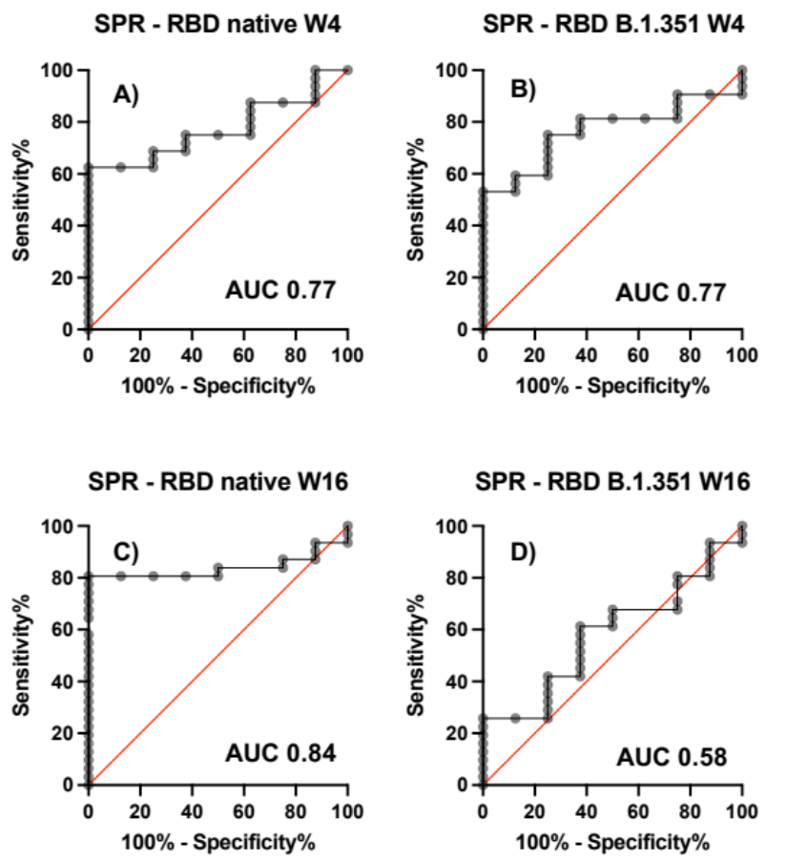
Figure S6. Receiver-operator characteristic curves (ROC) for the SPR detection of anti-IgG targeting the RBD proteins (native and B.1.351) in serum samples of SARS-CoV-2 positive (n=32 for week 4 and n=31 for week 16) and negative (n=8) individuals at weeks 4 and 16 post-infection.

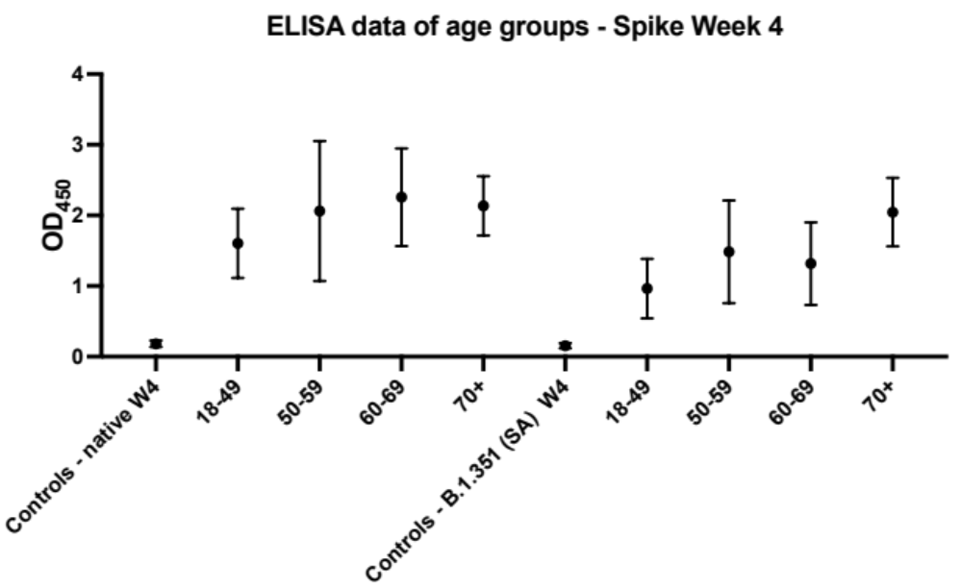
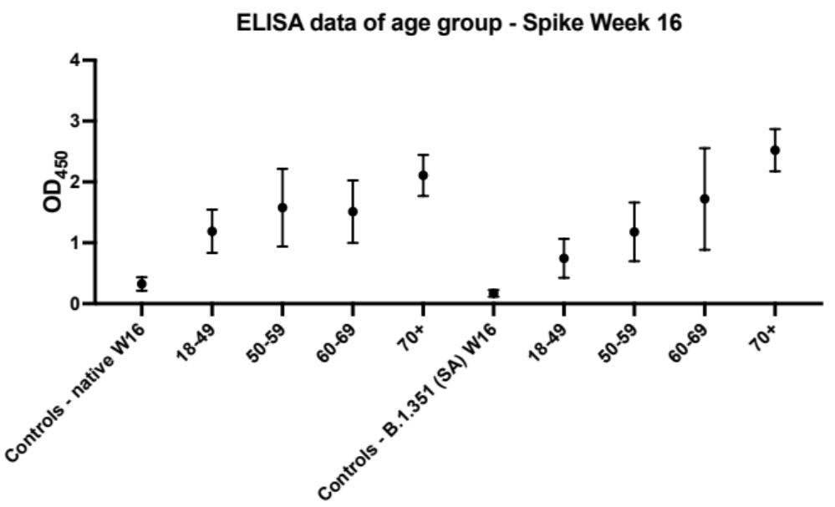
Figure S7. Average ELISA OD₄₅₀ of anti-IgG targeting the spike proteins (native and B.1.351) in serum samples of SARS-CoV-2 positive (n = 8 per age group) and negative (n = 8) individuals at weeks 4 (top) and 16 (bottom) post-infection. The error bars represent one standard deviation.

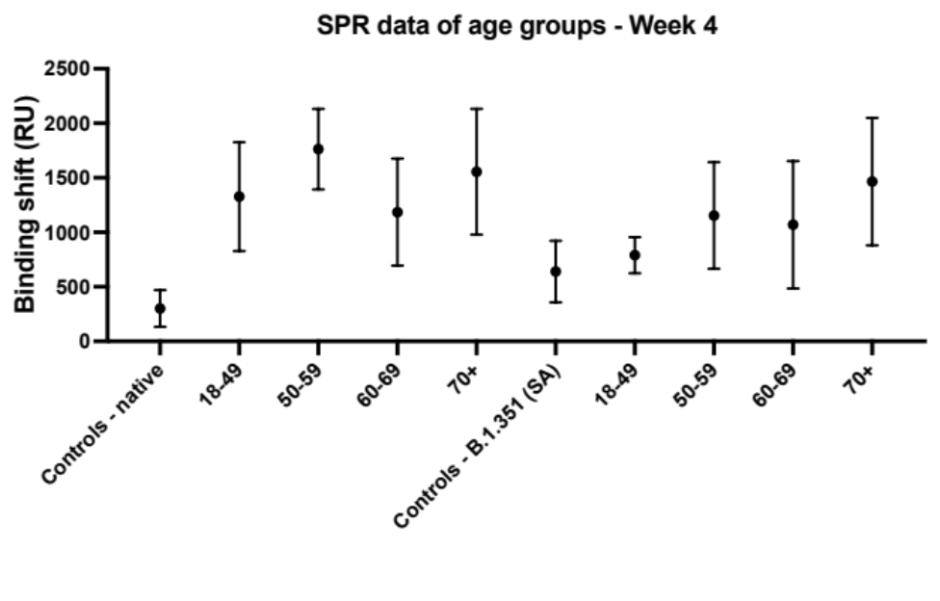
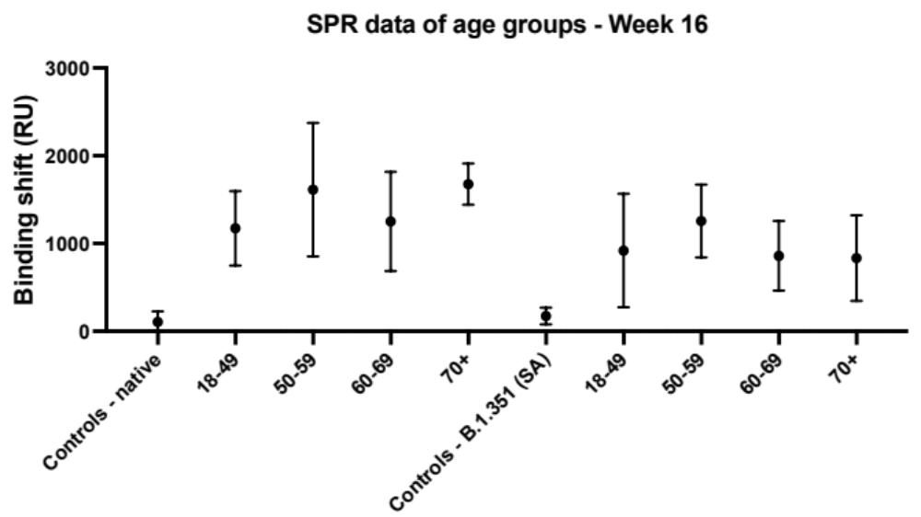
Figure S8. Average SPR binding shifts of anti-IgG targeting the spike proteins (native and B.1.351) in serum samples of SARS-CoV-2 positive (n = 8 per age group) and negative (n = 8) individuals at weeks 4 (top) and 16 (bottom) post-infection. The error bars represent one standard deviation.

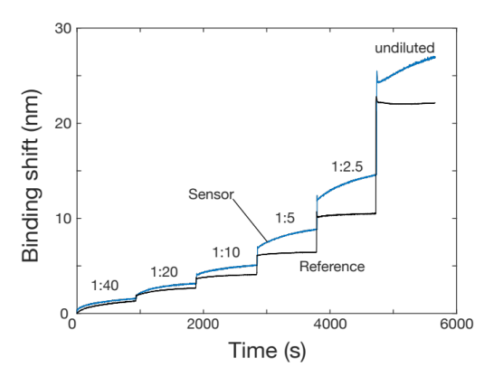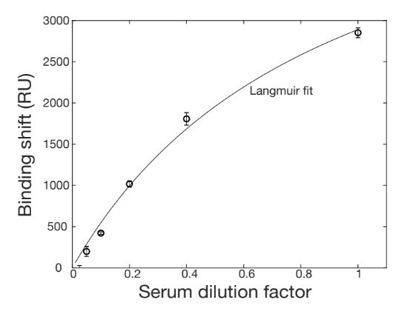
Figure S9. Left) Raw data for the SPR sensorgram for the anti-spike protein affinity assay using a SARS-CoV-2-positive serum at different dilution factors. 1 nm is approximately 330 RU. Right) A 1:1 binding site Langmuir isotherm was applied to estimate the K_{D}, expressed in units of dilution factor (fractional numbers are used in the x-axis, i.e., 1:5 dilution is 0.2). All data were corrected by the SPR response in the reference channel to remove the contribution of the nonspecific response of the serum.

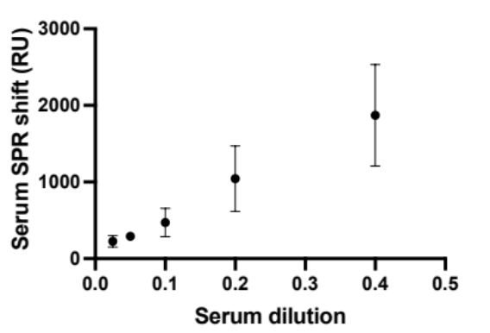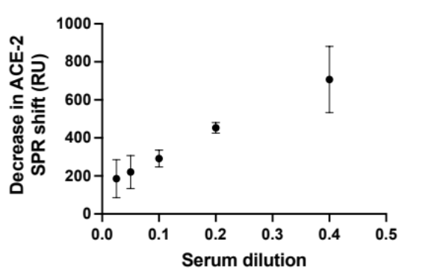
Figure S10. Left) SPR response from a SARS-CoV-2-positive serum as a function of the dilution factor of the serum in running buffer. Right) Decrease in the SPR response from human recombinant ACE-2 following the exposure of the SPR sensor to a SARS-CoV-2-positive serum. The decrease was calculated from the comparison of ACE-2 binding to the spike-coated SPR chip in the absence of SARS-CoV-2-positive serum in otherwise identical conditions. In both panels, the dilution is presented as a fractional number, i.e. 1:5 dilution is 0.2.

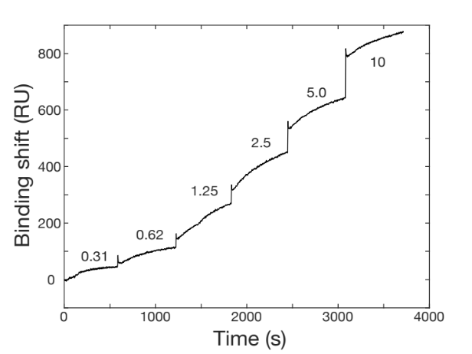
Figure S11. Typical sensorgram for the calibration of human recombinant ACE-2 on a spike SPR surface. Spike was immobilized at 20 µg/mL, while different concentrations of human recombinant ACE-2 were injected sequentially. All human recombinant ACE-2 concentrations are in µg/mL.

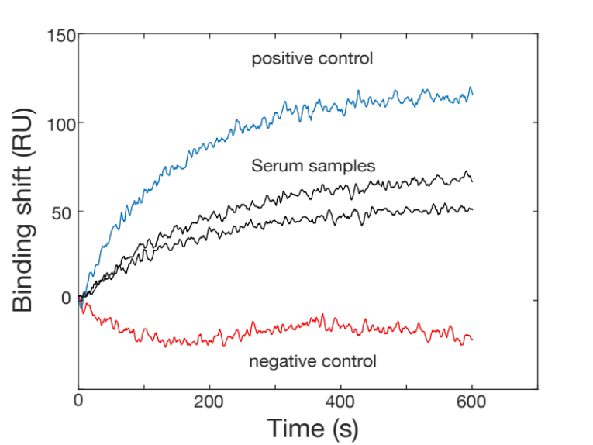
Figure S12. SPR sensorgram for the detection of ACE-2 for the determination of pseudo-neutralization. The blue curve refers to the positive control (detection of ACE-2 in absence of neutralizing antibody), the black curves are the ACE-2 binding measurements following exposure of the chip to the serum (duplicate), and the red curve shows the background signal in absence of ACE-2 (but with prior injection of the serum), consisting in the negative control.

References

1. F. Tian, B. Tong, L. Sun, S. Shi, B. Zheng, Z. Wang, X. Dong, P. Zheng, Mutation N501Y in RBD of Spike Protein Strengthens the Interaction between COVID-19 and its Receptor ACE2. bioRxiv, 2021.2002.2014.431117 (2021).

