Ekman et al. (2021) Primary care and Covid-19.
Supplementary material
Table S.1 Primary care consultations by month and sex, Sweden (selected regions), 2019 and 2020
 |  | 2019 |  |  |  | 2020
Month | Female | Male | Total | Male share (%) | Female | Male | Total | Male share (%)
January | 637,986 | 445,191 | 1,083,177 | 41 | 595,955 | 414,503 | 1,010,458 | 41
February | 605,089 | 422,881 | 1,027,970 | 41 | 583,193 | 405,589 | 988,782 | 41
March | 631,071 | 441,137 | 1,072,208 | 41 | 551,828 | 389,799 | 941,627 | 41
April | 625,018 | 440,546 | 1,065,564 | 41 | 439,530 | 310,718 | 750,248 | 41
May | 639,253 | 448,436 | 1,087,689 | 41 | 452,290 | 318,620 | 770,910 | 41
June | 525,586 | 375,186 | 900,772 | 42 | 498,549 | 356,511 | 855,060 | 42
July | 462,098 | 339,558 | 801,656 | 42 | 404,046 | 293,232 | 697,278 | 42
August | 527,652 | 381,578 | 909,230 | 42 | 477,537 | 335,800 | 813,337 | 41
September | 608,812 | 422,518 | 1,031,330 | 41 | 594,756 | 405,417 | 1,000,173 | 41
October | 664,491 | 455,471 | 1,119,962 | 41 | 604,771 | 413,371 | 1,018,142 | 41
November | 638,887 | 451,858 | 1,090,745 | 41 | 667,767 | 467,845 | 1,135,612 | 41
December | 514,431 | 374,534 | 888,965 | 42 | 510,172 | 356,119 | 866,291 | 41
Total | 7,080,374 | 4,998,894 | 12,079,268 |  | 6,380,394 | 4,467,524 | 10,847,918
Source: VTDB 2019 and 2020.

Figure S.1 Primary care consultations by type (On-site visits, LHS and Remote contacts, RHS), Sweden (selected regions), 2019 and 2020
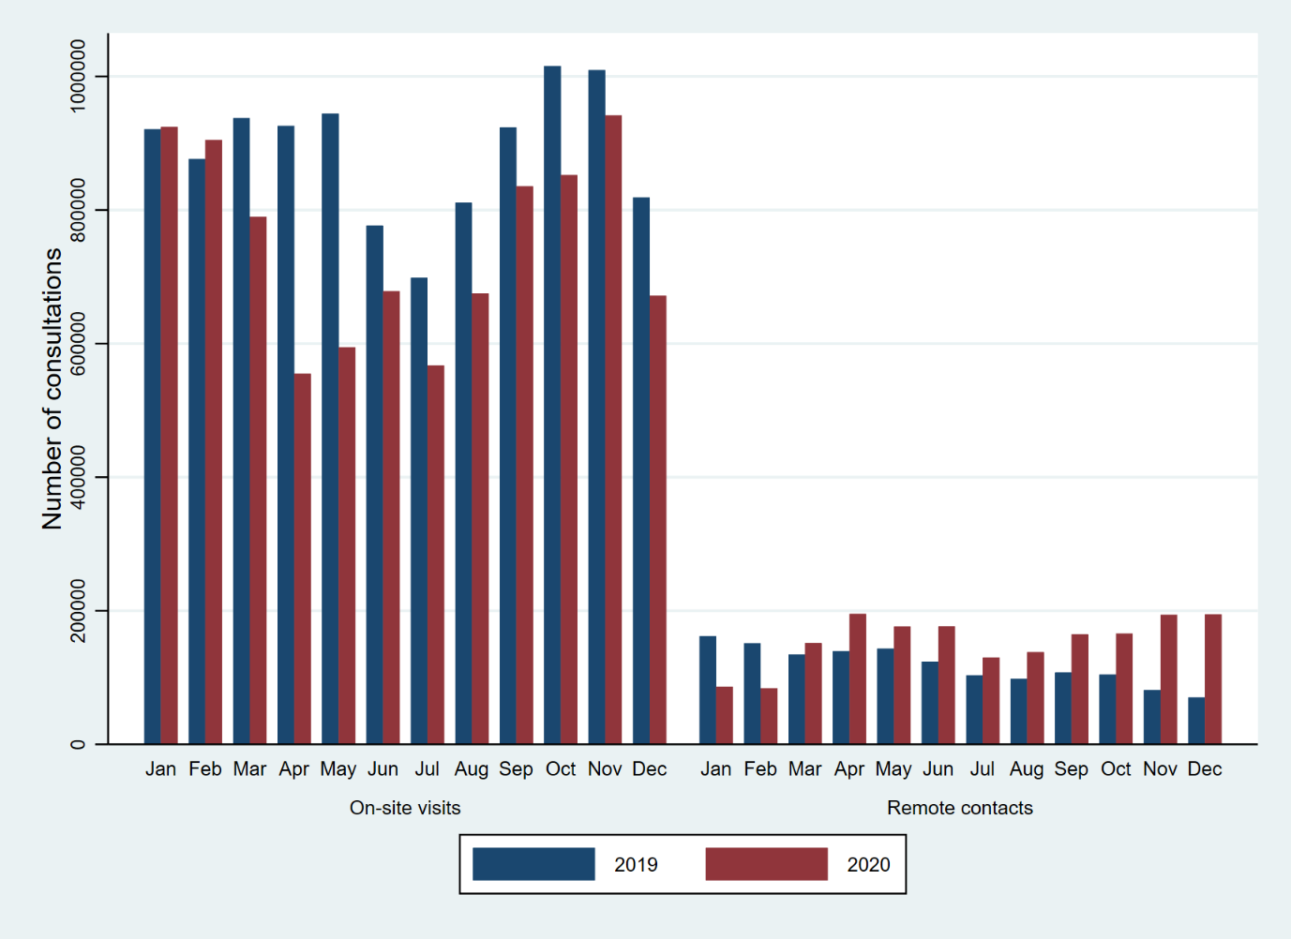
Source: VTDB 2019 and 2020.

Figure S.2 Estimated relative differences in total consultations between 2020 and 2019, Sweden (selected regions; %)

Source: VTDB 2019 and 2020.

Figure S.3 Primary care consultations by age groups and Quarter, Sweden (selected regions), 2019 and 2020
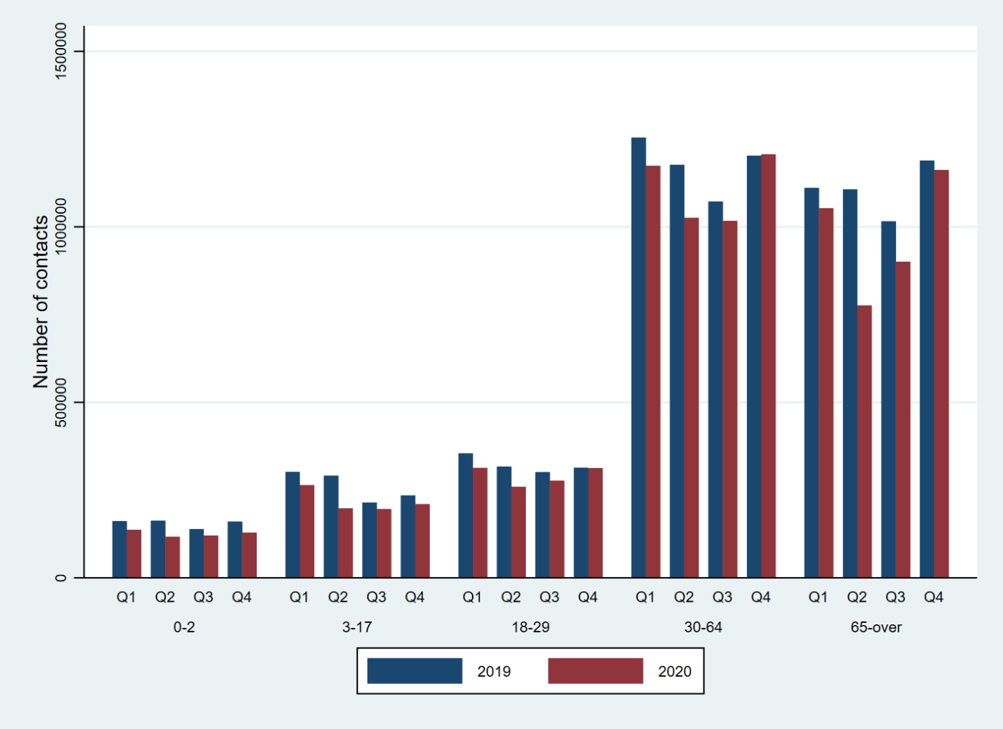
Source: VTDB 2019 and 2020.

