Supplementary material

Mitochondrial genome of Bactrocera fruit flies (Tephritidae: Dacini): Features, Structure and significance for Diagnosis

Castellanos, Nathaly Lara¹, Gunawardana, Disna N.¹, McCarthy, Bede², Sathish, Puthigae¹, George, Sherly⁴, Li, Dongmei^{1*}

¹Ministry for Primary Industries, Plant Health & Environmental Laboratory, 231 Morrin Road, Auckland, New Zealand.
²Ministry for Primary Industries, Plant Health & Environmental Laboratory, 14 Sir William Pickering Drive, Christchurch, New Zealand.
*Corresponding author

SUPPLEMENTARY NOTES

Supplementary material and methods

Sample selection and preparation for mitochondrial genome sequencing
A total of 411 adult fruit fly specimens were identified using available taxonomic keys [1, 2]. Dorsal and lateral photographs of representative specimens from each species were taken with a Canon EOS R5 camera, and Helicon Focus stacking software (Helicon Soft. Ltd.) was used to merge images from different focal plains. Then, a leg was used for DNA extraction for [3] the mitochondrial Cytochrome Oxidase I (COI) gene sequencing. The DNA extracted was used for PCR amplification with primers, LCO1490 and HCO2198 [3], also BP-F1 BP-R1 for B. passiflorae specimens [4] and FFCOI-F and HCO2198 for B. tryoni [5] due to the detection of Nuclear mitochondrial pseudo-COI (so-called NUMT) in the two species. For all the PCR reactions, 20 µL reactions were performed, consisting of 1× GoTaq master mix (Promega, Madison, WI), 250 nM of each primer, 0.5 µg/µL Bovine Serum Albumin (BSA, Sigma-Aldrich Co.), 1.5 mM additional MgCl₂ (Promega, Madison, WI), and 2 µL of DNA extract. The PCR cycle conditions were an initial denaturation step at 94°C for 5 min followed by 40 cycles of denaturation step at 94°C for 15 sec, annealing step at 50°C for 30 sec and an elongation step at 72°C for 45 sec, which was followed by a final elongation step at 72°C for 7 min. The PCR products were electrophoresed on 1.2% agarose (in 1x TAE buffer), gel stained with SYBR® safe (Life Technologies™, CA, USA), and visualised using a Gel Doc Software system (BioRad, Hercules, CA, USA). Each PCR product was diluted 2–4x with water depending on the band density and the dilutions were sequenced bi-directionally using the amplification primers at either EcoGene (Auckland, New Zealand) or Macrogen (Soul, South Korea). DNA sequences were analysed using Geneious Prime 2021.1.1 (https://www.geneious.com/). The DNA sequences were submitted to BOLD database under the project of “Ops Research Project Fruit Flies Pacific Islands” (ORPFF). After the sequence analysis, different haplotype from each species were selected for mitochondrial genome sequencing, as a result, 82 samples of 19 species, representing three genera were used for NovaSeq.

Samples real-time PCR assay development
A total of 104 fruit fly specimens from various geographical origins (Supplementary table S7 were used for the development and validation of the newly B. curvipennis duplex real-time PCR assay. In total, 15 specimens from the target species, 78 closely related Bactrocera sp. from the Pacific Islands, and other ten non-target Tephritidae flies from around the world were used. Most specimens were obtained from insect collections from Australia, Cook Islands, Fiji, French Polynesia, New Caledonia, Tonga and Vanuatu. Other specimens were intercepted at New Zealand borders from various countries. All adult specimens were identified using available taxonomic keys before conducting molecular analyses. All the adult specimens were identified morphologically using taxonomic keys by the entomologists in PHEL, and some specimens were confirmed by the specialist Dr Dick Drew. All the samples tested was also DNA barcoded and identified using BOLD identifier.

Repeatability and reproducibility
Repeatability (intra-run variation) and reproducibility (inter-run variation) each singleplex assay were reported as Cq standard deviation and per cent coefficient of variance (%CV) within and between assays. To estimate the repeatability (intra-run), eight concentrations (0.1 copy/µL to 1 × 10⁷ copies/µL) of “all-in-one” synthetic control were tested using five replicates. Also, the assays were run independently at different time in two different machines under the same conditions to calculate %CV as a measure of reproducibility (inter-run). Measurement of uncertainty (MU) was calculated using the standard deviation of the repeatability and reproducibility using the formula:

$$MU= \sqrt{Average of [StDEV{(Reproducibility)}^{2}+StDEV{(Repeatability)}^{2}]}$$

Supplementary results

Codon Usage
Codon usage in the fruit flies from the Pacific Islands followed the pattern of other Tephritids (Supplementary table 3) [6]. All PCGs started with standard initiation codons, except for the COI that stared with TGC a common feature in Diptera [7]. Each PCG is terminated with TAA or TAG as stop codons, or with a single T residue as an incomplete stop codon. These incomplete termination codons are common in animal mitochondrial DNA and is presumed to be filled by polyadenylation during the maturation of mRNA [8].
The extent of codon usage bias in the mitogenome was determined and compared based on the effective number of codons (Nc) and the codon adaptation index (CAI) values of 79 fruit fly’s species. The values obtained for Nc ranged from 25.77 to 59.15, with an average of 36.84 (Supplementary figure S 3A), while CAI values varied from 0.076 to 0.1667 (Supplementary figure S 3B). Using the conventional Nc lower than 35 and CAI higher than 0.3 to delineate strong codon bias, these averages indicated a generally weak codon usage bias in Bactrocera mitogenomes.

Sensitivity of B. curvipennis assay
Serial dilutions of genomic DNA from two different COI sequence variants of B. curvipennis (BCNC5 and BCNC7), were prepared in water to test whether the sensitivity is affected by the presence of mismatches and the inhibitors in the extractions. The efficiency of the real-time PCR was high and no apparently affected by the PCR inhibitors, with the limit of detection (LOD) for both B. curvipennis specimens of 10 fg/µL. There were small differences between the average Cq, the specimen BCNC5 with no mismatches the LOD was 35.84 compared to the Cq 37.67 observed in BCNC7 (Supplementary figure S 9A-C respectively). Additionally, the sensitivity and the efficiency of the multiplex assay was comparable with the singlexplex assays (Supplementary figure S 9). The LOD of the multiplex assay remains in 10 copies/µL of synthetic DNA template, with an average Cq of 34.22 in duplex compared with 33.71 in singleplex. The amplification efficiency was 95.0 % in duplex (Supplementary figure S 9C), comparable with 101.1 % efficiency observed in singleplex (Figure 5).

Repeatability and reproducibility
There are various factors that can introduce bias and contribute to the measurement of uncertainty in a molecular test. The value for the estimated measure of uncertainty for Bactrocera curvipennis was calculated to be 0.56 (Supplementary table S8), which means when B. curvipennis singleplex real-time PCR is performed, a confident Cq value of 25.00 should be read as 25.00 ± 0.36. If Cq values between 35.54 and 36.36 are obtained, the results should be interpreted as questionable and need to be further determined since the cut-off Cq is set to be 36.00.

References
1. Leblanc L. The dacine fruit flies (Diptera: Tephritidae: Dacini) of Oceania. Insecta Mundi. 2022.
2. Drew RAI, Drew RAI. The tropical fruit flies (Diptera: Tephritidae: Dacinae) of the Australasian region and Oceanic regions. Memoirs of the Queensland Museum. 1989;26:1--521.
3. Ratnasingham S, Hebert PDN. bold: The Barcode of Life Data System (http://www.barcodinglife.org). MolEco Notes. 2007;7:355–64.
4. Folmer O, Black M, Hoeh W, Lutz R, Vrijenhoek R. DNA primers for amplification of mitochondrial cytochrome c oxidase subunit I from diverse metazoan invertebrates. Molecular Marine Bio Biotech. 1994;3:294–9.
5. Li D, McCarthy B, Gunawardana DN, Waite DW, Anderson D, George S. Molecular identification of Bactrocera passiflorae (Diptera: Tephritidae): Challenge and solution for DNA barcoding. J App Ent. 2020;144:877–84.
6. Blacket MJ, Semeraro L, Malipatil MB. Barcoding Queensland Fruit Flies (Bactrocera tryoni): impediments and improvements. Mol Eco Res. 2012;12:428–36.
7. Zhang Y, Feng S, Zeng Y, Ning H, Liu L, Zhao Z, et al. The first complete mitochondrial genome of Bactrocera tsuneonis (Miyake) (Diptera: Tephritidae) by next-generation sequencing and its phylogenetic implications. Int J Bio Macromol. 2018;118:1229–37.
8. Cameron SL. Insect Mitochondrial Genomics: Implications for Evolution and Phylogeny. Annual Review of Entomology. 2014;59 Volume 59, 2014:95–117.
9. Ojala D, Montoya J, Attardi G. tRNA punctuation model of RNA processing in human mitochondria. Nature. 1981;290:470–4.

SUPPLEMENTARY TABLES

Samples for mitochondrial genome sequencing
Supplementary table S1 Sampling coverage and the list of samples obtained for mitogenome sequencing of fruit flies from the Pacific Islands.
Species | Individuals | Sample ID | Country of origin
Bactrocera anomala | 1 | BAV4 | Efate, Shefa Province, Vanuatu
B. caledoniensis | 1 | BNCa1 | Pocquereux, La Foa, New Caledonia
B. curvipennis | 5 | BCNC1, 5, 7, 10, 13 | Ouano, La Foa, New Caledonia
B. curvipennis | 2 | BQ112, T15_06386_2 | New Caledonia
B. distincta | 1 | 1B FF | Tailevu, Fiji
B. distincta | 3 | BDF1, 3, 4 | Nadi, Fiji
B. distincta | 1 | BDS1 | Samoa
B. facialis | 2 | BFT10-11 | Alaki, Tonga
B. facialis | 2 | BFT12,14 | Fo’ui, Tonga
B. facialis | 4 | BFT51, 69, 85, 87 | Longolongo Nuku'alofa, Tonga
B. facialis | 3 | BFT128, 36, 51 | Manuka, Tonga
B. kirki | 5 | BKS1 | Samoa
B. melanotus | 3 | BMC4,10,13 | Cook Islands
B. melanotus | 2 | BMC24, 26 | Rarotonga, Cook Islands
B. minuta | 1 | BMV2 | Efate, Shefa Province, Vanuatu
B. neohumeralis | 2 | BQ115,1188 | Cairns, Queensland, Australia
B. neohumeralis | 1 | BQ123 | Dalrymple Islet, Torres strait, Queensland, Australia
B. neohumeralis | 1 | BQ127 | Old Mapoom, Queensland, Australia
B. passiflorae | 2 | 3A-FF,3B-FF | Nausori, Fiji
B. passiflorae | 3 | SE_02801A-C | Fiji
B. passiflorae | 1 | BPF3 | Suva-Lami, Fiji
B. passiflorae | 1 | BPF4 | Nadi, Fiji
B. passiflorae | 1 | BPF15 | Fiji
B. obscura | 1 | BOS2 | Samoa
B. psidii | 1 | BPNC1 | Col d'Amieu, Sarraméa, New Caledonia
B. psidii | 2 | BPNC10, 16 | Sarraméa, New Caledonia
B. trilineola | 3 | BTV2, 8, 18 | Efate, Shefa Province, Vanuatu
B. tryoni | 1 | Bt 10 | Coen, Queensland, Australia
B. tryoni | 1 | Bt 15 | Mourilyan Harbour, Queensland, Australia
B. tryoni | 1 | Bt 16 | Brisbane, Queensland, Australia
B. tryoni | 2 | Bt 1,16 | Brisbane, Queensland, Australia
B. tryoni | 1 | Bt 2 | Gladstone, Queensland, Australia
B. tryoni | 1 | Bt 4 | Bundaberg, Queensland, Australia
B. tryoni | 1 | Bt 8 | Cairns, Queensland, Australia
B. tryoni | 1 | BTFP1 | French Polynesia
B. tryoni | 5 | T15_06386/15, 16, 18, 19, 28 | New Caledonia
B. tryoni | 3 | T15_01099#102,112, T15_00905#57 | New Zealand (2015 Response samples, it has been eradicated)
B. umbrosa | 1 | BUNC8 | Pocquereux, La Foa, New Caledonia
B. umbrosa | 1 | BUV1 | Shefa Province, Vanuatu
B. xanthodes | 2 | 2A-FF, 2B-FF | Suva-Lami, Fiji
B. xanthodes | 1 | BXC1 | Cook Islands
B. xanthodes | 1 | BXF2 | Nadi, Fiji
B. xanthodes | 1 | BXFP1 | French Polynesia
Dacus aneuvittatus | 1 | BXS1 | New Caledonia
Dirioxa pornia | 1 | DANC1 | Sarraméa, New Caledonia
Zeugodacus gracilis | 1 | BGV2 | Efate, Shefa Province, Vanuatu

Genome assembly statistics
Supplementary table S2 Mitochondrial genome assembly statistics for the 82 fruit flies from the Pacific Islands with the number of reads, coverage depth, nucleotide composition and length of the whole mitogenome and the control region.
Species | Sample | GenBank  Accession  # | Raw reads (millions) | Coverage depth (reads) | length (bp) | AT (%) | Control region (bp)
Bactrocera anomala | BAV4 | PV604183 | 30.6 | 769 | 15,912 | 74.0 | 949
B. caledoniensis | BNCa1 | PV604212 | 28.2 | 1,113 | 15,944 | 73.8 | 955
B. curvipennis | BCNC1 | PV604194 | 28.3 | 1,977 | 15,928 | 72.5 | 953
B. curvipennis | BCNC10 | PV604205 | 41.0 | 2,017 | 15,925 | 72.5 | 952
B. curvipennis | BCNC15 | PV604216 | 28.5 | 3,681 | 15,926 | 72.5 | 953
B. curvipennis | BCNC5 | PV604227 | 24.1 | 1,682 | 15,928 | 72.5 | 953
B. curvipennis | BCNC7 | PV604238 | 28.4 | 1,857 | 15,926 | 72.5 | 953
B. curvipennis | BQ112 | PV604225 | 23.3 | 2,262 | 15,927 | 72.5 | 954
B. curvipennis | T15_06386_2 | PV604258 | 7.0 | 1,397 | 15,925 | 72.4 | 953
B. distincta | 1B FF | PV604249 | 9.8 | 975 | 15,926 | 74.0 | 946
B. distincta | BDF1 | PV604260 | 19.8 | 4,082 | 15,926 | 74.1 | 945
B. distincta | BDF3 | PV604264 | 24.8 | 2,303 | 15,917 | 74.2 | 944
B. distincta | BDF4 | PV604184 | 18.1 | 2,035 | 15,926 | 74.1 | 943
B. distincta | BDS1 | PV604185 | 21.9 | 3,328 | 15,929 | 74.0 | 945
B. facialis | BFT10 | PV604186 | 20.9 | 1,384 | 15,931 | 71.8 | 950
B. facialis | BFT11 | PV604187 | 20.3 | 1,671 | 15,927 | 71.6 | 949
B. facialis | BFT12 | PV604188 | 21.3 | 1,309 | 15,930 | 71.6 | 951
B. facialis | BFT14 | PV604189 | 16.4 | 493 | 15,931 | 71.8 | 950
B. facialis | BFT28 | PV604190 | 22.0 | 1,639 | 15,930 | 71.8 | 951
B. facialis | BFT36 | PV604191 | 24.2 | 1,857 | 15,930 | 71.6 | 950
B. facialis | BFT41 | PV604192 | 23.4 | 2,432 | 15,930 | 71.8 | 951
B. facialis | BFT51 | PV604193 | 21.0 | 1,202 | 15,928 | 71.7 | 949
B. facialis | BFT69 | PV604195 | 22.3 | 423 | 15,929 | 71.6 | 950
B. facialis | BFT85 | PV604196 | 23.2 | 1,297 | 15,931 | 71.6 | 950
B. facialis | BFT87 | PV604197 | 21.1 | 796 | 15,930 | 71.9 | 950
B. kirki | BKS1 | PV604199 | 21.9 | 1,816 | 15,936 | 74.1 | 953
B. kirki | BKS2 | PV604200 | 22.1 | 4,839 | 15,932 | 74.2 | 952
B. kirki | BKS3 | PV604201 | 21.0 | 1,635 | 15,933 | 74.2 | 952
B. kirki | BKS4 | PV604202 | 19.1 | 5,274 | 15,931 | 74.2 | 951
B. kirki | BKS5 | PV604203 | 17.0 | 2,493 | 15,931 | 74.2 | 951
B. melanotus | BMC10 | PV604204 | 17.6 | 1,617 | 15,944 | 73.6 | 953
B. melanotus | BMC13 | PV604206 | 22.0 | 1,985 | 15,946 | 73.7 | 953
B. melanotus | BMC24 | PV604207 | 22.6 | 1,315 | 15,946 | 73.7 | 953
B. melanotus | BMC26 | PV604208 | 22.0 | 1,409 | 15,938 | 73.6 | 952
B. melanotus | BMC4 | PV604209 | 23.4 | 1,715 | 15,952 | 73.7 | 953
B. minuta | BMV2 | PV604210 | 22.6 | 1,669 | 15,927 | 71.9 | 949
B. neohumeralis | BQ115 | PV604226 | 16.3 | 824 | 15,928 | 72.4 | 953
B. neohumeralis | BQ118 | PV604228 | 16.5 | 1,117 | 15,926 | 72.4 | 952
B. neohumeralis | BQ123 | PV604229 | 17.8 | 1,609 | 15,927 | 72.5 | 955
B. neohumeralis | BQ127 | PV604230 | 19.6 | 1,995 | 15,928 | 72.5 | 954
B. obscura | BOS2 | PV604212 | 16.4 | 4,752 | 15,883 | 73.5 | 950
B. passiflorae | 3A FF | PV604213 | 10.6 | 880 | 15,928 | 71.8 | 950
B. passiflorae | 3B FF | PV604214 | 9.8 | 1,025 | 15,928 | 71.8 | 949
B. passiflorae | BPF15 | PV604215 | 22.7 | 1,493 | 15,927 | 71.8 | 950
B. passiflorae | BPF3 | PV604217 | 20.0 | 2,191 | 15,931 | 71.7 | 950
B. passiflorae | BPF4 | PV604218 | 22.3 | 1,484 | 15,930 | 71.7 | 950
B. passiflorae | SE_02801A | PV604219 | 17.5 | 1,701 | 15,929 | 71.7 | 950
B. passiflorae | SE_02801B | PV604220 | 20.3 | 508 | 15,931 | 71.7 | 950
B. passiflorae | SE_02801C | PV604221 | 19.3 | 1,841 | 15,933 | 71.8 | 950
B. psidii | BPNC1 | PV604222 | 32.2 | 906 | 15,938 | 74.2 | 951
B. psidii | BPNC10 | PV604223 | 25.9 | 1,225 | 15,938 | 74.2 | 952
B. psidii | BPNC16 | PV604224 | 31.3 | 941 | 15,942 | 74.2 | 952
B. trilineola | BTV18 | PV604243 | 24.2 | 1,543 | 15,939 | 74.0 | 962
B. trilineola | BTV2 | PV604244 | 21.4 | 1,577 | 15,929 | 74.0 | 953
B. trilineola | BTV8 | PV604245 | 18.5 | 921 | 15,931 | 74.0 | 955
B. tryoni | Bt 10 -C6 | PV604232 | 10.2 | 1,848 | 15,923 | 72.4 | 953
B. tryoni | Bt 15 -C7 | PV604233 | 15.0 | 1,120 | 15,925 | 72.4 | 953
B. tryoni | Bt 16 -C8 | PV604234 | 8.8 | 1,610 | 15,886 | 72.4 | 951
B. tryoni | Bt 1-C2 | PV604231 | 12.0 | 1,199 | 15,928 | 72.4 | 953
B. tryoni | Bt 2 -C3 | PV604235 | 10.2 | 886 | 15,924 | 72.4 | 953
B. tryoni | Bt 4 -C4 | PV604236 | 11.0 | 1,449 | 15,924 | 72.4 | 953
B. tryoni | Bt 8 -C5 | PV604237 | 9.2 | 704 | 15,926 | 72.4 | 954
B. tryoni | BTFP1 | PV604239 | 22.4 | 921 | 15,924 | 72.4 | 952
B. tryoni | BTNC1 | PV604240 | 23.9 | 1,087 | 15,926 | 72.4 | 954
B. tryoni | BTNC2 | PV604241 | 24.7 | 636 | 15,929 | 72.4 | 953
B. tryoni | BTNC3 | PV604242 | 20.6 | 649 | 15,927 | 72.4 | 954
B. tryoni | T15_06386-16 | PV604257 | 9.6 | 932 | 15,926 | 72.5 | 953
B. tryoni | T15_06386-28 | PV604259 | 8.8 | 1,230 | 15,927 | 72.4 | 953
B. tryoni | T15_01099#102 | PV604261 | 8.8 | 230 | 15,927 | 72.4 | 952
B. tryoni | T15_01099#112 | PV604262 | 10.2 | 455 | 15,926 | 72.4 | 952
B. tryoni | T15_00905#57 | PV604263 | 9.4 | 598 | 15,927 | 72.4 | 952
B. umbrosa | BUNC8 | PV604246 | 30.3 | 2,064 | 15,897 | 70.6 | 946
B. umbrosa | BUV1 | PV604247 | 13.7 | 686 | 15,896 | 70.5 | 947
B. xanthodes | 2A FF | PV604248 | 9.6 | 1,088 | 15,830 | 70.5 | 925
B. xanthodes | 2B FF | PV604250 | 9.2 | 803 | 15,851 | 70.5 | 924
B. xanthodes | BXC1 | PV604251 | 20.9 | 3,155 | 15,838 | 70.5 | 923
B. xanthodes | BXF2 | PV604252 | 27.7 | 4,134 | 15,841 | 70.5 | 923
B. xanthodes | BXFP1 | PV604253 | 23.3 | 909 | 15,834 | 70.5 | 924
B. xanthodes | BXS2 | PV604254 | 21.5 | 2,494 | 15,838 | 70.5 | 924
Dacus aneuvittatus | DANC1 | PV604255 | 24.2 | 2174 | 15,725 | 72.8 | 718
Dirioxa pornia | DPNC1 | PV604256 | 32.0 | 1484 | 15,912 | 75.0 | 1,031
Zeugodacus gracilis | BGV2 | PV604198 | 29.7 | 7,435 | 16,023 | 73.5 | 1,132

Codon Usage
Supplementary table S3 Usage of start/stop codons in fruit flies’ mitochondrial genomes sequenced in this study. Distinctive codons are highlighted in bold.
Species | ND2 | CO1 | CO2 | ATP8 | ATP6 | CO3 | ND3 | ND5 | ND4 | ND4L | ND6 | CYTB | ND1
Bactrocera anomala | ATT/TAA | TCG/TA | ATG/TAA | GTG/TAA | ATG/TAA | ATG/TAA | ATT/TAG | ATT/T | ATG/TAG | ATG/TAA | ATT/TAA | ATG/TAG | ATA/T
B. curvipennis | ATT/TAA | TCG/TA | ATG/TAA | GTG/TAA | ATG/TAA | ATG/TAA | ATT/TAG | ATT/T | ATG/TAG | ATG/TAA | ATT/TAA | ATG/TAG | ATA/T
B. distincta | ATT/TAA | TCG/TA | ATG/TAA | GTG/TAA | ATG/TAA | ATG/TAA | ATG/TAG | ATT/T | ATG/TAA | ATG/TAA | ATT/TAA | ATG/TAG | ATA/T
B. facialis | ATT/TAA | TGC/TA | ATG/TAA | GTG/TAA | ATG/TAA | ATG/TAA | ATT/TAG | ATT/T | ATG/TAG | ATG/TAA | ATT/TAA | ATG/TAG | ATA/T
B. kirki | ATT/TAA | TCG/TA | ATG/TAA | GTG/TAA | ATG/TAA | ATG/TAA | ATT/TAG | ATT/T | ATG/TAG | ATG/TAA | ATT/TAA | ATG/TAG | ATA/T
B. melanotus | ATT/TAA | TGC/TA | ATG/TAA | GTG/TAA | ATG/TAA | ATG/TAA | ATT/TAG | ATT/T | ATG/TAG | ATG/TAA | ATT/TAA | ATG/TAG | ATA/T
B. minuta | ATT/TAA | TCG/TA | ATG/TAA | GTG/TAA | ATG/TAA | ATG/TAA | ATT/TAG | ATT/T | ATG/TAG | ATG/TAA | ATT/TAA | ATG/TAG | ATA/T
B. caledoniensis | ATT/TAA | TCG/TA | ATG/TAA | GTG/TAA | ATG/TAA | ATG/TAA | ATT/TAG | ATT/T | ATG/TAG | ATG/TAA | ATT/TAA | ATG/TAG | ATA/T
B. neohumeralis | ATT/TAA | TGC/TA | ATG/TAA | GTG/TAA | ATG/TAA | ATG/TAA | ATT/TAG | ATT/T | ATG/TAG | ATG/TAA | ATT/TAA | ATG/T | ATT/T
B. obscura | ATT/TAG | TCG/TA | ATG/TAA | GTG/TAA | ATG/TAA | ATG/TAA | ATT/TAG | ATT/T | ATG/TAG | ATG/TAA | ATT/TAA | ATG/TAG | ATA/T
B. passiflorae | ATT/TAA | TGC/TA | ATG/TAA | GTG/TAA | ATG/TAA | ATG/TAA | ATT/TAG | ATT/T | ATG/TAG | ATG/TAA | ATT/TAA | ATG/TAG | ATA/T
B. psidii | ATT/TAG | TCG/TA | ATG/TAA | GTG/TAA | ATG/TAA | ATG/TAA | ATT/TAG | ATT/T | ATG/TAG | ATG/TAA | ATT/TAA | ATG/TAG | ATA/T
B. trilineola | ATT/TAA | TCG/T | ATG/TAA | GTG/TAA | ATG/TAA | ATG/TAA | ATT/TAG | ATT/T | ATG/TAG | ATG/TAA | ATT/TAA | ATG/TAG | ATA/T
B. tryoni | ATT/TAA | TGC/TA | ATG/TAA | GTG/TAA | ATG/TAA | ATG/TAA | ATT/TAG | ATT/T | ATG/TAG | ATG/TAA | ATT/TAA | ATG/T | ATT/T
B. umbrosa | ATT/TAA | TCG/TA | ATG/TAA | ATG/TAA | ATG/TAA | ATG/TAA | ATT/TAG | ATT/T | ATG/TAG | ATG/TAA | ATT/TAA | ATG/TAG | ATA/T
B. xanthodes | ATT/TAA | TCG/TA | ATG/TAA | ATC/TAA | ATG/TAA | ATG/TAA | ATG/TAG | ATT/T | ATG/TAA | ATG/TAA | ATT/TAA | ATG/TAG | ATA/T
Dacus aneuvittatus | ATT/TAA | TCG/T | ATG/TAA | ATC/TAA | ATG/TAA | ATG/TAA | ATT/TAG | ATT/T | ATG/TAA | ATG/TAA | ATC/TAA | ATG/TAG | ATA/T
Dirioxia pornia | ATT/TAA | TCG/T | ATG/TCA | ATT/TAA | ATG/TAA | ATG/TAA | ATT/TAG | ATT/T | ATG/T | ATG/TAA | ATT/TAA | ATG/TAG | ATA/T
Zeugodacus gracilis | ATT/TAA | TCG/T | ATG/TAA | ATC/TAA | ATG/TAA | ATG/TAA | ATT/TAG | ATT/T | ATG/TAA | ATG/TAA | ATC/TAA | ATG/TAG | ATA/T

Primers and probes
Supplementary table S4 Primers and probes and their targeting region in the ND2, CO1 and CO3 genes developed for detection of Bactrocera curvipennis.
Primer name | Gene | Primer type | Tm (°C) | Product size (bp) | Sequences (5’ – 3’)
ND2_1133F_BC | ND2 | Forward | 45.7 | 119–189bp | TTTATCTACGACTGTGC
ND2_1138F_BC | ND2 | Forward | 52.9 | 114-184bp | CTACGACTATGCTTCGCG
ND2_1192P_BC | ND2 | Probe | 65.6 | 114-189bp | CAL610-ApdUpdUGApdUApdUAApdUpdUA  pdUCAApdCAApdCApdUpdUpdU-BHQ2plus
ND2_1251R_BC | ND2 | Reverse | 49.1 | 114-119bp | GGAGATAAACGATAGGACC
ND2_1323R_BC | ND2 | Reverse | 46.9 | 184-189pb | TTAACTTAAAGCCTTGTATGA
COI_1970F_BTC | COI | Forward | 53.7 | 151-224bp | TCACTTAGCTGGTATCTCATCG
COI_2117P_BC | COI | Probe | 57.3 | 165-172bp | CAL610-TACCAGTTTTAGCGGGAGCTATTACT  ATAC-BHQ2
COI_2176R_BTC | COI | Reverse | 47.5 | 208bp | AAGGATGTATTTAAGTTTCGAT
CO3_5145F_BC | CO3 | Forward | 58.5 | 166-196bp | ATATGACCCCCTGCGGGA
CO3_5171F_BTC | CO3 | Forward | 53.2 | 140-170bp | CTTTAACCCATTCCAAATCCCA
CO3_5239P_BC | CO3 | Probe | 55.1 | 140-224bp | CAL610-AGCTCACCATAGTTTAATAGAAGGTA  ATCA-BHQ2
CO3_5310R_BC | CO3 | Reverse | 51.5 | 166-170bp | CTAGAAGAACTGTAAAAAATAGACCC
Note: Six assays were tested (the one was selected was in BOLD):
1) ND2_1133F_BC/ND2_1192P_BC+/ND2_1251R_BC;
2) ND2_1133F_BC /ND2_1192P_BC+/ND2_1323R_BC;
3) ND2_1138F_BC /ND2_1192P_BC+/ND2_1251R_BC;
4) COI_1970F_BTC/COI_2117P_BC/COI_2176R_BTC;
5) CO3_5154F_BC/CO3_5239P_BC/CO3_5310R_BC;
6) CO3_5171F_BTC/CO3_5239P_BC/CO3_5310R_BC.

Optimized conditions
Supplementary table S5 Optimised PCR mastermix composition for the duplex assay for detection of B. curvipennis with Applied Biosystems 18S Internal Control (Applied Biosystems Cat#4308329).
Master Mix composition (Multiplex) |  | Volume per reaction (µL)
Water |  | 4.3
2x Probe supermix |  | 10.0
5 µM Primer F (300 nM) | ND2_1138F_BC | 1.2
5 µM Primer R (300 nM) | ND2_1251R_BC | 1.2
5 µM Probe (200 nM) | ND2_1192P_BC+ | 0.8
10 µM Primer F (50 nM) | Rib F | 0.1
10 µM Primer R (50 nM) | Rib R | 0.1
40 µM Probe (200 nM) | Rib Pr | 0.1
BSA 10 µg/µl |  | 0.2
DNA template |  | 2.0
Total volume |  | 20.0

Supplementary table S6 Optimised PCR cycling conditions for the B. curvipennis real-time PCR assay used for further specificity and sensitivity evaluations
Step | Time | Temp | Cycles
Initial denaturation | 2 min | 95°C | Hold
Denaturation | 15 sec | 95°C | } x 40
Annealing and extension | 60 sec | 60°C | } x 40
 | Plate read after each cycle

Samples real-time PCR assay development
Supplementary table S7 Target and non-target species used in developing a real-time PCR assay for detecting Bactrocera curvipennis, including results from initial specificity screening, assay optimization, blind panel testing, and multiplex validation. Quantification cycle (Cq) thresholds are reported as the mean of technical replicates, with 0 indicating no amplification.
Organism name | Sample Reference number | Country of origin | Life stage | Lure or Host | Sample source¹ | DNA extraction² | Initial specificity | Assay optimization | Specificity | Blind test | Multiplex | Internal control (18S)
Bactrocera alquilonis | BQ17 | Australia | Adult | Unknown | Collection | DNeasy | 0 | 0
B. alquilonis | BQ21 | Australia | Adult | Unknown | Collection | DNeasy |  |  |  | 0
B. anomala | BAV2 | Vanuatu | Adult | Cue-Lure | Collection | DNeasy |  |  | 0
B. caledoniensis | BNCa2 | New Caledonia | Adult | MDF trap³ | Collection | DNeasy | 0
B. caledoniensis | BNCa3 | New Caledonia | Adult | MDF trap³ | Collection | DNeasy |  |  |  | 0 |  | 28.1
B. carambolae | INDN H1 | Indonesia | Larvae | Podophyllum peltatum | Border | DNeasy |  |  | 0
B. correcta | C19_00291 | Singapore | Larvae | Ziziphus jujuba | Border | DNeasy | 0 |  | 0
B. curvipennis | BCNC10 | New Caledonia | Adult | Ximenia americana | Collection | DNeasy |  | 18.7
B. curvipennis | BCNC11 | New Caledonia | Adult | Ximenia americana | Collection | DNeasy |  | 20.2
B. curvipennis | BCNC12 | New Caledonia | Adult | Ximenia americana | Collection | DNeasy |  |  |  | 20.5 | 19.1 | 20.4
B. curvipennis | BCNC13 | New Caledonia | Adult | Ximenia americana | Collection | DNeasy |  |  | 21.8
B. curvipennis | BCNC14 | New Caledonia | Adult | Ximenia americana | Collection | DNeasy |  |  |  | 18.6
B. curvipennis | BCNC2 | New Caledonia | Adult | Ximenia americana | Collection | DNeasy |  |  | 18.2
B. curvipennis | BCNC3 | New Caledonia | Adult | Ximenia americana | Collection | DNeasy |  |  |  | 23.8
B. curvipennis | BCNC4 | New Caledonia | Adult | Ximenia americana | Collection | DNeasy |  |  |  |  | 22.3 | 19
B. curvipennis | BCNC5 | New Caledonia | Adult | Ximenia americana | Collection | DNeasy |  | 16.9 |  |  | 16.9 | 18.7
B. curvipennis | BCNC6 | New Caledonia | Adult | Ximenia americana | Collection | DNeasy |  |  |  |  | 22.4 | 19.1
B. curvipennis | BCNC7 | New Caledonia | Adult | Ximenia americana | Collection | DNeasy |  | 23.8
B. curvipennis | BCNC8 | New Caledonia | Adult | Ximenia americana | Collection | DNeasy |  |  |  | 24.7 | 23.3 | 23.3
B. curvipennis | BCNC9 | New Caledonia | Adult | Ximenia americana | Collection | DNeasy |  |  | 20.5
B. curvipennis | BQ112 | New Caledonia | Adult | Cue-Lure | Collection | DNeasy | 20.4 | 21.4
B. curvipennis | T15_06386 | New Caledonia | Pupae | Rubus sp. | Border | DNeasy |  |  | 18.6
B. distincta | BDF6 | Fiji | Adult | Cue-Lure | Collection | DNeasy |  |  | 0
B. distincta | BDS2 | Samoa | Adult | Unknown | Collection | DNeasy |  |  |  | 0
B. distincta | BDT1 | Tonga | Adult | Unknown | Collection | DNeasy | 0 |  |  |  |  | 21.1
B. dorsalis | T18_02202 | China | Adult | FF traps | Collection | DNeasy |  |  |  | 0 | 0 | 22.1
B. dorsalis | T19_0659313 | Vietnam | Larvae | Nephelium lappaceum | Border | DNeasy |  |  |  |  | 0 | 19.7
B. dorsalis | T23_00420 | Unknown | Larvae | Litchi chinensis | Border | DNeasy |  |  |  |  | 0 | 28.2
B. dorsalis complex | BDFP1 | French Polynesia | Adult | Unknown | Collection | DNeasy | 0 |  |  |  |  | 22.7
B. dorsalis complex | T19_6923 | Thailand | Larvae | Dimocarpus longan | Border | DNeasy |  |  | 0
B. dorsalis complex | T24_02010 | Taiwan | Egg | Litchi chinensis | Border | DNeasy |  |  |  |  | 0 | 21.9
B. facialis (clade1) | BFT39 | Tonga | Adult | Cue-Lure | Collection | PrepGEM |  |  | 0
B. facialis (clade1) | BFT61 | Tonga | Adult | Cue-Lure | Collection | PrepGEM |  |  |  | 0
B. facialis (clade2) | BFT13 | Tonga | Adult | Cue-Lure | Collection | PrepGEM | 0
B. facialis (clade2) | BFT71 | Tonga | Adult | Cue-Lure | Collection | PrepGEM |  |  |  |  | 0 | 24
B. jarvisi | T15_0063a | Australia | Larvae | Mangifera indica | Border | DNeasy | 0
B. jarvisi | T17_04198 | Australia | Larvae | Mangifera indica | Border | DNeasy |  |  | 0
B. jarvisi | T24_00686 | Australia | Larvae | Mangifera indica | Border | DNeasy |  |  |  |  | 0 | 26.2
B. kirki | BKS5 | Samoa | Adult | Unknown | Collection | DNeasy |  |  | 0
B. kirki | BKT2 | Tonga | Adult | FF traps | Collection | DNeasy |  |  |  | 0 |  | 28.1
B. kirki | T20_00489 | Tonga | Larvae | Ficus carica | Border | DNeasy | 0
B. latifrons | T18_02583 | Malaysia | Pupae | Capsicum sp. | Border | DNeasy |  |  | 0 |  |  | 21.7
B. melanotus | BMC17 | Cook Islands | Adult | Unknown | Collection | DNeasy |  |  | 0
B. melanotus | BMC27 | Cook Islands | Adult | Unknown | Collection | DNeasy |  |  |  | 0
B. melanotus | BMC9 | Cook Islands | Adult | Unknown | Collection | DNeasy | 0
B. minuta | BMV6 | Vanuatu | Adult | Cue-Lure | Collection | DNeasy |  |  |  | 0
B. minuta | BMV9 | Vanuatu | Adult | Cue-Lure | Collection | DNeasy | 0 |  |  |  |  | 30.9
B. mucrons | BMNC1 | New Caledonia | Adult | MDF trap³ | Collection | DNeasy | 0 |  |  |  |  | 23.9
B. neohumeralis | BNA2 | Australia | Adult | Cue-Lure | Collection | DNeasy |  |  | 0
B. neohumeralis | BQ115 | Australia | Adult | Syzygium sp. | Border | DNeasy | 0 | 0
B. neohumeralis | BQ118 | Australia | Adult | Syzygium sp. | Collection | DNeasy |  |  | 0 |  |  | 25
B. neohumeralis | BQ123 | Australia | Adult | Laboratory colony | Border | DNeasy |  | 0
B. neohumeralis | BQ127 | Australia | Adult | Laboratory colony | Border | DNeasy | 0 | 0
B. neohumeralis | BQ132 | Australia | Adult | Unknown | Collection | DNeasy |  |  | 0 |  | 0 | 18.9
B. obscura | BOS5 | Samoa | Adult | Unknown | Collection | DNeasy | 0 |  |  |  |  | 38.9
B. paraxanthodes | DIP 04/16_A | New Caledonia | Adult | Laboratory colony | Collection | DNeasy |  |  | 0
B. passiflorae | BPF13 | Fiji | Adult | Cue-Lure | Collection | DNeasy |  |  | 0
B. passiflorae | BPF16 | Fiji | Adult | Cue-Lure | Collection | DNeasy |  |  |  | 0
B. passiflorae | SE_02801B | Fiji | Adult | Cue-Lure | Collection | DNeasy | 0
B. passiflorae | T24_02220 | Fiji | Larvae | Syzygium malaccense | Border | DNeasy |  |  |  |  | 0 | 23.2
B. psidii | BPNC1 | New Caledonia | Adult | Malaise trap | Collection | DNeasy | 0 |  |  |  |  | 23.3
B. psidii | BPNC17 | New Caledonia | Adult | Psidium guajava | Collection | DNeasy |  |  |  |  | 0 | 19.9
B. psidii | BPNC6 | New Caledonia | Adult | Laboratory colony | Collection | DNeasy |  |  | 0
B. psidii | BPNC9 | New Caledonia | Adult | Laboratory colony | Collection | DNeasy |  |  |  | 0
B. scutellata | T18_02201 | China | Adult | Fruit Fly traps | Collection | DNeasy |  |  |  |  | 0 | 21.9
B. trilineola | BTV16 | Vanuatu | Adult | Cue-Lure | Collection | DNeasy |  |  | 0
B. trilineola | BTV45 | Vanuatu | Adult | Cue-Lure | Collection | DNeasy |  |  |  | 0
B. trilineola | BTV55 | Vanuatu | Adult | Cue-Lure | Collection | DNeasy | 0
B. tryoni | T20_00284 | Australia | Larvae | Mangifera indica | Border | DNeasy |  |  |  | 0
B. tryoni | T20_00284A | Australia | Larvae | Mangifera indica | Border | DNeasy |  |  | 0 |  |  | 20.4
B. tryoni | T22_02819 | Australia | Eggs | Fragaria sp. | Border | DNeasy |  |  |  |  | 0 | 22.2
B. tryoni | T24_01197 | Australia | Larvae | Mangifera indica | Border | DNeasy |  |  |  |  | 0 | 29.0
B. tryoni | BTFP1 | French Polynesia | Adult | Unknown | Collection | DNeasy |  | 0
B. tryoni | BTFP12 | French Polynesia | Adult | Unknown | Collection | DNeasy |  |  | 0
B. tryoni | BTFP15 | French Polynesia | Adult | Unknown | Collection | DNeasy | 0 | 0
B. tryoni | BTFP19 | French Polynesia | Adult | Unknown | Collection | DNeasy |  |  |  | 0
B. tryoni | BTFP4 | French Polynesia | Adult | Unknown | Collection | DNeasy | 0
B. tryoni | BTT16(4) | French Polynesia | Adult | Unknown | Collection | DNeasy |  |  |  |  | 0 | 21.1
B. tryoni | BTNC10 | New Caledonia | Adult | Psidium guajava | Collection | DNeasy |  |  |  | 0
B. tryoni | BTNC14 | New Caledonia | Adult | Laboratory colony | Collection | DNeasy |  |  | 0 |  |  | 20.3
B. tryoni | BTNC7 | New Caledonia | Adult | Psidium guajava | Collection | DNeasy |  |  | 0
B. tryoni complex | T22_00275 | Australia | Larvae | Litchi chinensis | Border | DNeasy |  |  |  |  | 0 | 23.9
B. tryoni complex | T22_00275 | Australia | Larvae | Litchi chinensis | Border | DNeasy |  |  |  |  | 0 | 23.2
B. tryoni complex | T22_00530 | Australia | Larvae | Litchi chinensis | Border | DNeasy |  |  |  |  | 0 | 26.1
B. tryoni complex | T22_03599 | Australia | Larvae | Mangifera indica | Border | DNeasy |  |  |  |  | 0 | 25.4
B. tryoni complex | T22_03599 | Australia | Larvae | Mangifera indica | Border | DNeasy |  |  |  |  | 0 | 23.5
B. tryoni complex | T23_00633 | Australia | Eggs | Litchi chinensis | Border | DNeasy |  |  |  |  | 0 | 28.4
B. tryoni complex | T23_00790 | Australia | Eggs | Litchi chinensis | Border | DNeasy |  |  |  |  | 0 | 28.4
B. tryoni complex | T23_01006 | Australia | Eggs | Litchi chinensis | Border | DNeasy |  |  |  |  | 0 | 25.5
B. tryoni complex | T23_03604 | Australia | Larvae | Citrus x siniensis | Border | DNeasy |  |  |  |  | 0 | 21.6
B. umbrosa | BUNC5 | New Caledonia | Adult | Artocarpus heterophyllus | Collection | DNeasy |  |  |  | 0
B. umbrosa | BUV14 | Vanuatu | Adult | Methyl eugenol | Collection | DNeasy | 0 |  |  |  |  | 23.7
B. umbrosa | BUV7 | Vanuatu | Adult | Methyl eugenol | Collection | DNeasy |  |  | 0
B. xanthodes | BXF4 | Fiji | Adult | Methyl eugenol | Collection | DNeasy |  |  |  | 0
B. xanthodes | T20_02837B | Fiji | Larvae | Artocarpus altilis | Border | DNeasy |  |  | 0
B. xanthodes | T23_02922 | Fiji | Larvae | Artocarpus altilis | Border | DNeasy |  |  |  |  | 0 | 21.6
B. xanthodes | BXFP3 | French Polynesia | Adult | Unknown | Collection | DNeasy |  |  | 0
B. xanthodes | BXFP5 | French Polynesia | Adult | Unknown | Collection | DNeasy | 0 |  |  |  |  | 23.8
B. xanthodes | T17_02953 | Samoa | Larvae | Artocarpus altilis | Border | DNeasy |  |  | 0 |  | 0 | 19.4
B. zonata | BQ27 | Sri Lanka | Adult | Laboratory colony | Border | DNeasy | 0
Ceratitis capitata | CQ3 | Hawai |  | Laboratory colony | Collection | DNeasy |  |  |  |  | 0 | 20.4
Dacus aneuvittatus | DANC5 | New Caledonia | Adult | Laboratory colony | Collection | DNeasy |  |  |  | 0 |  | 23.7
Dirioxa pornia | DPNC2 | New Caledonia | Adult | Psidium guajava | Collection | DNeasy |  |  | 38.2 |  |  | 25.3
Zeugodacus. gracialis | BGV2 | Vanuatu | Adult | Cue-Lure | Collection | DNeasy |  |  | 0
¹Overseas collection or border interception
²DNA extraction method of Qiagen Blood and Tissue kit (DNeasy) and PrepGEM were used for the samples.
³Medium-density fibreboard (MDF)

Repeatability and reproducibility
Supplementary table S8 Reproducibility of B. curvipennis real-time PCR assay. Data from the positive control standardisation of five repeat for each concentration on two thermocyclers.
 | Repeatability (%CV)¹ |  | Reproducibility (%CV)²
Bac_TC_allin_control | Run 1 | Run 2 | Run 1 ∼Run 2
1000000 copies/µl | 0.75 | 0.88 | 2.57
100000 copies/µl | 0.13 | 0.82 | 1.86
10000 copies/µl | 0.41 | 0.44 | 1.53
1000 copies/µl | 0.39 | 0.51 | 0.52
100 copies/µl | 0.39 | 0.74 | 0.56
10 copies/µl | 0.22 | 0.16 | 0.31
1 copy/µl | 0.91 | 0.99 | 0.98
Measurement of uncertainty (MU)³ | 0.36
¹ Repeatability: percentage coefficient of variation (%CV) for intra-run repeatability
²Reproducibility: percentage coefficient of variation (%CV) for inter-run repeatability
³Measurement of uncertainty:

Supplementary table S9 Taxonomic information, geographical source, and GenBank accession numbers for mitochondrial genome sequences from tephritid taxa used in the present analyses.
Accession | Subfamilily | Tribe | Species | Topology | Country of origin
MT036766.1 | Dacinae | Ceratitidini | Ceratitis anonae | circular | Cameroon
MT036767.1 | Dacinae | Ceratitidini | C. anonae | circular | Cameroon
MT036768.1 | Dacinae | Ceratitidini | C. anonae | circular | Cameroon
MT036765.1 | Dacinae | Ceratitidini | C. anonae | circular | Cameroon
MT036781.1 | Dacinae | Ceratitidini | C. bremii | circular | Guinea
NC_000857.1 | Dacinae | Ceratitidini | C. capitata | circular | Greece
MT036782.1 | Dacinae | Ceratitidini | C. capitata | circular | Kenya
ON861815.1 | Dacinae | Ceratitidini | C. capitata | circular | South Africa
ON861816.1 | Dacinae | Ceratitidini | C. capitata | circular | South Africa
NC_071251.1 | Dacinae | Ceratitidini | C. cosyra | circular | South Africa
ON861818.1 | Dacinae | Ceratitidini | C. cosyra | circular | South Africa
MT036783.1 | Dacinae | Ceratitidini | C. cosyra | circular | Sudan
MT036784.1 | Dacinae | Ceratitidini | C. cosyra | circular | Zimbabwe
MT036785.1 | Dacinae | Ceratitidini | C. ditissima | circular | Nigeria
MT036769.1 | Dacinae | Ceratitidini | C. fasciventris | circular | Burundi
MT036770.1 | Dacinae | Ceratitidini | C. fasciventris | circular | Burundi
MT036771.1 | Dacinae | Ceratitidini | C. fasciventris | circular | Burundi
MT036772.1 | Dacinae | Ceratitidini | C. fasciventris | circular | Burundi
MT036773.1 | Dacinae | Ceratitidini | C. fasciventris | circular | Burundi
NC_035497.1 | Dacinae | Ceratitidini | C. fasciventris | circular | Kenya
MT036774.1 | Dacinae | Ceratitidini | C. pallidula | circular | Tanzania
MT036775.1 | Dacinae | Ceratitidini | C. pallidula | circular | Tanzania
MT036786.1 | Dacinae | Ceratitidini | C. punctata | circular | Guinea
MT036787.1 | Dacinae | Ceratitidini | C. querita | circular | Kenya
MT036776.1 | Dacinae | Ceratitidini | C. quilicii | circular | Tanzania
MT036777.1 | Dacinae | Ceratitidini | C. quilicii | circular | Tanzania
MT036778.1 | Dacinae | Ceratitidini | C. quilicii | circular | Tanzania
MT036779.1 | Dacinae | Ceratitidini | C. quilicii | circular | Tanzania
MT036780.1 | Dacinae | Ceratitidini | C. quilicii | circular | Tanzania
NC_053846.1 | Dacinae | Ceratitidini | C. quilicii | circular | Tanzania
ON861819.1 | Dacinae | Ceratitidini | C. quilicii | circular | Tanzania
ON861820.1 | Dacinae | Ceratitidini | C. quilicii | circular | Tanzania
MT036788.1 | Dacinae | Ceratitidini | C. quinaria | circular | Sudan
MT036800.1 | Dacinae | Ceratitidini | C. rosa | circular | China
MT036790.1 | Dacinae | Ceratitidini | C. rosa | circular | South Africa
MT036791.1 | Dacinae | Ceratitidini | C. rosa | circular | South Africa
MT036792.1 | Dacinae | Ceratitidini | C. rosa | circular | South Africa
MT036793.1 | Dacinae | Ceratitidini | C. rosa | circular | South Africa
MT036794.1 | Dacinae | Ceratitidini | C. rosa | circular | South Africa
MT036795.1 | Dacinae | Ceratitidini | C. rosa | circular | South Africa
ON861821.1 | Dacinae | Ceratitidini | C. rosa | circular | South Africa
ON861822.1 | Dacinae | Ceratitidini | C. rosa | circular | South Africa
MT036796.1 | Dacinae | Ceratitidini | C. rosa | circular | Tanzania
MT036797.1 | Dacinae | Ceratitidini | C. rosa | circular | Tanzania
MT036798.1 | Dacinae | Ceratitidini | C. rosa | circular | Tanzania
MT036799.1 | Dacinae | Ceratitidini | C. rosa | circular | Tanzania
NC_053847.1 | Dacinae | Ceratitidini | C. rosa | circular | Tanzania
MT036789.1 | Dacinae | Ceratitidini | C. rubivora | circular | Tanzania
MF434829.1 | Dacinae | Ceratitidini | Neoceratitis asiatica | circular | China
MH374118.1 | Dacinae | Dacini | Bactrocerea albistrigata | circular | Indonesia
NC_028327.1 | Dacinae | Dacini | B. arecae | circular | Malaysia
NC_042712.1 | Dacinae | Dacini | B. biguttula | circular | South Africa
NC_071745.1 | Dacinae | Dacini | B. bryoniae | circular | Papua New Guinea
MG916967.1 | Dacinae | Dacini | B. carambolae | circular | Greece
MT121278.1 | Dacinae | Dacini | B. carambolae | circular | Indonesia
MT121279.1 | Dacinae | Dacini | B. carambolae | circular | Indonesia
MT121280.1 | Dacinae | Dacini | B. carambolae | circular | Indonesia
MT121281.1 | Dacinae | Dacini | B. carambolae | circular | Indonesia
MT121282.1 | Dacinae | Dacini | B. carambolae | circular | Indonesia
MT121283.1 | Dacinae | Dacini | B. carambolae | circular | Indonesia
NC_009772.1 | Dacinae | Dacini | B. carambolae | circular | Japan
MN104218.1 | Dacinae | Dacini | B. carambolae | linear | Malaysia
MN104219.1 | Dacinae | Dacini | B. carambolae | circular | Malaysia
MT121286.1 | Dacinae | Dacini | B. carambolae | circular | Philippines
MN104217.1 | Dacinae | Dacini | B. carambolae | circular | Suriname
OR085849.1 | Dacinae | Dacini | B. cinnabaria | circular | Malaysia
MT121259.1 | Dacinae | Dacini | B. correcta | circular | China
NC_018787.1 | Dacinae | Dacini | B. correcta | circular | China
NC_071737.1 | Dacinae | Dacini | B. curvifera | circular | Papua New Guinea
DQ917577.1 | Dacinae | Dacini | B. dorsalis | circular | China
MT121284.1 | Dacinae | Dacini | B. dorsalis | circular | China
MT121304.1 | Dacinae | Dacini | B. dorsalis | circular | China
MT121305.1 | Dacinae | Dacini | B. dorsalis | circular | China
MT121306.1 | Dacinae | Dacini | B. dorsalis | circular | China
NC_008748.1 | Dacinae | Dacini | B. dorsalis | circular | China
PP485725.1 | Dacinae | Dacini | B. dorsalis | circular | China
PP485726.1 | Dacinae | Dacini | B. dorsalis | circular | China
PP485727.1 | Dacinae | Dacini | B. dorsalis | circular | China
PP485728.1 | Dacinae | Dacini | B. dorsalis | circular | China
PP485729.1 | Dacinae | Dacini | B. dorsalis | circular | China
PP485730.1 | Dacinae | Dacini | B. dorsalis | circular | China
PP485731.1 | Dacinae | Dacini | B. dorsalis | circular | China
PP485732.1 | Dacinae | Dacini | B. dorsalis | circular | China
PP485733.1 | Dacinae | Dacini | B. dorsalis | circular | China
PP485734.1 | Dacinae | Dacini | B. dorsalis | circular | China
PP485735.1 | Dacinae | Dacini | B. dorsalis | circular | China
PP485736.1 | Dacinae | Dacini | B. dorsalis | circular | China
PP485737.1 | Dacinae | Dacini | B. dorsalis | circular | China
PP485738.1 | Dacinae | Dacini | B. dorsalis | circular | China
PP485739.1 | Dacinae | Dacini | B. dorsalis | circular | China
PP485740.1 | Dacinae | Dacini | B. dorsalis | circular | China
PP485741.1 | Dacinae | Dacini | B. dorsalis | circular | China
PP485742.1 | Dacinae | Dacini | B. dorsalis | circular | China
PP485743.1 | Dacinae | Dacini | B. dorsalis | circular | China
PP485744.1 | Dacinae | Dacini | B. dorsalis | circular | China
PP485745.1 | Dacinae | Dacini | B. dorsalis | circular | China
PP485746.1 | Dacinae | Dacini | B. dorsalis | circular | China
PP485747.1 | Dacinae | Dacini | B. dorsalis | circular | China
PP485748.1 | Dacinae | Dacini | B. dorsalis | circular | China
PP485749.1 | Dacinae | Dacini | B. dorsalis | circular | China
PP485750.1 | Dacinae | Dacini | B. dorsalis | circular | China
PP485751.1 | Dacinae | Dacini | B. dorsalis | circular | China
PP485752.1 | Dacinae | Dacini | B. dorsalis | circular | China
PP485753.1 | Dacinae | Dacini | B. dorsalis | circular | China
PP485754.1 | Dacinae | Dacini | B. dorsalis | circular | China
PP485755.1 | Dacinae | Dacini | B. dorsalis | circular | China
PP485756.1 | Dacinae | Dacini | B. dorsalis | circular | China
PP485757.1 | Dacinae | Dacini | B. dorsalis | circular | China
PP485758.1 | Dacinae | Dacini | B. dorsalis | circular | China
PP485759.1 | Dacinae | Dacini | B. dorsalis | circular | China
PP485760.1 | Dacinae | Dacini | B. dorsalis | circular | China
PP485761.1 | Dacinae | Dacini | B. dorsalis | circular | China
PP485762.1 | Dacinae | Dacini | B. dorsalis | circular | China
PP485763.1 | Dacinae | Dacini | B. dorsalis | circular | China
PP485764.1 | Dacinae | Dacini | B. dorsalis | circular | China
PP485765.1 | Dacinae | Dacini | B. dorsalis | circular | China
PP485766.1 | Dacinae | Dacini | B. dorsalis | circular | China
PP485767.1 | Dacinae | Dacini | B. dorsalis | circular | China
PP485768.1 | Dacinae | Dacini | B. dorsalis | circular | China
PP485769.1 | Dacinae | Dacini | B. dorsalis | circular | China
PP485770.1 | Dacinae | Dacini | B. dorsalis | circular | China
PP485771.1 | Dacinae | Dacini | B. dorsalis | circular | China
PP485772.1 | Dacinae | Dacini | B. dorsalis | circular | China
PP485773.1 | Dacinae | Dacini | B. dorsalis | circular | China
PP485774.1 | Dacinae | Dacini | B. dorsalis | circular | China
PP485775.1 | Dacinae | Dacini | B. dorsalis | circular | China
PP485776.1 | Dacinae | Dacini | B. dorsalis | circular | China
PP485777.1 | Dacinae | Dacini | B. dorsalis | circular | China
PP485778.1 | Dacinae | Dacini | B. dorsalis | circular | China
PP485779.1 | Dacinae | Dacini | B. dorsalis | circular | China
PP485780.1 | Dacinae | Dacini | B. dorsalis | circular | China
PP485781.1 | Dacinae | Dacini | B. dorsalis | circular | China
PP485782.1 | Dacinae | Dacini | B. dorsalis | circular | China
PP485783.1 | Dacinae | Dacini | B. dorsalis | circular | China
PP485784.1 | Dacinae | Dacini | B. dorsalis | circular | China
PP485785.1 | Dacinae | Dacini | B. dorsalis | circular | China
PP485786.1 | Dacinae | Dacini | B. dorsalis | circular | China
PP485787.1 | Dacinae | Dacini | B. dorsalis | circular | China
PP485788.1 | Dacinae | Dacini | B. dorsalis | circular | China
PP485789.1 | Dacinae | Dacini | B. dorsalis | circular | China
PP485790.1 | Dacinae | Dacini | B. dorsalis | circular | China
PP485791.1 | Dacinae | Dacini | B. dorsalis | circular | China
PP485792.1 | Dacinae | Dacini | B. dorsalis | circular | China
PP485793.1 | Dacinae | Dacini | B. dorsalis | circular | China
PP485794.1 | Dacinae | Dacini | B. dorsalis | circular | China
PP485795.1 | Dacinae | Dacini | B. dorsalis | circular | China
PP485796.1 | Dacinae | Dacini | B. dorsalis | circular | China
PP485797.1 | Dacinae | Dacini | B. dorsalis | circular | China
PP485798.1 | Dacinae | Dacini | B. dorsalis | circular | China
PP485799.1 | Dacinae | Dacini | B. dorsalis | circular | China
PP485800.1 | Dacinae | Dacini | B. dorsalis | circular | China
PP485801.1 | Dacinae | Dacini | B. dorsalis | circular | China
PP485802.1 | Dacinae | Dacini | B. dorsalis | circular | China
PP485803.1 | Dacinae | Dacini | B. dorsalis | circular | China
PP485804.1 | Dacinae | Dacini | B. dorsalis | circular | China
PP485805.1 | Dacinae | Dacini | B. dorsalis | circular | China
PP485806.1 | Dacinae | Dacini | B. dorsalis | circular | China
PP485807.1 | Dacinae | Dacini | B. dorsalis | circular | China
PP485808.1 | Dacinae | Dacini | B. dorsalis | circular | China
PP485809.1 | Dacinae | Dacini | B. dorsalis | circular | China
PP485810.1 | Dacinae | Dacini | B. dorsalis | circular | China
PP485811.1 | Dacinae | Dacini | B. dorsalis | circular | China
PP485812.1 | Dacinae | Dacini | B. dorsalis | circular | China
PP485813.1 | Dacinae | Dacini | B. dorsalis | circular | China
PP485814.1 | Dacinae | Dacini | B. dorsalis | circular | China
PP485815.1 | Dacinae | Dacini | B. dorsalis | circular | China
PP485816.1 | Dacinae | Dacini | B. dorsalis | circular | China
PP485817.1 | Dacinae | Dacini | B. dorsalis | circular | China
PP485818.1 | Dacinae | Dacini | B. dorsalis | circular | China
PP485819.1 | Dacinae | Dacini | B. dorsalis | circular | China
PP485820.1 | Dacinae | Dacini | B. dorsalis | circular | China
PP485821.1 | Dacinae | Dacini | B. dorsalis | circular | China
PP485822.1 | Dacinae | Dacini | B. dorsalis | circular | China
PP485823.1 | Dacinae | Dacini | B. dorsalis | circular | China
PP485824.1 | Dacinae | Dacini | B. dorsalis | circular | China
PP485825.1 | Dacinae | Dacini | B. dorsalis | circular | China
PP485826.1 | Dacinae | Dacini | B. dorsalis | circular | China
PP485827.1 | Dacinae | Dacini | B. dorsalis | circular | China
PP485828.1 | Dacinae | Dacini | B. dorsalis | circular | China
PP485829.1 | Dacinae | Dacini | B. dorsalis | circular | China
PP485830.1 | Dacinae | Dacini | B. dorsalis | circular | China
PP485831.1 | Dacinae | Dacini | B. dorsalis | circular | China
PP485832.1 | Dacinae | Dacini | B. dorsalis | circular | China
PP485833.1 | Dacinae | Dacini | B. dorsalis | circular | China
PP485834.1 | Dacinae | Dacini | B. dorsalis | circular | China
PP485835.1 | Dacinae | Dacini | B. dorsalis | circular | China
PP485836.1 | Dacinae | Dacini | B. dorsalis | circular | China
PP485837.1 | Dacinae | Dacini | B. dorsalis | circular | China
PP485838.1 | Dacinae | Dacini | B. dorsalis | circular | China
PP485839.1 | Dacinae | Dacini | B. dorsalis | circular | China
PP485840.1 | Dacinae | Dacini | B. dorsalis | circular | China
MT121298.1 | Dacinae | Dacini | B. dorsalis | circular | India
MT121299.1 | Dacinae | Dacini | B. dorsalis | circular | India
MT121300.1 | Dacinae | Dacini | B. dorsalis | circular | India
MT121287.1 | Dacinae | Dacini | B. dorsalis | circular | Indonesia
MT121288.1 | Dacinae | Dacini | B. dorsalis | circular | Indonesia
MT121289.1 | Dacinae | Dacini | B. dorsalis | circular | Indonesia
MT121290.1 | Dacinae | Dacini | B. dorsalis | circular | Indonesia
MT121291.1 | Dacinae | Dacini | B. dorsalis | circular | Indonesia
KX534207.1 | Dacinae | Dacini | B. dorsalis | circular | Kenya
MN104220.1 | Dacinae | Dacini | B. dorsalis | circular | Kenya
DQ917578.1 | Dacinae | Dacini | B. dorsalis | circular | Malaysia
MT121295.1 | Dacinae | Dacini | B. dorsalis | circular | Mali
MT121296.1 | Dacinae | Dacini | B. dorsalis | circular | Mali
MT121297.1 | Dacinae | Dacini | B. dorsalis | circular | Mali
MT121292.1 | Dacinae | Dacini | B. dorsalis | circular | Myanmar
MT121293.1 | Dacinae | Dacini | B. dorsalis | circular | Myanmar
MT121294.1 | Dacinae | Dacini | B. dorsalis | circular | Myanmar
DQ995281.1 | Dacinae | Dacini | B. dorsalis | circular | Philippines
MT121285.1 | Dacinae | Dacini | B. dorsalis | circular | South Africa
ON861823.1 | Dacinae | Dacini | B. dorsalis | circular | South Africa
ON861824.1 | Dacinae | Dacini | B. dorsalis | circular | South Africa
MT121301.1 | Dacinae | Dacini | B. dorsalis | circular | Uganda
MT121302.1 | Dacinae | Dacini | B. dorsalis | circular | Uganda
MT121303.1 | Dacinae | Dacini | B. dorsalis | circular | Uganda
MT121307.1 | Dacinae | Dacini | B. dorsalis | circular | USA: Hawaii
MT121308.1 | Dacinae | Dacini | B. dorsalis | circular | USA: Hawaii
MT121309.1 | Dacinae | Dacini | B. dorsalis | circular | USA: Hawaii
KM244662.1 | Dacinae | Dacini | B. dorsalis | linear
KT343905.1 | Dacinae | Dacini | B. dorsalis | circular
MG916968.1 | Dacinae | Dacini | B. dorsalis | circular
NC_062138.1 | Dacinae | Dacini | B. frauenfeldi | circular | Australia
MT121261.1 | Dacinae | Dacini | B. frauenfeldi | circular | Papua New Guinea
NC_071738.1 | Dacinae | Dacini | B. fulvicauda | circular | Papua New Guinea
MT121263.1 | Dacinae | Dacini | B. latifrons | circular | China
NC_029466.1 | Dacinae | Dacini | B. latifrons | circular | Malaysia
NC_037722.1 | Dacinae | Dacini | B. limbifera | circular | Indonesia
NC_029467.1 | Dacinae | Dacini | B. melastomatos | circular | Malaysia
MT121264.1 | Dacinae | Dacini | B. minax | circular | China
NC_014402.1 | Dacinae | Dacini | B. minax | circular | China
NC_071739.1 | Dacinae | Dacini | B. moluccensis | circular | Papua New Guinea
NC_071740.1 | Dacinae | Dacini | B. musae | circular | Papua New Guinea
MZ520733.1 | Dacinae | Dacini | B. neohumeralis | circular | Australia
MZ520734.1 | Dacinae | Dacini | B. neohumeralis | circular | Australia
MZ520735.1 | Dacinae | Dacini | B. neohumeralis | circular | Australia
MZ520736.1 | Dacinae | Dacini | B. neohumeralis | circular | Australia
NC_062139.1 | Dacinae | Dacini | B. neohumeralis | circular | Australia
NC_071741.1 | Dacinae | Dacini | B. nigrotibialis | circular | India
NC_071742.1 | Dacinae | Dacini | B. occipitalis | circular | Philippines
GU108468.1 | Dacinae | Dacini | B. oleae | circular | Algeria
KR677101.1 | Dacinae | Dacini | B. oleae | circular | Iran
KR677102.1 | Dacinae | Dacini | B. oleae | circular | Iran
KR677103.1 | Dacinae | Dacini | B. oleae | circular | Iran
KR677104.1 | Dacinae | Dacini | B. oleae | circular | Iran
KR677105.1 | Dacinae | Dacini | B. oleae | circular | Iran
KR677106.1 | Dacinae | Dacini | B. oleae | circular | Iran
KR677107.1 | Dacinae | Dacini | B. oleae | circular | Iran
GU108460.1 | Dacinae | Dacini | B. oleae | circular | Israel
GU108472.1 | Dacinae | Dacini | B. oleae | circular | Israel
AY210703.1 | Dacinae | Dacini | B. oleae | circular | Italy
GU108459.1 | Dacinae | Dacini | B. oleae | circular | Italy
GU108464.1 | Dacinae | Dacini | B. oleae | circular | Italy
GU108470.1 | Dacinae | Dacini | B. oleae | circular | Italy
GU108471.1 | Dacinae | Dacini | B. oleae | circular | Italy
MT121269.1 | Dacinae | Dacini | B. oleae | circular | Italy
GU108466.1 | Dacinae | Dacini | B. oleae | circular | Kenya
GU108476.1 | Dacinae | Dacini | B. oleae | circular | Kenya
GU108474.1 | Dacinae | Dacini | B. oleae | circular | Morocco
GU108463.1 | Dacinae | Dacini | B. oleae | circular | Pakistan
GU108469.1 | Dacinae | Dacini | B. oleae | circular | Pakistan
GU108477.1 | Dacinae | Dacini | B. oleae | circular | Pakistan
GU108473.1 | Dacinae | Dacini | B. oleae | circular | Portugal
NC_005333.1 | Dacinae | Dacini | B. oleae | circular | Portugal
GU108462.1 | Dacinae | Dacini | B. oleae | circular | South Africa
GU108478.1 | Dacinae | Dacini | B. oleae | circular | South Africa
GU108461.1 | Dacinae | Dacini | B. oleae | circular | Turkey
GU108465.1 | Dacinae | Dacini | B. oleae | circular | Turkey
CM090314.1 | Dacinae | Dacini | B. oleae | circular | USA
GU108475.1 | Dacinae | Dacini | B. oleae | circular | USA
GU108479.1 | Dacinae | Dacini | B. oleae | circular | USA
GU108467.1 | Dacinae | Dacini | B. oleae | circular | Italy
OR085850.1 | Dacinae | Dacini | B. propinqua | circular | Malaysia
NC_037723.1 | Dacinae | Dacini | B. ritsemai | circular | Indonesia
MT121270.1 | Dacinae | Dacini | B. rubigina | circular | China
NC_046521.1 | Dacinae | Dacini | B. rubigina | circular | China
NC_046952.1 | Dacinae | Dacini | B. ruiliensis | circular | China
OK127889.1 | Dacinae | Dacini | B. sp. 'yunnanensis' | circular | China
MT121271.1 | Dacinae | Dacini | B. thailandica | circular | China
NC_053983.1 | Dacinae | Dacini | B. thailandica | circular | China
MZ520738.1 | Dacinae | Dacini | B. tryoni | circular | Australia
MZ520737.1 | Dacinae | Dacini | B. tryoni | circular | Australia
MT121272.1 | Dacinae | Dacini | B. tryoni | circular | IAEA Laboratory strain
NC_014611.1 | Dacinae | Dacini | B. tryoni | circular
MN883026.1 | Dacinae | Dacini | B. tsuneonis | circular | China
MN539610.1 | Dacinae | Dacini | B. tsuneonis | circular | China
NC_038164.1 | Dacinae | Dacini | B. tsuneonis | circular | China
MT196006.1 | Dacinae | Dacini | B. tuberculata | linear | China
NC_071743.1 | Dacinae | Dacini | B. tuberculata | circular | China
MT121274.1 | Dacinae | Dacini | B. umbrosa | circular | Indonesia
NC_029468.1 | Dacinae | Dacini | B. umbrosa | circular | Malaysia
MT121275.1 | Dacinae | Dacini | B. umbrosa | circular | Papua New Guinea
NC_071744.1 | Dacinae | Dacini | B. wuzhishana | circular | China
MT121277.1 | Dacinae | Dacini | B. zonata | circular | India
NC_027725.1 | Dacinae | Dacini | B. zonata | circular | India
MN583036.1 | Dacinae | Dacini | B. zonata | circular | Iran
NC_071725.1 | Dacinae | Dacini | Dacus armatus | circular | Ghana
NC_071726.1 | Dacinae | Dacini | D. axanus | circular | Papua New Guinea
NC_046468.1 | Dacinae | Dacini | D. bivittatus | circular | South Africa
MG962405.1 | Dacinae | Dacini | D. ciliatus | linear | Iran
NC_043843.1 | Dacinae | Dacini | D. conopsoides | circular | Indonesia
NC_071727.1 | Dacinae | Dacini | D. durbanensis | circular | South Africa
NC_071728.1 | Dacinae | Dacini | D. eclipsis | circular | South Africa
MZ087939.1 | Dacinae | Dacini | D. haikouensis | circular | China
NC_071729.1 | Dacinae | Dacini | D. humeralis | circular | Ghana
MT121244.1 | Dacinae | Dacini | D. longicornis | circular | China
NC_032690.1 | Dacinae | Dacini | D. longicornis | circular | China
NC_053984.1 | Dacinae | Dacini | D. trimacula | circular | China
MK940811.1 | Dacinae | Dacini | D. trimacula | circular | China
MT121245.1 | Dacinae | Dacini | D. trimacula | circular | China
NC_071730.1 | Dacinae | Dacini | D. venetatus | circular | South Africa
NC_061932.1 | Dacinae | Dacini | D. vijaysegarani | circular | Malaysia
NC_079944.1 | Dacinae | Dacini | Zeugodacus calumniatus | circular | Malaysia
KT625492.2 | Dacinae | Dacini | Z. caudatus | circular | Indonesia
KT625491.2 | Dacinae | Dacini | Z. caudatus | circular | Malaysia
NC_062801.1 | Dacinae | Dacini | Z. caudatus | circular
MT121248.1 | Dacinae | Dacini | Z. cilifer | circular | China
NC_052852.1 | Dacinae | Dacini | Z. cilifer | circular
MT121249.1 | Dacinae | Dacini | Z. cucurbitae | circular | Bangladesh
MH900082.1 | Dacinae | Dacini | Z. cucurbitae | linear | China
NC_016056.1 | Dacinae | Dacini | Z. cucurbitae | circular | China
OQ158899.1 | Dacinae | Dacini | Z. cucurbitae | circular | Wildtype lab colony
NC_071732.1 | Dacinae | Dacini | Z. depressus | circular | China
MT477832.1 | Dacinae | Dacini | Z. depressus | circular | China
KY131831.1 | Dacinae | Dacini | Z. depressus | circular
KT159730.1 | Dacinae | Dacini | Z. diaphorus | circular | China
MT121251.1 | Dacinae | Dacini | Z. diaphorus | circular | China
NC_071733.1 | Dacinae | Dacini | Z. diversus | circular | China
NC_079945.1 | Dacinae | Dacini | Z. heinrichi | circular | Malaysia
NC_071734.1 | Dacinae | Dacini | Z. hochii | circular | China
OQ730415.1 | Dacinae | Dacini | Z. hochii | circular | Malaysia
NC_067083.1 | Dacinae | Dacini | Z. mukiae | circular | China
NC_049063.1 | Dacinae | Dacini | Z. proprediaphora | circular | China
NC_071735.1 | Dacinae | Dacini | Z. rubellus | circular | China
MH900080.1 | Dacinae | Dacini | Z. scutellaris | linear | China
MT121255.1 | Dacinae | Dacini | Z. scutellaris | circular | China
NC_061658.1 | Dacinae | Dacini | Z. scutellaris | circular | China
MF358969.1 | Dacinae | Dacini | Z. scutellatus | circular | China
KT159731.1 | Dacinae | Dacini | Z. scutellatus | circular | China
MT121256.1 | Dacinae | Dacini | Z. scutellatus | circular | China
NC_027254.1 | Dacinae | Dacini | Z. scutellatus | circular | China
NC_062140.1 | Dacinae | Dacini | Z. strigifinis | circular | Australia
MT121257.1 | Dacinae | Dacini | Z. tau | circular | Bangladesh
MF966383.1 | Dacinae | Dacini | Z. tau | circular | China
MH900081.1 | Dacinae | Dacini | Z. tau | circular | China
NC_027290.1 | Dacinae | Dacini | Z. tau | circular | China
MF966384.1 | Dacinae | Dacini | Z. tau | circular | Malaysia
NC_071736.1 | Dacinae | Dacini | Z. triangularis | circular | Papua New Guinea
NC_071731.1 | Dacinae | Dacini | Zeugodacus atrifacies | circular | China
MH900079.1 | Dacinae | Gastrozonini | Acrotaeniostola dissimilis | circular | China
NC_052851.1 | Phytalmiinae | Acanthonevrini | Felderimyia fuscipennis | circular | China
NC_020463.1 | Tephritinae | Cecidocharini | Procecidochares utilis | circular | China
OK127891.1 | Tephritinae | Cecidocharini | Procecidochares utilis | circular | China
OZ060076.1 | Tephritinae | Tephritini | Campiglossa producta | linear | United Kingdom
NC_071720.1 | Trypetinae | Carpomyini | Carpomya incompleta | circular | Italy
MN095236.1 | Trypetinae | Carpomyini | C. vesuviana | linear | China
MT121231.1 | Trypetinae | Carpomyini | C. vesuviana | circular | China
NC_071721.1 | Trypetinae | Carpomyini | C. vesuviana | circular | Iran
NC_087865.1 | Trypetinae | Carpomyini | Myiopardalis pardalina | circular | China
MT121234.1 | Trypetinae | Carpomyini | Ragholetis batava | circular | Mongolia
NC_071722.1 | Trypetinae | Carpomyini | R. batava | circular | Mongolia
MT121233.1 | Trypetinae | Carpomyini | R. batava | circular | Mongolia
MW027532.1 | Trypetinae | Carpomyini | R. cerasi | circular | Austria
NC_061399.1 | Trypetinae | Carpomyini | R. cerasi | circular | Hungary
MT121236.1 | Trypetinae | Carpomyini | R. cerasi | circular | Italy
MT121235.1 | Trypetinae | Carpomyini | R. cerasi | circular | Italy
MW027531.1 | Trypetinae | Carpomyini | R. cerasi | circular | Italy
MW027530.1 | Trypetinae | Carpomyini | R. cerasi | circular | Vienna
NC_071723.1 | Trypetinae | Carpomyini | R. completa | circular | Italy
MN443930.1 | Trypetinae | Carpomyini | R. cornivora | circular | USA
MN443931.1 | Trypetinae | Carpomyini | R. cornivora | circular | USA
MN443939.1 | Trypetinae | Carpomyini | R. mendax | circular | USA
MN443932.1 | Trypetinae | Carpomyini | R. pomonella | circular | USA
MN443933.1 | Trypetinae | Carpomyini | R. pomonella | circular | USA
MN443934.1 | Trypetinae | Carpomyini | R. pomonella | linear | USA
MN443935.1 | Trypetinae | Carpomyini | R. pomonella | circular | USA
MN443936.1 | Trypetinae | Carpomyini | R. pomonella | circular | USA
MN443937.1 | Trypetinae | Carpomyini | R. pomonella | circular | USA
MN443938.1 | Trypetinae | Carpomyini | R. pomonella | circular | USA
NC_071724.1 | Trypetinae | Carpomyini | R. pomonella | circular | USA
MN443945.1 | Trypetinae | Carpomyini | R. zephyria | circular | USA
MN443940.1 | Trypetinae | Carpomyini | R. zephyria | circular | USA
MN443941.1 | Trypetinae | Carpomyini | R. zephyria | circular | USA
MN443942.1 | Trypetinae | Carpomyini | R. zephyria | circular | USA
MN443943.1 | Trypetinae | Carpomyini | R. zephyria | circular | USA
MN443944.1 | Trypetinae | Carpomyini | R. zephyria | circular | USA
NC_071713.1 | Trypetinae | Toxotrypanini | Anastrepha distincta | circular | Colombia
MT121221.1 | Trypetinae | Toxotrypanini | A. fraterculus | circular | Colombia
NC_034912.1 | Trypetinae | Toxotrypanini | A. fraterculus | circular | Colombia
MT121223.1 | Trypetinae | Toxotrypanini | A. ludens | circular | Mexico
NC_071714.1 | Trypetinae | Toxotrypanini | A. ludens | circular | Mexico
CM051870.1 | Trypetinae | Toxotrypanini | A. ludens | circular | USA Laboratory strain
CM051344.1 | Trypetinae | Toxotrypanini | A. obliqua | circular | Colombia
NC_071715.1 | Trypetinae | Toxotrypanini | A. obliqua | circular | Colombia
NC_071716.1 | Trypetinae | Toxotrypanini | A. ornata | circular | Colombia
NC_071717.1 | Trypetinae | Toxotrypanini | A. serpentina | circular | Colombia
NC_071718.1 | Trypetinae | Toxotrypanini | A. striata | circular | Colombia
NC_071719.1 | Trypetinae | Toxotrypanini | A. suspensa | circular | Mexico
NC_001322.1 | Drosophilinae | Drosophilini | Drosophila yakuba | circular | USA

SUPPLEMENTARY FIGURES

Comparison phylogenetic tree by genus
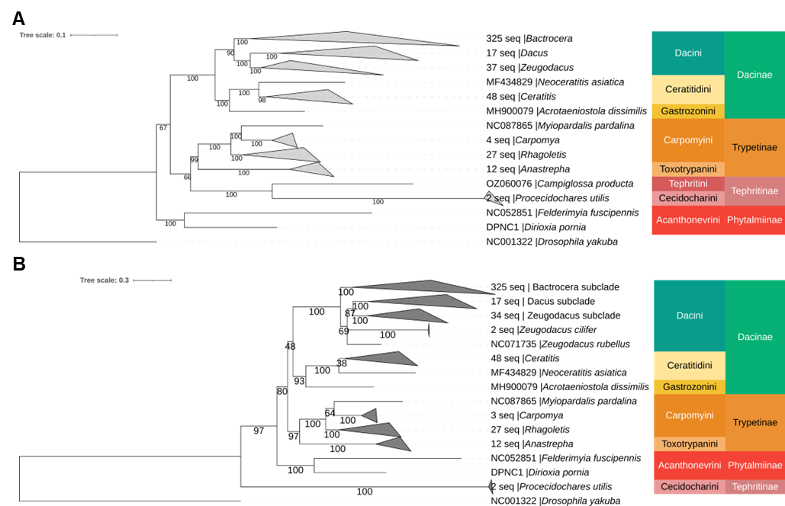
Supplementary figure S1 Reconstructed phylogenetic tree of Tephritidae fruit flies inferred from the (A) whole mitogenome dataset using IQ-TREE, (B) PCGs dataset with partitions using RAxML. Maximum likelihood (ML) bootstrap support values are shown at each node. Genus clades have been collapsed to improve visualization of the tree’s topology. The number of specimens used in each collapsed clade is specified. Coloured strips denote tribes and subfamilies.

Complete phylogenetic tree (PCGs)
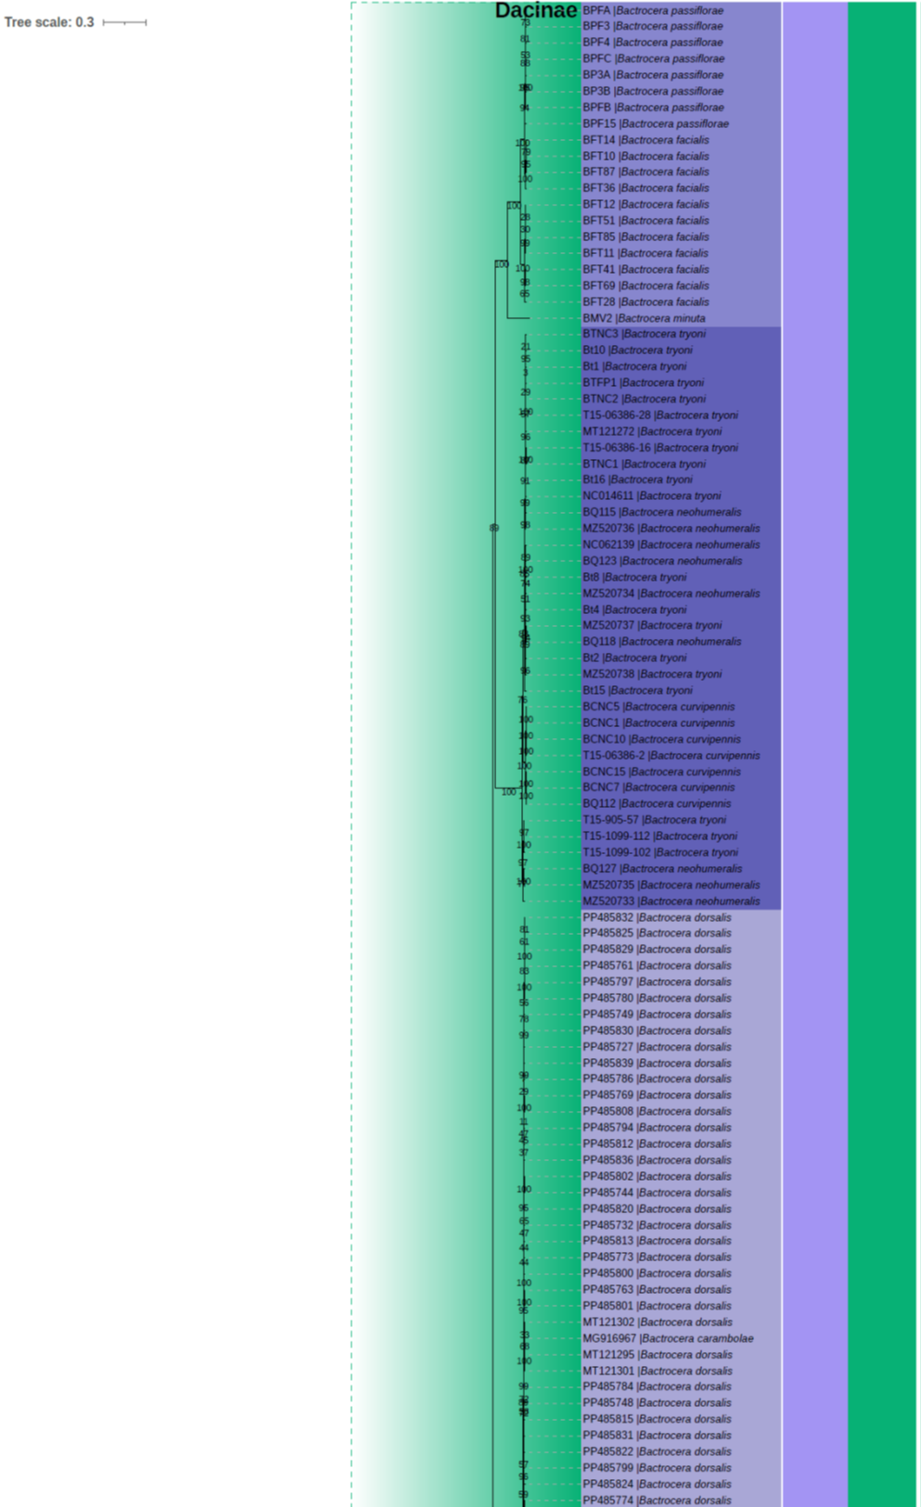
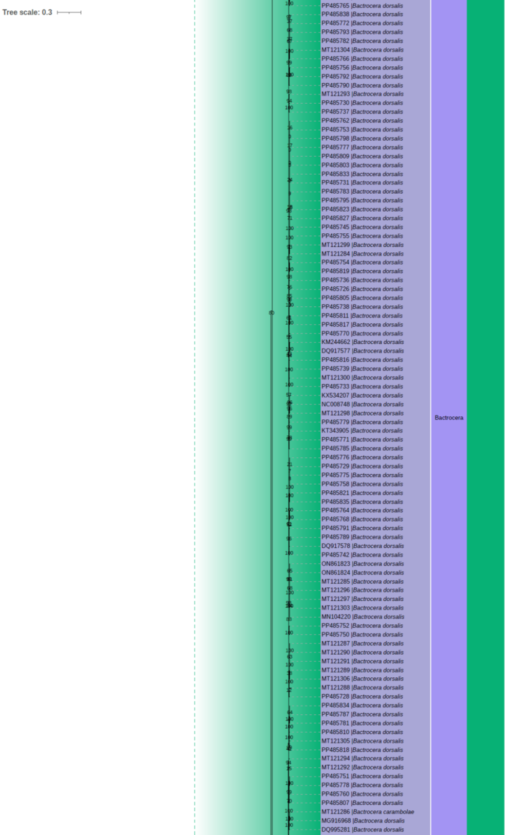
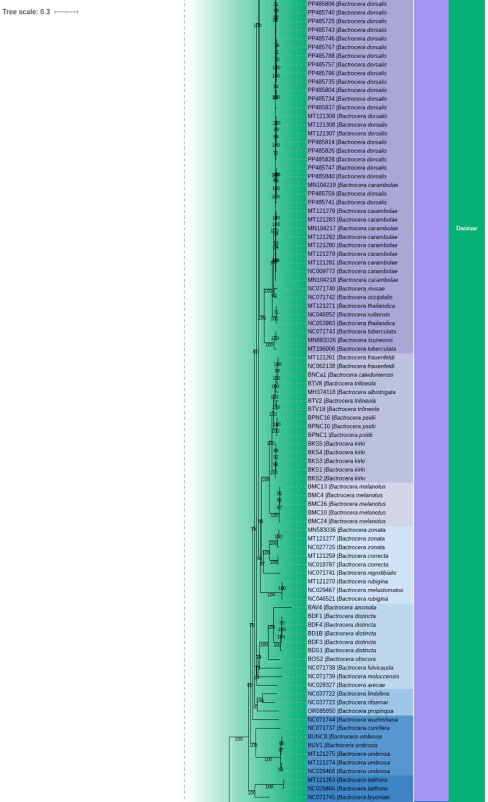
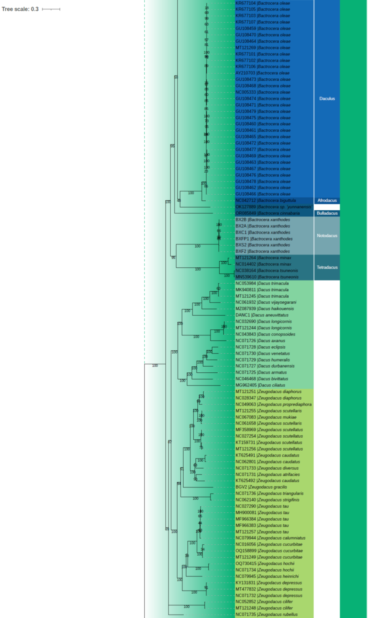
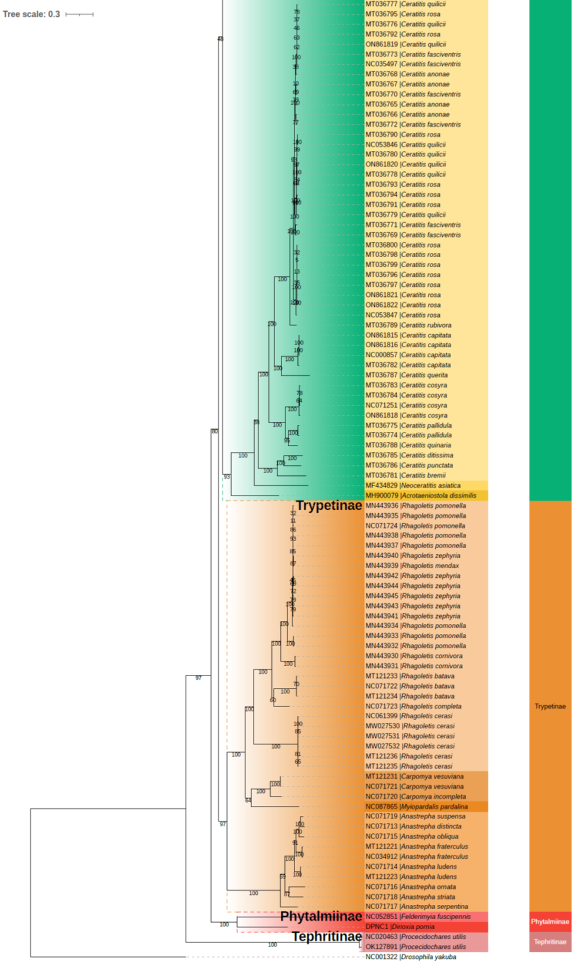
Supplementary figure S2 Reconstructed phylogenetic tree of Tephritidae fruit flies inferred from the PCGs dataset with partitions using RAxML. Maximum likelihood (ML) bootstrap support values are shown at each node. Coloured strips denote tribes and subgenera of Bactrocera genus.

Synonymous and non-synonymous substitutions
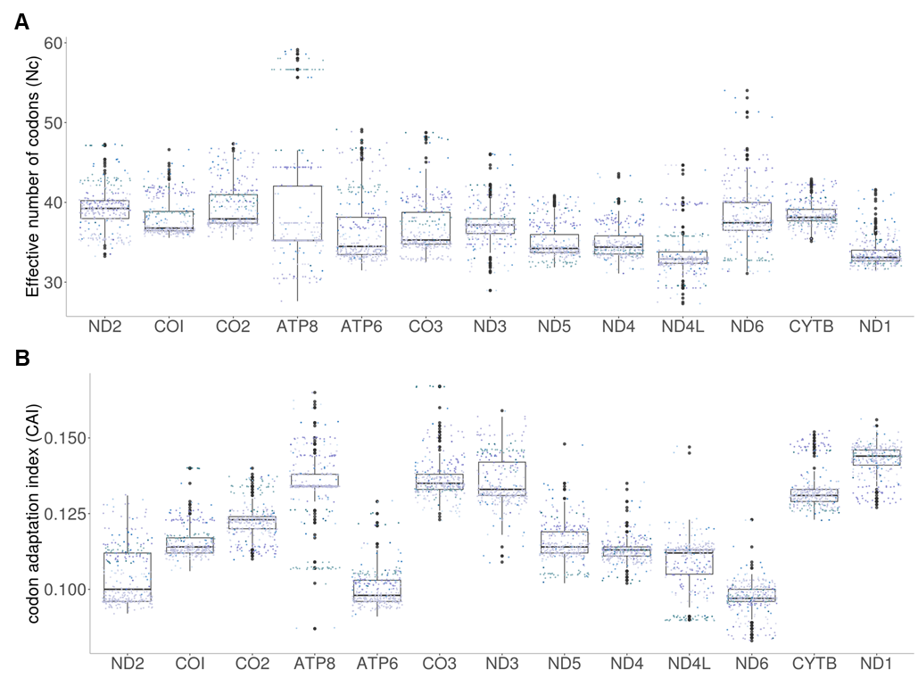
Supplementary figure S3 Synonymous and nonsynonymous substitution rates across the 13 mitochondrial protein-coding genes (PCGs) in Bactrocera fruit flies. Boxplots show (A) nonsynonymous substitution rate (Ka) and (B) synonymous substitution rate (Ks) for each gene. Each data point represents individual Bactrocera specimens, with point colours indicating different Bactrocera clades.

Codon usage
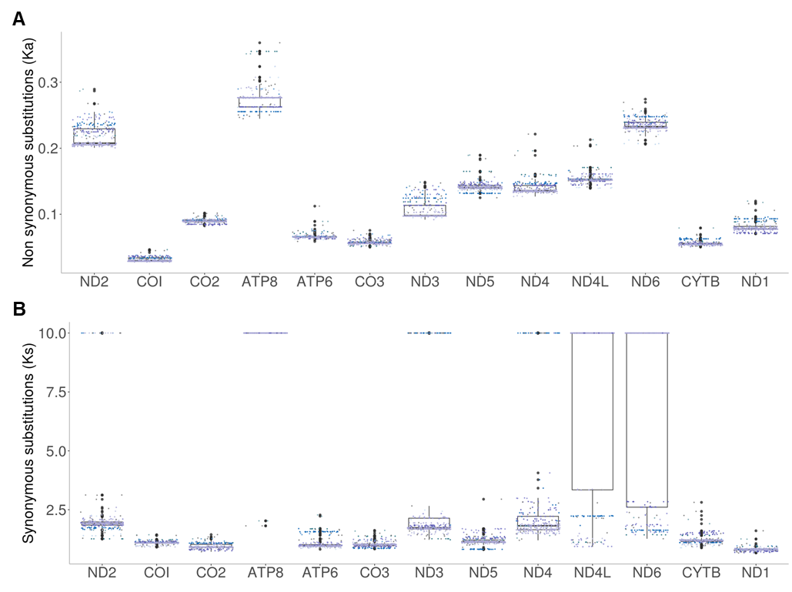
Supplementary figure S4 Codon usage across the 13 mitochondrial protein-coding genes (PCGs) in Bactrocera fruit flies. Boxplots show (A) effective number of codons (Nc) and (B) codon adaptation index (CAI) for each gene. Each data point represents individual Bactrocera specimens, with point colours indicating different Bactrocera clades.

Selectivity result from other primers/probestested
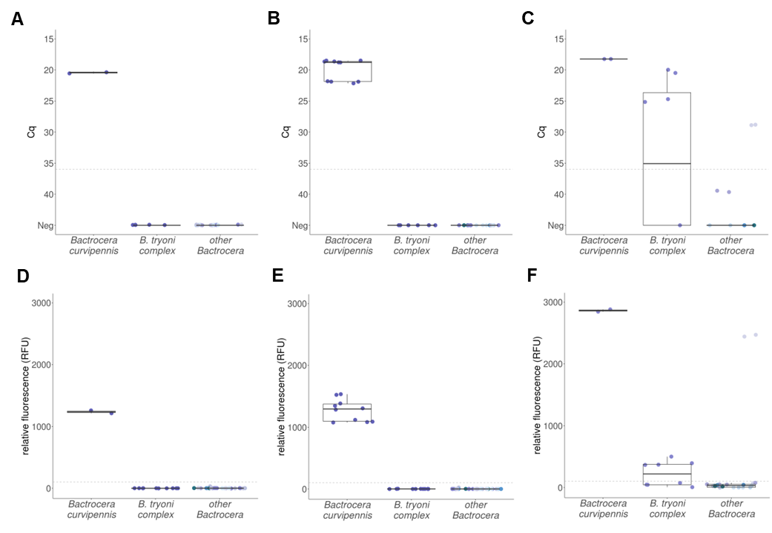
Supplementary figure S5 Specificity assessment of real-time PCR assays for Bactrocera curvipennis detection. (A–C) Boxplot of Cq values for specific and non-specific amplifications across different samples, cut-off set at 36 cycles (grey dotted line). (D–F) Boxplot of relative fluorescence unit (RFU) for specific and non-specific amplifications, fluorescence threshold set at 100 RFU (grey dotted line). Primer-probe combinations are as follows: (A, D) ND2_1133F_BC and ND2_1251R_BC, with probe ND2_1192P_BC+. (B, E) ND2_1138F_BC and ND2_1323R_BC, with probe ND2_1192P_BC. (C, F) CO3_5145F_BC and CO3_5310R_BC, with probe COX3_5239P_BC. Each data point represents samples from different Bactrocera clades.

In silico specificity
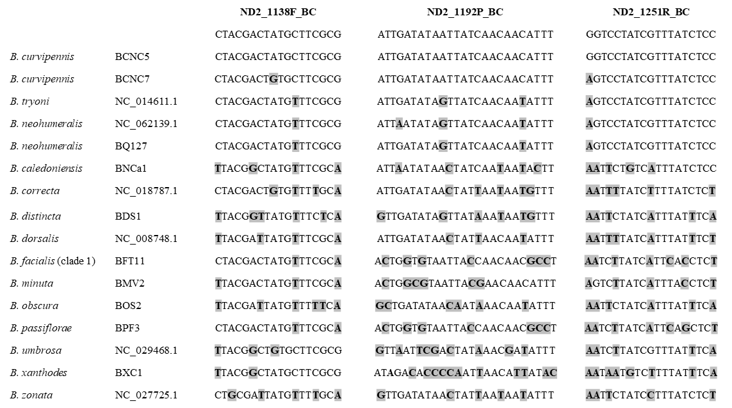
Supplementary figure S6 Alignment of the amplified regions of the ND2 sequences of Bactrocera curvipennis, its closely related species and commonly intercepted Bactrocera fruit flies. The bold highlighted letters indicate the SNPs in the species to the selected primers/probe. The reverse compliment (RC) of the primer ND2_1251R_BC was shown.

Effect of mismatches
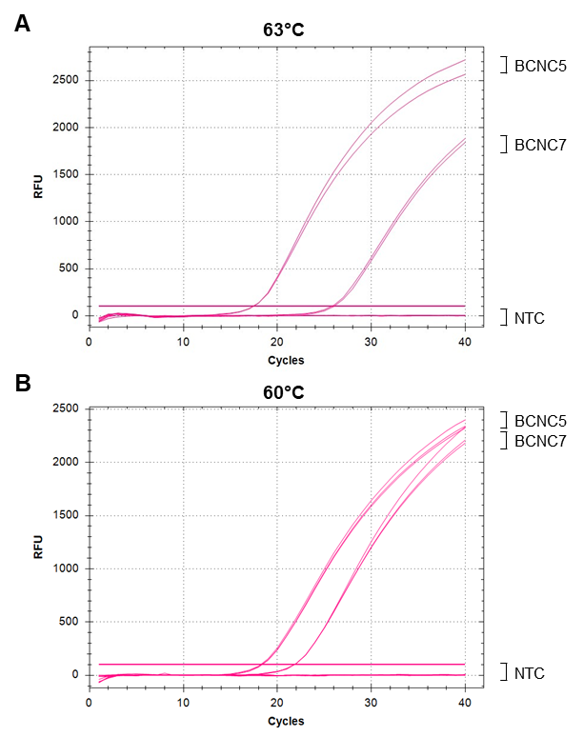
Supplementary figure S7 Amplification curves of Bactrocera curvipennis ND2 real-time PCR assay showing the effects of mismatches present in the different haplotypes of the target species on the cycle quantification (Cq) and fluorescence intensity (RFU) at 63°C (A) or 60°C (B) annealing and extension. Performed with 300 nM primers and probes with no added BSA.

All-in-one control
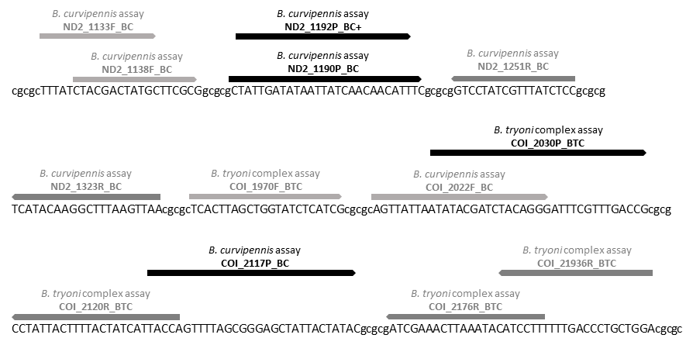
Supplementary figure S8 Primers and probe concatenated sequence for the Bactrocera curvipennis and B. tryoni complex real-time PCR assay within the synthetic template Bac_TC_allin_control. Nucleotides in lowercase indicate connecting strings of Cs and Gs.

Sensitivity of the ND2 real-time PCR assay in Singleplex and duplex formats
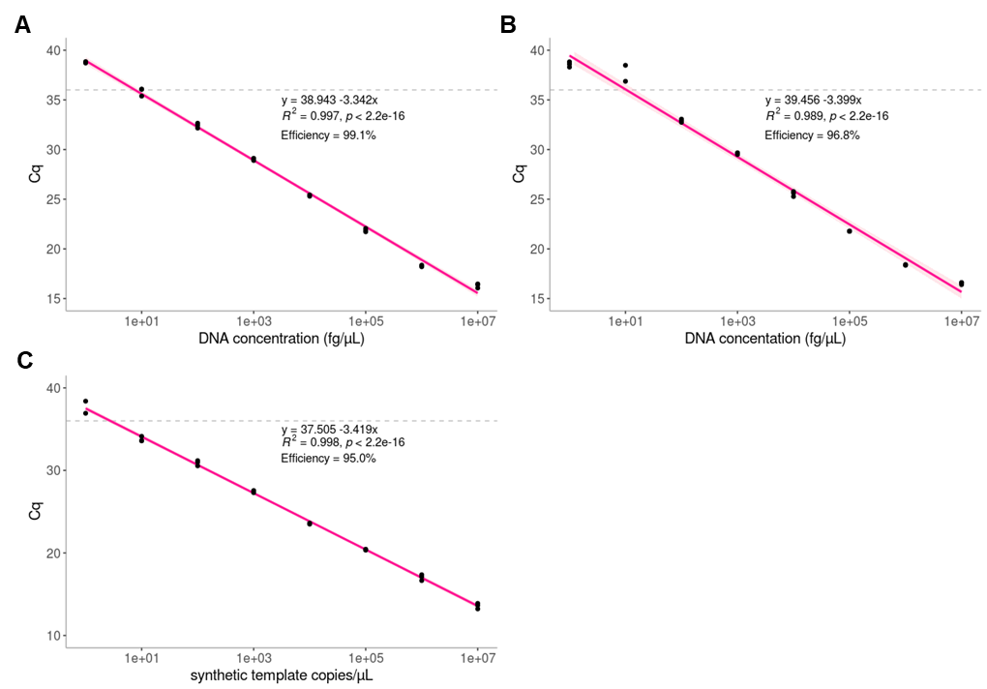
Supplementary figure S 9 Sensitivity of the ND2 real-time PCR assay for Bactrocera curvipennis detection. The assay was evaluated in a singleplex format with genomic DNA from specimens BCNC5 (A) and BCNC7 (B), and in a duplex format with the synthetic template Bac_TC_allin_control with 18S internal control (C). Linear regression was performed on the Cq values across serial dilutions of genomic or synthetic DNA, generating a standard curve of Cq values plotted against the log concentration of genomic DNA (range = 10 ng/µL to 1 fg/µL) or log copy number of the Bac_TC_allin_control (range = 10⁷–1 copies). Shaded pink areas indicate 95% confidence intervals.

