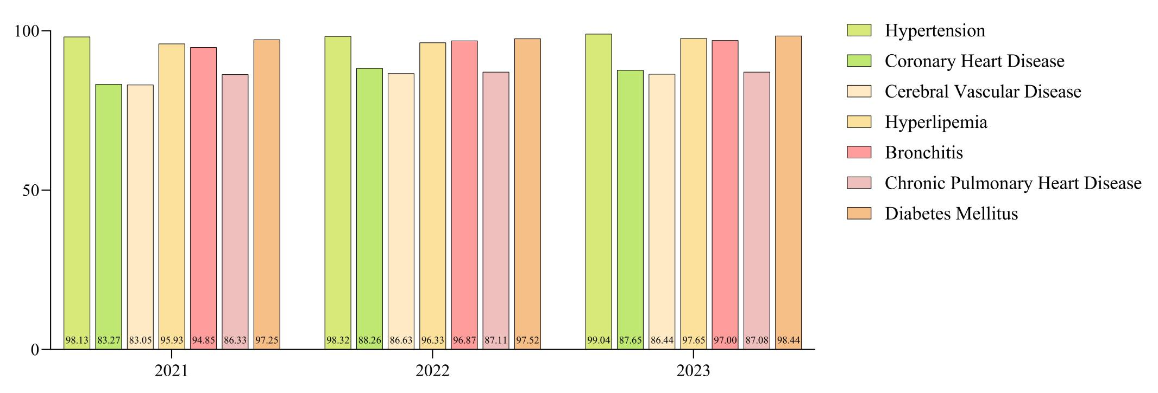
Figure S1 Changes in the Diagnosis Rates of Different Chronic Diseases in Primary Health Care in Henan, China, 2021-2023

Table 2 Types and Reasons for the Inability to Diagnose Three Types of Chronic Diseases in Henan, China
Disease Groups | Disease Classification | Types for Inability to Diagnose (N) | Fail to make a correct diagnosis according to the clinical pathway (N, %) | Fail to correctly utilize or apply diagnostic-related scales and/or tools (N, %) | Fail to correctly interpret laboratory test results and/or imaging reports (N, %) | Reasons for Inability to Diagnose (N) | Insufficient manpower (N, %) | Lack of skills (N, %) | Lack of equipment (N, %) | Policy constraint (N, %) | Low demand (N, %) | Low efficiency (N, %) | High risk (N, %)
Cardiovascular diseases | Hypertension | 64 | 21, 32.81 | 24, 37.50 | 19, 29.69 | 127 | 27, 21.26 | 33, 25.98 | 54, 42.52 | 7, 5.51 | 2, 1.57 | 2, 1.57 | 2, 1.57
Cardiovascular diseases | Coronary Heart Disease | 644 | 196, 30.43 | 288, 44.72 | 160, 24.84 | 1596 | 290, 18.17 | 388, 24.31 | 747, 46.80 | 63, 3.95 | 46, 2.88 | 7, 0.44 | 55,3.45
Cardiovascular diseases | Cerebral Vascular Disease | 595 | 190, 31.93 | 248, 41.68 | 157, 26.39 | 1531 | 238, 15.55 | 347, 22.66 | 817, 53.36 | 58, 3.79 | 34, 2.22 | 4, 0.26 | 33,2.16
Cardiovascular diseases | Hyperlipemia | 57 | 15, 26.32 | 26, 45.61 | 16, 28.07 | 128 | 24, 18.75 | 32, 25.00 | 52, 40.63 | 11, 8.59 | 7, 5.47 | 1, 0.78 | 1, 0.78
Chronic respiratory diseases | Bronchitis | 146 | 47, 32.19 | 62, 42.47 | 37, 25.34 | 347 | 74, 21.33 | 79, 22.77 | 167, 48.13 | 12, 3.46 | 10, 2.88 | 1, 0.29 | 4, 1.15
Chronic respiratory diseases | Chronic Pulmonary Heart Disease | 591 | 195, 32.99 | 254, 42.98 | 142, 24.03 | 1256 | 245, 19.51 | 338, 26.91 | 574, 45.70 | 38, 3.03 | 47, 3.74 | 3, 0.24 | 11,0.88
Diabetes | Diabetes Mellitus | 66 | 21, 31.82 | 29, 43.94 | 16, 24.24 | 173 | 32, 18.50 | 38, 21.97 | 83, 47.98 | 12, 6.94 | 4, 2.31 | 3, 1.73 | 1, 0.58

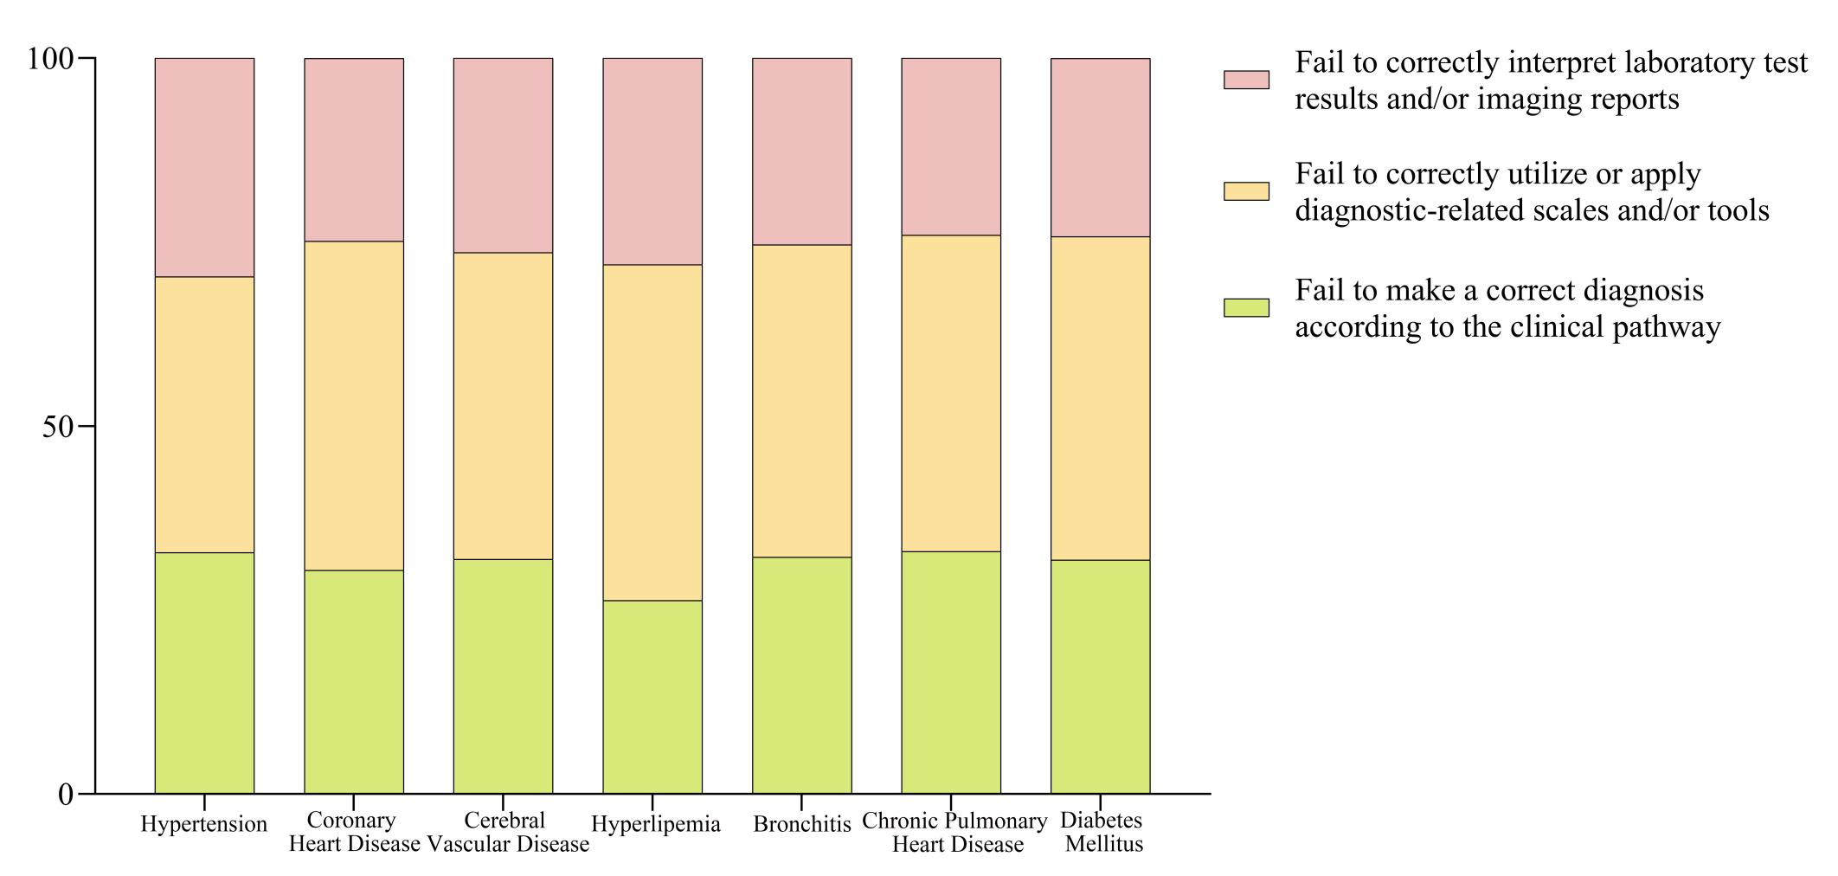
Figure S2 Types for the Inability to Diagnose Three Types of Chronic Diseases in Henan, China

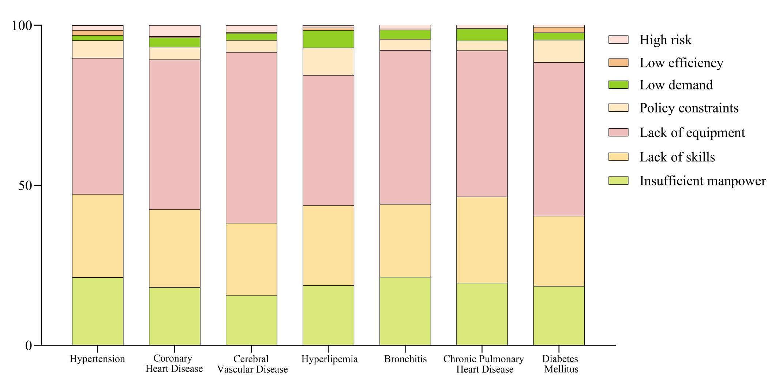

Figure S3 Reasons for the Inability to Diagnose Three Types of Chronic Diseases in Henan, China

Table 3 Types and Reasons for the Inability to Treatment Three Types of Chronic Diseases in Henan, China
Disease Groups | Disease Classification | Types for Inability to Treatment(N) | Failure to administer medication according to standard clinical pathways (N, %) | Failure to perform surgical procedures according to standard clinical pathways (N, %) | Failure to conduct routine case management properly (N, %) | Failure to properly transfer cases (N, %) | Reasons for Inability to Treatment (N) | Insufficient manpower (N, %) | Lack of skills (N, %) | Lack of equipment (N, %) | Policy constraint (N, %) | Low demand (N, %) | Low efficiency (N, %) | High risk (N, %)
Cardiovascular diseases | Hypertension | 43 | 14, 32.56 | 14, 32.56 | 8, 18.60 | 7, 16.28 | 84 | 16, 19.05 | 27, 32.14 | 32, 38.10 | 3, 3.57 | 3, 3.57 | 2, 2.38 | 1, 1.19
Cardiovascular diseases | Coronary Heart Disease | 179 | 53, 29.61 | 59, 32.96 | 41, 22.91 | 26, 14.53 | 311 | 65, 20.90 | 83, 26.69 | 104, 33.44 | 22, 7.07 | 13, 4.18 | 6, 1.93 | 18, 5.79
Cardiovascular diseases | Cerebral Vascular Disease | 111 | 33, 29.73 | 42, 37.84 | 21, 18.92 | 15, 13.51 | 231 | 46, 19.91 | 60, 25.97 | 74, 32.03 | 18, 7.79 | 12, 5.19 | 3, 1.30 | 18, 7.79
Cardiovascular diseases | Hyperlipemia | 46 | 17, 36.96 | 17, 36.96 | 7, 15.22 | 5, 10.87 | 75 | 18, 24.00 | 23, 30.67 | 24, 32.00 | 5, 6.67 | 2, 2.67 | 2, 2.67 | 1, 1.33
Chronic respiratory diseases | Bronchitis | 66 | 17, 25.76 | 26, 39.39 | 15, 22.73 | 8, 12.12 | 124 | 29, 23.39 | 33, 26.61 | 50, 40.32 | 7, 5.65 | 3, 2.42 | 1, 0.81 | 1, 0.81
Chronic respiratory diseases | Chronic Pulmonary Heart Disease | 291 | 90, 30.93 | 100, 34.36 | 72, 24.74 | 29, 9.97 | 472 | 88, 18.64 | 139, 29.45 | 165, 34.96 | 30, 6.36 | 30, 6.36 | 3, 0.64 | 17, 3.60
Diabetes | Diabetes Mellitus | 118 | 40, 33.90 | 34, 28.81 | 29, 24.58 | 15, 12.71 | 154 | 31, 20.13 | 59, 38.31 | 43, 27.92 | 10, 6.49 | 4, 2.60 | 3, 1.95 | 4, 2.60

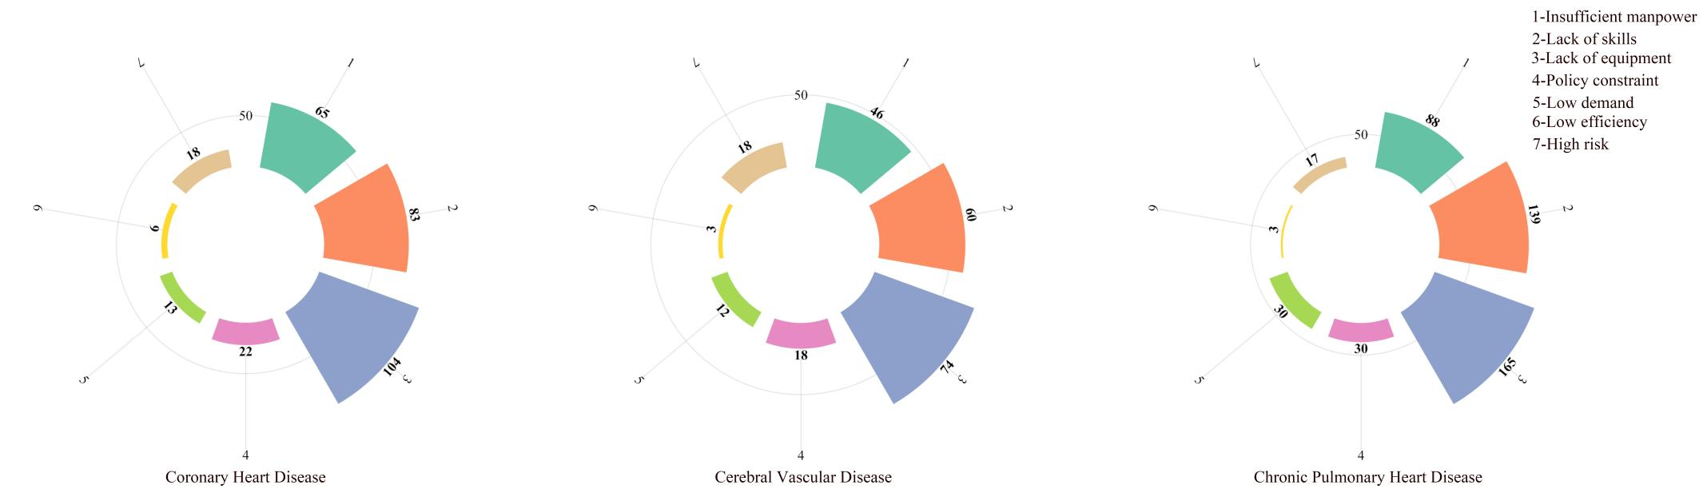
Figure S4 Reasons for the Inability to Treatment Three Types of Chronic Diseases in Henan, China

