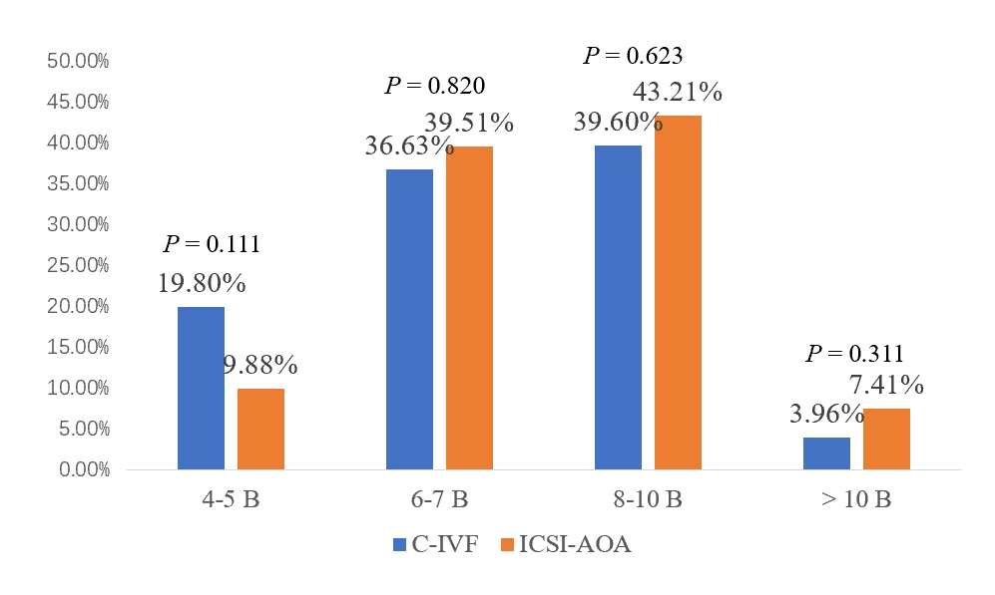
Supplementary figure 1. The number of D3 embryo blastomeres after C-IVF and ICSI-AOA cycles in couples with embryo developmental problems.
Note: 4-5 B: 4-5 blastomeres; 6-7 B: 6-7 blastomeres; 8-10 B: 8-10 blastomeres; >10 B: > 10 blastomeres.
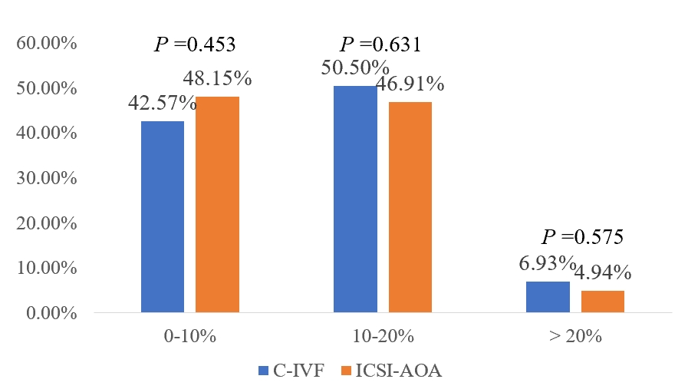
Supplementary figure 2. Proportion of D3 available embryos with different degree of fragmentation after C-IVF and ICSI-AOA cycles in couples with embryo developmental problems.

