Supplementary Information for
Expanding frontiers of complex reaction network exploration through a general reactive machine learning potential

Guoao Li¹, Haobo Ling¹, Guoqiang Wang¹*, Manyi Yang^{1,2}* and Shuhua Li¹*

¹State Key Laboratory of Coordination Chemistry, Key Laboratory of Mesoscopic Chemistry of Ministry of Education, New Cornerstone Science Laboratory, School of Chemistry and Chemical Engineering, Nanjing University, Nanjing, China.
²The Institute of Green Chemistry and Engineering, Nanjing University, Suzhou, China.
- mail: wangguoqiang710@nju.edu.cn; manyi.yang@nju.edu.cn; shuhua@nju.edu.cn

Contents
Supplementary Figures 3
Supplementary Tables 10
Supplementary References 35

Supplementary Figures

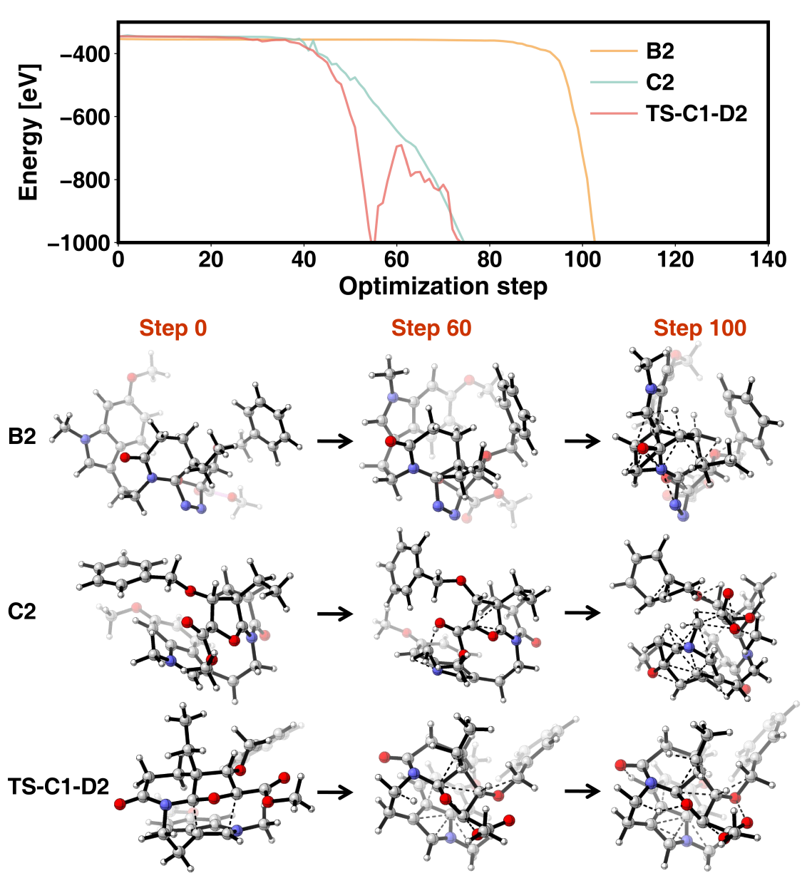

Supplementary Fig 1| NeuralNEB optimized energy profiles and structural changes for intermediates B2, C2 and the transition state TS-C1-D2 of the vindoline cascade (Fig. 6). These calculations are performed using the Berny optimizer in Gaussian 16 with a maximum step size of 0.1 Bohr. For each case, as the optimization progresses, the atoms become excessively close, resulting in non-physical structures and failures of the optimization. Meanwhile, the energy predicted by NeuralNEB decreases to unrealistic values.

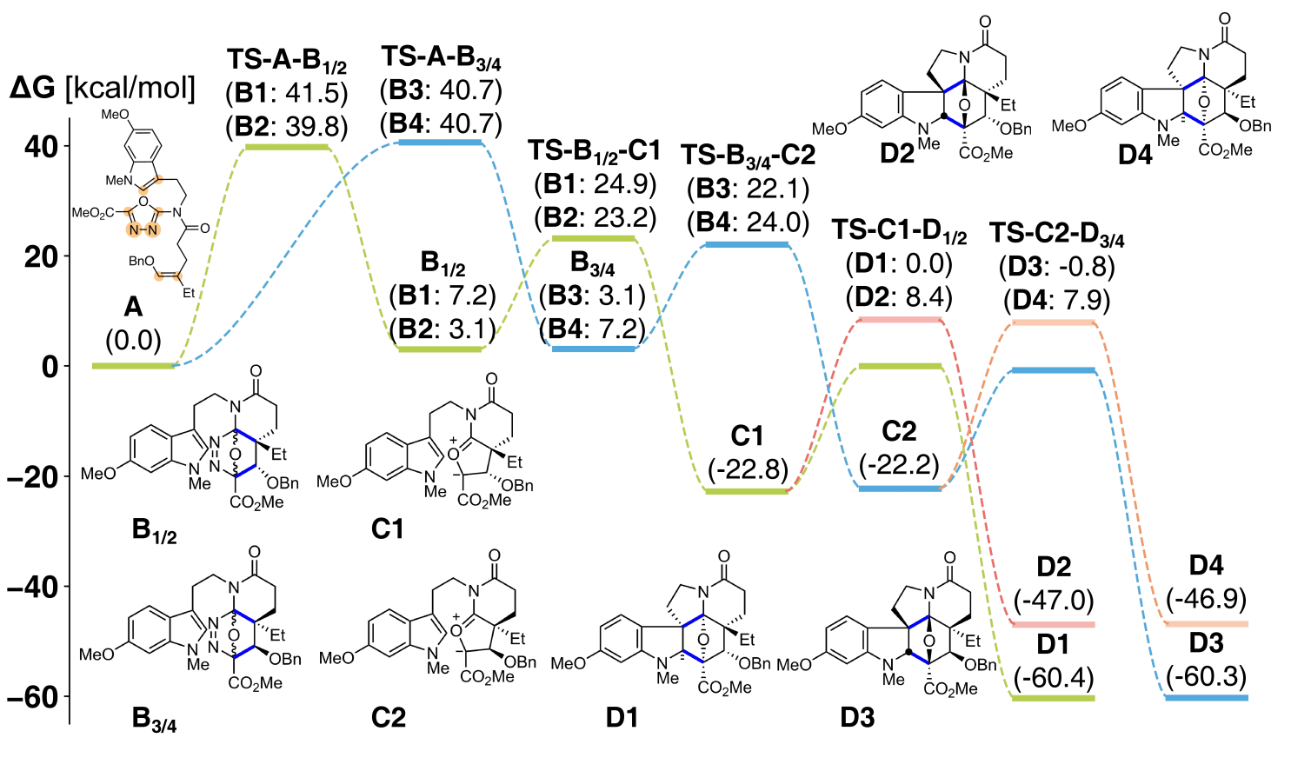

Supplementary Fig 2| Gibbs free energy profiles for the MDCD-NN calculated cascade reaction of 1,3,4-oxadiazole A leading to four stereoisomers of vindoline D (D1-D4). All relative Gibbs free energies are provided in parentheses (kcal/mol). The orange-shaded dot in A represents the active atom assigned in MD/CD search, while the blue bold bond in B-D represents the newly formed bond in the previous step. Starting from oxadiazole A, two major competing pathways are identified through MDCD-NN-accelerated MD/CD automated search. The kinetically favored pathways begin with an intramolecular [4+2] cycloaddition (TS-A-B) between the electron-deficient azadiene and the olefin dienophile, forming intermediates B1-B4, followed by the retro-[4+2] N₂ release (TS-B-C), generating carbonyl ylide intermediates C1/C2, and terminated by the endo-preferred 1,3-dipolar cycloaddition (TS-C-D), leading to products D1-D4. The [4+2] cycloaddition serves as the rate-determining step (free energy barrier: ~40 kcal/mol; experimental conditions: 230 °C, 32 hours), while the diastereoselectivity is governed by the 1,3-dipolar cycloaddition step. Both MDCD-NN and DFT calculations suggest that the experimentally observed main products, the pair of enantiomers D1 and D3, are the major stereoisomers. The MDCD-NN calculations show barrier differences (ΔΔG†) of 8.4 kcal/mol and 8.7 kcal/mol for the formation of D1/D2 and D3/D4, while DFT methods predict consistent differences of 2.5 kcal/mol and 4.1 kcal/mol, respectively (Supplementary Table 5). Alternative pathways, exhibiting higher activation barriers, involve the [4+2] cycloaddition/N₂ release between the azadiene and indole moieties, producing intermediates F/G (Supplementary Table 4).

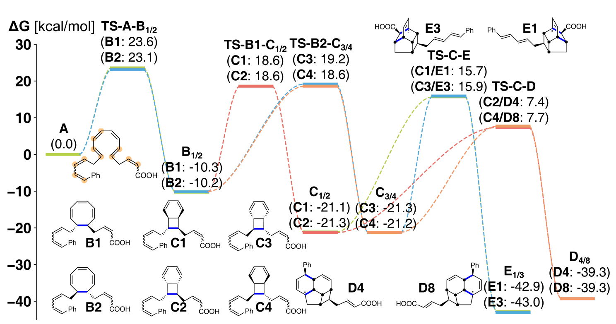

Supplementary Fig 3| Gibbs free energy profiles for the endiandric acid cascade leading to products D4/D8 and E1/E3 calculated with MDCD-NN. The relative Gibbs free energies are provided in parentheses (kcal/mol). The orange-shaded dot in A represents the active atom assigned in MD/CD search, while the blue bold bond in B-E represents the newly formed bond in the previous step. Among all pathways identified by the MDCD-NN-accelerated MD/CD automated search, the pathways leading to the experimentally observed racemic enantiomers D4/D8 and E1/E3 are the most energetically favorable, consistent with DFT results (Supplementary Table 7) and prior experimental observations¹⁻⁴. The process is initiated with the 8π-electrocyclization (TS-A-B) of reagent A to form the 8-membered-ring intermediates B1/B2, followed by the 6π-electrocyclization（TS-B-C） of intermediate B, yielding the [4.2.0] bicyclic intermediates C1-C4. The final step involves the intramolecular [4+2] cycloaddition at distinct sites (TS-C-D and TS-C-E) of intermediates C to generate products D and E. The MDCD-NN-driven profiles show almost identical reaction energies (-21.1 to -21.3 kcal/mol) and barrier heights (28.8 to 29.4 kcal/mol) for the formation of intermediates C1-C4 from A, while the reverse process has barrier heights up to 44.9 kcal/mol. These results indicate that intermediates C1-C4 are generated from A via a non-selective and irreversible process, thereby rationalizing the experimental observation that structural isomers D4/D8 and E1/E3 can be simultaneously obtained.

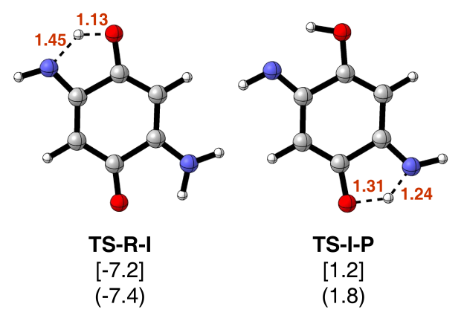

Supplementary Fig 4| Comparison of Deep-TDA CV values for double proton transfer TSs in 2,5-diamino-1,4-benzoquinone calculated with MDCD-NN. The CV values of the TS geometries optimized by static calculations (in brackets) coincide with that of saddle points along the dynamic FES (in parentheses), which are TS-R-I: -7.2 .vs. -7.4 and TS-I-P: 1.2 .vs. 1.8, confirming the accuracy of the OPES-enhanced dynamic sampling. Key interatomic distances (in Å). Carbon, oxygen, nitrogen, and hydrogen atoms are colored in gray, red, blue, and white, respectively.

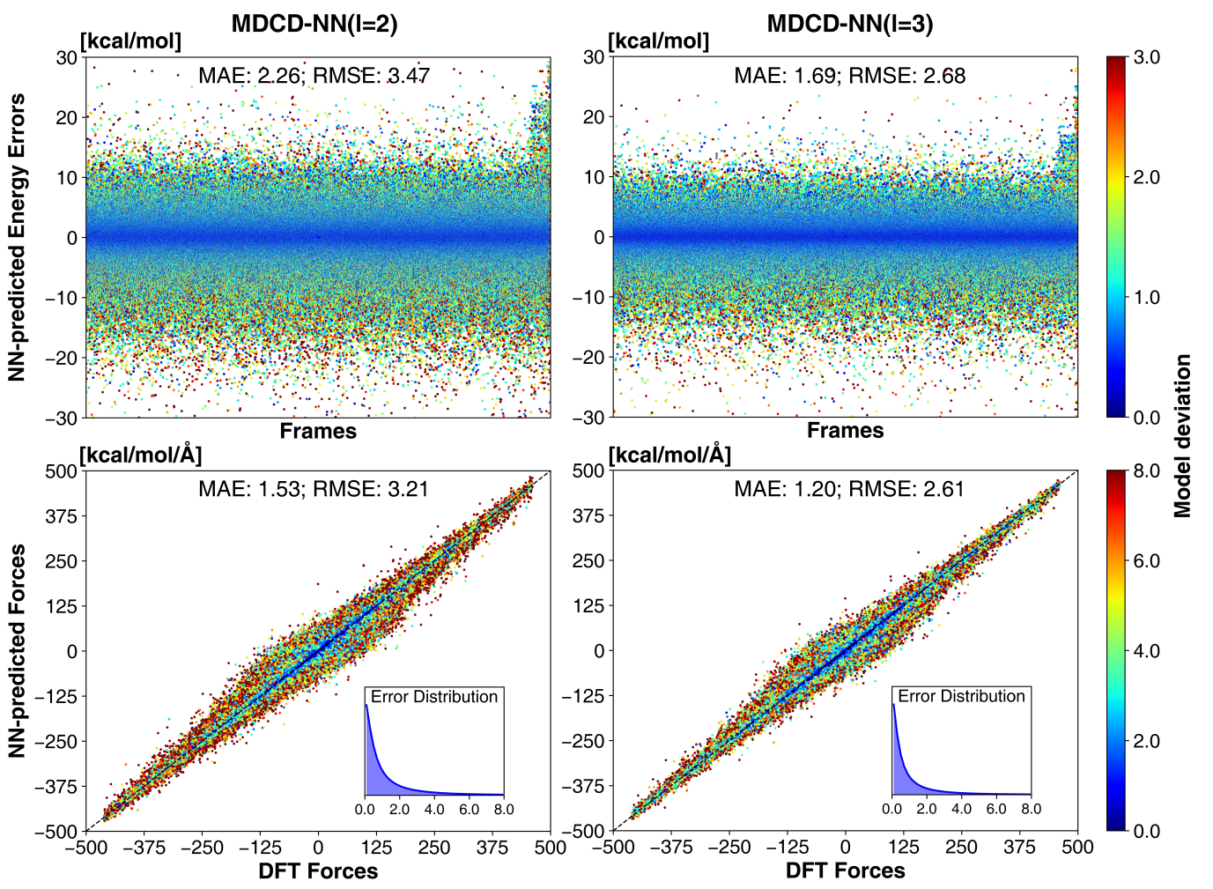

Supplementary Fig 5| Comparison of the energy and atomic forces calculated on MDCD20 training set using DFT and MDCD-NN models. The performance of the ensembles of four MDCD-NN models with l=2 (left panels) and l=3 (right panels) are estimated using MAE/RMSE error metrics on energy (top, kcal/mol) and atomic forces (bottom, kcal/mol/Å). Model deviation values are shown alongside individual energy and force data points. For energy predictions, the MDCD-NN (l=2) model achieves MAE and RMSE errors of 2.26 and 3.47 kcal/mol respectively, while the l=3 variant demonstrates improved accuracy with MAE = 1.69 kcal/mol and RMSE = 2.68 kcal/mol. For the atomic forces, the MDCD-NN (l=2) model gives MAE and RMSE values of 1.53 and 3.21 kcal/mol/Å, respectively. The l=3 model further reduces MAE and RMSE errors to 1.20 kcal/mol/Å and 2.61 kcal/mol/Å.

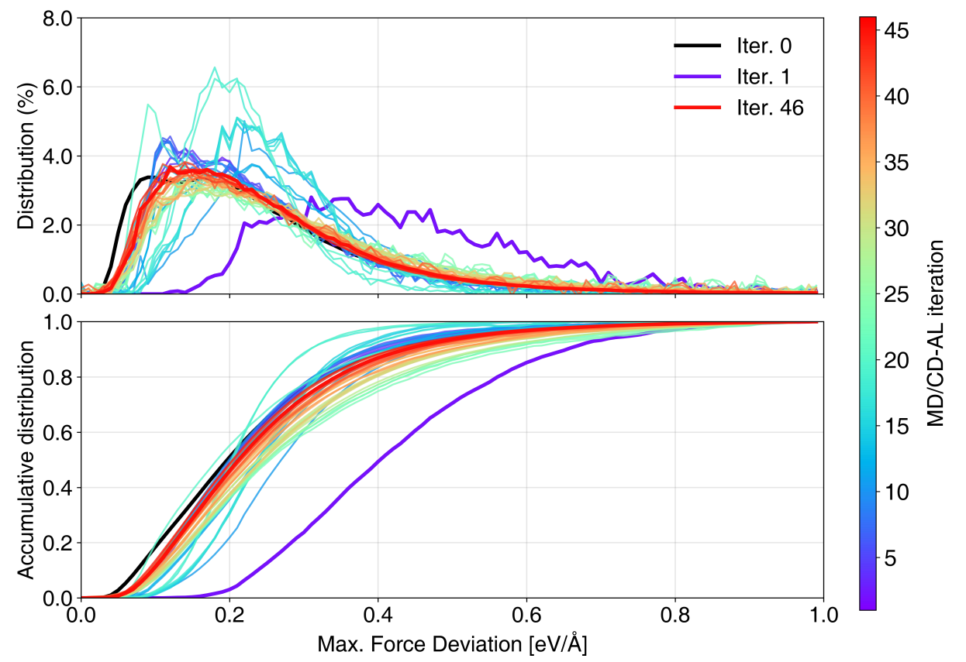

Supplementary Fig 6| Evolution of the distribution and cumulative distribution curves of the maximal force deviations during MD/CD-AL iterations. The color of the distribution curve is black for iteration number 0 and varies from purple at iteration number 1 to red at iteration number 46. The force deviations are calculated as (Eq. 3) in method section of the main text.

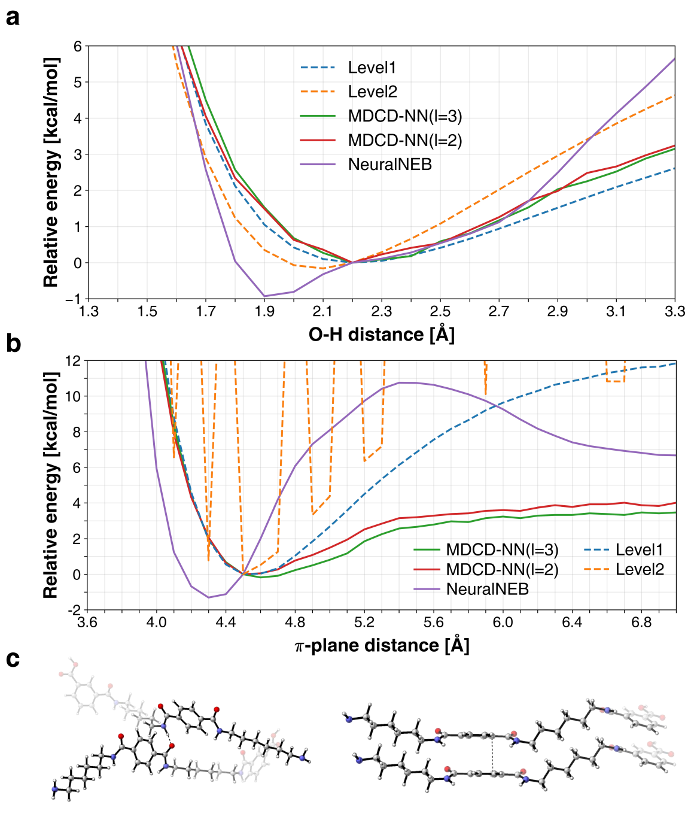

Supplementary Fig 7| Comparison of MDCD-NN and NeuralNEB in estimating hydrogen bonding and π-π stacking interactions in PA6T dimers. a, Hydrogen bond interactions. Relative energy changes are plotted against O-H distances (dashed line in c, left) within 1.3-3.3 Å. b, π-π stacking interactions. Relative energy changes are evaluated as a function of interplanar separation (dashed line in c, right) within 3.6-7.0 Å. c, Structure illustrations with atom color scheme: gray (C), red (O), blue (N), white (H). Energy curves are calculated using MDCD-NN: l=3 (green solid line) and l=2 (red solid line), along with its reference DFT method (Level1, gCP(TZ)-ωB97X-D4/def2-TZVP, blue dashed line); NeuralNEB is also included (purple solid line), with its reference DFT (Level2, ωB97X/6-31G(d), orange dashed line). For the hydrogen bonding, both MDCD-NN (l=2) and MDCD-NN (l=3) accurately reproduce the minimum energy position at 2.2 Å, consistent with Level1, while NeuralNEB exhibits larger relative energy deviations and underestimates the minimum-energy O-H distance (predicted: 1.9 Å vs. Level2: 2.1 Å). For the π-π stacking, MDCD-NN predicts equilibrium distances (l=2: 4.5 Å; l=3: 4.6 Å) in close agreement with Level1 (4.5 Å), with qualitatively accurate energy trends during dimer separation. NeuralNEB yields nonphysical energy profiles featuring a maximum at 5.4 Å. Notably, its reference method Level2 fails to describe this interaction adequately.

Supplementary Tables

Supplementary Table 1. Detailed list of reaction systems in the Manual-200 dataset. Structures at the left of the dashed arrows (reactants) are the starting structures for MD/CD automated exploration.
Studied reactions | Formula | Number of heavy atoms | Studied reactions | Formula | Number of heavy atoms
1 | 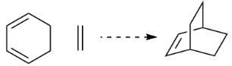 | 8 | 101 | 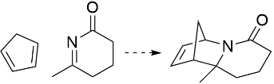 | 13
2 | 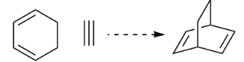 | 8 | 102 | 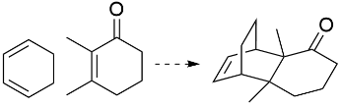 | 14
3 | 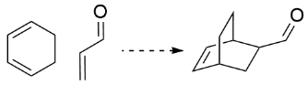 | 10 | 103 | 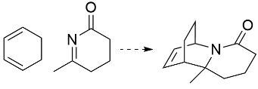 | 14
4 | 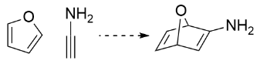 | 8 | 104 | 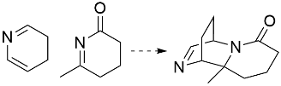 | 14
5 | 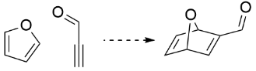 | 9 | 105 | 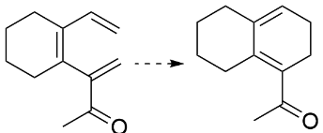 | 13
6 | 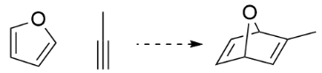 | 8 | 106 | 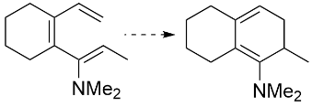 | 14
7 | 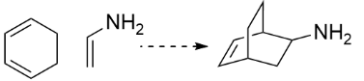 | 9 | 107 | 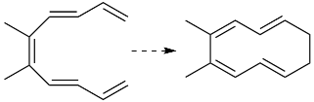 | 12
8 | 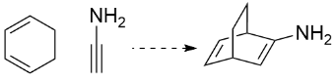 | 9 | 108 | 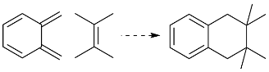 | 14
9 | 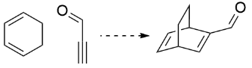 | 10 | 109 | 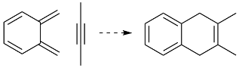 | 12
10 | 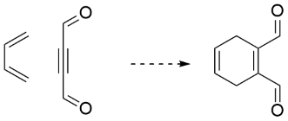 | 10 | 110 | 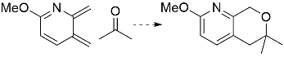 | 14
11 | 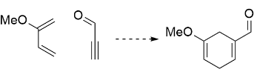 | 10 | 111 | 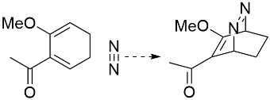 | 13
12 | 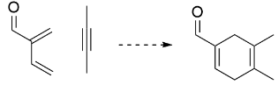 | 10 | 112 | 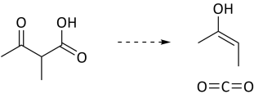 | 8
13 | 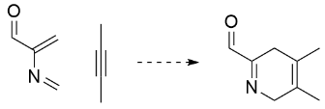 | 10 | 113 | 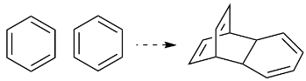 | 12
14 | 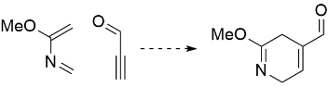 | 10 | 114 | 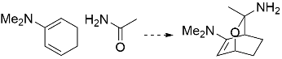 | 13
15 | 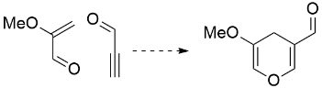 | 10 | 115 | 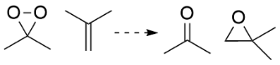 | 9
16 | 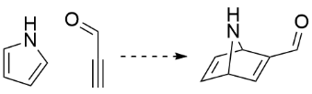 | 9 | 116 | 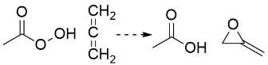 | 8
17 | 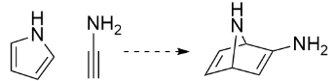 | 8 | 117 | 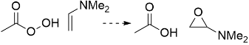 | 10
18 | 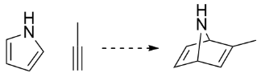 | 8 | 118 | 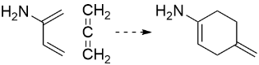 | 8
19 | 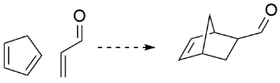 | 9 | 119 | 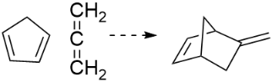 | 8
20 | 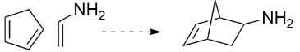 | 8 | 120 | 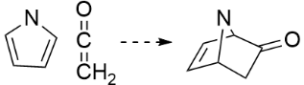 | 8
21 | 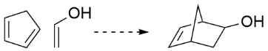 | 8 | 121 | 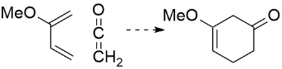 | 9
22 | 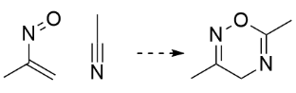 | 8 | 122 | 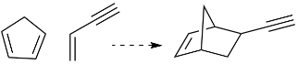 | 9
23 | 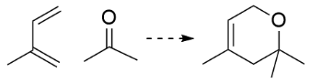 | 9 | 123 | 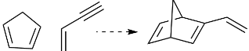 | 9
24 | 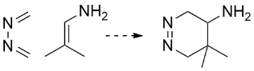 | 9 | 124 | 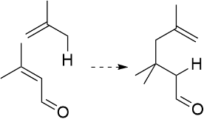 | 10
25 | 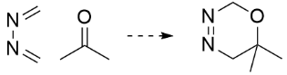 | 8 | 125 | 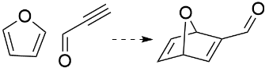 | 9
26 | 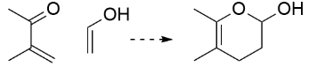 | 9 | 126 | 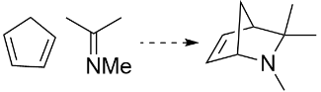 | 10
27 | 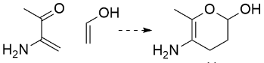 | 9 | 127 | 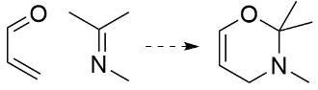 | 9
28 | 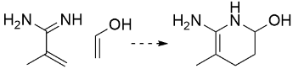 | 9 | 128 | 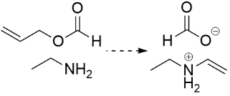 | 9
29 | 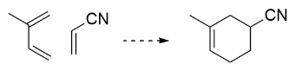 | 9 | 129 | 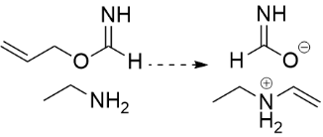 | 9
30 | 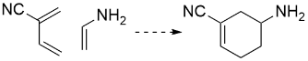 | 9 | 130 | 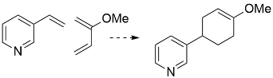 | 14
31 | 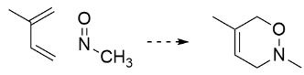 | 8 | 131 | 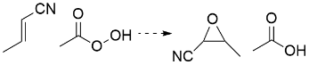 | 10
32 | 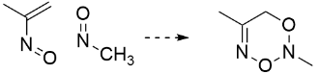 | 8 | 132 | 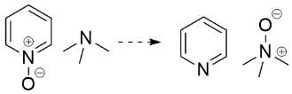 | 11
33 | 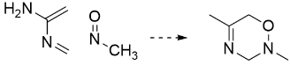 | 8 | 133 | 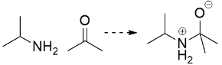 | 8
34 | 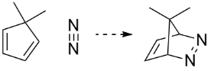 | 9 | 134 | 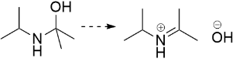 | 8
35 | 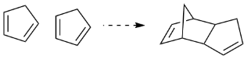 | 10 | 135 | 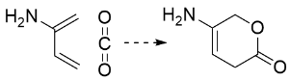 | 8
36 | 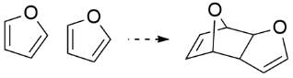 | 10 | 136 | 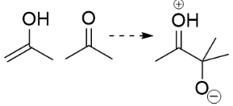 | 8
37 | 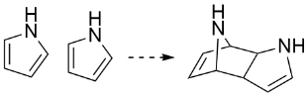 | 10 | 137 | 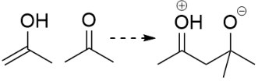 | 8
38 | 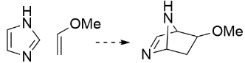 | 9 | 138 | 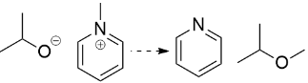 | 11
39 | 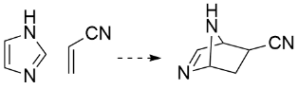 | 9 | 139 | 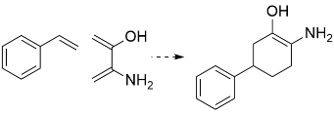 | 14
40 | 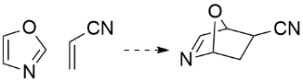 | 9 | 140 | 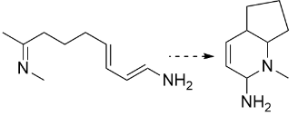 | 12
41 | 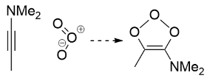 | 9 | 141 | 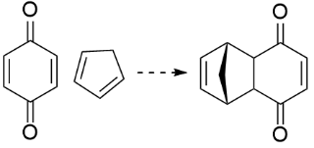 | 13
42 | 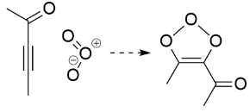 | 9 | 142 | 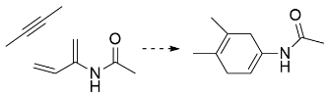 | 12
43 | 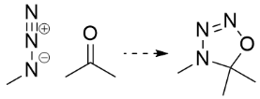 | 8 | 143 | 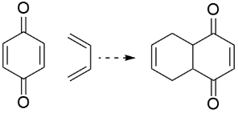 | 12
44 | 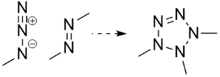 | 8 | 144 | 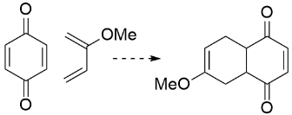 | 14
45 | 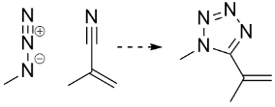 | 9 | 145 | 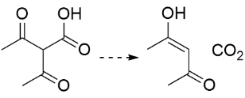 | 10
46 | 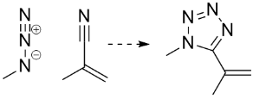 | 9 | 146 | 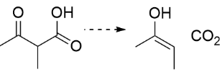 | 8
47 | 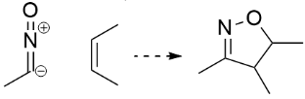 | 8 | 147 | 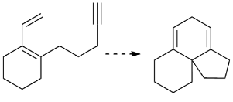 | 13
48 | 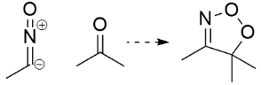 | 8 | 148 | 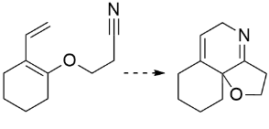 | 13
49 | 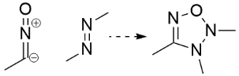 | 8 | 149 | 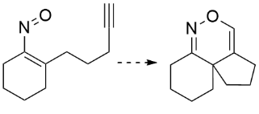 | 13
50 | 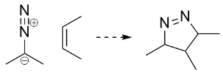 | 8 | 150 | 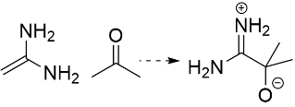 | 8
51 | 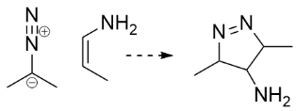 | 8 | 151 | 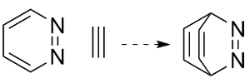 | 8
52 | 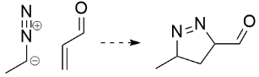 | 8 | 152 | 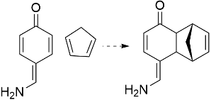 | 14
53 | 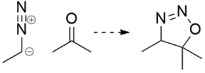 | 8 | 153 | 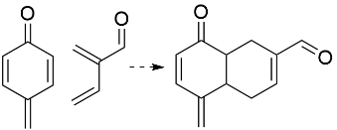 | 14
54 | 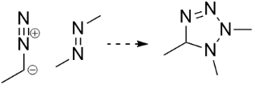 | 8 | 154 | 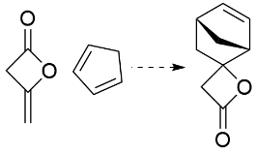 | 11
55 | 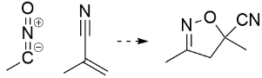 | 9 | 155 | 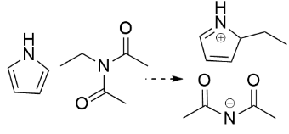 | 14
56 | 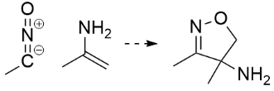 | 8 | 156 | 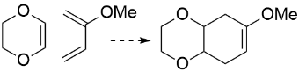 | 12
57 | 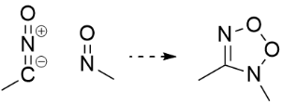 | 7 | 157 | 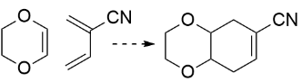 | 12
58 | 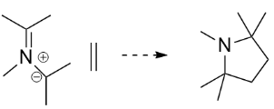 | 10 | 158 | 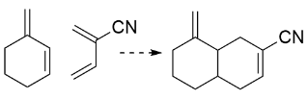 | 13
59 | 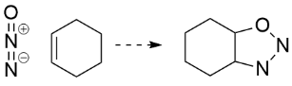 | 9 | 159 | 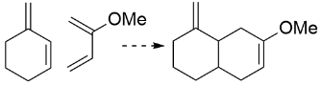 | 13
60 | 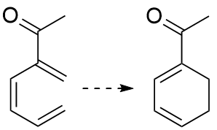 | 9 | 160 | 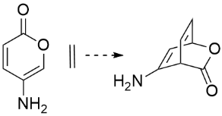 | 10
61 | 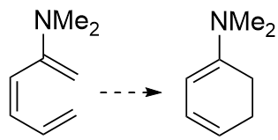 | 9 | 161 | 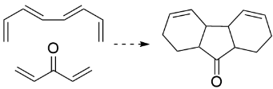 | 14
62 | 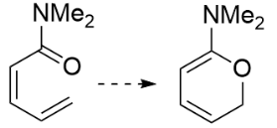 | 9 | 162 | 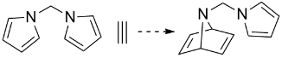 | 11
63 | 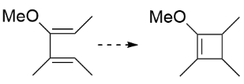 | 9 | 163 | 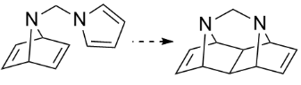 | 11
64 | 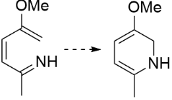 | 9 | 164 | 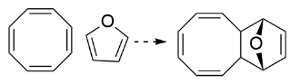 | 13
65 | 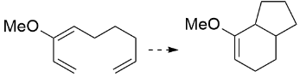 | 11 | 165 | 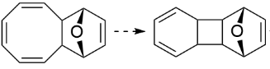 | 13
66 | 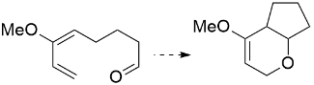 | 11 | 166 | 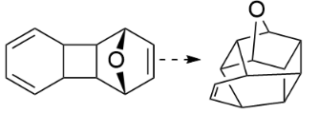 | 13
67 | 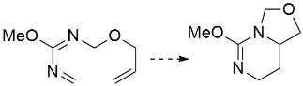 | 11 | 167 | 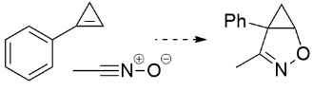 | 13
68 | 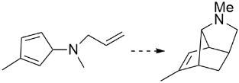 | 11 | 168 | 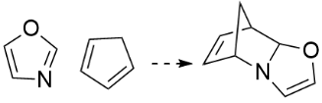 | 10
69 | 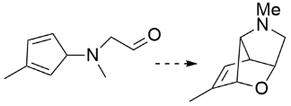 | 11 | 169 | 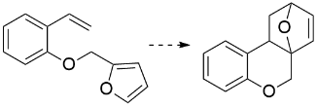 | 15
70 | 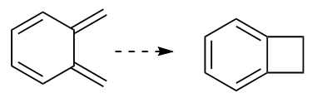 | 8 | 170 | 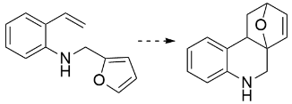 | 15
71 | 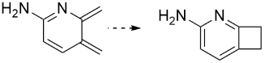 | 9 | 171 | 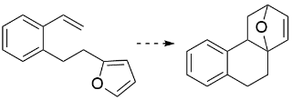 | 15
72 | 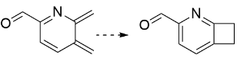 | 10 | 172 | 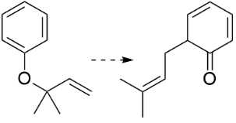 | 12
73 | 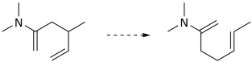 | 10 | 173 | 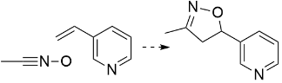 | 12
74 | 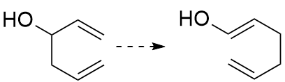 | 8 | 174 | 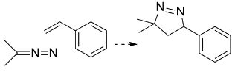 | 12
75 | 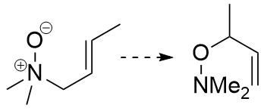 | 8 | 175 | 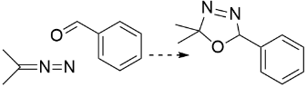 | 12
76 | 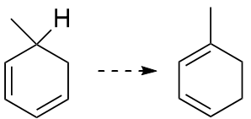 | 7 | 176 | 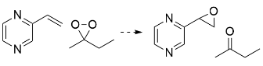 | 14
77 | 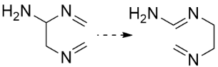 | 7 | 177 | 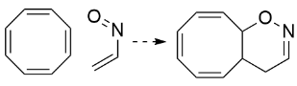 | 12
78 | 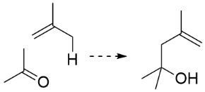 | 8 | 178 | 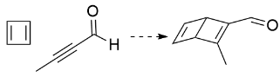 | 9
79 | 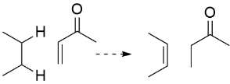 | 9 | 179 | 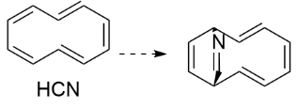 | 13
80 | 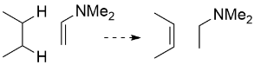 | 9 | 180 | 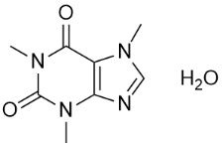 | 15
81 | 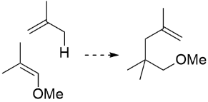 | 10 | 181 | 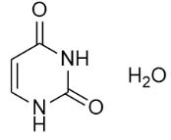 | 9
82 | 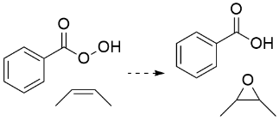 | 14 | 182 | 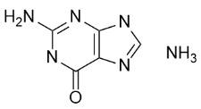 | 12
83 | 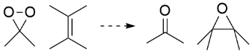 | 11 | 183 | 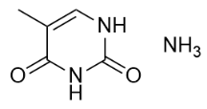 | 10
84 | 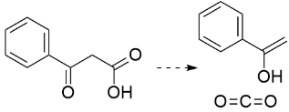 | 12 | 184 | 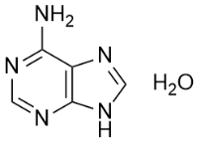 | 11
85 | 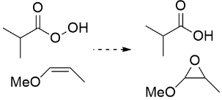 | 11 | 185 | 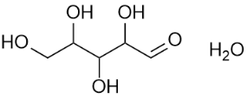 | 11
86 | 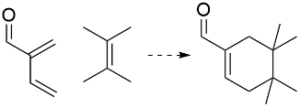 | 12 | 186 | 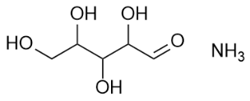 | 11
87 | 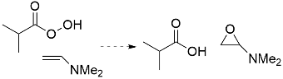 | 12 | 187 | 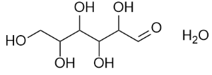 | 12
88 | 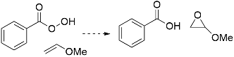 | 14 | 188 | 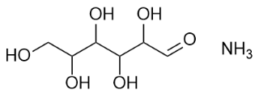 | 12
89 | 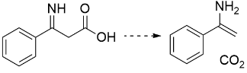 | 12 | 189 | 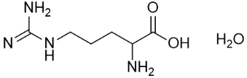 | 13
90 | 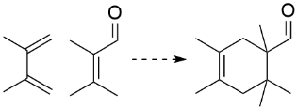 | 13 | 190 | 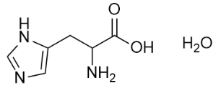 | 12
91 | 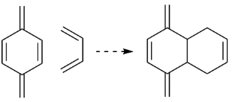 | 12 | 191 | 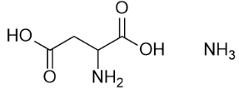 | 10
92 | 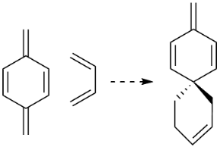 | 12 | 192 | 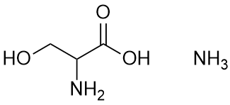 | 8
93 | 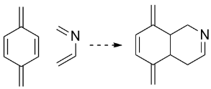 | 12 | 193 | 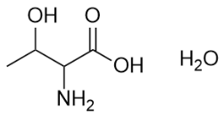 | 9
94 | 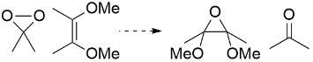 | 13 | 194 | 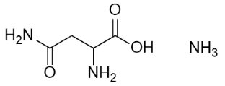 | 10
95 | 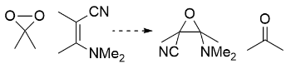 | 14 | 195 | 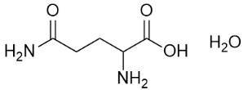 | 11
96 | 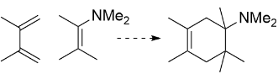 | 14 | 196 | 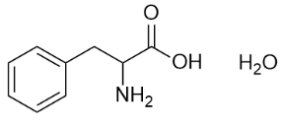 | 13
97 | 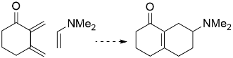 | 14 | 197 | 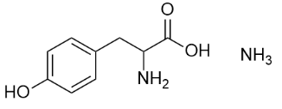 | 14
98 | 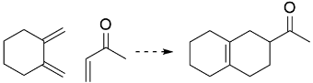 | 13 | 198 | 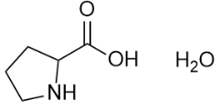 | 9
99 | 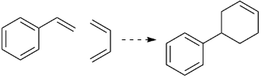 | 12 | 199 | 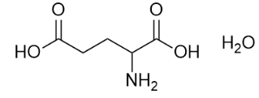 | 11
100 | 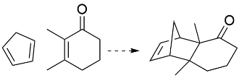 | 14 | 200 | 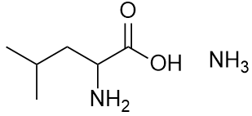 | 10

Supplementary Table 2. Detailed list of the 100 textbook elementary reactions used to validate the MDCD-NN model. The 50 reactions included in MDCD20 are already shown in Supplementary Table 1 (No. 1, 2, 3, 5, 7, 13, 14, 17, 20, 21, 25, 28, 34, 38, 40, 61, 63, 64, 65, 66, 69, 70, 71, 73, 75, 76, 78, 79, 82, 83, 84, 105, 109, 112, 113, 116, 118, 120, 128, 132, 133, 135, 136, 144, 165, 166, 171, 172, 173, 174). Another 50 are listed in this table. The reaction types are as follows: cycloaddition (1-11), electrocyclization (12-15), sigmatropic reaction (16-23), Aldol reaction (24, 25), Baeyer-Villiger oxidation (26, 27), Cope elimination (28, 29), Eschweiler-Clarke reaction (30, 31), Kiliani-Fisher synthesis (32-36), Wolff-Kisner-Huang reduction (37, 38), Michael addition (39, 40), Prilezhaev epoxidation (41-43), Arndt-Eistert homologation (44, 45), Alder-ene reaction (46, 47), Hantzsch reaction (48), Hofmann elimination (49), and Leuckart-Wallach reaction (50).
Studied reactions | Formula | Number of heavy atoms | Studied reactions | Formula | Number of heavy atoms
1 | 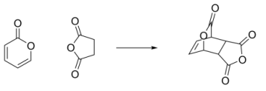 | 14 | 26 | 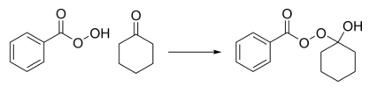 | 17
2 | 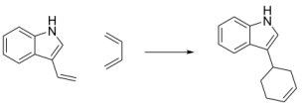 | 15 | 27 | 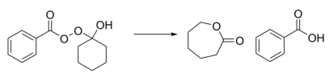 | 17
3 | 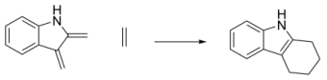 | 13 | 28 | 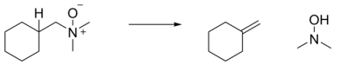 | 11
4 | 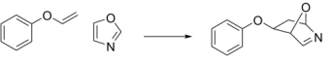 | 14 | 29 | 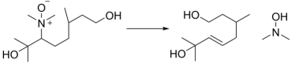 | 16
5 | 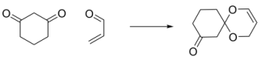 | 12 | 30 | 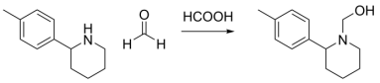 | 18
6 | 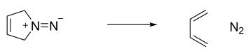 | 6 | 31 | 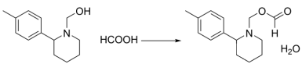 | 18
7 | 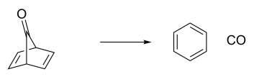 | 8 | 32 | 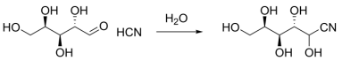 | 13
8 | 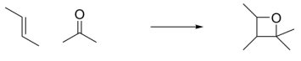 | 8 | 33 | 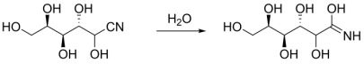 | 13
9 | 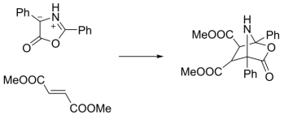 | 28 | 34 | 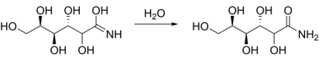 | 14
10 | 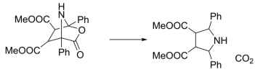 | 28 | 35 | 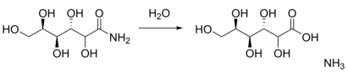 | 14
11 | 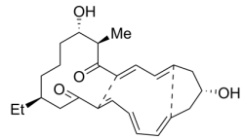 | 29 | 36 | 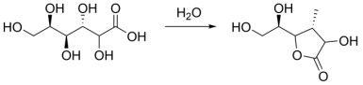 | 14
12 | 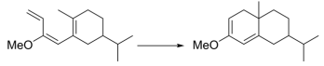 | 16 | 37 | 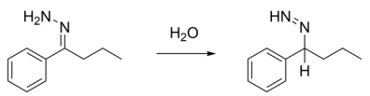 | 13
13 | 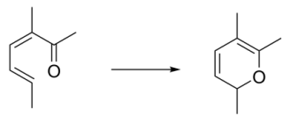 | 9 | 38 | 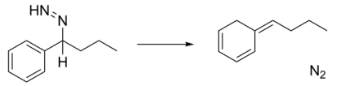 | 12
14 | 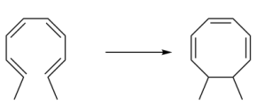 | 10 | 39 | 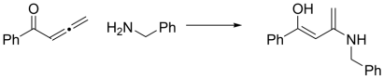 | 19
15 | 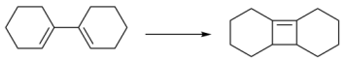 | 12 | 40 | 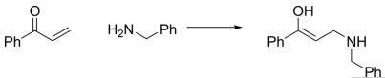 | 18
16 | 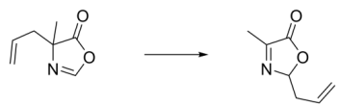 | 10 | 41 | 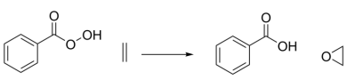 | 12
17 | 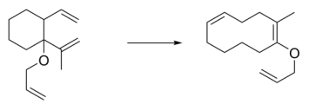 | 15 | 42 | 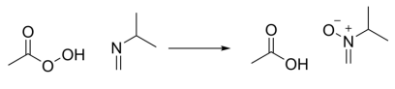 | 10
18 | 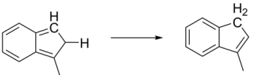 | 10 | 43 | 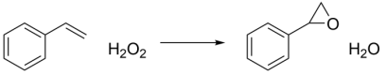 | 10
19 | 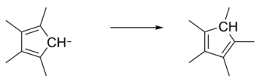 | 10 | 44 | 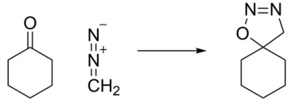 | 10
20 | 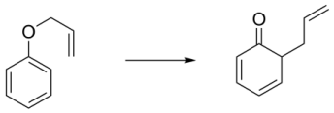 | 10 | 45 | 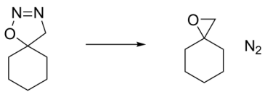 | 10
21 | 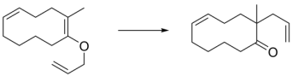 | 15 | 46 | 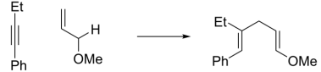 | 15
22 | 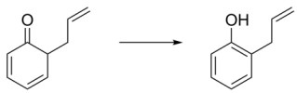 | 10 | 47 | 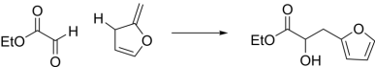 | 13
23 | 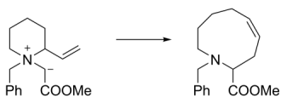 | 20 | 48 | 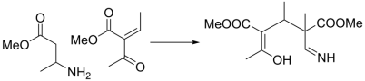 | 18
24 | 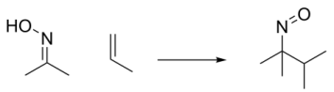 | 8 | 49 | 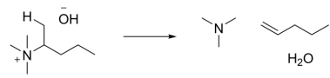 | 10
25 | 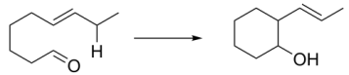 | 10 | 50 | 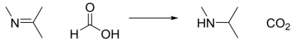 | 8

Supplementary Table 3. Summary of active learning procedure for building the MDCD20 dataset. For each MD/CD-AL iteration of active learning, the reported metrics include the dataset size, the lower and upper bound of model deviations ($σ_{lo}$ and $σ_{up}$).
Iteration | Dataset size | $σ_{lo}$ [eV/Å] | $σ_{up}$ [eV/Å] | Iteration | Dataset size | $σ_{lo}$ [eV/Å] | $σ_{up}$ [eV/Å]
1 | 574624 | 0.40 | 3.00 | 24 | 845375 | 0.10 | 0.60
2 | 600467 | 0.40 | 3.00 | 25 | 862445 | 0.10 | 0.60
3 | 614038 | 0.40 | 3.00 | 26 | 870445 | 0.10 | 0.60
4 | 628523 | 0.40 | 1.20 | 27 | 884437 | 0.10 | 0.60
5 | 642370 | 0.40 | 1.20 | 28 | 894430 | 0.10 | 0.60
6 | 656914 | 0.40 | 1.20 | 29 | 909389 | 0.10 | 0.60
7 | 669559 | 0.40 | 1.20 | 30 | 919360 | 0.10 | 0.60
8 | 683143 | 0.40 | 1.20 | 31 | 929332 | 0.10 | 0.60
9 | 697923 | 0.40 | 1.20 | 32 | 939304 | 0.10 | 0.60
10 | 711509 | 0.40 | 1.20 | 33 | 949627 | 0.10 | 0.60
11 | 725777 | 0.40 | 1.20 | 34 | 959355 | 0.10 | 0.60
12 | 740084 | 0.40 | 1.20 | 35 | 969186 | 0.10 | 0.60
13 | 754391 | 0.20 | 0.60 | 36 | 979147 | 0.10 | 0.60
14 | 763673 | 0.20 | 0.60 | 37 | 989033 | 0.10 | 0.60
15 | 777494 | 0.20 | 0.60 | 38 | 998990 | 0.10 | 0.60
16 | 789483 | 0.20 | 0.60 | 39 | 1008846 | 0.10 | 0.60
17 | 806258 | 0.20 | 0.60 | 40 | 1018797 | 0.10 | 0.60
18 | 770503 | 0.20 | 0.60 | 41 | 1028719 | 0.10 | 0.60
19 | 787278 | 0.20 | 0.60 | 42 | 1038640 | 0.10 | 0.60
20 | 796034 | 0.20 | 0.60 | 43 | 1048530 | 0.10 | 0.60
21 | 800795 | 0.20 | 0.60 | 44 | 1063452 | 0.10 | 0.60
22 | 810252 | 0.20 | 0.60 | 45 | 1073375 | 0.10 | 0.60
23 | 831117 | 0.10 | 0.60 | 46 | 1083317 | 0.10 | 0.60

Supplementary Table 4. Imaginary frequency (ImF); electronic energies (E); the total Gibbs free energies (G); relative electronic energies (ΔE) and relative Gibbs free energies (ΔG) for the lowest-energy conformers involved in the reaction network of vindoline cascade, obtained by the MDCD-NN-assisted MD/CD exploration.
Species | ImF [cm⁻¹] | E [Hartree] | G [Hartree] | ΔE [kcal/mol] | ΔG [kcal/mol]
N2 | 0 | -109.597733 | -109.610486 | - | -
A | 0 | -1835.336457 | -1834.799055 | 0.00 | 0.00
B1 | 0 | -1835.323251 | -1834.787579 | 8.29 | 7.20
B2 | 0 | -1835.334412 | -1834.794188 | 1.28 | 3.05
B3 | 0 | -1835.333730 | -1834.794120 | 1.71 | 3.10
B4 | 0 | -1835.325045 | -1834.787590 | 7.16 | 7.19
C1 | 0 | -1725.753244 | -1725.224821 | -9.11 | -22.75
C2 | 0 | -1725.755325 | -1725.225228 | -10.42 | -22.24
D1 | 0 | -1725.821969 | -1725.284765 | -52.24 | -60.36
D2 | 0 | -1725.799862 | -1725.263407 | -38.36 | -46.96
D3 | 0 | -1725.822077 | -1725.284621 | -52.30 | -60.27
D4 | 0 | -1725.799719 | -1725.263273 | -38.27 | -46.88
E1 | 0 | -1725.746245 | -1725.218918 | -4.72 | -19.04
E2 | 0 | -1725.757478 | -1725.230346 | -11.77 | -26.22
E3 | 0 | -1725.743841 | -1725.219553 | -3.21 | -19.44
E4 | 0 | -1725.753567 | -1725.229029 | -9.31 | -25.39
F1 | 0 | -1835.302830 | -1834.765055 | 21.10 | 21.34
F2 | 0 | -1835.282482 | -1834.747412 | 33.87 | 32.41
F3 | 0 | -1835.296729 | -1834.766607 | 24.93 | 20.36
F4 | 0 | -1835.280113 | -1834.747104 | 35.36 | 32.60
G1 | 0 | -1725.710429 | -1725.178347 | 17.76 | 6.41
G2 | 0 | -1725.708707 | -1725.177344 | 18.84 | 7.04
TS-A-B1 | 552i | -1835.267050 | -1834.732980 | 43.55 | 41.46
TS-A-B2 | 594i | -1835.268988 | -1834.735635 | 42.34 | 39.80
TS-A-B3 | 554i | -1835.268701 | -1834.734242 | 42.52 | 40.67
TS-A-B4 | 565i | -1835.268414 | -1834.734271 | 42.70 | 40.65
TS-B1-C1 | 593i | -1835.293212 | -1834.759303 | 27.14 | 24.94
TS-B2-C1 | 537i | -1835.294110 | -1834.762080 | 26.57 | 23.20
TS-B3-C2 | 552i | -1835.296550 | -1834.763864 | 25.04 | 22.08
TS-B4-C2 | 584i | -1835.294504 | -1834.760737 | 26.33 | 24.04
TS-C1-D1 | 321i | -1725.718037 | -1725.188619 | 12.98 | -0.03
TS-C1-D2 | 449i | -1725.709353 | -1725.175113 | 18.43 | 8.44
TS-C2-D3 | 313i | -1725.717499 | -1725.189758 | 13.32 | -0.75
TS-C2-D4 | 401i | -1725.709604 | -1725.175921 | 18.27 | 7.94
TS-C1-E1 | 463i | -1725.708455 | -1725.184207 | 18.99 | 2.74
TS-C1-E2 | 326i | -1725.723995 | -1725.192391 | 9.24 | -2.40
TS-C2-E3 | 515i | -1725.706374 | -1725.180653 | 20.30 | 4.97
TS-C2-E4 | 341i | -1725.724426 | -1725.190671 | 8.97 | -1.32
TS-A-F1 | 383i | -1835.264394 | -1834.730494 | 45.22 | 43.02
TS-A-F2 | 367i | -1835.258473 | -1834.719392 | 48.94 | 49.99
TS-A-F3 | 309i | -1835.263928 | -1834.730681 | 45.51 | 42.91
TS-A-F4 | 377i | -1835.257217 | -1834.718942 | 49.72 | 50.27
TS-F1-G1 | 577i | -1835.259334 | -1834.728434 | 48.40 | 44.32
TS-F2-G1 | 615i | -1835.255997 | -1834.718734 | 50.49 | 50.40
TS-F3-G2 | 569i | -1835.258006 | -1834.729690 | 49.23 | 43.53
TS-F4-G2 | 606i | -1835.248029 | -1834.717712 | 55.49 | 51.04

Supplementary Table 5. gCP(TZ)-ωB97X-D4/def2-TZVP recomputed imaginary frequency (ImF); electronic energies (E); the total Gibbs free energies (G); relative electronic energies (ΔE) and relative Gibbs free energies (ΔG) for the lowest-energy conformers involved in the MDCD-NN-calculated reaction network of vindoline cascade.
Species | ImF [cm⁻¹] | E [Hartree] | G [Hartree] | ΔE [kcal/mol] | ΔG [kcal/mol]
N2 | 0 | -109.599240 | -109.611985 | - | -
A | 0 | -1835.348970 | -1834.809571 | 0.00 | 0.00
B1 | 0 | -1835.335298 | -1834.795747 | 8.58 | 8.67
B2 | 0 | -1835.350832 | -1834.806705 | -1.17 | 1.80
B3 | 0 | -1835.348111 | -1834.804685 | 0.54 | 3.07
B4 | 0 | -1835.338468 | -1834.796457 | 6.59 | 8.23
C1 | 0 | -1725.769629 | -1725.237791 | -12.49 | -25.23
C2 | 0 | -1725.772104 | -1725.238697 | -14.04 | -25.80
D1 | 0 | -1725.835070 | -1725.294731 | -53.55 | -60.96
D2 | 0 | -1725.811575 | -1725.268848 | -38.81 | -44.72
D3 | 0 | -1725.835224 | -1725.293447 | -53.65 | -60.15
D4 | 0 | -1725.811565 | -1725.268816 | -38.80 | -44.70
E1 | 0 | -1725.757472 | -1725.226160 | -4.86 | -17.93
E2 | 0 | -1725.766370 | -1725.236418 | -10.44 | -24.37
E3 | 0 | -1725.751269 | -1725.224512 | -0.97 | -16.90
E4 | 0 | -1725.764485 | -1725.236324 | -9.26 | -24.31
F1 | 0 | -1835.323292 | -1834.782780 | 16.11 | 16.81
F2 | 0 | -1835.300702 | -1834.760516 | 30.29 | 30.78
F3 | 0 | -1835.320007 | -1834.780545 | 18.17 | 18.21
F4 | 0 | -1835.297860 | -1834.759793 | 32.07 | 31.24
G1 | 0 | -1725.722026 | -1725.189573 | 17.38 | 5.03
G2 | 0 | -1725.723700 | -1725.191561 | 16.33 | 3.78
TS-A-B1 | 551i | -1835.284446 | -1834.748274 | 40.49 | 38.46
TS-A-B2 | 577i | -1835.285122 | -1834.749296 | 40.07 | 37.82
TS-A-B3 | 569i | -1835.286985 | -1834.750997 | 38.90 | 36.76
TS-A-B4 | 551i | -1835.285248 | -1834.748797 | 39.99 | 38.14
TS-B1-C1 | 503i | -1835.311981 | -1834.775407 | 23.21 | 21.44
TS-B2-C1 | 365i | -1835.318086 | -1834.778978 | 19.38 | 19.20
TS-B3-C2 | 349i | -1835.317497 | -1834.781529 | 19.75 | 17.60
TS-B4-C2 | 504i | -1835.313903 | -1834.775452 | 22.00 | 21.41
TS-C1-D1 | 299i | -1725.733887 | -1725.198037 | 9.94 | -0.28
TS-C1-D2 | 434i | -1725.730321 | -1725.194026 | 12.18 | 2.23
TS-C2-D3 | 300i | -1725.733883 | -1725.198038 | 9.94 | -0.28
TS-C2-D4 | 451i | -1725.728552 | -1725.191567 | 13.29 | 3.78
TS-C1-E1 | 556i | -1725.715669 | -1725.188825 | 21.37 | 5.50
TS-C1-E2 | 426i | -1725.733148 | -1725.199429 | 10.41 | -1.16
TS-C2-E3 | 534i | -1725.718870 | -1725.187524 | 19.36 | 6.31
TS-C2-E4 | 423i | -1725.729699 | -1725.196474 | 12.57 | 0.70
TS-A-F1 | 515i | -1835.283615 | -1834.747563 | 41.01 | 38.91
TS-A-F2 | 336i | -1835.278850 | -1834.738030 | 44.00 | 44.89
TS-A-F3 | 508i | -1835.283410 | -1834.747901 | 41.14 | 38.70
TS-A-F4 | 309i | -1835.277089 | -1834.737151 | 45.11 | 45.44
TS-F1-G1 | 377i | -1835.283826 | -1834.749922 | 40.88 | 37.43
TS-F2-G1 | 526i | -1835.277176 | -1834.738347 | 45.05 | 44.69
TS-F3-G2 | 348i | -1835.283865 | -1834.751792 | 40.85 | 36.26
TS-F4-G2 | 528i | -1835.272033 | -1834.737063 | 48.28 | 45.50

Supplementary Table 6. Imaginary frequency (ImF); electronic energies (E); the total Gibbs free energies (G); relative electronic energies (ΔE) and relative Gibbs free energies (ΔG) for the lowest-energy conformers involved in the reaction network of endiandric acid cascade, obtained by the MDCD-NN-assisted MD/CD exploration.
Species | ImF [cm⁻¹] | E [Hartree] | G [Hartree] | ΔE [kcal/mol] | ΔG [kcal/mol]
A | 0 | -1042.047190 | -1041.698705 | 0.00 | 0.00
B1 | 0 | -1042.070212 | -1041.715051 | -14.45 | -10.26
B2 | 0 | -1042.070320 | -1041.714914 | -14.51 | -10.17
B3 | 0 | -1042.072168 | -1041.715230 | -15.67 | -10.37
B4 | 0 | -1042.070176 | -1041.715629 | -14.42 | -10.62
C1 | 0 | -1042.091207 | -1041.732362 | -27.62 | -21.12
C2 | 0 | -1042.088407 | -1041.732647 | -25.86 | -21.30
C3 | 0 | -1042.091404 | -1041.732616 | -27.74 | -21.28
C4 | 0 | -1042.091242 | -1041.732530 | -27.64 | -21.23
C5 | 0 | -1042.085662 | -1041.730074 | -24.14 | -19.68
C6 | 0 | -1042.085698 | -1041.728071 | -24.16 | -18.43
C7 | 0 | -1042.087026 | -1041.730721 | -25.00 | -20.09
C8 | 0 | -1042.085805 | -1041.728300 | -24.23 | -18.57
D1 | 0 | -1042.056198 | -1041.687987 | -5.65 | 6.73
D2 | 0 | -1042.084783 | -1041.715397 | -23.59 | -10.47
D3 | 0 | -1042.130558 | -1041.761922 | -52.31 | -39.67
D4 | 0 | -1042.129678 | -1041.761339 | -51.76 | -39.30
D5 | 0 | -1042.055659 | -1041.687305 | -5.31 | 7.15
D6 | 0 | -1042.083921 | -1041.715102 | -23.05 | -10.29
D7 | 0 | -1042.130414 | -1041.761814 | -52.22 | -39.60
D8 | 0 | -1042.129535 | -1041.761296 | -51.67 | -39.28
D9 | 0 | -1042.053219 | -1041.685498 | -3.78 | 8.29
D10 | 0 | -1042.082378 | -1041.713540 | -22.08 | -9.31
D11 | 0 | -1042.129320 | -1041.759974 | -51.54 | -38.45
D12 | 0 | -1042.126233 | -1041.756670 | -49.60 | -36.37
D13 | 0 | -1042.053739 | -1041.686161 | -4.11 | 7.87
D14 | 0 | -1042.083006 | -1041.713851 | -22.48 | -9.50
D15 | 0 | -1042.129625 | -1041.760375 | -51.73 | -38.70
D16 | 0 | -1042.126377 | -1041.756717 | -49.69 | -36.40
E1 | 0 | -1042.133070 | -1041.767008 | -53.89 | -42.86
E2 | 0 | -1042.129966 | -1041.763460 | -51.94 | -40.63
E3 | 0 | -1042.133429 | -1041.767375 | -54.12 | -43.09
E4 | 0 | -1042.130450 | -1041.763883 | -52.25 | -40.90
E5 | 0 | -1042.127615 | -1041.761404 | -50.47 | -39.34
E6 | 0 | -1042.121191 | -1041.754238 | -46.44 | -34.85
E7 | 0 | -1042.121352 | -1041.754442 | -46.54 | -34.98
E8 | 0 | -1042.127741 | -1041.761695 | -50.55 | -39.53
F1 | 0 | -1042.127615 | -1041.756231 | -50.47 | -36.10
F2 | 0 | -1042.130199 | -1041.757987 | -52.09 | -37.20
F3 | 0 | -1042.134577 | -1041.762685 | -54.84 | -40.15
F4 | 0 | -1042.131975 | -1041.759749 | -53.20 | -38.31
F5 | 0 | -1042.127956 | -1041.756849 | -50.68 | -36.49
F6 | 0 | -1042.127041 | -1041.753853 | -50.11 | -34.61
F7 | 0 | -1042.126431 | -1041.754140 | -49.72 | -34.79
F8 | 0 | -1042.132926 | -1041.761162 | -53.80 | -39.19
F9 | 0 | -1042.134541 | -1041.762713 | -54.81 | -40.17
F10 | 0 | -1042.131939 | -1041.759737 | -53.18 | -38.30
F11 | 0 | -1042.127723 | -1041.756291 | -50.54 | -36.14
F12 | 0 | -1042.130145 | -1041.757893 | -52.06 | -37.14
F13 | 0 | -1042.126556 | -1041.754282 | -49.80 | -34.88
F14 | 0 | -1042.132962 | -1041.761215 | -53.82 | -39.23
F15 | 0 | -1042.127884 | -1041.756827 | -50.64 | -36.47
F16 | 0 | -1042.126933 | -1041.753707 | -50.04 | -34.51
F17 | 0 | -1042.128207 | -1041.756656 | -50.84 | -36.36
F18 | 0 | -1042.131886 | -1041.759656 | -53.15 | -38.25
F19 | 0 | -1042.134775 | -1041.762771 | -54.96 | -40.20
F20 | 0 | -1042.130307 | -1041.758126 | -52.16 | -37.29
F21 | 0 | -1042.128602 | -1041.757244 | -51.09 | -36.73
F22 | 0 | -1042.132837 | -1041.761129 | -53.74 | -39.17
F23 | 0 | -1042.126610 | -1041.754252 | -49.84 | -34.86
F24 | 0 | -1042.127130 | -1041.754003 | -50.16 | -34.70
F25 | 0 | -1042.131850 | -1041.759635 | -53.12 | -38.23
F26 | 0 | -1042.130342 | -1041.758109 | -52.18 | -37.28
F27 | 0 | -1042.134685 | -1041.762738 | -54.90 | -40.18
F28 | 0 | -1042.128315 | -1041.756747 | -50.91 | -36.42
F29 | 0 | -1042.132801 | -1041.761103 | -53.72 | -39.16
F30 | 0 | -1042.127095 | -1041.753930 | -50.14 | -34.65
F31 | 0 | -1042.126682 | -1041.754374 | -49.88 | -34.93
F32 | 0 | -1042.128494 | -1041.757189 | -51.02 | -36.70
F33 | 0 | -1042.144123 | -1041.772373 | -60.83 | -46.23
F34 | 0 | -1042.145451 | -1041.774046 | -61.66 | -47.28
F35 | 0 | -1042.143836 | -1041.773484 | -60.65 | -46.92
F36 | 0 | -1042.143908 | -1041.772181 | -60.69 | -46.11
F37 | 0 | -1042.144590 | -1041.773273 | -61.12 | -46.79
F38 | 0 | -1042.137466 | -1041.766392 | -56.65 | -42.47
F39 | 0 | -1042.137699 | -1041.767028 | -56.80 | -42.87
F40 | 0 | -1042.144267 | -1041.773020 | -60.92 | -46.63
F41 | 0 | -1042.142831 | -1041.770267 | -60.02 | -44.91
F42 | 0 | -1042.143513 | -1041.771258 | -60.44 | -45.53
F43 | 0 | -1042.143190 | -1041.771985 | -60.24 | -45.98
F44 | 0 | -1042.141916 | -1041.769278 | -59.44 | -44.29
F45 | 0 | -1042.143029 | -1041.769982 | -60.14 | -44.73
F46 | 0 | -1042.133806 | -1041.761547 | -54.35 | -39.43
F47 | 0 | -1042.137179 | -1041.765726 | -56.47 | -42.06
F48 | 0 | -1042.142401 | -1041.770412 | -59.75 | -45.00
F49 | 0 | -1042.143998 | -1041.772328 | -60.75 | -46.20
F50 | 0 | -1042.145882 | -1041.774397 | -61.93 | -47.50
F51 | 0 | -1042.143998 | -1041.772172 | -60.75 | -46.10
F52 | 0 | -1042.143693 | -1041.773616 | -60.56 | -47.01
F53 | 0 | -1042.144518 | -1041.773180 | -61.07 | -46.73
F54 | 0 | -1042.137448 | -1041.766276 | -56.64 | -42.40
F55 | 0 | -1042.144393 | -1041.773145 | -61.00 | -46.71
F56 | 0 | -1042.137771 | -1041.767131 | -56.84 | -42.94
F57 | 0 | -1042.142042 | -1041.769424 | -59.52 | -44.38
F58 | 0 | -1042.142885 | -1041.772057 | -60.05 | -46.03
F59 | 0 | -1042.142742 | -1041.770098 | -59.96 | -44.80
F60 | 0 | -1042.143890 | -1041.771606 | -60.68 | -45.75
F61 | 0 | -1042.142419 | -1041.770626 | -59.76 | -45.13
F62 | 0 | -1042.137018 | -1041.765688 | -56.37 | -42.03
F63 | 0 | -1042.142903 | -1041.769849 | -60.06 | -44.64
F64 | 0 | -1042.133698 | -1041.761294 | -54.28 | -39.28
TS-A-B1 | 947i | -1042.009687 | -1041.661107 | 23.53 | 23.59
TS-A-B2 | 910i | -1042.010566 | -1041.661927 | 22.98 | 23.08
TS-A-B3 | 933i | -1042.005380 | -1041.657032 | 26.24 | 26.15
TS-A-B4 | 909i | -1042.004788 | -1041.655258 | 26.61 | 27.26
TS-B1-C1 | 827i | -1042.021422 | -1041.669073 | 16.17 | 18.59
TS-B1-C2 | 827i | -1042.021368 | -1041.669049 | 16.20 | 18.61
TS-B2-C3 | 833i | -1042.019628 | -1041.668135 | 17.30 | 19.18
TS-B2-C4 | 827i | -1042.021135 | -1041.669066 | 16.35 | 18.60
TS-B3-C5 | 825i | -1042.019036 | -1041.663718 | 17.67 | 21.95
TS-B3-C6 | 831i | -1042.015339 | -1041.661684 | 19.99 | 23.23
TS-B4-C7 | 830i | -1042.018372 | -1041.666169 | 18.08 | 20.42
TS-B4-C8 | 827i | -1042.015160 | -1041.661199 | 20.10 | 23.54
TS-C1-D1 | 467i | -1041.985498 | -1041.623638 | 38.71 | 47.11
TS-C1-D2 | 913i | -1041.981623 | -1041.617540 | 41.14 | 50.93
TS-C2-D3 | 1015i | -1042.035239 | -1041.679955 | 7.50 | 11.77
TS-C2-D4 | 1014i | -1042.042184 | -1041.686972 | 3.14 | 7.36
TS-C3-D5 | 467i | -1041.985839 | -1041.622634 | 38.50 | 47.74
TS-C3-D6 | 918i | -1041.980797 | -1041.617292 | 41.66 | 51.09
TS-C4-D7 | 1002i | -1042.035670 | -1041.679907 | 7.23 | 11.80
TS-C4-D8 | 1009i | -1042.041502 | -1041.686410 | 3.57 | 7.72
TS-C5-D9 | 469i | -1041.984045 | -1041.621606 | 39.62 | 48.38
TS-C5-D10 | 916i | -1041.979792 | -1041.616085 | 42.29 | 51.84
TS-C6-D11 | 1001i | -1042.028833 | -1041.672109 | 11.52 | 16.69
TS-C6-D12 | 992i | -1042.038021 | -1041.680576 | 5.75 | 11.38
TS-C7-D13 | 470i | -1041.984386 | -1041.622588 | 39.41 | 47.76
TS-C7-D14 | 772i | -1041.975037 | -1041.609018 | 45.28 | 56.28
TS-C8-D15 | 1019i | -1042.028743 | -1041.671971 | 11.58 | 16.78
TS-C8-D16 | 1006i | -1042.038397 | -1041.680924 | 5.52 | 11.16
TS-C1-E1 | 723i | -1042.035419 | -1041.673692 | 7.39 | 15.70
TS-C1-E2 | 712i | -1042.027236 | -1041.665190 | 12.52 | 21.03
TS-C3-E3 | 735i | -1042.035149 | -1041.673334 | 7.56 | 15.92
TS-C3-E4 | 715i | -1042.026034 | -1041.659956 | 13.28 | 24.32
TS-C6-E5 | 721i | -1042.028313 | -1041.665201 | 11.85 | 21.02
TS-C6-E6 | 721i | -1042.013455 | -1041.651156 | 21.17 | 29.84
TS-C8-E7 | 736i | -1042.000876 | -1041.637745 | 29.06 | 38.25
TS-C8-E8 | 735i | -1042.027631 | -1041.665004 | 12.27 | 21.15
TS-C1-F1 | 801i | -1042.024742 | -1041.658893 | 14.09 | 24.98
TS-C1-F2 | 769i | -1042.028869 | -1041.662313 | 11.50 | 22.84
TS-C1-F3 | 779i | -1042.027200 | -1041.660210 | 12.54 | 24.16
TS-C1-F4 | 781i | -1042.026859 | -1041.661134 | 12.76 | 23.58
TS-C1-F5 | 818i | -1042.024096 | -1041.656929 | 14.49 | 26.21
TS-C1-F6 | 796i | -1042.025370 | -1041.658796 | 13.69 | 25.04
TS-C1-F7 | 800i | -1042.022266 | -1041.655320 | 15.64 | 27.22
TS-C1-F8 | 805i | -1042.027685 | -1041.661533 | 12.24 | 23.33
TS-C2-F9 | 780i | -1042.027326 | -1041.660343 | 12.46 | 24.07
TS-C2-F10 | 781i | -1042.026859 | -1041.661135 | 12.76 | 23.58
TS-C2-F11 | 801i | -1042.024957 | -1041.659115 | 13.95 | 24.84
TS-C2-F12 | 768i | -1042.028977 | -1041.662393 | 11.43 | 22.79
TS-C2-F13 | 800i | -1042.022409 | -1041.655453 | 15.55 | 27.14
TS-C2-F14 | 804i | -1042.027757 | -1041.661589 | 12.19 | 23.29
TS-C2-F15 | 817i | -1042.024257 | -1041.657121 | 14.39 | 26.09
TS-C2-F16 | 796i | -1042.025496 | -1041.658922 | 13.61 | 24.96
TS-C3-F17 | 804i | -1042.025334 | -1041.659089 | 13.71 | 24.86
TS-C3-F18 | 783i | -1042.026662 | -1041.661083 | 12.88 | 23.61
TS-C3-F19 | 780i | -1042.027846 | -1041.660826 | 12.14 | 23.77
TS-C3-F20 | 769i | -1042.028600 | -1041.662086 | 11.67 | 22.98
TS-C3-F21 | 820i | -1042.024742 | -1041.657621 | 14.09 | 25.78
TS-C3-F22 | 808i | -1042.027434 | -1041.661227 | 12.40 | 23.52
TS-C3-F23 | 799i | -1042.023127 | -1041.656043 | 15.10 | 26.77
TS-C3-F24 | 795i | -1042.025011 | -1041.658461 | 13.92 | 25.25
TS-C4-F25 | 783i | -1042.026734 | -1041.661153 | 12.84 | 23.56
TS-C4-F26 | 769i | -1042.028690 | -1041.662148 | 11.61 | 22.94
TS-C4-F27 | 780i | -1042.027900 | -1041.660836 | 12.10 | 23.76
TS-C4-F28 | 803i | -1042.025478 | -1041.659276 | 13.62 | 24.74
TS-C4-F29 | 808i | -1042.027559 | -1041.661341 | 12.32 | 23.45
TS-C4-F30 | 796i | -1042.025155 | -1041.658592 | 13.83 | 25.17
TS-C4-F31 | 799i | -1042.023271 | -1041.656120 | 15.01 | 26.72
TS-C4-F32 | 820i | -1042.024885 | -1041.657753 | 14.00 | 25.70
TS-C5-F33 | 763i | -1042.032637 | -1041.667677 | 9.13 | 19.47
TS-C5-F34 | 734i | -1042.036890 | -1041.670660 | 6.46 | 17.60
TS-C5-F35 | 751i | -1042.034737 | -1041.668398 | 7.81 | 19.02
TS-C5-F36 | 752i | -1042.033212 | -1041.667834 | 8.77 | 19.37
TS-C5-F37 | 772i | -1042.031614 | -1041.665907 | 9.77 | 20.58
TS-C5-F38 | 741i | -1042.032117 | -1041.665991 | 9.46 | 20.53
TS-C5-F39 | 777i | -1042.032494 | -1041.666846 | 9.22 | 19.99
TS-C5-F40 | 765i | -1042.032817 | -1041.667007 | 9.02 | 19.89
TS-C6-F41 | 765i | -1042.030646 | -1041.664715 | 10.38 | 21.33
TS-C6-F42 | 734i | -1042.035167 | -1041.667974 | 7.54 | 19.28
TS-C6-F43 | 752i | -1042.033194 | -1041.666172 | 8.78 | 20.41
TS-C6-F44 | 759i | -1042.030412 | -1041.664330 | 10.53 | 21.57
TS-C6-F45 | 775i | -1042.029587 | -1041.662918 | 11.05 | 22.46
TS-C6-F46 | 743i | -1042.030305 | -1041.663251 | 10.60 | 22.25
TS-C6-F47 | 780i | -1042.030861 | -1041.664635 | 10.25 | 21.38
TS-C6-F48 | 757i | -1042.031381 | -1041.664960 | 9.92 | 21.18
TS-C7-F49 | 753i | -1042.032637 | -1041.667480 | 9.13 | 19.59
TS-C7-F50 | 740i | -1042.036872 | -1041.670859 | 6.47 | 17.47
TS-C7-F51 | 762i | -1042.033140 | -1041.668085 | 8.82 | 19.21
TS-C7-F52 | 742i | -1042.034037 | -1041.668167 | 8.25 | 19.16
TS-C7-F53 | 765i | -1042.031758 | -1041.666219 | 9.68 | 20.39
TS-C7-F54 | 750i | -1042.032476 | -1041.666285 | 9.23 | 20.34
TS-C7-F55 | 774i | -1042.032637 | -1041.666800 | 9.13 | 20.02
TS-C7-F56 | 780i | -1042.032009 | -1041.666229 | 9.53 | 20.38
TS-C8-F57 | 775i | -1042.028708 | -1041.662470 | 11.60 | 22.74
TS-C8-F58 | 755i | -1042.032942 | -1041.665771 | 8.94 | 20.67
TS-C8-F59 | 756i | -1042.030610 | -1041.664481 | 10.40 | 21.48
TS-C8-F60 | 740i | -1042.035185 | -1041.668213 | 7.53 | 19.13
TS-C8-F61 | 776i | -1042.029982 | -1041.664066 | 10.80 | 21.74
TS-C8-F62 | 783i | -1042.030412 | -1041.663969 | 10.53 | 21.80
TS-C8-F63 | 769i | -1042.029641 | -1041.663145 | 11.01 | 22.31
TS-C8-F64 | 751i | -1042.030771 | -1041.663612 | 10.30 | 22.02

Supplementary Table 7. gCP(TZ)-ωB97X-D4/def2-TZVP recomputed imaginary frequency (ImF); electronic energies (E); the total Gibbs free energies (G); relative electronic energies (ΔE) and relative Gibbs free energies (ΔG) for the lowest-energy conformers involved in the MDCD-NN-calculated reaction network of endiandric acid cascade.
Species | ImF [cm⁻¹] | E [Hartree] | G [Hartree] | ΔE [kcal/mol] | ΔG [kcal/mol]
A | 0 | -1042.049937 | -1041.700940 | 0.00 | 0.00
B1 | 0 | -1042.082010 | -1041.726145 | -20.13 | -15.82
B2 | 0 | -1042.082016 | -1041.726030 | -20.13 | -15.74
B3 | 0 | -1042.083211 | -1041.725488 | -20.88 | -15.40
B4 | 0 | -1042.081042 | -1041.725693 | -19.52 | -15.53
C1 | 0 | -1042.094938 | -1041.735639 | -28.24 | -21.77
C2 | 0 | -1042.092133 | -1041.735633 | -26.48 | -21.77
C3 | 0 | -1042.094941 | -1041.735606 | -28.24 | -21.75
C4 | 0 | -1042.094552 | -1041.735345 | -28.00 | -21.59
C5 | 0 | -1042.089711 | -1041.733355 | -24.96 | -20.34
C6 | 0 | -1042.087930 | -1041.730057 | -23.84 | -18.27
C7 | 0 | -1042.090237 | -1041.733420 | -25.29 | -20.38
C8 | 0 | -1042.087934 | -1041.730115 | -23.84 | -18.31
D1 | 0 | -1042.067975 | -1041.698064 | -11.32 | 1.80
D2 | 0 | -1042.095625 | -1041.725363 | -28.67 | -15.33
D3 | 0 | -1042.139124 | -1041.769190 | -55.97 | -42.83
D4 | 0 | -1042.137900 | -1041.768591 | -55.20 | -42.45
D5 | 0 | -1042.067977 | -1041.698093 | -11.32 | 1.79
D6 | 0 | -1042.095511 | -1041.725673 | -28.60 | -15.52
D7 | 0 | -1042.139078 | -1041.769156 | -55.94 | -42.81
D8 | 0 | -1042.137899 | -1041.768639 | -55.20 | -42.48
D9 | 0 | -1042.064833 | -1041.695235 | -9.35 | 3.58
D10 | 0 | -1042.092782 | -1041.722790 | -26.89 | -13.71
D11 | 0 | -1042.138003 | -1041.767344 | -55.26 | -41.67
D12 | 0 | -1042.133909 | -1041.763679 | -52.69 | -39.37
D13 | 0 | -1042.064835 | -1041.695221 | -9.35 | 3.59
D14 | 0 | -1042.092637 | -1041.722520 | -26.80 | -13.54
D15 | 0 | -1042.138430 | -1041.767909 | -55.53 | -42.02
D16 | 0 | -1042.133911 | -1041.763676 | -52.69 | -39.37
E1 | 0 | -1042.141135 | -1041.773798 | -57.23 | -45.72
E2 | 0 | -1042.137747 | -1041.769658 | -55.10 | -43.12
E3 | 0 | -1042.141130 | -1041.773900 | -57.22 | -45.78
E4 | 0 | -1042.137746 | -1041.769668 | -55.10 | -43.13
E5 | 0 | -1042.135863 | -1041.768218 | -53.92 | -42.22
E6 | 0 | -1042.129238 | -1041.760723 | -49.76 | -37.51
E7 | 0 | -1042.129220 | -1041.760921 | -49.75 | -37.64
E8 | 0 | -1042.135850 | -1041.768465 | -53.91 | -42.37
F1 | 0 | -1042.132137 | -1041.759702 | -51.58 | -36.87
F2 | 0 | -1042.135032 | -1041.762287 | -53.40 | -38.50
F3 | 0 | -1042.139350 | -1041.766676 | -56.11 | -41.25
F4 | 0 | -1042.136408 | -1041.763742 | -54.26 | -39.41
F5 | 0 | -1042.132283 | -1041.760033 | -51.67 | -37.08
F6 | 0 | -1042.131094 | -1041.757427 | -50.93 | -35.45
F7 | 0 | -1042.131104 | -1041.757749 | -50.93 | -35.65
F8 | 0 | -1042.136994 | -1041.764543 | -54.63 | -39.91
F9 | 0 | -1042.139118 | -1041.766588 | -55.96 | -41.19
F10 | 0 | -1042.136117 | -1041.763500 | -54.08 | -39.26
F11 | 0 | -1042.132437 | -1041.759989 | -51.77 | -37.05
F12 | 0 | -1042.134667 | -1041.761962 | -53.17 | -38.29
F13 | 0 | -1042.131244 | -1041.757845 | -51.02 | -35.71
F14 | 0 | -1042.137184 | -1041.764708 | -54.75 | -40.02
F15 | 0 | -1042.132048 | -1041.759826 | -51.53 | -36.95
F16 | 0 | -1042.130286 | -1041.756691 | -50.42 | -34.98
F17 | 0 | -1042.132134 | -1041.759708 | -51.58 | -36.88
F18 | 0 | -1042.136407 | -1041.763749 | -54.26 | -39.41
F19 | 0 | -1042.139347 | -1041.766688 | -56.11 | -41.26
F20 | 0 | -1042.135039 | -1041.762306 | -53.40 | -38.51
F21 | 0 | -1042.132288 | -1041.760022 | -51.68 | -37.07
F22 | 0 | -1042.136995 | -1041.764536 | -54.63 | -39.91
F23 | 0 | -1042.131109 | -1041.757748 | -50.94 | -35.65
F24 | 0 | -1042.131093 | -1041.757435 | -50.93 | -35.45
F25 | 0 | -1042.136122 | -1041.763501 | -54.08 | -39.26
F26 | 0 | -1042.134666 | -1041.761950 | -53.17 | -38.28
F27 | 0 | -1042.139126 | -1041.766591 | -55.97 | -41.20
F28 | 0 | -1042.132446 | -1041.759983 | -51.78 | -37.05
F29 | 0 | -1042.137191 | -1041.764705 | -54.75 | -40.01
F30 | 0 | -1042.130289 | -1041.756684 | -50.42 | -34.98
F31 | 0 | -1042.131241 | -1041.757856 | -51.02 | -35.72
F32 | 0 | -1042.132052 | -1041.759823 | -51.53 | -36.95
F33 | 0 | -1042.148049 | -1041.775649 | -61.57 | -46.88
F34 | 0 | -1042.148647 | -1041.776342 | -61.94 | -47.32
F35 | 0 | -1042.147986 | -1041.776534 | -61.53 | -47.44
F36 | 0 | -1042.147801 | -1041.775353 | -61.41 | -46.69
F37 | 0 | -1042.147732 | -1041.775520 | -61.37 | -46.80
F38 | 0 | -1042.140954 | -1041.768224 | -57.11 | -42.22
F39 | 0 | -1042.141701 | -1041.769450 | -57.58 | -42.99
F40 | 0 | -1042.147825 | -1041.775624 | -61.43 | -46.86
F41 | 0 | -1042.146733 | -1041.773140 | -60.74 | -45.31
F42 | 0 | -1042.145857 | -1041.772716 | -60.19 | -45.04
F43 | 0 | -1042.146431 | -1041.774158 | -60.55 | -45.94
F44 | 0 | -1042.144986 | -1041.771738 | -59.64 | -44.43
F45 | 0 | -1042.145879 | -1041.772486 | -60.20 | -44.90
F46 | 0 | -1042.135687 | -1041.762012 | -53.81 | -38.32
F47 | 0 | -1042.140176 | -1041.767187 | -56.63 | -41.57
F48 | 0 | -1042.144496 | -1041.771677 | -59.34 | -44.39
F49 | 0 | -1042.148049 | -1041.775647 | -61.57 | -46.88
F50 | 0 | -1042.148641 | -1041.776337 | -61.94 | -47.31
F51 | 0 | -1042.147805 | -1041.775359 | -61.41 | -46.70
F52 | 0 | -1042.147984 | -1041.776518 | -61.53 | -47.43
F53 | 0 | -1042.147727 | -1041.775525 | -61.36 | -46.80
F54 | 0 | -1042.140957 | -1041.768234 | -57.12 | -42.23
F55 | 0 | -1042.147820 | -1041.775611 | -61.42 | -46.86
F56 | 0 | -1042.141702 | -1041.769450 | -57.58 | -42.99
F57 | 0 | -1042.144990 | -1041.771739 | -59.65 | -44.43
F58 | 0 | -1042.146434 | -1041.774162 | -60.55 | -45.95
F59 | 0 | -1042.146739 | -1041.773145 | -60.74 | -45.31
F60 | 0 | -1042.145857 | -1041.772696 | -60.19 | -45.03
F61 | 0 | -1042.144486 | -1041.771673 | -59.33 | -44.39
F62 | 0 | -1042.140176 | -1041.767171 | -56.63 | -41.56
F63 | 0 | -1042.145881 | -1041.772468 | -60.21 | -44.88
F64 | 0 | -1042.135689 | -1041.762020 | -53.81 | -38.33
TS-A-B1 | 523i | -1042.034983 | -1041.682676 | 9.38 | 11.46
TS-A-B2 | 517i | -1042.034631 | -1041.682665 | 9.60 | 11.47
TS-A-B3 | 525i | -1042.029138 | -1041.677246 | 13.05 | 14.87
TS-A-B4 | 530i | -1042.029095 | -1041.676820 | 13.08 | 15.14
TS-B1-C1 | 622i | -1042.042900 | -1041.688579 | 4.42 | 7.76
TS-B1-C2 | 622i | -1042.042795 | -1041.688639 | 4.48 | 7.72
TS-B2-C3 | 624i | -1042.041500 | -1041.687356 | 5.29 | 8.52
TS-B2-C4 | 622i | -1042.042798 | -1041.688703 | 4.48 | 7.68
TS-B3-C5 | 632i | -1042.039337 | -1041.681393 | 6.65 | 12.27
TS-B3-C6 | 643i | -1042.034212 | -1041.679113 | 9.87 | 13.70
TS-B4-C7 | 633i | -1042.039067 | -1041.684222 | 6.82 | 10.49
TS-B4-C8 | 640i | -1042.033283 | -1041.677864 | 10.45 | 14.48
TS-C1-D1 | 642i | -1041.996436 | -1041.631455 | 33.57 | 43.60
TS-C1-D2 | 687i | -1042.007428 | -1041.642822 | 26.67 | 36.47
TS-C2-D3 | 544i | -1042.051410 | -1041.687225 | -0.92 | 8.61
TS-C2-D4 | 531i | -1042.051963 | -1041.687827 | -1.27 | 8.23
TS-C3-D5 | 642i | -1041.996150 | -1041.630683 | 33.75 | 44.09
TS-C3-D6 | 687i | -1042.007519 | -1041.643306 | 26.62 | 36.17
TS-C4-D7 | 545i | -1042.051258 | -1041.687065 | -0.83 | 8.71
TS-C4-D8 | 531i | -1042.051964 | -1041.687861 | -1.27 | 8.21
TS-C5-D9 | 643i | -1041.993611 | -1041.628676 | 35.35 | 45.35
TS-C5-D10 | 686i | -1042.004592 | -1041.640075 | 28.45 | 38.19
TS-C6-D11 | 538i | -1042.042750 | -1041.677881 | 4.51 | 14.47
TS-C6-D12 | 522i | -1042.046322 | -1041.681328 | 2.27 | 12.31
TS-C7-D13 | 643i | -1041.994520 | -1041.629540 | 34.77 | 44.80
TS-C7-D14 | 652i | -1041.996690 | -1041.628835 | 33.41 | 45.25
TS-C8-D15 | 537i | -1042.042740 | -1041.677880 | 4.52 | 14.47
TS-C8-D16 | 522i | -1042.046322 | -1041.681307 | 2.27 | 12.32
TS-C1-E1 | 575i | -1042.053307 | -1041.690962 | -2.11 | 6.26
TS-C1-E2 | 591i | -1042.041091 | -1041.678532 | 5.55 | 14.06
TS-C3-E3 | 575i | -1042.053293 | -1041.690944 | -2.11 | 6.27
TS-C3-E4 | 590i | -1042.041045 | -1041.675007 | 5.58 | 16.27
TS-C6-E5 | 568i | -1042.046300 | -1041.683420 | 2.28 | 10.99
TS-C6-E6 | 602i | -1042.028061 | -1041.665140 | 13.73 | 22.46
TS-C8-E7 | 602i | -1042.023290 | -1041.658164 | 16.72 | 26.84
TS-C8-E8 | 569i | -1042.046295 | -1041.683325 | 2.29 | 11.05
TS-C1-F1 | 601i | -1042.044857 | -1041.678405 | 3.19 | 14.14
TS-C1-F2 | 592i | -1042.047842 | -1041.680887 | 1.31 | 12.58
TS-C1-F3 | 607i | -1042.046037 | -1041.679286 | 2.45 | 13.59
TS-C1-F4 | 589i | -1042.046803 | -1041.680386 | 1.97 | 12.90
TS-C1-F5 | 639i | -1042.042062 | -1041.675110 | 4.94 | 16.21
TS-C1-F6 | 597i | -1042.045004 | -1041.677395 | 3.10 | 14.77
TS-C1-F7 | 611i | -1042.042056 | -1041.674609 | 4.95 | 16.52
TS-C1-F8 | 625i | -1042.044730 | -1041.678144 | 3.27 | 14.30
TS-C2-F9 | 606i | -1042.046410 | -1041.679610 | 2.21 | 13.38
TS-C2-F10 | 590i | -1042.046629 | -1041.680238 | 2.08 | 12.99
TS-C2-F11 | 601i | -1042.045196 | -1041.678715 | 2.98 | 13.95
TS-C2-F12 | 593i | -1042.047585 | -1041.680636 | 1.48 | 12.74
TS-C2-F13 | 610i | -1042.042014 | -1041.674539 | 4.97 | 16.57
TS-C2-F14 | 625i | -1042.045032 | -1041.678435 | 3.08 | 14.12
TS-C2-F15 | 639i | -1042.041928 | -1041.674963 | 5.03 | 16.30
TS-C2-F16 | 600i | -1042.045052 | -1041.677490 | 3.07 | 14.72
TS-C3-F17 | 601i | -1042.044867 | -1041.678403 | 3.18 | 14.14
TS-C3-F18 | 589i | -1042.046806 | -1041.680395 | 1.96 | 12.89
TS-C3-F19 | 606i | -1042.046037 | -1041.679285 | 2.45 | 13.59
TS-C3-F20 | 592i | -1042.047840 | -1041.680886 | 1.32 | 12.58
TS-C3-F21 | 639i | -1042.042057 | -1041.675110 | 4.94 | 16.21
TS-C3-F22 | 625i | -1042.044727 | -1041.678150 | 3.27 | 14.30
TS-C3-F23 | 611i | -1042.042054 | -1041.674617 | 4.95 | 16.52
TS-C3-F24 | 597i | -1042.045004 | -1041.677395 | 3.10 | 14.77
TS-C4-F25 | 590i | -1042.046618 | -1041.680239 | 2.08 | 12.99
TS-C4-F26 | 593i | -1042.047592 | -1041.680642 | 1.47 | 12.74
TS-C4-F27 | 606i | -1042.046408 | -1041.679609 | 2.21 | 13.39
TS-C4-F28 | 601i | -1042.045200 | -1041.678705 | 2.97 | 13.95
TS-C4-F29 | 625i | -1042.045026 | -1041.678436 | 3.08 | 14.12
TS-C4-F30 | 600i | -1042.045044 | -1041.677465 | 3.07 | 14.73
TS-C4-F31 | 610i | -1042.042019 | -1041.674536 | 4.97 | 16.57
TS-C4-F32 | 639i | -1042.041925 | -1041.674974 | 5.03 | 16.29
TS-C5-F33 | 522i | -1042.053004 | -1041.686711 | -1.92 | 8.93
TS-C5-F34 | 517i | -1042.054983 | -1041.688062 | -3.17 | 8.08
TS-C5-F35 | 576i | -1042.050670 | -1041.684046 | -0.46 | 10.60
TS-C5-F36 | 530i | -1042.053061 | -1041.686833 | -1.96 | 8.85
TS-C5-F37 | 569i | -1042.048960 | -1041.682094 | 0.61 | 11.83
TS-C5-F38 | 508i | -1042.051199 | -1041.683254 | -0.79 | 11.10
TS-C5-F39 | 581i | -1042.049330 | -1041.682787 | 0.38 | 11.39
TS-C5-F40 | 572i | -1042.050450 | -1041.683489 | -0.32 | 10.95
TS-C6-F41 | 514i | -1042.050007 | -1041.682944 | -0.04 | 11.29
TS-C6-F42 | 509i | -1042.052185 | -1041.684457 | -1.41 | 10.34
TS-C6-F43 | 571i | -1042.049219 | -1041.681749 | 0.45 | 12.04
TS-C6-F44 | 574i | -1042.046389 | -1041.679415 | 2.23 | 13.51
TS-C6-F45 | 561i | -1042.046348 | -1041.678652 | 2.25 | 13.99
TS-C6-F46 | 499i | -1042.048926 | -1041.680105 | 0.63 | 13.07
TS-C6-F47 | 575i | -1042.047757 | -1041.680380 | 1.37 | 12.90
TS-C6-F48 | 523i | -1042.050854 | -1041.683729 | -0.58 | 10.80
TS-C7-F49 | 522i | -1042.053004 | -1041.686720 | -1.92 | 8.92
TS-C7-F50 | 517i | -1042.054980 | -1041.688069 | -3.16 | 8.08
TS-C7-F51 | 529i | -1042.053064 | -1041.686831 | -1.96 | 8.85
TS-C7-F52 | 545i | -1042.051619 | -1041.684876 | -1.06 | 10.08
TS-C7-F53 | 569i | -1042.048961 | -1041.682089 | 0.61 | 11.83
TS-C7-F54 | 508i | -1042.051202 | -1041.683257 | -0.79 | 11.10
TS-C7-F55 | 572i | -1042.050454 | -1041.683495 | -0.32 | 10.95
TS-C7-F56 | 581i | -1042.049330 | -1041.682787 | 0.38 | 11.39
TS-C8-F57 | 550i | -1042.048155 | -1041.680813 | 1.12 | 12.63
TS-C8-F58 | 571i | -1042.049213 | -1041.681756 | 0.45 | 12.04
TS-C8-F59 | 514i | -1042.049998 | -1041.682944 | -0.04 | 11.29
TS-C8-F60 | 509i | -1042.052184 | -1041.684453 | -1.41 | 10.35
TS-C8-F61 | 574i | -1042.046386 | -1041.679421 | 2.23 | 13.50
TS-C8-F62 | 575i | -1042.047762 | -1041.680352 | 1.36 | 12.92
TS-C8-F63 | 561i | -1042.046352 | -1041.678647 | 2.25 | 13.99
TS-C8-F64 | 498i | -1042.048932 | -1041.680106 | 0.63 | 13.07

Supplementary Table 8. Imaginary frequency (ImF); electronic energies (E); the total Gibbs free energies with p = 1 atm (G_{std}) and p = 349 atm (G₃₄₉); relative electronic energies (ΔE) and relative Gibbs free energies at 1 atm and 349 atm (ΔG_{std}, ΔG₃₄₉) for the lowest-energy conformers involved in the reaction network of proline-catalyzed asymmetric Aldol reaction, obtained by the MDCD-NN-assisted MD/CD exploration. As illustrated in Fig. 7, The favored pathway starts with a nucleophilic attack in which the amino group of the catalyst (Cat.) reacts with acetone (A) to form the carbinol amine intermediate C. In this step, a second molecule of Cat. facilitates the proton transfer process. The subsequent dehydration of C yields the iminium intermediate D, with the carboxylate group serving as the proton donor. The carboxylate anion in D may either deprotonate the methyl group to generate the enamine intermediate E (the active species for the Aldol reaction) or undergo a reversible nucleophilic attack to produce the amide intermediate J. The carbon-carbon bond formation step proceeds concertedly with proton transfer between E and B via TS-E-F, forming iminium-aldol intermediates F1-F4. These intermediates undergo hydrolysis to generate carbinol amines G1/G2, ultimately releasing Cat. and the Aldol products H1/H2 via a multimolecular proton transfer mechanism involving an additional Cat. molecule. The carbon-carbon formation step serves as the rate/enantioselectivity-determining step with stereoselectivity ΔΔG† of 2.7 kcal/mol for the formation of products R-H and S-H. The free energy barriers for generating anti-R (leading to R-H) and anti-S (leading to S-H) are 32.1 kcal/mol and 34.8 kcal/mol, respectively. Although the reaction is thermoneutral according to MDCD-NN calculations, it is slightly exothermic (-1.2 kcal/mol) at the DFT level.
Species | ImF [cm⁻¹] | E [Hartree] | G_{std} [Hartree] | G₃₄₉ [Hartree] | ΔE [kcal/mol] | ΔG_{std} [kcal/mol] | ΔG₃₄₉ [kcal/mol]
Cat. | 0 | -401.455448 | -401.343434 | -401.337906 | 0.00 | 0.00 | 0.00
A | 0 | -193.300781 | -193.245263 | -193.239080 | 0.00 | 0.00 | 0.00
B | 0 | -550.441760 | -550.363770 | -550.358243 | 0.00 | 0.00 | 0.00
H₂O | 0 | -76.474068 | -76.470474 | -76.464947 | - | - | -
TS-A-C | 1508i | -594.701617 | -594.510456 | -594.504928 | 34.27 | 49.10 | 45.22
TS-A-C_Cat | 110i | -996.217501 | -995.892589 | -995.887061 | -3.65 | 24.81 | 17.46
C | 0 | -594.770432 | -594.574377 | -594.568849 | -8.91 | 8.99 | 5.11
TS-C-D | 538i | -594.732140 | -594.541663 | -594.536135 | 15.12 | 29.51 | 25.63
D | 0 | -518.248312 | -518.078290 | -518.072761 | 21.24 | 25.06 | 24.65
TS-D-E | 1351i | -518.235868 | -518.069644 | -518.064117 | 29.05 | 30.48 | 30.07
E | 0 | -518.267477 | -518.098982 | -518.093453 | 9.21 | 12.07 | 11.66
TS-E-F1 | 513i | -1068.696424 | -1068.424669 | -1068.419141 | 17.25 | 35.97 | 32.09
F1 (anti-R) | 0 | -1068.742827 | -1068.467368 | -1068.461839 | -11.86 | 9.18 | 5.30
TS-E-F2 | 502i | -1068.693620 | -1068.420407 | -1068.414879 | 19.01 | 38.65 | 34.77
F2 (anti-S) | 0 | -1068.740943 | -1068.464129 | -1068.458600 | -10.68 | 11.21 | 7.33
TS-E-F3 | 657i | -1068.691850 | -1068.420872 | -1068.415344 | 20.12 | 38.35 | 34.47
F3 (syn-R) | 0 | -1068.746613 | -1068.469640 | -1068.464112 | -14.24 | 7.75 | 3.87
TS-E-F4 | 648i | -1068.689390 | -1068.418721 | -1068.413193 | 21.67 | 39.70 | 35.82
F4 (syn-S) | 0 | -1068.744406 | -1068.469564 | -1068.464037 | -12.85 | 7.80 | 3.92
TS-F1-G1 | 551i | -1145.190695 | -1144.897042 | -1144.891514 | 4.58 | 34.78 | 27.43
TS-F3-G1 | 490i | -1145.190426 | -1144.896646 | -1144.891118 | 4.75 | 35.03 | 27.68
G1 (R) | 0 | -1145.231356 | -1144.931598 | -1144.926070 | -20.94 | 13.10 | 5.75
TS-F2-G2 | 507i | -1145.190910 | -1144.896804 | -1144.891277 | 4.44 | 34.93 | 27.58
TS-F4-G2 | 440i | -1145.194122 | -1144.897707 | -1144.892179 | 2.43 | 34.36 | 27.01
G2 (S) | 0 | -1145.233115 | -1144.932883 | -1144.927355 | -22.04 | 12.29 | 4.94
TS-G1-H1 | 1553i | -1145.166722 | -1144.871940 | -1144.866412 | 19.62 | 50.53 | 43.18
TS-G1-H1_Cat | 157i | -1546.687146 | -1546.250322 | -1546.244794 | -21.15 | 28.60 | 17.78
H1 (R) | 0 | -743.762306 | -743.602777 | -743.597250 | -12.40 | 3.93 | 0.05
TS-G2-H2 | 1610i | -1145.164066 | -1144.867868 | -1144.862339 | 21.29 | 53.09 | 45.74
TS-G2-H2_Cat | 165i | -1546.680901 | -1546.249911 | -1546.244383 | -17.23 | 28.86 | 18.04
H2 (S) | 0 | -743.762252 | -743.602795 | -743.597268 | -12.37 | 3.91 | 0.03
TS-F1-I1 | 1699i | -1145.158826 | -1144.860636 | -1144.855108 | 24.58 | 57.62 | 50.28
TS-F3-I1 | 1498i | -1145.122023 | -1144.824639 | -1144.819111 | 47.67 | 80.21 | 72.86
I1 | 0 | -1145.202269 | -1144.899658 | -1144.894130 | -2.69 | 33.14 | 25.79
TS-F2-I2 | 1697i | -1145.159149 | -1144.861388 | -1144.855860 | 24.37 | 57.15 | 49.80
TS-F4-I2 | 1376i | -1145.130008 | -1144.831457 | -1144.825928 | 42.66 | 75.93 | 68.59
I2 | 0 | -1145.206109 | -1144.904069 | -1144.898541 | -5.10 | 30.37 | 23.02
J | 0 | -518.286874 | -518.114890 | -518.109362 | -2.96 | 2.09 | 1.68
TS-F1-K1 | 471i | -1068.700049 | -1068.425981 | -1068.420453 | 14.98 | 35.15 | 31.27
K1 | 0 | -1068.723448 | -1068.451370 | -1068.445842 | 0.30 | 19.22 | 15.34
TS-F2-K2 | 446i | -1068.700964 | -1068.428273 | -1068.422745 | 14.41 | 33.71 | 29.83
K2 | 0 | -1068.726462 | -1068.451249 | -1068.445721 | -1.59 | 19.29 | 15.41
TS-F3-K3 | 536i | -1068.705001 | -1068.432183 | -1068.426655 | 11.87 | 31.26 | 27.38
K3 | 0 | -1068.723268 | -1068.449796 | -1068.444268 | 0.41 | 20.20 | 16.32
TS-F4-K4 | 537i | -1068.703350 | -1068.430488 | -1068.424959 | 12.91 | 32.32 | 28.44
K4 | 0 | -1068.723161 | -1068.449641 | -1068.444113 | 0.48 | 20.30 | 16.42
TS-F1-L1 | 244i | -1068.712970 | -1068.437204 | -1068.431676 | 6.87 | 28.11 | 24.23
L1 | 0 | -1068.742845 | -1068.467394 | -1068.461866 | -11.88 | 9.16 | 5.28
TS-F2-L2 | 222i | -1068.712053 | -1068.436374 | -1068.430845 | 7.45 | 28.63 | 24.75
L2 | 0 | -1068.741804 | -1068.467188 | -1068.461660 | -11.22 | 9.29 | 5.41
TS-F3-L3 | 168i | -1068.708124 | -1068.432963 | -1068.427435 | 9.91 | 30.77 | 26.89
L3 | 0 | -1068.748336 | -1068.471769 | -1068.466241 | -15.32 | 6.42 | 2.54
TS-F4-L4 | 175i | -1068.709792 | -1068.434868 | -1068.429340 | 8.87 | 29.57 | 25.69
L4 | 0 | -1068.744370 | -1068.469524 | -1068.463995 | -12.83 | 7.82 | 3.94

Supplementary Table 9. gCP(TZ)-ωB97X-D4/def2-TZVP recomputed imaginary frequency (ImF); electronic energies (E); the total Gibbs free energies with p = 1 atm (G_{std}) and p = 349 atm (G₃₄₉); relative electronic energies (ΔE) and relative Gibbs free energies at 1 atm and 349 atm (ΔG_{std}, ΔG₃₄₉) for the lowest-energy conformers involved in the MDCD-NN-calculated reaction network of proline-catalyzed asymmetric Aldol reaction.
Species | ImF [cm⁻¹] | E [Hartree] | G_{std} [Hartree] | G₃₄₉ [Hartree] | ΔE [kcal/mol] | ΔG_{std} [kcal/mol] | ΔG₃₄₉ [kcal/mol]
Cat | 0 | -401.455973 | -401.343032 | -401.337504 | 0.00 | 0.00 | 0.00
A | 0 | -193.300049 | -193.245237 | -193.239055 | 0.00 | 0.00 | 0.00
B | 0 | -550.441565 | -550.363114 | -550.357586 | 0.00 | 0.00 | 0.00
H₂O | 0 | -76.472446 | -76.468653 | -76.463125 | - | - | -
TS-A-C | 1532i | -594.702434 | -594.510739 | -594.505211 | 33.63 | 48.65 | 44.77
TS-A-C_Cat | 211i | -996.228509 | -995.900449 | -995.894921 | -10.36 | 19.36 | 12.01
C | 0 | -594.772235 | -594.574346 | -594.568818 | -10.17 | 8.74 | 4.86
TS-C-D | 547i | -594.740461 | -594.547491 | -594.541963 | 9.76 | 25.59 | 21.71
D | 0 | -518.255468 | -518.085722 | -518.080194 | 17.64 | 21.27 | 20.86
TS-D-E | 1373i | -518.238610 | -518.071738 | -518.066210 | 28.22 | 30.04 | 29.63
E | 0 | -518.270318 | -518.100882 | -518.095353 | 8.32 | 11.76 | 11.35
TS-E-F1 | 454i | -1068.709617 | -1068.436583 | -1068.431055 | 9.74 | 28.96 | 25.08
F1 | 0 | -1068.750173 | -1068.472130 | -1068.466602 | -15.71 | 6.65 | 2.77
TS-E-F2 | 464i | -1068.707645 | -1068.433528 | -1068.428000 | 10.98 | 30.87 | 26.99
F2 | 0 | -1068.747318 | -1068.468608 | -1068.463079 | -13.92 | 8.86 | 4.98
TS-E-F3 | 467i | -1068.703775 | -1068.431494 | -1068.425966 | 13.41 | 32.15 | 28.27
F3 | 0 | -1068.753776 | -1068.474899 | -1068.469371 | -17.97 | 4.91 | 1.03
TS-E-F4 | 477i | -1068.702470 | -1068.430074 | -1068.424546 | 14.23 | 33.04 | 29.16
F4 | 0 | -1068.750075 | -1068.472777 | -1068.467249 | -15.65 | 6.25 | 2.37
TS-F1-G1 | 536i | -1145.199766 | -1144.902843 | -1144.897315 | -1.37 | 30.46 | 23.11
TS-F3-G1 | 685i | -1145.198741 | -1144.902664 | -1144.897136 | -0.72 | 30.57 | 23.22
G1 | 0 | -1145.237436 | -1144.935054 | -1144.929527 | -25.00 | 10.25 | 2.90
TS-F2-G2 | 666i | -1145.199223 | -1144.902750 | -1144.897222 | -1.03 | 30.52 | 23.17
TS-F4-G2 | 583i | -1145.203455 | -1144.906627 | -1144.901098 | -3.68 | 28.08 | 20.74
G2 | 0 | -1145.239808 | -1144.936386 | -1144.930858 | -26.49 | 9.41 | 2.06
TS-G1-H1 | 1508i | -1145.176842 | -1144.879390 | -1144.873861 | 13.02 | 45.18 | 37.83
TS-G1-H1_Cat | 105i | -1546.708609 | -1546.263067 | -1546.263668 | -34.54 | 19.67 | 5.01
H1 | 0 | -743.764633 | -743.604066 | -743.598538 | -14.44 | 2.69 | -1.19
TS-G2-H2 | 1576i | -1145.172874 | -1144.875494 | -1144.869966 | 15.51 | 47.62 | 40.27
TS-G2-H2_Cat | 178i | -1546.695745 | -1546.262001 | -1546.256473 | -26.47 | 20.34 | 9.52
H2 | 0 | -743.764634 | -743.604055 | -743.598526 | -14.44 | 2.70 | -1.18
TS-F1-I1 | 1652i | -1145.170348 | -1144.870289 | -1144.864760 | 17.09 | 50.89 | 43.54
TS-F3-I1 | 1332i | -1145.134300 | -1144.835258 | -1144.829730 | 39.71 | 72.87 | 65.52
I1 | 0 | -1145.210223 | -1144.905925 | -1144.900398 | -7.93 | 28.53 | 21.18
TS-F2-I2 | 1658i | -1145.172010 | -1144.872353 | -1144.866825 | 16.05 | 49.59 | 42.24
TS-F4-I2 | 1278i | -1145.144091 | -1144.843930 | -1144.838401 | 33.57 | 67.43 | 60.08
I2 | 0 | -1145.214897 | -1144.911404 | -1144.905876 | -10.86 | 25.09 | 17.74
J | 0 | -518.290087 | -518.115826 | -518.110297 | -4.09 | 2.38 | 1.97
TS-F1-K1 | 503i | -1068.706480 | -1068.432440 | -1068.426912 | 11.71 | 31.56 | 27.68
K1 | 0 | -1068.730806 | -1068.455479 | -1068.449951 | -3.55 | 17.10 | 13.22
TS-F2-K2 | 543i | -1068.707378 | -1068.434450 | -1068.428922 | 11.15 | 30.30 | 26.42
K2 | 0 | -1068.733420 | -1068.456056 | -1068.450528 | -5.19 | 16.74 | 12.86
TS-F3-K3 | 726i | -1068.712949 | -1068.439705 | -1068.434176 | 7.65 | 27.00 | 23.12
K3 | 0 | -1068.729204 | -1068.453831 | -1068.448302 | -2.55 | 18.13 | 14.25
TS-F4-K4 | 602i | -1068.711262 | -1068.437896 | -1068.432368 | 8.71 | 28.13 | 24.25
K4 | 0 | -1068.729492 | -1068.453894 | -1068.448366 | -2.73 | 18.09 | 14.21
TS-F1-L1 | 200i | -1068.723700 | -1068.446467 | -1068.440939 | 0.90 | 22.76 | 18.88
L1 | 0 | -1068.750175 | -1068.472158 | -1068.466630 | -15.71 | 6.63 | 2.75
TS-F2-L2 | 180i | -1068.722712 | -1068.445542 | -1068.440014 | 1.52 | 23.34 | 19.46
L2 | 0 | -1068.748424 | -1068.470651 | -1068.465123 | -14.61 | 7.58 | 3.70
TS-F3-L3 | 128i | -1068.719970 | -1068.443670 | -1068.438142 | 3.25 | 24.51 | 20.63
L3 | 0 | -1068.755345 | -1068.476390 | -1068.470862 | -18.95 | 3.98 | 0.10
TS-F4-L4 | 147i | -1068.720279 | -1068.444011 | -1068.438483 | 3.05 | 24.30 | 20.42
L4 | 0 | -1068.750067 | -1068.472776 | -1068.467248 | -15.64 | 6.25 | 2.37

Supplementary Table 10. MDCD-NN and gCP(TZ)-ωB97X-D4/def2-TZVP computed imaginary frequency (ImF); electronic energies (E); the total Gibbs free energies (G); relative electronic energies (ΔE) and relative Gibbs free energies (ΔG) for the species involved in double proton transfer in 2,5-diamino-1,4-benzoquinone.
Method | Species | ImF [cm⁻¹] | E [Hartree] | G [Hartree] | ΔE [kcal/mol] | ΔG [kcal/mol]
MDCD-NN | R | 0 | -492.541704 | -492.457055 | 0.00 | 0.00
MDCD-NN | TS-R-I | 1214i | -492.498773 | -492.415659 | 26.94 | 25.98
MDCD-NN | I | 0 | -492.500693 | -492.414397 | 25.73 | 26.77
MDCD-NN | TS-I-P | 1386i | -492.485997 | -492.402449 | 34.96 | 34.27
MDCD-NN | P | 0 | -492.507475 | -492.419809 | 21.48 | 23.37
gCP(TZ)-ωB97X-D4/def2-TZVP | R | 0 | -492.540912 | -492.454171 | 0.00 | 0.00
gCP(TZ)-ωB97X-D4/def2-TZVP | TS-R-I | 938i | -492.505188 | -492.420376 | 22.42 | 21.21
gCP(TZ)-ωB97X-D4/def2-TZVP | I | 0 | -492.506701 | -492.418756 | 21.47 | 22.22
gCP(TZ)-ωB97X-D4/def2-TZVP | TS-I-P | 1347i | -492.496443 | -492.411251 | 27.90 | 26.93
gCP(TZ)-ωB97X-D4/def2-TZVP | P | 0 | -492.513908 | -492.424710 | 16.95 | 18.49

Supplementary References
- Nicolaou, K. C., Petasis, N. A., Zipkin, R. E. & Uenishi, J. The endiandric acid cascade. Electrocyclizations in organic synthesis. I. Stepwise, stereocontrolled total synthesis of endiandric acids A and B. J. Am. Chem. Soc. 104, 5555–5557 (1982).
- Nicolaou, K. C., Petasis, N. A., Uenishi, J. & Zipkin, R. E. The endiandric acid cascade. Electrocyclizations in organic synthesis. 2. Stepwise, stereocontrolled total synthesis of endiandric acids C-G. J. Am. Chem. Soc. 104, 5557–5558 (1982).
- Nicolaou, K. C., Zipkin, R. E. & Petasis, N. A. The endiandric acid cascade. Electrocyclizations in organic synthesis. 3. ‘Biomimetic’ approach to endiandric acids A-G. Synthesis of precursors. J. Am. Chem. Soc. 104, 5558–5560 (1982).
- Nicolaou, K. C., Petasis, N. A. & Zipkin, R. E. The endiandric acid cascade. Electrocyclizations in organic synthesis. 4. Biomimetic approach to endiandric acids A-G. Total synthesis and thermal studies. J. Am. Chem. Soc. 104, 5560–5562 (1982).

