Supplementary results
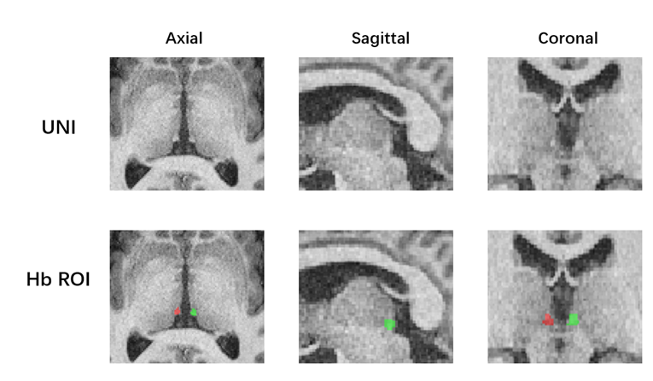
Supplementary Figure 1. The ROI of Habenula in MP2RAGE-UNI
Supplementary Figure 2. Differences between patients with FED and HCs in absolute hemisphere Hb volume (A), normalized hemisphere Hb volume (B), and T1 value (C) within gender subgroups.
Supplementary Figure 3. The correlation between the age and total absolute/normalized habenula volume, T1 value and TIV in participants with FED and healthy controls.
Supplementary Figure 4. The correlation between the HDRS and total absolute/normalized habenula volume and T1 value in participants with FED.
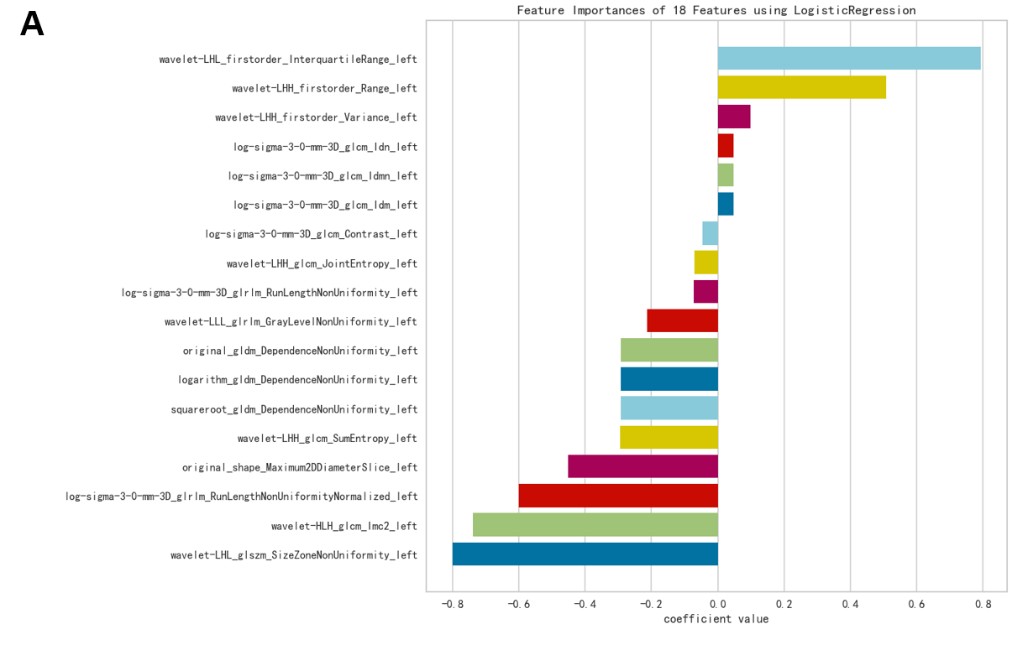
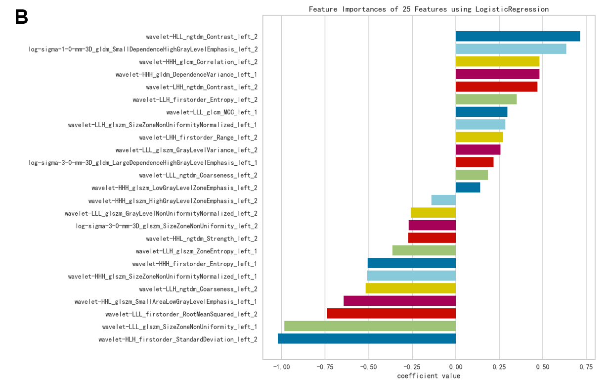
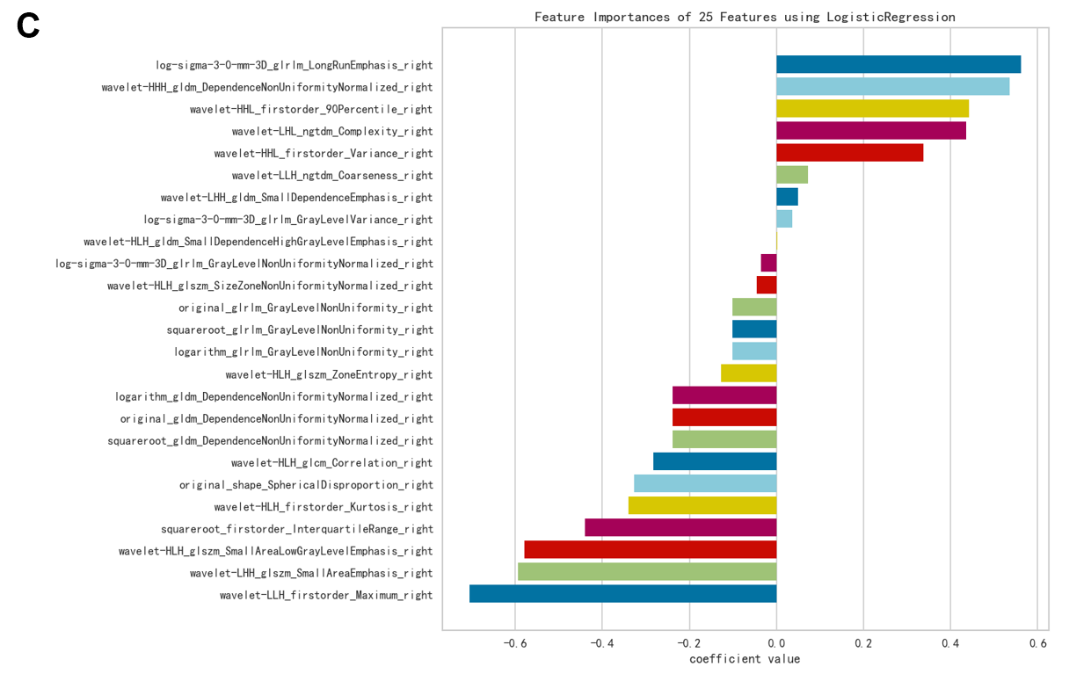
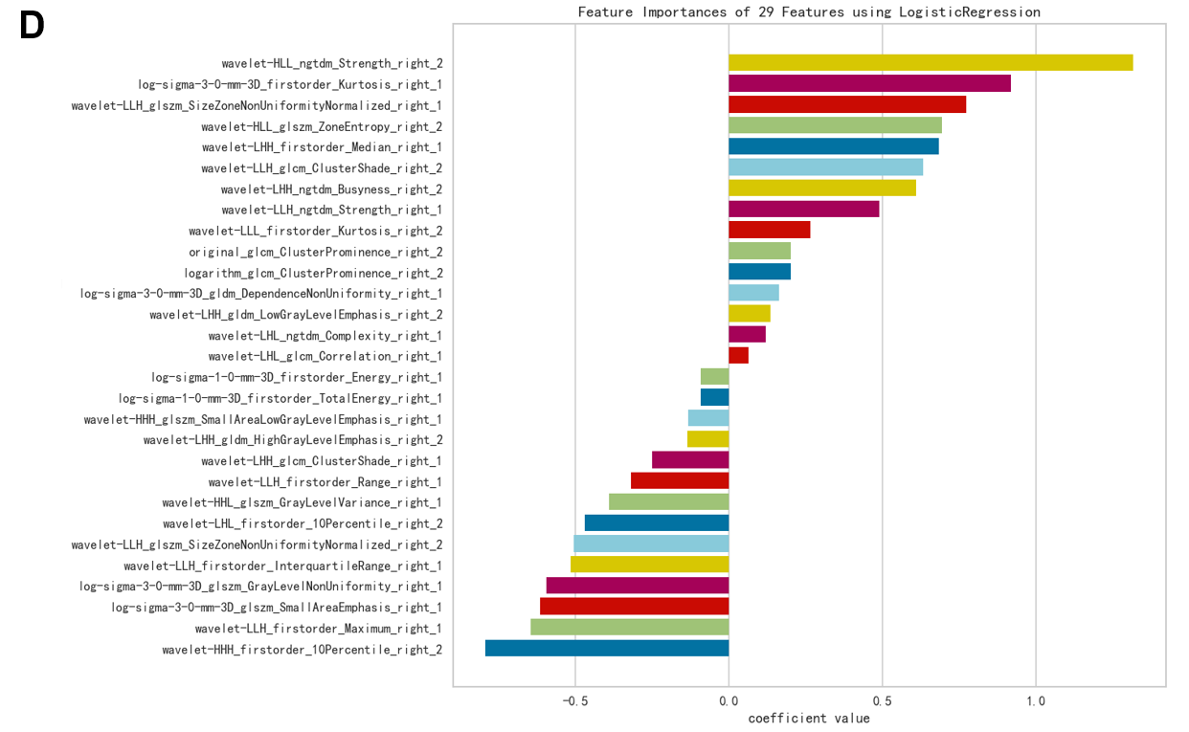
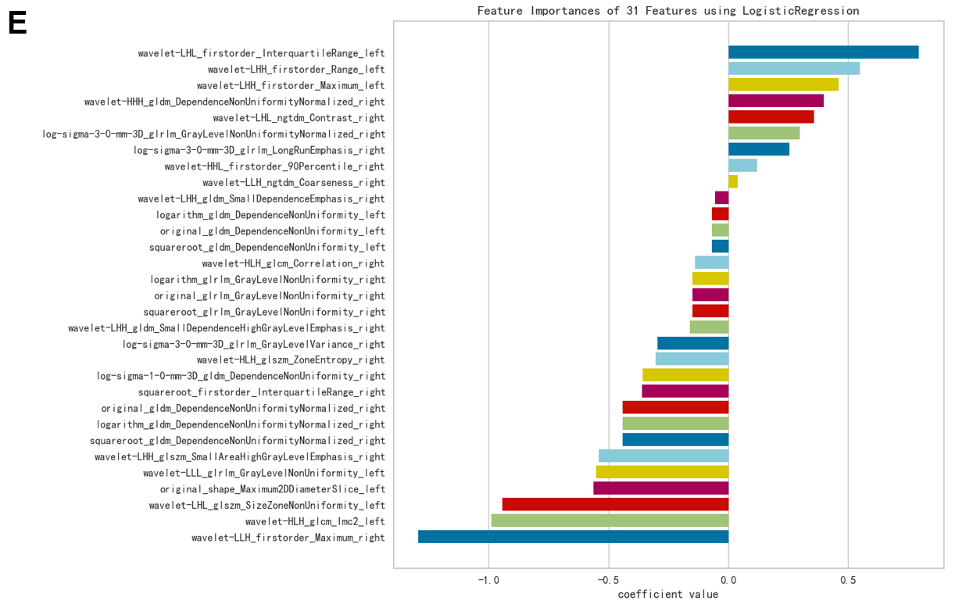
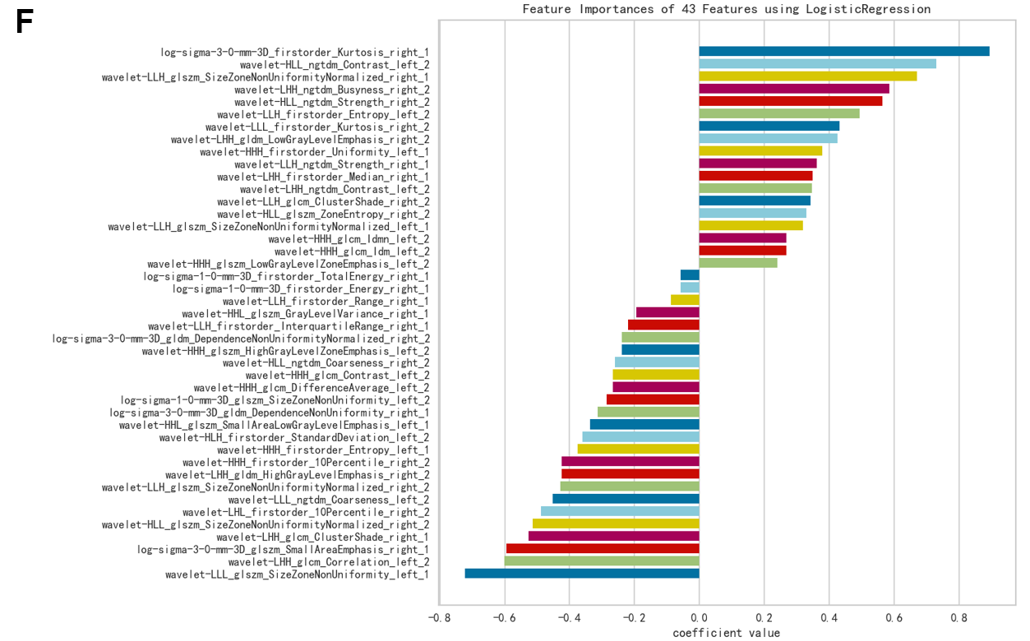
Supplementary Figure 5. The feature names and feature coefficients for each model strategy
- Radiomics model of Left Hb. (B) Radiomics model of Left Hb clusters. (C) Radiomics model of Right Hb. (D) Radiomics model of Right Hb clusters. (E) Radiomics model of Left and Right Hb. (F) Radiomics model of Left and Right Hb clusters.

 | HCs | Participants with  FED | Test statistic | p  Value
Absolute total volume  (mm³ ± SD) | 62.82 ± 8.07 | 60.11 ± 10.22 | t = 1.426 | 0.157
Normalized total volume（x10-5) | 4.27 ± 0.62 | 4.13 ± 0.64 | t = 1.041 | 0.301
Absolute right volume  (mm³ ± SD) | 32.18 ± 4.60 | 30.65 ± 5.14 | t = 1.519 | 0.132
Normalized right volume（x10^{-5）} | 2.19 ± 0.34 | 2.11 ± 0.33 | t = 1.110 | 0.270
Absolute left volume (mm³ ± SD) | 30.64 ± 4.05 | 29.46 ± 5.69 | t = 1.158 | 0.250
Normalized left volume（x10⁻⁵） | 2.08 ± 0.31 | 2.02 ± 0.36 | t = 0.842 | 0.402
TIV (cm³ ± SD) | 1480.66 ± 127.66 | 1456.91 ±121.44 | t = 0.924 | 0.358
Total T1 value（ms） | 2097.20 ± 83.99 | 2076.28 ± 60.79 | t = 1.383 | 0.170
Right T1 value（ms） | 1049.16 ± 48.29 | 1035.32 ± 35.71 | t = 1.579 | 0.118
Left T1 value（ms） | 1048.04 ± 40.80 | 1040.96 ± 31.42 | t = 0.943 | 0.348

Supplementary Table 1. Comparison of the absolute, normalized habenula volume and T1 value between the Participants with FED and HCs.

NO | methods | Data type | AUC | SEN | SPE | F1_Score
1 | left | validation | 0.835 | 0.829 | 0.811 | 0.780
1 | left | test | 0.656 | 0.667 | 0.625 | 0.696
2 | left_1+left_2 | validation | 0.850 | 0.743 | 0.781 | 0.743
2 | left_1+left_2 | test | 0.698 | 0.583 | 0.750 | 0.667
3 | right | validation | 0.795 | 0.714 | 0.742 | 0.693
3 | right | test | 0.667 | 0.500 | 0.625 | 0.571
4 | right_1+right_2 | validation | 0.882 | 0.829 | 0.789 | 0.798
4 | right_1+right_2 | test | 0.771 | 0.500 | 0.750 | 0.600
5 | left+right | validation | 0.902 | 0.829 | 0.747 | 0.773
5 | left+right | test | 0.708 | 0.583 | 0.750 | 0.667
6 | left_1+left_2+right_1+right_2 | validation | 0.986 | 0.943 | 0.906 | 0.917
6 | left_1+left_2+right_1+right_2 | test | 0.844 | 0.750 | 0.875 | 0818

Supplementary Table 2. The AUC, sensitivity, specificity and F1 score of different models in the validation and test dataset.

