Supplementary Material

Quality by Design development of Celtis iguanaea (Jacq.) Planch (Cannabaceae) microparticles with in vivo gastroprotective efficacy

Rúbia Bellard e Silva¹, José Luís Rodrigues Martins², Dionys de Souza Almeida³, Gabriela Viana Ferreira¹, Kátia Regina Ribeiro¹, Mairon César Coimbra¹, Laura Jéssica Pereira¹, Emmilly de Oliveira Alves¹, Marx Osório Araújo Pereira⁴, Eric de Souza Gil⁴, Rodolfo de Paula Vieira⁵, André Luís Lacerda Bachi⁶, Jônatas Bussador do Amaral⁷, Gustavo Fernando de Frazão Lima¹, José Augusto Ferreira Perez Villar¹, Camile Aparecida da Silva¹, James Oluwagbamigbe Fajemiroye³, Elson Alves Costa³, Renê Oliveira do Couto¹*

¹Federal University of São João del-Rei, Midwest Campus Dona Lindu, Divinópolis, Minas Gerais, Brazil.

²Postgraduate Program in Pharmaceutical Sciences, Pharmacology and Therapeutics, Evangelical University of Goiás-Unievangélica, University Avenue Km 3.5, Anápolis 75083-515, GO, Brazil

³Institute of Biological Sciences, Department of Pharmacology, Federal University of Goiás, Campus Samambaia, Campus Street, Goiânia 74001-97, GO, Brazil.

⁴Laboratory of Pharmaceutical and Environmental Analysis (LAFAM), Faculty of Pharmacy, Federal University of Goiás (UFG), Goiânia, Goiás, Brazil.

⁵Evangelical University of Goiás-Unievangélica, Laboratory of Pulmonary and Exercise Immunology, Anápolis 75083-515, GO, Brazil

⁶Postgraduate Program in Health Sciences, Santo Amaro University (UNISA), São Paulo 04829-300, SP, Brazil.

⁷ENT Research Laboratory, Department of Otorhinolaryngology-Head and Neck Surgery, Federal University of Sao Paulo (UNIFESP), São Paulo 04021-001, SP, Brazil.

*Corresponding author: Renê Oliveira do Couto

“Dona Lindu” Midwest Campus, Universidade Federal de São João del-Rei (UFSJ), Divinopolis 35501-296, MG, Brazil

Experimental

Determination of Solid Content (Sc)

Samples (2 mL) of the Celtis iguanaea hydroethanolic leaf extract (HECi) were placed in Petri dishes and weighed using an analytical balance. The dishes were then placed in an oven at 102.5 °C until a constant weight was achieved, and the final measurement was recorded (BRASIL, 2019). Equation S1 shows how the result was calculated:
$Sc\left(\%m/m\right)=\frac{m_{i}-m_{f} }{m_{i}}×100$ (Eq. S1)

Where mi is the initial mass of the container with the sample before heating (g), and mf is the final mass of the container with the sample after heating (g). The experiments were performed in triplicate and the results were expressed as mean ± standard deviation (SD).

Apparent density (ρ)

Apparent density was determined using a pre-calibrated 5 mL glass pycnometer, which was weighed before analysis. The measurement was performed in quadruplicate by transferring the sample to the pycnometer and weighing it (BRASIL, 2019). Density was calculated using Equation S2:
$ρ\left(\frac{g}{mL}\right)=\frac{m_{s+p}-m_{p} }{5}$ (Eq. S2)

Where m_{s+p} is the mass of the pycnometer filled up with sample, and m_{p} is the mass of the empty pycnometer. The experiments were performed in quintuplicate and the results were expressed as mean ± SD.

Extraction Yield (EY)

The EY was calculated based on the Sc obtained relative to the mass of the plant material used in the extraction process. Equation S3 illustrates this relationship:
$EY \left(\%m/m\right)=\frac{V×ρ×Sc}{m(1-Mc)}×100$ (Eq. S3)

Where V is the final volume of HECi (L); ρ is the apparent density (g/mL); Sc is the solid content of HECi (% m/m); m is the mass of Celtis iguanaea herbal drug used in the percolation (g); and Mc is the moisture content in the Celtis iguanaea herbal drug (% m/m). The experiments were performed in quintuplicate and the results were expressed as mean ± SD.

Determination of pH

The potentiometric determination of pH was performed using a pH meter (Brazil), which measured the potential difference between two electrodes immersed in the HECi (BRASIL, 2019). The experiments were performed in quintuplicate and the results were expressed as mean ± SD.

Determination of Drying Yield (DY)

The DY was calculated as the ratio between the mass of the dried extract collected at the cyclone outlet (m_{SDCi}, g), and the sum of the proportion of the dry residue mass in the feed extract (m_{HEC}i x Sc) and the mass of leucine (m_{L})as expressed by Equation S4:
$DY\left(\%m/m\right)=\frac{m_{SDCi}}{\left(m_{HECi}×Sc\right)+m_{L}}×100$ (Eq. S4)

Determination of Moisture Content (Mc)

The Mc was determined using the gravimetric method. SDCi samples (1.5 g ) were dried in an oven at 102.5°C for approximately 15 hours (BRASIL, 2019). The mass was recorded, and the Mc was calculated using Equation S5:
$Mc\left(\%m/m\right)=\frac{m_{i}-m_{f} }{m_{i}}×100$ (Eq. S5)

Where mi is the initial mass of the container with the sample before heating (g) and mf is the final mass of the container with the sample before heating (g). The experiments were performed in triplicate and the results were expressed as mean ± SD.

Determination of Total Polyphenols Content (TPc)

TPc was determined using the Folin-Ciocalteu method in 96-well microplates (Granato and Nunes, 2017; Singleton et al., 1999). The standard solution for the calibration curve was prepared by dissolving 10 mg of gallic acid in 70% ethanol in a 25 mL volumetric flask. The alkalizing solution was prepared by dissolving 1 g of Na₂CO₃ in purified water in a 10 mL volumetric flask. Finally, the Folin-Ciocalteu reagent was diluted in water at a 1:2 ratio (Granato and Nunes, 2017; Singleton et al., 1999). To construct the calibration curve, aliquots of 25, 50, 100, 200, 300, and 500 µL of the standard solution were transferred into polymeric microtubes in triplicate, and the volume was adjusted to 1 mL with 70% (m/m) ethanol, followed by vortex homogenization.

Afterward, 25 µL of the diluted standard solution or extract (HECi or SDCi solution), 200 µL of water, and 25 µL of the Folin-Ciocalteu reagent solution were added to each well. The plate was then homogenized and incubated for 5 minutes in the dark. After incubation, 25 µL of the Na₂CO₃ solution was added, followed by homogenization and further incubation for 60 minutes in the dark. Finally, absorbance was measured at 725 nm using a spectrophotometer. For the HECi, the TPc was determined relative to the plant material using Equation S6:
$TPc \left({mg}/g\right)=\frac{CP}{1000×ρ×Sc}$ (Eq. S6)

Where CP is the phenolic concentration of the extract (HECi) obtained from the standard curve (µg/mL); ρ is the extract apparent density (g/mL); and Sc is the extract dry residue (%).

Regarding the SDCi, samples (0.025 g) were weighed and transferred to a 5 mL volumetric flask, which was then filled to volume with 70% (m/m) ethanol. The TPc was determined relative to the plant material using Equation S7:
$TPc \left({mg}/g\right)=\frac{CP}{C_{sol}\left(1-\frac{Mc}{100}\right)}×\left(1+\frac{Lc}{100}\right)$ (Eq. S7)

Where CP is the phenolic concentration in the SDCi, obtained from the standard curve (µg/mL); C_{sol} is the concentration of the SDCi solution (5 mg/mL); Mc is the moisture content of the SDCi; and Lc is the theoretical leucine content. All the experiments were performed in at least in triplicate and the results were expressed as mean ± SD.

Determination of Total Flavonoid Content (TFc)

The TFc was determined by the spectrophotometric method based on the reaction with AlCl₃ (Kosalec et al., 2005).To prepare the standard solution, 1 mg of rutin was dissolved in 70% ethanol in a 10 mL volumetric flask. The reagent solution was prepared by dissolving 1 g of AlCl₃ in purified water in a 50 mL volumetric flask. For the calibration curve, 500 µL of the AlCl₃ solution was added to test tubes, followed by aliquots of 25, 50, 100, 200, 400, and 600 µL of the standard solution, and 70% ethanol was added to complete the reaction volume to 2.5 mL. To determine the flavonoid content of the HECi, 100 µL of the extract and 1.9 mL of 70% ethanol were added to the AlCl₃ solution. The tubes were vortexed, and the mixture was allowed to rest in the dark for 45 minutes. After this period, the absorbance was measured at 425 nm using a spectrophotometer. For the HECi, the TPc was determined relative to the plant material using Equation S8:
$TFc \left({mg}/g\right)=\frac{CF}{1000×ρ×Sc}$ (Eq. S8)

Where CF is the flavonoid concentration of the extract (HECi) obtained from the standard curve (µg/mL); ρ is the extract apparent density (g/mL); and Sc is the extract dry residue (%).

Regarding the SDCi, samples (0.025 g) were weighed and transferred to a 5 mL volumetric flask, which was then filled to volume with 70% (m/m) ethanol. The TPc was determined relative to the plant material using Equation S9:
$TFc \left({mg}/g\right)=\frac{CF}{C_{sol}\left(1-\frac{Mc}{100}\right)}×\left(1+\frac{Lc}{100}\right)$ (Eq. S9)

Where CF is the flavonoid concentration in the SDCi, obtained from the standard curve (µg/mL); C_{sol} is the concentration of the SDCi solution (5 mg/mL); Mc is the moisture content of the SDCi; and Lc is the theoretical leucine content. All the experiments were performed in at least in triplicate and the results were expressed as mean ± SD.

Determination of Total Phytosterols Content (TPSc)

The standard solution was prepared by dissolving 0.01 g of β-sitosterol in CHCl₃ in a 10 mL volumetric flask. The extract was diluted in CHCl₃ to a concentration of 1 mg/mL. The Liebermann-Buchard (LB) reagent was prepared by adding 50 mL of acetic anhydride to an amber bottle in an ice bath, followed by the careful addition of 5 mL of sulfuric acid to the acetic anhydride after thirty minutes. The standard curve was created using aliquots of 160, 210, 260, 500, and 600 µL of the standard solution, followed by chloroform to complete the reaction volume to 2.0 mL, and 500 µL of the LB reagent (Araújo et al., 2013a).

For sample analysis, an aliquot of 50 mg was transferred to a 5 mL flask and completed with CHCl₃. A 200 µL aliquot of the extract solution, 1.8 mL of chloroform, and 500 µL of the LB reagent were added in triplicate to test tubes. The tubes were vortexed, and the mixture was left to rest in the dark for 5 minutes. Afterward, the absorbance was measured using a spectrophotometer at 625 nm (L. B. D. C. Araújo et al., 2013). The result was obtained using Equation S10:
$TPSc \left({mg}/g\right)=\frac{CPS}{C_{sol}\left(1-\frac{Mc}{100}\right)}×\left(1+\frac{Lc}{100}\right)$ (Eq. S10)

Where CPS is the phytosterol concentration in the SDCi, obtained from the standard curve (µg/mL); C_{sol} is the concentration of the SDCi solution (5 mg/mL); Mc is the moisture content of the SDCi; and Lc is the theoretical leucine content. The experiments were performed in at least in triplicate and the results were expressed as mean ± SD.

Reducing capacity

To assess the antioxidant activity related to the extract (HECi or SDCi) reducing capacity, the widely quoted DPPH method (Brand-Williams et al., 1995) was used, with adaptations for 96-well microplate assays (Araújo et al., 2013b). The DPPH solution was prepared by dissolving 1 mg of DPPH in 70% ethanol in a 50 mL volumetric flask. The several extract samples were diluted to 5000; 2500; 1000; 100, and 10 μg/mL in 70% (m/m) ethanol.

In each well, 75 µL of the diluted samples were pipetted in triplicate, 150 µL of the DPPH solution was added to the wells for the experiment, and 150 µL of 70% ethanol was added to the blank wells. The reaction was allowed to proceed for 30 minutes in the dark at room temperature. After this period, absorbance was measured at 517 nm using a spectrophotometer, and the percentage of antioxidant activity was calculated according to Equation S11.
$\% DPPH inhibition= \left[1-\left(\frac{{Abs}_{sample}-{Abs}_{blank}}{{Abs}_{DPPH}}\right)\right]×100$ (Eq. S11)

Where Abs_{sample} is the sample absorbance; Abs_{blank} is the blank absorbance, and Abs_{DPPH} is the absorbance of DPPH solution. Finally, the median inhibitory concentration (IC₅₀, μg/mL) was calculated, which is the extract concentration capable of decolorizing 50% of the DPPH solution. In this pursuit, we used probit analysis methods, the most appropriate technique for calculating IC₅₀. The experiments were performed in at least in triplicate and the results were expressed as mean ± SD.

Overall in vitro antioxidant capacity

Voltammetric experiments were conducted using a potentiostat/galvanostat in a single-compartment electrochemical cell (3 mL) with a three-electrode system. This system comprised a carbon paste electrode as the working electrode, a platinum (Pt) wire as the counter electrode, and a silver/silver chloride/saturated potassium chloride (Ag/AgCl/KCl𝑠𝑎𝑡) electrode as the reference electrode (Leite et al., 2018).

Before each measurement, five cycles of cyclic voltammetry (CV) were performed at a scan rate of 100 mV/s to activate the working electrode surface. The experimental conditions for Differential Pulse Voltammetry (DPV) included a pulse of 2.6 mV, a scan rate of 10 mV/s, and a potential range from 0.1 to 1.0 V. For Square Wave Voltammetry (SWV), a frequency of 25 Hz, a scan rate of 50 mV/s, and a potential range from 0 to 1.0 V were used. Both voltammetric assays were conducted with a pulse amplitude of 50 mV, using a phosphate buffer solution (PBS, pH 7.0) as the electrolyte. A 100 µL aliquot of the extract was added to 1 mL of PBS. For comparison, the same analysis was performed using gallic acid dissolved in water at 1% (w/v) (Leite et al., 2018). The data generated were analyzed and processed using Origin 8® software (OriginLab, Northampton, Massachusetts, USA), enabling the construction of voltammograms (Leite et al., 2018).

The electrochemical index (EI) is calculated as the sum of the ratios between the anodic peak current (Ipa) and the anodic peak potential (Epa) for the peaks observed in the DPV analysis, as represented in Equation S12 (Leite et al., 2018):
$EI(µA/V)=\sum_{i=1}^{n}{\left(\frac{{I_{pa}}_{i}}{{E_{pa}}_{i}}\right)}$ (Eq. S12)

Where Ipa_{i} is the anodic peak current i (µA) and Epa_{i} is the anodic peak potential i (V).

Determination of Energy Efficiency (η)

The drying energy efficiency (η) was determined using Equation S13:
$η (\%)=\frac{IT-OT}{IT-T_{env}}×100$ (Eq. S13)

Where IT is the drying air inlet temperature (°C); OT is the drying air outlet temperature (°C); and T_{env} is the room air temperature(°C). Two calculations were performed: one using the initial outlet temperature (Ti) and another using the final outlet temperature (Tf). The average of these values was considered the overall drying efficiency.

Figures

Figure S1: Differential pulse voltammogram (DPV) (a) and square wave voltammogram (SWV) (b) of Celtis iguanaea hydroethanolic leaf extract

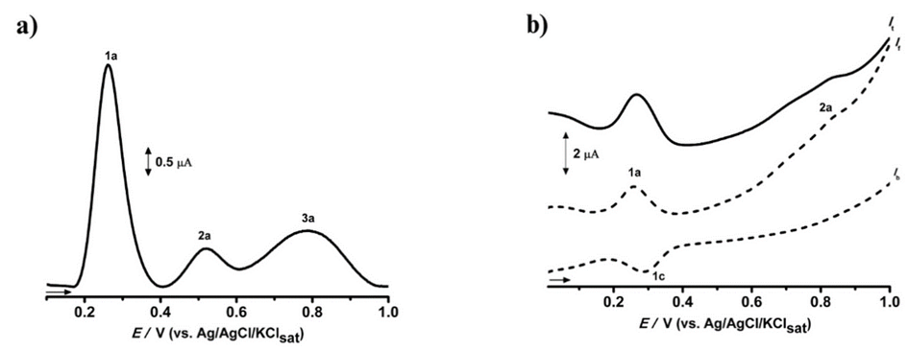

a, anodic peak; c, cathodic peak; It, total current; If, direct current; and Ib, reverse current.

Figure S2: Aspects of the dried extracts in the test for selection of drying adjuvants a) colloidal silicon dioxide; b) microcrystalline cellulose; c) mannitol; d) starch and e) leucine.

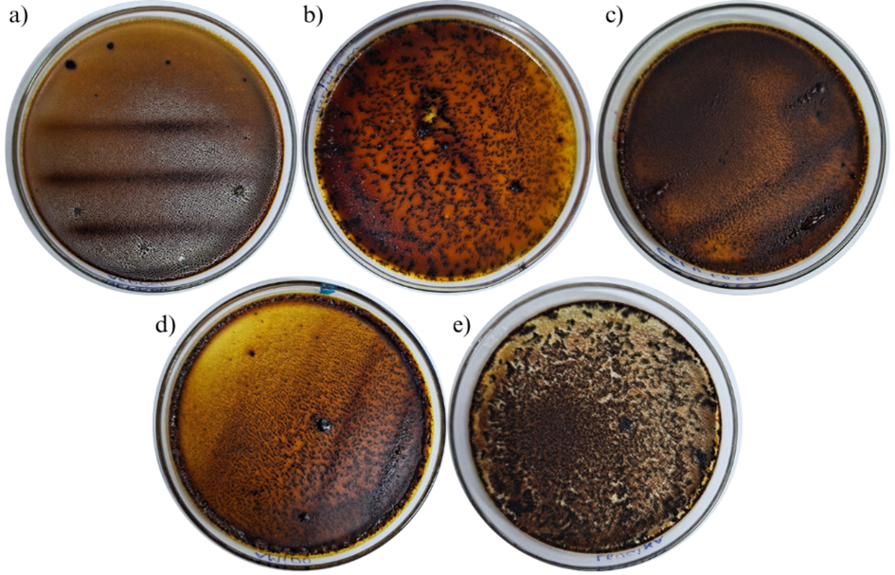

Figure S3: Differential pulse voltammogram (DPV) (a) and square wave voltammogram (SWV) (b) of Celtis iguanaea spray-dried extract (SDCi) obtained at experimental run 1 of the Box-Behnken design of experiments

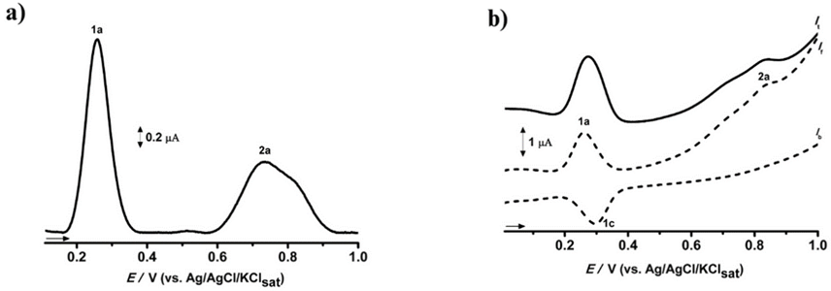

a, anodic peak; c, cathodic peak; It, total current; If, direct current; and Ib, reverse current.

Figure S4: Differential pulse voltammogram (DPV) (a) and square wave voltammogram (SWV) (b) of Celtis iguanaea spray-dried extract (SDCi) obtained at experimental run 2 of the Box-Behnken design of experiments

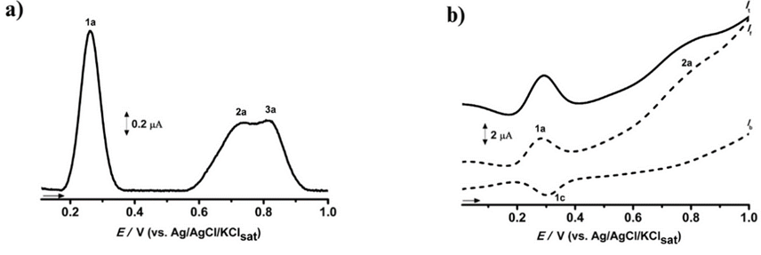

a, anodic peak; c, cathodic peak; It, total current; If, direct current; and Ib, reverse current.

Figure S5: Differential pulse voltammogram (DPV) (a) and square wave voltammogram (SWV) (b) of Celtis iguanaea spray-dried extract (SDCi) obtained at experimental run 3 of the Box-Behnken design of experiments

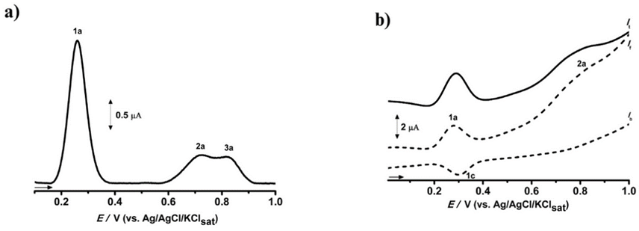

a, anodic peak; c, cathodic peak; It, total current; If, direct current; and Ib, reverse current.

Figure S6: Differential pulse voltammogram (DPV) (a) and square wave voltammogram (SWV) (b) of Celtis iguanaea spray-dried extract (SDCi) obtained at experimental run 4 of the Box-Behnken design of experiments

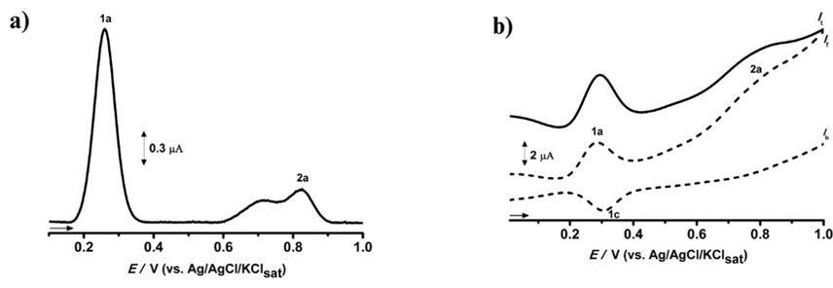

a, anodic peak; c, cathodic peak; It, total current; If, direct current; and Ib, reverse current.

Figure S7: Differential pulse voltammogram (DPV) (a) and square wave voltammogram (SWV) (b) of Celtis iguanaea spray-dried extract (SDCi) obtained at experimental run 5 of the Box-Behnken design of experiments

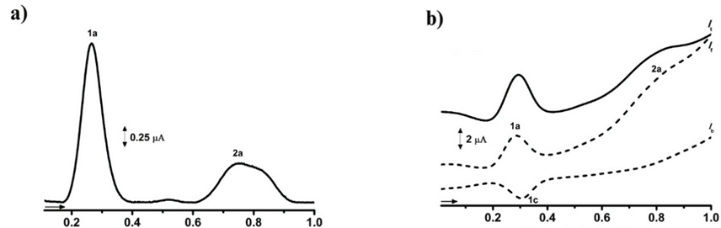

a, anodic peak; c, cathodic peak; It, total current; If, direct current; and Ib, reverse current.

Figure S8: Differential pulse voltammogram (DPV) (a) and square wave voltammogram (SWV) (b) of Celtis iguanaea spray-dried extract (SDCi) obtained at experimental run 6 of the Box-Behnken design of experiments

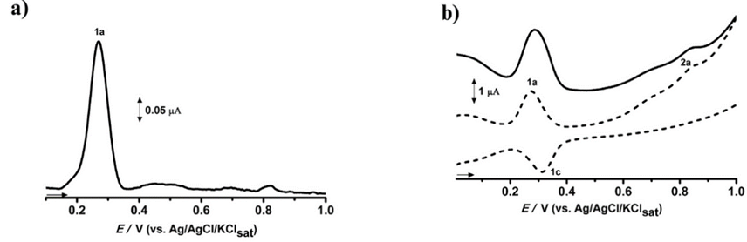

a, anodic peak; c, cathodic peak; It, total current; If, direct current; and Ib, reverse current.

Figure S9: Differential pulse voltammogram (DPV) (a) and square wave voltammogram (SWV) (b) of Celtis iguanaea spray-dried extract (SDCi) obtained at experimental run 7 of the Box-Behnken design of experiments

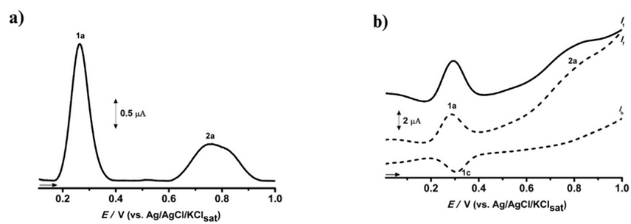

a, anodic peak; c, cathodic peak; It, total current; If, direct current; and Ib, reverse current.

Figure S10: Differential pulse voltammogram (DPV) (a) and square wave voltammogram (SWV) (b) of Celtis iguanaea spray-dried extract (SDCi) obtained at experimental run 8 of the Box-Behnken design of experiments

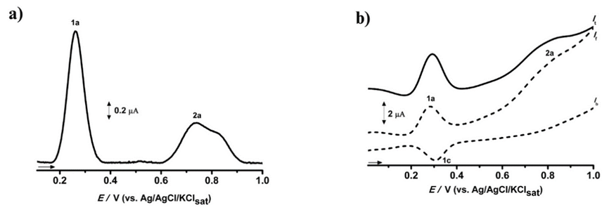

a, anodic peak; c, cathodic peak; It, total current; If, direct current; and Ib, reverse current.

Figure S11: Differential pulse voltammogram (DPV) (a) and square wave voltammogram (SWV) (b) of Celtis iguanaea spray-dried extract (SDCi) obtained at experimental run 9 of the Box-Behnken design of experiments

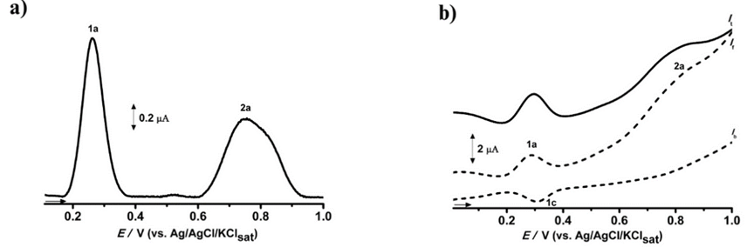

a, anodic peak; c, cathodic peak; It, total current; If, direct current; and Ib, reverse current.

Figure S12: Differential pulse voltammogram (DPV) (a) and square wave voltammogram (SWV) (b) of Celtis iguanaea spray-dried extract (SDCi) obtained at experimental run 10 of the Box-Behnken design of experiments

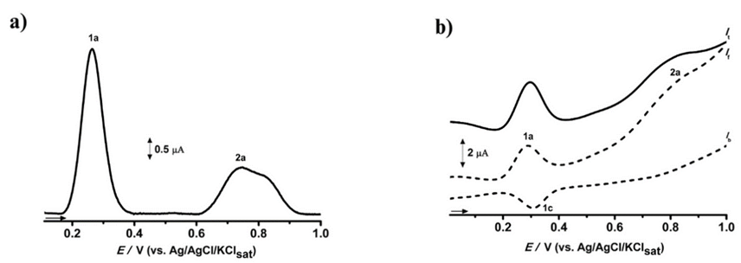

a, anodic peak; c, cathodic peak; It, total current; If, direct current; and Ib, reverse current.

Figure S13: Differential pulse voltammogram (DPV) (a) and square wave voltammogram (SWV) (b) of Celtis iguanaea spray-dried extract (SDCi) obtained at experimental run 11 of the Box-Behnken design of experiments

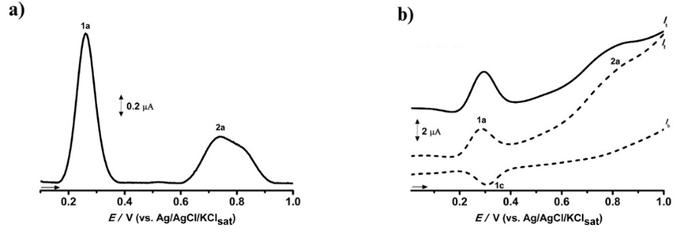

a, anodic peak; c, cathodic peak; It, total current; If, direct current; and Ib, reverse current.

Figure S14: Differential pulse voltammogram (DPV) (a) and square wave voltammogram (SWV) (b) of Celtis iguanaea spray-dried extract (SDCi) obtained at experimental run 12 of the Box-Behnken design of experiments

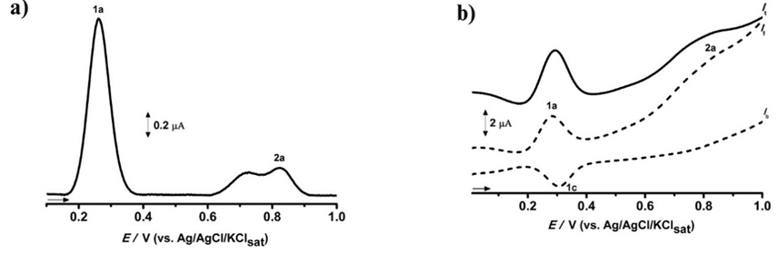

a, anodic peak; c, cathodic peak; It, total current; If, direct current; and Ib, reverse current.

Figure S15: Differential pulse voltammogram (DPV) (a) and square wave voltammogram (SWV) (b) of Celtis iguanaea spray-dried extract (SDCi) obtained at experimental run 13 of the Box-Behnken design of experiments

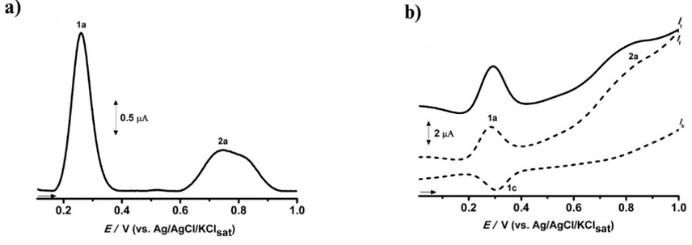

a, anodic peak; c, cathodic peak; It, total current; If, direct current; and Ib, reverse current.

Figure S16: Differential pulse voltammogram (DPV) (a) and square wave voltammogram (SWV) (b) of Celtis iguanaea spray-dried extract (SDCi) obtained at experimental run 14 of the Box-Behnken design of experiments

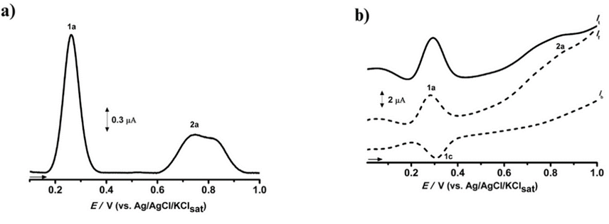

a, anodic peak; c, cathodic peak; It, total current; If, direct current; and Ib, reverse current.

Figure S17: Differential pulse voltammogram (DPV) (a) and square wave voltammogram (SWV) (b) of Celtis iguanaea spray-dried extract (SDCi) obtained at experimental run 15 of the Box-Behnken design of experiments

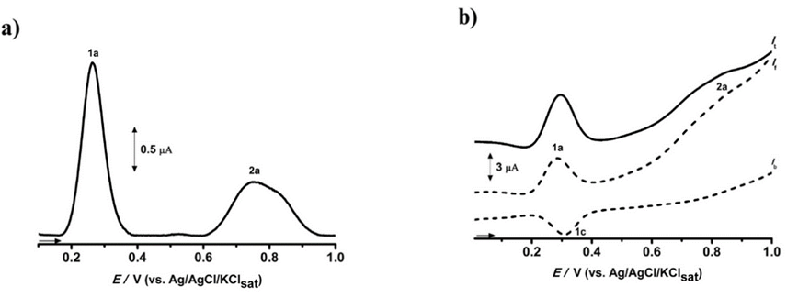

a, anodic peak; c, cathodic peak; It, total current; If, direct current; and Ib, reverse current.

Figure S18: Contour plots of drying yield (DY) as a function of (a) drying air temperature (IT) and extract feed rate (Ef); (b) drying air temperature (IT) and leucine content (Lc); and (c) extract feed rate (Ef) and leucine content (Lc)

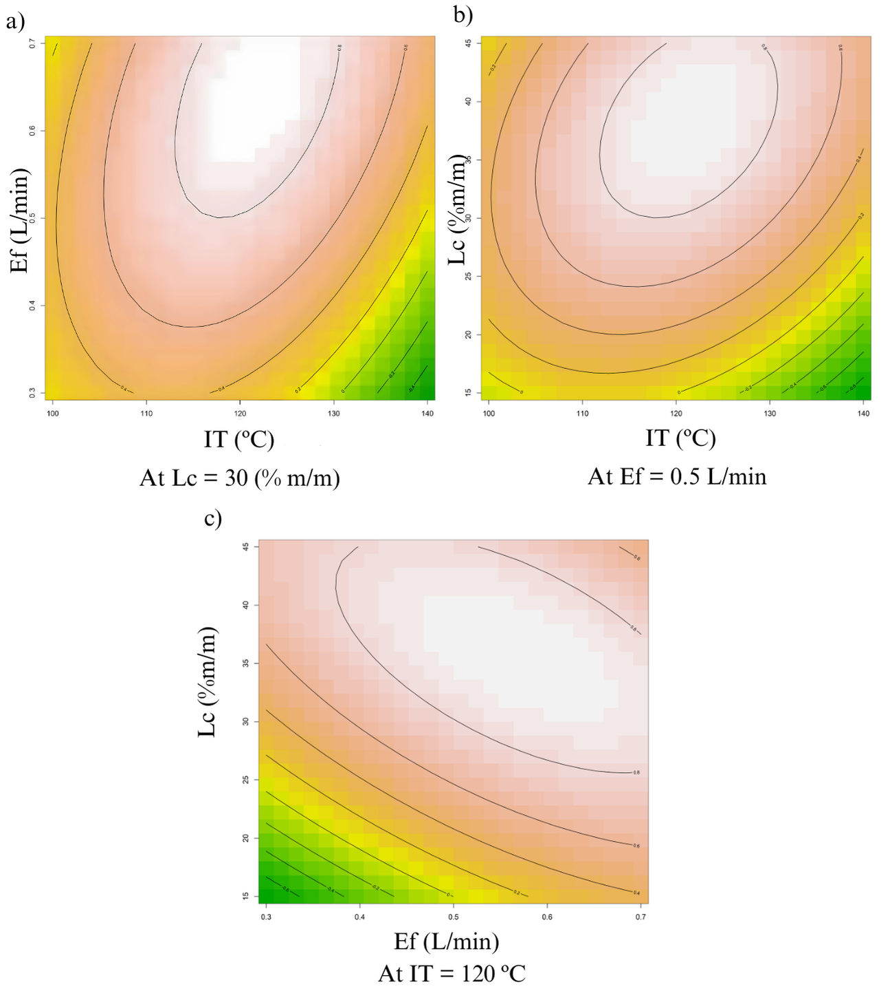

Figure S19: Chromatographic profiles of the optimized Celtis iguanaea spray-dried extract (SDCi11) recorded at (a) 254 nm and (b) 330 nm.

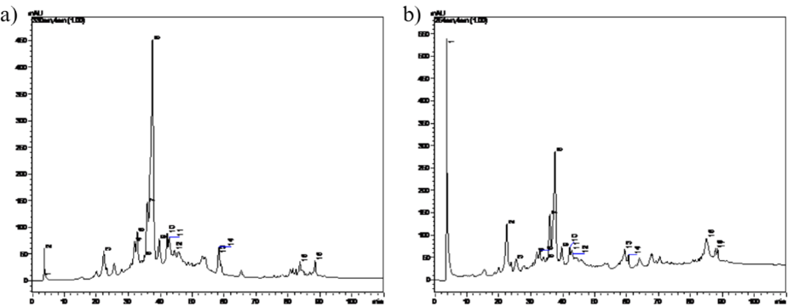

Table S1: Current (Ipa), potential (Epa), and electrochemical index (EIpa) for each anodic peak as revealed the Differential Pulse Voltammetry (DPV) of the several Celtis iguanaea spray-dried extract (SDCi)
Extract | Anodic peak current  _{Ipa} (µA) |  |  | Anodic peak potential  _{Epa} (V) |  |  | Anodic peak electrochemical index  EI_{pa} (µA/V)
Extract | 1a | 2a | 3a | 1a | 2a | 3a | 1a | 2a | 3a
SDCI1 | 1.74 | 0.64 | - | 0.26 | 0.74 | - | 6.74 | 0.87 | -
SDCI2 | 1.34 | 0.16 | 0.25 | 0.26 | 0.72 | 0.83 | 5.16 | 0.23 | 0,30
SDCI3 | 2.38 | 0.20 | 0.18 | 0.26 | 0.71 | 0.83 | 9.15 | 0.29 | 0,22
SDCI4 | 1.74 | 0.21 | - | 0.26 | 0.83 | - | 6.67 | 0.25 | -
SDCI5 | 1.97 | 0.49 | - | 0.27 | 0.75 | - | 7.43 | 0.65 | -
SDCI6 | 0.32 | - | - | 0.27 | - | - | 1.19 | - | -
SDCI7 | 2.34 | 0.63 | - | 0.26 | 0.76 | - | 8.89 | 0.83 | -
SDCI8 | 1.49 | 0.45 | - | 0.26 | 0.74 | - | 5.71 | 0.61 | -
SDCI9 | 1.22 | 0.61 | - | 0.26 | 0.76 | - | 4.65 | 0.81 | -
SDCI10 | 1.52 | 0.43 | - | 0.27 | 0.75 | - | 5.72 | 0.58 | -
SDCI11 | 1.44 | 0.45 | - | 0.26 | 0.74 | - | 5.52 | 0.61 | -
SDCI12 | 1.47 | 0.14 | - | 0.26 | 0.83 | - | 5.64 | 0.16 | -
SDCI13 | 2.24 | 0.58 | - | 0.26 | 0.75 | - | 8.61 | 0.78 | -
SDCI14 | 1.77 | 0.50 | - | 0.26 | 0.75 | - | 6.74 | 0.66 | -
SDCI15 | 1.95 | 0.61 | - | 0.26 | 0.75 | - | 7.43 | 0.82 | -

References
Araújo, L.B.D.C., Silva, S.L., Galvão, M.A.M., Ferreira, M.R.A., Araújo, E.L., Randau, K.P., Soares, L.A.L., 2013. Total phytosterol content in drug materials and extracts from roots of Acanthospermum hispidum by UV-VIS spectrophotometry. Rev. Bras. Farmacogn. 23, 736–742. https://doi.org/10.1590/S0102-695X2013000500004
Araújo, S.G., Pinto, M.E.A., Silva, N.L., Santos, F.J.L. dos, Castro, A.H.F., Lima, L.A.R. dos S., 2013. Atividades antioxidante e alelopática do extrato e frações obtidos de Rosmarinus officinalis. BBR - Biochem. Biotechnol. Reports 2, 35–43. https://doi.org/10.5433/2316-5200.2013v2n1p35
Brand-Williams, W., Cuvelier, M.E., Berset, C., 1995. Use of a free radical method to evaluate antioxidant activity. LWT - Food Sci. Technol. https://doi.org/10.1016/S0023-6438(95)80008-5
BRASIL, 2019. Ministério da Saúde. Agência Nacional de Vigilância Sanitária. Farmacopeia Brasileira 6 ed. Brasília: Fundação Oswaldo Cruz.
Granato, D., Nunes, D., 2017. Análises Químicas, Propriedades Funcionais e Controle de Qualidade de Alimentos e Bebidas: Uma Abordagem Teórico-Prática, 1st ed.
Kosalec, I., Pepeljnjak, S., Bakmaz, M., Vladimir-Knežević, S., 2005. Flavonoid analysis and antimicrobial activity of commercially available propolis products. Acta Pharm. 55, 423–430.
Leite, K.C. de S., Garcia, L.F., Lobón, G.S., Thomaz, D.V., Moreno, E.K.G., de Carvalho, M.F., Rocha, M.L., dos Santos, W.T.P., Gil, E. de S., 2018. Antioxidant activity evaluation of dried herbal extracts: an electroanalytical approach. Rev. Bras. Farmacogn. 28, 325–332. https://doi.org/10.1016/j.bjp.2018.04.004
Singleton, V.L., Orthofer, R., Lamuela-Raventós, R.M., 1999. Analysis of Total Phenols and Other Oxidation Substrates and Antioxidants by Means of Folin-Ciocalteu Reagent. Methods Enzymol. 299, 152–178. https://doi.org/10.1016/S0076-6879(99)99017-1

