and permissions information is available at www.nature.com/reprints.
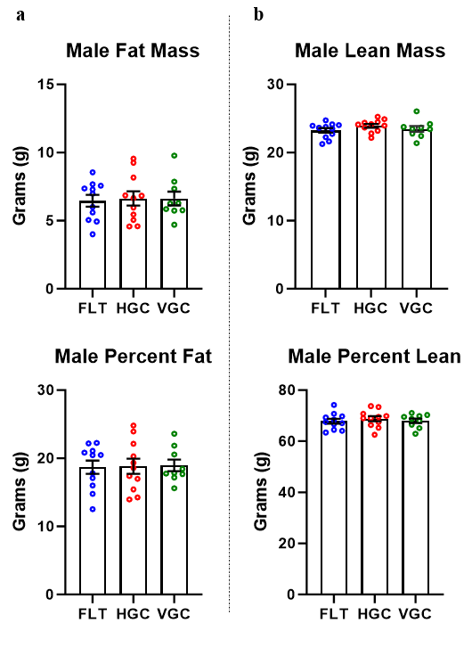

Extended Data Fig. 1 | Male F1 offspring body composition. (a) Adult body composition (fat mass and % fat mass) and (b) lean mass and percentage lean mass for male F1-FLT (n=11), F1-HGC (n=11) and F1-VGC (n=9). Means ± SEM are reported with individual offspring represented by open circles, no significant differences were observed.

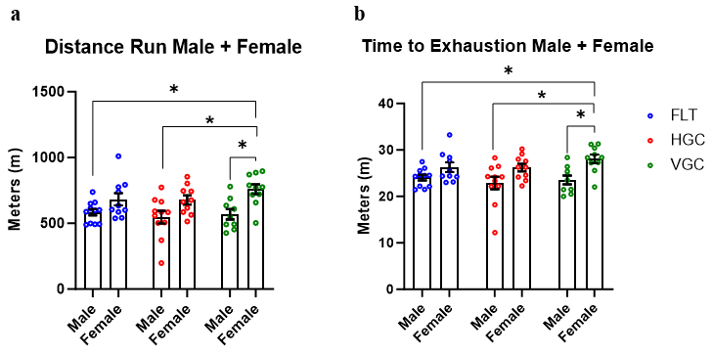 Extended Data Fig. 2 | Aerobic Endurance in F1 Offspring Derived from Maternal Spaceflight Exposure. (a) Distance traversed (meters) and (b) time to exhaustion (minutes) by male and female F1 offspring indicated no effect of maternal exposure. *Means ± SEM are different (p< 0.05) with individual offspring represented by open circles.

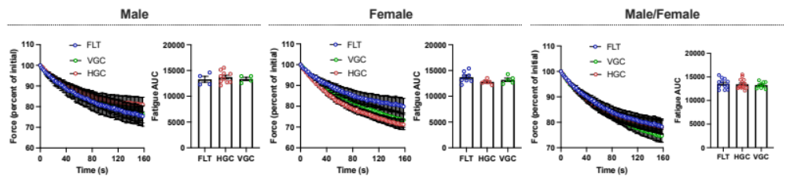 Extended Data Fig. 3 | Isolated soleus muscle fatigue curves and AUC analysis in F1 Offspring Derived from Maternal Spaceflight Exposure. Fatigue was assessed with 70 Hz volleys every 2s for 160 s and the AUC analyzed with a one-way ANOVA. Means ± SEM.

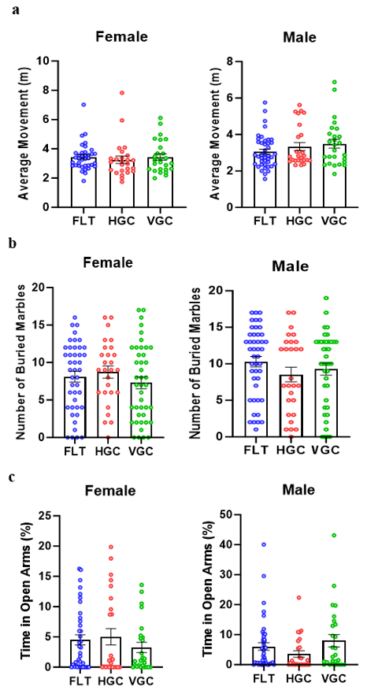
Extended Data Fig. 4 | Behavioral and Locomotor Effects of Maternal Spaceflight Exposure on F2 Offspring. (a) Average locomotor activity for the three maternal environmental exposures were compared within sex for adult (82-110 day old) F2 offspring (n= 43, 26, 26 for males and n=37, 25, 27 for females in the FLT, HGC and VGC groups, respectively). Similarly, (b) marble burying and (c) elevated plus maze were compared within sex across the F2 offspring groups. Means ± SEM with individual offspring represented by open circles are shown.

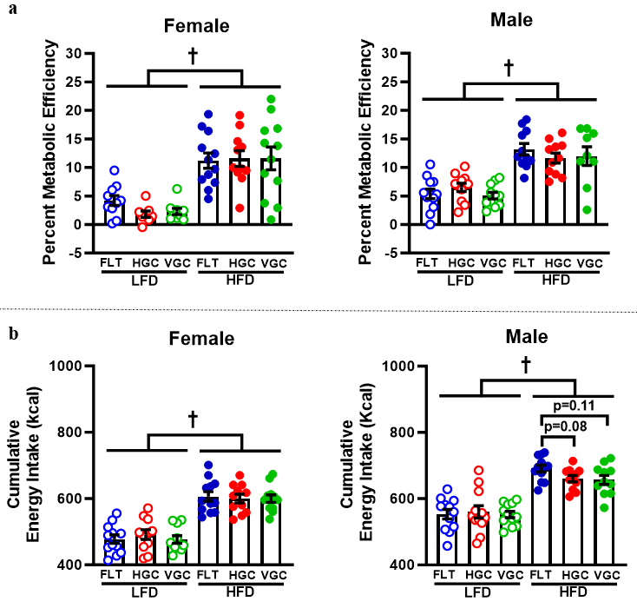 Extended Data Fig. 5 | Energy Uptake and Metabolic Efficiency in F2 animals. F2 Male and female offspring subjected to either a LFD or HFD across HGC, VGC, and FLT groups showed cumulative metabolic efficiency over 8 weeks (a) and cumulative energy intake over 8 weeks (b). † p<0.05 main effect of diet group with individual offspring represented by open circles.

