Supplementary Information
Carbon dynamics control contemporary mercury burial in Arctic Ocean sediments
C. Gobeil, S. Johannessen, M.A. Goñi, Z.Z.A. Kuzyk & D. Cossa

This document includes additional information (2 tables and 8 figures) related to the manuscript entitled Carbon dynamics control contemporary mercury burial in Arctic Ocean sediments by C. Gobeil, S. Johannessen, M.A. Goñi, D. Cossa and Z.Z.A. Kuzyk.

Table S1. Geographical coordinates and water depth at the sampling sites in the North American Arctic margin.
Table S2. Statistical characteristics of the regional linear relationships between OC and Hg in NAAM sediments shown in Fig. 3. r²: Pearson correlation coefficient; CI: confidence interval (p<0.01) of the y-intercept value at OC = 0; S: y-intercept statistically differs from zero (p<0.01); NS: y-intercept is not significantly different from zero (p<0.01).
Fig. S1. Sediment core profiles of the mercury–organic carbon ratio (Hg:OC), grouped by region. Core locations are shown in Fig. 1.
Fig. S2. Sediment core profiles of reduced sulphur (S_{RED}), defined as the total sulfur contained in authigenic iron monosulphide and pyrite (Kuzyk et al., 2017), grouped by region. Core locations are shown in Fig. 1.
Fig. S3. Sediment core profiles of Fe associated to poorly and well-crystallized oxyhydroxides (Fe_{OX}), as determined through extraction with a sodium dithionite solution at pH ~4.7 (Macdonald and Gobeil, 2012), grouped by region. Core locations are shown in Fig. 1.
Fig. S4. Sediment core profiles of inorganic carbon (IC) grouped by region. Core locations are shown in Fig. 1.
Fig. S5. Relationship between the Hg:OC ratio and the isotopic composition of organic carbon (ẟ¹³C) in sediments of the Bering and Chukchi Seas (orange square), the Barrow Canyon (brown diamond), the Beaufort Sea (green circle), the Canadian Archipelago (blue triangle), the Lancaster Sound (blue cross), and the Davis Strait (black asterisk). Note that results for the five cores from the interior of the Canadian Archipelago (VS1, FS1, BE2, PS2 and PS1), in which the inorganic carbon concentrations are particularly elevated, are not included in the calculations of the coefficient of determination (R²).
Fig. S6. Average concentrations of Hg associated to terrigenous organic carbon in black (Hg_{OCTERR}), marine organic carbon in red (Hg_{OCMAR}), inorganic carbon in grey (Hg_{IC}) and aluminosilicates (Hg_{Al}) in each of the cores, grouped by region. Core locations are shown in Fig. 1.
Fig. S7. Depth profiles of organic carbon (OC) and inorganic carbon (IC) in the cores from the Amerasian (11, 18 and 26) and Eurasian (35, 36 and 37) basins of the Arctic Ocean. These cores were collected at water depths varying between 2265 m and 4230 m. Core locations are shown in Fig. 1.
Fig. S8. Comparison between modelled and measured Hg concentrations in sediments samples from the Amerasian and Eurasian basins in the deep central Arctic Ocean. Core locations are shown on Fig. 1. Best fit between modelled and measured concentrations was obtained with terrigenous, marine and inorganic endmembers of 11.2 µg_{Hg} g_{OCTerr}⁻¹, 0.80 µg_{Hg} g_{OCMAR}⁻¹ and 0.35 µg_{Hg} g_{IC}⁻¹, respectively.

Table S1. Geographical coordinates and water depth at the sampling sites in the North American Arctic margin.
 | Latitude  (N) | Longitude  (W) | Water Depth  (m)
North Bering Sea Shelf
SLIP1 | 62.014 | 175.056 | 80
SLIP3 | 62.393 | 174.570 | 73
SLIP4 | 63.029 | 173.458 | 73
Chukchi Sea Shelf
UTN3 | 67.334 | 169.000 | 50
UTN5 | 67.670 | 168.958 | 51
UTN7 | 68.000 | 168.933 | 58
Barrow Canyon
BC4 | 71.930 | 154.887 | 599
BC5 | 72.000 | 154.708 | 1015
BC6 | 72.233 | 154.037 | 2125
Mackenzie Slope
CG1 | 70.562 | 142.858 | 204
CG2 | 70.700 | 142.833 | 619
CG3 | 70.461 | 140.160 | 566
Canadian Archipelago
QM1 | 68.667 | 103.004 | 113
VS1 | 70.249 | 98.929 | 210
FS1 | 70.999 | 97.998 | 141
PS1 | 73.597 | 96.295 | 245
PS2 | 73.000 | 96.218 | 340
BE2 | 71.973 | 95.998 | 431
Lancaster S. & Baffin B.
CAA2 | 73.935 | 86.108 | 368
CAA1 | 73.927 | 81.814 | 630
BB11 | 73.933 | 77.930 | 850
Davis Strait
DS2 | 66.758 | 58.545 | 780
DS1 | 65.488 | 57.771 | 575
DS5 | 68.037 | 57.537 | 340

Table S2. Statistical characteristics of the regional linear relationships between OC and Hg in NAAM sediments shown in Fig. 3. r²: Pearson correlation coefficient; CI: confidence interval (p<0.01) of the y-intercept value at OC = 0; S: y-intercept statistically differs from zero (p<0.01); NS: y-intercept is not significantly different from zero (p<0.01).
Region | r² | y-intercept ± CI | Significance
Bering and Chukchi Seas  (SLIP1,3,4; UTN3,5,7) | 0.78 | 16.5 ± 2.3 | S
Upper Barrow Canyon  (BC4,5) | 0.65 | 3.39 ± 16.0 | NS
Beaufort Slope  (CG2,3) | 0.65 | 16.0 ± 19.7 | NS
Davis Strait  (DS1,2,5) | 0.64 | –0.48 ± 1.9 | NS
Lancaster Sound (CAA1,2; BB11) | 0.65 | 4.3 ± 6.7 | NS
Canadian Archipelago  (VS1; FS1; BE2; PS1,2) | 0.95 | 1.6 ± 1.2 | S
Amerasian Basin  (11;18;26) | 0.66 | 0.39 ± 12.7 | NS
Eurasian Basin  (35;36;37) | 0.55 | –1.8 ± 33.1 | NS

Fig. S1. Sediment core profiles of the mercury–organic carbon ratio (Hg:OC), grouped by region. Core locations are shown in Fig. 1.

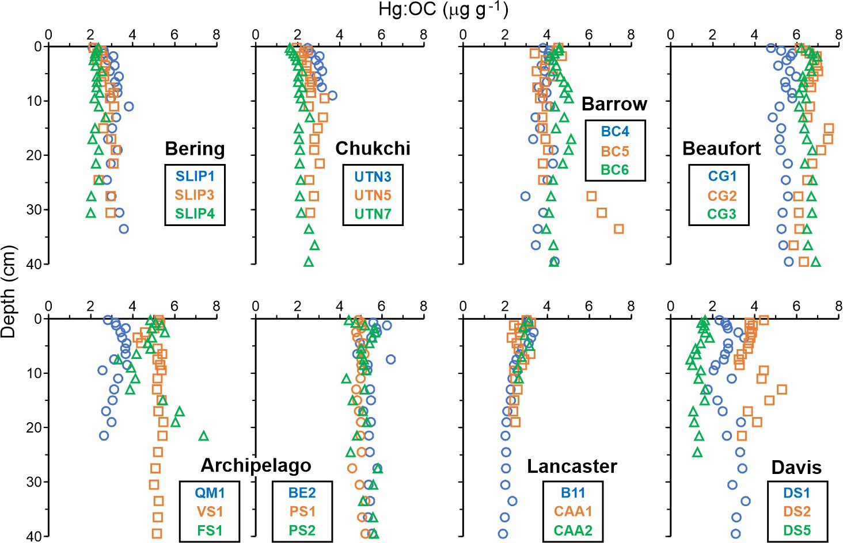

Fig. S2. Sediment core profiles of reduced sulphur (S_{RED}), defined as the total sulfur contained in authigenic iron monosulphide and pyrite (Kuzyk et al., 2017), grouped by region. Core locations are shown in Fig. 1.

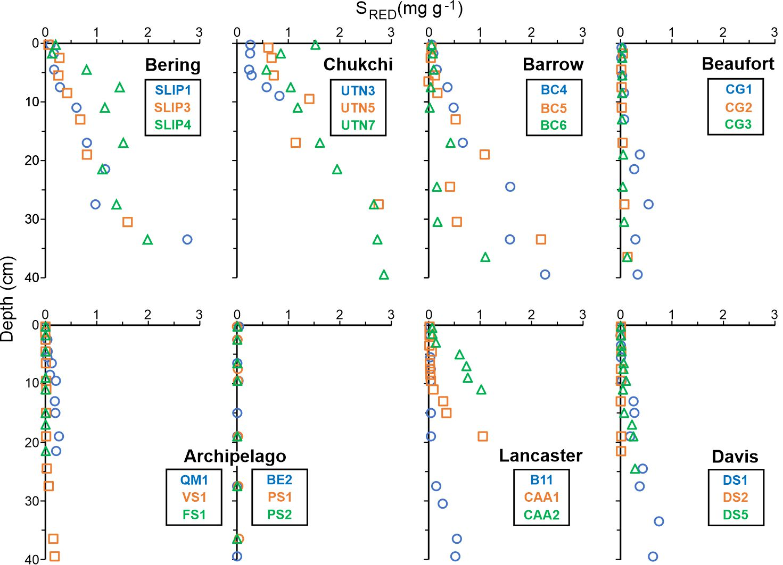

Fig. S3. Sediment core profiles of Fe associated to poorly and well-crystallized oxyhydroxides (Fe_{OX}), as determined through extraction with a sodium dithionite solution at pH ~4.7 (Macdonald and Gobeil, 2012), grouped by region. Core locations are shown in Fig. 1.

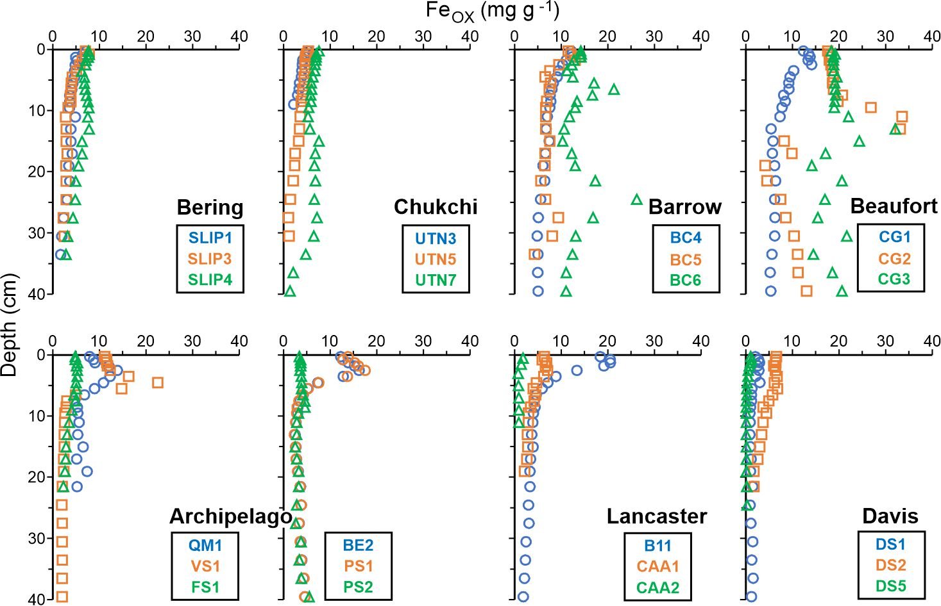

Fig. S4. Sediment core profiles of inorganic carbon (IC) grouped by region. Core locations are shown in Fig. 1.

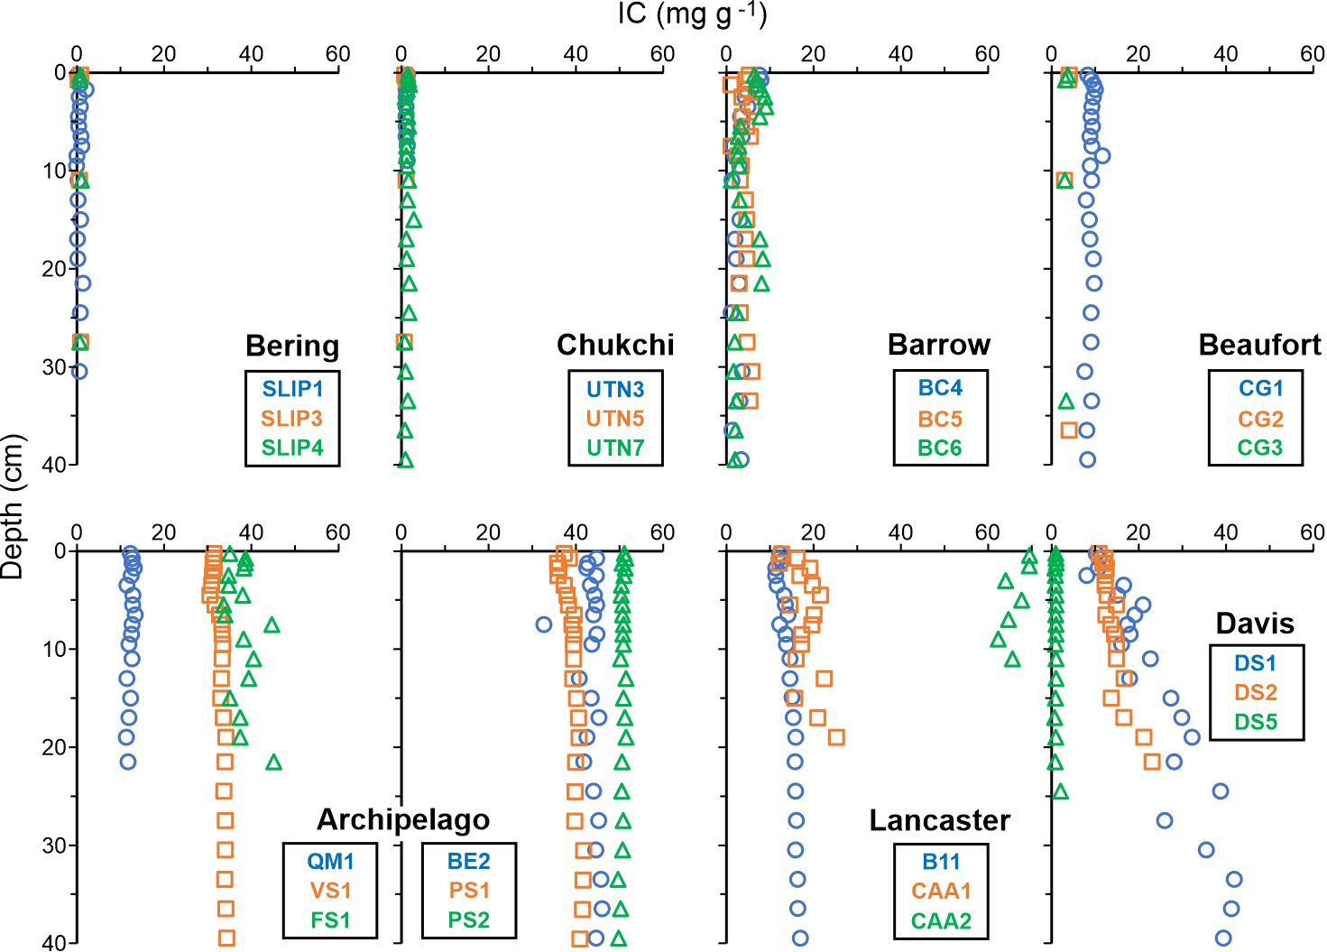

Fig. S5. Relationship between the Hg:OC ratio and the isotopic composition of organic carbon (ẟ¹³C) in sediments of the Bering and Chukchi Seas (orange square), the Barrow Canyon (brown diamond), the Beaufort Sea (green circle), the Canadian Archipelago (blue triangle), the Lancaster Sound (blue cross), and the Davis Strait (black asterisk). Note that results for the five cores from the interior of the Canadian Archipelago (VS1, FS1, BE2, PS2 and PS1), in which the inorganic carbon concentrations are particularly elevated, are not included in the calculations of the coefficient of determination (r²).

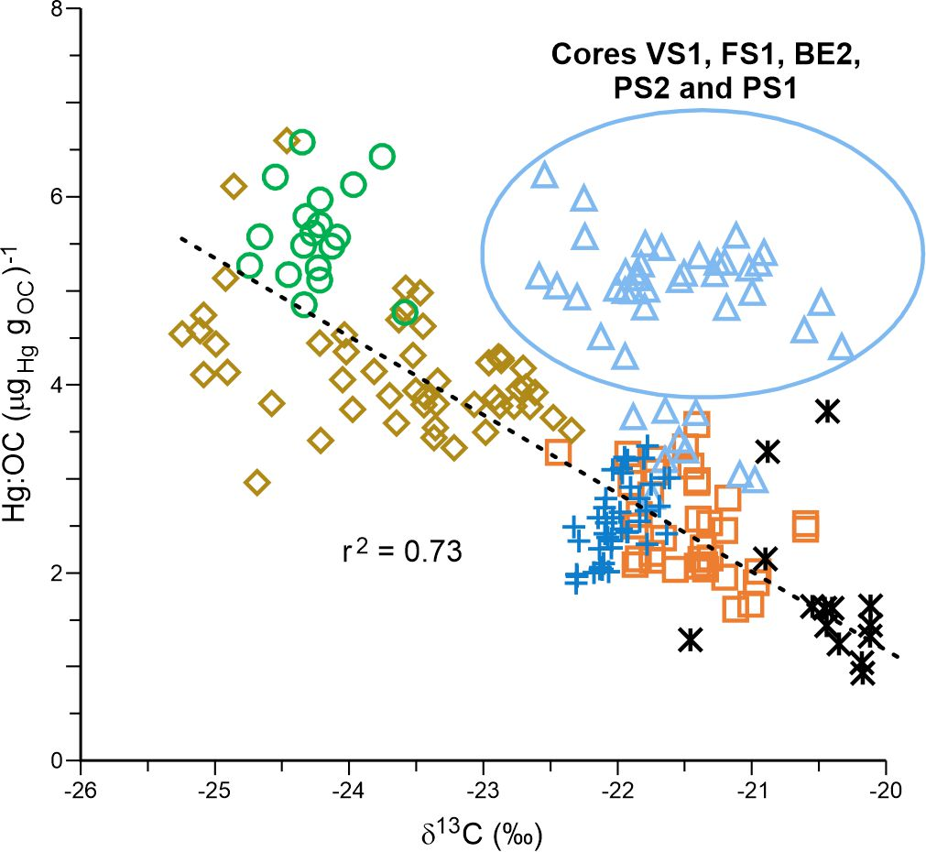

Fig. S6. Average concentrations of Hg associated to terrigenous organic carbon in black (Hg_{OCTERR}), marine organic carbon in red (Hg_{OCMAR}), inorganic carbon in grey (Hg_{IC}) and aluminosilicates (Hg_{Al}) in each of the cores, grouped by region. Core locations are shown in Fig. 1.

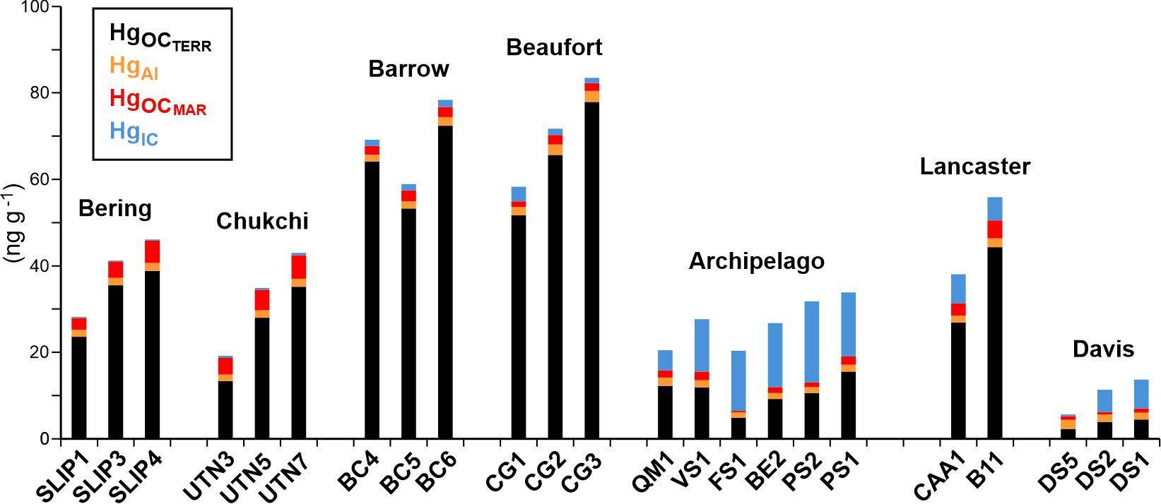

Fig. S7. Depth profiles of organic carbon (OC) and inorganic carbon (IC) in the cores from the Amerasian (11, 18 and 26) and Eurasian (35, 36 and 37) basins of the Arctic Ocean. These cores were collected at water depths varying between 2265 m and 4230 m. Core locations are shown in Fig. 1.

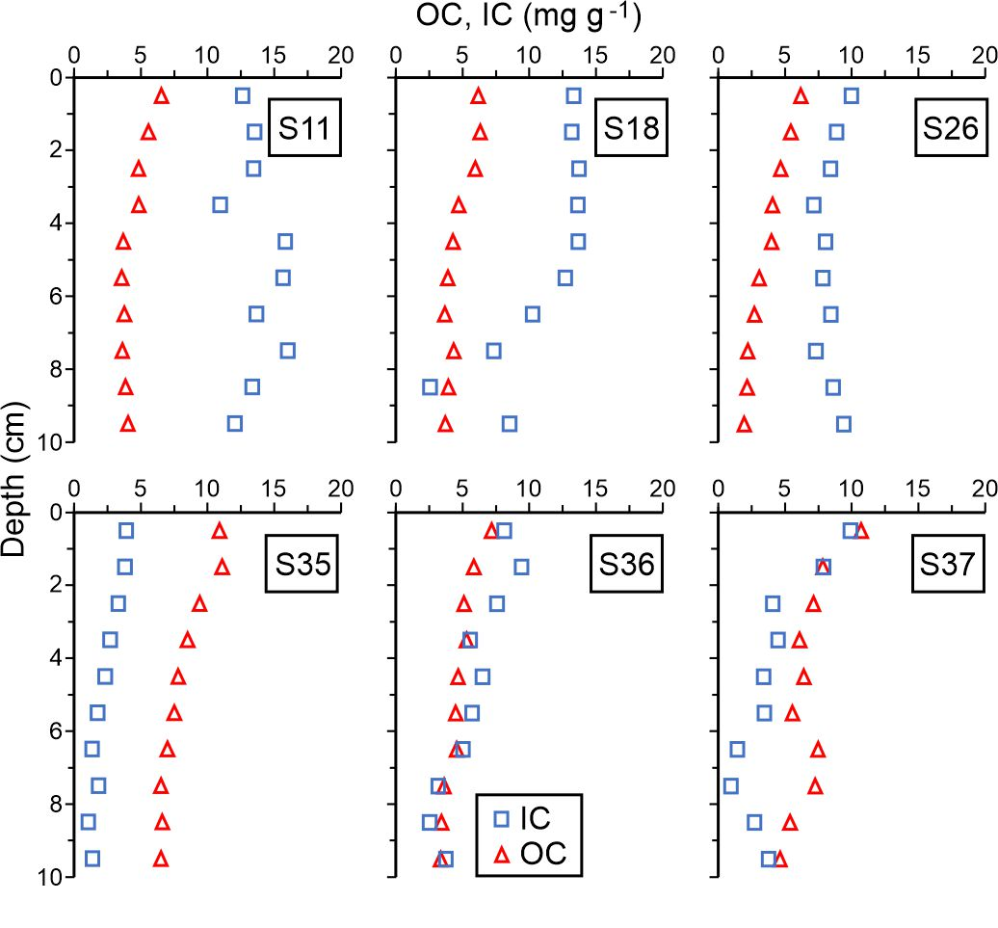
Fig. S8. Comparison between modelled and measured Hg concentrations in sediments samples from the Amerasian and Eurasian basins in the deep central Arctic Ocean. Core locations are shown on Fig. 1. Best fit between modelled and measured concentrations was obtained with terrigenous, marine and inorganic endmembers of 11.2 µg_{Hg} g_{OCTerr}⁻¹ and 0.80 µg_{Hg} g_{OCMAR}⁻¹, respectively.

