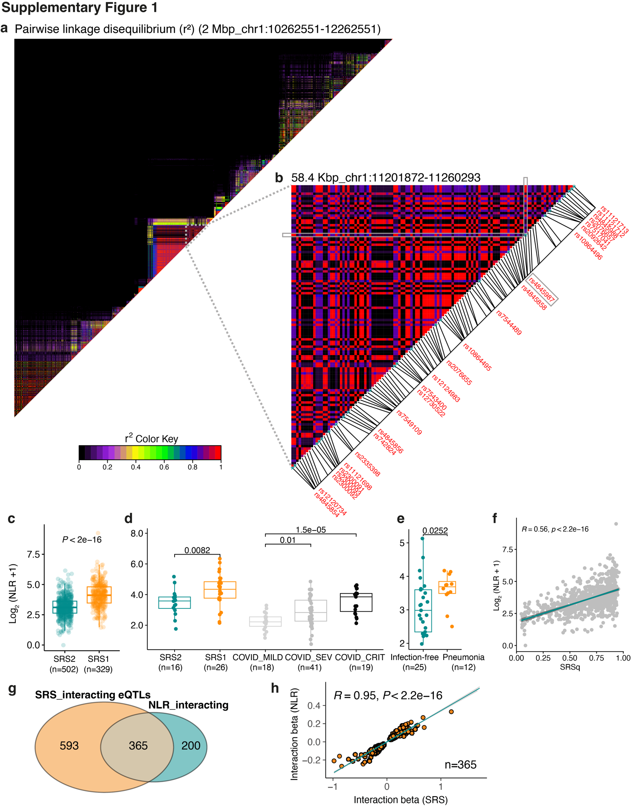
Fig. S1. (a) Pairwise linkage disequilibrium (r²) for SNPs tested for eQTL association at the MTOR gene locus (±1 Mbp from the MTOR transcription start site). r² was calculated using PLINK with GAinS genotype data (n=1,168) and visualised with LDheatmap. (b) A zoomed-in view of the locus containing the 25 MTOR lead eQTL variants (red text). rs4845987 is highlighted within the grey square. (c-e) Box plots showing the heightened N-to-T ratios are associated with severe disease. Cell counts from sepsis and COVID-19 patients were retrieved from GAinS cohort (c) and COMBAT Consortium³⁰ (d). 48h post-operative pneumonia data was obtained from Torrance & Zhang et al³¹ (e). (f) Correlation of log2 NLR and SRSq in samples derived from sepsis patients of the UK GAinS cohort (n=831). Pearson’s r and p values are shown. (g) Venn diagram showing the overlap of SRS-interacting and NLR-interacting eQTLs identified in sepsis patients (n=638). (h) Correlation of effect sizes of the shared SRS- and NLR-interacting eQTL associations.

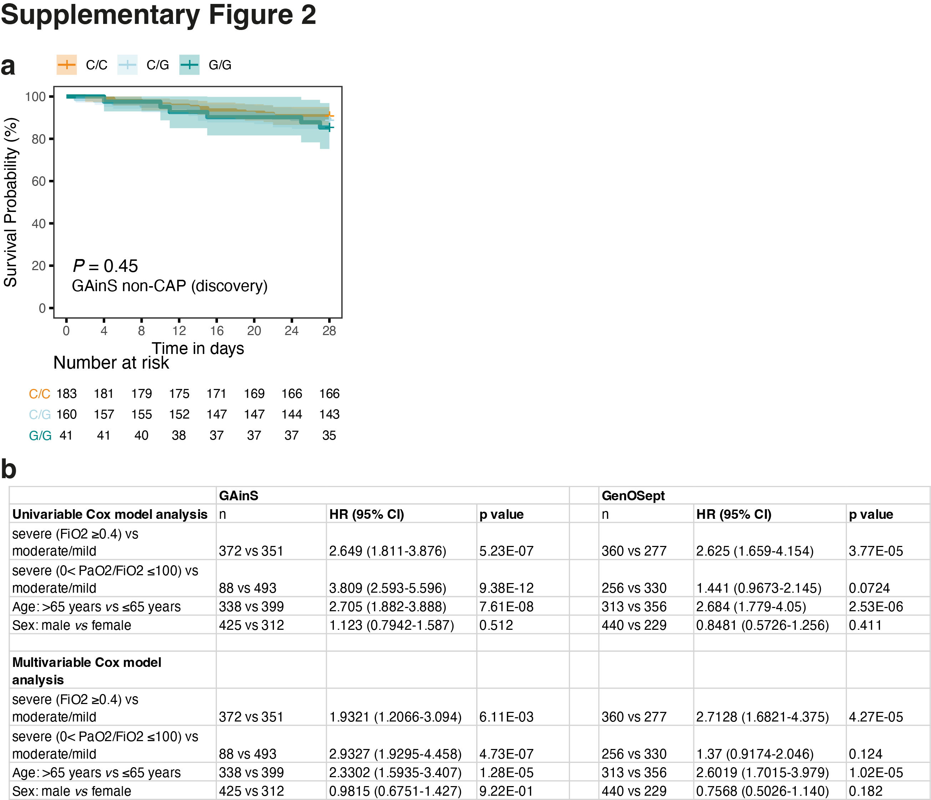
Fig. S2. (a) Kaplan–Meier curves for 28-day mortality in sepsis non-CAP patients of GAinS (n= 384) cohort with different alleles of the MTOR eQTL rs4845987. P value was calculated using cox regression adjusted for age and gender. (b) Cox regression analysis for hypoxia-related prognostic factors associated with sepsis 28-day mortality in GAinS (left) and GenOSept (right) sepsis CAP cohorts.

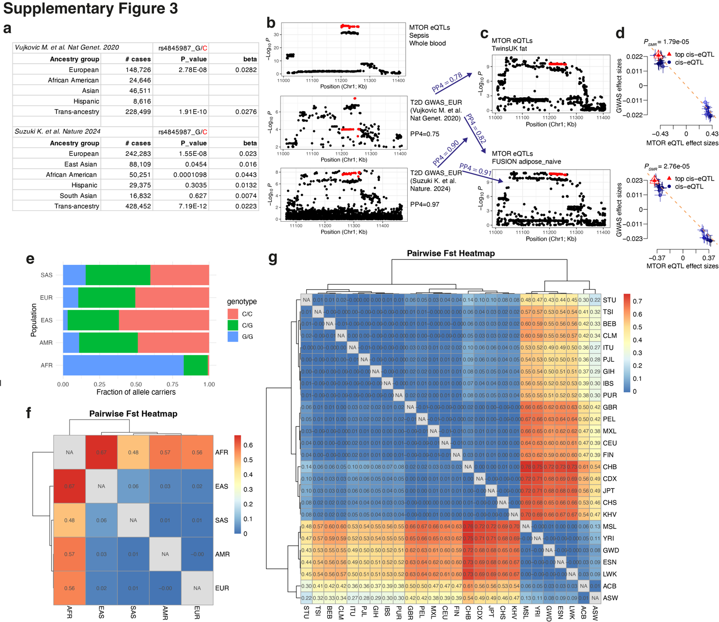
Fig. S3. (a) T2D GWAS association results for rs4845987 across different ancestral groups. The effect allele C was highlighted in red. (b-c) Regional plots showing the colocalisation of the MTOR eQTL associations in sepsis whole blood, GWAS risk SNPs for T2D (b), and MTOR eQTLs identified in adipose tissue (c). (d) Dot plots showing the effect sizes of SNPs used for the SMR/HEIDI analysis from T2D GWAS ⁴¹ on the y axis, against eQTL data in adipose tissue on the x axis. Error bars represent the standard errors of the SNP effects. (e) Fraction of rs4845987 allele carriers across the five superpopulations of the 1000 Genomes Project. Genotype data was downloaded from http://ftp.1000genomes.ebi.ac.uk/vol1/ftp/data_collections/1000_genomes_project/release/. (f-g) Heatmaps of pairwise Fst for the 25 MTOR lead eQTLs (r²>0.95) across 5 superpopulations (f), and 26 subpopulations (g) based on the 1000 Genomes Project data. Fst was calculated using Weir and Cockerham method as implemented in the R package hierfstat ⁵⁰. Abbreviations: AFR:African; AMR:American; EAS:East Asian; EUR:European; SAS:South Asian. ACB:African Caribbean; ASW:African Ancestry in Southwest US; BEB:Bengali; CDX:Dai Chinese; CEU:Utah residents (CEPH) with Northern and Western European; CHB:Han Chinese; CHS:Southern Han Chinese; CLM:Colombian; ESN:Esan in Nigeria; FIN:Finnish; GBR:British; GIH:Gujarati; GWD:Gambian Mandinka; IBS:Iberian; ITU:Telugu; JPT:Japanese; KHV:Kinh Vietnamese; LWK:Luhya; MSL:Mende; MXL:Mexican; PEL:Peruvian; PJL:Punjabi; PUR:Puerto Rican; STU:Tamil; TSI: Toscani; YRI: Yoruba.

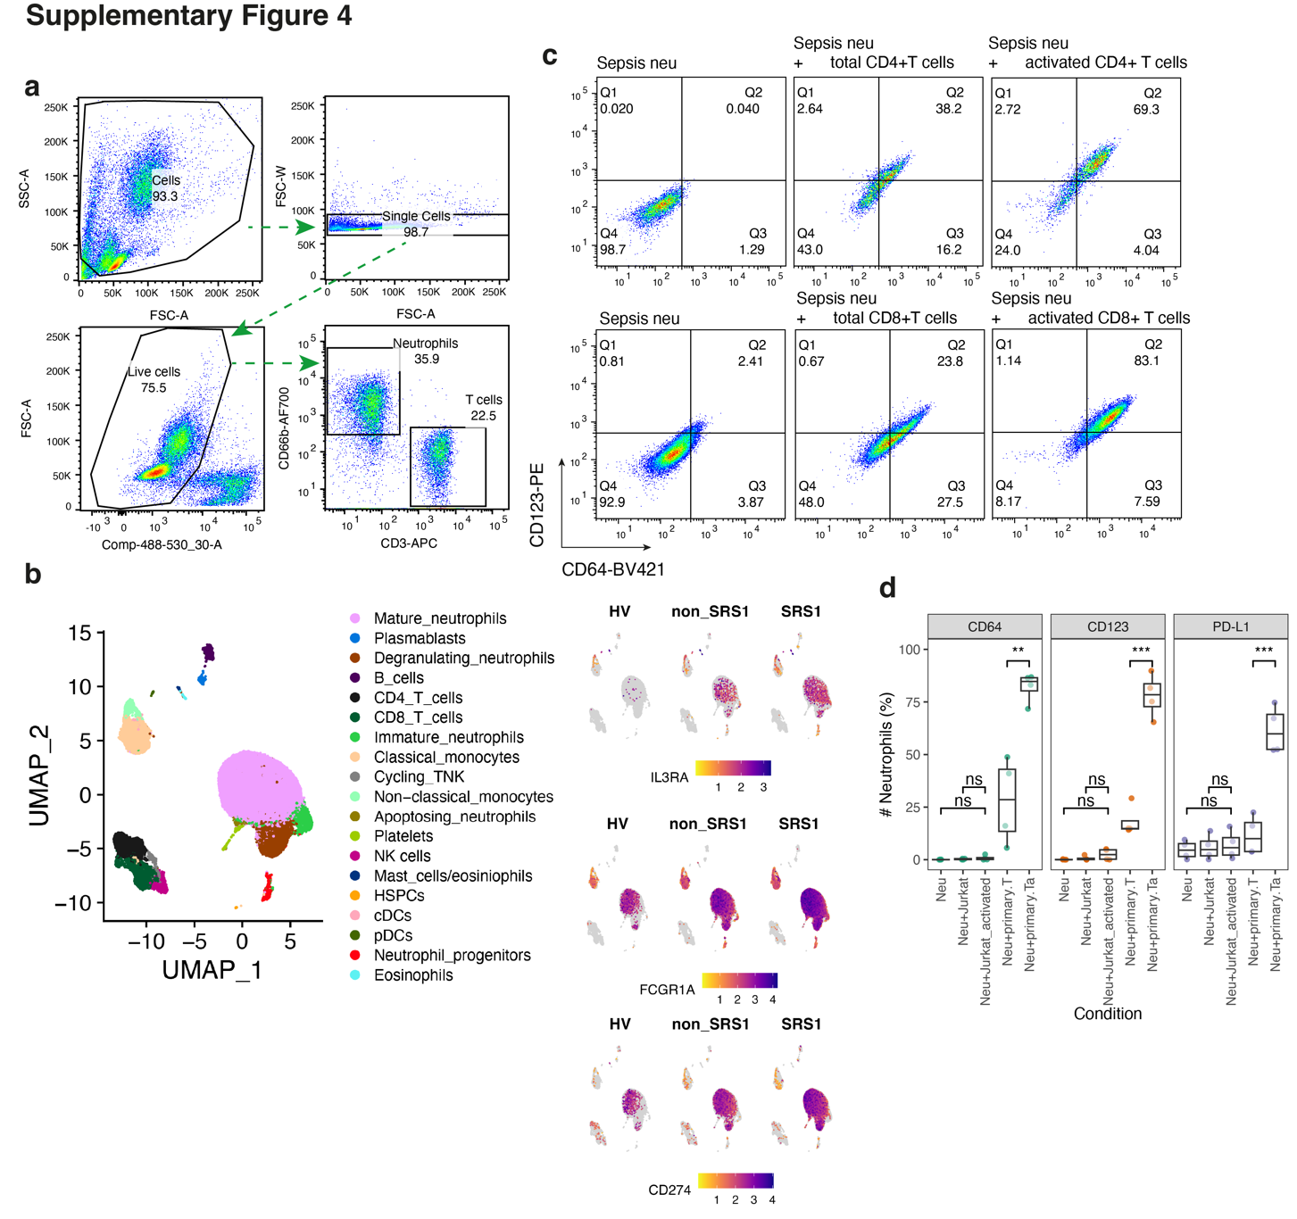
Fig. S4. (a) Flow cytometry gating strategy for Neu-to-T cell co-culture. (b) UMAP projection of the Kwok et al. whole blood sepsis scRNA-seq dataset ⁸ coloured according to broad cell lineages (upper left panel), and for the expression of IL3RA (encoding CD123), FCGR1A (CD64) and CD274 (PD-L1) in healthy volunteers (HV), non-SRS1 and SRS1 sepsis patients. Data was visualised using R packages Seurat and scCustomize. (c) Representative flow cytometry panels showing the upregulation of CD123 and CD64 expression on sepsis neutrophils co-cultured with allogeneic CD4+ (upper panels) or CD8+ (lower panels) T cell with or without TCR activation. (d) Bar plot showing the flow cytometry quantifications for CD64, CD123 and PD-L1 levels in sepsis neutrophils in the presence of Jurkat, or primary resting T cells with or w/o anti-CD3/CD28 Dynabeads. .

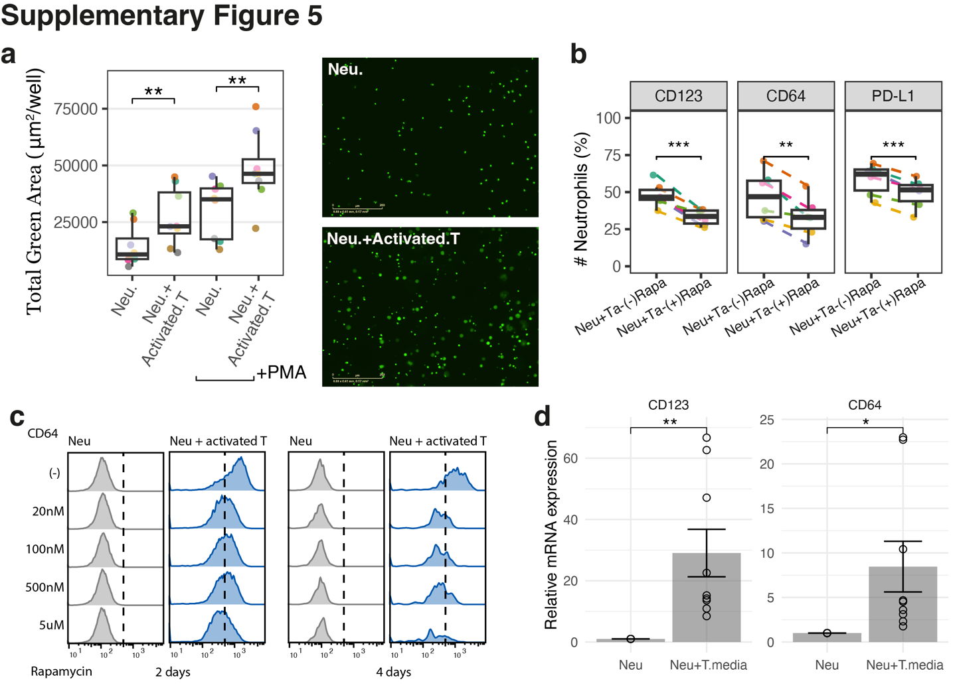
Fig. S5. (a) Quantification of NETosis using Incucyte S3 live cell analysis instrument and Cytotox green dye with or without PMA treatment for 4-6 hours (left panel), and the representative images (right panels) showing the enhanced NETosis on neutrophils when co-cultured with activated T cells. For quantification, the green objects <300 μm² (apoptotic cells) were filtered out. (b) Box plots showing the expression of markers on sepsis neutrophils in the presence of activated T cells with or w/o rapamycin pre-treatment (100nM for 2 days). P value was calculated by two-tailed paired t-test. (c) Flow cytometry histograms for the CD64 expression on sepsis neutrophil co-cultured with activated T cells in the presence of rapamycin with different concentrations for 2 days (left panels) or 4 days (right panels). (d) Bar plots of gene expression measured using qRT-PCR normalized to β-Actin (2^{–∆∆Ct}) in sepsis neutrophils in the presence of conditioned media from T cells treated with anti-CD3/CD28 beads for 2days. Error bars represent SEM of 9 independent replicates. P value was calculated by two-tailed t-test. *P<0.05; **P<0.01;***P<0.001.

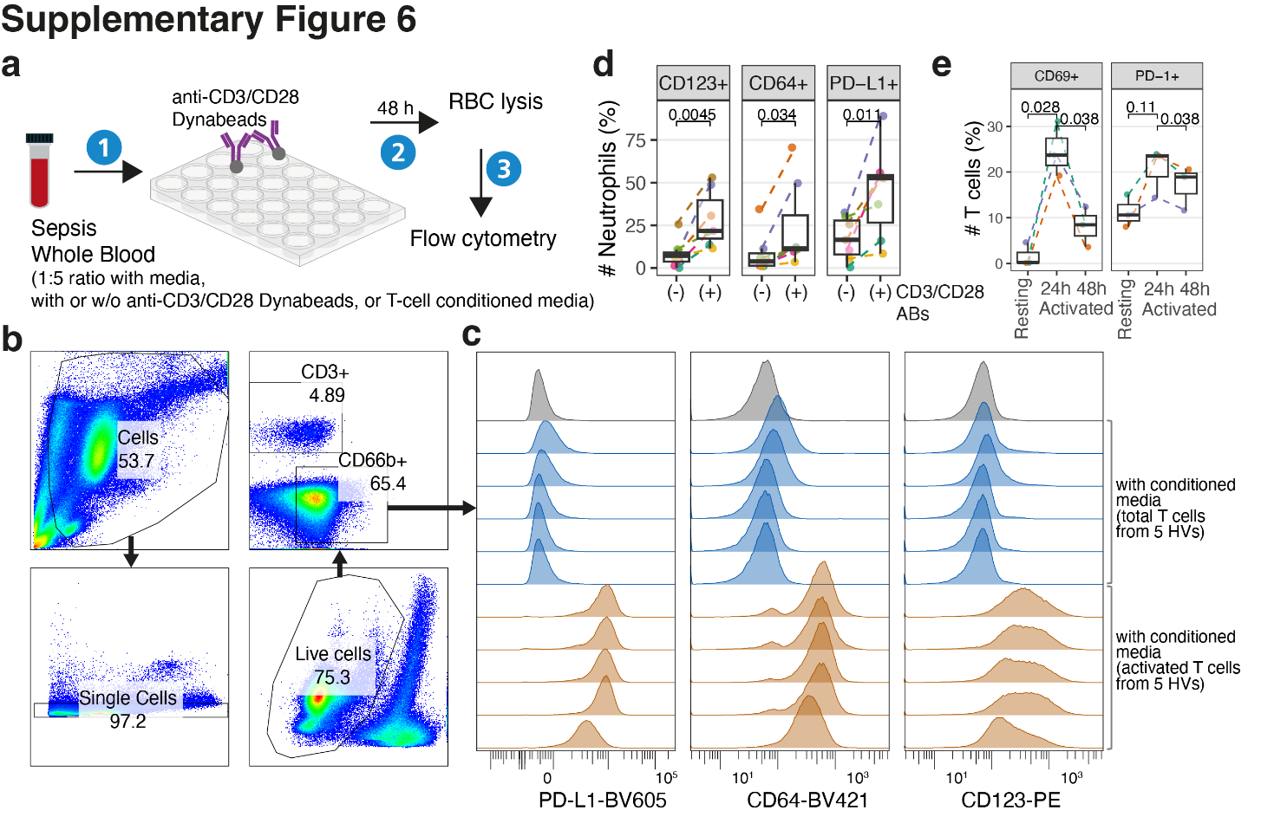
Fig. S6. (a) Schematic of ex vivo co-culture of sepsis whole blood with anti-CD3/CD28 Dynabeads or T cell conditioned media. (b-c) Sepsis whole blood collected by a BD Vacutainer EDTA tube was cultured in T cell media (grey), or conditioned media from either resting T cells (blue) or activated T cells (orange) at a 1:4 ratio for 48 hours. CD66b+ neutrophils were gated though flow cytometry, followed by quantification of surface markers PD-L1, CD64 and CD123. T cells derived from 5 different healthy donors were cultured with (activated) or without (resting) anti-CD3/CD28 Dynabeads at 1 x 10⁶ cells/ml. T cell conditioned media (supernatant) was harvested in 48 hours.
(d) Quantification of expression markers on CD66b+ neutrophils in whole blood from sepsis patients (n=7) with or without anti-CD3/CD28 T cell activation for 48 hours. (e) Quantification of CD69 and PD-1 expression on CD3+ T cells in sepsis whole blood (n=3) following anti-CD3/CD28 activation for 24 or 48 hours. P values were calculated using a two-tailed paired t-test.
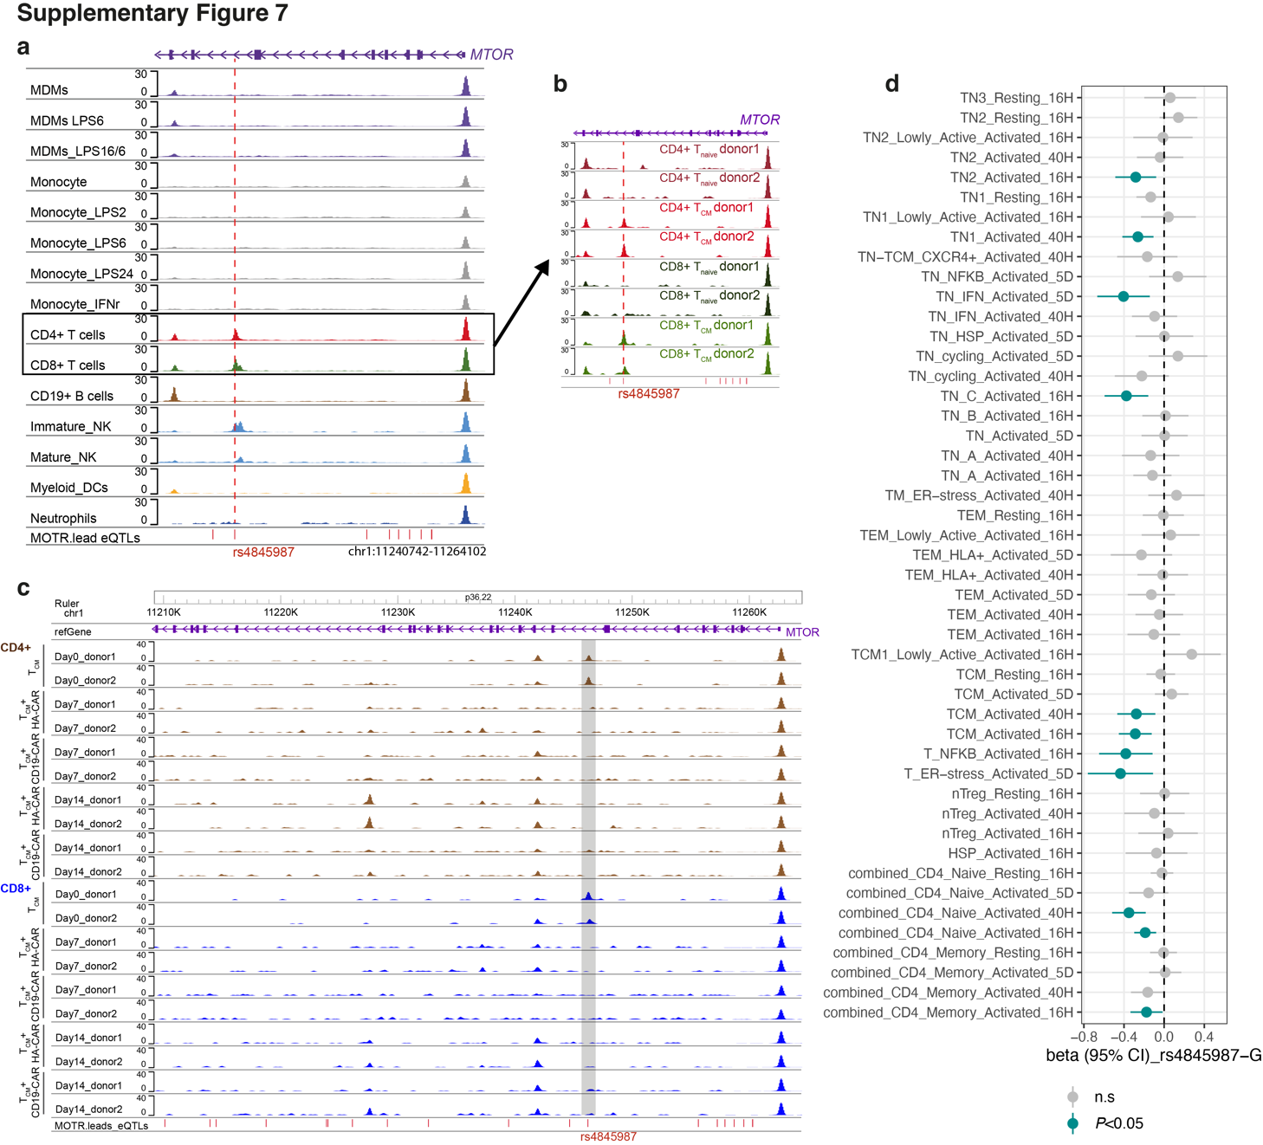
Fig. S7. (a) Genome browser tracks showing a MTOR eQTL (in red dashed line) resides in ATACseq peaks of CD4+ and CD8+ T cells. ATAC-seq raw data in different immune cells listed in Table S6, were uniformly processed (see Method) and the average sequencing depth for each dataset is shown on the y axis. (b-c) ATAC-seq tracks showing the variant-containing enhancer of the MTOR locus in CD4+ and CD8+ central memory T (T_{CM}) cells derived from two different healthy donors (b), followed by GD2-targeting (HA-28ζ) and CD19-targeting (CD19-28ζ) CAR T cell production with anti-CD3/CD28 Dynabeads (c). Sequencing data were downloaded from GSE168882⁵⁸. (d) eQTL associations for MTOR across CD4+ T cell subsets based on a sc-RNAseq dataset⁵⁹. Cells were activated with anti-CD3/CD28 Dynabeads for 16 hours (16H), 40 hours (40H) or 5 days (5D). Association data were retrieved from eQTL Catalogue³².

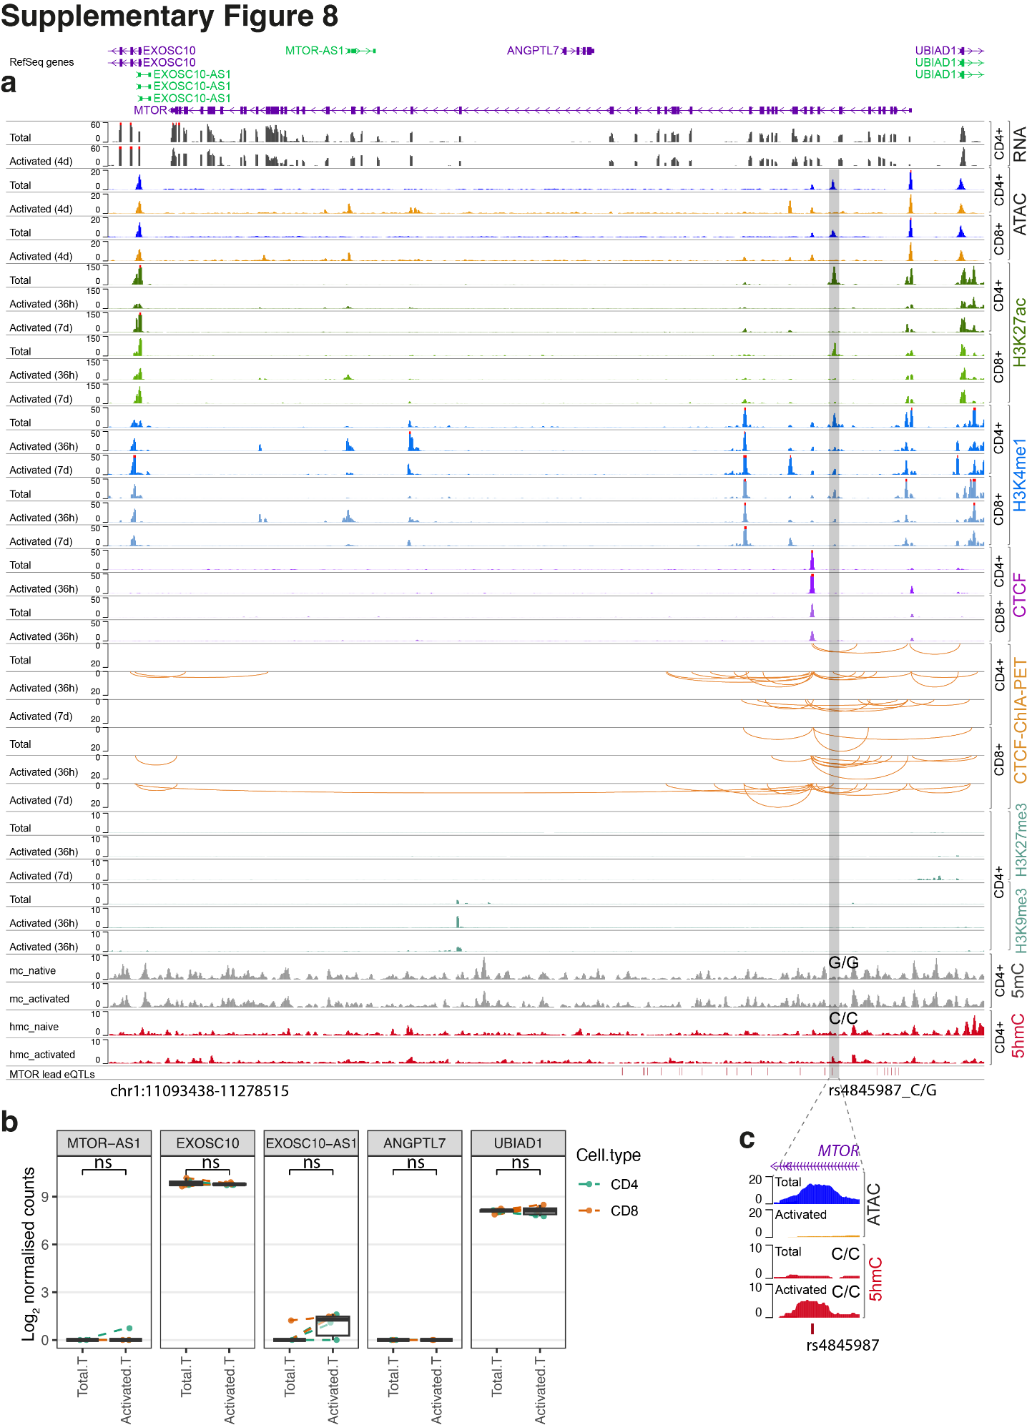
Fig. S8. (a) Genome browser tracks showing the variant-containing enhancer (highlighted in grey) in the MTOR locus. Processed signal files for histone modifications and CTCF ChIP-seq and CTCF ChIA-PET looping data were downloaded from the Encyclopedia of DNA Elements (ENCODE) project⁵⁷ (Table S7). Only interaction loops with PET count score more than or equal to 5 are shown. (b) Box plot showing the expression changes of the enhancer-surrounding gene transcripts including MTOR-AS1, EXOSC10, EXOSC10-AS1, ANGPTL7 and UBIAD1 in T cells upon activation (n=6 from 3 healthy donors). (c) MeDIP-seq data for 5mC and 5hmC modifications in resting and activated CD4+ T cells (anti-CD3/CD28 for 2-3days) (GSE74850)⁶⁰ were analysed as described in the Methods section. Sample genotype was determined using the aligned sequence reads.

