Supplementary material

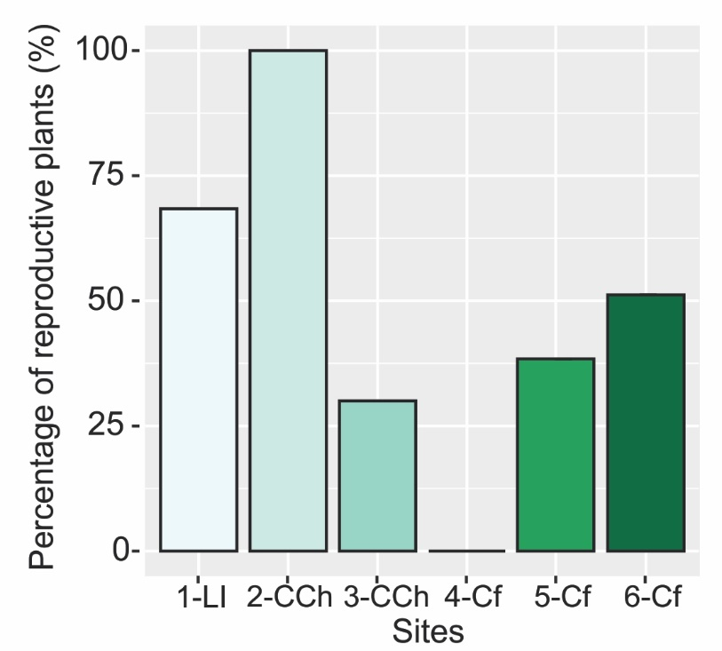
Fig. S1 Analysis of percentage of reproductive individuals of M. pyrifera from different sites along the Comau Fjord. Abbreviations: Lilihuapi Island (1-LI), Cahuelmo sector (2-CCh, 3-CCh), Comau Fjord interior (4-Cf, 5-Cf and 6-Cf). Values are means ± C.I., n= 126.

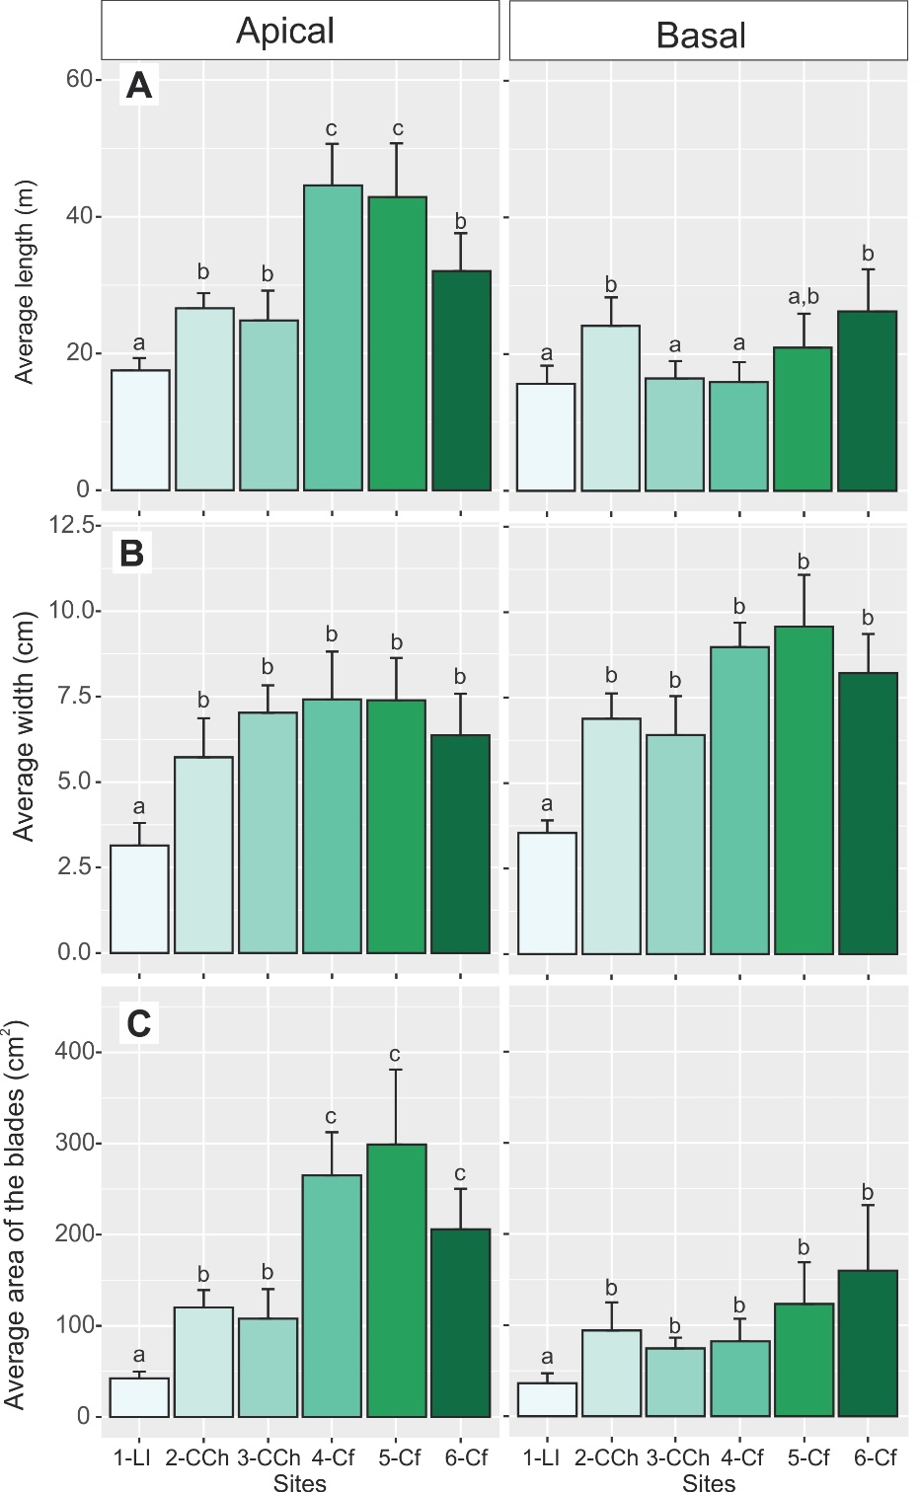
Fig. S2 Variation in (A) length (m), (B) width (cm), and (C) area (cm²) for blade type (Apical and Basal) of M. pyrifera in the different sites along the Comau Fjord. Abbreviations: Lilihuapi Island (1-Li), Cahuelmo sector (2-CCh, 3-CCh), Comau Fjord inside (4-Cf, 5-Cf and 6-Cf). Values are means ± C.I., n= 196. Different letters denote significant mean differences (p < 0.05) among means according to post hoc Tukey's HSD test.

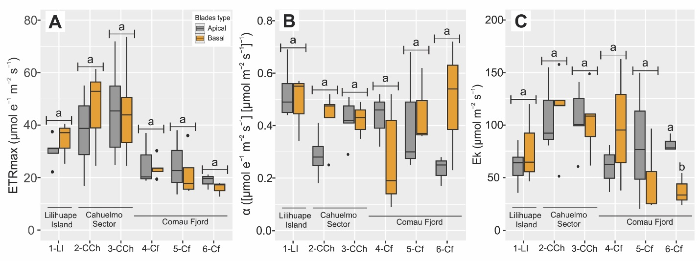

Fig. S3 Photochemical characterization of M. pyrifera based on fluorescence at different sites along a Comau fjord measured in situ using a Diving-PAM according to blade type (Apical and Basal). ETR-based P-E curve parameters, (A) Electron Transfer Rate-ETR_{max}, (B) Photosynthetic efficiency-α, and (C) Photochemical Saturation-E_{k}. All recorded parameters correspond to mean values ± CI (n= 8). Abbreviations: Lilihuapi Island (1-Li), Cahuelmo sector (2-CCh, 3-CCh), Comau Fjord inside (4-Cf, 5-Cf and 6-Cf). Different letters denote significant mean differences (p < 0.05) among means according to post hoc Tukey's HSD test.

Table S1 Results of the analysis of morphometric characteristics at (A) individual level of total length (m), wet biomass (kg/ind.), diameter and height maximum of holdfast (cm), number of stipes, reproductive condition and (B) blades morphological characteristics of M. pyrifera from different sampling sites along the Comau Fjord. Abbreviations: Lilihuapi Island (1-LI), Cahuelmo sector (2-CCh, 3-CCh), Comau Fjord interior (4-Cf, 5-Cf and 6-Cf). Values are means ± C.I., n= 126. Different letters denote significant mean differences (p < 0.05) among means according to post hoc Tukey's HSD test.

A) Morphological Thallu, n = 126
Sites |  | 1-Li | 2-CCh | 3-CCh | 4-Cf | 5-Cf | 6-Cf
Number plants |  | 19 | 7 | 21 | 25 | 13 | 41
Size (m) |  | 0.71 ± 0.12 (a) | 3.19 ± 0.24(b) | 0.98 ± 0.21(a) | 1.12 ± 0.23(a) | 1.35 ± 0.31(a) | 1.31 ± 0.27(a)
Wet biomass (g) |  | 58.95 ± 18.24 (a) | 554.70 ± 158.52(b) | 103.82 ± 42.27(a) | 80.96 ± 22.13(a) | 158.05 ± 86.81(a) | 206.31 ± 76.21(a)
Maximun holdfast diamter (cm) |  | 2.18 ± 0.25(a,b) | 2.97 ± 0.53(a) | 1.63 ± 0.32(b,c) | 1.86 ± 0.38(a,c) | 2.70 ± 0.81(a,b) | 1.94 ± 0.41(a,b,c)
Maximum holdfast height (cm) |  | 0.91 ± 0.14(a) | 1.75 ± 0.54(b) | 1.10 ± 0.22(a,b) | 1.26 ± 0.21(a,b) | 1.79 ± 0.56(a,b) | 1.18 ± 0.27(a,b)
Number stipes |  | 2.31 ± 0.39(a,b) | 3.71 ± 0.45(a) | 3.66 ± 0.85(a) | 1.95 ± 0.33(b) | 2.66 ± 0.78(a,b) | 3.08 ± 0.68(a)
Reproductive State (%) |  | 68.4 | 100 | 30 | 0 | 38.4 | 51.2
B) Morphological Blades, n = 196
Sites |  | 1-Li | 2-CCh | 3-CCh | 4-Cf | 5-Cf | 6-Cf
Number blades |  | 37 | 39 | 34 | 27 | 26 | 29
Blade Length (cm) | Apical | 17.52 ± 1.81(a) | 26.61 ± 2.19(b) | 24.84 ± 4.35(b) | 44.59 ± 6.08(c) | 42.88 ± 7.85(c) | 32.04 ± 5.54(b)
Blade Length (cm) | Basal | 15.67 ± 2.63(a) | 24.14 ± 4.15(b) | 16.43 ± 2.55(a) | 15.90 ± 2.90(a) | 20.94 ± 4.98(a,b) | 26.23 ± 6.17(b)
Blade Length (cm) | All | 17.02 ± 1.46(a) | 25.72 ± 1.97(b,c) | 20.39 ± 2.75(a,c) | 29.72 ± 6.53(b) | 31.91 ± 6.24(b) | 29.84 ± 4.06(b)
Blade Width (cm) | Apical | 3.54 ± 0.36(a) | 6.88 ± 0.74(b) | 6.40 ± 1.13(b) | 8.97 ± 0.71(b) | 9.58 ± 1.51(b) | 8.21 ± 1.14(b)
Blade Width (cm) | Basal | 3.14 ± 0.65(a) | 5.72 ± 1.14(a) | 7.02 ± 0.80(b) | 7.41 ± 1.40(b) | 7.39 ± 1.23(b) | 6.36 ± 1.21(b)
Blade Width (cm) | All | 3.43 ± 0.30(a) | 6.46 ± 0.62(b) | 6.73 ± 0.65(b) | 8.16 ± 0.81(c) | 8.48 ± 1.01(c) | 7.51 ± 0.86(b,c)
Blade Area (cm²) | Apical | 42.31 ±7.55(a) | 120.23 ± 18.99(b) | 107.82 ± 32.46(b) | 265.016 ± 47.36(c) | 298.86 ± 82.23(c) | 205.80 ± 44.52(c)
Blade Area (cm²) | Basal | 36.26 ± 10.97(a) | 94.18 ± 30.79(b) | 74.48 ± 11.79(b) | 82.22 ± 24.77(b) | 123.18 ± 45.76(b) | 159.74 ± 71.93(b)
Blade Area (cm²) | All | 40.68 ± 6.05(a) | 110.88 ± 16.11(b) | 90.17 ± 16.59(b) | 170.23 ± 44.08(c) | 211.02 ± 56.64(c) | 188.33 ± 37.03(c)

Table S2 Results of the statistical analysis for the comparison between the type blades (Apical and Basal) of M. pyrifera from the different sampling sites in Comau Fjord considering their morphometry (n= 196 blades). Abbreviations: Lilihuapi Island (1-LI), Cahuelmo sector (2-CCh, 3-CCh), Comau Fjord interior (4-Cf, 5-Cf and 6-Cf). Results of one-factor ANOVA (α = 0.05) are included. *DF degrees of freedom, SE standard error, MS mean squares, F F statistic; p values in bold indicate significant differences (p < 0.05).

Variable |  | ANOVA
 |  | DF | SE | MS | F | Pr(>F)
Blades type | 1-Li x length | 35 | 4.3660 | 0.03631 | 1.3190 | 0.2586
Blades type | 1-Li x width | 35 | 0.9218 | 0.0373 | 1.3570 | 0.2519
Blades type | 1-Li x area | 35 | 18.2100 | 0.0225 | 0.8060 | 0.3754
Blades type | 2-CCh x length | 38 | 5.9680 | 0.0392 | 1.5490 | 0.2210
Blades type | 2-CCh x width | 38 | 1.8400 | 0.08584 | 3.568 | 0.0665
Blades type | 2-CCh x area | 38 | 48.1200 | 0.06332 | 2.569 | 0.1173
Blades type | 3-CCh x length | 32 | 6.7370 | 0.2916 | 13.17 | 0.0010
Blades type | 3-CCh x width | 32 | 0.1139 | 0.04031 | 1.344 | 0.2549
Blades type | 3-CCh x area | 32 | 0.1937 | 0.09847 | 3.495 | 0.0707
Blades type | 4-Cf x length | 25 | 7.8610 | 0.7822 | 89.8 | < 0.0001
Blades type | 4-Cf x width | 25 | 1.9300 | 0.1501 | 4.414 | 0.0459
Blades type | 4-Cf x area | 25 | 62.5100 | 0.6975 | 57.64 | < 0.0001
Blades type | 5-Cf x length | 24 | 0.1545 | 0.5423 | 28.43 | < 0.0001
Blades type | 5-Cf x width | 24 | 2.287 | 0.1986 | 5.948 | 0.0225
Blades type | 5-Cf x area | 24 | 0.2408 | 0.4579 | 20.27 | 0.0001
Blades type | 6-Cf x length | 27 | 0.06311 | 0.1536 | 1.819 | 0.1887
Blades type | 6-Cf x width | 27 | 0.1117 | 0.2015 | 6.814 | 0.0146
Blades type | 6-Cf x area | 27 | 96.4 | 0.05457 | 1.558 | 0.2226

Table S3 Characterization of the water column of the Comau Fjord up to 6 meters of depth at two recording stations (Lilihuapi Island and Huinay Coastal Station). The information collected corresponds to a dataset available from the research Laudien et al. (2017). Data description: Physical oceanographic profiles of seven CTD casts for Comau Fjord in 2011. Alfred Wegener Institute, Helmholtz Centre for Polar and Marine Research, Bremerhaven, PANGAEA, https://doi.org/10.1594/PANGAEA.884120. Bentho-Pelagic Processes @ AWI (AWI_BPP) (URI: https://www.awi.de/en/science/biosciences.html).
Site | Date/Time | Latitude | Longitude | Depth water  [m] | Temp  [°C] | Salinity  [PSU] | PAR  [µmol m⁻²s⁻¹] | Average |  |  | Attenuation PAR [%]
 |  |  |  |  |  |  |  | Temp  [°C] | Salinity  [PSU] | PAR  [µmol m⁻²s⁻¹] | Attenuation PAR [%]
Lilihuapi_2 | 2011-02-24T16:12 | -42.177 | -72.588 | 0.338 | 17.604 | 27.546 | 151.460 | 16.976±0.641 | 28.340±0.641 | 285.594±138.941 | 31.747
Lilihuapi_2 | 2011-02-24T16:12 | -42.177 | -72.588 | 0.633 | 17.603 | 27.553 | 143.400
Lilihuapi_2 | 2011-02-24T16:12 | -42.177 | -72.588 | 0.73 | 17.606 | 27.552 | 142.620
Lilihuapi_2 | 2011-02-24T16:12 | -42.177 | -72.588 | 0.957 | 17.609 | 27.551 | 174.260
Lilihuapi_2 | 2011-02-24T16:12 | -42.177 | -72.588 | 1.403 | 17.604 | 27.544 | 156.630
Lilihuapi_2 | 2011-02-24T16:12 | -42.177 | -72.588 | 1.962 | 17.558 | 27.501 | 165.980
Lilihuapi_2 | 2011-02-24T16:12 | -42.177 | -72.588 | 2.454 | 17.342 | 27.568 | 210.650
Lilihuapi_2 | 2011-02-24T16:12 | -42.177 | -72.588 | 2.957 | 17.024 | 27.870 | 246.830
Lilihuapi_2 | 2011-02-24T16:12 | -42.177 | -72.588 | 3.364 | 16.872 | 28.064 | 277.870
Lilihuapi_2 | 2011-02-24T16:12 | -42.177 | -72.588 | 3.925 | 16.788 | 28.267 | 307.900
Lilihuapi_2 | 2011-02-24T16:12 | -42.177 | -72.588 | 4.542 | 16.629 | 28.983 | 498.410
Lilihuapi_2 | 2011-02-24T16:12 | -42.177 | -72.588 | 5.159 | 16.317 | 29.555 | 506.710
Lilihuapi_2 | 2011-02-24T16:12 | -42.177 | -72.588 | 5.69 | 16.123 | 29.710 | 453.450
Lilihuapi_2 | 2011-02-24T16:12 | -42.177 | -72.588 | 5.874 | 16.034 | 29.839 | 422.530
Lilihuapi_2 | 2011-02-24T16:12 | -42.177 | -72.588 | 6.128 | 15.932 | 29.999 | 425.210
X-Huinay_3 | 2011-03-08T16:02 | -42.390 | -72.447 | 0.269 | 18.937 | 22.574 | 94.750 | 18.555±0.406 | 24.342±1.786 | 194.926±32.281
X-Huinay_3 | 2011-03-08T16:02 | -42.390 | -72.447 | 0.281 | 18.938 | 22.573 | 199.130
X-Huinay_3 | 2011-03-08T16:02 | -42.390 | -72.447 | 0.38 | 18.938 | 22.572 | 188.510
X-Huinay_3 | 2011-03-08T16:02 | -42.390 | -72.447 | 0.368 | 18.938 | 22.571 | 110.090
X-Huinay_3 | 2011-03-08T16:02 | -42.390 | -72.447 | 0.591 | 18.939 | 22.571 | 179.230
X-Huinay_3 | 2011-03-08T16:02 | -42.390 | -72.447 | 1.166 | 18.941 | 22.573 | 165.920
X-Huinay_3 | 2011-03-08T16:02 | -42.390 | -72.447 | 1.796 | 18.941 | 22.571 | 183.730
X-Huinay_3 | 2011-03-08T16:02 | -42.390 | -72.447 | 2.215 | 18.941 | 22.573 | 212.700
X-Huinay_3 | 2011-03-08T16:02 | -42.390 | -72.447 | 2.707 | 18.942 | 22.577 | 225.360
X-Huinay_3 | 2011-03-08T16:02 | -42.390 | -72.447 | 3.076 | 18.939 | 22.589 | 229.80
X-Huinay_3 | 2011-03-08T16:02 | -42.390 | -72.447 | 3.585 | 18.934 | 22.623 | 219.030
X-Huinay_3 | 2011-03-08T16:02 | -42.390 | -72.447 | 4.081 | 18.898 | 23.005 | 225.080
X-Huinay_3 | 2011-03-08T16:02 | -42.390 | -72.447 | 4.447 | 18.788 | 23.618 | 225.400
X-Huinay_3 | 2011-03-08T16:02 | -42.390 | -72.447 | 4.726 | 18.565 | 25.122 | 215.900
X-Huinay_3 | 2011-03-08T16:02 | -42.390 | -72.447 | 5.027 | 18.305 | 25.957 | 203.200
X-Huinay_3 | 2011-03-08T16:02 | -42.390 | -72.447 | 5.027 | 18.153 | 26.166 | 196.010
X-Huinay_3 | 2011-03-08T16:02 | -42.390 | -72.447 | 5.027 | 18.107 | 26.191 | 202.060
X-Huinay_3 | 2011-03-08T16:02 | -42.390 | -72.447 | 4.985 | 18.115 | 26.129 | 205.930
X-Huinay_3 | 2011-03-08T16:02 | -42.390 | -72.447 | 5.021 | 18.120 | 26.066 | 206.510
X-Huinay_3 | 2011-03-08T16:02 | -42.390 | -72.447 | 5.041 | 18.117 | 26.170 | 202.520
X-Huinay_3 | 2011-03-08T16:02 | -42.390 | -72.447 | 5.027 | 18.099 | 26.234 | 199.690
X-Huinay_3 | 2011-03-08T16:02 | -42.390 | -72.447 | 5.041 | 18.097 | 26.176 | 206.360
X-Huinay_3 | 2011-03-08T16:02 | -42.390 | -72.447 | 5.168 | 18.102 | 26.178 | 208.950
X-Huinay_3 | 2011-03-08T16:02 | -42.390 | -72.447 | 5.596 | 18.091 | 26.294 | 192.290
X-Huinay_3 | 2011-03-08T16:02 | -42.390 | -72.447 | 6.087 | 17.991 | 26.876 | 175.000

Table S4. Results of analysis of variance (ANOVA) for comparisons between blade types (Apical and Basal) considering physiological characteristics for each sampling site of M. pyrifera in Comau Fjord (n = 8). Abbreviations: Lilihuapi Island (1-LI), Cahuelmo sector (2-CCh, 3-CCh), Comau Fjord interior (4-Cf, 5-Cf and 6-Cf). The results of one-way ANOVA data are included (α = 0.05). *DF degrees of freedom, SE standard error, MS mean squares, F F statistic; P values in bold indicate significant differences (p < 0.05).

 |  | ANOVA
Sites | Variable | DF | SE | MS | F | Pr(>F)
 | ETR_{max} | 6 | 5.9760 | 0.1017 | 0.6790 | 0.4415
1-Li | α | 6 | 0.1118 | 0.0372 | 0.2321 | 0.6470
 | E_{k} | 6 | 26.9100 | 0.0968 | 0.6427 | 0.4533
 | ETR_{max} | 7 | 15.6500 | 0.1043 | 0.8147 | 0.3967
2-CCh | α | 7 | 0.1017 | 0.3907 | 4.4890 | 0.0719
 | E_{k} | 7 | 48.3300 | 0.0506 | 0.3731 | 0.5606
 | ETR_{max} | 10 | 17.6400 | 0.0005 | 0.0045 | 0.9477
3-CCh | α | 10 | 0.0671 | 0.0001 | 0.0002 | 0.9997
 | E_{k} | 10 | 29.1700 | 0.0016 | 0.0159 | 0.9021
 | ETR_{max} | 6 | 6.6660 | 0.0166 | 0.1015 | 0.7608
4-Cf | α | 6 | 0.1642 | 0.2318 | 1.8100 | 0.2271
 | E_{k} | 6 | 76.5300 | 0.2240 | 1.7320 | 0.2362
 | ETR_{max} | 6 | 10.8900 | 0.0279 | 0.1435 | 0.7204
5-Cf | α | 6 | 0.2266 | 0.1049 | 0.5863 | 0.4784
 | E_{k} | 6 | 48.8800 | 0.1514 | 0.8923 | 0.3882
 | ETR_{max} | 5 | 2.8590 | 0.2678 | 1.4630 | 0.2931
6-Cf | α | 5 | 0.1798 | 0.4458 | 3.2170 | 0.1473
 | E_{k} | 5 | 12.6300 | 0.8251 | 18.8800 | 0.0122

