Table of Contents
Supplemental Figures for
A multi-trait genome wide association scan of coronary artery disease and subclinical atherosclerosis traits.

Supplemental Figure 1. Manhattan Plots for Stage 1 Mult-trait GWASs 2
Supplemental Figure 2. Manhattan Plots for Stage 2 Mult-trait GWASs 3
Supplemental Figure 3. Manhattan Plots for Stage 3 Mult-trait GWASs 4

Supplemental Figure 1. Manhattan Plots for Stage 1 Mult-trait Genome-wide Association Studies

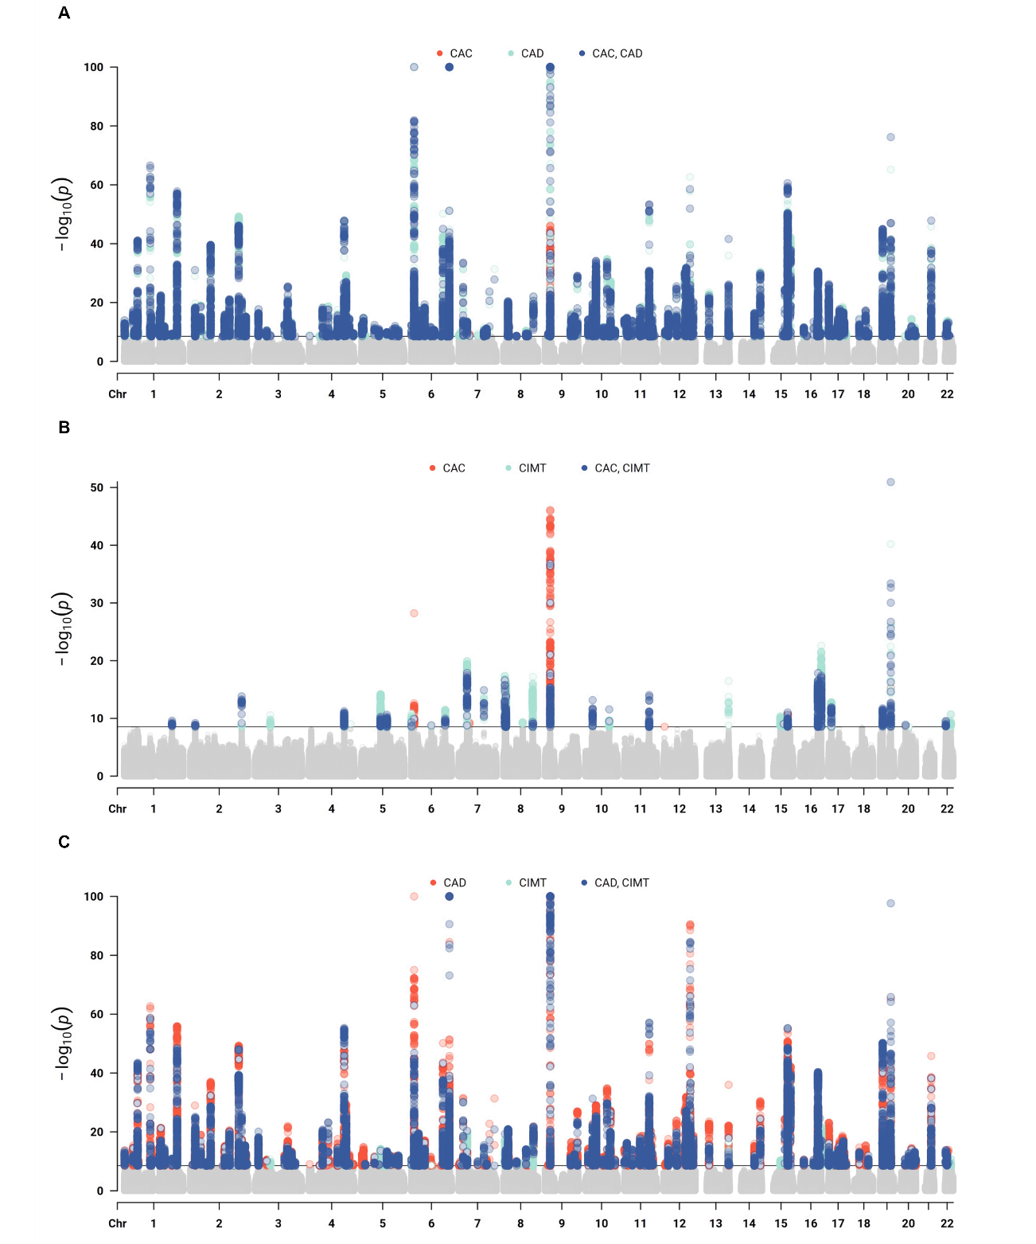
Abbreviations: CAC, coronary artery calcification; CAD, coronary artery disease; CIMT, carotid intima media thickness; GWASs, genome-wide association studies
Supplemental Figure 1 represents the results from the multi-trait genome-wide association studies (GWASs) conducted in Stage 1. Panel A is a Manhattan plot summarizing coronary artery calcification (CAC) and coronary artery disease (CAD) analysis. Panel B represents CAC and carotid intima media thickness (CIMT) analysis. Panel C is CAD and CIMT analysis. Red and light blue dots are P value associations for a variant in the single trait GWAS. Dark blue dots are the P-value associations for the multi-trait GWAS. Dots are colored if they meet the GWAS significance threshold of 3.3×10⁻⁹.

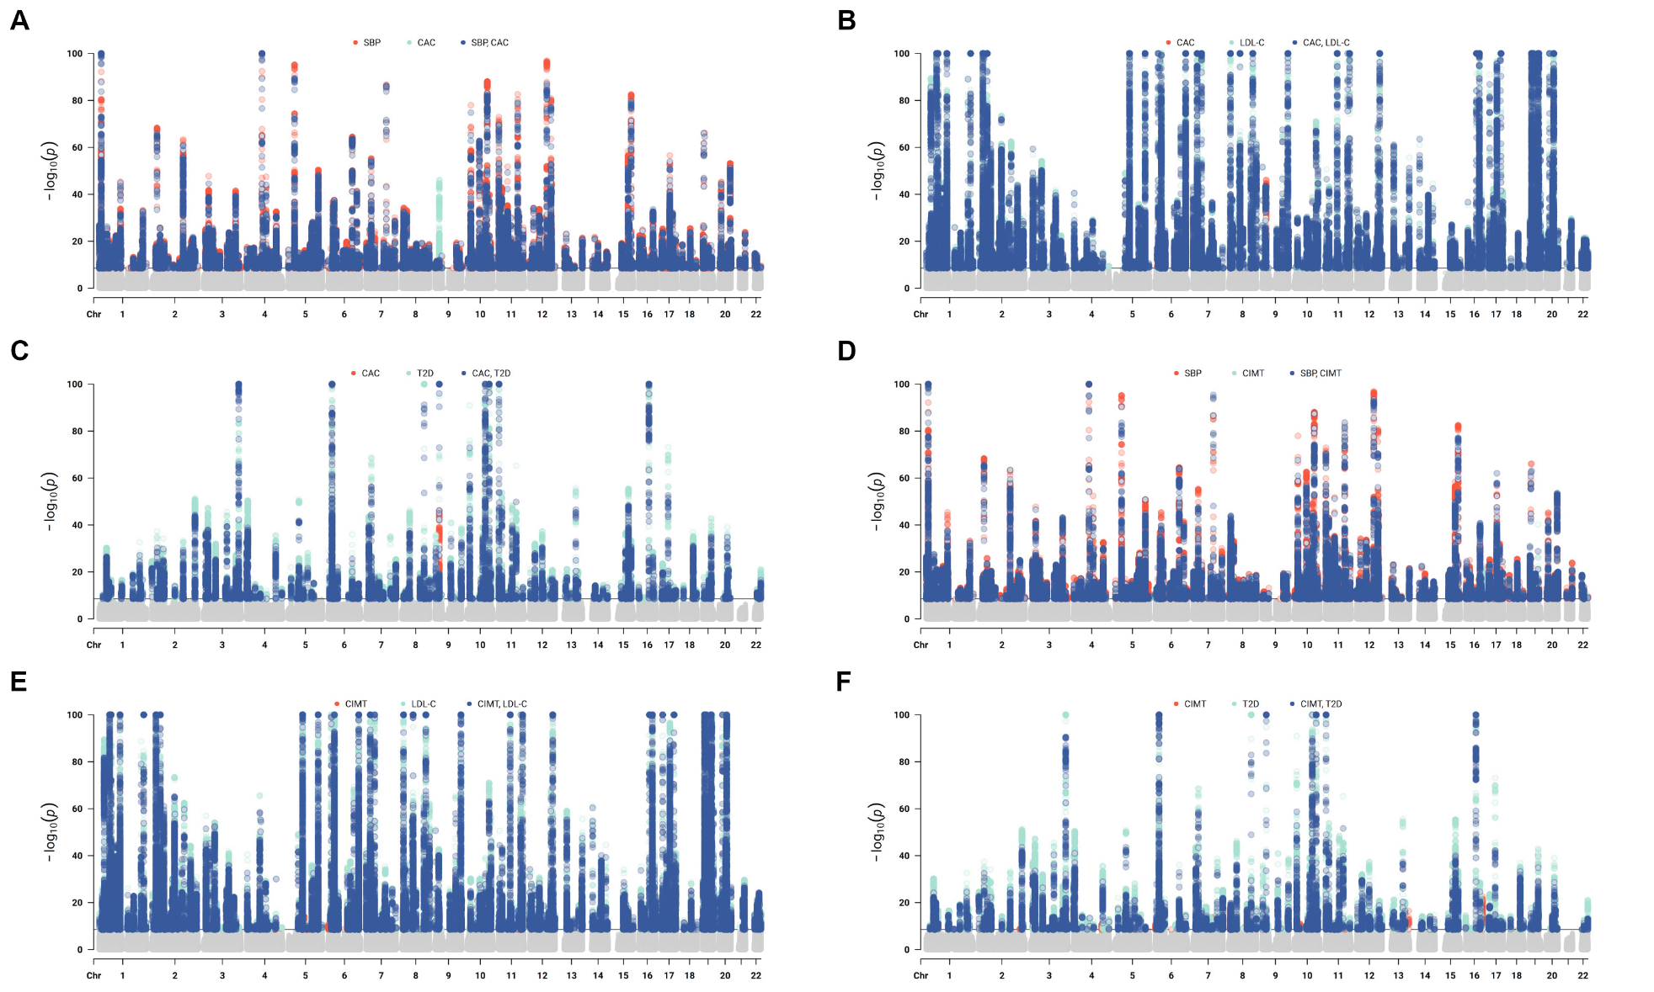
Supplemental Figure 2. Manhattan Plots for Stage 2 Mult-trait Genome-wide Association Studies

Abbreviations: CAC, coronary artery calcification; CIMT, carotid intima media thickness; GWAS, genome-wide association study LDL-C, low-density lipoprotein cholesterol; T2D, type 2 diabetes ; SBP, systolic blood pressure
Supplemental Figure 2 represents the multi-trait genome-wide association studies (GWASs) conducted in Stage 2. Panel A is a Manhattan plot summarizing coronary artery calcification (CAC) and systolic blood pressure (SBP) analysis. Panel B represents CAC and type 2 diabetes (T2D) analysis. Panel C is CAC and low-density lipoprotein cholesterol (LDL-C) analysis. Panel D-F are the same risk factors but analyzed with carotid intima media thickness. Red and light blue dots are P value associations for a variant in the single trait GWAS. Dark blue dots are the P-value associations for the multi-trait GWAS. Dots are colored if they meet the GWAS significance threshold of 3.3×10⁻⁹.

Supplemental Figure 3. Manhattan Plots for Stage 3 Mult-trait Genome-wide Association Studies
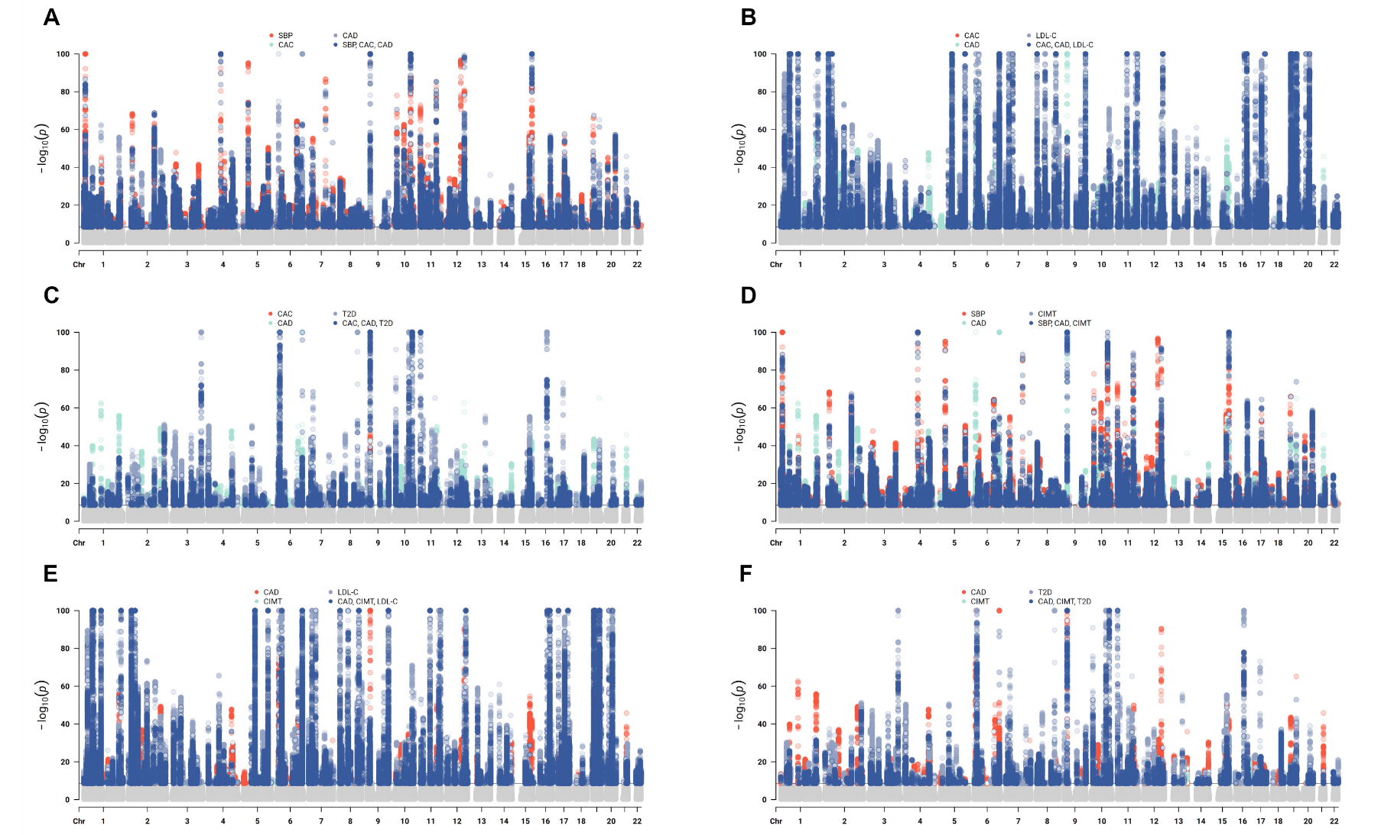
Abbreviations: CAC , coronary artery calcification; CAD, coronary artery disease; CIMT, carotid intima media thickness; GWAS, genome-wide association study; LDL-C, low-density lipoprotein cholesterol; T2D,type 2 diabetes; SBP, systolic blood pressure
Supplemental Figure 3 represents the multi-trait genome-wide association studies (GWASs) conducted in Stage 3. Panel A is a Manhattan plot summarizing coronary artery calcification (CAC), coronary artery disease (CAD) and systolic blood pressure (SBP) analysis. Panel B represents CAC, CAD and type 2 diabetes (T2D) analysis. Panel C is CAC, CAD and low-density lipoprotein cholesterol (LDL-C) analysis. Panel D-F are the same risk factors but analyzed with carotid intima media thickness and CAD. Red and light blue dots are P value associations for a variant in the single trait GWAS. Dark blue dots are the P-value associations for the multi-trait GWAS. Dots are colored if they meet the GWAS significance threshold of 3×10⁻⁹.

