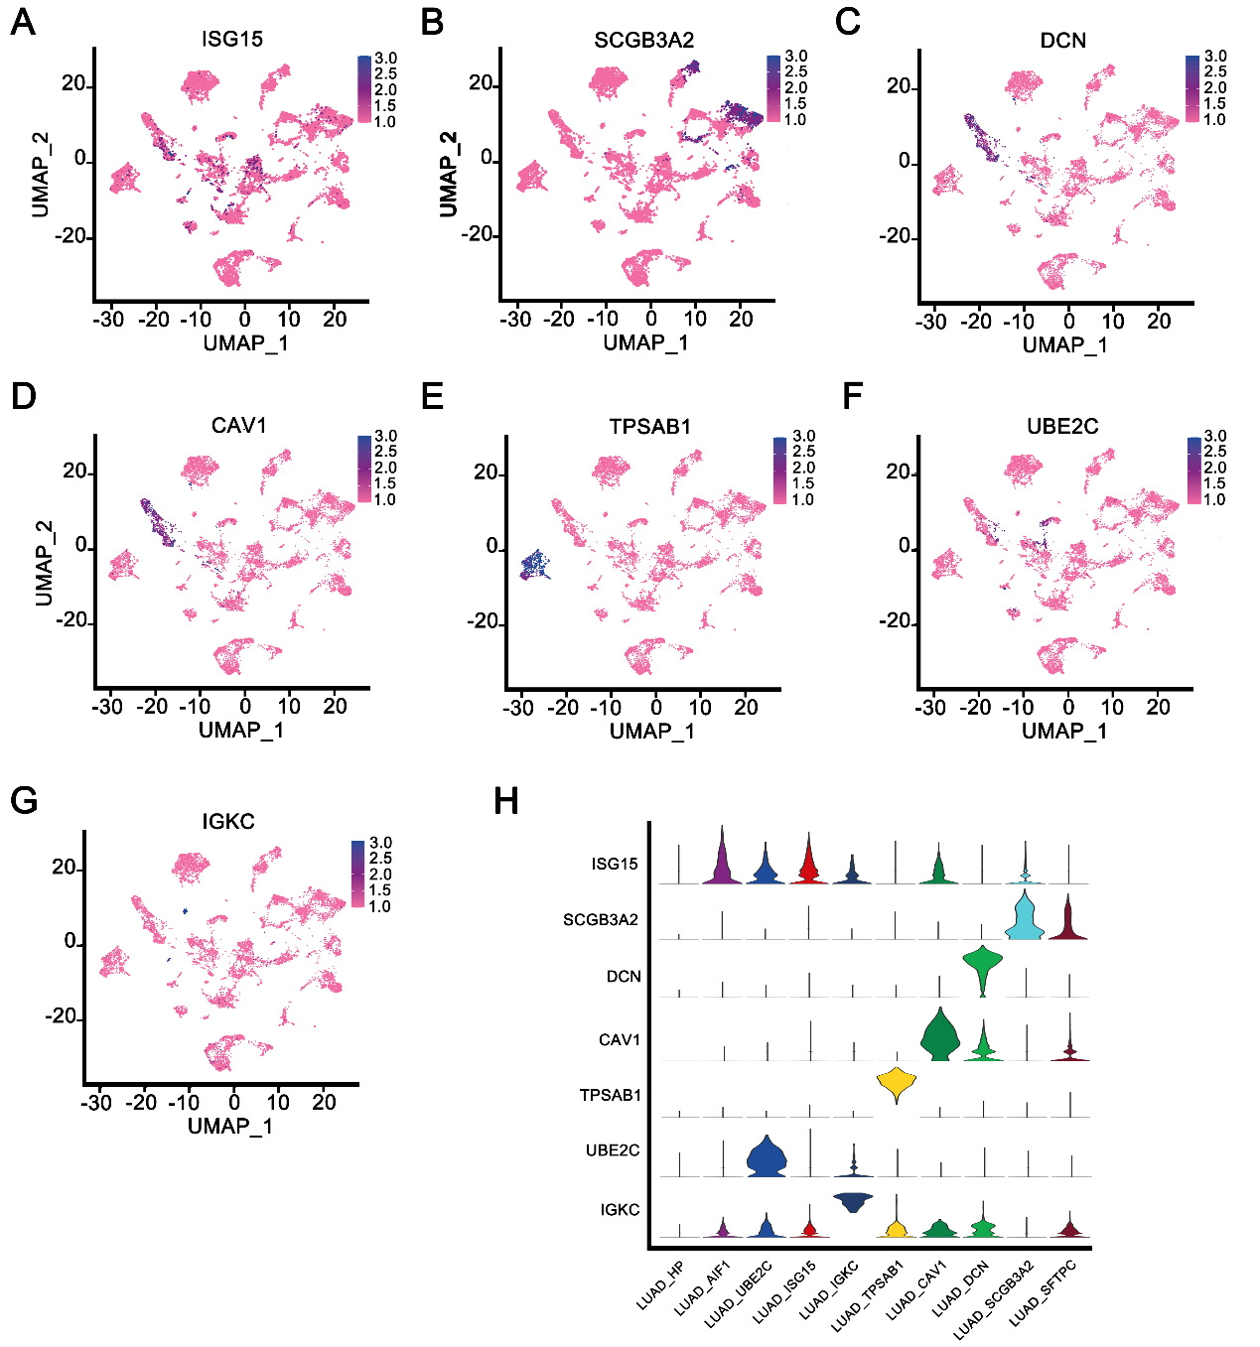
Fig.S1. Expression of marker genes in subpopulations of LUAD cells.
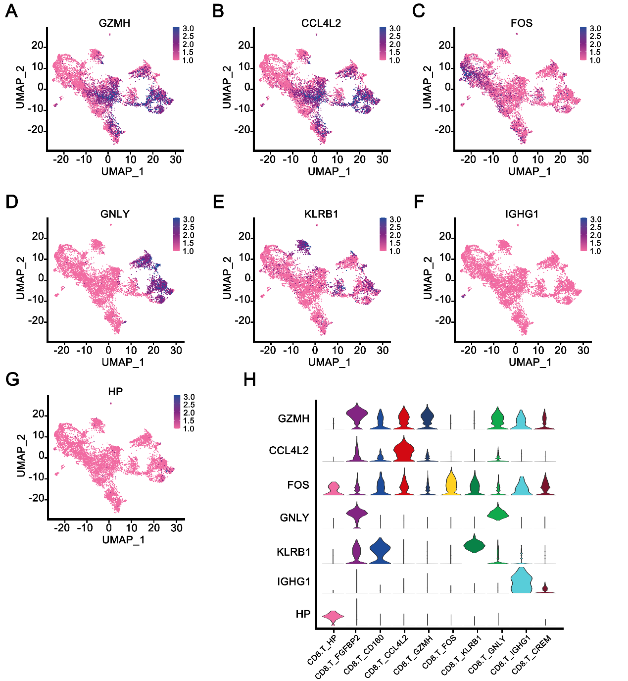
Fig.S2. Expression of marker genes in subpopulations of CD8⁺T cells.
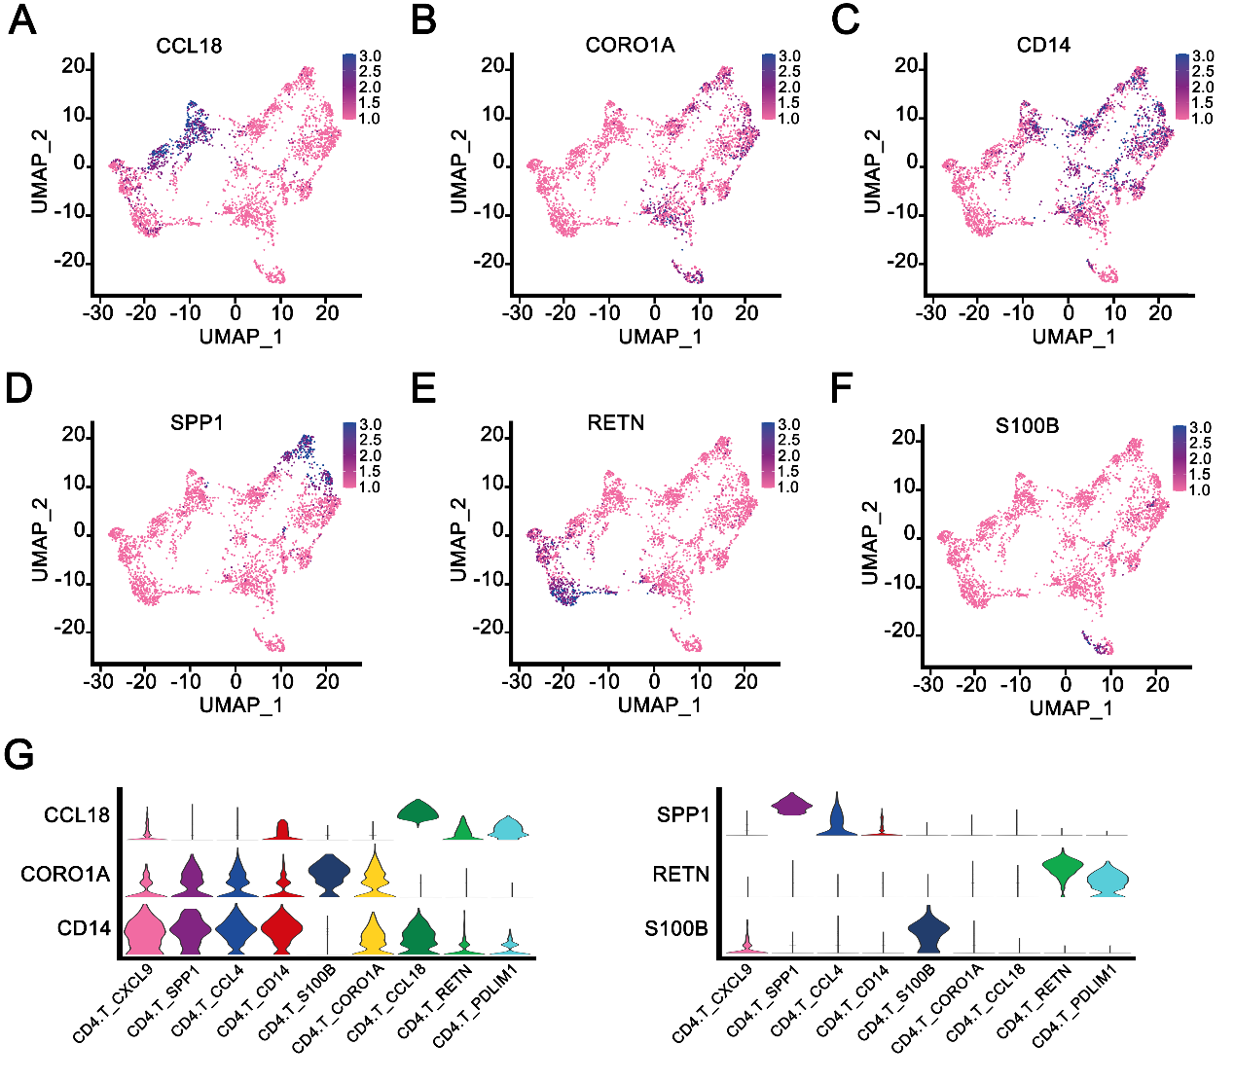
Fig.S3. Expression of marker genes in subpopulations of CD4⁺T cells.
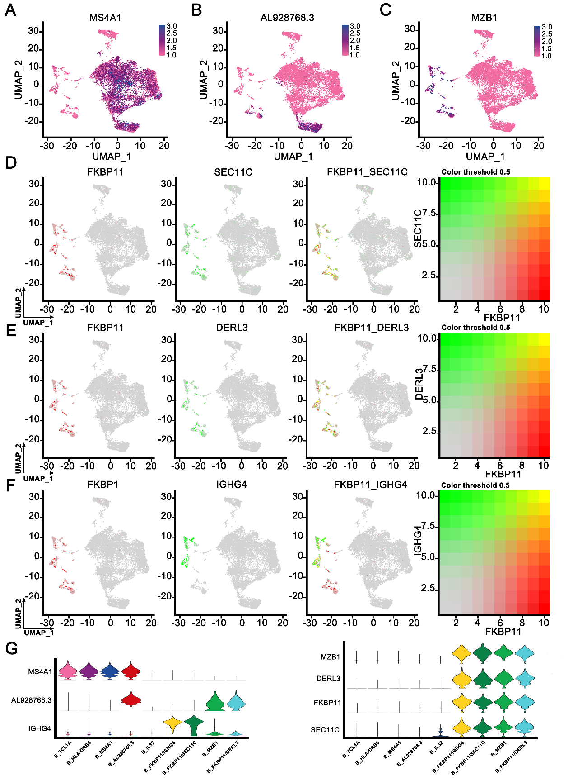
Fig.S4. Expression of marker genes in subpopulations of B cells.
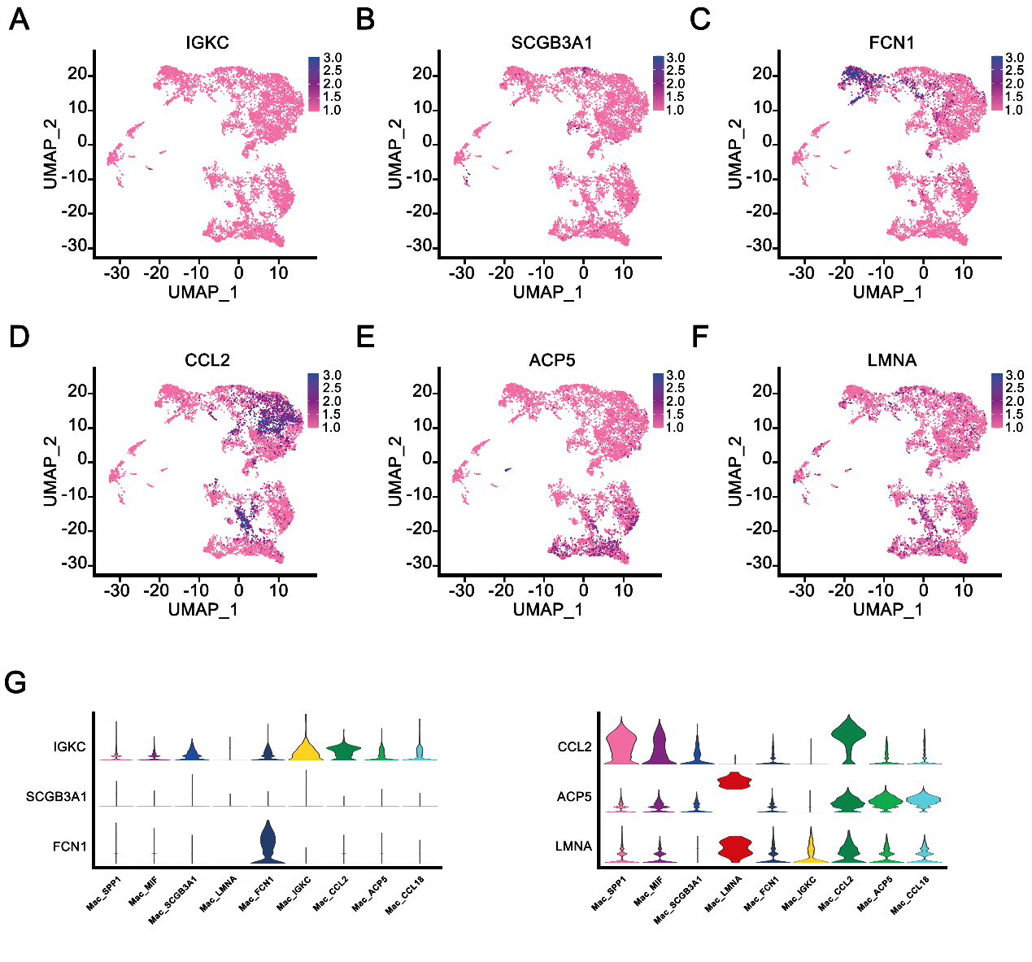
Fig.S5. Expression of marker genes in subpopulations of macrophage cells.

