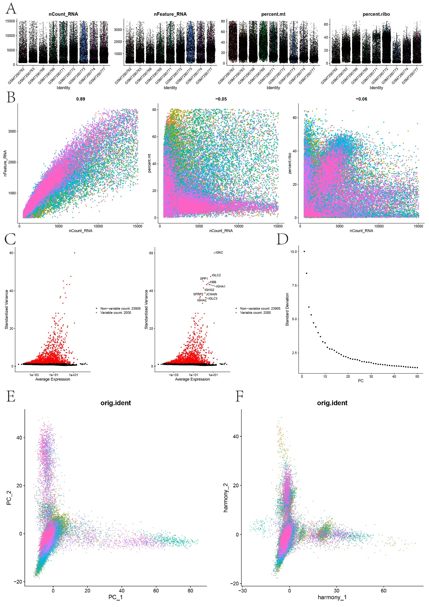

Figure S1. Single Cell Pretreatment.
(A) Visualization results of quality control of single cell RNA sequencing data. Each subgraph shows the number of genes, the number of transcripts detected in the cell (UMI count), the proportion of mitochondrial genes (%MT), and the proportion of ribosomal genes (%Ribo) respectively. The x-axis represents cells, and the y-axis represents corresponding index values. (B) The scatter plot of the relationship between the depth of cell sequencing and the content of mitochondrial gene. The left figure shows the positive correlation between cell sequencing depth (total UMIcounts) and gene number (r value is 0.87), the middle figure shows the negative correlation between cell sequencing depth and mitochondrial gene ratio (r value is -0.56), and the right figure shows an example of the positive correlation between cell sequencing depth and ribosome gene ratio (r value is 0.31). The x-axis represents the sequencing depth (total UMIcounts) of each cell, and the y-axis represents the proportion of mitochondrial genes (%MT). Blue dots represent cells in the normal range, and red dots may be abnormal or low-quality cells. The correlation coefficient at the top is used to quantify the strength and direction of the relationship between them.

(c) Volcanic map of differentially expressed genes. The x-axis represents the logfoldchange of gene expression level between samples, and the y-axis represents the significance of differential expression (-log10(p-value)). The red dots are significantly differentially expressed genes (FDR<0.05), and the marker genes are candidate genes with biological significance.

(d) Gravel diagram of principal component analysis (PCA) results. The x-axis is the principal component number, and the y-axis is the variance contribution ratio of each principal component. Used to select the number of significant principal components.

(e) visualization of E)PCA results. Two-dimensional scatter plot composed of the first two principal components (PC1 and PC2). Each point represents a cell, and different colors represent different cell groups.

(f) The results of double principal component analysis (PCA) were re-visualized after adjustment. After the color and point distribution are updated, it is used to explore the correction effect of potential batch effect or other technical deviation.

