Toileting behaviours of the UK public: insights for reducing demographic bias in wastewater-based epidemiology sampling strategies
Margaret E. Knight ^{a,}*, Caitlin Kirkwood ª, Jasmine M. S. Grimsley ^{b}, Matthew Wade ^{c}, Gareth Cross ^{d}, Luke Lewis-Borrell ^{c}, Charlotte Rimmer ª, Andrew J. Weightman ^{e}, Kata Farkas ^{a,f}, Martina Feilzer ^{g}, Rachel Williams a,f, Davey L. Jones ^{a,f}
ª School of Environmental & Natural Sciences, Bangor University, Bangor, LL57 2UW, UK
^{b} Moeseg Consulting, Suite 01, 64 Nile Street, London, N1 7SR, UK
^{c} Environmental Monitoring for Health Protection, UK Health Security Agency, London, E14 4PU, UK
^{d} Science Evidence Advice Division, Health and Social Services Group, Welsh Government, Cathays Park, Cardiff, CF10 3NQ, UK
^{e} Microbiomes, Microbes and Informatics Group, Organisms and Environment Division, School of Biosciences, Museum Avenue, Cardiff University, Cardiff, CF10 3AX, UK
^{f} Verily Life Sciences LLC., Dallas, Texas, 75019, USA
^{g} Bangor University, Neuadd Ogwen, School of Social Sciences, Bangor, LL57 2DG, UK.

*Corresponding author at: School of Environmental and Natural Sciences, Bangor University, Bangor, LL57 2UW, Wales, UK
E-mail address: maggie.knight@bangor.ac.uk (M. Knight).

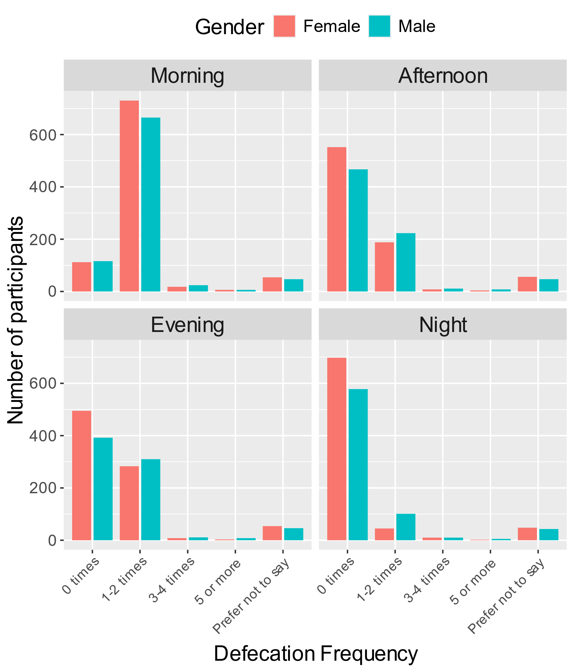
Supplementary figure S1 Diurnal variation in defecation frequency by gender

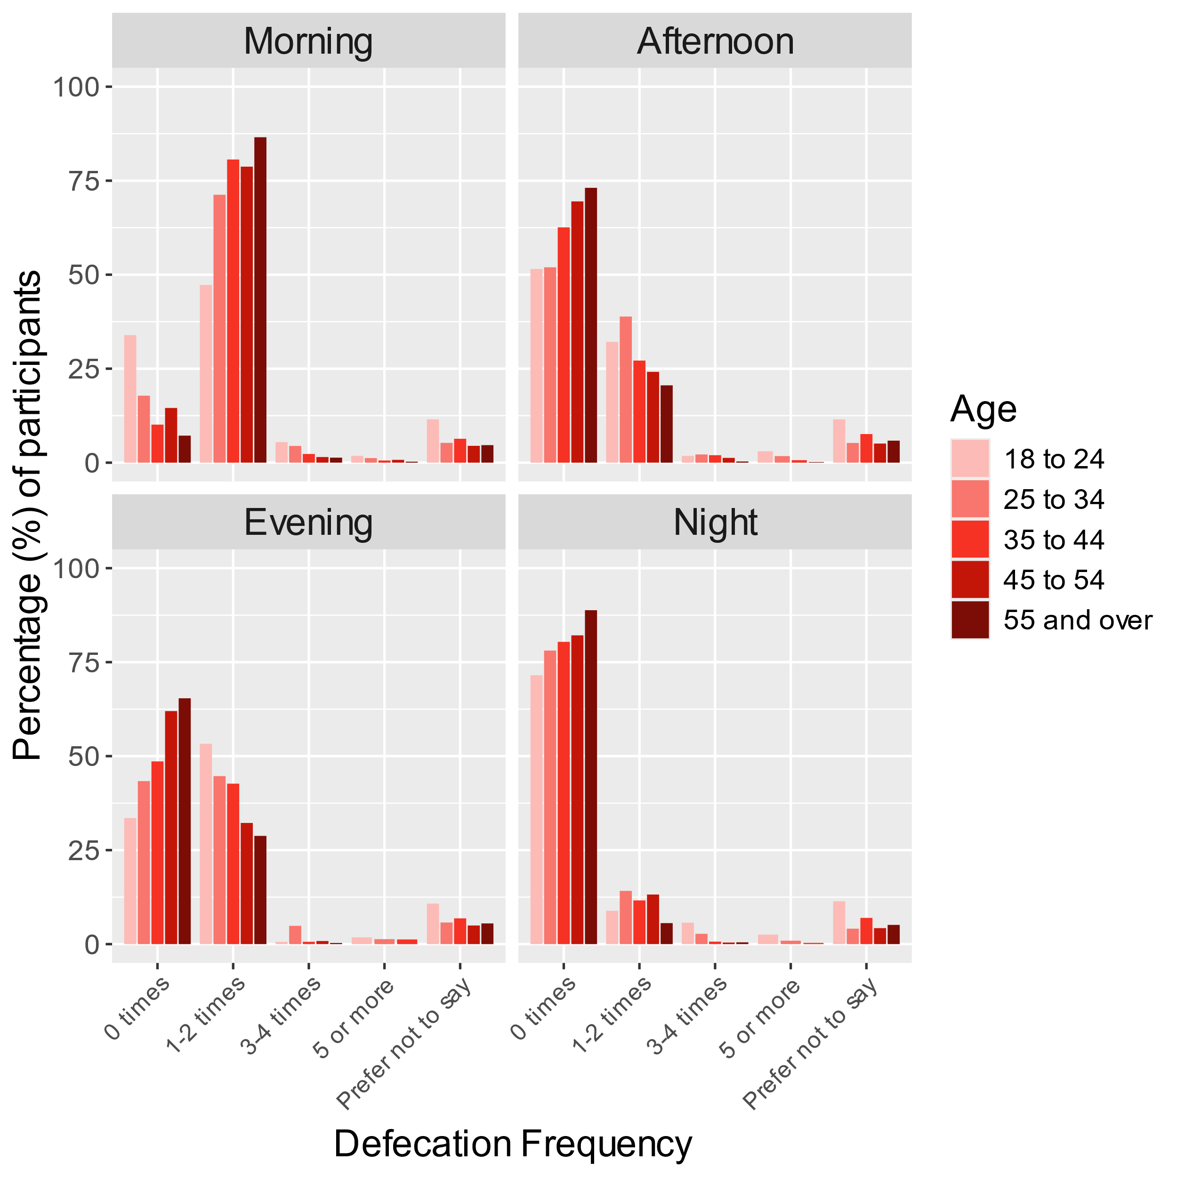
Supplementary figure S2 Diurnal variation in defecation frequency by age
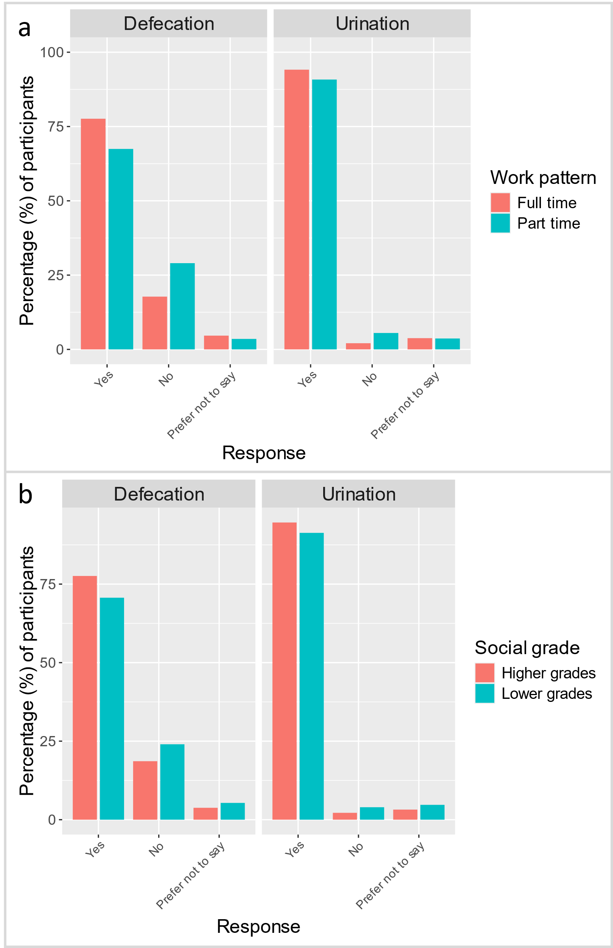
Supplementary figure 3 Preferences for toilet use at work between (a) full and part time workers and (b) participants in the higher social grades (ABC1) and lower social grades (C2DE)
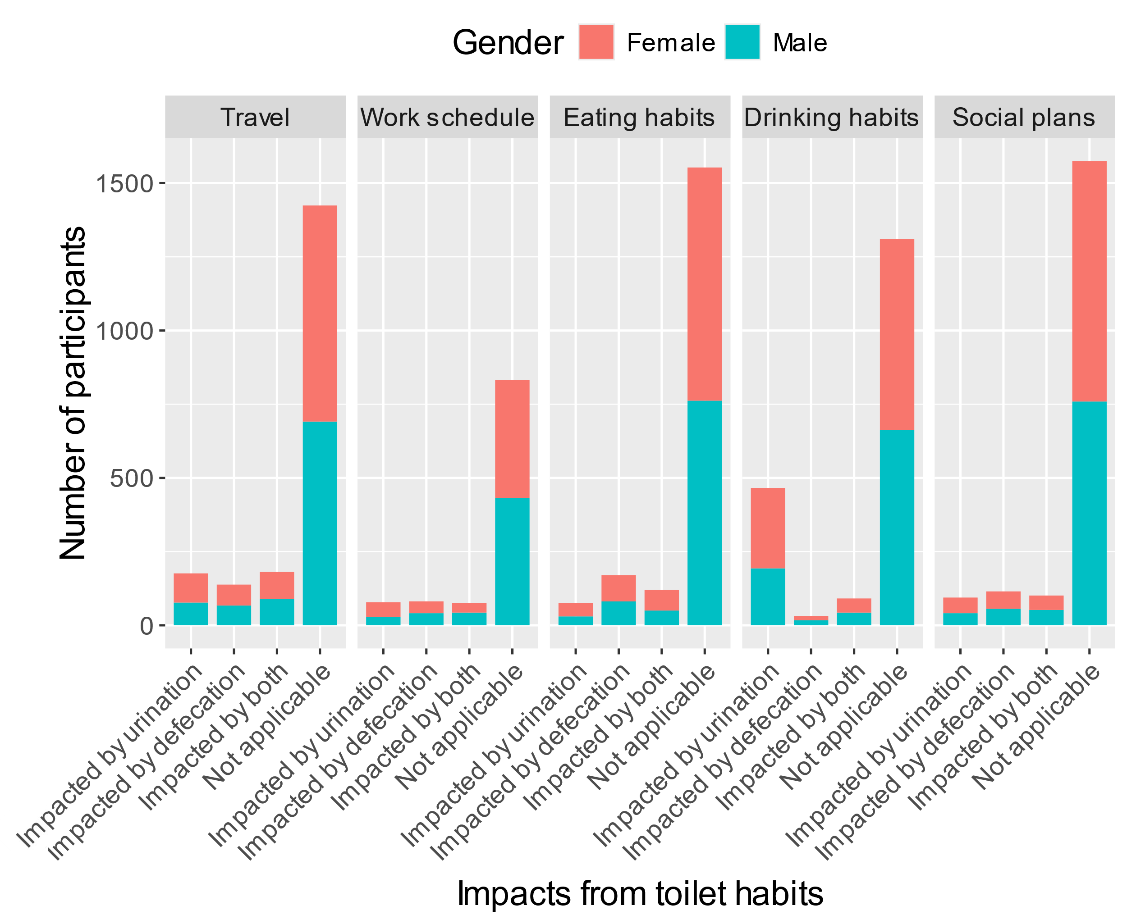
Supplementary figure 4 Impact of toilet habits on different activities by gender

Table S1. Social grade categories used in the questionnaire. Approximated Social Grade with its six categories A, B, C1, C2, D and E is a socio-economic classification produced by the ONS (UK Office for National Statistics) by applying an algorithm developed by members of the MRS Census & Geodemographics Group. It applies to every Household Reference Persons (HRP) aged 16 to 64. Social Grade based on the census 2011 data is available for all four UK countries (England, Wales, Northern Ireland and Scotland).
Social grade | Description | % of UK population
AB | Higher & intermediate managerial, administrative, professional occupations | 22.17
C1 | Supervisory, clerical & junior managerial, administrative, professional occupations | 30.84
C2 | Skilled manual occupations | 20.94
DE | Semi-skilled & unskilled manual occupations, Unemployed and lowest grade occupations | 26.05

