Supplementary information
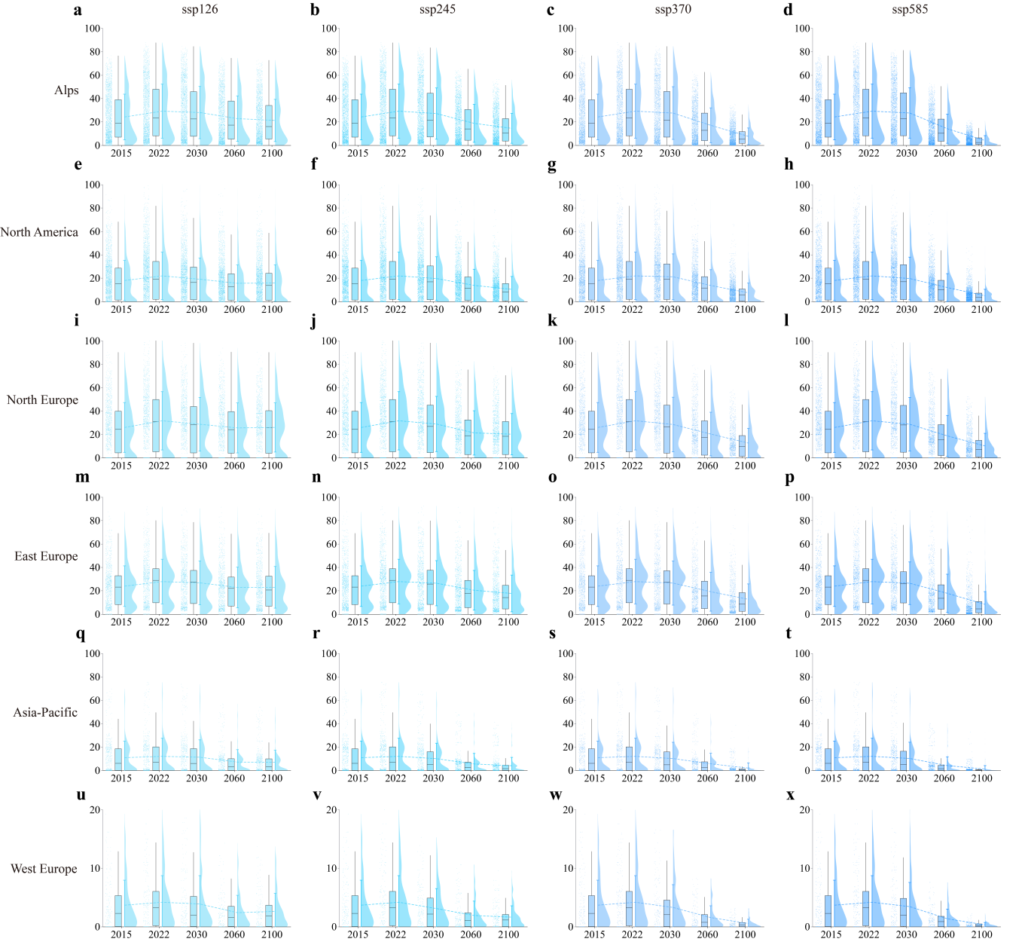
Supplementary Fig1: Regional snow depth statistics at ski resorts in the northern hemisphere. This figure presents the statistical snow depth data of ski resorts in different regions of the Northern Hemisphere under SSP-RCP four scenarios (SSP126, SSP245, SSP370, and SSP585) in the years 2015, 2022, 2030, 2060, and 2100. The rows represent different regions, including the Alps, North America, Northern Europe, Eastern Europe, the Asia-Pacific, and Western Europe, while the columns represent the four climate scenarios.
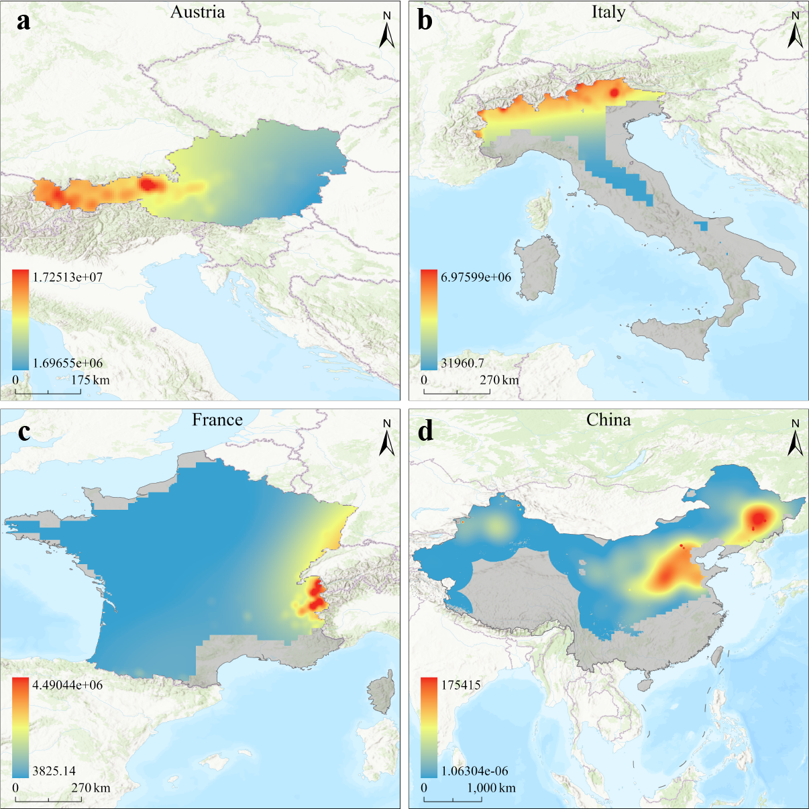
Supplementary Fig. 2: Direct ski revenue gridded data for representative countries in 2022. a–d, illustrate the direct ski revenue gridded data for Austria, Italy, France, and China, respectively.
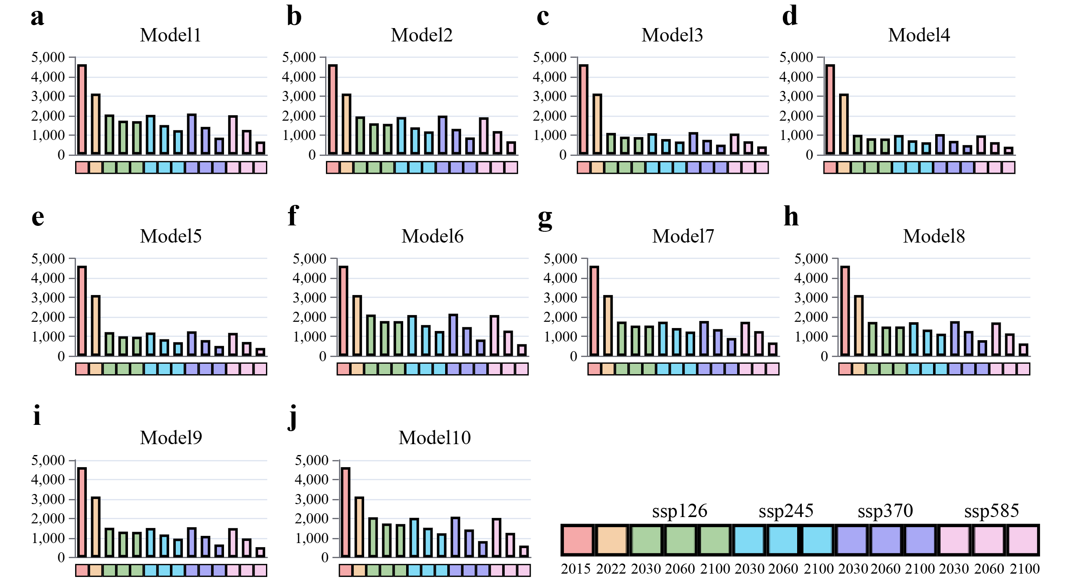
Supplementary Fig.3: Machine learning predictions of direct ski revenue for 30 ski countries in the northern hemisphere. a-j, display the computational results from the ten selected regression models used in this study.
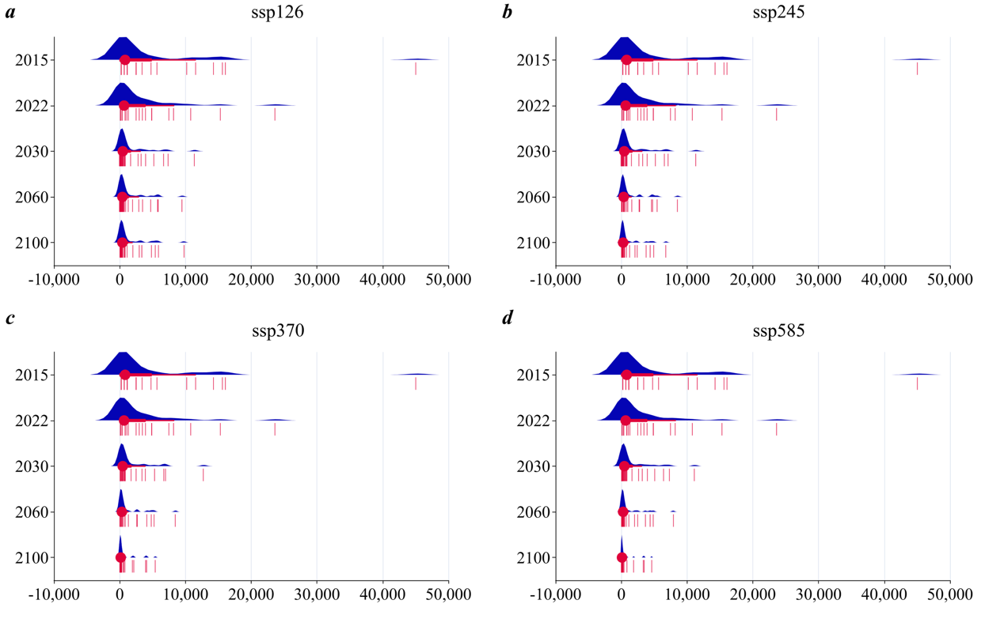
Supplementary Fig. 4: Data distribution of direct ski revenue for 30 ski countries in the northern hemisphere. a–d, present the direct ski revenue for the 30 ski countries under SSP126, SSP245, SSP370, and SSP585 scenarios for the years 2015, 2022, 2030, 2060, and 2100.

Supplementary Table 1: Snow depth decline elastic coefficient of total loss
Country | SSP126_2060 | SSP126_2100 | SSP585_2060 | SSP585_2100
Austria | 4.13 | 3.82 | 1.95 | 1.18
Belgium | -2.06 | -2.59 | -0.83 | 0.49
Germany | -2.09 | -1.49 | 0.89 | 1.50
Denmark | 8.95 | 10.88 | 4.28 | 2.19
Estonia | 1.82 | 2.76 | 1.22 | 0.91
Spain | 1.59 | 1.35 | 0.95 | 0.92
Finland | 0.18 | 0.22 | 0.37 | 0.67
France | 6.91 | 6.50 | 3.86 | 1.76
Greece | -0.73 | -0.22 | 0.67 | 0.86
Croatia | -11.77 | -10.84 | -3.51 | 0.26
Hungary | 0.69 | 0.47 | 0.71 | 0.79
Italy | 2.65 | 3.07 | 1.70 | 1.10
Lithuania | 0.28 | 0.27 | 0.47 | 0.49
Latvia | 3.43 | 2.80 | 1.55 | 1.04
Poland | 0.50 | 0.50 | 0.50 | 0.84
Portugal | -1.97 | -2.36 | 0.37 | 0.88
Romania | -4.37 | -3.47 | -0.80 | 0.33
Sweden | 3.59 | 3.35 | 1.96 | 1.33
Slovenia | -14.79 | -10.48 | -1.57 | 0.60
Slovakia | 1.42 | 1.43 | 0.94 | 0.91
United Kingdom | 0.27 | 0.01 | 0.53 | 0.81
United States | 1.45 | 1.34 | 0.90 | 0.78
Japan | 12.88 | 13.94 | 5.66 | 2.37
China | -0.47 | -0.52 | -0.05 | 0.26
Canada | 0.10 | 0.10 | 0.32 | 0.44
South Korea | 1.97 | 2.02 | 1.23 | 1.02
India | 3.26 | 3.09 | 2.01 | 1.40
Russia | -0.88 | -0.64 | 0.02 | 0.34
Switzerland | 1.82 | 2.46 | 1.34 | 1.06
Norway | 4.45 | 4.84 | 2.50 | 1.45
Total | 2.65 | 2.55 | 1.57 | 1.14

Supplementary Table 2: Snow depth decline elasticity coefficient of indirect loss
Country | SSP126_2060 | SSP126_2100 | SSP585_2060 | SSP585_2100
Austria | 4.10 | 3.80 | 1.94 | 1.17
Belgium | -0.20 | -0.24 | 0.36 | 0.79
Germany | 1.75 | 2.13 | 1.99 | 1.60
Denmark | 9.04 | 11.01 | 4.32 | 2.20
Estonia | 1.76 | 2.70 | 1.23 | 0.92
Spain | 1.85 | 1.59 | 1.00 | 0.93
Finland | 0.76 | 0.96 | 0.63 | 0.77
France | 6.76 | 6.37 | 3.80 | 1.75
Greece | -0.10 | 0.31 | 0.80 | 0.90
Croatia | -3.17 | -2.80 | -0.36 | 0.75
Hungary | 1.65 | 1.12 | 1.19 | 0.91
Italy | 2.61 | 3.02 | 1.69 | 1.10
Lithuania | 0.84 | 0.81 | 0.79 | 0.80
Latvia | 3.26 | 2.67 | 1.50 | 1.03
Poland | 0.91 | 0.90 | 0.77 | 0.90
Portugal | 0.98 | 0.98 | 1.01 | 1.01
Romania | -1.09 | -0.78 | 0.13 | 0.65
Sweden | 3.69 | 3.45 | 2.01 | 1.36
Slovenia | -7.81 | -5.42 | -0.35 | 0.79
Slovakia | 1.41 | 1.43 | 0.94 | 0.92
United Kingdom | 1.20 | 0.77 | 0.82 | 0.89
United States | 1.50 | 1.39 | 0.92 | 0.79
Japan | 12.30 | 13.32 | 5.45 | 2.32
China | -0.20 | -0.24 | 0.08 | 0.33
Canada | 0.19 | 0.21 | 0.37 | 0.47
South Korea | 1.89 | 1.93 | 1.18 | 0.99
India | 3.59 | 3.39 | 2.16 | 1.45
Russia | -0.61 | -0.44 | 0.11 | 0.39
Switzerland | 1.79 | 2.42 | 1.32 | 1.06
Norway | 4.39 | 4.77 | 2.48 | 1.44
Total | 2.64 | 2.53 | 1.56 | 1.13

Supplementary Table 3: Snow depth decline elastic coefficient of inbound and/or outbound ski tourism loss
Country | SSP126_2060 | SSP126_2100 | SSP585_2060 | SSP585_2100
Austria | 4.12 | 3.82 | 1.94 | 1.17
Belgium | -0.49 | -0.60 | 0.17 | 0.74
Germany | 2.42 | 2.75 | 2.18 | 1.61
Denmark | 8.95 | 10.89 | 4.28 | 2.19
Estonia | 1.79 | 2.73 | 1.23 | 0.91
Spain | 1.75 | 1.50 | 0.98 | 0.93
Finland | 0.45 | 0.57 | 0.49 | 0.72
France | 6.83 | 6.43 | 3.83 | 1.75
Greece | -0.45 | 0.01 | 0.73 | 0.88
Croatia | -7.36 | -6.72 | -1.90 | 0.51
Hungary | 0.97 | 0.66 | 0.85 | 0.82
Italy | 2.60 | 3.02 | 1.68 | 1.09
Lithuania | 0.77 | 0.74 | 0.75 | 0.77
Latvia | 2.97 | 2.43 | 1.41 | 1.01
Poland | 0.66 | 0.65 | 0.60 | 0.86
Portugal | -0.30 | -0.47 | 0.74 | 0.95
Romania | -2.49 | -1.93 | -0.27 | 0.51
Sweden | 3.61 | 3.37 | 1.97 | 1.34
Slovenia | -12.06 | -8.50 | -1.09 | 0.67
Slovakia | 1.41 | 1.43 | 0.94 | 0.92
United Kingdom | 0.68 | 0.34 | 0.66 | 0.84
United States | 1.53 | 1.43 | 0.95 | 0.80
Japan | 12.64 | 13.69 | 5.57 | 2.35
China | 0.21 | 0.19 | 0.30 | 0.45
Canada | 0.15 | 0.16 | 0.34 | 0.46
South Korea | 1.92 | 1.96 | 1.20 | 1.00
India | 3.58 | 3.38 | 2.15 | 1.45
Russia | -0.12 | -0.09 | 0.29 | 0.47
Switzerland | 1.79 | 2.42 | 1.33 | 1.06
Norway | 4.38 | 4.77 | 2.48 | 1.44
Total | 2.97 | 2.86 | 1.72 | 1.20

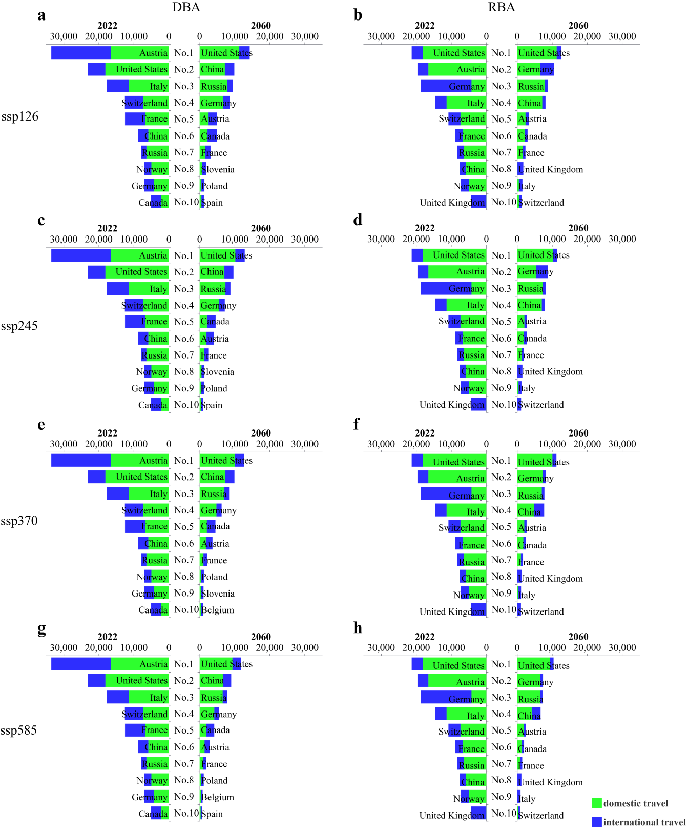
Supplementary Fig. 5: Ski industry tourist market structure in the northern hemisphere. This figure presents the ski total output of the top ten ski tourist destinations or tourist original countries in the Northern Hemisphere for 2022 and 2060. The rows represent the four climate scenarios (SSP126, SSP245, SSP370, and SSP585), while the columns distinguish between destination accounts and tourist original market accounts.
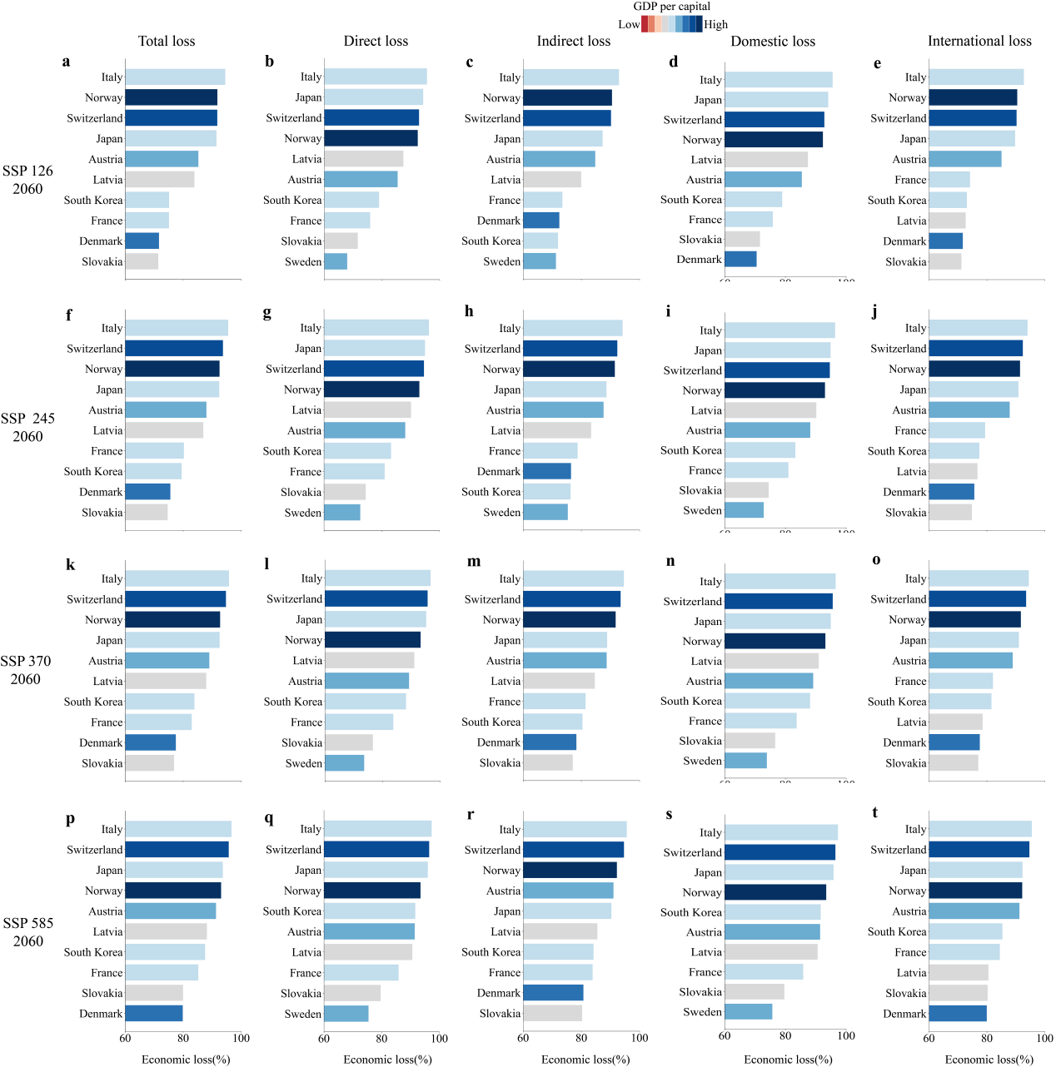
Supplementary Fig. 6: Ski economic losses rates for representative countries. This figure illustrates the losses rates compared to 2022, including direct loss, indirect loss, domestic loss, and international loss for representative countries in the Northern Hemisphere under different climate scenarios in 2060. The rows correspond to SSP126, SSP245, SSP370, and SSP585.
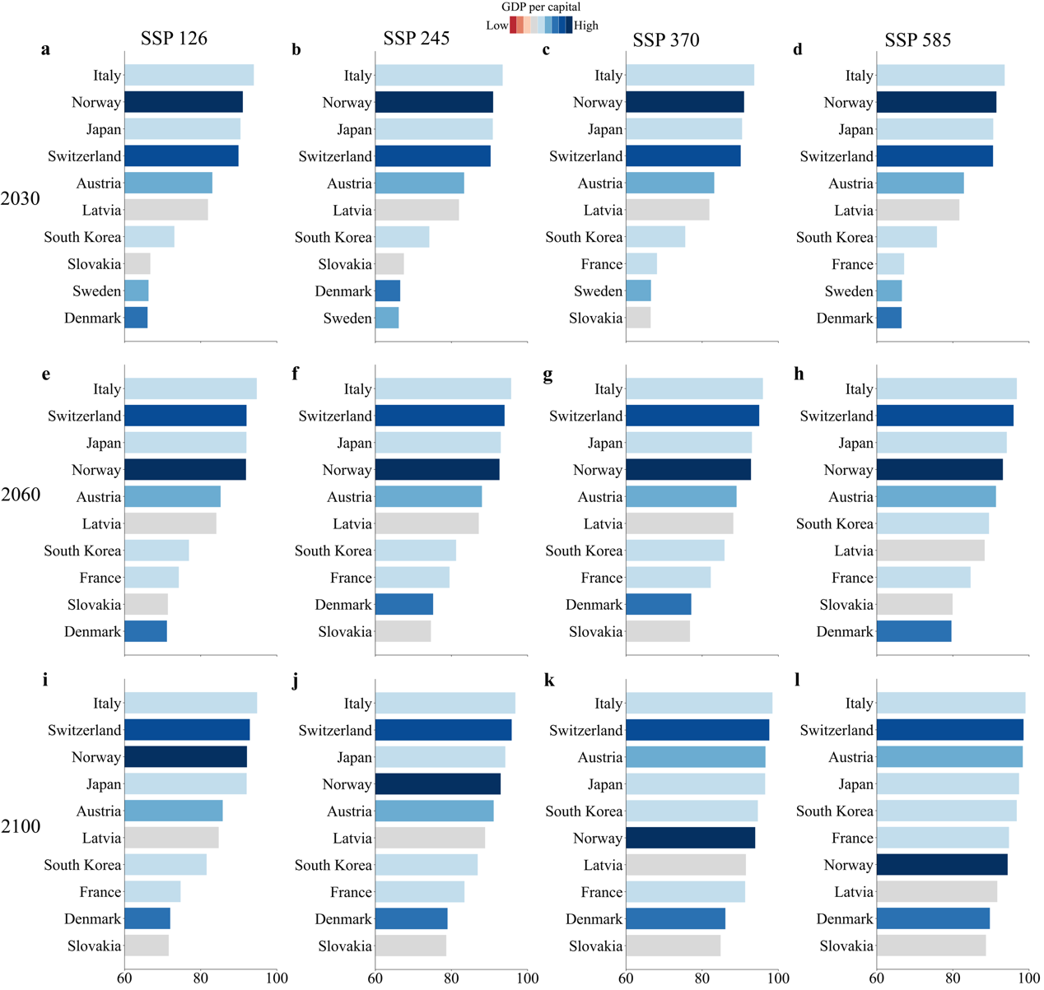
Supplementary Figure 7: Ski unemployment rates for representative countries. This figure presents the unemployment rates for representative countries in the Northern Hemisphere for the years 2030, 2060, and 2100 under four climate scenarios. The rows represent different years, while the columns represent SSP126, SSP245, SSP370, and SSP585 scenarios.

Supplementary Method 1: Snow depth Data Evaluation
Reference snow depth datasets: European Centre for Medium-Range Weather Forecast Reanalysis v5-Land (ERA5-Land) and the Global Land Data Assimilation System (GLDAS). To cross-validate the performance of the downscaled NHMSD snow depth dataset, two long-term reanalysis monthly snow depth datasets were employed: ERA5-Land and GLDAS. These datasets were used for historical validation (1980–2014) and future scenario analysis (2015–2023). ERA5-Land, developed by the European Centre for Medium-Range Weather Forecasts, is a high-resolution reanalysis dataset generated using 4D-Var data assimilation, providing approximately 0.1° spatial resolution and covering various surface meteorological variables, including snow depth⁶¹ ⁶². GLDAS, developed by NASA and the National Oceanic and Atmospheric Administration, is based on the Noah Land Surface Model and integrates ground observations, satellite remote sensing, and reanalysis data to generate key terrestrial variables, including snow depth, at a 0.25° spatial resolution⁶³.
Evaluation approach. Monthly synthesized snow depth observations from GHCN and GSOD were used as theoretical true values to evaluate the performance of the newly developed NHMSD, as well as the widely used ERA5-Land and GLDAS reanalysis snow depth datasets. ERA5-Land and GLDAS provide globally distributed meteorological and surface variables, widely recognized as benchmark datasets in climate research. ERA5-Land, in particular, serves as the standard for reanalysis data and is extensively used for meteorological and climate validation studies⁶¹. Therefore, ERA5-Land was selected as the primary reference for validation, while GLDAS was used for supplementary comparison to ensure comprehensiveness.
CMIP6 future snow depth simulations from 2015 onward provided an opportunity to evaluate their accuracy against remote sensing and reanalysis datasets. To comprehensively assess NHMSD, a two-phase validation process was implemented: Phase 1 focused on the historical period (1980–2014), while Phase 2 examined future scenarios (2015–2023) under the four SSP scenarios (SSP126, SSP245, SSP370, and SSP585). These SSP scenarios represent different greenhouse gas emission pathways influencing global temperature, snowfall, and other climatic variables. Thus, a comprehensive evaluation of NHMSD under future conditions was essential. This staged validation approach ensured the applicability and accuracy of NHMSD under varying model conditions.
For assessment, four widely used statistical metrics were employed: Pearson correlation coefficient (CORR), root mean square error (RMSE), bias (BIAS), and mean absolute error (MAE). CORR measures the linear relationship between simulated and actual snow depth values, RMSE evaluates the average magnitude of simulation errors, BIAS characterizes systematic errors in the simulated dataset, and MAE reflects the average absolute deviation in the simulated dataset. These metrics were utilized to assess the effectiveness of the downscaling methodology and the accuracy and consistency of each model. The evaluation results are presented in Supplementary Figure8.
$$\begin{aligned}CORR=\frac{\sum_{i=1}^{n}{\left(x_{i}-\overline{x}\right)\left(y_{i}-\overline{y}\right)}}{\sqrt{\sum_{i=1}^{n}{(x_{i}-\overline{x})^{2}}\sum_{i=1}^{n}{(y_{i}-\overline{y})^{2}}}}\#\left(1\right)\end{aligned}$$
$$\begin{aligned}RMSE=\sqrt{\frac{1}{n}\sum_{i=1}^{n}{(x_{i}-y_{i})^{2}}}\#\left(2\right)\end{aligned}$$
$$\begin{aligned}BIAS=\frac{1}{n}\sum_{i=1}^{n}{\left(x_{i}-y_{i}\right)}\#\left(3\right)\end{aligned}$$
$$\begin{aligned}MAE=\frac{1}{n}\sum_{i=1}^{n}{\left|x_{i}-y_{i}\right|}\#\left(4\right)\end{aligned}$$

Supplementary Method 2: The generation of FDSD and MOD10C1
The temporally and spatially continuous FDSD was generated using the random forest algorithm. This approach integrates data from multiple sources, including the Advanced Microwave Scanning Radiometer for the Earth Observing System (AMSR-E), Advanced Microwave Scanning Radiometer-2 (AMSR2), Global Snow Monitoring for Climate Research (GlobSnow), Northern Hemisphere Snow Depth datasets, the European Centre for Medium-Range Weather Forecasts Reanalysis (ERA-Interim), and the Modern-Era Retrospective Analysis for Research and Applications version 2 (MERRA-2)⁵³. In addition, it incorporates geographical information (latitude and longitude) and topographical data (elevation). According to accuracy assessments, the combined snow depth dataset achieved a coefficient of determination (R²) of 0.81, a root mean square error (RMSE) of 7.69 cm, and a mean absolute error (MAE) of 2.74, which was markedly superior to previous snow depth datasets^{53,54}. To match the temporal resolution of the monthly CMIP6 simulations, monthly mean snow depth data were generated from the original dataset for the ski seasons of 1980–2014, downscaling the CMIP6 historical snow depth data from its original resolution to 0.25°.
The MOD10C1 dataset was generated using the normalized difference snow index algorithm, which effectively distinguishes snow from other surface cover types by leveraging the different reflectance properties of snow and clouds in the shortwave infrared and visible bands^{55,56}. The MOD10C1 dataset comprises three sub-datasets: fractional snow cover (FSC), cloud cover, and clear-sky index (CI). FSC represents the snow cover percentage in each pixel, ranging from 0% (no snow) to 100% (complete snow cover). CI indicates data quality, with 100% representing clear skies and 0% indicating complete cloud cover, a factor critical to ensuring the reliability of the FSC data. To match the temporal resolution of the monthly CMIP6 snow depth dataset, daily FSC and CI data for the 2000–2014 ski seasons were aggregated into monthly averages. Subsequently, the spatial characteristics of the monthly CI and FSC data were employed to downscale the CMIP6 historical snow depth data from 0.25° to 0.05°.

Supplementary Method 3: Coupled spatial downscaling approach
Stage 1: Downscaled the original baseline CMIP6 snow depth dataset to 0.25° by the Delta statistical downscaling method. In this stage, the Delta method was applied to enhance spatial detail and accuracy by analyzing the differences between the original CMIP6 snow depth dataset and the 0.25° FDSD dataset then reapplying this correction to the original CMIP6 dataset. Initially, the original trend of the CMIP6 snow depth data in the baseline period was resampled to 0.25° to match the dataset ($SD_{y,m}^{h,L}$). Next, each ski season's monthly average snow depth (2000–2014) was calculated to generate the low-resolution CMIP6 snow depth climatology ($Clim_{m}^{h,L}$). It enabled the derivation of the anomaly sequence of the original CMIP6 snow depth ($Anom_{y,m}^{h,L}$) (Equation 5) during the baseline period. Meanwhile, the high-resolution snow depth climatology ($Clim_{m}^{h,M}$) was computed using the FDSD dataset, and by multiplying it with the corresponding monthly CMIP6 snow depth anomaly sequence (Equation 6), a 0.25° downscaled CMIP6 snow depth dataset ($SD_{y,m}^{h,M}$) (NHMSD-025) was produced for the baseline period.
$$\begin{aligned}Anom_{y,m}^{h,L}=\frac{SD_{y,m}^{h,L}}{Clim_{m}^{h,L}} \#\left(5\right)\end{aligned}$$
$$\begin{aligned}SD_{y,m}^{h,M}=Anom_{y,m}^{h,L}×Clim_{m}^{h,M}\#\left(6\right)\end{aligned}$$
Stage 2: Downscaled the baseline 0.25° CMIP6 snow depth dataset to 0.05° by the spatial feature transferred downscaling method. The snow cover probability (SCP) is the ratio of FSC to CI (Equation 7). It is closely related to changes in snow depth, thus providing a critical spatial reference for snow depth downscaling⁵⁷. In this study, the 0.05° SCP was obtained from the FSC and CI values of the MOD10C1 dataset. Since each grid cell in NHMSD-025 corresponds to 25 grid cells at 0.05°, we set the window size as 0.25° × 0.25° and calculated the weight for each 0.05° grid cell within this window. Specifically, the weight ($W_{i,y,m}$) for each grid cell was determined by dividing the SCP of that grid cell ($SCP_{i,y,m}$) by the sum of all SCP values within the window (Equation 8). Finally, by multiplying the weight by the total number of grid cells (N = 25) and applying the 0.25° snow depth downscaling from NHMSD-025 (Equation 9), we obtained the 0.05° CMIP6 snow depth ($SD_{i,y,m}^{h,H}$) (NHMSD-005) for the baseline period.
$$\begin{aligned}SCP=\frac{FSC}{CI}\#\left(7\right)\end{aligned}$$
$$\begin{aligned} W_{i,y,m}=\frac{SCP_{i,y,m}}{\sum_{j∈N}{SCP_{j,y,m}}}\#\left(8\right)\end{aligned}$$
$$\begin{aligned}SD_{i,y,m}^{h,H}=W_{i,y,m}×SD_{i,y,m}^{h,M}×N\#\left(9\right)\end{aligned}$$
Stage 3: Downscaled the original CMIP6 snow depth dataset to 0.05° for the non-baseline period. The non-baseline period includes the historical period (1980–2000) and future scenarios (2015–2100). First, for both the historical period and the four future scenarios (SSP126, SSP245, SSP370, and SSP585), the original CMIP6 snow depth dataset was resampled ($SD_{y_{o},m_{o}}^{other,L}$) at a spatial resolution of 0.05°. Then, we calculated the snow depth climatology ($Clim_{m_{o}}^{other,L}$) and derived the anomaly sequence for the non-baseline period ($Anom_{y_{o},m_{o}}^{other,L}$) from the original CMIP6 snow depth dataset using Equation 10. Next, using the baseline NHMSD-005, we computed the monthly average snow depth for each ski season to obtain a 0.05° reference snow depth climatology ($Clim_{m}^{h,H}$) (Equation 11). Finally, by multiplying the 0.05° reference snow depth climatology with the original CMIP6 snow depth anomaly sequence for each non-baseline year and month, we generated the 0.05° CMIP6 snow depth dataset ($SD_{y_{o},m_{o}}^{other,H}$) (Equation 12). This process ensures that the downscaled CMIP6 snow depth dataset retains the overall trends of large-scale climate patterns and provides enhanced spatial resolution and accuracy in finer details for historical and future projections.
$$\begin{aligned}Anom_{y_{o},m_{o}}^{other,L}=\frac{SD_{y_{o},m_{o}}^{other,L}}{Clim_{m_{o}}^{other,L}} \#\left(10\right)\end{aligned}$$
$$\begin{aligned}Clim_{m}^{h,H}=\frac{1}{Y}\sum_{y=1}^{Y}{SD_{m}^{h,H}} \#\left(11\right)\end{aligned}$$
$$\begin{aligned}SD_{y_{o},m_{o}}^{other,H}=Anom_{y_{o},m_{o}}^{other,L}×Clim_{m}^{h,H} \#\left(12\right)\end{aligned}$$

Supplementary Table 4: Key information on the 21 selected cmip6 snow depth simulations
No | Model | Spatial resolution
1 | BCC-CSM2-MR | 1.13°×1.13°
2 | CAS-ESM2-0 | 1.41°×1.41°
3 | FGOALS-f3-L | 1.25°×1.00°
4 | FGOALS-g3 | 1.00°×1.00°
5 | TaiESM1 | 1.25°×0.94°
6 | CanESM5 | 2.81°×2.81°
7 | CanESM5-1 | 2.81°×2.81°
8 | CanESM5-CanOE | 2.81°×2.81°
9 | CESM2 | 1.25°×0.94°
10 | CESM2-WACCM | 1.25°×0.94°
11 | GFDL-ESM4 | 1.25°×1.00°
12 | CMCC-CM2-SR5 | 1.25°×0.94°
13 | CMCC-ESM2 | 1.25°×0.94°
14 | EC-Earth3 | 0.70°×0.70°
15 | EC-Earth3-Veg-LR | 1.13°×1.13°
16 | IPSL-CM6A-LR | 2.50°×1.27°
17 | MIROC6 | 1.41°×1.40°
18 | MIROC-ES2L | 2.81°×2.81°
19 | MRI-ESM2-0 | 1.13°×1.13°
20 | NorESM2-LM | 2.50°×1.90°
21 | NorESM2-MM | 1.25°×0.94°

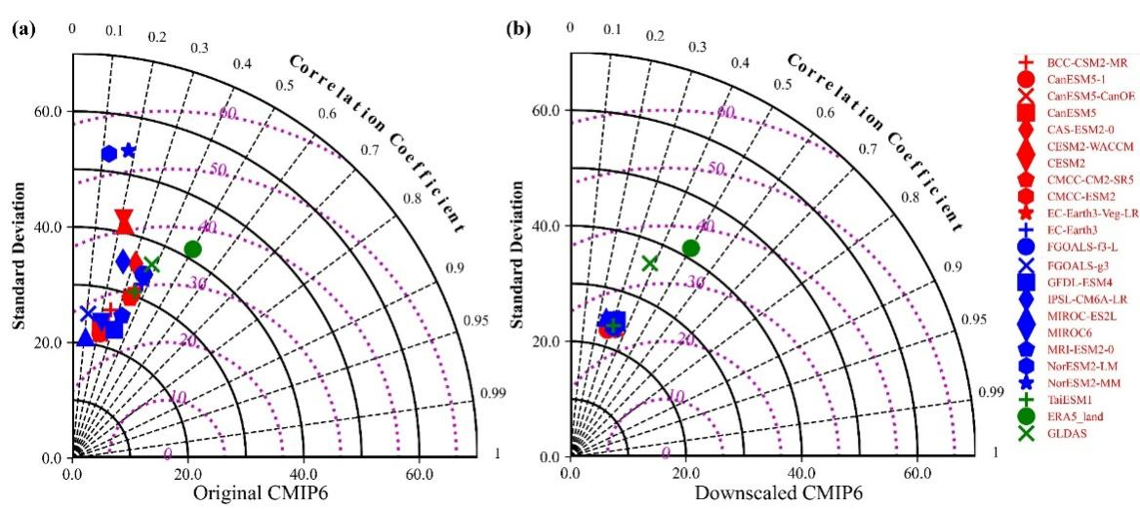
Supplementary Fig.8: Comparison of observed snow depth during the ski season. Figure (a) presents the original CMIP6 GCMs, while figure (b) compares NHMSD, ERA5-Land, and GLDAS with observed snow depth during the ski season from 1980 to 2014 using a Taylor diagram.
Supplementary Table 5: Hyperparameter space tested during XGBoost model training
Parameters | Range
max_depth | [5, 6, 7]
learning_rate | (0.01, 0.05, 'log-uniform')
n_estimators | [100, 200,500, 800]
gamma | (0.1, 0.5, 'uniform')
reg_alpha | (1e-3, 10, 'log-uniform')
reg_lambda | (1e-3, 10, 'log-uniform')
min_child_weight | [3, 5, 10]
subsample | (0.4, 1.0, 'uniform')
colsample_bytree | (0.5, 1.0, 'uniform')
Note: Column names correspond to XGBoost parameter names. Parameters not listed here were set to default values.
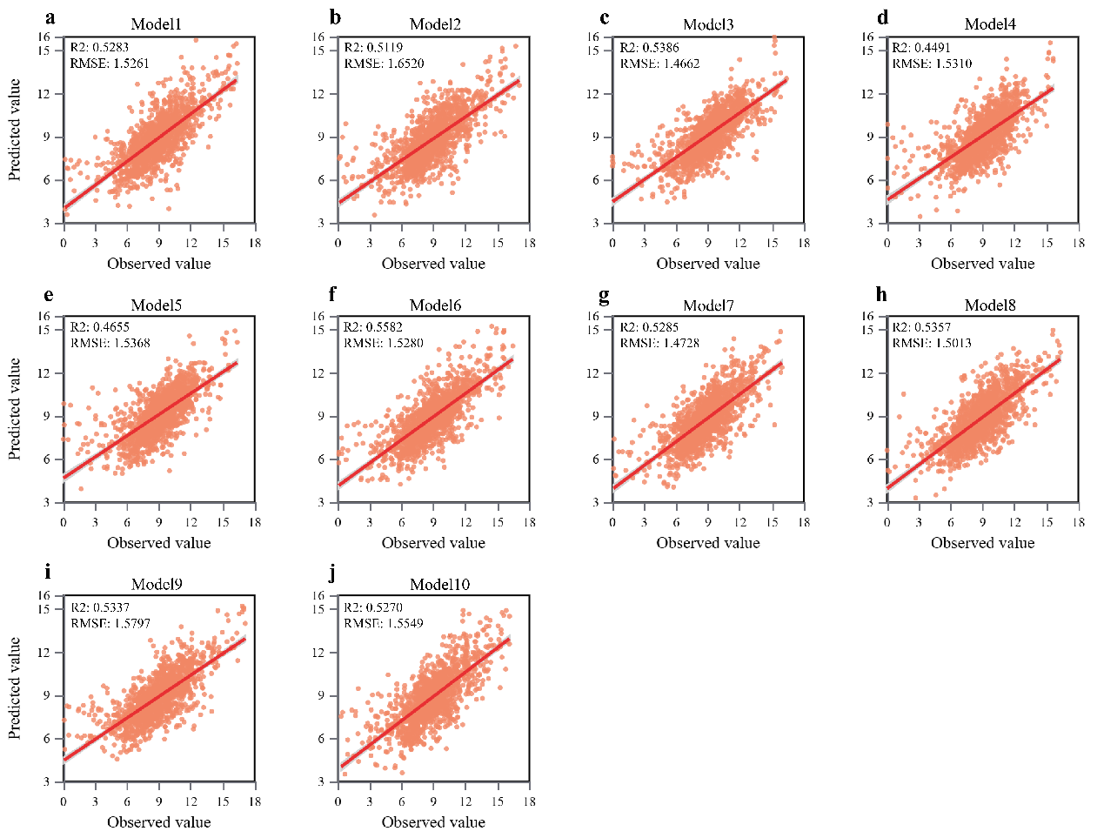
Supplementary Fig.9: XGBoost model performance

Supplementary Table 6: 41 Industry sectors related to the ski industry
ID | Sector
1 | Agricultural and livestock products
2 | Oil and gas extraction and associated services
3 | Mineral exploitation
4 | Food processing
5 | Textile manufacturing, including textiles, clothing, shoes and hats
6 | Leather manufacturing
7 | Wood processing and paper printing
8 | Petroleum refining, coking products, nuclear fuel processing products, chemical products and non-metallic mineral products
9 | Metal smelting and production of metal products
10 | Equipment manufacturing industry
11 | Scrap recycling industry
12 | Energy production and supply sector
13 | Sales, maintenance and repair of automobiles, motorcycles and their parts
14 | Other transportation industries
15 | Financial services sector
16 | Garbage disposal industry
17 | Others
18 | Forestry, logging and related service activities (02)
19 | Fishing, operating of fish hatcheries and fish farms; service activities incidental to fishing (05)
20 | Mining of coal and lignite; extraction of peat (10)
21 | Manufacture of tobacco products (16)
22 | Collection, purification and distribution of water (41)
23 | Wholesale trade and commission trade, except of motor vehicles and motorcycles (51)
24 | Retail trade, except of motor vehicles and motorcycles; repair of personal and household goods (52)
25 | Hotels and restaurants (55)
26 | Transport via railways
27 | Other land transport
28 | Air transport (62)
29 | Supporting and auxiliary transport activities; activities of travel agencies (63)
30 | Post and telecommunications (64)
31 | Real estate activities (70)
32 | Renting of machinery and equipment without operator and of personal and household goods (71)
33 | Computer and related activities (72)
34 | Research and development (73)
35 | Other business activities (74)
36 | Public administration and defence; compulsory social security (75)
37 | Education (80)
38 | Health and social work (85)
39 | Activities of membership organisation n.e.c. (91)
40 | Recreational, cultural and sporting activities (92)
41 | Other service activities (93)

