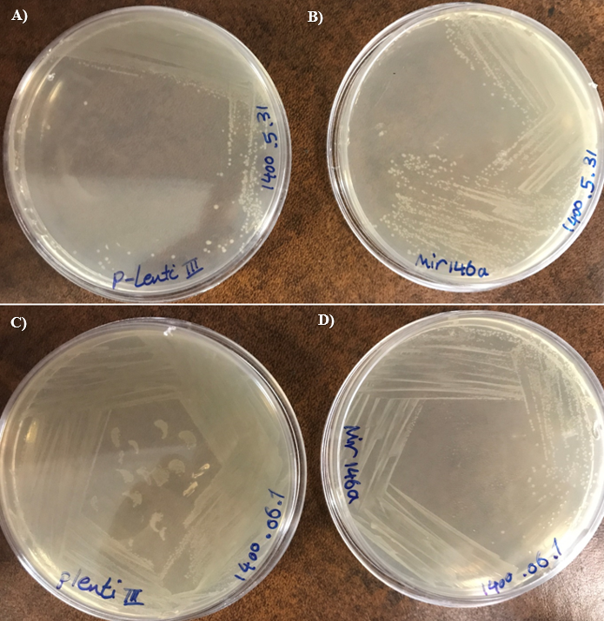
S1. Cultivation of A and C) MOC pLentiIII, and B and D) miR-146a vectors.

S2. OD results of plasmid extraction by Nanodrop device.
Figure | OD | Vector
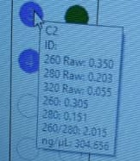 | 304.65 ng/ µl | MOC pLentiIII
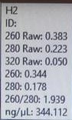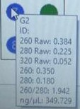 | A: 344.112 ng/ µl  B:349.72 ng/ µl | MOC pLentiIII
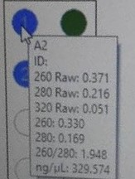 | 329.57 ng/ µl | MOC pLentiIII
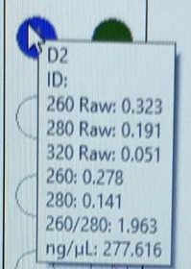 | 277.61 ng/ µl | MOC pLentiIII
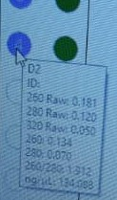 | 134.08 ng/ µl | MiR-146a
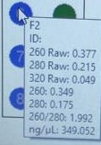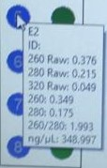 | A: 349.05 ng/ µl  B:348.997 ng/ µl | MiR-146a
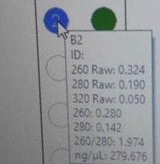 | 279.67 ng/ µl | MiR-146a
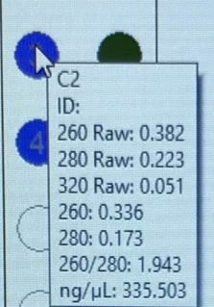 | 335.50 ng/ µl | MiR-146a

