Supplementary material

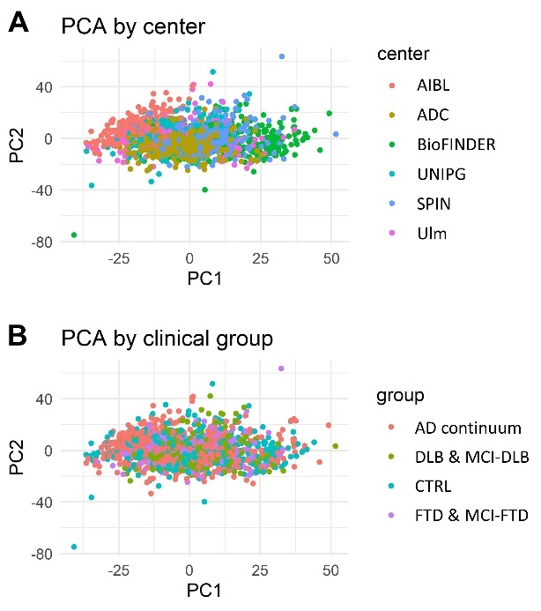
Figure S1. Principal component analysis (PCA) of the included samples and proteins. The samples in the PCA plot were colored according to A) center and B) clinical group. Center was found significantly associated with the first principal component (PC1, p<0.001) by one-way analysis of variance. This effect was, at least partially, motivated by group imbalance among centers, e.g., most subjects from AIBL belonged to the AD continuum group, while most CTRL belonged to BioFINDER. Abbreviations used: AD, Alzheimer’s disease; CTRL, controls; DLB, dementia with Lewy bodies; FTD, frontotemporal dementia; MCI, mild cognitive impairment; PC, principal component; PCA, principal component analysis.

Figure S3. Specific markers for DLB with and without positive Aβ markers. A-B) Volcano plots displaying -log₁₀ of q-values (p-values adjusted for age, sex and multiple comparisons) on the y-axis and coefficients (beta) resulting from applying logistic regression on z-scored NPX data for the DLB Aβ+ vs CTRL (A), DLB Aβ+ vs AD-dem (B), DLB Aβ- vs CTRL (C), and DLB Aβ- vs AD-dem (D). The horizontal line refers to q-value = 0.05, the two vertical represent arbitrary thresholds (± 0.5) for beta. E) Among the proteins considered, ITGAV and ITGAM were found to be consistently downregulated in DLB Aβ± in all comparisons. The effect size (Cohen’s d) is reported for each comparison. Proteins are represented using the names of genes encoding for them, other abbreviations include Aβ±: positive or negative biomarker of brain amyloidosis, AD: Alzheimer’s disease, AD-dem: AD at dementia stage, CTRL: controls, DLB: dementia with Lewy bodies.

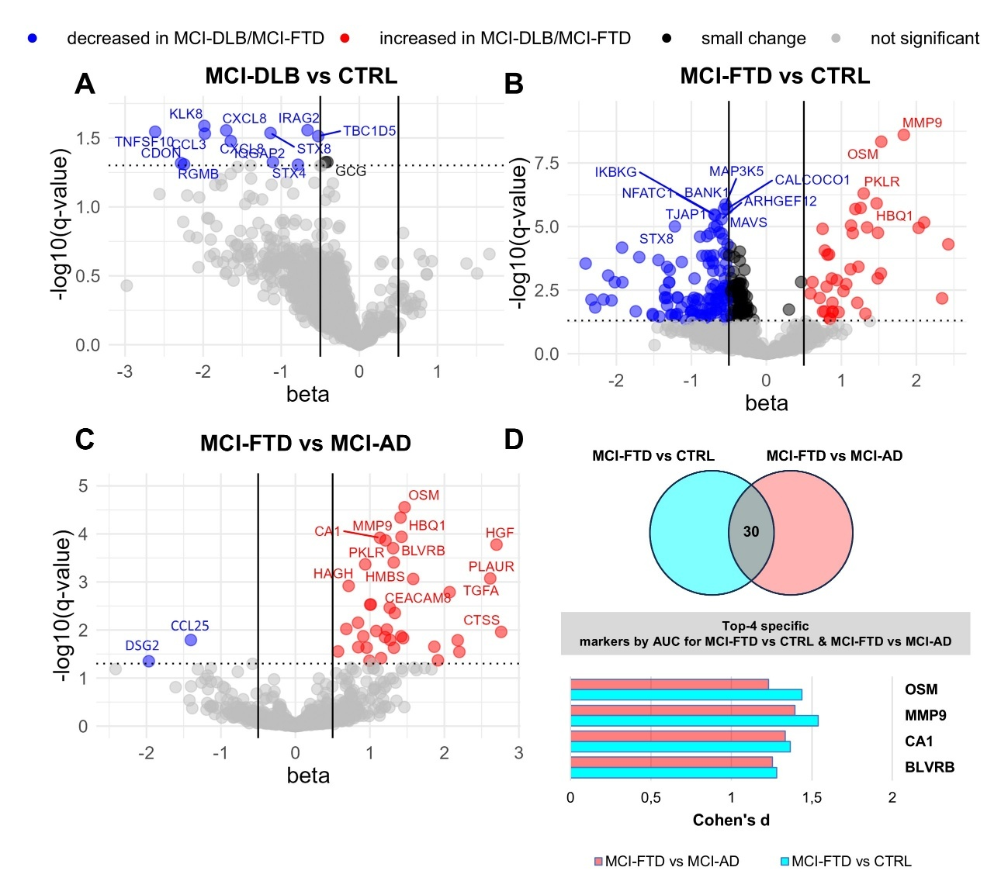

Figure S4. Specific markers for MCI-DLB and MCI-FTD. A-C) Volcano plots displaying -log₁₀ of q-values (p-values adjusted for age, sex and multiple comparisons) on the y-axis and coefficients (beta) resulting from applying logistic regression on z-scored NPX data for: A) MCI-DLB (n=25) vs CTRL (n=362), B) MCI-FTD (n=45) vs CTRL, C) MCI-FTD vs MCI-AD (n=157). The horizontal line refers to q-value = 0.05, the two vertical represent arbitrary thresholds (± 0.5) for beta. None of the proteins analyzed showed a q < 0.05 for MCI-DLB vs MCI-AD. D) 31 proteins showed q < 0.05 for MCI-FTD vs CTRL and MCI-FTD vs MCI-AD. Among those, OSM, MMP9, CA1 and BLVRB were those showing the highest average AUC, which are shown with their effect size (Cohen’s d) for each comparison. Proteins are represented using the names of genes encoding for them, other abbreviations include AD: Alzheimer’s disease, AUC: area under the ROC curve, CTRL: controls, MCI-DLB: mild cognitive impairment due to Lewy body disease, MCI-FTD: mild cognitive impairment due to frontotemporal degeneration.

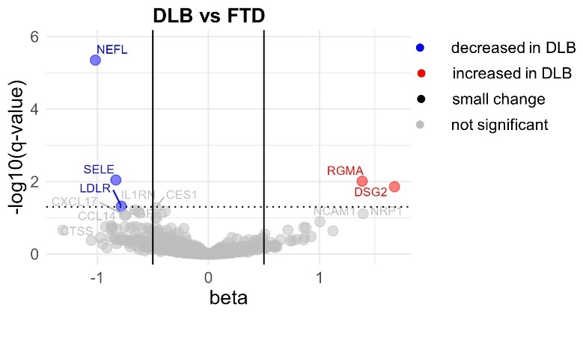
Figure S5. DLB vs FTD. Volcano plots displaying -log₁₀ of q-values (p-values adjusted for age, sex and multiple comparisons) on the y-axis and coefficients (beta) resulting from applying logistic regression on z-scored NPX data for the DLB (n=167) vs FTD (n=163). The horizontal line refers to q-value = 0.05, the two vertical represent arbitrary thresholds (± 0.5) for beta. Proteins are represented using the names of genes encoding for them, other abbreviations include DLB: dementia with Lewy bodies, FTD: frontotemporal dementia.

Figure S6. Protein selection within training sets. For each of the DLB vs AD-dem (A), DLB vs CTRL (B), FTD vs AD-dem (C), and FTD vs CTRL (D) comparisons, we applied in training sets a 100-fold cross validated LASSO binomial regression and analyzed the selection proportion of PEA proteins in 5-variable models. To identify a composite biomarker for the molecular staging of AD (E), we applied Gaussian LASSO regression, using the clinical stages of AD as numeric variables (preAD=1, MCI-AD=2, AD-dem=3). For DLB vs AD-dem, n=119 DLB and n=120 AD-dem were used for model training, n=48 DLB and n=55 AD-dem were used for testing. For DLB vs CTRL, n=110 DLB and n=260 CTRL were used for training, n=57 DLB and n=102 CTRL were used for testing. For FTD vs AD-dem, n=115 FTD and n=121 AD-dem were used for training, n=48 FTD and n=54 AD-dem were used for testing. For FTD vs CTRL, n=117 FTD and n=250 CTRL were used for training, n=46 FTD and n=112 CTRL were used for testing. For AD staging, after filtering out samples with MMSE outside IQR, for model training, n=86 preAD, n=109 MCI-AD, and n=83 AD-dem were used. For model testing, n=41 preAD, n=48 MCI-AD, and n=38 AD-dem were used. Proteins are represented using the names of genes encoding for them, other abbreviations include AD: Alzheimer’s disease, AD-dem: Alzheimer’s disease at dementia stage, CTRL: controls, DLB: dementia with Lewy bodies, FTD: frontotemporal dementia, LASSO: least absolute shrinkage selection operator, MCI-AD: mild cognitive impairment due to AD, preAD: preclinical AD.

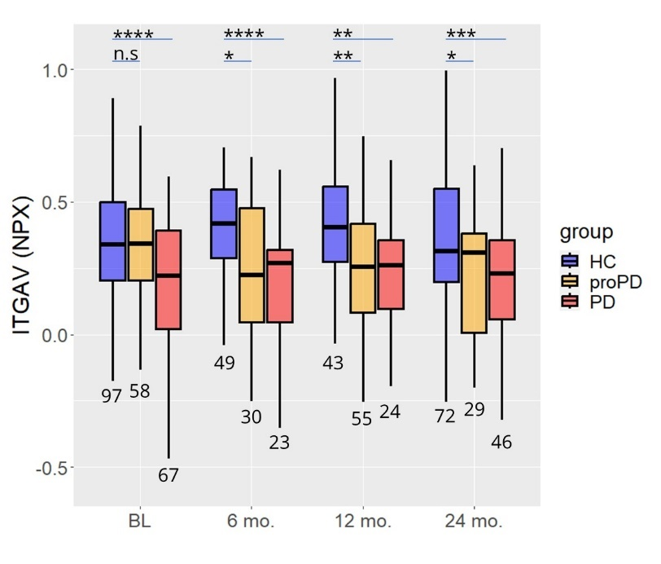
Figure S7. Boxplots displaying the NPX values of ITGAV at different timepoints in PD, proPD, and HC. The boxplots report the 25% (lower hinge), 50% (median), and 75% quantiles (upper hinge). The lower whiskers indicate the smallest observation greater than or equal to the lower hinge = 1.5 interquartile range; the upper whiskers indicate the largest observation less than or equal to the upper hinge = 1.5 interquartile range. The p-values reported refers to linear mixed models’ analysis: *0.01<p≤0.05, **0.001<p≤0.01, ***0.0001<p≤0.001, ****p≤0.0000. Abbreviations. HC: healthy controls, PD: Parkinson’s disease, proPD: prodromal PD.

Cohort | Aβ assay and cutoff | Tau assay and cutoff
ADC | Innotest ELISA CSF Aβ₄₂<813 pg/mL  Elecsys CSF Aβ₄₂<1000⁷² pg/mL | Innotest ELISA CSF pTau>52 pg/mL  Elecsys CSF pTau>24 pg/mL¹⁹
AIBL | Aβ PET >25 centiloids²¹ | Tau PET meta temporal SUVR>1.19²²
BioFINDER | Euroimmun ELISA CSF Aβ₄₂/Aβ₄₀<0.088 | Euroimmun pTau181>65.04 pg/mL or tTau>462.91 pg/mL
SPIN | Lumipulse CSF Aβ₄₂/Aβ₄₀<0.062 | Lumipulse CSF pTau181>63 pg/mL or tTau>456 pg/mL
UNIPG | Lumipulse CSF Aβ₄₂/Aβ₄₀<0.072⁸ | Lumipulse CSF pTau181>50 pg/mL⁸
Ulm | Lumipulse CSF Aβ₄₂<450 pg/mL | Lumipulse pTau181>65 pg/mL or  tTau>380 pg/mL
Table S1. Biomarker assays and cutoff values for determining the A and T biological anchors in the multicentric bPRIDE cohort. Abbreviations. Aβ: amyloid-beta, ADC: Amsterdam Dementia Cohort; AIBL: Australian Imaging Biomarker & Lifestyle Flagship Study of Ageing cohort, BioFINDER: The Swedish BioFINDER study cohort, CSF; cerebrospinal fluid, ELISA: enzyme-linked immunosorbent assay, SPIN: Sant Pau Initiative on Neurodegeneration, Ulm: University of Ulm cohort, UNIPG: University of Perugia cohort.

Prevalent pathology | N | age (y) | sex (%M) | NIA A | NIA B | NIA C | Braak α-syn | N Braak α-syn >3)
AD | 103 | 86.8±6.8 | 17% | 3.0 ± 0.1 | 3.0±0.1 | 2.8±0.5 | 1.7±2.2 | 24
Lewy | 12 | 87.7±6.7 | 25% | 2.8 ± 0.6 | 2.3±0.6 | 1.6±1.1 | 5.8±0.4 | 12
Vascular | 14 | 86.5±4.2 | 29% | 2.4 ± 0.9 | 1.6±0.6 | 1.4±1.1 | 0.2±0.8 | 0
Table S2. Demographic and neuropathological features of the VARS cohort. NIA A, NIA B and NIA C refer to diffuse Aβ plaque burden (based on Thal phases; 0=0, 1=1/2, 2=3, 3=4), neurofibrillary tangle burden (based on Braak stages; 0=None, 1=I/II, 2=III/IV, 3=V/VI), and neuritic plaque location and density (based on the Consortium to Establish a Registry for Alzheimer’s Disease [CERAD] score; 0=None, 1=Sparse, 2=Moderate, 3=Frequent), respectively. Each of the 3 components is scored 0–3. Braak α-syn refers to the Braak stages for α-synuclein, scored from 1-6, being 1 the onset of the disease with Lewy bodies in the lower brainstem and 6 the most severe stage of the disease with the presence of Lewy bodies in the neocortex. Numerical variables are reported as mean ± standard deviation, categorical variables as percentage. The reported age refers to the age at the time of blood sampling.

Group | N BL | Age at BL (y) | Sex (%M) | DD (y) | MoCA | H&Y | UPDRS-III | LEDD
HC | 97 | 60.8±10.6 | 70% |  | 28.2±1.1 | 0±0.1 | 1.1±2 | 0
PD | 67 | 61.4±11.2 | 70% | 0.4±0.5 | 27±2.2 | 1.5±0.5 | 20.7±9 | 0
proPD | 57 | 68.6±6.3 | 70% |  | 26.3±3.2 | 0.1±0.4 | 4.2±4.5 | 1.8±13.2
Table S3. Demographical and clinical characteristics at baseline (BL) of the participants of the PPMI 9000 study. Numerical variables are reported as mean ± standard deviation, categorical variables as percentage. Abbreviations BL: baseline, DD: disease duration, HC: healthy controls, H&Y: Hoen and Yahar scale, LEDD: levodopa equivalent dose; MoCA: Montreal cognitive assessment, M: males, UPDRS-III: unified Parkinson’s disease rating scale part III.

protein | ↑/↓ in AD | preAD vs CTRL | MCI-AD vs CTRL | AD-dem vs CTRL | AD-dem vs FTD | AD-dem vs DLB | avg
GFAP | ↑ | 0.68 (0.64-0.73) | 0.78 (0.73-0.83) | 0.83 (0.79-0.87) | 0.76 (0.71-0.81) | 0.7 (0.65-0.76) | 0.74
CALCOCO1 | ↓ | 0.62 (0.57-0.67) | 0.7 (0.64-0.75) | 0.8 (0.76-0.84) | 0.71 (0.65-0.76) | 0.74 (0.69-0.79) | 0.72
MAP3K5 | ↓ | 0.6 (0.55-0.65) | 0.71 (0.66-0.76) | 0.79 (0.75-0.83) | 0.68 (0.62-0.74) | 0.74 (0.68-0.79) | 0.71
BIN2 | ↓ | 0.61 (0.56-0.66) | 0.7 (0.65-0.75) | 0.79 (0.75-0.83) | 0.68 (0.63-0.74) | 0.72 (0.67-0.77) | 0.7
SUSD1 | ↓ | 0.6 (0.54-0.65) | 0.67 (0.62-0.72) | 0.76 (0.71-0.8) | 0.69 (0.63-0.74) | 0.74 (0.68-0.79) | 0.7
TRAF2 | ↓ | 0.6 (0.55-0.65) | 0.68 (0.63-0.73) | 0.78 (0.73-0.82) | 0.68 (0.62-0.74) | 0.72 (0.67-0.77) | 0.7
TJAP1 | ↓ | 0.6 (0.55-0.65) | 0.68 (0.63-0.73) | 0.78 (0.73-0.82) | 0.69 (0.63-0.74) | 0.71 (0.66-0.77) | 0.69
TBC1D23 | ↓ | 0.59 (0.54-0.65) | 0.68 (0.63-0.74) | 0.78 (0.74-0.83) | 0.68 (0.62-0.73) | 0.71 (0.66-0.76) | 0.69
ZBTB16 | ↓ | 0.6 (0.55-0.66) | 0.64 (0.58-0.69) | 0.73 (0.69-0.78) | 0.7 (0.64-0.75) | 0.71 (0.66-0.77) | 0.69
NFATC1 | ↓ | 0.59 (0.53-0.64) | 0.63 (0.58-0.68) | 0.74 (0.7-0.79) | 0.71 (0.66-0.77) | 0.7 (0.64-0.75) | 0.69
MAVS | ↓ | 0.59 (0.54-0.64) | 0.69 (0.64-0.74) | 0.78 (0.74-0.83) | 0.68 (0.62-0.73) | 0.7 (0.64-0.75) | 0.69
EIF4G1 | ↓ | 0.61 (0.56-0.66) | 0.69 (0.63-0.74) | 0.77 (0.72-0.81) | 0.67 (0.61-0.73) | 0.7 (0.64-0.75) | 0.68
SKAP2 | ↓ | 0.6 (0.55-0.65) | 0.69 (0.63-0.74) | 0.77 (0.72-0.81) | 0.67 (0.61-0.73) | 0.7 (0.65-0.76) | 0.68
CRACR2A | ↓ | 0.6 (0.55-0.66) | 0.72 (0.67-0.77) | 0.76 (0.72-0.81) | 0.64 (0.59-0.7) | 0.71 (0.65-0.76) | 0.68
PDLIM7 | ↓ | 0.6 (0.55-0.66) | 0.68 (0.63-0.73) | 0.77 (0.73-0.82) | 0.66 (0.61-0.72) | 0.7 (0.65-0.76) | 0.68
IRAG2 | ↓ | 0.6 (0.54-0.65) | 0.72 (0.67-0.77) | 0.78 (0.73-0.82) | 0.63 (0.57-0.69) | 0.71 (0.66-0.77) | 0.68
TBC1D5 | ↓ | 0.61 (0.56-0.66) | 0.73 (0.68-0.78) | 0.76 (0.72-0.81) | 0.64 (0.58-0.7) | 0.71 (0.65-0.76) | 0.68
STX8 | ↓ | 0.59 (0.54-0.65) | 0.71 (0.66-0.76) | 0.76 (0.72-0.81) | 0.65 (0.59-0.71) | 0.7 (0.65-0.76) | 0.68
TARBP2 | ↓ | 0.59 (0.54-0.64) | 0.65 (0.6-0.7) | 0.75 (0.71-0.8) | 0.68 (0.62-0.73) | 0.69 (0.64-0.75) | 0.68
CASP2 | ↓ | 0.6 (0.55-0.65) | 0.67 (0.61-0.72) | 0.75 (0.7-0.8) | 0.67 (0.61-0.73) | 0.69 (0.63-0.74) | 0.68
SRC | ↓ | 0.6 (0.55-0.65) | 0.66 (0.61-0.71) | 0.76 (0.71-0.81) | 0.67 (0.61-0.72) | 0.69 (0.64-0.75) | 0.68
SCAMP3 | ↓ | 0.59 (0.54-0.64) | 0.68 (0.63-0.73) | 0.76 (0.71-0.81) | 0.66 (0.61-0.72) | 0.69 (0.63-0.74) | 0.68
CLIP2 | ↓ | 0.59 (0.54-0.65) | 0.65 (0.6-0.7) | 0.75 (0.7-0.8) | 0.68 (0.62-0.73) | 0.69 (0.63-0.74) | 0.68
HEXIM1 | ↓ | 0.59 (0.54-0.64) | 0.65 (0.6-0.7) | 0.74 (0.69-0.79) | 0.68 (0.62-0.73) | 0.69 (0.64-0.75) | 0.68
ARHGEF12 | ↓ | 0.59 (0.54-0.64) | 0.66 (0.6-0.71) | 0.75 (0.7-0.79) | 0.68 (0.63-0.74) | 0.68 (0.62-0.74) | 0.68
F11R | ↓ | 0.57 (0.51-0.62) | 0.66 (0.61-0.72) | 0.74 (0.7-0.79) | 0.67 (0.61-0.72) | 0.7 (0.65-0.76) | 0.67
AXIN1 | ↓ | 0.59 (0.54-0.64) | 0.63 (0.58-0.69) | 0.73 (0.68-0.78) | 0.69 (0.64-0.75) | 0.67 (0.62-0.73) | 0.67
STX4 | ↓ | 0.61 (0.56-0.66) | 0.71 (0.65-0.76) | 0.76 (0.71-0.8) | 0.64 (0.59-0.7) | 0.68 (0.63-0.74) | 0.67
MAP2K6 | ↓ | 0.59 (0.54-0.64) | 0.65 (0.6-0.7) | 0.74 (0.7-0.79) | 0.67 (0.61-0.73) | 0.69 (0.63-0.74) | 0.67
IRAK1 | ↓ | 0.59 (0.54-0.64) | 0.66 (0.61-0.72) | 0.74 (0.7-0.79) | 0.67 (0.61-0.73) | 0.67 (0.62-0.73) | 0.67
CORO1A | ↓ | 0.61 (0.56-0.66) | 0.71 (0.66-0.76) | 0.77 (0.72-0.81) | 0.63 (0.57-0.69) | 0.67 (0.62-0.73) | 0.67
YES1 | ↓ | 0.59 (0.54-0.64) | 0.62 (0.57-0.68) | 0.74 (0.69-0.78) | 0.68 (0.62-0.73) | 0.67 (0.62-0.73) | 0.67
VPS37A | ↓ | 0.59 (0.54-0.64) | 0.66 (0.61-0.71) | 0.75 (0.7-0.8) | 0.66 (0.61-0.72) | 0.67 (0.61-0.72) | 0.67
IKBKG | ↓ | 0.59 (0.53-0.64) | 0.64 (0.59-0.7) | 0.72 (0.68-0.77) | 0.68 (0.63-0.74) | 0.66 (0.6-0.72) | 0.66
BANK1 | ↓ | 0.59 (0.53-0.64) | 0.63 (0.57-0.68) | 0.74 (0.69-0.78) | 0.69 (0.64-0.75) | 0.65 (0.6-0.71) | 0.66
MPIG6B | ↓ | 0.59 (0.54-0.64) | 0.63 (0.58-0.68) | 0.71 (0.66-0.76) | 0.67 (0.61-0.72) | 0.68 (0.63-0.74) | 0.66
INPPL1 | ↓ | 0.59 (0.54-0.64) | 0.61 (0.56-0.67) | 0.71 (0.66-0.76) | 0.69 (0.63-0.74) | 0.67 (0.61-0.72) | 0.66
SNAP29 | ↓ | 0.6 (0.55-0.65) | 0.64 (0.58-0.69) | 0.72 (0.68-0.77) | 0.67 (0.61-0.72) | 0.67 (0.61-0.72) | 0.66
MGLL | ↓ | 0.6 (0.55-0.65) | 0.63 (0.58-0.69) | 0.73 (0.68-0.77) | 0.67 (0.61-0.72) | 0.67 (0.61-0.72) | 0.66
CDKN1A | ↓ | 0.6 (0.54-0.65) | 0.6 (0.55-0.66) | 0.72 (0.67-0.77) | 0.69 (0.63-0.75) | 0.65 (0.6-0.71) | 0.66
PLXNA4 | ↓ | 0.58 (0.53-0.64) | 0.64 (0.59-0.69) | 0.7 (0.65-0.75) | 0.67 (0.61-0.73) | 0.67 (0.61-0.73) | 0.66
DBNL | ↓ | 0.6 (0.55-0.65) | 0.66 (0.6-0.71) | 0.74 (0.69-0.78) | 0.65 (0.59-0.71) | 0.66 (0.61-0.72) | 0.66
MVK | ↓ | 0.59 (0.54-0.65) | 0.63 (0.58-0.68) | 0.71 (0.66-0.76) | 0.68 (0.63-0.74) | 0.65 (0.6-0.71) | 0.66
AIFM1 | ↓ | 0.59 (0.54-0.64) | 0.64 (0.58-0.69) | 0.72 (0.67-0.76) | 0.66 (0.61-0.72) | 0.66 (0.61-0.72) | 0.66
CASP3 | ↓ | 0.6 (0.54-0.65) | 0.63 (0.57-0.68) | 0.71 (0.67-0.76) | 0.67 (0.61-0.73) | 0.66 (0.6-0.72) | 0.66
CIAPIN1 | ↓ | 0.6 (0.55-0.65) | 0.64 (0.58-0.69) | 0.73 (0.68-0.78) | 0.65 (0.6-0.71) | 0.66 (0.6-0.72) | 0.66
CLEC1B | ↓ | 0.6 (0.55-0.65) | 0.62 (0.57-0.68) | 0.71 (0.67-0.76) | 0.66 (0.6-0.72) | 0.67 (0.61-0.72) | 0.66
PMVK | ↓ | 0.61 (0.56-0.66) | 0.6 (0.55-0.66) | 0.7 (0.65-0.75) | 0.67 (0.61-0.73) | 0.67 (0.61-0.73) | 0.66
ABL1 | ↓ | 0.58 (0.53-0.64) | 0.66 (0.61-0.72) | 0.74 (0.7-0.79) | 0.64 (0.58-0.7) | 0.67 (0.61-0.72) | 0.66
CD40 | ↓ | 0.56 (0.51-0.61) | 0.63 (0.57-0.68) | 0.72 (0.68-0.77) | 0.65 (0.59-0.71) | 0.68 (0.63-0.74) | 0.66
Table S4. Area under the ROC curve (AUC) values for top 50 AD-specific plasma proteins ranked by average AUC. Average AUC value (avg) was calculated by averaging AUC values of the preAD vs CTRL, MCI-AD vs CTRL and AD-dem vs CTRL comparisons and then average this value with those produced by the AD-dem vs DLB and AD-dem vs FTD comparisons. AUC values for each comparison are also shown, with 95% confidence intervals in brackets calculated by the Hanley and McNeil's method. AD specificity was defined based on the consistent sign of beta values (logistic regression coefficient) and q-value < 0.05 in all the above-considered comparisons. Arrows are used to describe whether the protein considered was found to be increased (↑) or decreased (↓) in AD.

protein | ↑/↓ in DLB | DLB vs CTRL | DLB vs AD-dem | avg
ITGAV | ↓ | 0.78 (0.73-0.82) | 0.68 (0.63-0.74) | 0.73
ITGAM | ↓ | 0.75 (0.71-0.8) | 0.68 (0.62-0.73) | 0.72
ITGB2 | ↓ | 0.72 (0.67-0.77) | 0.66 (0.6-0.71) | 0.69
PI3 | ↑ | 0.71 (0.66-0.76) | 0.65 (0.59-0.7) | 0.68
B4GAT1 | ↓ | 0.75 (0.7-0.8) | 0.61 (0.56-0.67) | 0.68
DPP4 | ↓ | 0.73 (0.68-0.77) | 0.62 (0.56-0.68) | 0.67
CRTAC1 | ↓ | 0.65 (0.6-0.71) | 0.65 (0.59-0.71) | 0.65
MYOC | ↓ | 0.71 (0.66-0.76) | 0.57 (0.51-0.63) | 0.64
OMG | ↓ | 0.68 (0.63-0.73) | 0.6 (0.54-0.66) | 0.64
GDNF | ↑ | 0.63 (0.58-0.68) | 0.63 (0.57-0.69) | 0.63
CLEC4A | ↓ | 0.62 (0.57-0.67) | 0.63 (0.57-0.69) | 0.63
CD276 | ↑ | 0.64 (0.59-0.69) | 0.59 (0.53-0.65) | 0.61
COMP | ↓ | 0.63 (0.58-0.68) | 0.59 (0.53-0.65) | 0.61
TFF3 | ↑ | 0.6 (0.55-0.65) | 0.56 (0.5-0.62) | 0.58
IGFBP1 | ↓ | 0.57 (0.52-0.63) | 0.59 (0.53-0.65) | 0.58
TACSTD2 | ↓ | 0.58 (0.53-0.63) | 0.58 (0.52-0.64) | 0.58
CA6 | ↓ | 0.58 (0.53-0.63) | 0.58 (0.51-0.64) | 0.58
OGN | ↑ | 0.58 (0.52-0.63) | 0.54 (0.48-0.6) | 0.56
DSG2 | ↑ | 0.56 (0.5-0.61) | 0.55 (0.49-0.62) | 0.56
Table S5. Area under the ROC curve (AUC) values for 19 DLB-specific plasma proteins ranked by average AUC. Average AUC value (avg) was calculated by averaging AUC values of the DLB vs CTRL and DLB vs AD-dem comparisons. AUC values for each comparison are also shown, with 95% confidence intervals in brackets calculated by the Hanley and McNeil's method. DLB specificity was defined based on the consistent sign of beta values (logistic regression coefficient) and q-value < 0.05 in the two comparisons. Arrows are used to describe whether the protein considered was found to be increased (↑) or decreased (↓) in DLB.

protein | ↑/↓ in FTD | FTD vs CTRL | FTD vs AD-dem | avg
NEFL | ↑ | 0.81 (0.76-0.85) | 0.64 (0.58-0.69) | 0.72
ITGAV | ↓ | 0.73 (0.68-0.78) | 0.64 (0.58-0.69) | 0.68
NCAN | ↓ | 0.68 (0.63-0.73) | 0.67 (0.61-0.73) | 0.68
MYOC | ↓ | 0.73 (0.68-0.78) | 0.6 (0.54-0.66) | 0.67
COMP | ↓ | 0.67 (0.62-0.73) | 0.63 (0.57-0.69) | 0.65
NTRK3 | ↓ | 0.65 (0.59-0.7) | 0.65 (0.59-0.7) | 0.65
ITGAM | ↓ | 0.68 (0.63-0.73) | 0.61 (0.55-0.67) | 0.64
CRTAC1 | ↓ | 0.64 (0.59-0.69) | 0.64 (0.58-0.69) | 0.64
CD34 | ↓ | 0.65 (0.6-0.7) | 0.6 (0.54-0.66) | 0.63
CNTN4 | ↓ | 0.65 (0.6-0.7) | 0.59 (0.53-0.66) | 0.62
PON3 | ↓ | 0.65 (0.6-0.7) | 0.59 (0.53-0.65) | 0.62
NOTCH3 | ↓ | 0.61 (0.56-0.67) | 0.62 (0.57-0.68) | 0.62
DEFB4A | ↑ | 0.63 (0.58-0.68) | 0.59 (0.53-0.66) | 0.61
CST6 | ↑ | 0.62 (0.57-0.67) | 0.6 (0.54-0.66) | 0.61
HPGDS | ↓ | 0.66 (0.61-0.72) | 0.56 (0.5-0.62) | 0.61
IGFBP1 | ↓ | 0.6 (0.55-0.66) | 0.62 (0.56-0.68) | 0.61
F3 | ↓ | 0.62 (0.56-0.67) | 0.6 (0.54-0.66) | 0.61
RGMA | ↓ | 0.64 (0.59-0.69) | 0.56 (0.5-0.62) | 0.6
SCGB3A2 | ↓ | 0.6 (0.55-0.66) | 0.58 (0.52-0.64) | 0.59
COL6A3 | ↑ | 0.56 (0.5-0.61) | 0.58 (0.52-0.64) | 0.57
CA6 | ↓ | 0.56 (0.51-0.62) | 0.56 (0.5-0.62) | 0.56
FABP4 | ↑ | 0.52 (0.46-0.57) | 0.52 (0.46-0.58) | 0.52
MMP3 | ↑ | 0.51 (0.46-0.56) | 0.53 (0.47-0.59) | 0.52
Table S6. Area under the ROC curve (AUC) values for 19 FTD-specific plasma proteins ranked by average AUC. Average AUC value (avg) was calculated by averaging AUC values of the FTD vs CTRL and FTD vs AD-dem comparisons. AUC values for each comparison are also shown, with 95% confidence intervals in brackets calculated by the Hanley and McNeil's method FTD specificity was defined based on the consistent sign of beta values (logistic regression coefficient) and q-value < 0.05 in the two comparisons. Arrows are used to describe whether the protein considered was found to be increased (↑) or decreased (↓) in FTD.

panel protein | DLB vs AD-dem | DLB vs CTRL | FTD vs AD-dem | FTD vs CTRL | AD staging
ITGAM | -0.12 | -0.8 |  | -0.197
ITGAV | -0.7 | -0.9 |  | -0.325 | -0.217
CD38 | 0.44
CALCOCO1 | 0.24
FLT3LG |  | -0.4 |  | -0.056 | -0.32
MAP3K5 |  |  |  | -0.01 | -0.004
IRAG2 |  |  |  | -0.13
B4GAT1 |  |  |  | -0.81
TRAF2 |  |  |  |  | -0.019
TNFSF10 |  |  |  | -0.325 | -0.23
OSM |  |  |  | 0.138 | 0.075
NCAN |  |  |  | -0.315
NEFL |  |  | 1 | 1.319 | 0.06
RET |  |  |  |  | -0.144
PI3 |  | 0.03
GFAP | -0.36 | 0.07 | -1 |  | 0.245
PECAM1 |  |  |  |  | -0.07
CDKN1A
EGFR
ERBB3 |  | -1
NTRK3

Table S7. Coefficients of multivariable models. The LASSO coefficients are reported for the DLB vs AD-dem, DLB vs CTRL, FTD vs AD-dem, FTD vs CTRL comparisons and AD staging. Proteins are represented using the names of genes encoding for them, other abbreviations include AD: Alzheimer’s disease, AD-dem: Alzheimer’s disease at dementia stage, CTRL: controls, DLB: dementia with Lewy bodies, FTD: frontotemporal dementia, LASSO: least absolute shrinkage selection operator.

