Supporting Information

An Efficient and stable magnetic nano-biocatalyst for biodiesel synthesis in recyclable ionic liquids
Xiu Xing, Zi-Wen Zhou, Yun-Jie Wei, Yan-Hong Liu, Kun Li, Xiao-Qi Yu and Na Wang *
Key Laboratory of Green Chemistry Technology, Ministry of Education, College of Chemistry, Sichuan
University, Chengdu 610064, PR China
* Correspondence: wnchem@scu.edu.cn; Tel.: +86-288-541-5886

Preparation of magnetic Fe₃O₄ nanoparticles

Magnetic particles were prepared by the conventional co-precipitation method (Talekar et al. 2012). In a typical procedure, 3.7 mmol FeCl₂·4H₂O and 7.5 mmol FeCl₃·6H₂O were dissolved in 25 mL deionized water under nitrogen with vigorous stirring at room temperature. Then, as 7ml of 30% NaOH was added drop by drop, a black precipitate formed gradually in the system. After aging for 2 hours in the mother liquor, the resulting magnetic particles were washed several times with deionized water until neutral and dried under vacuum at -70 °C.

Functionalization of Fe₃O₄ magnetic nanoparticles with APTES

The Fe₃O₄ magnetic nanoparticles(200mg) were introduced in 25 ml of methanol containing 250 μL of deionized water and 1mL of APTES, and the mixture was sonicated for 30 minutes. Then, 15 mL glycerol was added, and the reaction system was refluxed at 90 °C for 8 h with mechanical agitation (Xing et al. 2019). The particles were separated by centrifugation (8000 rpm for 10 min) and were washed three times with methanol and water, respectively.

Activity assay

The yield of the ester produced by the transesterification between 2-phenylethanol and vinyl acetate was regarded as a reference for the enzyme activity. First, 5 mg of magnetic RML CLEAs was dispersed in 2 mL of n-hexane containing 2-phenylethanol (10 mg/mL) and vinyl acetate (20 mg/mL). The mixture was incubated in a temperature-controlled shaker (200 rpm, 24 h, 40 °C). The reaction was quenched through the isolation of immobilized lipase with a magnet. The samples were separated from the reaction medium for the analysis of High-Performance Liquid Chromatography (HPLC). HPLC was conducted with Waters Associates equipment (Waters 2695 with 2998 Photodiode Array Detector), with the C₁₈ column at a flow rate of 1.0 mL/min on 30 °C column temperature. The mobile phase composed of MeOH and water using a 70:30 v/v ratio. Additionally, the wavelength of the UV detector was set at 237 nm, when the retention time of the product was 3.9 min.

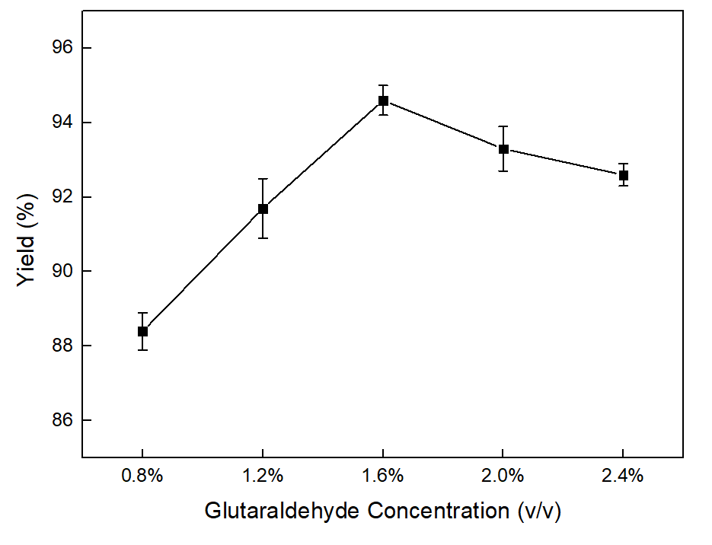
Figure S1 Effect of glutaraldehyde concentration on activity of magnetic RML CLEAs. Reactions performed with 5mg magnetic RML CLEAs and 2 mL of n-hexane containing 0.2 mmol of 2-phenylethanol and 0.4 mmol of vinyl acetate at 50 °C for 24 h.

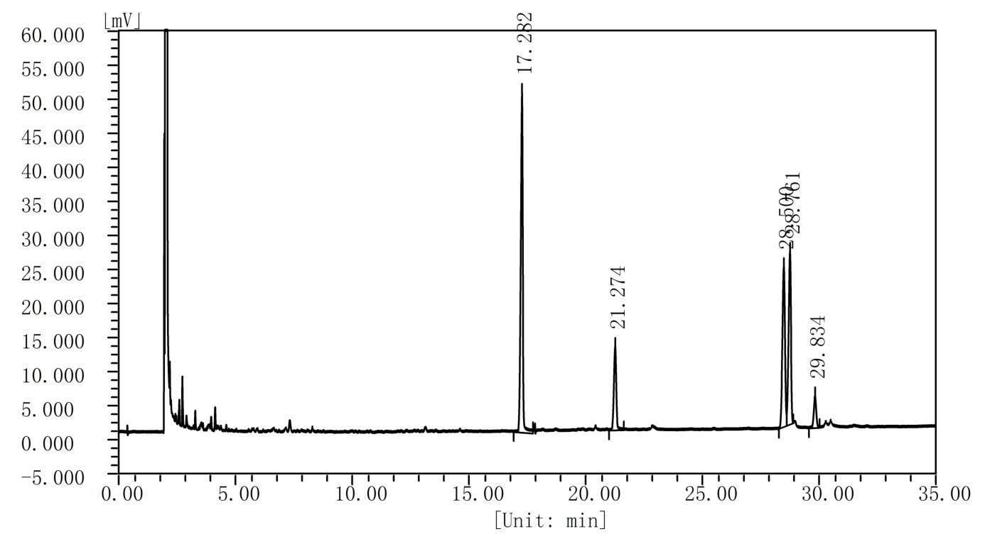

Figure S2 Gas chromatography (GC) of biodiesel production catalyzed by magnetic RML CLEAs in [BMIM][PF₆]. Methyl pentadecanoate (internal standard): t=17.282; Methyl palmitate: t=21.274; Methyl linoleate: t=28.500; Methyl oleate: t=28.761; Methyl stearate: t=29.834.

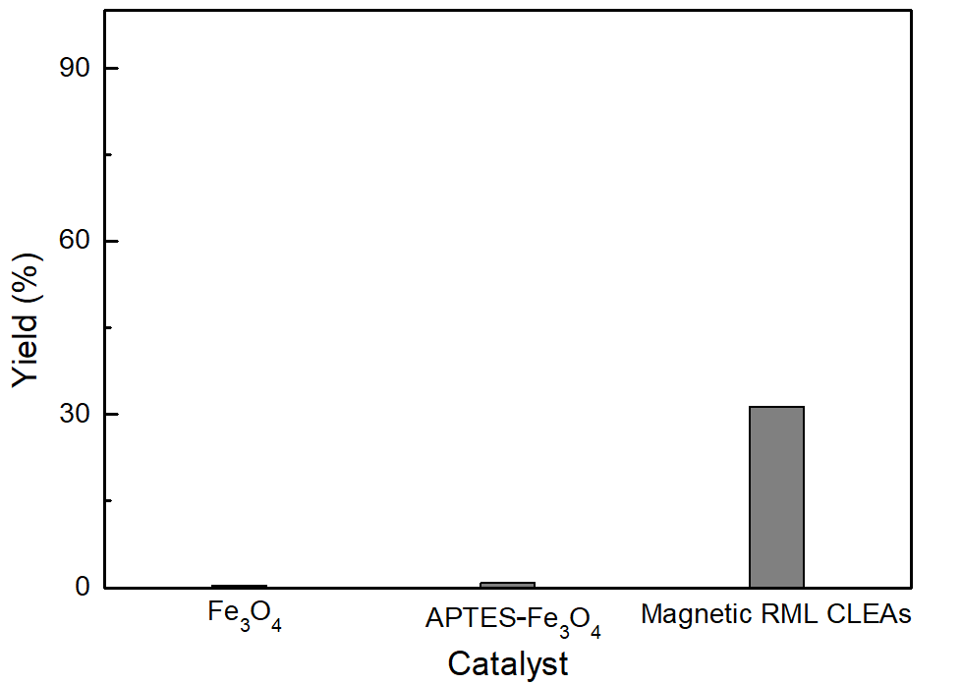

Figure S3 The FAME yield in the presence Fe₃O₄, APTES- Fe₃O₄ and magnetic RML CLEAs. The reaction conditions were: time 48h, temperature 50 °C, catalyst 2wt% and methanol/oil molar ratio 5:1.

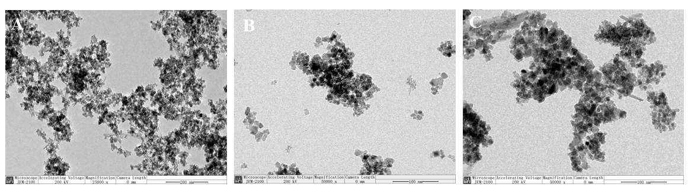
Figure S4 TEM images of (A) Fe₃O₄, (B) APTES-Fe₃O₄, (C) magnetic RML CLEAs

References
Talekar S, Ghodake V, Ghotage T, Rathod P, Deshmukh P, Nadar S, Mulla M, Ladole M (2012) Novel magnetic cross-linked enzyme aggregates (magnetic CLEAs) of alpha amylase, Bioresour. Technol. 123: 542-547.
Xing X, Jia JQ, Zhang JF, Zhou ZW, Li J, Wang N, Yu XQ (2019) CALB Immobilized onto Magnetic Nanoparticles for Efficient Kinetic Resolution of Racemic Secondary Alcohols: Long-Term Stability and Reusability, Molecules 24: 490.

