Supplementary Information
Synthesis of promising brominated flavonoids as antidiabetic and anti-glycation agents

Rita Hairani1,2 and Warinthorn Chavasiri1,*
1Center of Excellence in Natural Products Chemistry, Department of Chemistry, Faculty of Science, Chulalongkorn University, Bangkok 10330, Thailand
2Department of Chemistry, Faculty of Mathematics and Natural Sciences, Mulawarman University, Samarinda 75123, Indonesia

* Corresponding author:
Assistant Professor Dr. Warinthorn Chavasiri
Room 1329 Mahamakut Building, Department of Chemistry, Faculty of Science, Chulalongkorn University, Phayathai Road, Pathumwan Bangkok 10330, Thailand
E-mail address: warinthorn.c@chula.ac.th

Contents
Figure S1. ¹H NMR spectrum of kaempferol (F5) in DMSO-d₆ 4
Figure S2. ¹³C NMR spectrum of kaempferol (F5) in DMSO-d₆ 4
Figure S3. ¹H NMR spectrum of pinocembrin (F8) in CDCl₃ 5
Figure S4. ¹³C NMR spectrum of pinocembrin (F8) in CDCl₃ 5
Figure S5. ¹H NMR spectrum of pinostrobin (F9) in acetone-d₆ 6
Figure S6. ¹³C NMR spectrum of pinostrobin (F9) in acetone-d₆ 6
Figure S7. ¹H NMR spectrum of alpinetin (F10) in DMSO-d₆ 7
Figure S8. ¹³C NMR spectrum of alpinetin (F10) in DMSO-d₆ 7
Figure S9. ¹H NMR spectrum of F1a in DMSO-d₆ 8
Figure S10. ¹³C NMR spectrum of F1a in DMSO-d₆ 8
Figure S11. ¹H NMR spectrum of F2a in DMSO-d₆ 9
Figure S12. ¹³C NMR spectrum of F2a in DMSO-d₆ 9
Figure S13. ¹H NMR spectrum of F3a in DMSO-d₆ 10
Figure S14. ¹³C NMR spectrum of F3a in DMSO-d₆ 10
Figure S15. HRESIMS spectrum of F3a 11
Figure S16. ¹H NMR spectrum of F4a in DMSO-d₆ 11
Figure S17. ¹³C NMR spectrum of F4a in DMSO-d₆ 12
Figure S18. ¹H NMR spectrum of F5a in DMSO-d₆ 12
Figure S19. ¹³C NMR spectrum of F5a in DMSO-d₆ 13
Figure S20. ¹H NMR spectrum of F6a in DMSO-d₆ 13
Figure S21. ¹³C NMR spectrum of F6a in DMSO-d₆ 14

Figure S22. ¹H NMR spectrum of F7a in acetone-d₆ 14
Figure S23. ¹³C NMR spectrum of F7a in acetone-d₆ 15
Figure S24. ¹H NMR spectrum of F8a in DMSO-d₆ 15
Figure S25. ¹³C NMR spectrum of F8a in DMSO-d₆ 16
Figure S26. ¹H NMR spectrum of F9a in CDCl_{3.} 16
Figure S27. ¹³C NMR spectrum of F9a in CDCl₃ 17
Figure S28. ¹H NMR spectrum of F10a in DMSO-d₆ 17
Figure S29. ¹³C NMR spectrum of F10a in DMSO-d₆ 18
Figure S30. HRESIMS spectrum of F10a 18
Figure S31. ¹H NMR spectrum of F11a in DMSO-d₆ 19
Figure S32. ¹³C NMR spectrum of F11a in DMSO-d₆ 19
Figure S33. ¹H NMR spectrum of F12a in DMSO-d₆ 20
Figure S34. ¹³C NMR spectrum of F12a in DMSO-d₆ 20
Table S1. Screening results of tested compounds on ⍺-glucosidase, ⍺-amylase, and
glycation inhibitory activities 21
Figure S35. ⍺-Glucosidase inhibition of selected flavonoids, their brominated derivatives,
and acarbose with various concentrations 22
Figure S36. ⍺-Amylase inhibition of selected flavonoids, their brominated derivatives,
and acarbose with various concentrations 23
Figure S37. Glycation inhibitory activity of selected flavonoids, their brominated
derivatives, and AG with various concentrations 23

Figure S1. ¹H NMR spectrum of kaempferol (F5) in DMSO-d₆

Figure S2. ¹³C NMR spectrum of kaempferol (F5) in DMSO-d₆

Figure S3. ¹H NMR spectrum of pinocembrin (F8) in acetone-d₆

Figure S4. ¹³C NMR spectrum of pinocembrin (F8) in acetone-d₆
Figure S5. ¹H NMR spectrum of pinostrobin (F9) in CDCl₃

Figure S6. ¹³C NMR spectrum of pinostrobin (F9) in CDCl₃

Figure S7. ¹H NMR spectrum of alpinetin (F10) in DMSO-d₆

Figure S8. ¹³C NMR spectrum of alpinetin (F10) in DMSO-d₆

x
Figure S9. ¹H NMR spectrum of F1a in DMSO-d₆

Figure S10. ¹³C NMR spectrum of F1a in DMSO-d₆

Figure S11. ¹H NMR spectrum of F2a in DMSO-d₆

Figure S12. ¹³C NMR spectrum of F2a in DMSO-d₆

Figure S13. ¹H NMR spectrum of F3a in DMSO-d₆

Figure S14. ¹³C NMR spectrum of F3a in DMSO-d₆

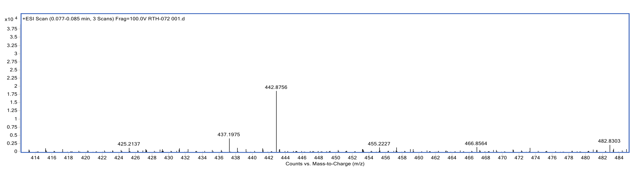
Figure S15. HRESIMS spectrum of F3a

Figure S16. ¹H NMR spectrum of F4a in DMSO-d₆

Figure S17. ¹³C NMR spectrum of F4a in DMSO-d₆

Figure S18. ¹H NMR spectrum of F5a in DMSO-d₆

Figure S19. ¹³C NMR spectrum of F5a in DMSO-d₆

Figure S20. ¹H NMR spectrum of F6a in DMSO-d₆
Figure S21. ¹³C NMR spectrum of F6a in DMSO-d₆

Figure S22. ¹H NMR spectrum of F7a in acetone-d₆
Figure S23. ¹³C NMR spectrum of F7a in acetone-d₆

Figure S24. ¹H NMR spectrum of F8a in DMSO-d₆
Figure S25. ¹³C NMR spectrum of F8a in DMSO-d₆

Figure S26. ¹H NMR spectrum of F9a in CDCl₃
Figure S27. ¹³C NMR spectrum of F9a in CDCl₃

Figure S28. ¹H NMR spectrum of F10a in in DMSO-d₆

Figure S29. ¹³C NMR spectrum of F10a in in DMSO-d₆

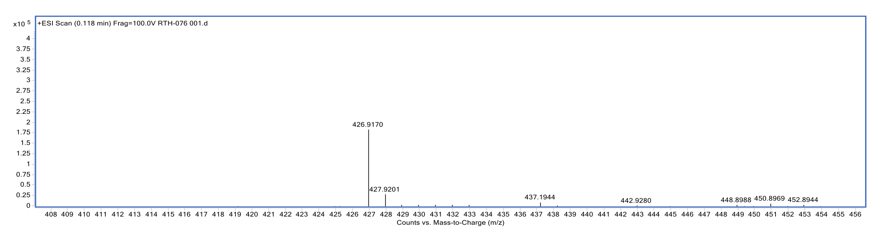
Figure S30. HRESIMS spectrum of F10a

Figure S31. ¹H NMR spectrum of F11a in DMSO-d₆

Figure S32. ¹³C NMR spectrum of F11a in DMSO-d₆
Figure S33. ¹H NMR spectrum of F12a in DMSO-d₆

Figure S34. ¹³C NMR spectrum of F12a in DMSO-d₆
Table S1. Screening results of tested compounds on α-glucosidase, α-amylase, and glycation inhibitory activities.
Compound | % Inhibition on α-glucosidase assay |  |  | % Inhibition on α-amylase assay |  |  | % Inhibition on anti-glycation assay
Compound | 1 | 2 | Mean ± SD | 1 | 2 | Mean ± SD | 1 | 2 | Mean ± SD
Flavones
Chrysin (F1) | 29.22 | 33.12 | 31.21 ± 2.81 | 22.33 | 22.85 | 22.59 ± 0.37 | 55.87 | 52.04 | 53.96 ± 2.71
6,8-Dibromochrysin (F1a) | 90.76 | 88.63 | 89.70 ± 1.51 | 9.22 | 14.13 | 11.68 ± 3.47 | 96.98 | 97.03 | 97.01 ± 0.04
Apigenin (F2) | 76.19 | 81.08 | 78.64 ± 3.46 | 88.04 | 86.90 | 87.47 ± 0.81 | 73.25 | 74.07 | 73.66 ± 0.58
6,8-Dibromoapigenin (F2a) | 81.38 | 82.57 | 81.98 ± 0.84 | 68.16 | 70.40 | 69.28 ± 1.58 | 96.34 | 99.29 | 97.82 ± 2.09
Luteolin (F3) | 32.53 | 36.20 | 34.37 ± 2.60 | 97.52 | 97.70 | 97.61 ± 0.13 | 95.35 | 97.28 | 96.32 ± 1.36
6,8-Dibromoluteolin (F3a) | 97.08 | 93.07 | 95.08 ± 2.84 | 99.84 | 97.29 | 98.57 ± 1.80 | 94.37 | 96.37 | 95.37 ± 1.41
Baicalein (F4) | 99.15 | 99.69 | 99.42 ± 0.38 | 63.75 | 64.33 | 64.04 ± 0.41 | 75.66 | 68.16 | 71.91 ± 5.30
8-Bromobaicalein (F4a) | 99.82 | 99.66 | 99.74 ± 0.11 | 0.00 | 0.00 | 0.00 ± 0.00 | 35.05 | 36.06 | 35.56 ± 0.71
Flavonols
Kaempferol (F5) | 37.82 | 41.72 | 39.77 ± 2.76 | 88.93 | 85.67 | 87.30 ± 2.31 | 76.47 | 80.19 | 78.33 ± 2.63
6,8-Dibromokaempferol (F5a) | 78.73 | 79.24 | 78.99 ± 0.36 | 100.18 | 96.19 | 98.19 ± 2.82 | 71.35 | 73.13 | 72.24 ± 1.26
Morin (F6) | 96.48 | 98.46 | 97.47 ± 1.40 | 55.10 | 48.53 | 51.82 ± 4.65 | 90.14 | 96.65 | 93.40 ± 4.60
6,8-Dibromomorin (F6a) | 99.92 | 98.83 | 99.38 ± 0.77 | 99.86 | 97.43 | 98.65 ± 1.72 | 93.46 | 92.16 | 96.28 ± 0.35
Quercetin (F7) | 98.66 | 98.70 | 98.68 ± 0.03 | 92.21 | 95.90 | 94.06 ± 2.61 | 101.18 | 98.31 | 99.75 ± 2.03
6,8-Dibromoquercetin (F7a) | 96.75 | 94.77 | 95.76 ± 1.40 | 70.19 | 72.82 | 71.51 ± 1.86 | 60.54 | 61.15 | 60.85 ± 0.43
Flavanones
Pinocembrin (F8) | 6.99 | 7.29 | 7.14 ± 0.21 | 24.41 | 26.04 | 25.23 ± 1.15 | 50.17 | 45.02 | 47.60 ± 3.64
6,8-Dibromopinocembrin (F8a) | 26.14 | 25.54 | 25.84 ± 0.42 | 50.41 | 51.85 | 51.13 ± 1.02 | 47.89 | 44.73 | 46.31 ± 2.23
Pinostrobin (F9) | 12.76 | 17.50 | 15.13 ± 3.35 | 12.74 | 12.96 | 12.85 ± 0.16 | 14.47 | 9.33 | 11.90 ± 3.63
6,8-Dibromopinostrobin (F9a) | 29.85 | 29.24 | 29.55 ± 0.43 | 17.60 | 24.03 | 20.82 ± 4.55 | 42.60 | 31.82 | 37.21 ± 7.62
Alpinetin (F10) | 0.00 | 0.00 | 0.00 ± 0.00 | 33.43 | 34.82 | 34.13 ± 0.98 | 29.01 | 25.20 | 27.11 ± 2.69
6,8-Dibromoalpinetin (F10a) | 0.00 | 0.00 | 0.00 ± 0.00 | 45.01 | 42.62 | 43.82 ± 1.69 | 48.67 | 42.62 | 45.65 ± 4.28
Naringenin (F11) | 26.76 | 26.30 | 26.53 ± 0.33 | 32.77 | 33.80 | 33.29 ± 0.73 | 59.07 | 54.71 | 56.89 ± 3.08
6,8-Dibromonaringenin (F11a) | 80.75 | 80.34 | 80.55 ± 0.29 | 52.28 | 46.63 | 49.46 ± 4.00 | 96.03 | 96.77 | 96.53 ± 0.34
Hesperetin (F12) | 45.75 | 45.02 | 45.39 ± 0.52 | 30.34 | 29.45 | 29.90 ± 0.63 | 55.45 | 47.78 | 51.62 ± 5.42
6,8-Dibromohesperetin (F12a) | 64.48 | 68.03 | 66.26 ± 2.51 | 40.05 | 40.99 | 40.52 ± 0.66 | 65.25 | 61.29 | 63.27 ± 2.80
Positive control
Acarbose | 37.77 | 37.96 | 37.87 ± 0.13 | 87.74 | 88.10 | 87.92 ± 0.25
Aminoguanidine hydrochloride |  |  |  |  |  |  | 79.50 | 79.82 | 79.66 ± 0.23

Figure S35. α-Glucosidase inhibition of selected flavonoids, their brominated derivatives, and acarbose with various concentrations

Figure S36. α-Amylase inhibition of selected flavonoids, their brominated derivatives, and acarbose with various concentrations

Figure S37. Glycation inhibitory activity of selected flavonoids, their brominated derivatives, and AG with various concentrations

