Supporting Information
Size-variable self-feedback nanomotors for glioblastoma therapy via mitochondrial mineralization

Tiantian Chen⁺, Yu Duan⁺, Yingjie Wang, Tiantian Liang, Shiluan Liu, Xue Xia, Chun Mao,* Mimi Wan*

State Key Laboratory of Microbial Technology, National and Local Joint Engineering Research Center of Biomedical Functional Materials, School of Chemistry and Materials Science, Nanjing Normal University, Nanjing 210023, P. R. China.

E-mail: maochun@njnu.edu.cn (C.M.), wanmimi@njnu.edu (M.W.)

Materials
Myristic acid (99.0%), 2-(6-chloro-1-H-benzotriazole-1-yl)-1,1,3,3-tetramethylaminium hexafluorophosphate (HCTU, 98.0%), o-phenylenediamine (OPD, 99.5%), boc-arg(pbf)-OH(98.0%), 1-hydroxybenzotriazole (HOBT, 97.0%), o-benzotriazol-1-yl-tetramethyluronium hexafluorophosphate (HBTU, 99.0%), 1,2-distearoyl-sn-glycero-3-phosphoethanolamine (DSPE, 97.0%), N,N-Diisopropylethylamine (DIPEA, 99%), tris(2-​carboxyethyl)​phosphine hydrochloride (TCEP, 98.0%), N,N' bis(acryloyl)cystine (BAC, 98%), L-lysine hydrochloride (L-Lys HCl, 90.0%) and ammonium persulfate (APS, 99.9%) were purchased from Shanghai Macklin Biochemical Technology Co., Ltd; Triethylamine (AR), 1,4-Dioxane (AR), curcumin (Cur), cholesterol (99.0%) and N,N,N',N'-Tetramethyl ethylenediamine (TEMED, 99%) were purchased from Shanghai Aladdin Biochemical Technology Co., Ltd; L-arginine (L-Arg, 98%) and 3-[[2-(methacryloyloxy)ethyl]dimethylammonium] propionate (CBMA, 98.0%) were purchased from Shanghai yuanye Bio-Technology Co., Ltd; 3,3′-dioctadecyloxacarbocyanine perchlorate (DiO), 1,1'-dioctadecyl-3,3,3',3'-tetramethylindocarbocyanine perchlorate (DiL) and Mito-Tracker Green were purchased from Jiangsu KeyGEN BioTECH Corp., Ltd; Agarose (BR, BY-R0100) purchased from Shanghai Baygene Bio-Technology Co., Ltd.; 3-(4,5-dimethylthiazol-2-acyl)-2,5-diphenyltetrazolium bromide (MTT) was purchased from ApexBio Technology Co., Ltd.; Cyanine5 maleimide was purchased from Duofluor Inc.; 4% paraformaldehyde was purchased from Biosharp Life Sciences, China; D-fluorescein potassium salt was purchased from Guangzhou Biolight Biotechnology Co., Ltd.

Preparation of N-Methacryloyl-L-arginine (M-Arg) and N-Methacryloyl-L-lysine (M-Lys)
Firstly, L-Arg (2.00 g, 11.5 mmol) was dissolved in a mixture of deionized water (20.0 mL) and 1,4-dioxane (8.5 mL). And then, triethylamine (4.5 mL, 32.3 mmol) was added to the mixture. After the system was cooled in an ice-water bath, methacrylic anhydride (3.0 mL, 18.9 mmol) was added dropwise within 10 min. Then remove the ice-water bath and stir the reaction at room temperature overnight. The mixture was added to acetone (about 400 mL) to precipitate the product M-Arg and repeated twice. Finally, the product was obtained by vacuum drying at 60 °C. The preparation of M-Lys was similar to M-Arg, except that L-Arg was replaced with L-Lys HCl (2.10 g, 11.5 mmol).

Preparation of PAC NMs and PLC NPs
PAC NMs were prepared by the radical polymerization reaction using M-Arg and CBMA as monomers and BAC as crosslinking agent. Firstly, CBMA (11.5 mg, 0.05 mmol), M-Arg (12.0 mg, 0.05 mmol) and BAC (5.0 mg, 0.02 mmol) were dispersed in a three necked flask containing 4.0 mL of H₂O. After purification in a N₂ atmosphere for 30 min, initiator APS (1.2 mg, 4.0 wt%) and TEMED (2.3 mg, 8.0 wt%) were added. The polymerization reaction was carried out under N₂ protection at room temperature for 4 h. The product was dialyzed for 48 h in a dialysis bag (with a cut-off molecular weight of 500 MwCO), and deionized water was replaced at 6, 12, and 24 h. Finally, a white solid was obtained by freeze-drying. The preparations of PLC NPs were similar to PAC NMs, except that M-Arg was replaced with M-Lys (10.7 mg, 0.05 mmol).

Preparation of NO-responsive degradable lipid (NOD)
NOD was prepared according to previous literature. Myristic acid (228.0 mg, 1.0 mmol) and HCTU (496.0 mg, 1.2 mmol) were dispersed in tetrahydrofuran (THF, 15.0 mL) and stirred until dissolved at 0°C in an anaerobic environment. Next, OPD (216.0 mg, 2 mmol) was dissolved in acetonitrile (2.0 mL) and added it to the above system. Finally, triisopropanolamine (574.0 mg, 3.0 mmol) was added to the above mixed system and stirred at room temperature for 24 h. The obtained mixed solution was dried using vacuum rotary evaporator to obtain the crude product. Finally, using petroleum ether/ethyl acetate as the eluent, the crude product was purified by column chromatography to obtain the final product NOD.

Preparation of NO-releasing lipid (NOR)
NOR was prepared according to previous literature. Boc-arg(Pbf)-OH (105.3 mg, 0.2 mmol), HOBT (40.5 mg, 0.3 mmol), and HBTU (113.8 mg, 0.3 mmol) were dispersed in anhydrous DMF (2.0 mL) and stirred to dissolve at 0°C in an anaerobic environment. Then DSPE (104.8 mg, 0.1 mmol) was dissolved in anhydrous trichloromethane (15.0 mL) and added to the above system. Finally, DIPEA (200.0 μL, 1.2 mmol) was added to the above mixed solution under dark conditions, and the reaction was stirred at room temperature for 24 h. After the reaction was completed, washed the reaction solution repeatedly with saturated NaHCO₃ solution (about 500 mL) and saturated NaCl solution (about 500 mL), then added anhydrous MgSO₄ and dried for 4 h. The obtained mixed solution was dried using a vacuum rotary evaporator to obtain the crude product. Using dichloromethane (DCM)/methanol (MeOH) as the eluent, the crude product was purified by column chromatography. The purified product was treated with DCM/trifluoroacetic acid (TFA) (4/1, v/v) mixture for 4 h. Finally, precipitate with anhydrous ether to obtain NOR.

Preparation of Lip NPs and NO-Lip NMs
Lip NPs were prepared by thin film hydration method. Firstly, DSPE (10.0 mg, 11.0 nmol), DSPE-PEG2000 (21.0 mg, 7.5 nmol) and cholesterol (1.2 mg, 3 nmol) were dissolved in trichloromethane (4.5 mL) and MeOH (1.5 mL), and the solvent was spin dried using vacuum rotary evaporator to obtain a fully dried film. Deionized water (10.0 mL) was added to the round bottom flask mentioned above. The reaction system was stirred at 85°C for 1 h to obtain a mixed solution of Lip NPs. Afterwards, it was extruded through a 400 nm polycarbonate film at 85°C. The product was centrifuged at 10000 rpm for 10 min, and freeze-dried. The preparation of NO Lip NMs was similar to Lip NPs, except that DSPE (10.0 mg, 11.0 nmol), DSPE-PEG2000 (21.0 mg, 7.5 nmol) and cholesterol (1.2 mg, 3 nmol) were replaced with NOR (8.1 mg, 9 nmol), NOD (1.5 mg, 4.5 nmol), DSPE-PEG2000 (21.0 mg, 7.5 nmol) and cholesterol (1.2 mg, 3 nmol).

Preparation of Lip@PAC NPs and NO-Lip@PAC NMs
Lip@PAC NPs were prepared by thin film hydration method. Firstly, DSPE (10.0 mg, 11.0 nmol), DSPE-PEG2000 (21.0 mg, 7.5 nmol) and cholesterol (1.2 mg, 3 nmol) were dissolved in trichloromethane (4.5 mL) and MeOH (1.5 mL), and the solvent was spin dried using vacuum rotary evaporator to obtain a fully dried film. Subsequently, PAC NMs dispersion (0.6 mg mL⁻¹, 10.0 mL) and the solvent was spin dried using vacuum rotary evaporator to obtain a fully dried film. The reaction system was stirred in 85°C for 1 h to obtain a mixed solution of Lip@PAC NPs. The mixed solution was extruded through a 400 nm polycarbonate film at 85°C. Then centrifuge at 10000 rpm for 10 min to remove unencapsulated PAC NMs and obtain the final product Lip@PAC NPs. The preparation of NO-Lip@PAC was similar to Lip@PAC NPs, except that DSPE (10.0 mg, 11.0 nmol), DSPE-PEG2000 (21.0 mg, 7.5 nmol) and cholesterol (1.2 mg, 3 nmol) were replaced with NOR (8.1 mg, 9 nmol), NOD (1.5 mg, 4.5 nmol), DSPE-PEG2000 (21.0 mg, 7.5 nmol) and cholesterol (1.2 mg, 3 nmol).

Preparation of NO-Lip@PAC@Cur NMs
NO-Lip@PAC@Cur NMs were prepared by thin film hydration method. Firstly, NOR (8.1 mg, 9 nmol), NOD (1.5 mg, 4.5 nmol), DSPE-PEG2000 (21.0 mg, 7.5 nmol), cholesterol (1.2 mg, 3 nmol) and Cur (3.0 mg) were dissolved in trichloromethane (4.5 mL) and MeOH (1.5 mL), and the solvent was spin dried using vacuum rotary evaporator to obtain a fully dried film. Subsequently, PAC NMs dispersion (0.6 mg mL⁻¹, 10.0 mL) and the solvent was spin dried using vacuum rotary evaporator to obtain a fully dried film. The reaction system was stirred in 85°C for 1 h to obtain a mixed solution of NO-Lip@PAC@Cur NMs. The mixed solution was extruded through a 400 nm polycarbonate film at 85°C. Then the mixture was centrifuged at 10000 rpm for 10 min to remove unencapsulated PAC NMs and Cur.

Detection of encapsulation efficiency and drug loading capacity
20.0 mg of different drug lipid ratios NO-Lip@PAC@Cur NMs were added to acetonitrile (5.0 mL) in an ultrasonication bath for demulsification. Then take 100.0 μL and dilute to 10 mL with acetonitrile. Use Multi-Function Measuring Instrument (Infinite® E Plex) to detect its absorbance at 420 nm and calculate the Cur content using the concentration absorbance standard curve of Cur.
The calculation formula for encapsulation efficiency and load efficiency are as follows:
Encapulation Efficency% = (Total drug amount-Free drug amount)/(Total drug amount)×100%
Loading Efficency% = (Loaded drug amount)/(Total nanomotros amount)×100%

Cy5-labeled different samples
Firstly, PLC NPs (10.0 mg) or PAC NMs (10.0 mg) were dispersed in distilled water (2.0 mL). Then TCEP (0.1 mg, 0.3 nmol) was added and stirred at room temperature for 12 h to partially reduce the disulfide bond to thiol. The reaction product was separated by centrifugation (8000 rpm, 10 min). Resuspend the product in distilled water (1.0 mL), add Cy5 maleimide (20.0 μL, 1.0 mg mL⁻¹), and stir the reaction at room temperature under N₂ protection in the absence of light for 24 h. The product was separated by centrifugation (8000 rpm, 10 min) and washed three times with distilled water. It was freeze-dried to obtain blue solid and stored in the dark for future use.

DiL or DiO labeled different samples
First, 10.0 mg of Lip, NO-Lip, Lip@PAC or NO-Lip@PAC were dispersed in distilled water (2.0 mL). Afterwards, DiL or DiO (10 μM, 1.0 mL) solution was added and incubated at 37°C for 10 min, followed by washing with PBS and centrifugation (10000 rpm, 10 min) to remove free DiL.

Characterization of the degradation behavior of NO-Lip@PAC in response to NO
1 mg mL⁻¹ of NO-Lip@PAC were incubated with PBS or 100 μM H₂O₂, and the above mixtures were taken at 0, 0.5, 1, 2, and 4 h respectively to prepare copper mesh samples. Then, the morphology was observed by transmission electron microscopy (H-7650, Hitachi, Japan).
Liposomes were labeled with DiO and PAC was labeled with Cy5. Then 1 mg mL⁻¹ of NO-Lip@PAC was incubated with GL261 or HUVECs cellular lysates (1 × 10⁶ cells mL⁻¹), and the co-localization of red fluorescence and green fluorescence was observed by confocal laser scanning microscope (CLSM) at 0, 0.5, 1, 2, and 4 h, respectively.

In vitro BBB model crossing
The bEnd.3 cells (100.0 µL, 2 × 10⁶ cells mL⁻¹) were seeded in the upper chamber of transwell and cultured for 10 days, during which the fresh culture medium was replaced every two days. Gl261 cells (500.0 µL, 2 × 10⁵ cells mL⁻¹) were seeded on the glass crawls in transwell lower chambers on day 8. Liposomes and PAC were labeled with DiL and Cy5 respectively. Then, 100μL, 50 μg mL⁻¹ of Lip@PAC or NO-Lip@PAC- were added to the upper chamber after removing the culture medium at day 10. The fresh culture medium without any samples was added as a control and continued incubation for 6 h. After that, the glass crawls were transferred to the glass-bottom cell culture dish, and the cell membrane and nucleus of Gl261 cells were labelled according to the operation protocol of Hoechst 33342 (C0031，Beijing Solarbio Science & Technology Co., Ltd), respectively. The fluorescence images were captured using CLSM, and the normalized fluorescence intensity was analyzed using Image J software.
For BBB transport efficiency of nanomotros, Gl261 cells (500.0 µL, 2 × 10⁵ cells mL⁻¹) were inoculated into 24-well plates in the lower chamber of the transwell on day 8 after inoculation with bEnd.3 cells, and the Gl261 cells were treated with an iNOS inhibitor (L-NMMA, 1 mM) for 24 h on day 9. Using Cy5 labeled PAC, after removing the medium on day 10, Cy5-labeled Lip@PAC or NO-Lip@PAC (100 μL, 50 μg mL-1) was added to the upper chamber and incubated for 6 h. Subsequently, the liquid in the chamber, the liquid in the well plates, and the cells were collected separately and the fluorescence intensities of the substances were measured using fluorescence spectrophotometers (Ex: 650 nm, Em: 670 nm) to calculate the fluorescence intensity of the substances. substances' fluorescence intensities to calculate the transport efficiency.

Cellular uptake for different samples.
Gl261 or bEnd.3 cells (1.0 mL, 1 × 10⁵ cells mL⁻¹) were inoculated in confocal dishes and incubated overnight. Using DiL-labeled liposomes and Cy5-labeled PAC NMs, Lip@PAC or NO-Lip@PAC (1 mL, 200 μg mL⁻¹in DMEM) were added into the above confocal dishes and incubated for 2, 6 or 12 h. Complete culture medium without samples was added as a control. After incubation with cells for 12 or 24 h, the cells were washed three times with PBS and labeled with Hoechst 33342. The cells were fixed with 4% paraformaldehyde and observed by CLSM (100 × objective).

Assessment of co-localization of the samples with mitochondria
Gl261 or bEnd.3 cells (1.0 mL, 1 × 10⁵ cells mL⁻¹) were inoculated in confocal dishes and incubated overnight. Then Cy5-labeled samples (PLC, PAC, Lip@PAC or NO-Lip@PAC, 1 mL, 200 μg mL⁻¹ in DMEM) were added into the above confocal dishes and incubated for 2 h. The cells were washed three times with PBS to remove free samples. Mitochondria was labeled with Mito-Tracker in green fluorescence, while nucleus was labeled with Hoechst 33342 in blue fluorescence. Fix cells with 4% paraformaldehyde, capture fluorescence images using CLSM (100 × objective), and analyze the fluorescence intensity of the obtained images using Image J software.

Assessment of mitochondrial mineralization behavior by fluorescence imaging of intracellular Ca²⁺
Gl261 or bEnd.3 cells (1.0 mL, 1 × 10⁵ cells mL⁻¹) were inoculated in confocal dishes and incubated overnight. Then different samples (Lip@PLC, NO-Lip@PAC, or NO-Lip@PAC@Cur, 1 mL, 200 μg mL⁻¹ in DMEM) were added and incubated for 24 h. The cells were washed three times with PBS to remove free samples. Intracellular Ca²⁺ was labeled with Fluo-4 (S1060, Beyotime Biotechnology) in green fluorescence mitochondrial Ca²⁺ was labeled with Rhod-2 (purchased from Shanghai yuanye Bio-Technology Co., Ltd) in red fluorescence. Cells were fixed with 4% paraformaldehyde. Fluorescence images were taken with CLSM, and the fluorescence intensity of the acquired images was analyzed using Image J software.

Erythrocyte Morphology and Hemolysis Rate Tests.
First, 4 mL of fresh blood was collected and centrifuged at 2500 rpm for 10 min. The lower layer of red blood cells (RBCs) was added into a phosphate-buffered saline (PBS) solution, and the resulting solution was centrifuged twice at 2500 rpm. Then the RBCs suspension (2% (v/v)) was prepared by dispersing RBCs in 100 mL of a PBS solution. Different concentrations of NO-Lip@PAC@Cur (25, 50, 100, 200, 400 μg mL⁻¹) or different samples (400 μg mL⁻¹, PAC@Cur, Lip-PAC@Cur, NO-Lip@PLC@Cur, NO-Lip@PAC@Cur) were added to the above RBCs suspensions. The negative and positive controls were a PBS solution and deionized water, respectively. The solutions were consecutively incubated at 37°C for 3h and then centrifuged at 2500 rpm for 15 min. The OD values of the supernatant were measured at 570 nm. The RBCs morphology was observed by dropping the solution before centrifugation onto a glass slide. The calculation formula for hemolysis rate is as follows:

Hemolysis ratio = (ODsamples - ODnegative)/(ODpostive - ODnegative) 100%

Results
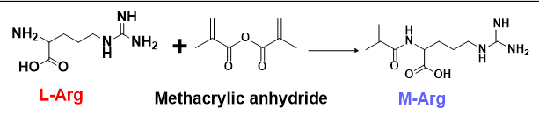
Figure S1. Synthesis process of N-Methacryloyl-L-arginine (M-Arg).

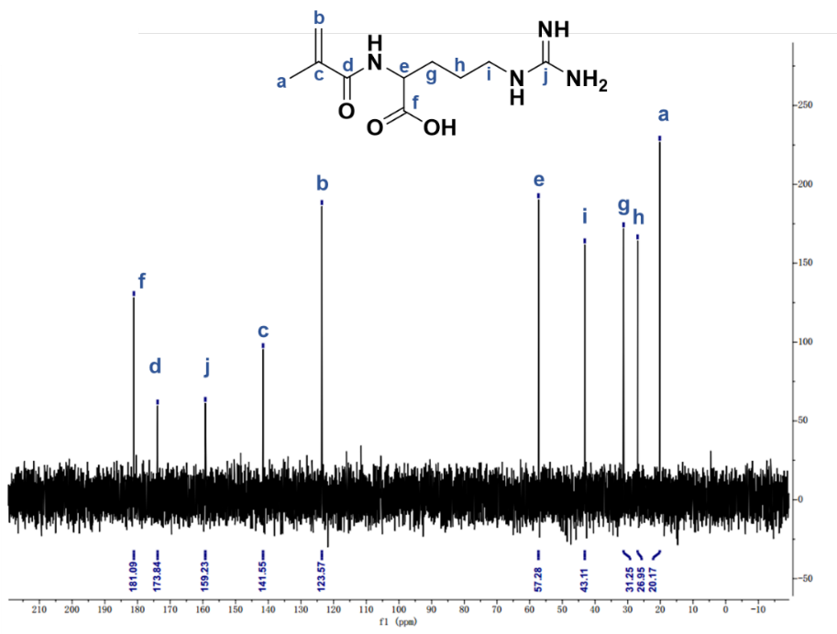
Figure S2. ¹³C NMR spectrum of M-Arg.

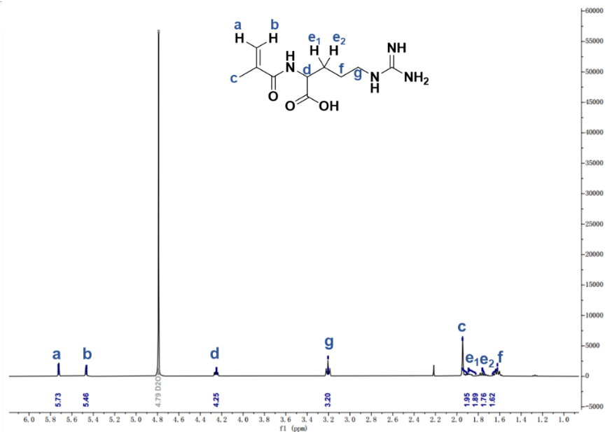
Figure S3. ¹H NMR spectrum of M-Arg.

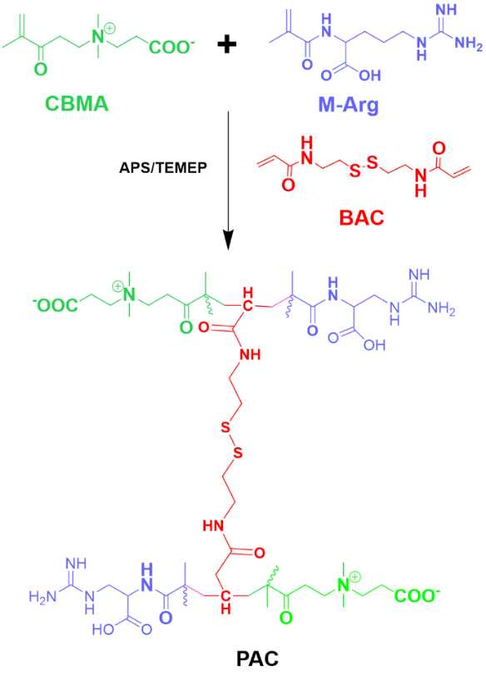
Figure S4. Synthesis process of PAC.

Figure S5. FTIR spectra of different samples.

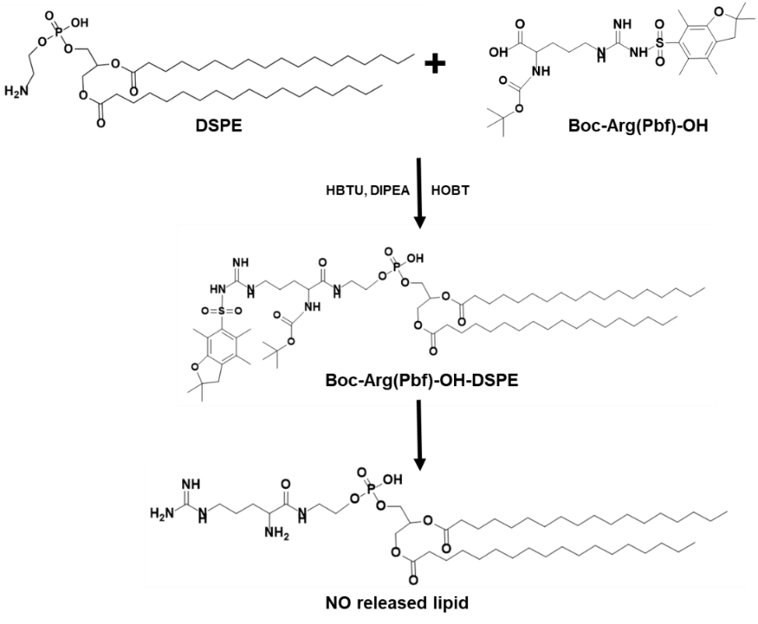
Figure S6. Synthesis process of nitric oxide -releasing lipid (NOR).

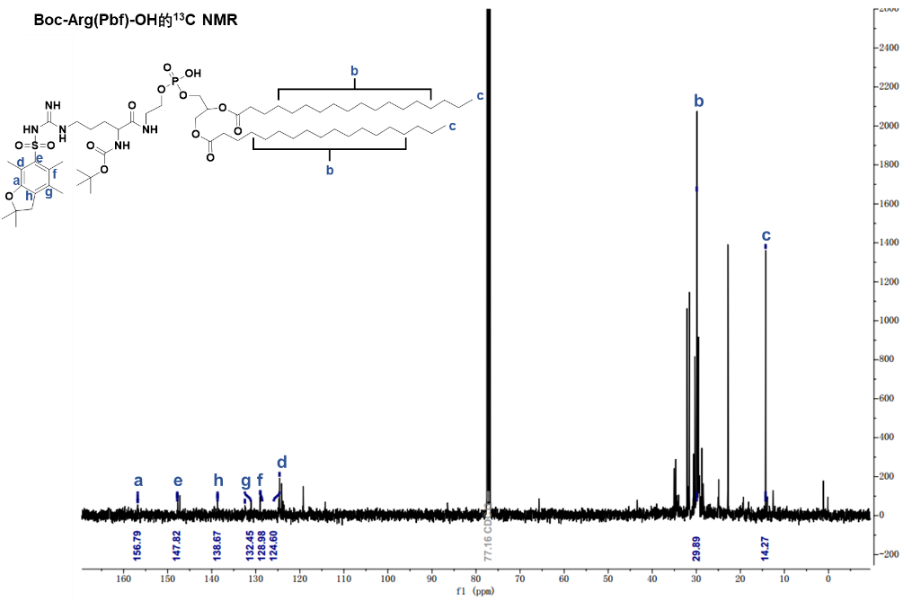
Figure S7. ¹³C NMR spectrum of Boc-arg(Pbf)-OH-DSPE.
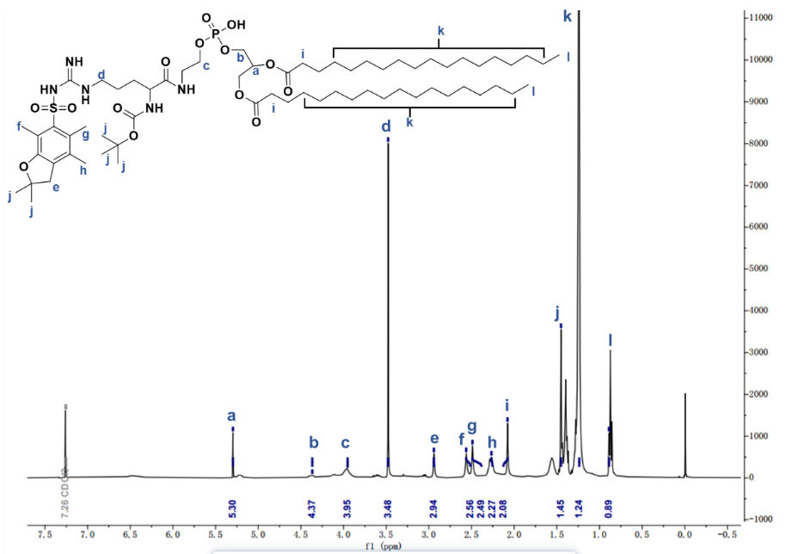
Figure S8. ¹H NMR spectrum of Boc-arg(Pbf)-OH-DSPE.

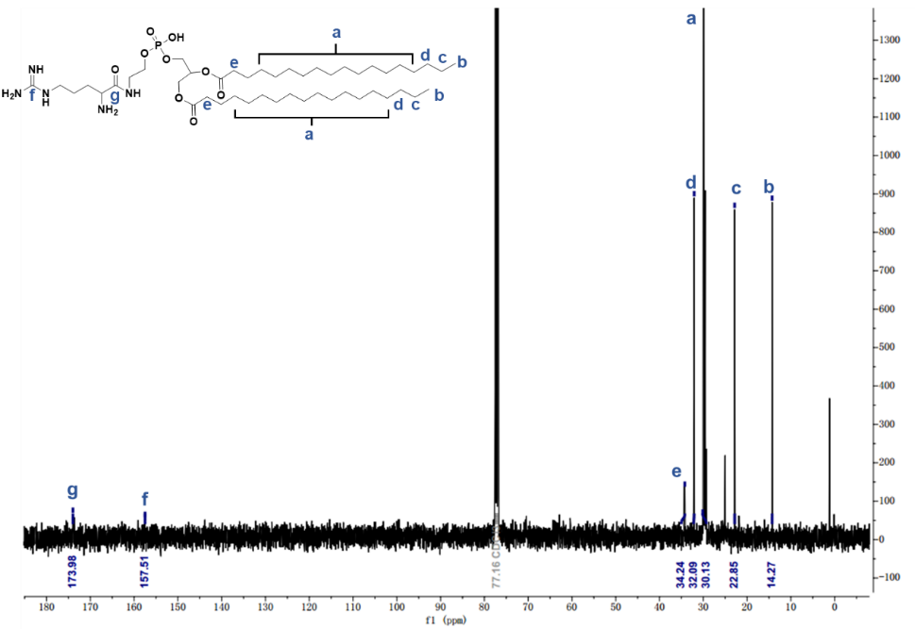
Figure S9. ¹³C NMR spectrum of NOR.

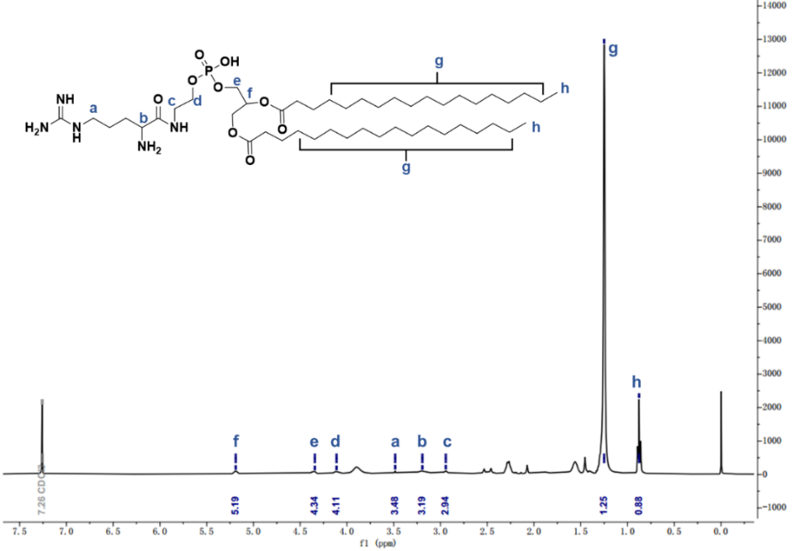
Figure S10. ¹H NMR spectrum of NOR.

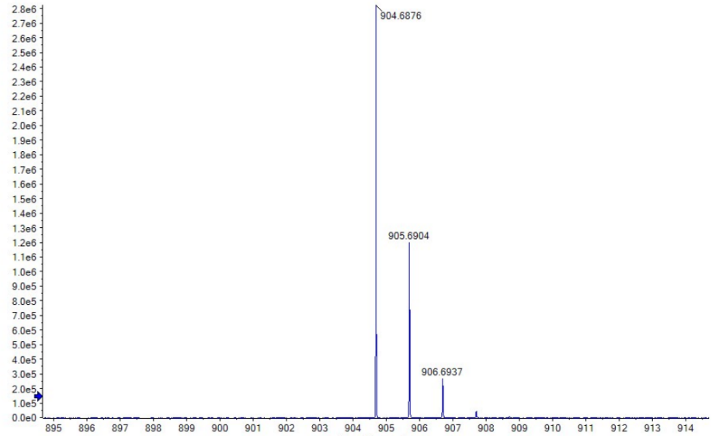
Figure S11. The mass spectrometry of NOR.

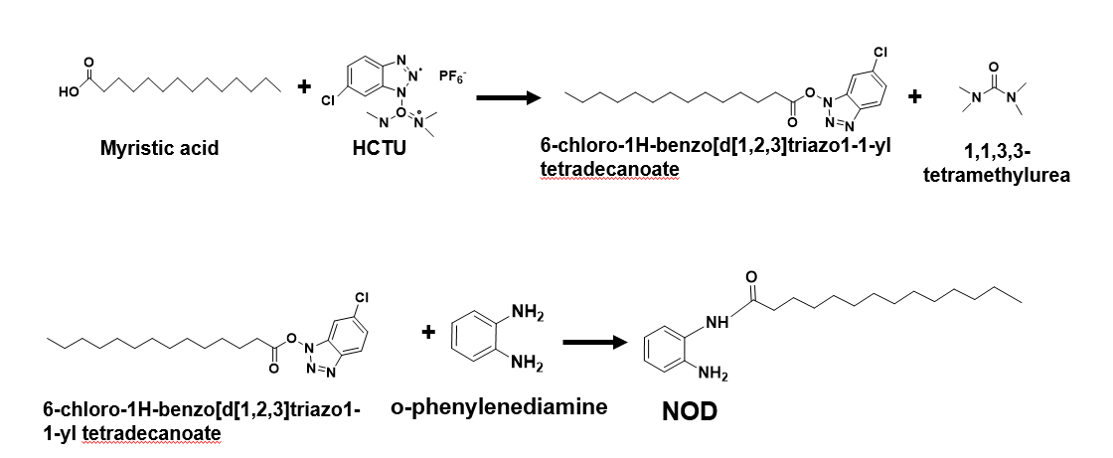
Figure S12. Synthesis process of nitric oxide-responsive degradable lipid (NOD).

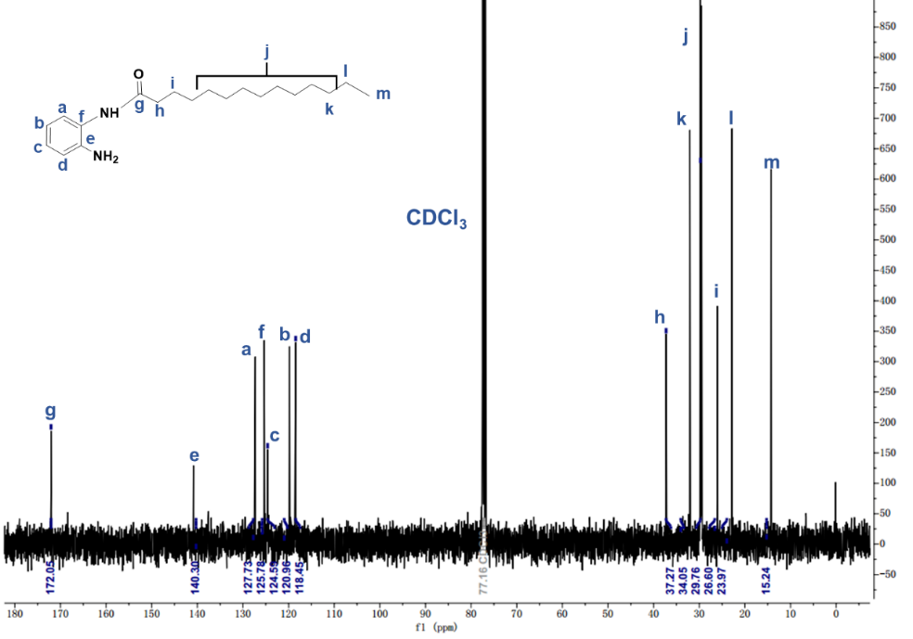
Figure S13. ¹³C NMR spectrum of NOD.
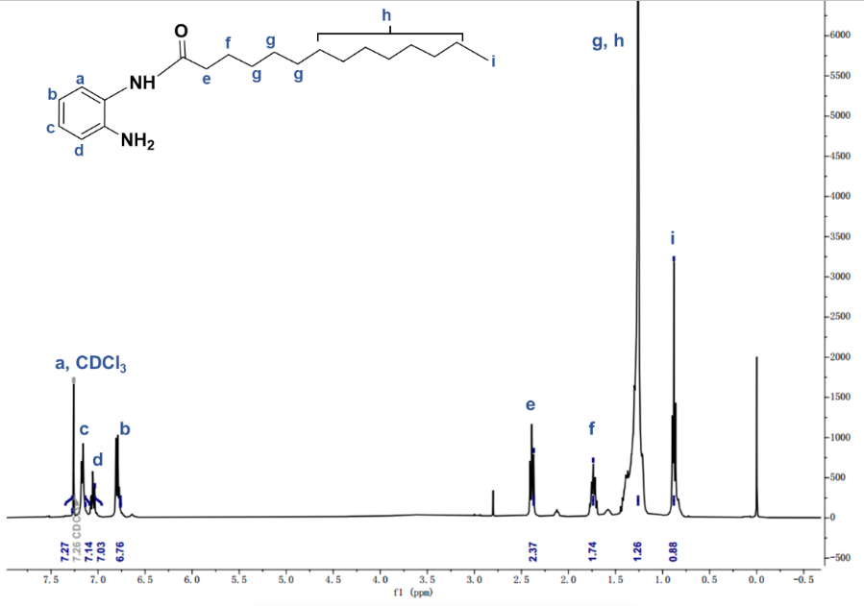
Figure S14. ¹H NMR spectrum of NOD.

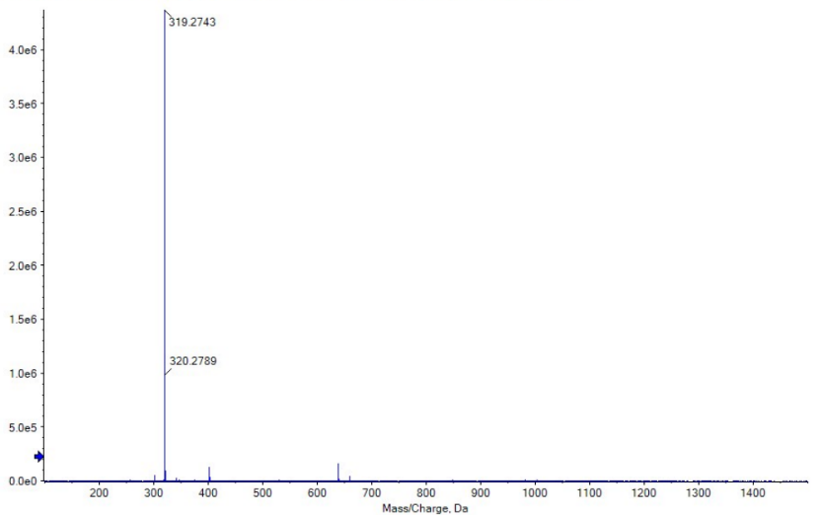
Figure S15. The mass spectrometry of NOD.

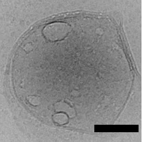
Figure S16. The Cryo-TEM of NO-Lip@PAC NMs (Scale bar: 100 nm)

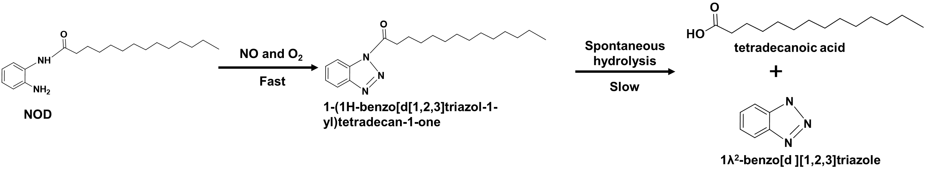
Figure S17. Mechanism for the degradation of NOD in responsive to NO.

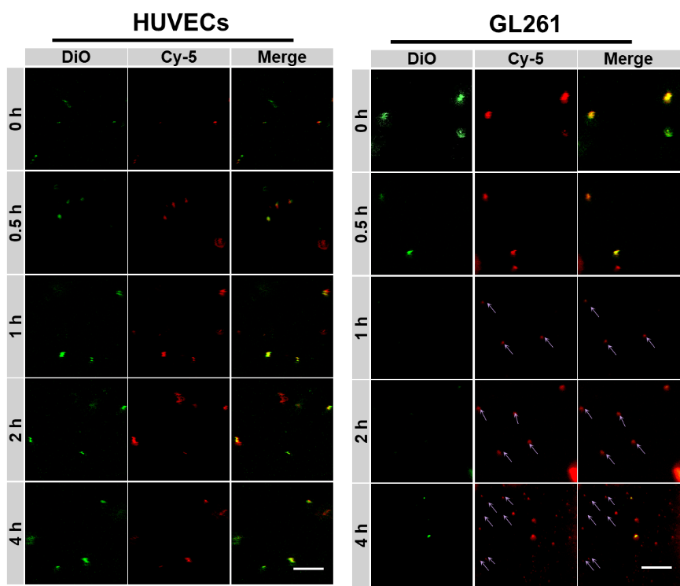
Figure S18. Representative CLSM images of NO-Lip@PAC incubated with HUVECs cell lysate and Gl261 cell lysate for different times (scale bar: 10 μm, green: DiO-labeled NO-Lip, red: Cy5-labeled PAC; purple arrow indicates the released PAC after the degradation of the lipid layer)
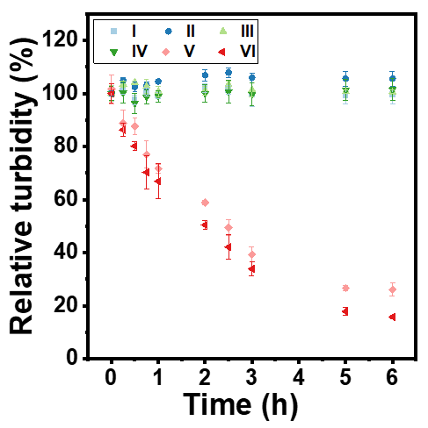
Figure S19. The change of turbidity with time in different systems (I: Lip@PAC in PBS solution, II: Lip@PAC in 100 μM H₂O₂ solution, III: Lip@PAC in 500 μM H₂O₂ solution, IV: NO-Lip@PAC in PBS solution, V: NO-Lip@PAC in 100 μM H₂O₂ solution, VI: NO-Lip@PAC in 500 μM H₂O₂ solution)

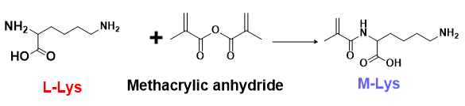
Figure S20. Synthesis process of N-methylacryloyl-lysine (M-Lys).
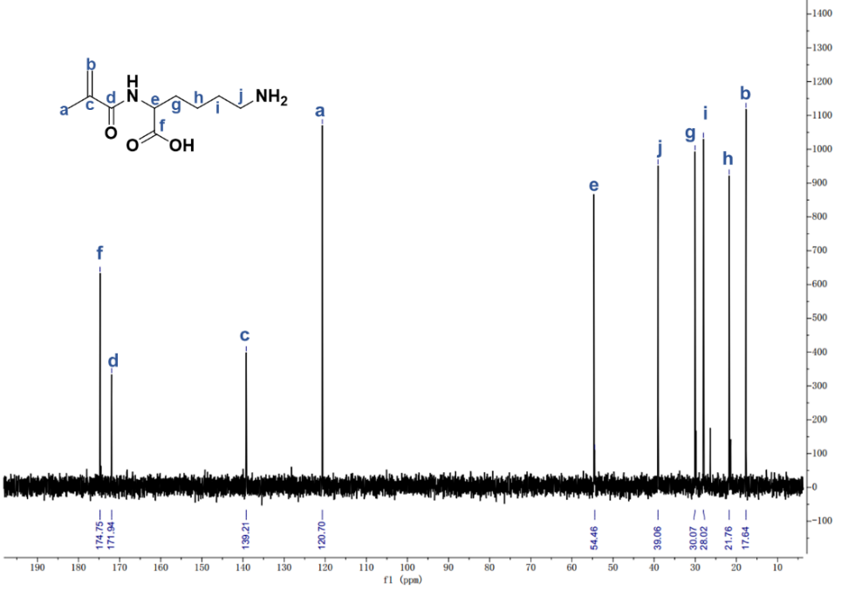
Figure S21. ¹³C NMR spectrum of M-Lys.

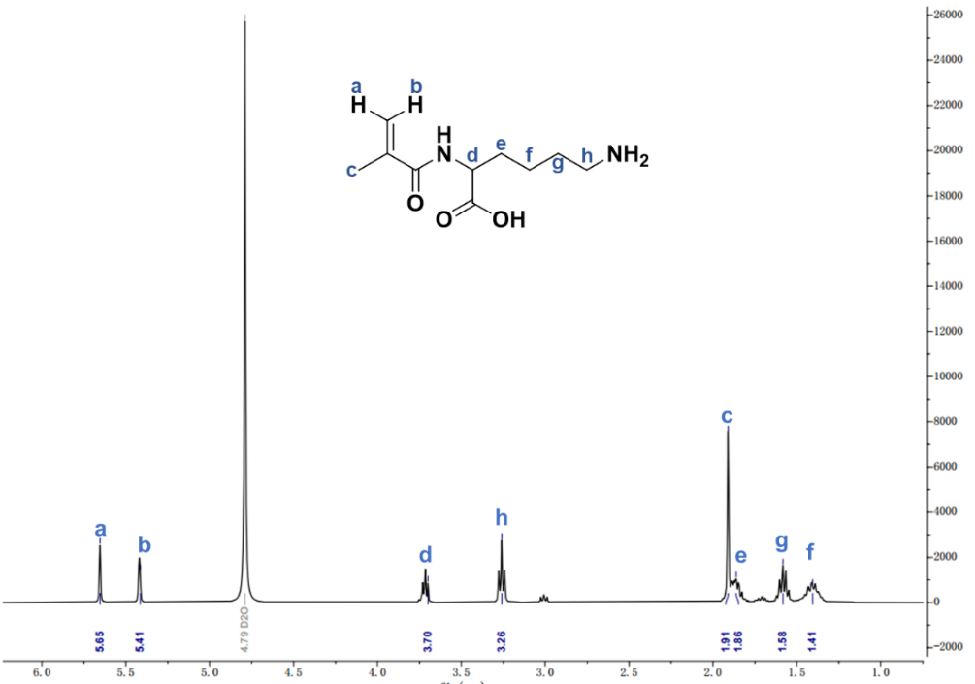
Figure S22. ¹H NMR spectrum of M-Lys.

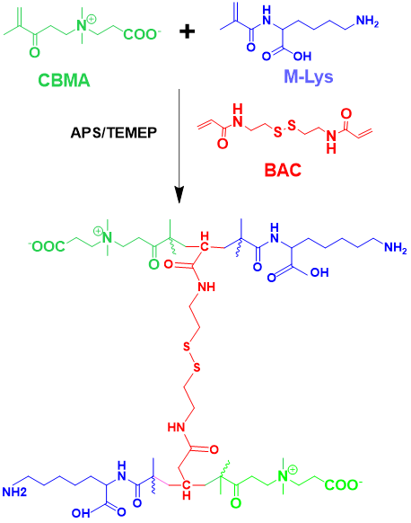
Figure S23. Synthesis process of PLC NPs.

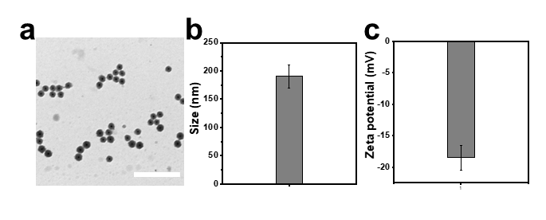
Figure S24. (a) TEM image (scale bar: 500 nm), (b) DLS and (c) zeta potential of PLC NPs. Data were shown as the mean ± s.d. (n=3 samples).

Figure S25. FTIR spectra of different samples.

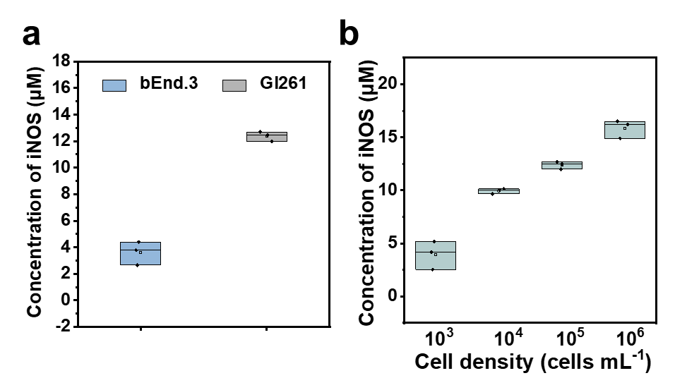
Figure S26. The concentration of iNOS in (a) bEnd.3 and Gl261 cells; and (b) Gl261 cells with different cells densities. Data are expressed as means ± SD, n=3

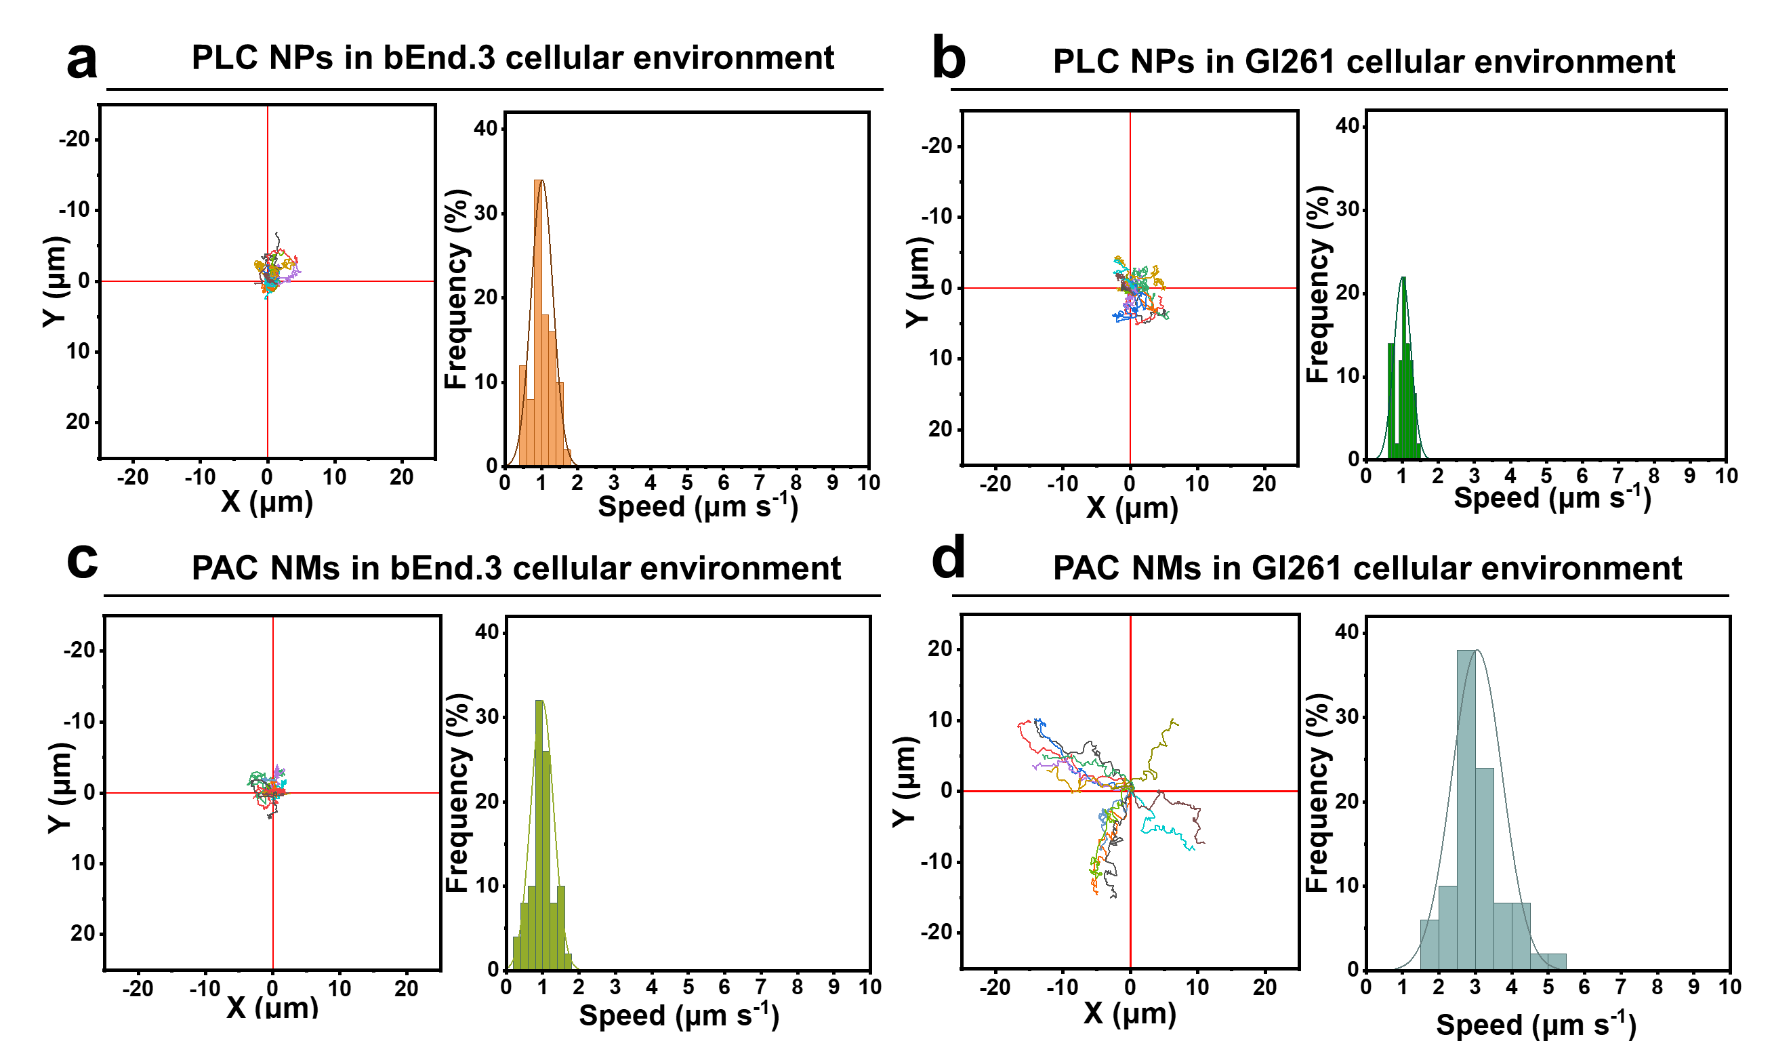
Figure S27. Normalized motion trajectories (n=20) and motion velocity distribution plots (n=50) of PLC NPs in (a) bEnd.3 and (b) Gl261 cellular environment; Normalized motion trajectories (n=20) and motion velocity distribution plots (n=50) of PAC NMs in (c) bEnd.3 and (d) Gl261 cellular environment.

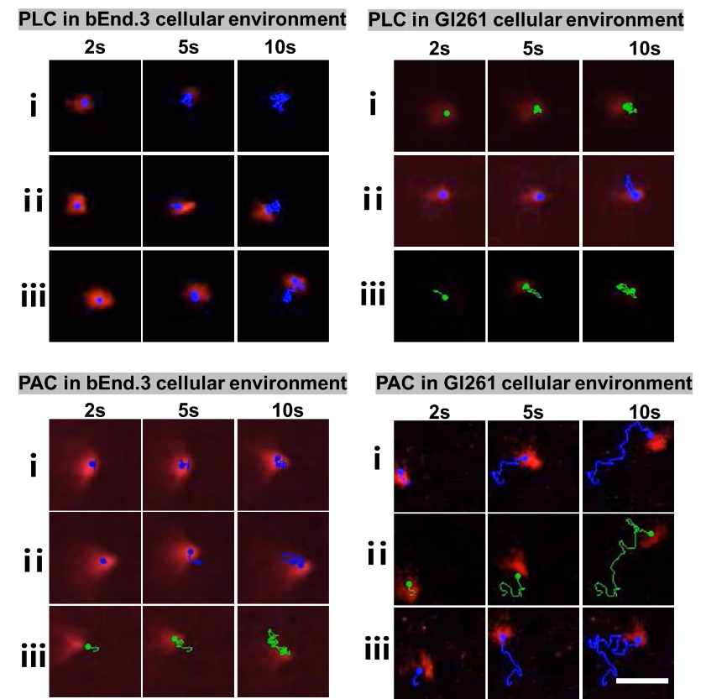
Figure S28. Time-lapse images of the tracking trajectories of PLC or PAC in bEnd.3 or Gl261 cellular environment (Scale bar: 10 μm)

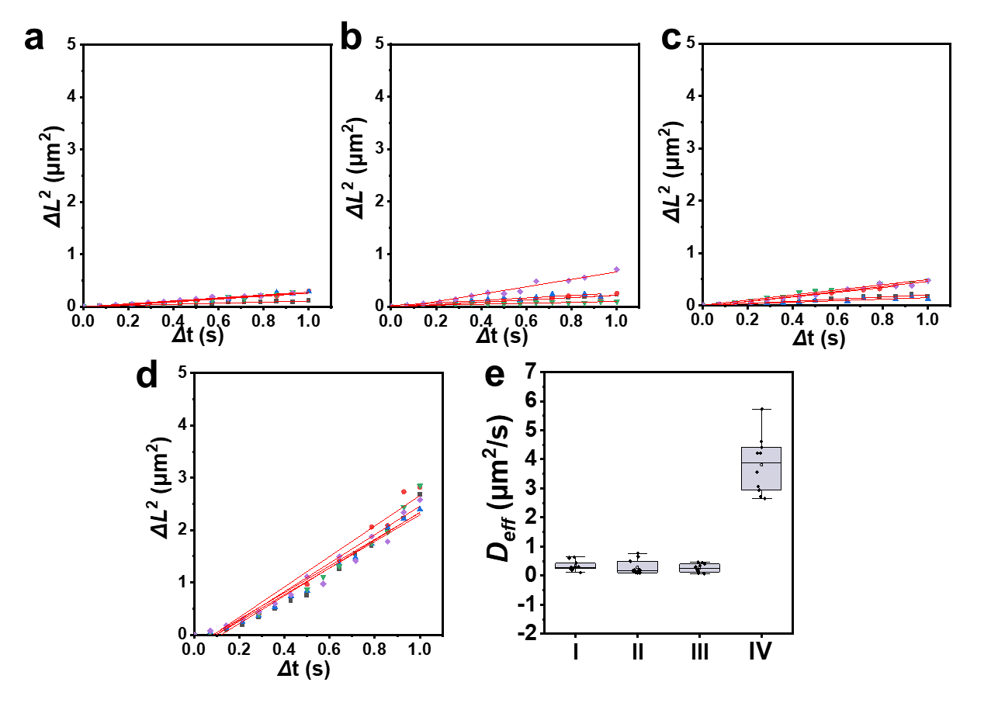
Figure S29. MSD versus time interval (Δt) analyzed from tracking trajectories in different environments (n=5). (a) PLC NPs in bEnd.3 cellular environment, (b) PLC NPs in Gl261 cellular environment, (c) PAC NMs in bEnd.3 cellular environment and (D)PAC NMs in Gl261 cellular environment; and diffusion coefficient values determined from the slope of the linear fitting curves of average MSD plots (n=10) (I: PLC NPs in bEnd.3 cellular environmen, II: PLC NPs in Gl261 cellular environment , III: PAC NMs in bEnd.3 cellular environmen, IV: PAC NMs in Gl261 cellular environment)

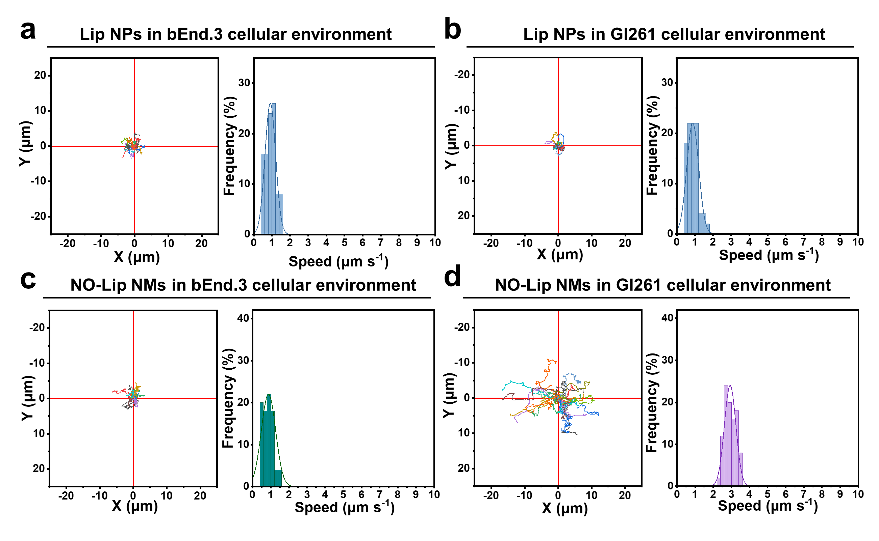
Figure S30. Normalized motion trajectories (n=20) and motion velocity distribution plots (n=50) of Lip NPs in (a) bEnd.3 and (b) Gl261 cellular environment; Normalized motion trajectories (n=20) and motion velocity distribution plots (n=50) of NO-Lip NMs in (c) bEnd.3 and (d) Gl261 cellular environment.
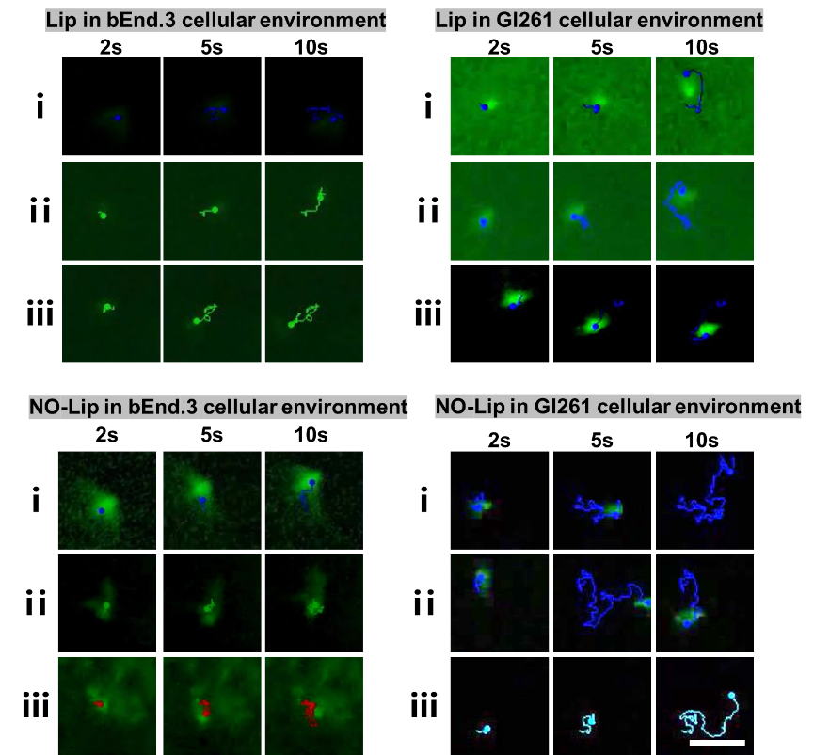
Figure S31. Time-lapse images of the tracking trajectories of Lip or NO-Lip in bEnd.3 or Gl261 cellular environment (Scale bar: 10 μm)

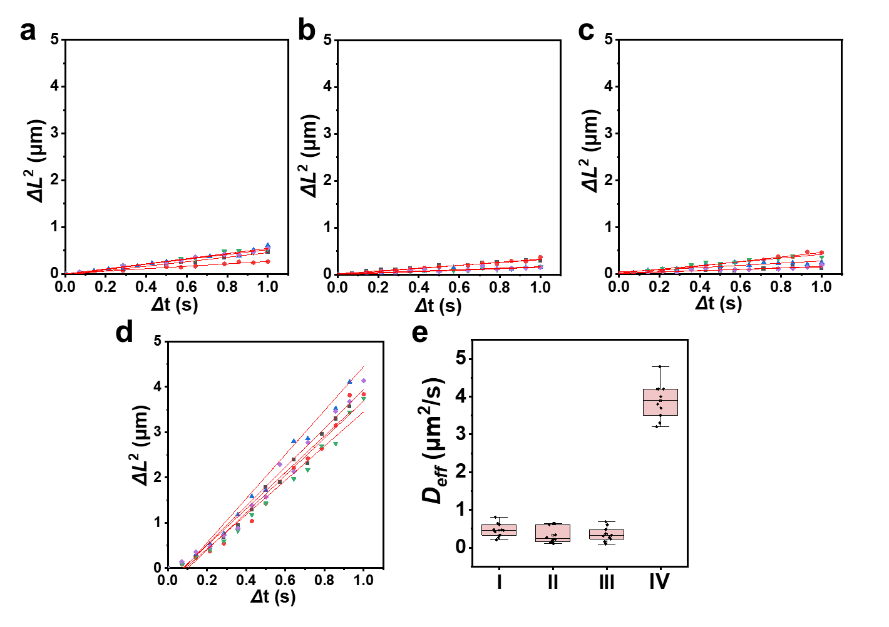
Figure S32. MSD versus time interval (Δt) analyzed from tracking trajectories in different environments (n=5). (a) Lip NPs in bEnd.3 cellular environment, (b) Lip NPs in Gl261 cellular environment, (c) NO-Lip NMs in bEnd.3 cellular environment and (D) NO-Lip NMs in Gl261 cellular environment; and diffusion coefficient values determined from the slope of the linear fitting curves of average MSD plots (n=10) (I: Lip NPs in bEnd.3 cellular environmen, II: Lip NPs in Gl261 cellular environment , III: NO-Lip NMs in bEnd.3 cellular environmen, IV: NO-Lip NMs in Gl261 cellular environment)

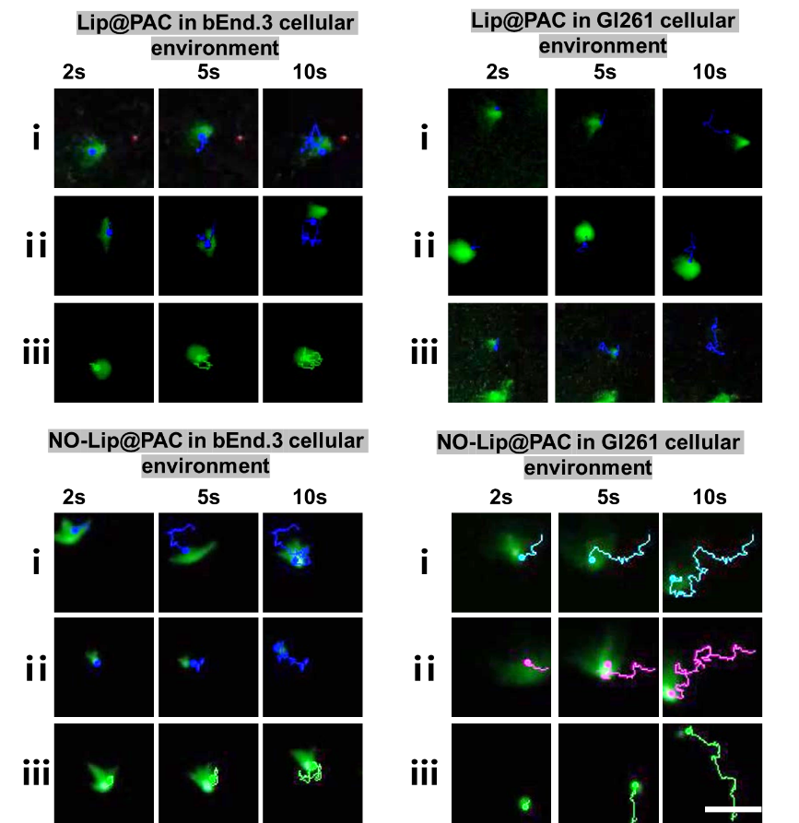
Figure S33. Time-lapse images of the tracking trajectories of Lip@PAC or NO-Lip@PAC in bEnd.3 or Gl261 cellular environment (Scale bar: 10 μm)

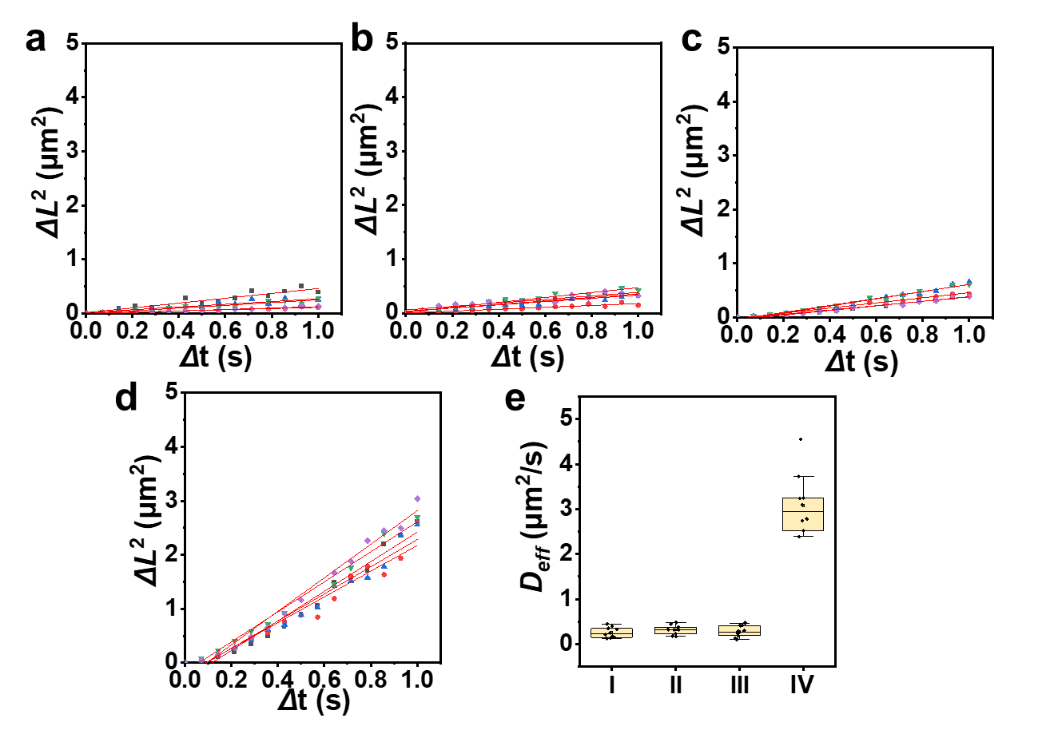
Figure S34. MSD versus time interval (Δt) analyzed from tracking trajectories in different environments (n=5). (a) Lip@PAC NPs in bEnd.3 cellular environment, (b) Lip@PAC NPs in Gl261 cellular environment, (c) NO-Lip@PAC NMs in bEnd.3 cellular environment and (D) NO-Lip@PAC NMs in Gl261 cellular environment; and diffusion coefficient values determined from the slope of the linear fitting curves of average MSD plots (n=10) (I: Lip@PAC NPs in bEnd.3 cellular environmen, II: Lip@PAC NPs in Gl261 cellular environment , III: NO-Lip@PAC NMs in bEnd.3 cellular environmen, IV: NO-Lip@PAC NMs in Gl261 cellular environment)
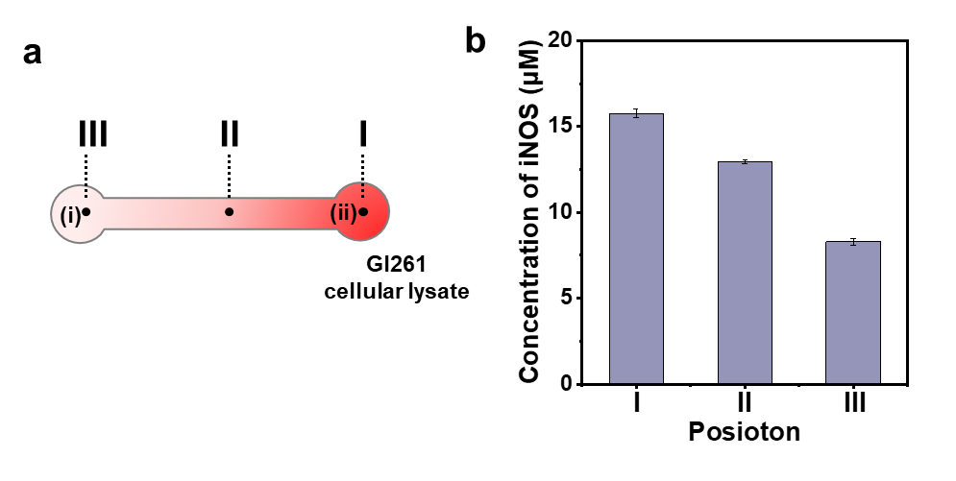
Figure S35. The concentration of iNOS and at the different position in straight channel, where the Gl261 cellular lysates at initial density of 5 × 10⁶ cells mL⁻¹ was mixed with the equal volume of agarose solution in right reservoir to form the network gels. And the values were detected at 15 min after the agarose solidified. Data are expressed as means ± SD, n=3.

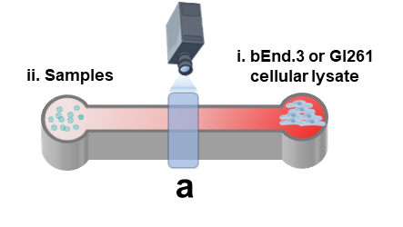
Figure S36. Schematic diagram of the experiment to verify the chemotaxis of nanomotros in a straight channel.

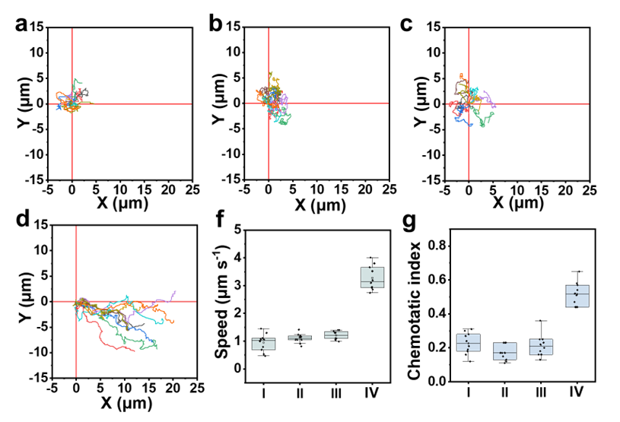
Figure S37. When collagen gel containing 5 ×10⁶ cells mL⁻¹ of bEnd.3 was filled in the right, the normalized movement trajectories of (a) Lip@PAC and (b) NO-Lip@PAC of direction distribution recorded in the observation area; When collagen gel containing 5 ×10⁶ cells mL⁻¹ of Gl261 was filled in the right, the normalized movement trajectories of (c) Lip@PAC and (d) NO-Lip@PAC of direction distribution recorded in the observation area; (f) Speed and (g) chemotaxis index in different environments (I: Lip@PAC in bEnd.3cellular lysate, II: NO-Lip@PAC in bEnd.3 cellular lysate, III: Lip@PAC in Gl261 cellular lysate, IV: NO-Lip@PAC in Gl261 cellular lysate)
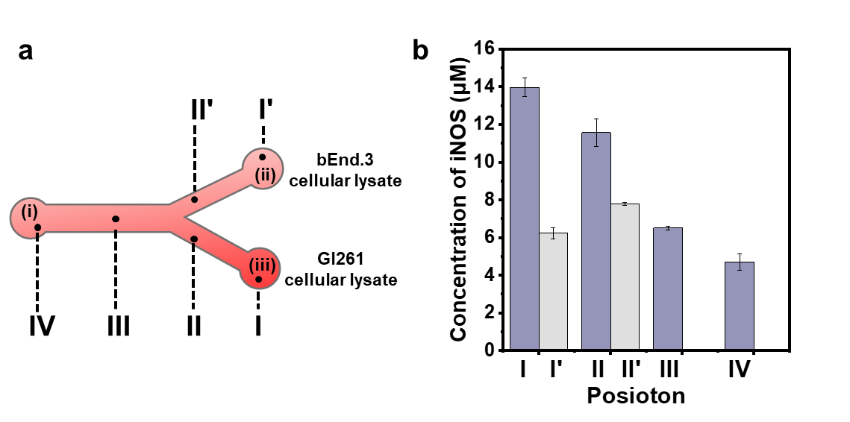
Figure S38. The concentration of iNOS and at the different position in Y-shaped channel, where the of bEnd.3 or Gl261 cellular lysates at initial density of 5 × 10⁶ cells mL⁻¹ was mixed with the equal volume of agarose solution in reservoir (ii) and (iii) respectively to form the network gels. And the values were detected at 15 min after the agarose solidified. Data are expressed as means ± SD, n=3.

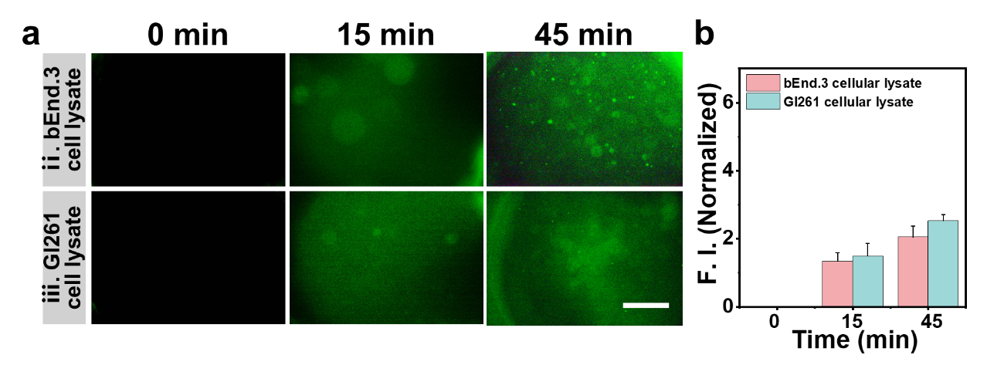
Figure S39. (a) Representative fluorescence images (scale bar: 1000 μm) and (b) fluorescence quantification of Lip@PAC NPs in Y-channel regions (ii) and (iii) at different times.

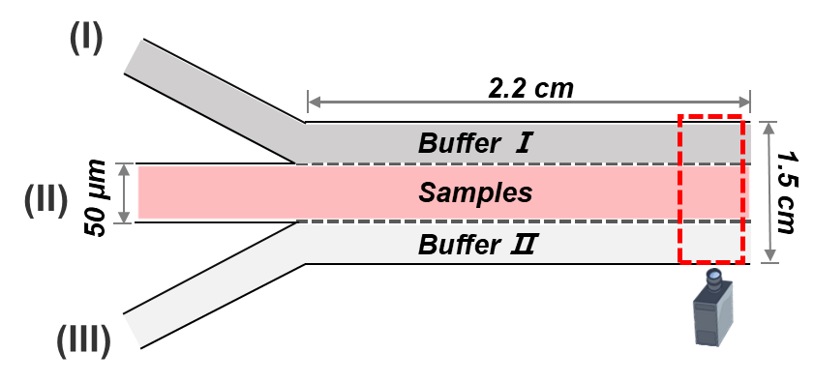
Figure S40. Schematic diagram of Ψ-shaped microfluidic channel.
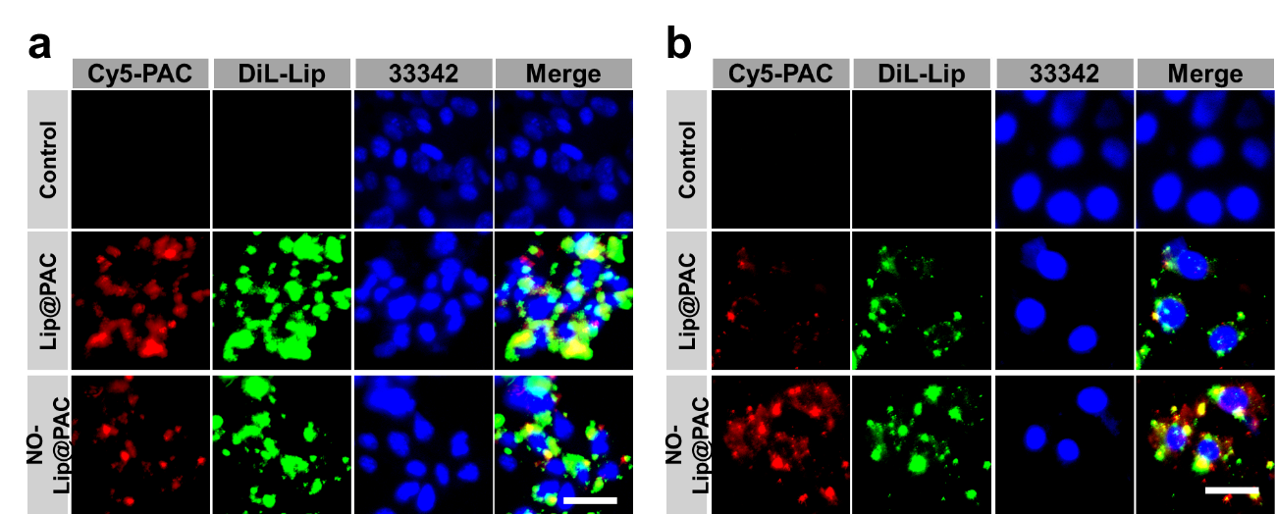

Figure S41. Representative CLSM images of (a) bEnd.3 cells in the upper chamber and (b) GL261 cells in the lower chamber of the transwell system after 6 h treatment with different samples (blue: Hoechst 33342 labeled nucleus, red: Cy5-labeled PAC, green: DiL-labeled Lip or NO-Lip; scale bar: 50 μm).

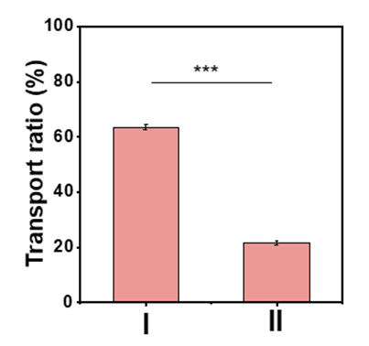
Figure S42. BBB transport efficiency of NO-Lip@PAC (I: normal Gl261 cells, II: Gl261 cells treated with L-NMMA for 24 h).

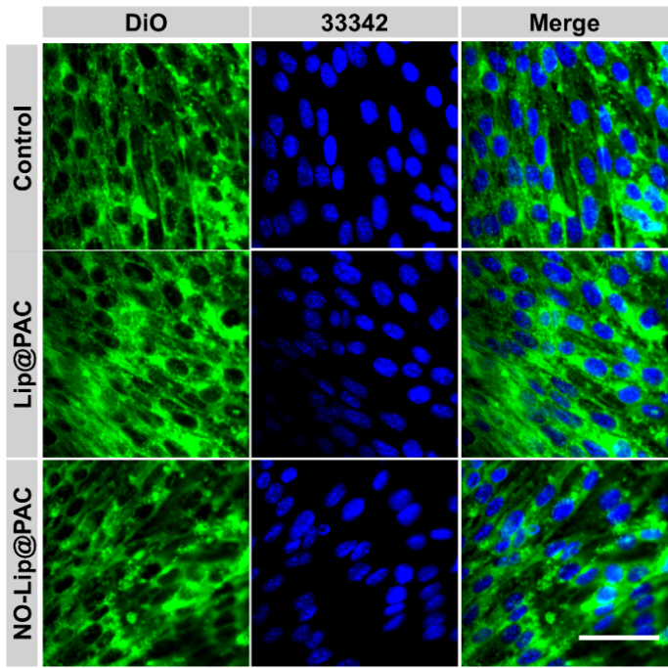
Figure S43. Representative CLSM images of bEnd.3 cells after 24 h treatment with different samples (blue: Hoechst 33342 labeled nucleus, green: cell membranes; scale bar: 50 μm)

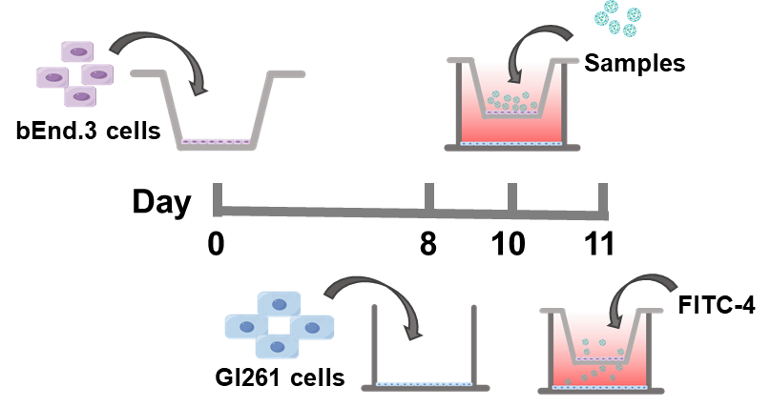
Figure S44. Schematic representation of BBB integrity assessment using FD-4.

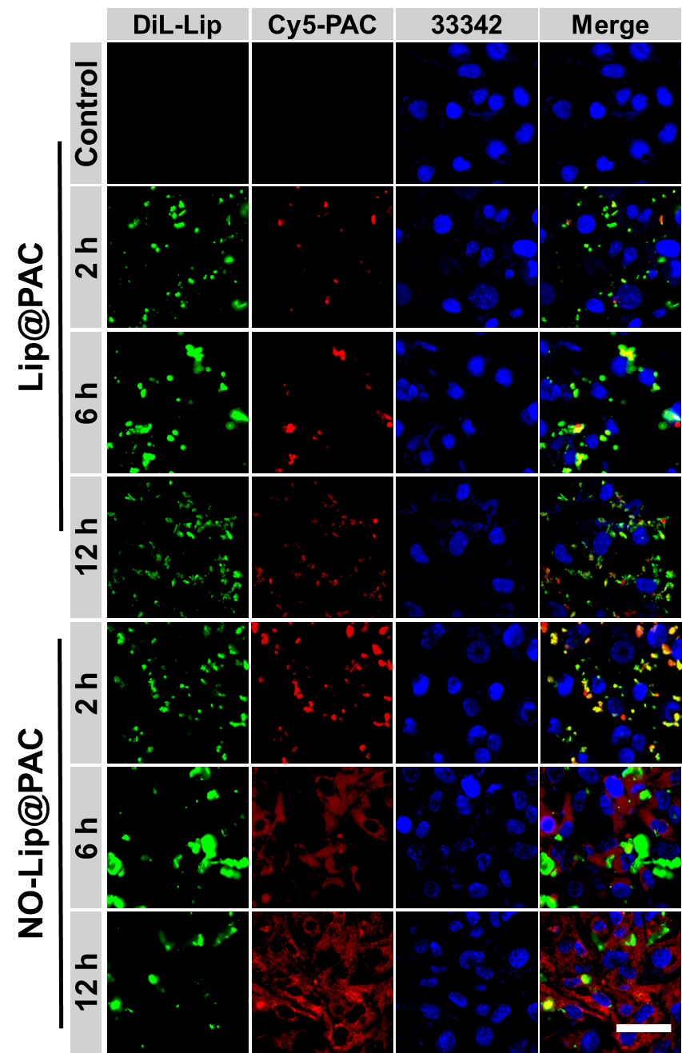
Figure S45. Representative CLSM images of different samples after uptake by Gl261 cells for 2, 6 and 12 h (blue: Hoechst 33342 labeled nucleus, green: DiL-labeled Lip or NO-Lip; red: Cy5-labeled PAC; scale bar: 50 μm).
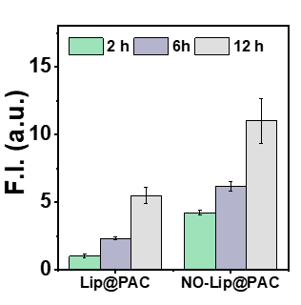
Figure S46. Representative CLSM images corresponding quantitative analysis of red fluorescence intensity in Figure S45. Data were shown as the mean ± s.d. (n=3 samples).

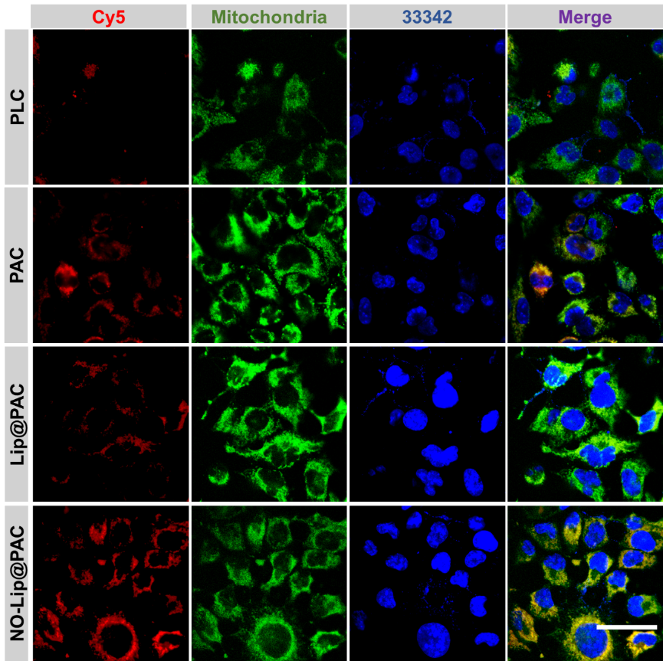
Figure S47. Representative CLSM images of different samples co-incubated with Gl261 cells for 2 h (blue: Hoechst 33342 labeled nucleus, green: Mito-Tracker labeled mitochondria; red: Cy5-labeled different samples; scale bar: 50 μm)

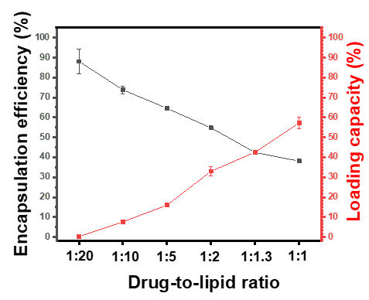
Figure S48. Encapsulation rate and loading of Cur with different drug-lipid ratios. Data were shown as the mean ± s.d. (n=3 samples).

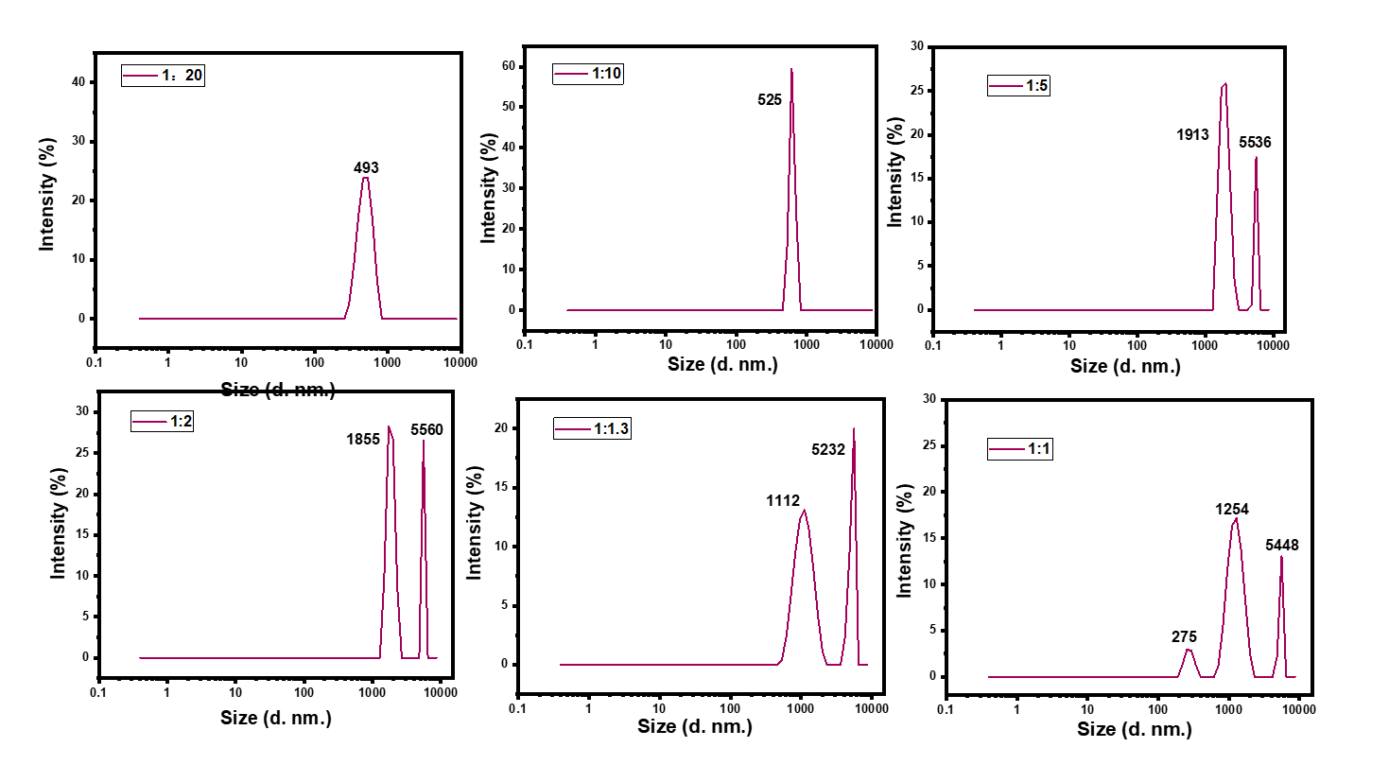
Figure S49. DLS of NO-Lip@PAC@Cur synthesized with different drug/lipid ratios.

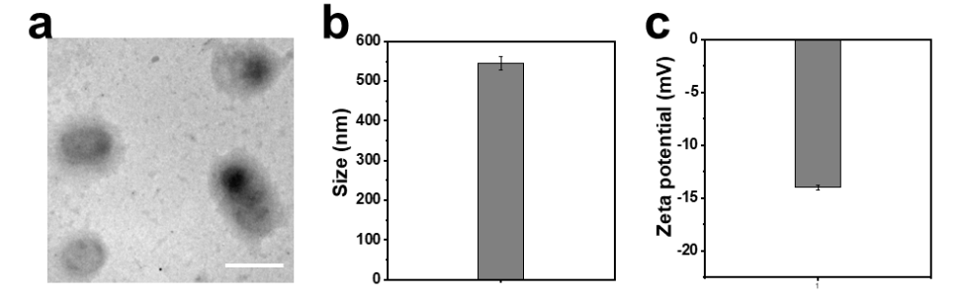
Figure S50. (a) TEM image (scale bar: 500 nm), (b) DLS and (c) zeta potential of NO-Lip@PAC@Cur. Data were shown as the mean ± s.d. (n=3 samples).

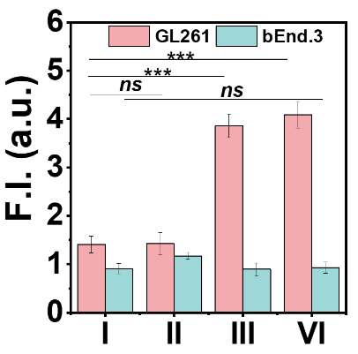
Figure S51. Fluorescence quantification of intracellular NO in bEnd.3 and Gl261 cells treated with different samples for 6 h (I: Control, II: Lip@PLC, III: NO-Lip@PAC, IV: NO-Lip@PAC@Cur). Data were shown as the mean ± s.d. (n=3 samples).
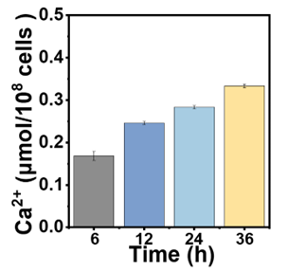
Figure S52. Ca²⁺ content in mitochondria treated with NO-Lip@PAC@Cur for different time in Gl261 cells.
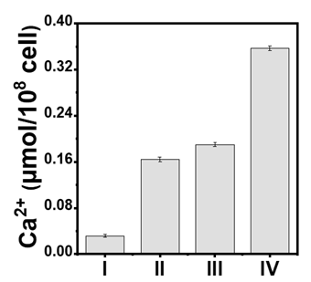
Figure S53. Ca²⁺ content in mitochondria treated with different samples in Gl261 cells (I: Control, II: A23187, III: NO-Lip@PAC, IV: NO-Lip@PAC@Cur).

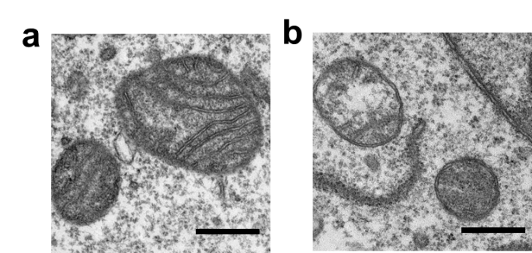
Figure S54. Bio-TEM images of Gl261 cellular mitochondria treated with (a) PBS and (b) NO-Lip@PAC@Cur (Scale bar: 500 nm)

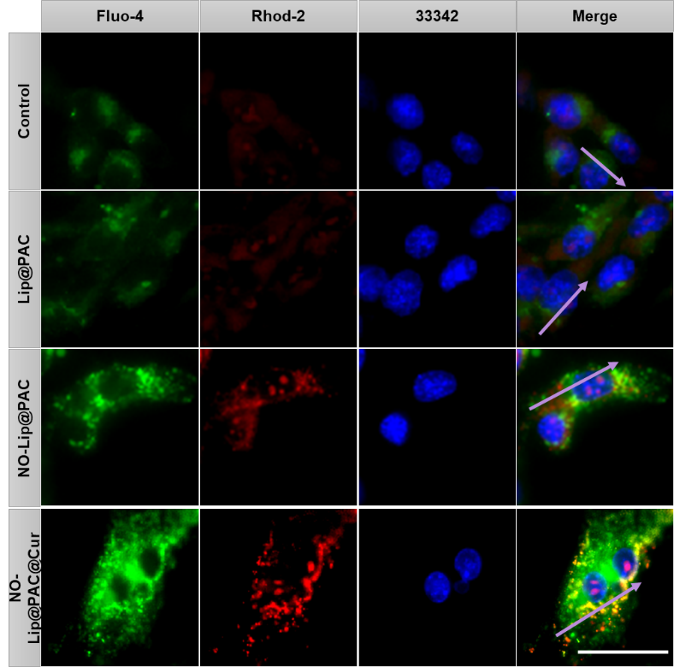
Figure S55. Representative CLSM images of cytoplasmic Ca²⁺ and mitochondrial Ca²⁺ of Gl261 cells co-incubated with different samples for 24 h (blue: Hoechst 33342 labeled nucleus, green: Fluo-4-labeled cytoplasmic Ca²⁺; red: Rhod-2-labeled mitochondrial Ca²⁺; scale bar: 20 μm)
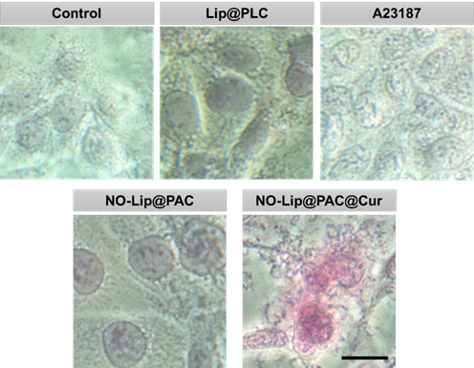
Figure S56. Calcium salt in different samples treated cells with Alizarin Red S Staining (Scale bar: 25 μm).

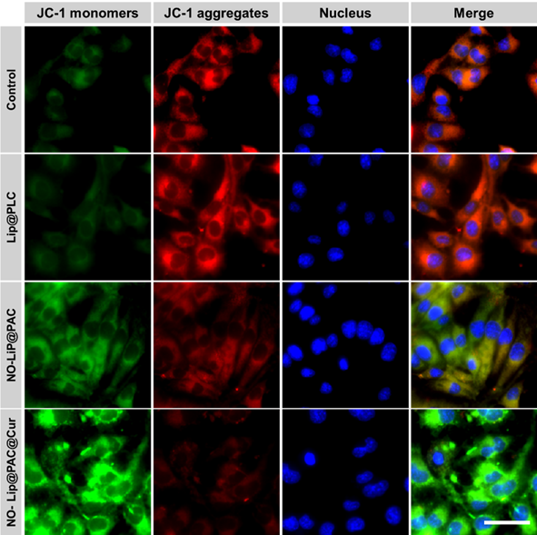
Figure S57. Representative CLSM images of Gl261 cells treated with different samples for 24 h (blue: Hoechst 33342 labeled nucleus, red: JC-1 aggregates, green: JC-1 monomers, scale bar: 50 μm).
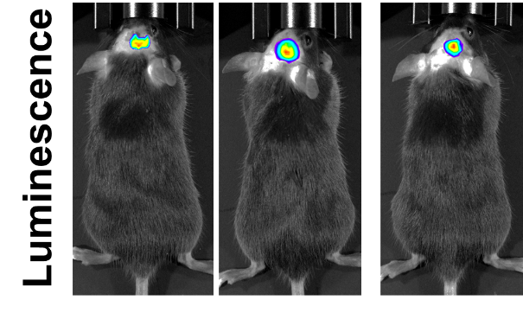
Figure S58. Typical chemiluminescence imaging of GBM in C57BL/6 mice before administration.
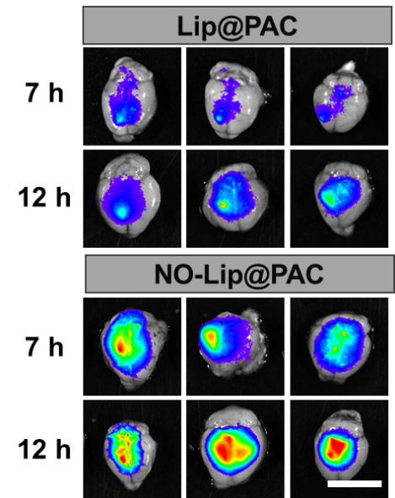
Figure S59.Cy5 fluorescence imaging of the brain after intravenous injection of different samples for 7 and 12 h (n=3, scale bar: 1 cm).

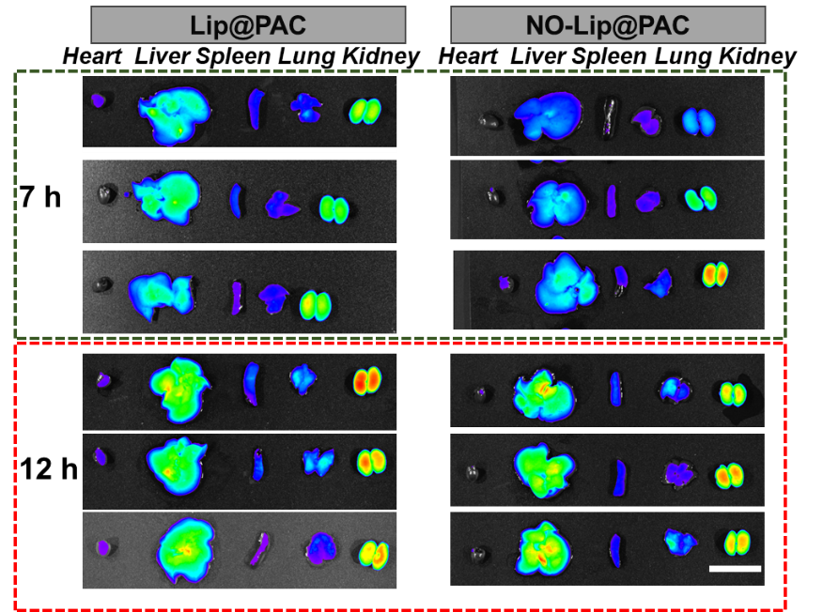
Figure S60. Cy5 fluorescence imaging of the major organs after intravenous injection of different samples for 7 and 12 h (n=3, scale bar: 1 cm).

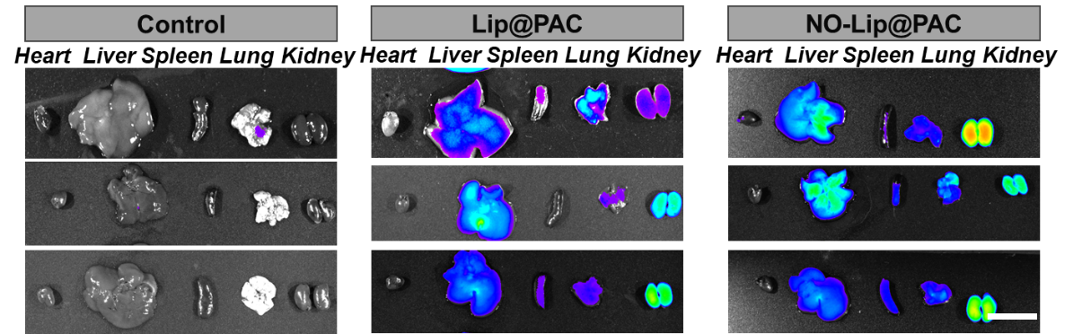
Figure S61. Cy5 fluorescence imaging of the major organs after intravenous injection of different samples for 24 h (n=3, scale bar: 1 cm).

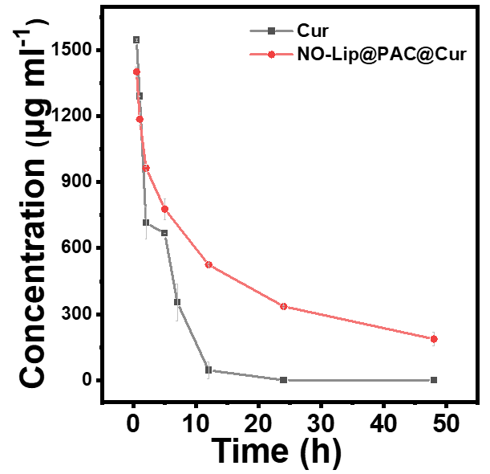
Figure S62. Pharmacokinetic profiles of Cur and NO-Lip@PAC@Cur. Data were shown as the mean ± s.d. (n=3 samples).
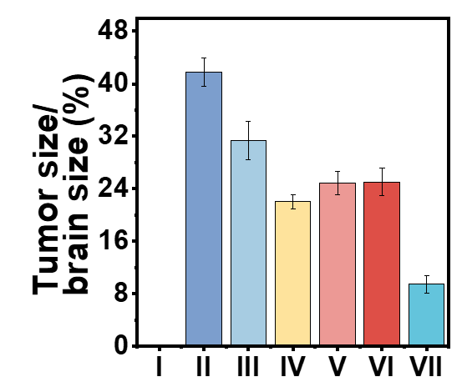
Figure S63. Quantitative analysis of tumor size after the end of treatment (I: sham, II: PBS, III: TMZ, IV: PAC@Cur, V: Lip@PAC@Cur, VI: NO-Lip@PLC@Cur, VII: NO-Lip@ PAC@Cur). Data were shown as the
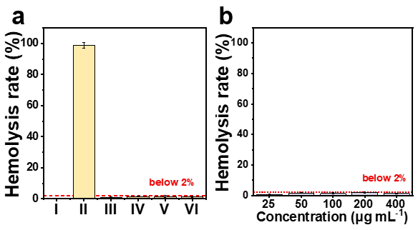
Figure S64. Hemolysis rate of the RBC solution after being treated with (a) different samples (I: negative, II: positive, III: PAC@Cur, IV:Lip-PAC@Cur, V:NO-Lip@PLC@Cur, VI: NO-Lip@PAC@Cur) and (b) different concentrations of NO-Lip@PAC@Cur for 3 h.

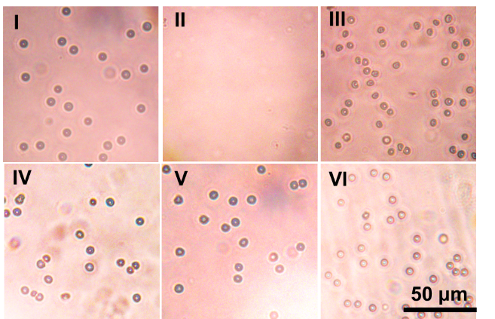
Figure S65. RBC morphology after being treated with different samples (I: negative (PBS), II: positive (water), III: PAC@Cur, IV:Lip-PAC@Cur, V:NO-Lip@PLC@Cur, VI: NO-Lip@PAC@Cur) (scale bar: 50 μm)
mean ± s.d. (n=3 samples).

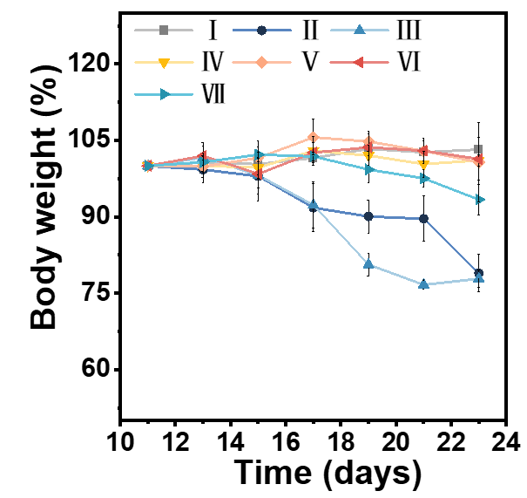
Figure S66. Changes in body weight of mice in different treatment groups (I: sham, II: PBS, III: TMZ, IV: PAC@Cur, V: Lip-PAC@Cur, VI: NO-Lip@PLC@Cur, VII: NO-Lip@PAC@Cur). Data were shown as the mean ± s.d. (n=3 samples).

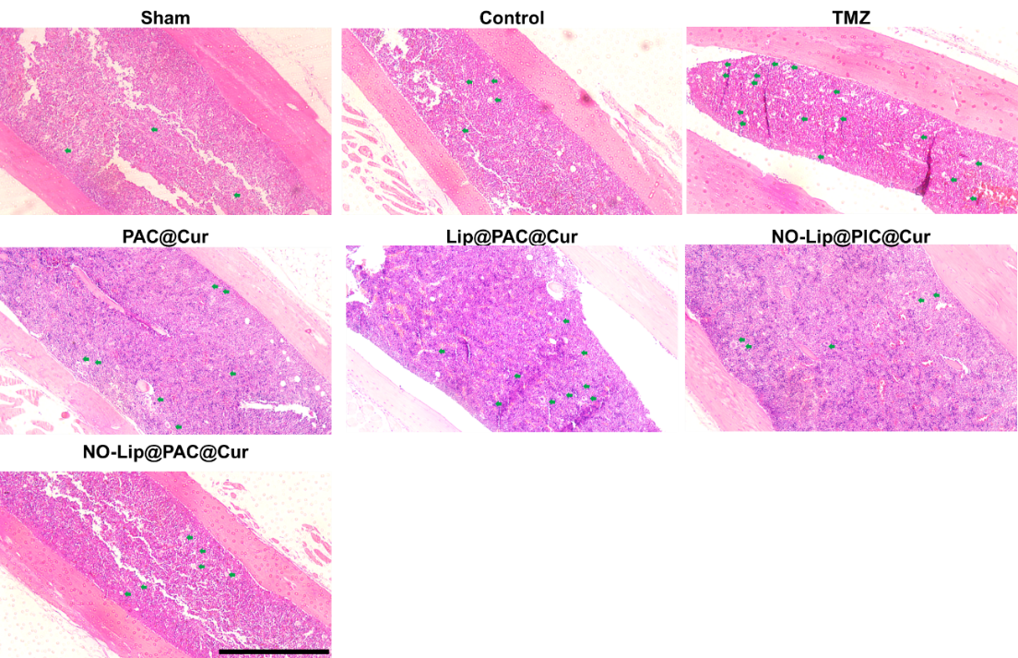
Figure S67. Representative images of H&E stained sections of from GBM mice treated with different samples, green arrows indicate the bone marrow vacuole, scale bar: 500 μm.

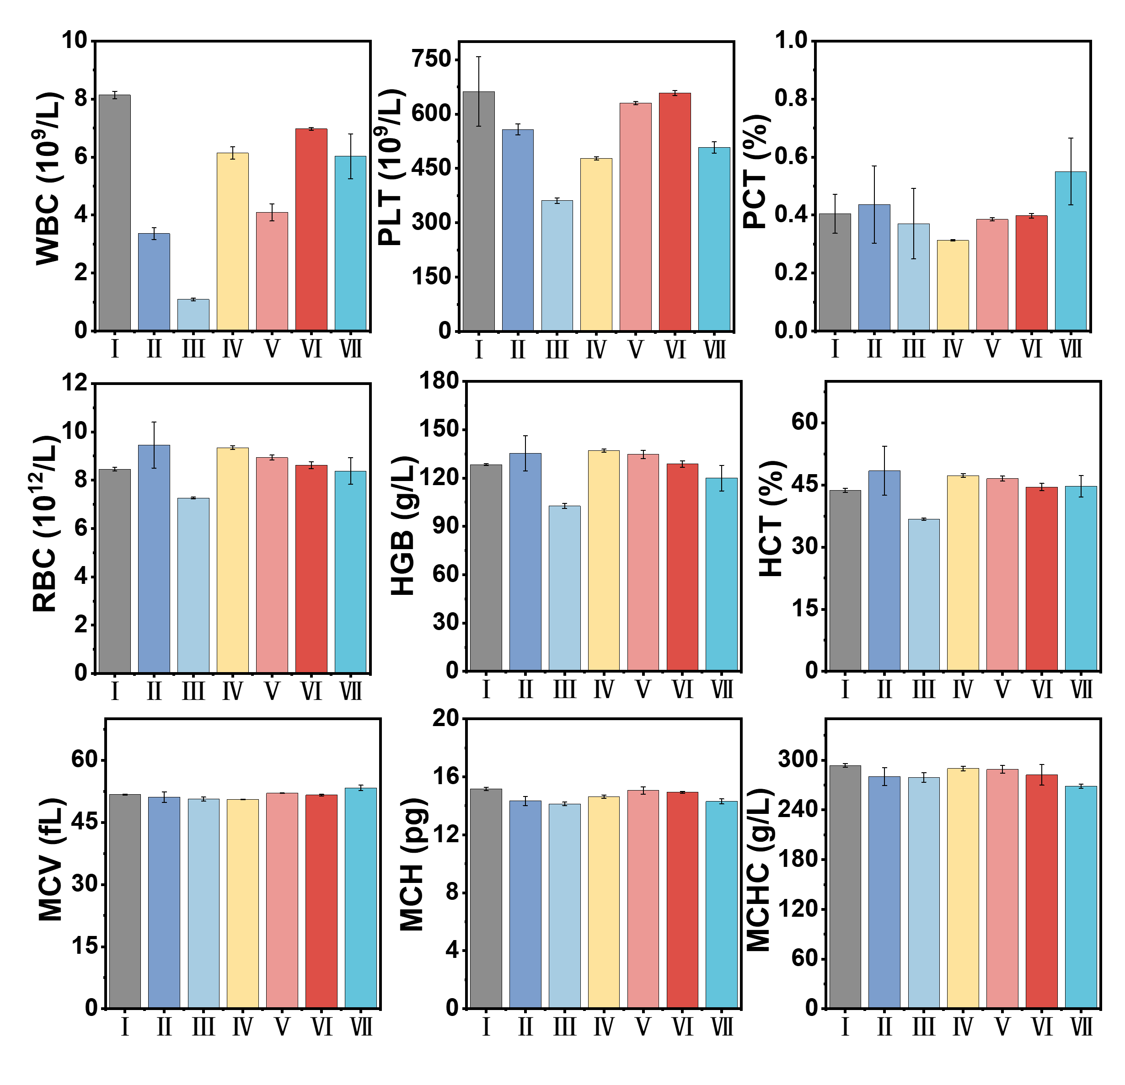
Figure S68. Hematological parameters of GBM in C57BL/6 mice in different treatment groups at the end of treatment (I: sham, II: PBS, III: TMZ, IV:PAC@Cur, V: Lip-PAC@Cur, VI: NO-Lip@PLC@Cur, VII: NO-Lip@PAC@Cur). Data were shown as the mean ± s.d. (n=3 samples).

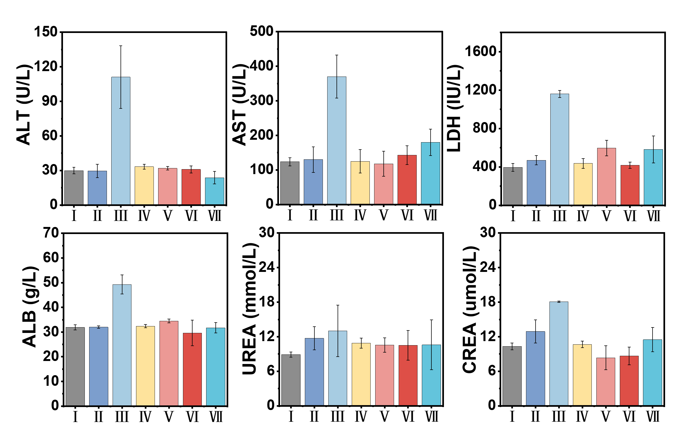
Figure S69. Blood biochemical parameters of GBM in C57BL/6 mice in different treatment groups at the end of treatment (I: sham, II: PBS, III: TMZ, IV: PAC@Cur, V: Lip-PAC@Cur, VI: NO-Lip@PLC@Cur, VII: NO-Lip@PAC@Cur). Data were shown as the mean ± s.d. (n=3 samples).

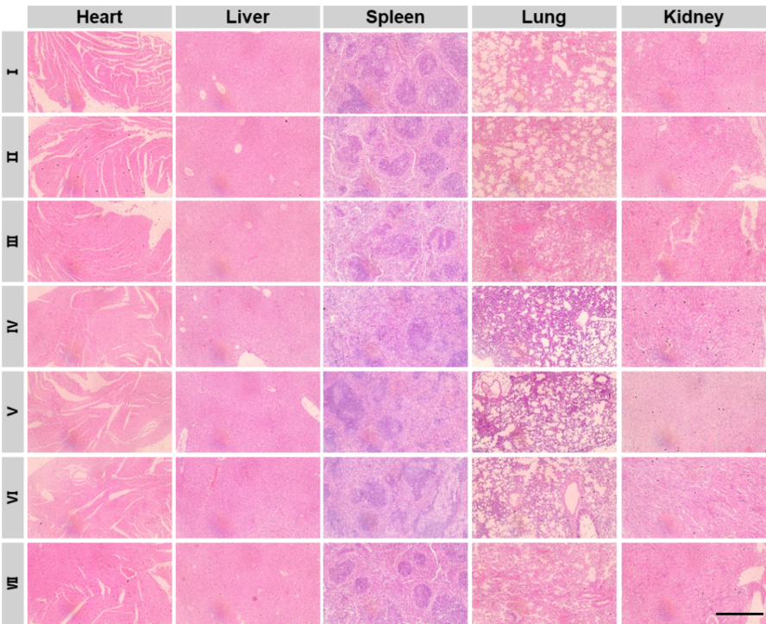
Figure S70. Representative images of H&E stained sections of the major organs from GBM mice treated with different samples (I:sham, II: PBS, III: TMZ, IV:PAC@Cur, V: Lip-PAC@Cur, VI: NO-Lip@PLC@Cur, VII: NO-Lip@PAC@Cur, scale bar: 500 μm).
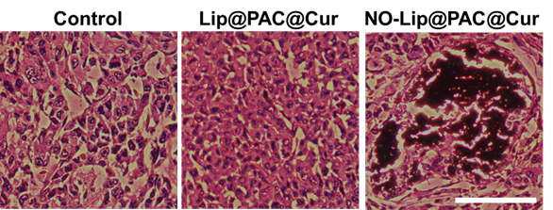
Figure S71. Optical images of von Kossa staining of tumor tissue sections (scale bar: 100 μm).

Table S1. Summary of GBM treatment strategies
Materials | Targeted strategy | Treatment strategy | Ref
NP–siRNA–CTX. | molecular recognition | gene therapy | ^{[1]}
BPLP-PLAs NPs | molecular recognition | immunotherapy | ^{[2]}
iRGD-loaded SPNPs | molecular recognition | gene therapy | ^{[3]}
siRNA micelles. | molecular recognition | gene therapy | ^{[4]}
MTX@MnO₂-Opca | molecular recognition | chemotherapeuty | ^{[5]}
iron oxide nanoparticle | molecular recognition | radiotherapy | ^{[6]}
CpG-exo/TGM | molecular recognition | immunotherapy | ^{[7]}
TrQβ@b-3WJ ^{iSCR}_{Let‑7g} | molecular recognition | gene therapy and radiotherapy | ^{[8]}
BSO-CAT@MOF-199 @DDM | molecular recognition | immunotherapy | ^{[9]}
ABNPs@mRNA | molecular recognition | gene therapy | ^{[10]}
Cannabidiol prodrug | molecular recognition | molecularly targeted therapy | ^{[11]}
Cu₂−xSe NPs | chemotaxis | immunotherapy | ^{[12]}
Au@ Cu₂−xSe NPs | molecular recognition | immunotherapy | ^{[13]}
CRISPR/Cas12a nanocapsule system | / | gene therapy and molecularly targeted therapy | ^{[14]}
Lipid nanoparticles | / | gene therapy | ^{[15]}
AMVY@NPs | molecular recognition | molecularly targeted therapy | ^{[16]}
silk fibroin microneedle | / | molecularly targeted therapy | ^{[17]}

Table S2. Fluorescence intensity quantification of brain tumors in different treatment groups during treatment.
 | Day 11  (Total Flux(×10⁵, p/s)) | Day 15  (Total Flux(×10⁵, p/s)) | Day 23  (Total Flux(×10⁵, p/s))
Sham | 0 | 0 | 0
PBS | 2.9 | 15.5 | 145.7
TMZ | 2.7 | 8.2 | 79.8
PAC@Cur | 1.7 | 8.3 | 33.8
Lip@PAC@Cur | 1.8 | 9.1 | 44.3
NO-Lip@PLC@Cur | 1.8 | 3.1 | 38.5
NO-Lip@PAC@Cur | 1.6 | 2.5 | 16.3

References
[1] K. Wang, F. M. Kievit, P. A. Chiarelli, Z. R. Stephen, G. Lin, J. R. Silber, R. G. Ellenbogen, M. Zhang, Adv. Funct. Mater. 2021, 31, 2007166.
[2] G. B. Kim, V. Aragon-Sanabria, L. Randolph, H. Jiang, J. A. Reynolds, B. S. Webb, A. Madhankumar, X. Lian, J. R. Connor, J. Yang, C. Dong, Bioact. Mater. 2020, 5, 624-635.
[3] J. V. Gregory, P. Kadiyala, R. Doherty, M. Cadena, S. Habeel, E. Ruoslahti, P. R. Lowenstein, M. G. Castro, J. Lahann, Nat. Commun. 2020, 11, 5687.
[4] T. Jiang, Y. Qiao, W. Ruan, D. Zhang, Q. Yang, G. Wang, Q. Chen, F. Zhu, J. Yin, Y. Zou, R. Qian, M. Zheng, B. Shi, Adv. Mater. 2021, 33, 2104779.
[5] C.-Y. Dong, Q.-X. Huang, H. Cheng, D.-W. Zheng, S. Hong, Y. Yan, M.-T. Niu, J.-G. Xu, X.-Z. Zhang, Adv. Mater. 2022, 34, 2109213.
[6] P. A. Chiarelli, R. A. Revia, Z. R. Stephen, K. Wang, F. M. Kievit, J. Sandhu, M. Upreti, S. Chung, R. G. Ellenbogen, M. Zhang, Mater. Today 2022, 56, 66-78.
[7] J. Cui, X. Wang, J. Li, A. Zhu, Y. Guo, L. Di, R. Wang, ACS Nano 2023, 17, 1464-1484.
[8] H.-H. Pang, C.-Y. Huang, P.-Y. Chen, N.-S. Li, Y.-P. Hsu, J.-K. Wu, H.-F. Fan, K.-C. Wei, H.-W. Yang, ACS Nano 2023, 17, 10407-10422.
[9] Q.-X. Huang, J.-L. Liang, Q.-W. Chen, X.-K. Jin, M.-T. Niu, C.-Y. Dong, X.-Z. Zhang, Nano Today 2023, 51, 101911.
[10] Y. Liu, D. Zhang, Y. An, Y. Sun, J. Li, M. Zheng, Y. Zou, B. Shi, Nano Today 2023, 49, 101790.
[11] S. Zhou, Y. Huang, Y. Chen, Y. Liu, L. Xie, Y. You, S. Tong, J. Xu, G. Jiang, Q. Song, N. Mei, F. Ma, X. Gao, H. Chen, J. Chen, Nat. Commun. 2023, 14, 435.
[12] T. Wang, M. Han, Y. Han, Z. Jiang, Q. Zheng, H. Zhang, Z. Li, ACS Nano 2024, 18, 6333-6347.
[13] H. Zhang, L. Yang, M. Han, Y. Han, Z. Jiang, Q. Zheng, J. Dong, T. Wang, Z. Li, ACS Nano 2024, 18, 23001-23013.
[14] W. Ruan, S. Xu, Y. An, Y. Cui, Y. Liu, Y. Wang, M. Ismail, Y. Liu, M. Zheng, Adv. Sci. 2024, 11, 2402178
[15] N. Rouatbi, A. A. Walters, P. M. Costa, Y. Qin, R. Liam-Or, V. Grant, S. M. Pollard, J. T.-W. Wang, K. T. Al-Jamal, J. Controlled Release 2024, 375, 776-787.
[16] J. Qi, L. Zhang, Z. Ren, Y. Yuan, J. Yu, Y. Zhang, L. Gu, X. Wang, Y. Wang, H. Xu, R. Yu, X. Zhou, J. Nanobiotechnology 2024, 22, 495.
[17] Z. Wang, Z. Yang, J. Jiang, Z. Shi, Y. Mao, N. Qin, T. H. Tao, Adv. Mater. 2022, 34, 2106606.

