Supplemental data
DNA hyper-methylation associated with schizophrenia may lead to breakdown of self-tolerance
Hui Wei,^{1,9#}, Yanbo Yuan, ^{2#}, Caiyun Zhu, ^{1,9#}, Mingjie Ma, ^{1,9}, Fude Yang, ³, Zheng Lu, ⁴, Chuanyue Wang, ⁵, Hong Deng, ⁶, Jingping Zhao, ⁷, Runhui Tian, ⁸, Wanwan Zhu, ^{1,9}, Yan Shen, ¹, Xin Yu, ^{2**}, Qi Xu, ^{1,9*}.

Table S1. Inclusion and exclusion criteria
Inclusion criteria | Exclusion criteria
Patients
Informed consent signed by patients or guardians | Brain organic diseases or other intercurrent clinical body diseases
Chinese Han | Head trauma history, lost consciousness over 30 min
Diagnosed of schizophrenia by ICD-10 | Diagnosed of other psychosis by ICD-10 (not for non-psychosis patients)
16 ≤ age ≤ 65 | Alcohol or other substance dependence or abuse
First episode, duration less than 3 years | Anti-psychiatric drug contraindications involved in this study
Without systematic anti-psychiatric treatment, continuous regular medication less than 1 month or continuous irregular medication less than 3 months | Participated in other clinical drug trails in 30 days
Education ≤ 3 years | Hypophrenia
 | Seizures
 | Pregnant or breastfeeding women
Controls
Healthy blood donors, male or female | Accord with the inclusion or exclusion criteria of patient group
 | Family history of mental or neurological disorders
 | Suffered severe head trauma or birth trauma
 | Suffered febrile convulsion
 | Adopted or single-parent in childhood

Table S2. Primers and probes.
Primer & probe | Sequence | Product length (bp)
Sequenom MassARRAY DNA quantitative methylation assay
cg14341177-F | aggaagagagAGTTTGGTAGTTAGGGAAGAAGGGT | 334
cg14341177-R | cagtaatacgactcactatagggagaaggctAACTTTACAAACACCCAAACCACTA
cg13978347-F | aggaagagagTTTTGATTTTTTGAGTGTAAATTAGGA | 520
cg13978347-R | cagtaatacgactcactatagggagaaggctAATAATTCCATTCTACATCCCCTTT
Quantitative real-time PCR assay
BICD2 total transcripts
BICD2-total-F | AATTTGTACTCCTTGATGTCATCCC | 142
BICD2-total-R | TGTCCTCACCAACACGCAGTC
BICD2-total-probe | HEX-TCTCCACATTCTGGTTGAT-MGB
BICD2 isoform 1 (NM_001003800)
BICD2-isoform_1-F | AGCCACACCGAGCGTAAGTC | 118
BICD2-isoform_1-R | CAGCCCCTAATCACAGTAAATGC
BICD2-isoform_1-probe | FAM-AACCAGGTGTTCTGCA-MGB
BICD2 isoform 2 (NM_015250)
BICD2-isoform_2-F | GTGCCAAAGCCGCCC | 99
BICD2-isoform_2-R | AAGGGGCTGCAGTGTGACA
BICD2-isoform_2-probe | FAM-CACCGAGCCTGTAGAG-MGB
GAPDH total transcripts
GAPDH-F | GCACCACCAACTGCTTAGCA | 106
GAPDH-R | GTCTTCTGGGTGGCAGTGATG
GAPDH-probe | FAM-TCGTGGAAGGACTCATGACCACAGTCC-MGB

Tables S3-S7 are large tables and we have provided as separate files in an appropriate spreadsheet format.

Table S3. Detailed DMS information
Table S3.1: DMS of baseline RSCZ
Table S3.2: DMS of endpoint RSCZ
Table S3.3: DMS of baseline NRSCZ
Table S3.4: DMS of endpoint NRSCZ

Table S4. State-dependent DMS in RSCZ
Table S4.1: RSCZ baseline v.s. CTL
Table S4.2: RSCZ endpoint v.s. CTL
Table S4.3: RSCZ baseline v.s. endpoint

Table S5. State-dependent DMS in NRSCZ
Table S5.1: NRSCZ baseline v.s. CTL
Table S5.2: NRSCZ endpoint v.s. CTL
Table S5.3: NRSCZ baseline v.s. endpoint

Table S6. GO enrichment information
Table S6.1: GO enrichment of RSCZ
Table S6.2: GO enrichment of NRSCZ

Table S7: Correlation analysis results
Table S7.1: Correlation analysis of RSCZ in the Discovery cohort
Table S7.2: Correlation analysis of NRSCZ in the Discovery cohort
Table S7.3: Correlation analysis of RSCZ in the Replication cohort
Table S7.4: Correlation analysis of NRSCZ in the Replication cohort
Table S7.5: Correlation analysis of RSCZ in the Meta cohort
Table S7.6: Correlation analysis of NRSCZ in the Meta cohort

Figure S1. Study design and analysis workflow.
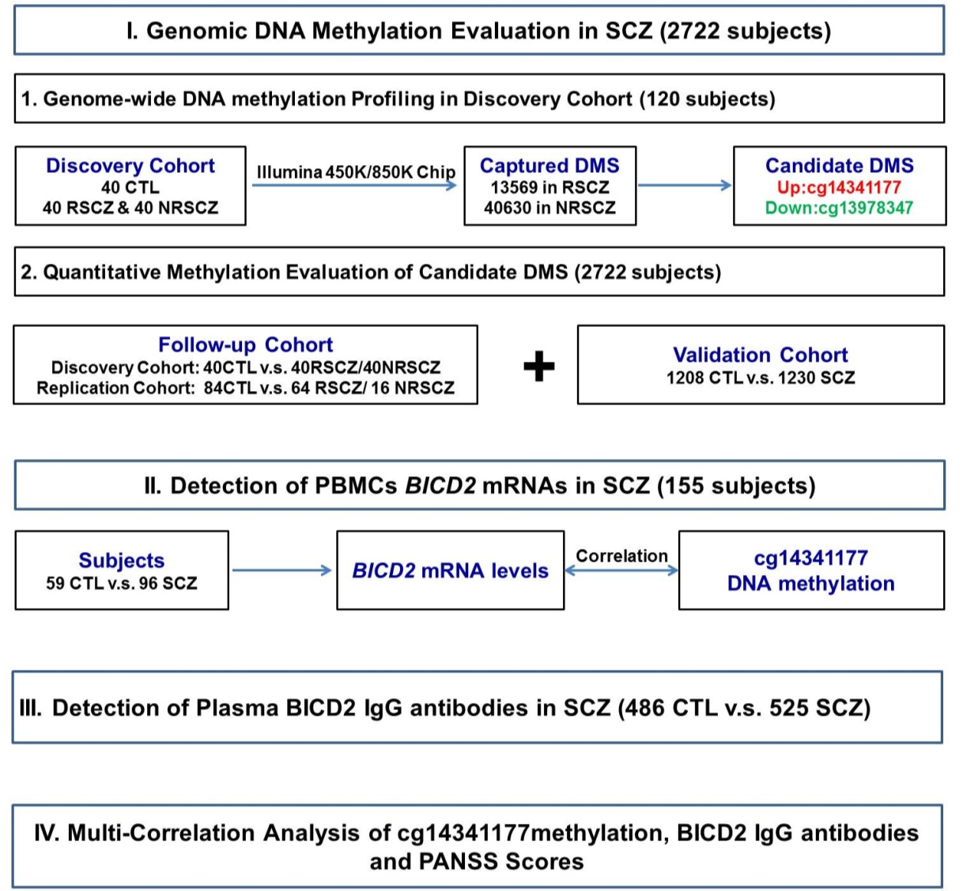

Figure S2. Schematic presentations of BICD2 gene and protein structures.
(A) The BICD2 gene locates at 9q22.31 and encodes a 6.5kb mRNA. There is an alternative splicing region with ~1.8 kb in length at the exon 7, which leads to a truncated isoform 2 mRNA. This could be represented as an alternative intron 7 (I7’), and the residual exon 7 could be represented as an alternative exon 8 (E8’). The I7’ comprises a 99 bp represent coding sequences (CDS) and an 1.7 kb 3' untranslated regions (3’-UTR) sequence, the identified cg14341177 is localized at 47 bp upstream of the 3’-AG splicing site and 18 bp upstream of the branching point (BP) sequence recognized by U2-dependent spliceosome. The dark blue boxes represent CDS and the light blue boxes represent untranslated regions UTR. (B) Schematic presentations of BICD2 protein. Coiled-coil (CC) domains are shown as slash boxes. The BICD2 isoform 2 lack the last 31 amino acid residues in isoform 1. Information is obtained from the UniPort database (Q8TD16) (1).

Figure S3. Schematic presentations of the in-house ELISA.

(A) HLA-II autoantigen prediction for BICD2 on the IEDB (2). The BICD2 isoform 1 C-terminal tail contained a 24mer autoantigen with excellent prediction scores, detailed prediction results are showed in Table S3. Amino acid residues with the prediction scores above the threshold were filled in yellow. (B). In-house ELISA for anti-BICD2 IgG antibody detection. The BICD2 isoform 1 C-terminal 24mer peptide was cross-linked onto a maleimide activated 96-well plate via sulfhydryl on cysteine and served as a linear antigen which captured anti-BICD2 IgG autoantibodies in subjects. An anti-human IgG-Fc fragment antibody conjugated with HRP was used as an ELISA 2nd antibody.

Figure S4. Expression profile of BICD2.
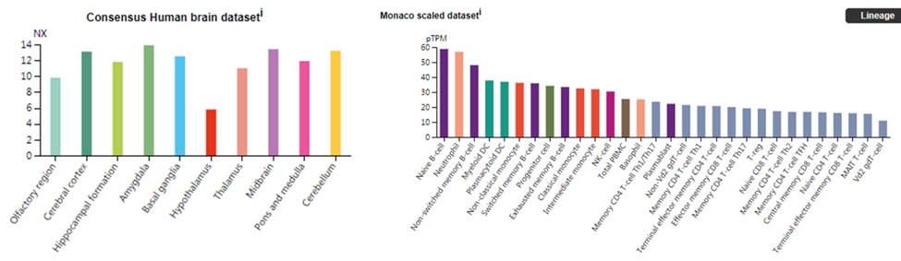

In the brain, BICD2 is widely expressed in most cognitive regions, including cortex, hippocampal formation and amygdala. In peripheral, it is abundant in B cells, neutrophil and dendritic cells. Data is obtained from The Human Protein Atalas database (ENSG00000185963-BICD2) (3) .

Supplemental references:
1. UniProt C (2019): UniProt: a worldwide hub of protein knowledge. Nucleic acids research. 47:D506-D515.
2. Vita R, Mahajan S, Overton JA, Dhanda SK, Martini S, Cantrell JR, et al. (2019): The Immune Epitope Database (IEDB): 2018 update. Nucleic acids research. 47:D339-D343.
3. Uhlen M, Fagerberg L, Hallstrom BM, Lindskog C, Oksvold P, Mardinoglu A, et al. (2015): Proteomics. Tissue-based map of the human proteome. Science. 347:1260419.

