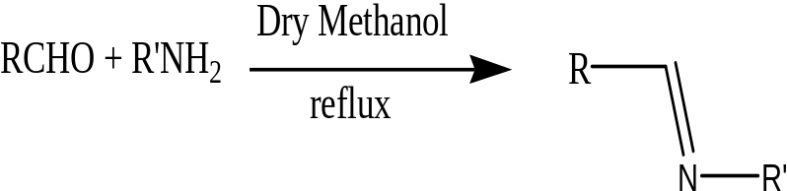

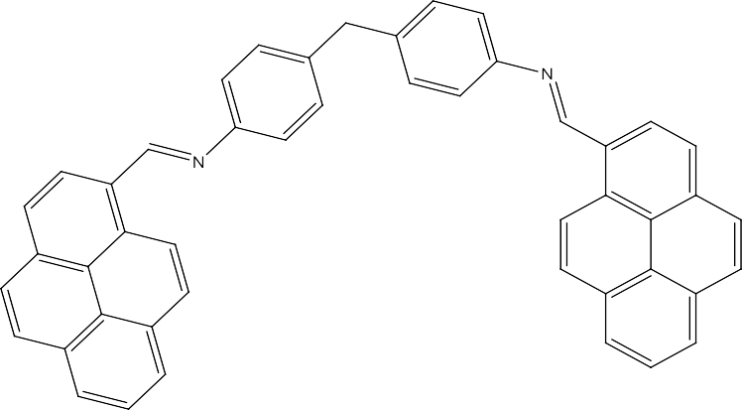

(NE, NE)-4,4’-methylenebis(N-(pyren-1-ylmethylene)aniline) (HL)

Scheme 1

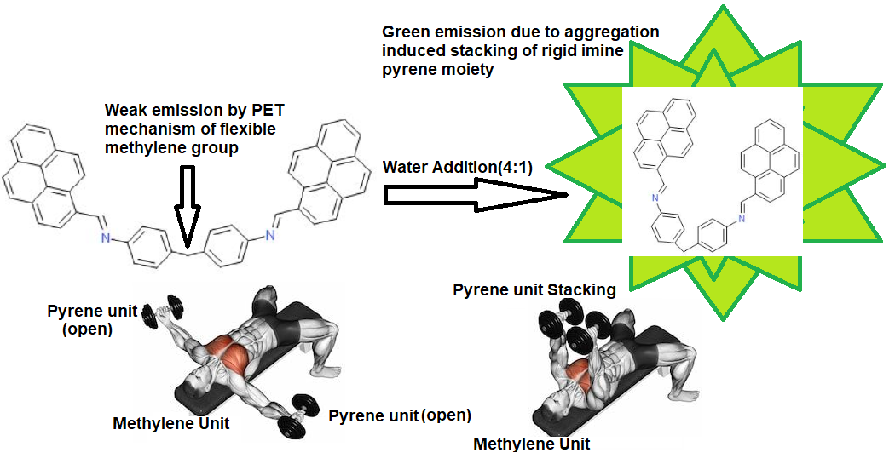
Scheme 2. Aggregation Induced emission of HL

