Supplementary Material
Aggregation Induced Emission Enhancement of a fascinating Pyrene mediated fluorescent chromophore
Dr. Uttam Panda*ª, Mr. Rajat Kumar Sahooª,

ªDepartment of Chemistry, Balasore College of Engineering and Technology,Sergarh, Balasore–756060, Odisha, India (Affiliated to Biju Patnaik University of Technology, Rourkela, Odisha)
Corresponding e-mail: uttamju88@gmail.com

Supporting Information
56.0
1758.06
1184.67
1719.35
1530.64
1583.87

54

52

50

48

46

44
%T
42

40

38

36

34

32
31.0
3500.0 3200 2800 2400 2000 1800 1600 1400 1200 1000 800 600 500.0
cm-1

Fig.S₁. FT-IR spectrum of (NE,NE)-4,4’-methylenebis(N-(pyren-1-ylmethylene)aniline) (HL)

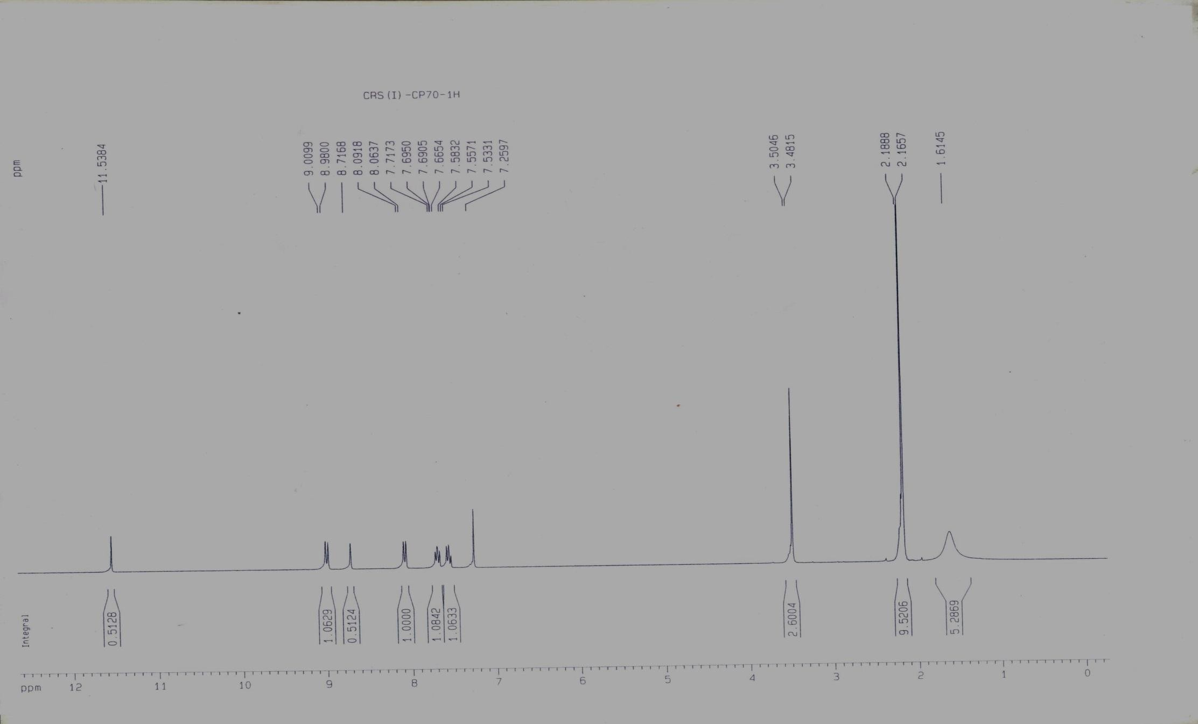
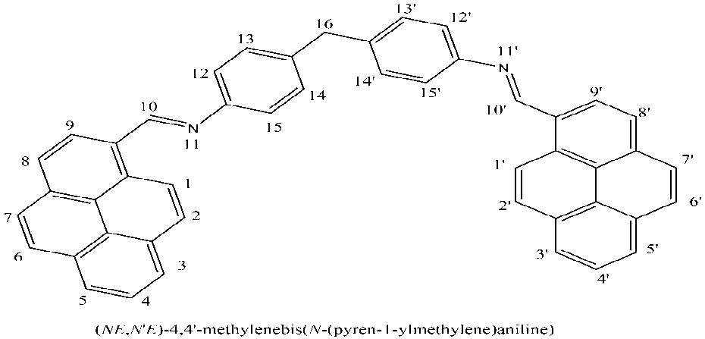

C-16

(C-10,C-10’) (C-13,14 & C-13’,14’) (C-3,4,5, & C-3’,4’,5’)

(C-12,15 & C-12’,15’) (C-6,7,1,2 & C-1’,2’,6’,7’’)

Fig.S₂-1H NMR spectrum of (NE,NE)-4,4’-methylenebis(N-(pyren-1-ylmethylene)aniline) (L)

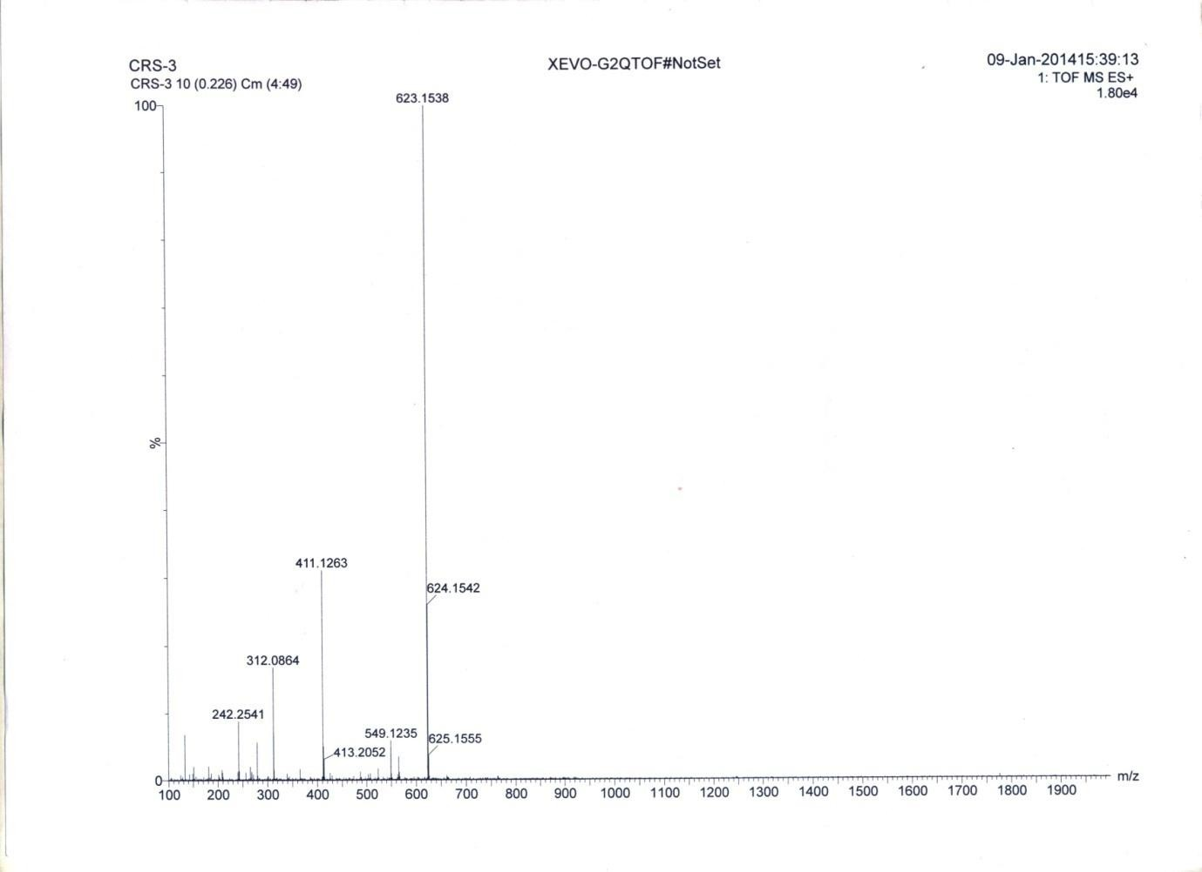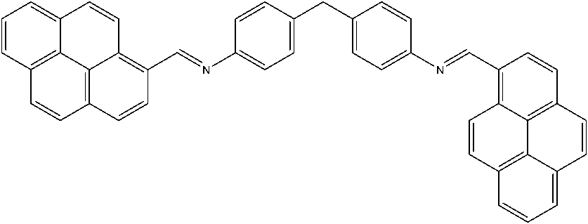

Fig. S₃- Mass spectrum of (NE,NE)-4,4’-methylenebis(N-(pyren-1-ylmethylene)aniline) (HL)

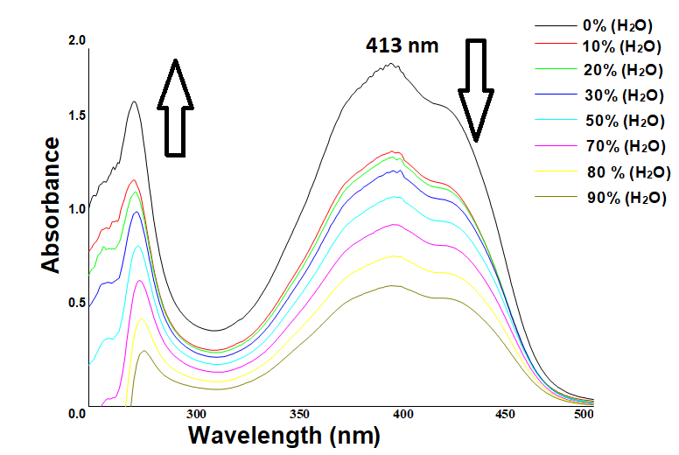

Fig.S₄. UV-vis spectral change of (NE,NE)-4,4’-methylenebis(N-(pyren-1-ylmethylene)aniline) in THF upon gradual addition of water

Table 1
- Contour plots of some selected molecular orbitals of HL

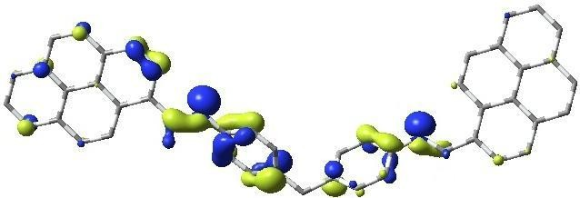
Homo-3; E, -6.22 eV; Pyrene, 31; imine, 29; biphenylethylene, 40%
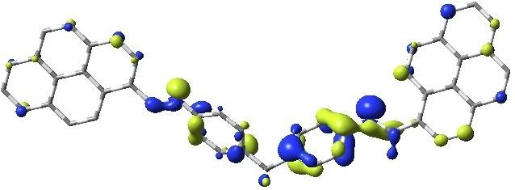
Homo-2; E, -6.08 eV; Pyrene, 33; imine, 24; biphenylethylene, 43%
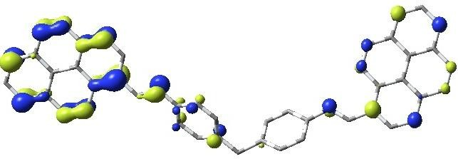
Homo-1; E, -5.5 eV; Pyrene, 79; imine, 09; biphenylethylene, 12%
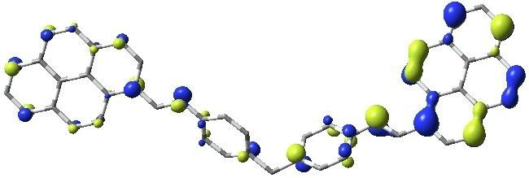
Homo; E, -5.44 eV; Pyrene, 72; imine, 10; biphenylethylene, 18%

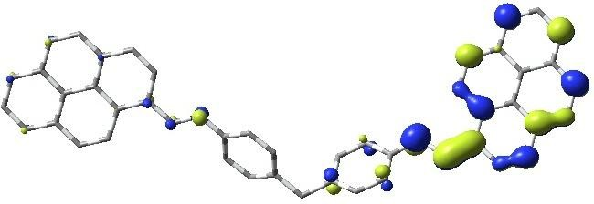
Lumo; E, -2.29 eV; Pyrene, 69; imine, 22; biphenylethylene, 09%
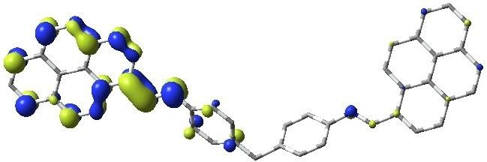
Lumo+1; E, -2.27 eV; Pyrene, 68; imine, 22; biphenylethylene, 10%
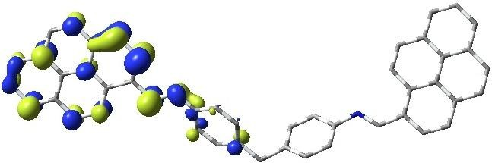
Lumo+2; E, -1.22 eV; Pyrene, 72; imine, 17; biphenylethylene, 11%
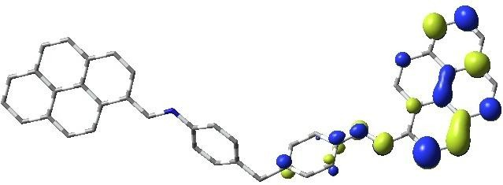
Lumo+3; E, -1.05 eV; Pyrene, 82; imine, 09; biphenylethylene, 09%

Table 2.
MO composition of HL

MO | Energy  (eV) | pyrene | imine | biphenylethylene
LUMO+6 | -0.45 | 24 | 01 | 75
LUMO+5 | -0.72 | 67 | 14 | 19
LUMO+4 | -0.82 | 85 | 06 | 09
LUMO+3 | -1.05 | 82 | 09 | 09
LUMO+2 | -1.22 | 72 | 17 | 11
LUMO+1 | -2.27 | 68 | 22 | 10
LUMO | -2.29 | 69 | 22 | 09
HOMO | -5.44 | 72 | 10 | 18
HOMO-1 | -5.5 | 79 | 09 | 12
HOMO-2 | -6.08 | 33 | 24 | 43
HOMO-3 | -6.22 | 31 | 29 | 40
HOMO-4 | -6.54 | 86 | 09 | 05
HOMO-5 | -6.55 | 88 | 08 | 04

TD-DFT data of HL in THF
Table 3.
IPCT: Interpyrene charge transfer; BPCT: Biphenylethylene to pyrene charge transfer; PBCT: Pyrene to biphenylethylene charge transfer

Excitation energy(ev) | Wavelength(nm  ) | f | Key Transitions | Character
2.8170 | 440.14 | 1.5512 | (60%) HOMO → LUMO | IPCT
2.9099 | 426.08 | 0.4794 | (68%) HOMO →  LUMO+1 | IPCT
2.9811 | 415.91 | 0.0660 | (70%) HOMO-1 →  LUMO | IPCT
3.0197 | 410.59 | 0.0862 | (82%) HOMO-1 →  LUMO+1 | IPCT
3.2602 | 380.30 | 0.0784 | (61%) HOMO-2 →  LUMO | IPCT, BPCT
3.3196 | 373.49 | 0.0202 | (41%) HOMO-2 →  LUMO+1 | IPCT, BPCT
3.5378 | 350.46 | 0.0441 | (51%) HOMO-4 →  LUMO+1 | IPCT
3.9234 | 316.01 | 0.0957 | (37%) HOMO →  LUMO+2 | IPCT
4.0782 | 304.01 | 0.0608 | (40%) HOMO-1→ LUMO+2  (36%) HOMO→  LUMO+2 | IPCT IPCT
4.1249 | 300.58 | 0.0605 | (54%) HOMO-5 →  LUMO+1 | IPCT
4.1705 | 297.29 | 0.4589 | (19%) HOMO →  LUMO+3 | IPCT
4.1807 | 296.57 | 0.1920 | (19%) HOMO →  LUMO+3 | IPCT
4.2450 | 292.07 | 0.0632 | (62%) HOMO-1 →  LUMO+3 | IPCT
4.5111 | 274.84 | 0.0496 | (39%) HOMO-1 →  LUMO+4 | IPCT
4.5996 | 269.55 | 0.0721 | (63%) HOMO →  LUMO+6 | PBCT
4.7774 | 259.52 | 0.0750 | (37%) HOMO-2 →  LUMO+5 | IPCT, BPCT
4.9535 | 250.29 | 0.1067 | (28%) HOMO-2 →  LUMO+4 | IPCT, BPCT
5.0994 | 243.14 | 0.0931 | (42%) HOMO-5 →  LUMO+3 | IPCT
5.4212 | 228.70 | 0.7059 | (48%) HOMO-4 →  LUMO+4 | IPCT

.

