Supplementary Information
Ballistic transport in nanodevices based on single-crystalline Cu thin films

Yongjin Cho¹, Su Jae Kim², Min-Hyoung Jung³, Yousil Lee⁴, Hu Young Jeong⁵, Young-Min Kim³, Hu-Jong Lee¹, Seong-Gon Kim⁶*, Se-Young Jeong^{7,8,9}*, and Gil-Ho Lee^{1,10}*

¹Department of Physics, Pohang University of Science and Technology, Pohang, Republic of Korea
²Crystal Bank Research Institute, Pusan National University, Busan 46241, Republic of Korea
³Department of Energy Science, Sungkyunkwan University, Suwon 16419, Republic of Korea
⁴Copper Innovative Technology (CIT) Co. Busan 46285, Republic of Korea
⁵ Graduate School of Semiconductor Materials and Devices Engineering, Ulsan National
Institute of Science and Technology, Ulsan 44919, Republic of Korea
⁶Department of Physics and Astronomy, Mississippi State University, Mississippi State, MS 39762, USA
⁷Department of Physics, Korea Advanced Institute of Science and Technology (KAIST), Daejeon 34141, Korea
⁸Gordon Center for Medical Imaging, Department of Radiology, Massachusetts General Hospital and Harvard Medical School, Boston, MA 02114, USA
⁹Department of Optics and Mechatronics Engineering, Engineering Research Center for Color-Modulated Extra-Sensory Perception Technology, Pusan National University, Busan 46241, Republic of Korea
¹⁰Asia Pacific Center for Theoretical Physics, Pohang 37673, Republic of Korea

*Corresponding authors. E-mail:
sk162@msstate.edu (S.-G.K.);
sjeong9@kaist.ac.kr (S.-Y.J);
lghman@postech.ac.kr (G.-H.L)
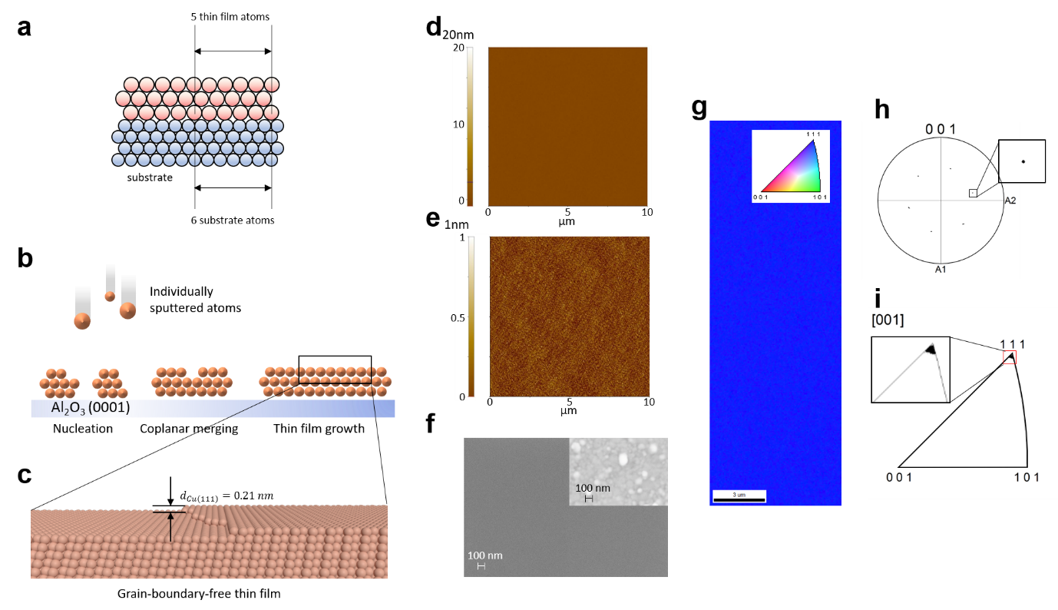
Supplementary Fig. 1 | Single-crystal thin film used for ballistic transport measurements. a, Scheme of EADM at the heteroepitaxy. b, 3 initial stages of thin film growth: 1. nucleation stage, 2. coherent-coplanar merging stage and 3. layer-by-layer growth stage. c, Scheme of surface and atomic stacking of SCCF. d-e, Actual atomic force microscopy images of samples presented with 20 nm resolution (d) and 1 nm resolution (e). f. SEM image of SCCF surface. Inset: an SEM image of a polycrystalline sample for comparison. g, EBSD map showing ideal crystallinity with alignment along the (111) plane. h, Inverse pole figure displaying a single spot corresponding to the (111) plane. i, [100] pole figure revealing the six-fold symmetry of {100}.

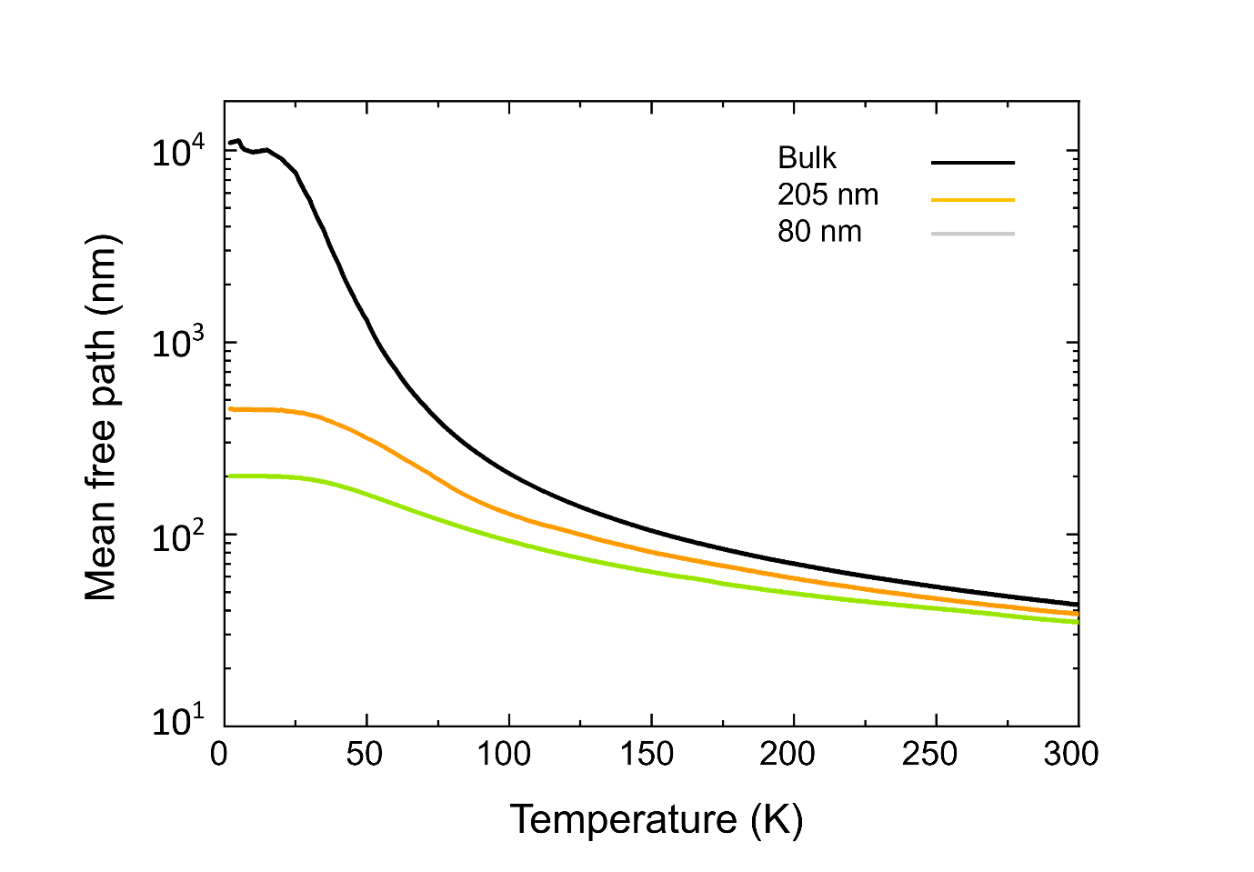

Supplementary Fig. 2. Mean free paths of electrons in single-crystal bulk and thin films with thicknesses of 205 and 80 nm, respectively. The mean free path was calculated from the relationship between the resistivity and mean free path.

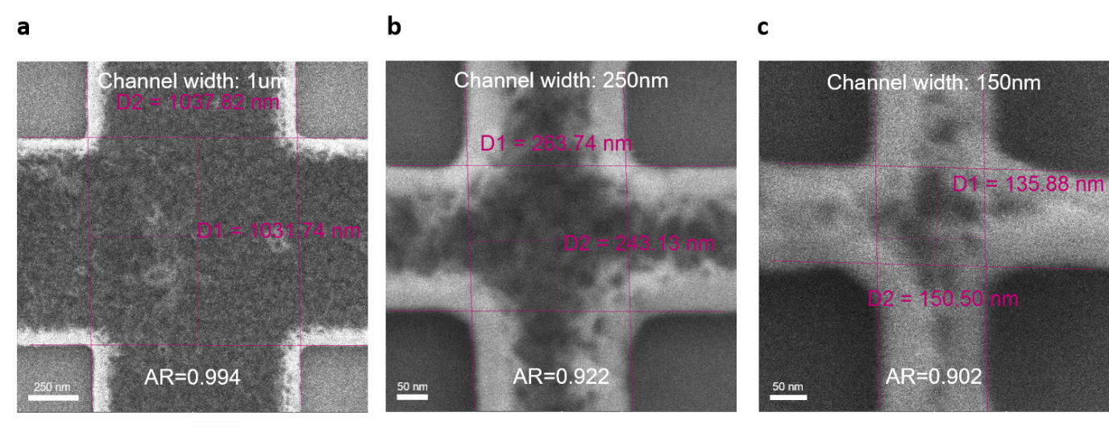
Supplementary Fig. 3 | SEM image of SCCF Hall bars with various channel widths. a, SEM image of an SCCF Hall bar device with a channel width W = 1 μm. (b), W = 250 nm (c) and W = 150 nm

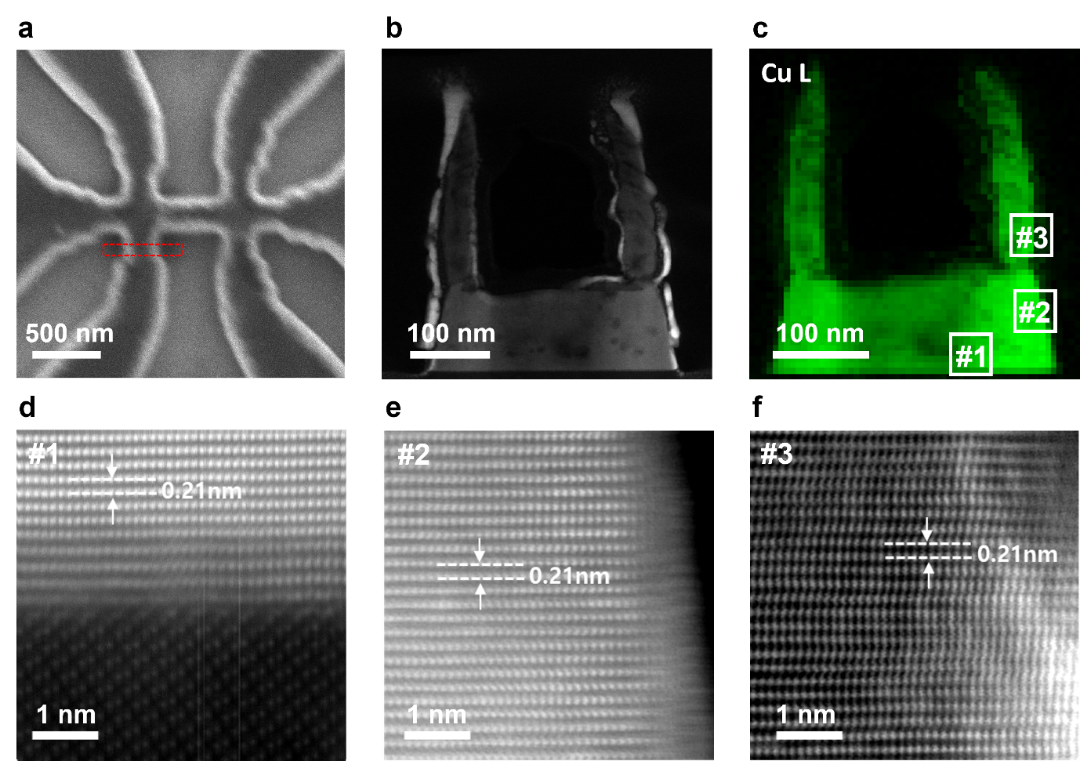
Supplementary Fig. 4 | Cross-sectional TEM image of ballistic transport in SCCF. a, SEM image of an SCCF Hall bar device with a channel width (W) of 250 nm. b, Low-magnification ADF-STEM image displaying the cross-sectional view of the SCCF Hall bar device. c, EELS-based elemental map of Cu. d–f, Enlarged atomic structure images for the regions marked by white boxes in c.

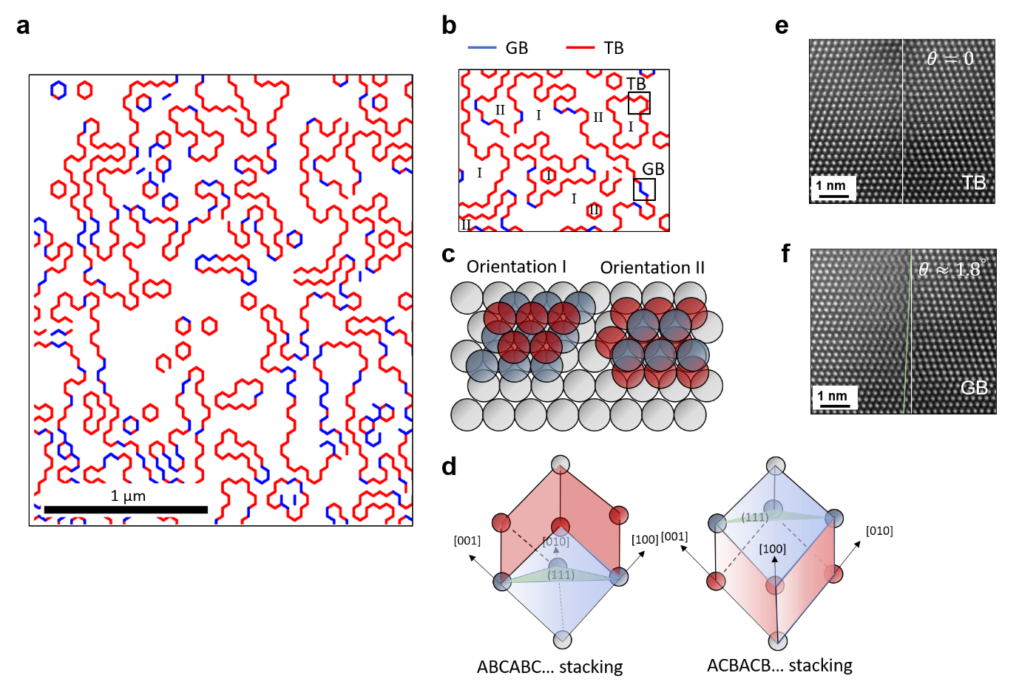
Supplementary Fig. 5 | Crystallographic structure at GB and TB. a, Misorientation line map of a single crystalline Cu thin film almost aligned along Cu(111), but still with a few GBs. b, Enlarged images of a with marks of orientations I and II. c, Atomic stacking of orientations I and II following ABC… and ACB..., respectively. d, 3D crystal structures of two different orientations I and II stacked along the diagonal direction of the cubic system. e–f, High-angle annular dark-field scanning transmission electron microscopy (HAADF-STEM) images showing the atomic stacking order near the TB (e) and GB (f) marked by boxes in b.

Supplementary note to Supplementary Fig. 5.
We analyzed the data from single-crystalline Cu thin films to distinguish between SCCFs and single-crystalline Cu thin films that are close to SCCFs but still have GBs. The GBs in single-crystalline Cu thin films differ significantly from those in PCCFs. While PCCFs can have arbitrary orientations, orientations in single-crystalline thin films are limited to two possibilities. Even if a single-crystalline thin film contains some GBs, these are very close to the TBs with a slight misorientation of less than 2° vertically. Nevertheless, electrons scatter at these slightly misoriented GBs, making ballistic transport difficult to observe. Therefore, ballistic behavior is only observed in extremely clean SCCF systems without GBs.

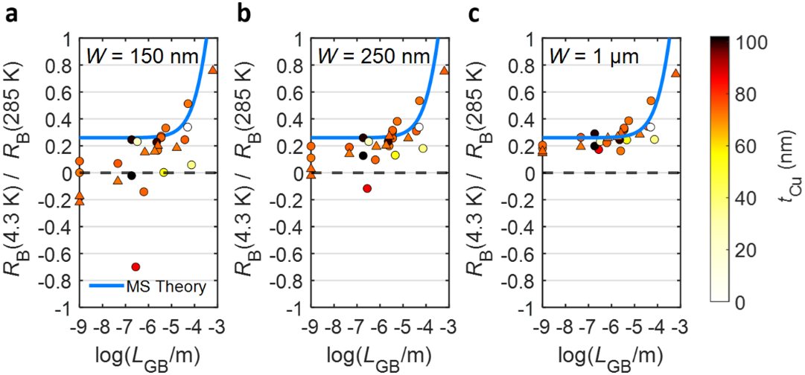

Supplementary Fig. 6 | GB dependence of electrical transport. a-c, Normalized bend resistance R_{B} as a function of GB length L_{GB} for W = 1 μm (a), W = 250 nm (b) and W = 150 nm (c). Blue solid line represents the MS theory fit for device with W = 1 μm, circles and triangles represent the device without and with annealing processes, respectively; the symbol colors represent thickness, t_{Cu}.

Supplementary note to Supplementary Fig. 6.
Supplementary Figs. 6a–c show the L_{GB} dependence of R_{B} at 4.3 K, normalized with that at 285 K. For devices with W = 1 μm, the normalized R_{B} shows similar L_{GB} dependence of resistivity as the film is in the diffusive regime for all L_{GB} values. However, for devices with W = 250 and 150 nm, the MS model fails to explain the normalized R_{B} for small values of L_{GB}, where l_{mfp} exceeds W, and R_{B} becomes negative.

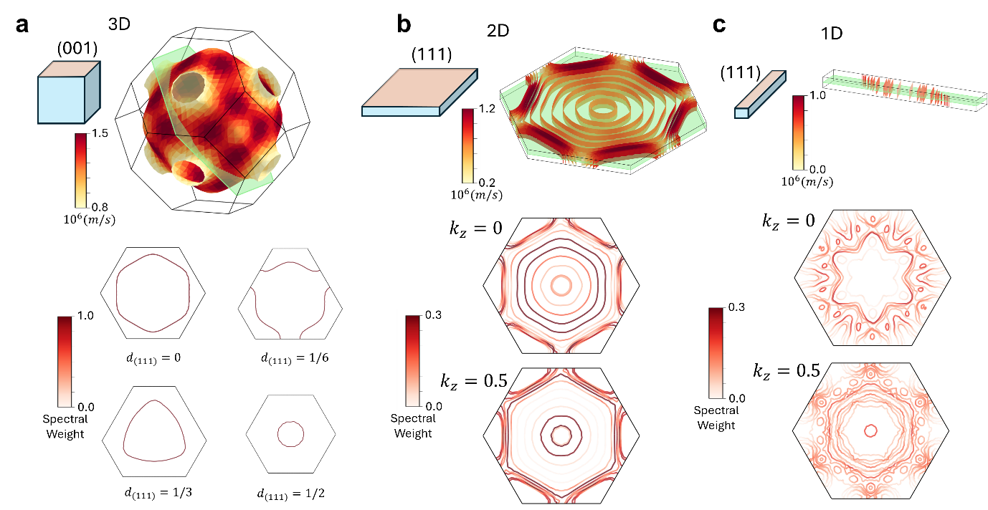
Supplementary Fig. 7 | Comparison of Fermi surfaces of 3D, 2D and 1D Cu (111). a, Fermi surface of Cu bulk (upper panel) and the intersections of Fermi surfaces with the (111) slice plane at various distances from the zone centre. b, Fermi surface of 2D Cu thin film (upper panel) and the 2D effective Fermi surfaces unfolded to 3D at different $k_{z}$ values. c, Fermi surface of 1D Cu(111) rod (upper panel) and the 1D effective Fermi surfaces obtained by band unfolding at different $k_{z}$ values. Color on the 3D Fermi surface represents the magnitude of the group velocity of the electrons. Color of the band in Fermi slices represents the spectral weight of the effective band.

Supplementary note to Figs. 4d and e.
If the density of state $g(ε)$ changes significantly near the Fermi energy $ε_{F}$, then temperature-induced chemical-potential $μ\left(T\right)$ shift occurs owing to thermal excitation of the electrons, as shown in equation (5)^{S1,S2}.
$$μ(T) = ε_{F}-\frac{π^{2}}{6}{(k_{B}T)}^{2}\frac{g^{'}(ε_{F})}{g(ε_{F})} (5)$$
The shift in chemical potential due to temperature changes is negligible in typical metals such as bulk copper. However, in semimetals, where conduction band minimum and valence band maximum are near the chemical potential, significant shifts can occur with temperature changes owing to considerable variations in the density of the state close to the Fermi level. This result suggests that the electronic band structure of the 90-nm-thick SCCF, modified by quantum confinement effect perpendicular to the film plane, has semimetal-like properties. This results in a change of carrier type at low temperature from single electron carrier to two carriers (electron and hole) due to temperature-induced chemical potential shift^{25,S1-S5}. For widths <250 nm, the Hall resistivity at 1.7 K (Fig. 4e) becomes linear, consistent with the phenomenon observed at 120 K. In addition, the semimetal-like behavior disappears possibly because of additional quantum confinement effects along the channel width direction.

References
S1. Ashcroft, N. W. et al. Solid State Physics, College edn. (Thomson Learning Inc., 1976).
S2. Song, W. et al. Temperature dependence of band shifts induced by impurity ionization in ZrTe 5. Phys. Rev. B 106, 115124 (2022).
S3. Zhigal'skii, G. P. et al. The physical properties of thin metal films. Vol. 13 (CRC Press, 2003).
S4. Chiang, T. C. Quantum physics of thin metal films. AAPPS Bull. 18, 2–10 (2008).
S5. Eckertova, L. Physics of thin films. SSBM (2012).

