RAN MODULATES ALLOSTERIC CROSSTALK BETWEEN IMPORTIN β SURFACES

Ying-Hui Ko ¹, Fenglin Li ², Stephanie Suinn ¹, Junwei Li ¹, Chun-Feng David Hou ³, Ravi K. Lokareddy ¹ and Gino Cingolani ^{1*}

¹ Dept. of Biochemistry and Molecular Genetics, The University of Alabama at Birmingham, 1825 University Blvd, Birmingham, AL 35294, USA
² Dept. of Biochemistry and Biophysics, Perelman School of Medicine, University of Pennsylvania, Philadelphia, PA 19104, USA
³ Department of Chemistry and Chemical Biology, Rutgers, the State University of New Jersey, Piscataway, NJ, 08854, USA

* Corresponding Author and Lead Contact:
E-mail: gcingola@uab.edu; Tel.: (205) 996 9730

125-character teaser. Comparative analysis of importin β conformational plasticity in the frozen-hydrated state.

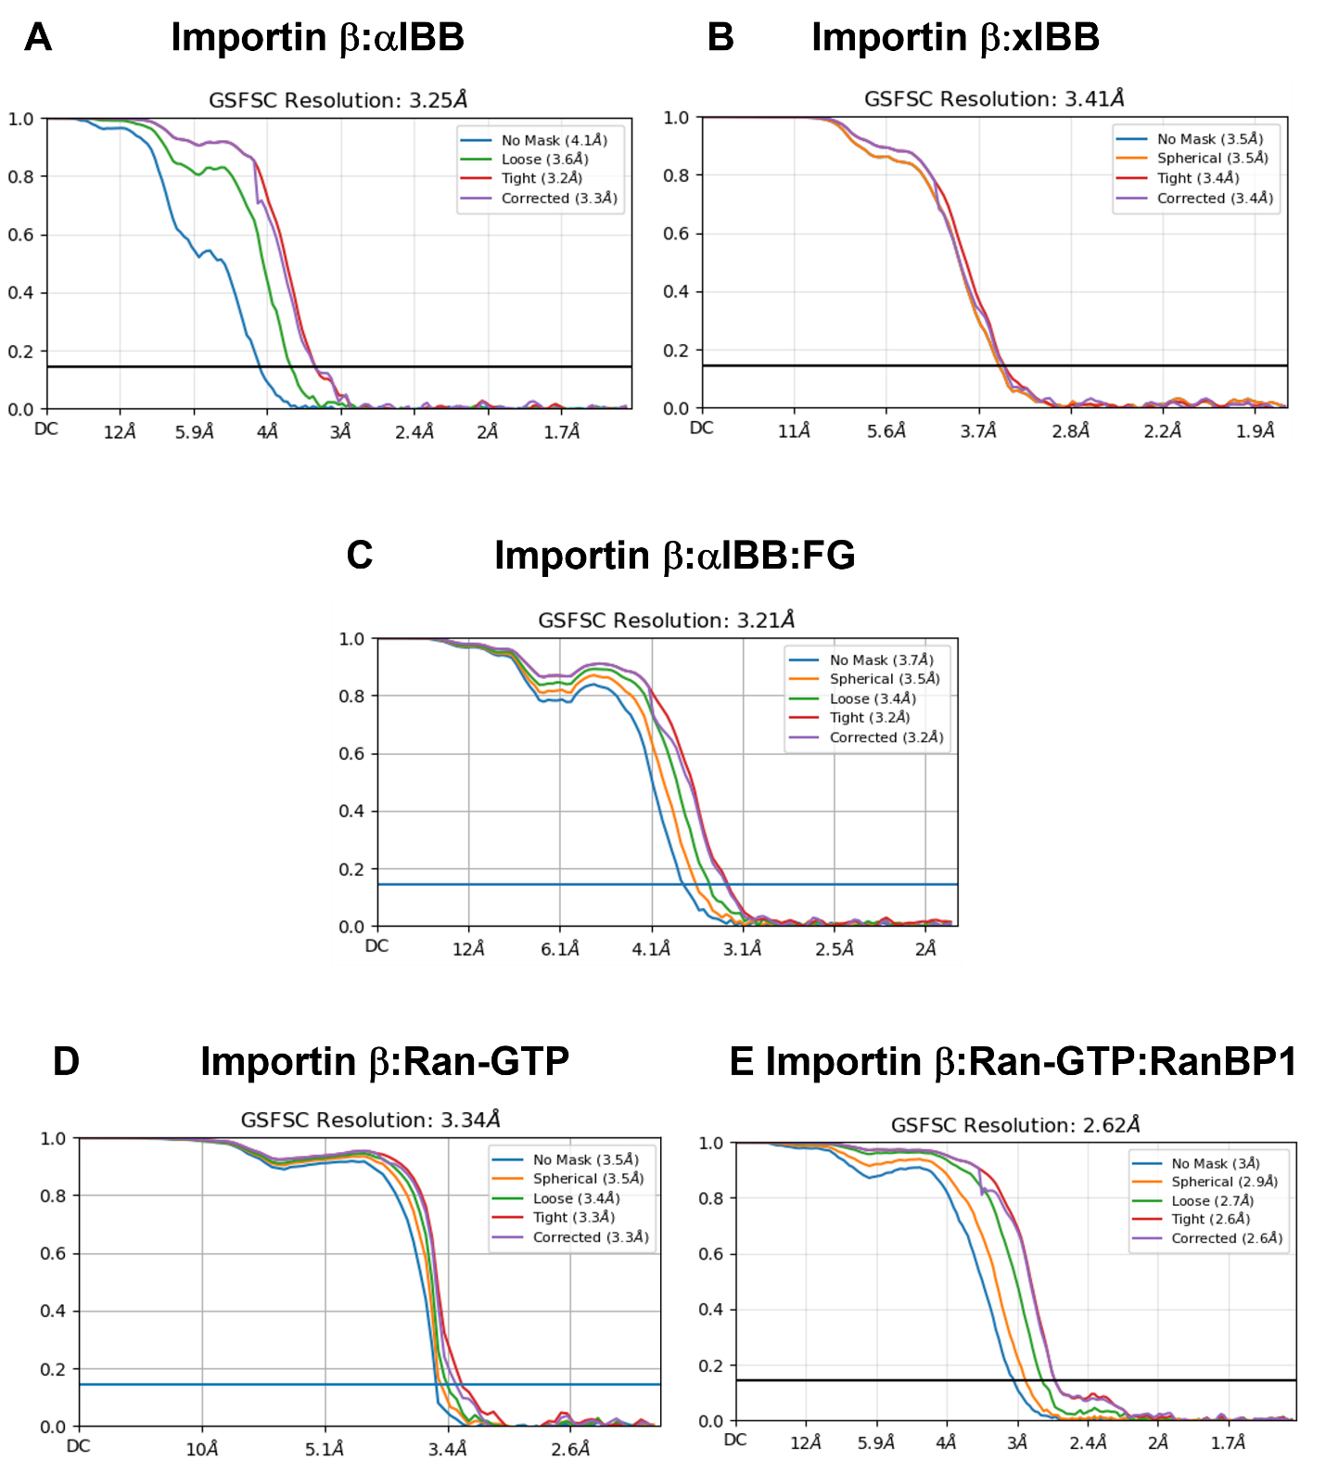

Supplemental Figure 1. Fourier Shell Correlation (FSC) resolution curves for all reconstructions reported in this paper: (A) importin β:αIBB; (B) importin β:xIBB; (C) importin β:αIBB:FG; (D) importin β:Ran-GTP; (E) importin β:Ran-GTP:RanBP1. The resolution for all FSC curves is indicated at 0.143 cut-off.

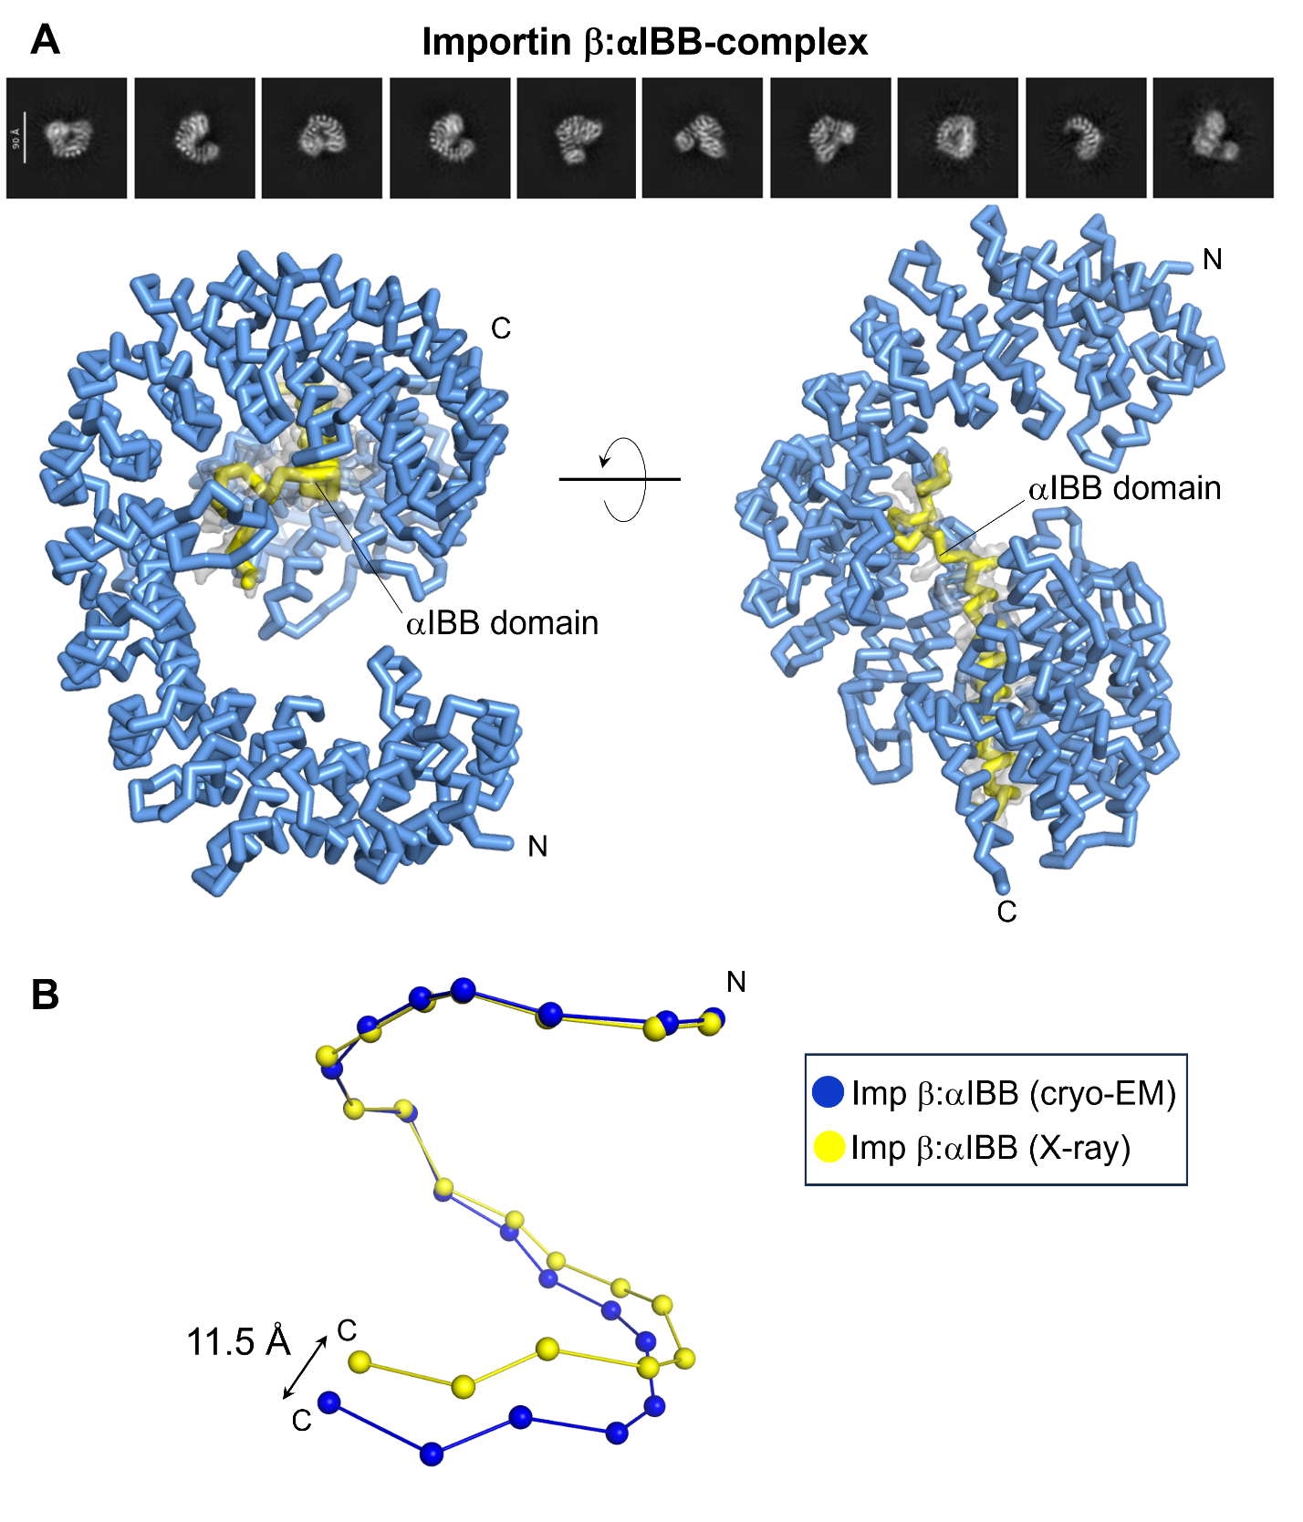

Supplemental Figure 2. Cryo-EM structure of the importin β:αIBB complex. (A) Representative 2D class averages (top) and 3D-structure of the importin β:αIBB complex (bottom). Importin β is colored blue with the αIBB in yellow. The final 3.3 Å cryo-EM density (colored gray) for the αIBB is overlaid onto the refined model. (B) Superimposition of importin β in the conformation observed in the cryo-EM reconstruction (blue) and crystal structure, PDB 1QGK (yellow), shown as beads-on-a-string. Each bead represents a HEAT repeat.

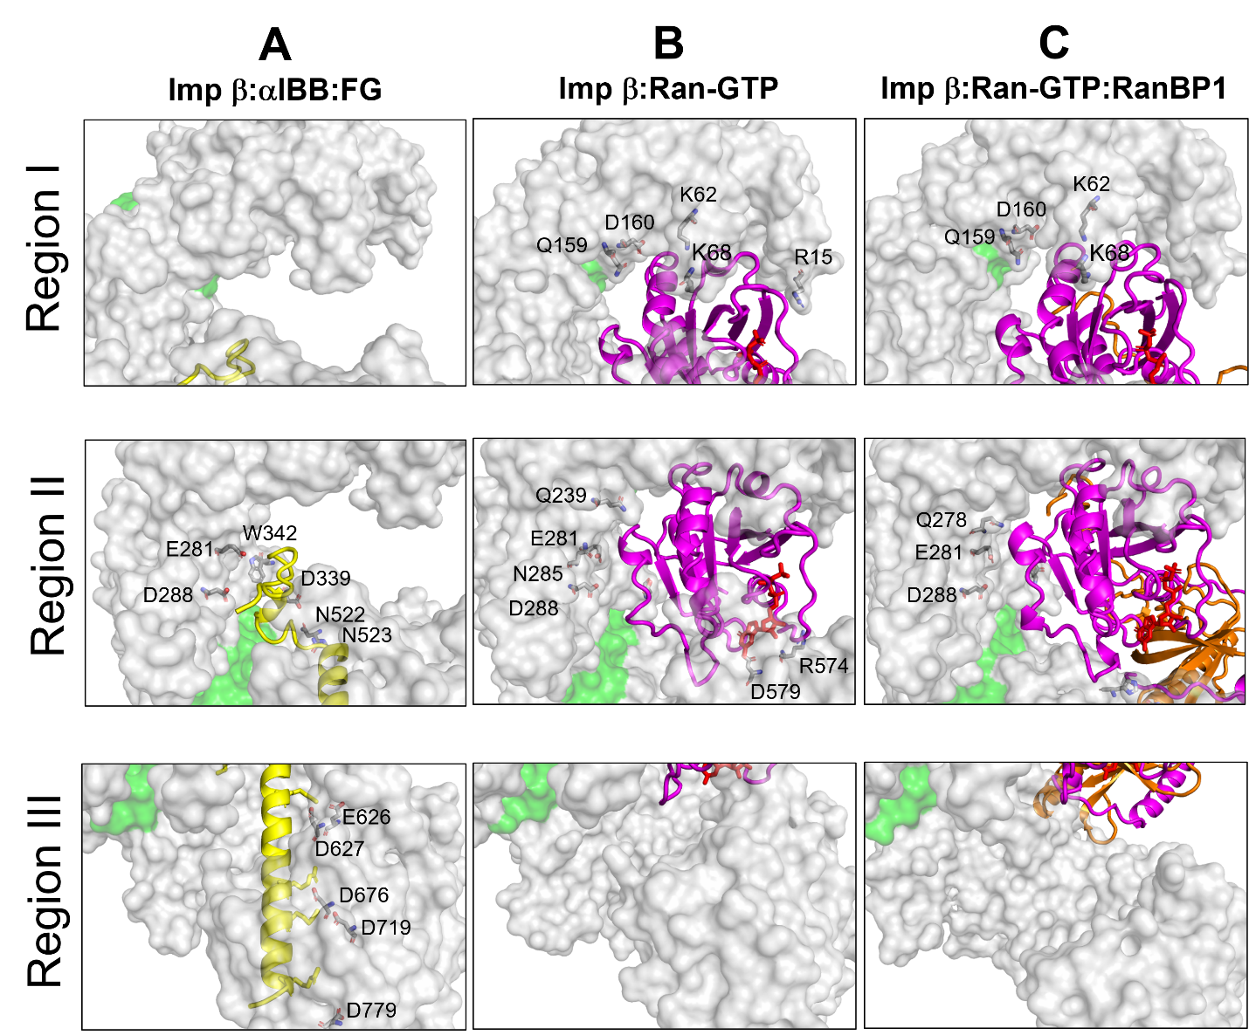

Supplemental Figure 3. αIBB and Ran-GTP bind to largely distinct regions of importin β. Magnified views of importin β region I (res. 1-252, HEATs 1-6), region II (res. 253-599, HEATs 7-13), and region III (res. 600-876, HEATs 14-19) in complex with αIBB (A), Ran-GTP (B) and Ran-GTP:RanBP1. (C) Contact residues are represented as sticks, and residue numbers are indicated. Importin β is shown as a semi-transparent gray surface. αIBB, Ran-GTP, and RanBP1 are shown in ribbon representation, colored yellow, magenta, and orange, respectively.

Supplementary Table 1. Volumes of the FG-binding pocket in importin β, as estimated by FPocketWeb.

 | Importin β:  αIBB:FG (Å³) | Importin β:  Ran-GTP (Å³) | Importin β:  Ran-GTP:RBP1 (Å³)
Pocket 1 | 502 | 122 | 303
Pocket 2 | 154 | 200 | 224
Pocket 3 | 214 | 232 | 195
Pocket 4 | 500 | 194 | 325
Pocket 5 | 545 | 582 | 290

