Supplementary appendix

European Association for the Study of Obesity (EASO) grade-based framework on Pharmacological Algorithm for the treatment of obesity and its complications

Barbara McGowan¹*, Andreea Ciudin²*, Jennifer L. Baker³, Luca Busetto⁴, Dror Dicker⁵, Gema Frühbeck⁶, Gijs H. Goossens⁷, Matteo Monami⁸, Paolo Sbraccia⁹, Borja Martinez-Tellez¹⁰, Euan Woodward¹¹, Volkan Yumuk¹².
*BM and AC equally contributed.

Affiliations
1. Department of Endocrinology and Diabetes, Guys & St Thomas ‘s Hospital NHS Trust, London, UK; 2. Diabetes and Metabolism Research Group, VHIR, Endocrinology Department, Vall d’Hebron University Hospital, Autonomous University Barcelona, Barcelona 08035, Spain. CIBERDEM (Instituto de Salud Carlos III), Madrid 28029, Spain; 3. Center for Clinical Research and Prevention, Copenhagen University Hospital-Bispebjerg and Frederiksberg, Frederiksberg, Denmark; 4. Department of Medicine, University of Padova, Padova, Italy; 5. Internal Medicine D and Obesity Clinic, Hasharon Hospital-Rabin Medical Center. Faculty of Medicine, Tel-Aviv University, Tel-Aviv, Israel; 6. Department of Endocrinology & Nutrition, Clínica Universidad de Navarra, CIBEROBN - Instituto de Salud Carlos III, IdiSNA, Pamplona, Spain; 7. Department of Human Biology, Institute of Nutrition and Translational Research in Metabolism (NUTRIM), Maastricht University Medical Center+, Maastricht, the Netherlands; 8. Diabetes Unit; Careggi Teaching Hospital and University of Florence, Florence, Italy. 9. Department of Systems Medicine, University of Rome Tor Vergata, Rome, Italy. 10. Department of Nursing, Physiotherapy and Medicine, CIBIS Research Center, University of Almería, Almería, Spain. CIBEROBN, Instituto de Salud Carlos III, Granada, Spain; 11. European Association for the Study of Obesity, Ireland; 12. Division of Endocrinology, Metabolism and Diabetes, Istanbul University-Cerrahpaşa, Cerrahpaşa Medical Faculty, Istanbul, Turkey.

Table of contents

Sommario
Figures 5
Figure 1S – Trial flow summary 5
Figure 2S – Risk of bias graph: review authors' judgements about each risk of bias item presented as percentages across all included studies. 6
Figure 3S – Risk of bias summary: review authors' judgements about each risk of bias item for each included study. 7
Figure 4S – Funnel plot for TBWL% at the endpoint. 8
Figure 5S – Effects of available OMM on TBWL% at 105-156 weeks. 9
Figure 6S – Network plots for trials reporting information on endpoint waist circumference (Panel A) and BMI (Panel B). 10
Figure 7S – Network forest plots showing the effects of each OMM on the reduction (differences from baseline to the endpoint) of waist circumference (Panel A) and BMI (Panel B). 11
Figure 8S – Network plots for trials reporting information on the proportion of subjects achieving a body weight reduction of at least 5% (Panel A), 10% (Panel B), 15% (Panel C), 20% (Panel D), and 25% (n= 2 RCTs with tirzepatide^{1,2}). 12
Figure 9S – Network forest plots for trials reporting information on the proportion of subjects achieving a body weight reduction of at least 5% (Panel A), 10% (Panel B), 15% (Panel C), 20% (Panel D), and 25% (Panel E). 14
Figure 10S – Network plots for trials reporting information on TBWL% at the endpoint (Panel A), 52 weeks (Panel B), and 53-104 weeks (Panel C), endpoint waist circumference (Panel D), and endpoint BMI (Panel E) in RCTs specifically designed for body weight reduction. 16
Figure 11S – Network forest plots showing the effects of each OMM on TBWL% at the endpoint (Panel A), 52 weeks (Panel B), and 53-104 weeks (Panel C), endpoint waist circumference (Panel D), and endpoint BMI (Panel E) in RCTs specifically designed for body weight reduction. 18
Figure 12S – Network plots for trials reporting information on the proportion of subjects achieving a body weight reduction of at least 5% (Panel A), 10% (Panel B), 15% (Panel C), 20% (Panel D), and 25% (n= 2 RCTs with tirzepatide^{1,2}) in RCTs specifically designed for body weight reduction. . 20
Figure 13S – Network forest plots for trials reporting information on the proportion of subjects achieving a body weight reduction of at least 5% (Panel A), 10% (Panel B), 15% (Panel C), 20% (Panel D), and 25% (Panel E) in RCTs specifically designed for body weight reduction. . 22
Figure 14S – Network plots for trials reporting information on HbA1c (Panel A) and FPG (Panel B). 24
Figure 15S – Network forest plots for trials reporting information on HbA1c (Panel A) and FPG (Panel B). 25
Figure 16S – Effects of OMM on complete diabetes remission rate. 26
Figure 17S – Effects of OMM on partial diabetes remission rate. 27
Figure 18S – Network plots for trials reporting information on total cholesterol (Panel A), HDL-cholesterol (Panel B), and triglycerides (Panel C). 28
Figure 19S – Network forest plots for trials reporting information on total cholesterol (Panel A), HDL-cholesterol (Panel B), and triglycerides (Panel C). 29
Figure 20S – Network plots for trials reporting information on systolic blood pressure (Panel A) and diastolic blood pressure (Panel B). 30
Figure 21S – Network forest plots for trials reporting information on systolic blood pressure (Panel A) and diastolic blood pressure (Panel B). 31
Figure 22S – Effects of OMM on hypertension remission rate. 32
Figure 23S – Effects of OMM on dyslipidemia remission rate. 33
Figure 24S – Effects of OMM on MASLD resolution. 34
Figure 25S – Effects of OMM on the risk of incident diabetes. 35
Figure 26S – Effects of OMM on restoring normoglycemia in placebo- (Panel A) and active- (Panel B) controlled trials. 36
Figure 27S – Network plots for trials reporting information on all-cause mortality (Panel A), MACE (Panel B), and cardiovascular mortality (Panel C). 37
Figure 28S – Network forest plots for trials reporting information on all-cause mortality (Panel A), MACE (Panel B), and cardiovascular mortality (Panel C). 38
Figure 29S – Effects of OMM on the risk of heart failure hospitalization. 39
Figure 30S – Effects of OMM on quality of life (Panel A: The Impact of Weight on Quality of Life-Lite; Panel B: Short-Form General Health; Panel C: Short-Form-36 Physical Functioning; Panel D: Short-Form-36 Physical Component). 40
Figure 31S – Network plots for trials reporting information on serious adverse events (Panel A), treatment discontinuation (Panel B), suicide attempt (Panel C), and major depression (Panel D). 43
Figure 32S – Network forest plots for trials reporting information on serious adverse events (Panel A), treatment discontinuation (Panel B), suicide attempt (Panel C), and major depression (Panel D). 45
Figure 33S – Effects of OMM on the risk of incident anxiety. 46
Figure 34S – Effects of OMM on WOMAC pain score (Panel A) and physical function (Panel B) score. 47
Figure 35S – Effects of OMM on TBWL% (Panel A), incident MACE (Panel B), acute myocardial infarction (Panel C), stroke (Panel D), cardiovascular mortality (Panel E) in RCTs performed on patients with established cardiovascular disease. 48
Figure 36S – Effects of OMM on TBWL% (Panel A), incident MACE (Panel B), cardiovascular mortality (Panel C), hospitalization for heart failure (Panel D), all-cause mortality (Panel E), change in Kansas City Cardiomyopathy Questionnaire clinical summary score (Panel F), change in 6-minute walking distance (Panel G) in RCTs performed on patients with previous heart failure. 50
Figure 37S – Effects of OMM on TBWL% (Panel A), Hb1c (Panel B), FPG (Panel C), incident diabetes Panel D), and normoglycemia restoration (Panel E) in RCTs performed on patients with prediabetes. 53
Figure 38S – Network plots for trials reporting information on TBWL% (Panel A), Hb1c (Panel B), FPG (Panel C), complete (Panel D) and partial (Panel E) diabetes remission in RCTs performed on patients with diabetes. 56
Figure 39S – Network forest plots for trials reporting information on TBWL% (Panel A), Hb1c (Panel B), and FPG (Panel C) in RCTs performed on patients with diabetes. 57
Figure 40S – Effects of OMM on complete (Panel A) and partial (Panel B) diabetes remission in RCTs performed on patients with diabetes. 58
Figure 41S – Effects of OMM on MASLD resolution (Panel A), decrease of at least one fibrosis stage (Panel B), liver fat content (Panel C), liver stiffness (Panel D), AST (Panel E), and ALT (Panel F) in RCTs performed on patients with MASLD. 59
Figure 42S – Effects of OMM on the change in the apnea-hypopnea index (AHI: the number of apneas and hypopneas during an hour of sleep) from baseline (Panel A) and on the percent change in AHI (Panel B) in RCTs performed on patients with OSAS. 61
Figure 43S – Effects of OMM on opioid use (Panel A) and WOMAC pain scale (Panel B) for semaglutide and KOOS pain scale for liraglutide in RCTs performed on patients with Knee osteoarthritis. 62
Figure 44S – Network plots for trials reporting information on TBWL% in RCT with baseline BMI 30-34.9 (Panel A) and 35.0-39.9 kg/m² (Panel B). 63
Figure 45S – Network forest plots for trials reporting information on TBWL% in RCT with baseline BMI 30-34.9 (Panel A) and 35.0-39.9 kg/m² (Panel B). 64
Figure 46S – Effects of OMM on TBWL% in RCTs with baseline BMI≥ 40 Kg/m². 65
Tables 66
Table 1S – PRISMA checklist. 66
Table 2S – Detailed information on search strategy 70
Table 3S – Critical outcomes for each subpopulation of patients with overweight/obesity. 72
Table 4S. Excluded trials and reasons for the exclusion. 73
Table 5S. Principal baseline characteristics of the included studies 74
References 84

Figures

Figure 1S – Trial flow summary

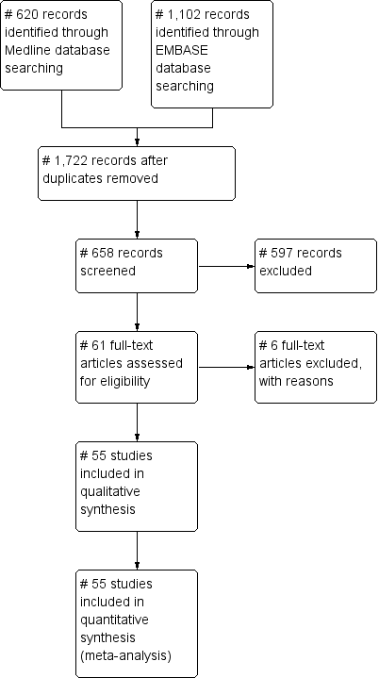

Figure 2S – Risk of bias graph: review authors' judgements about each risk of bias item presented as percentages across all included studies.

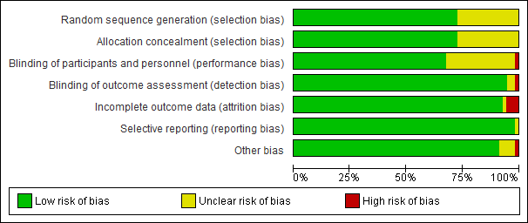

Figure 3S – Risk of bias summary: review authors' judgements about each risk of bias item for each included study.

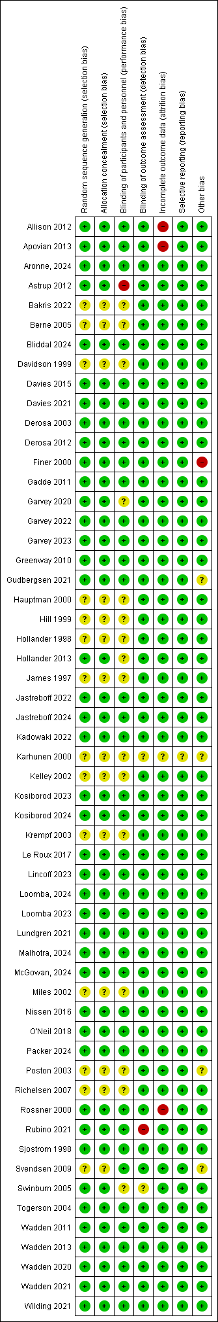

Figure 4S – Funnel plot for TBWL% at the endpoint.

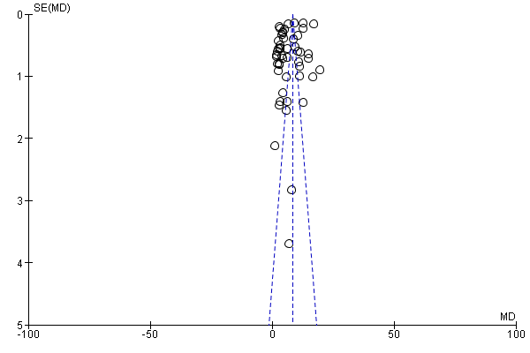

Figure 5S – Effects of available OMM on TBWL% at 105-156 weeks.

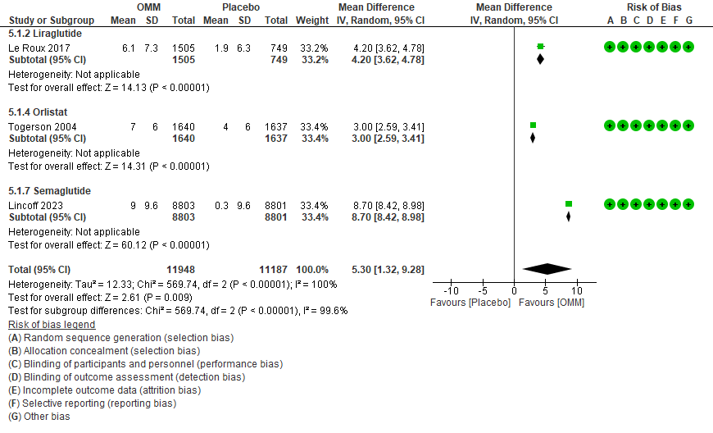

Figure 6S – Network plots for trials reporting information on endpoint waist circumference (Panel A) and BMI (Panel B).
A
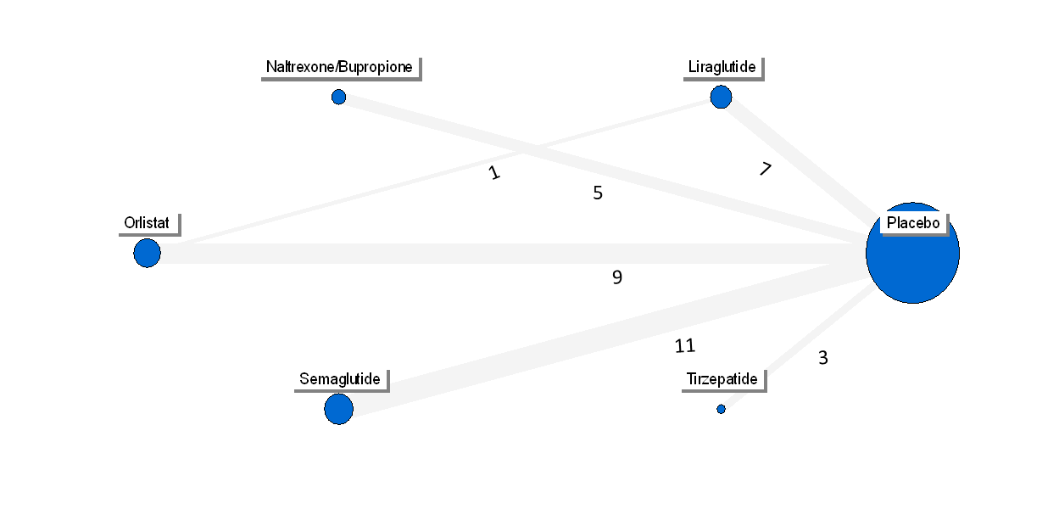
B
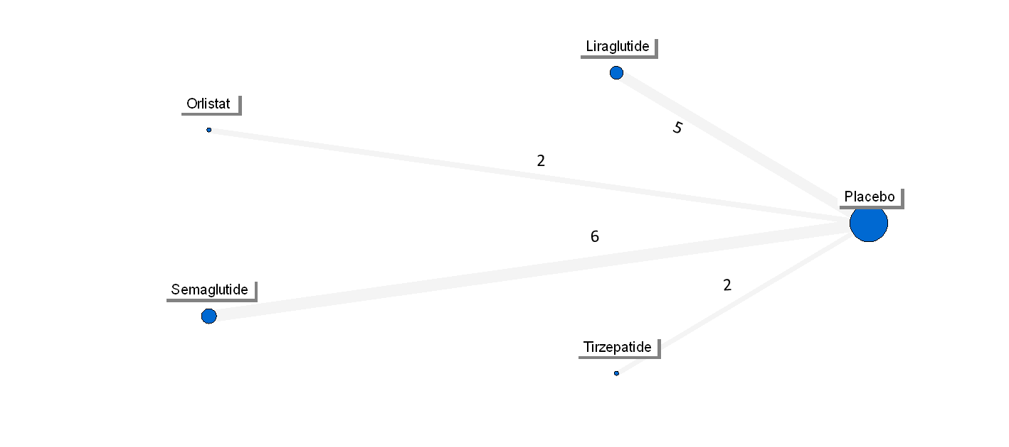

Figure 7S – Network forest plots showing the effects of each OMM on the reduction (differences from baseline to the endpoint) of waist circumference (Panel A) and BMI (Panel B).
A

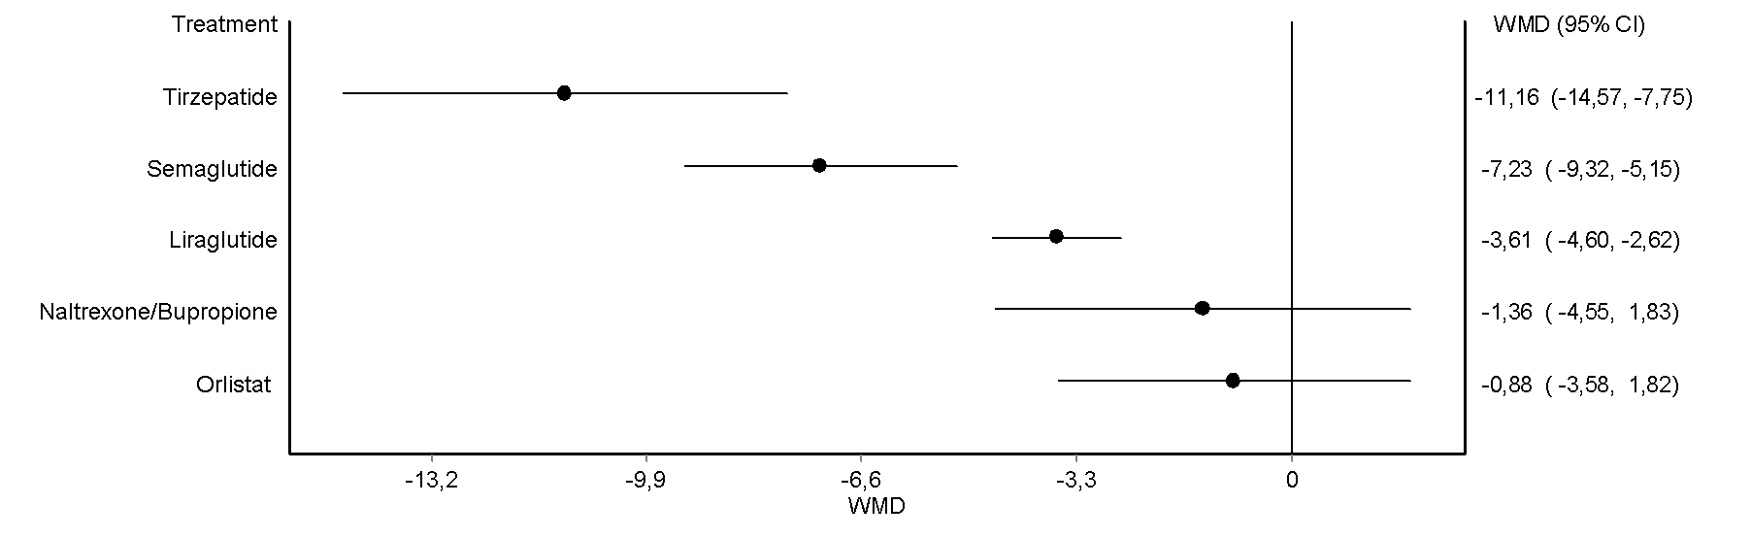

B

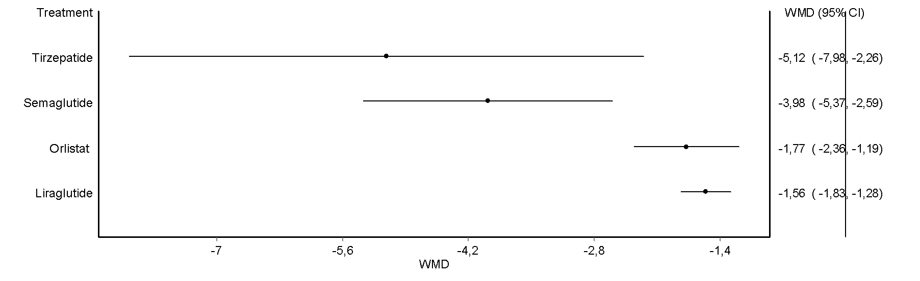

Figure 8S – Network plots for trials reporting information on the proportion of subjects achieving a body weight reduction of at least 5% (Panel A), 10% (Panel B), 15% (Panel C), 20% (Panel D), and 25% (n= 2 RCTs with tirzepatide^{1,2}).
A
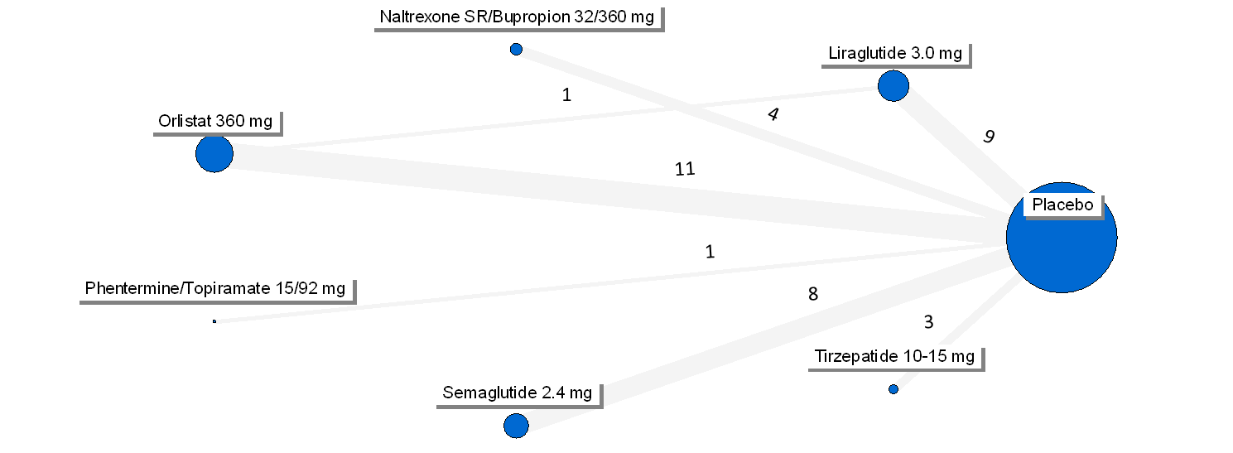

B
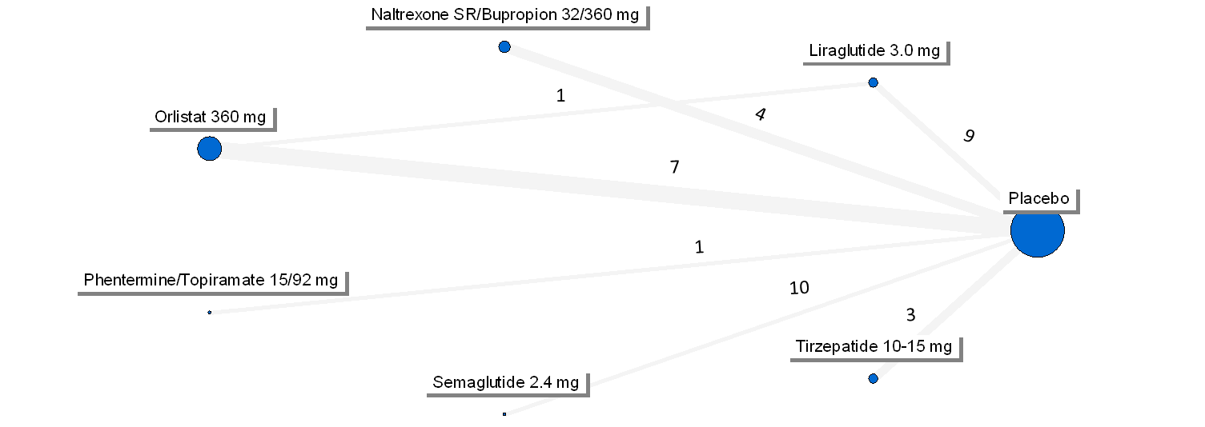

C
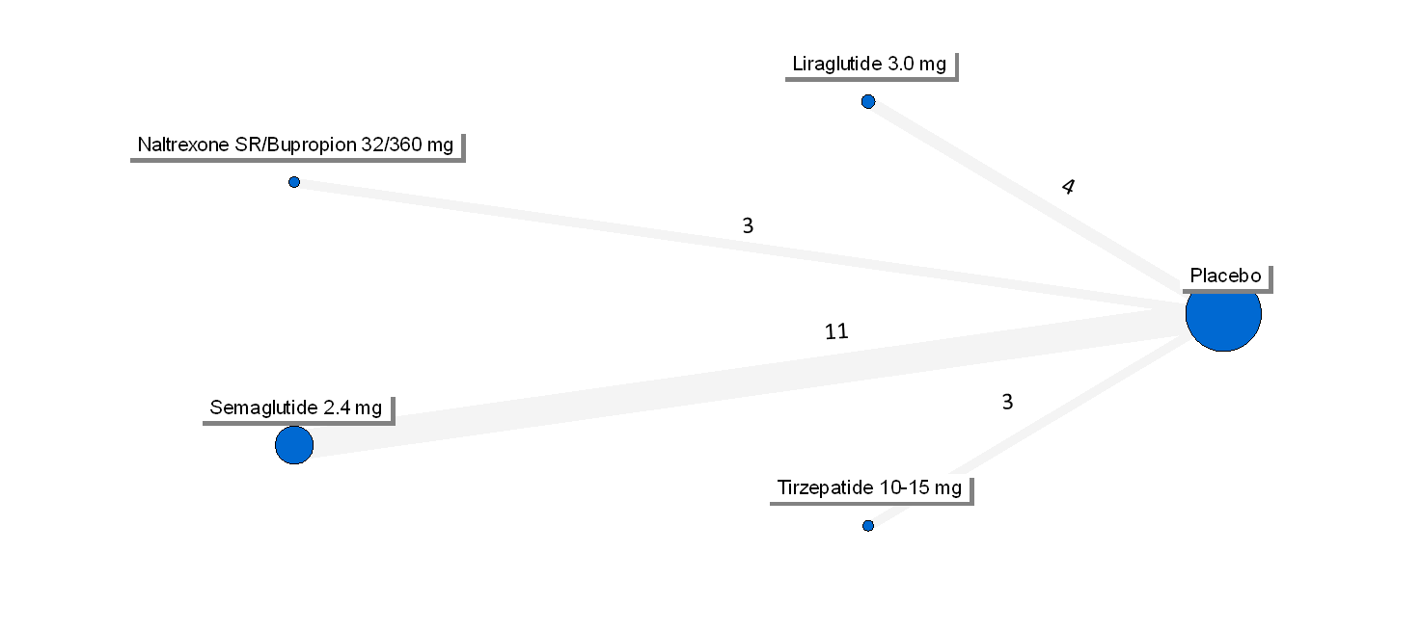

D
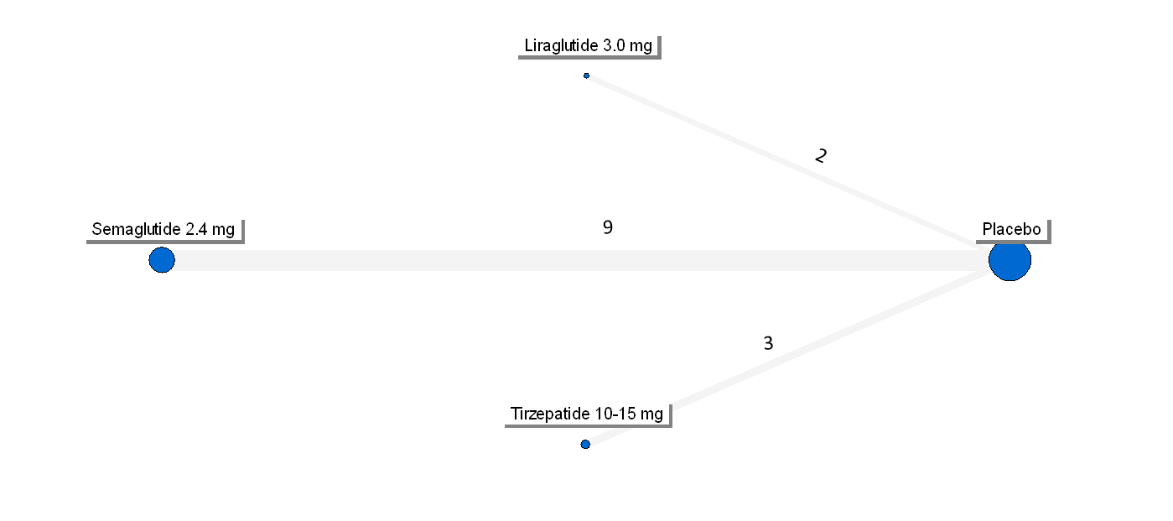

Figure 9S – Network forest plots for trials reporting information on the proportion of subjects achieving a body weight reduction of at least 5% (Panel A), 10% (Panel B), 15% (Panel C), 20% (Panel D), and 25% (Panel E).
A
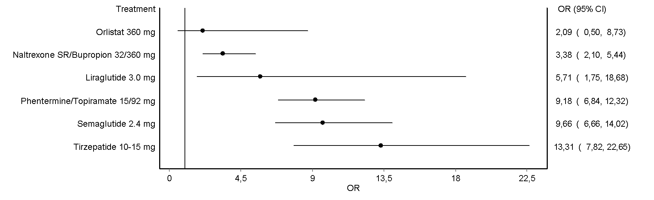
B

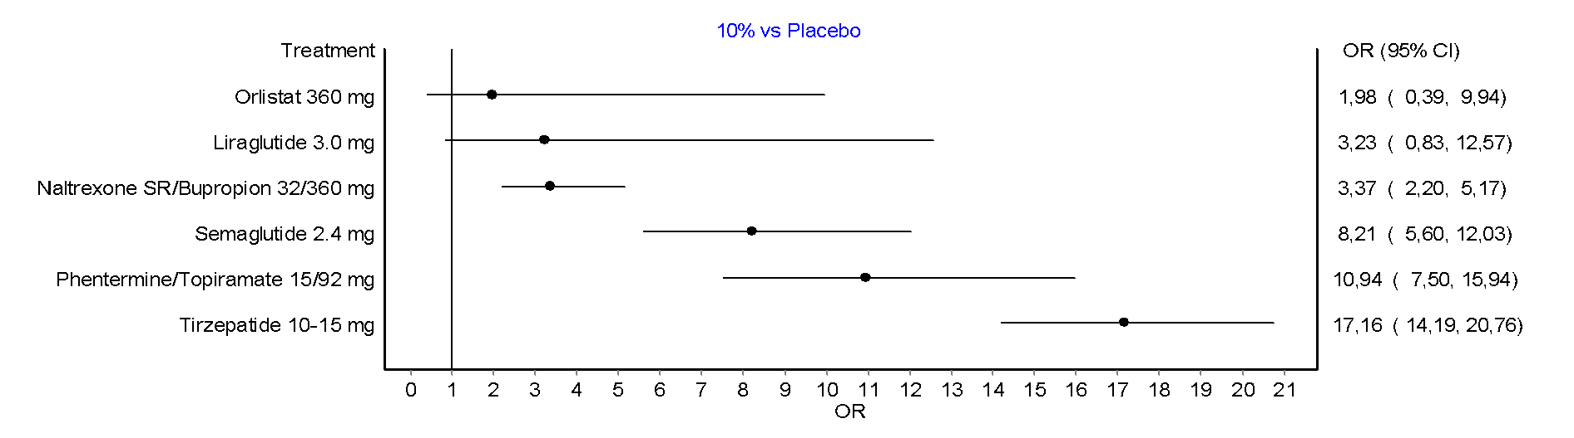
C
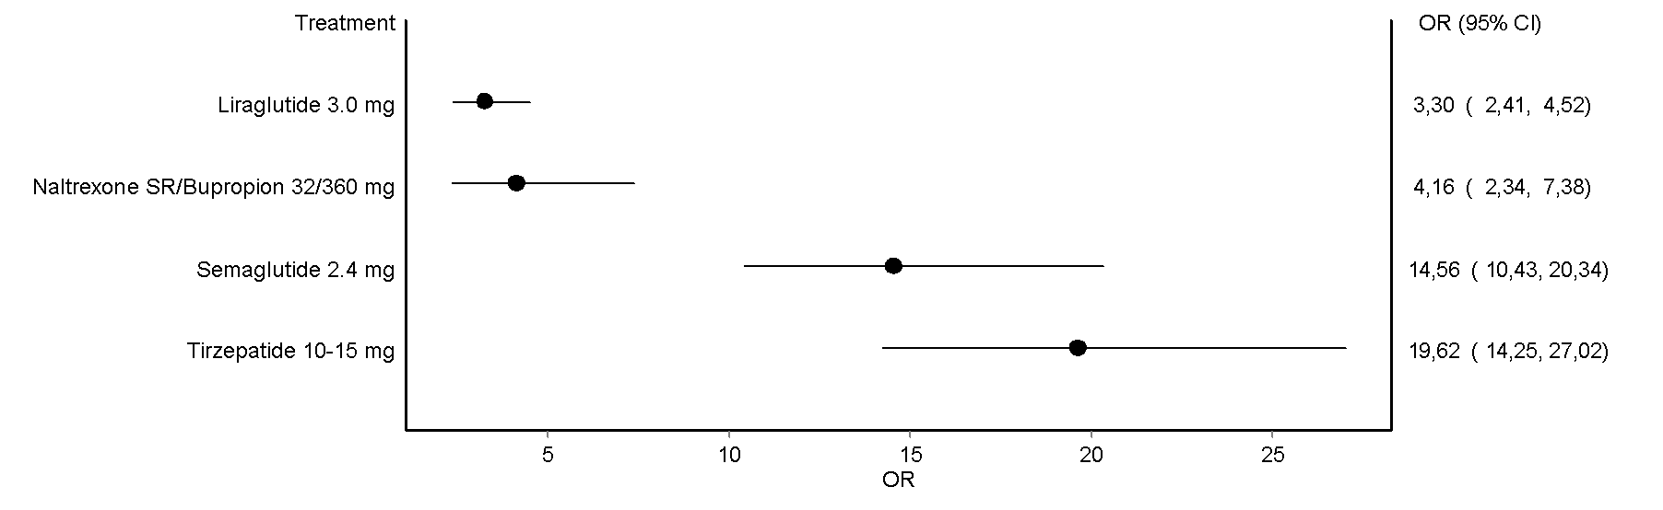

D
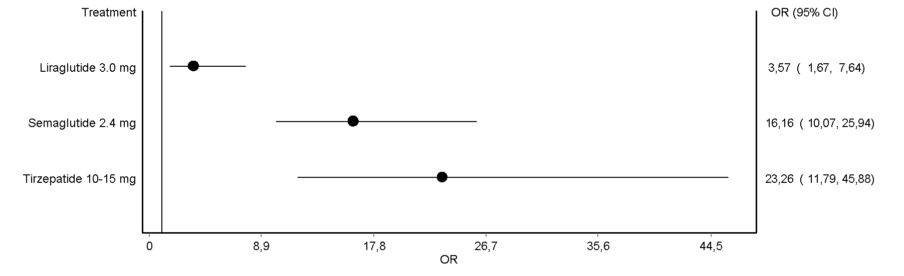

E
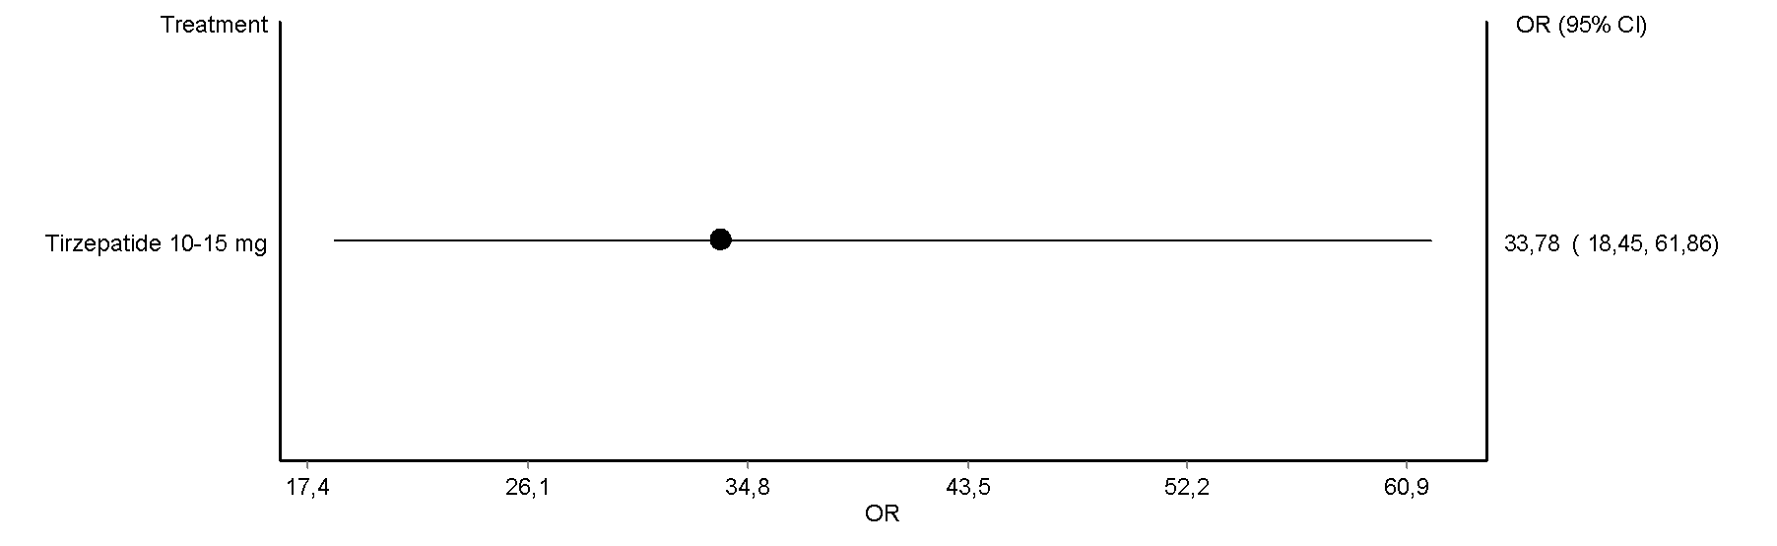

Figure 10S – Network plots for trials reporting information on TBWL% at the endpoint (Panel A), 52 weeks (Panel B), and 53-104 weeks (Panel C), endpoint waist circumference (Panel D), and endpoint BMI (Panel E) in RCTs specifically designed for body weight reduction.
A
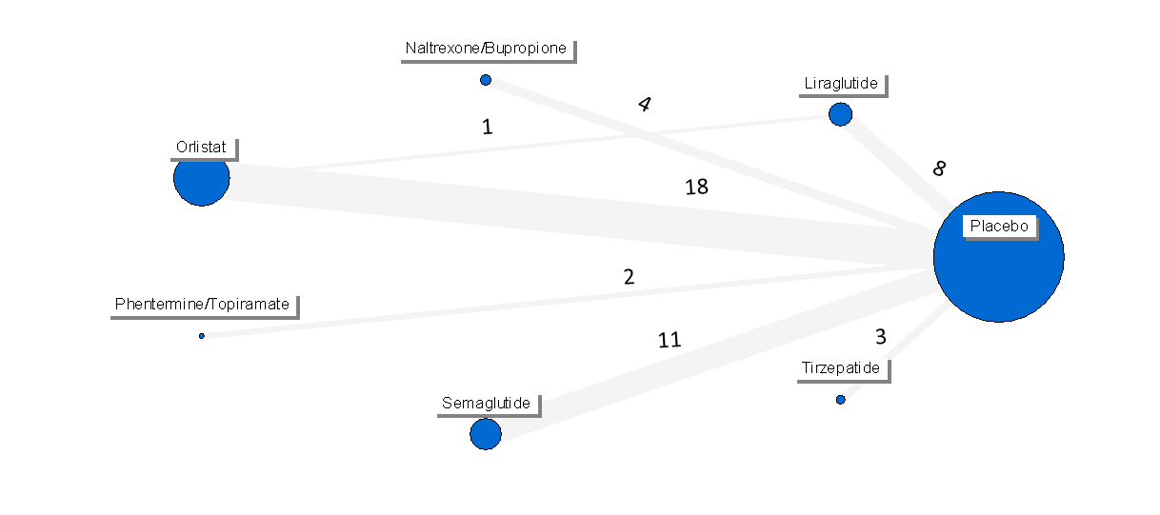
B
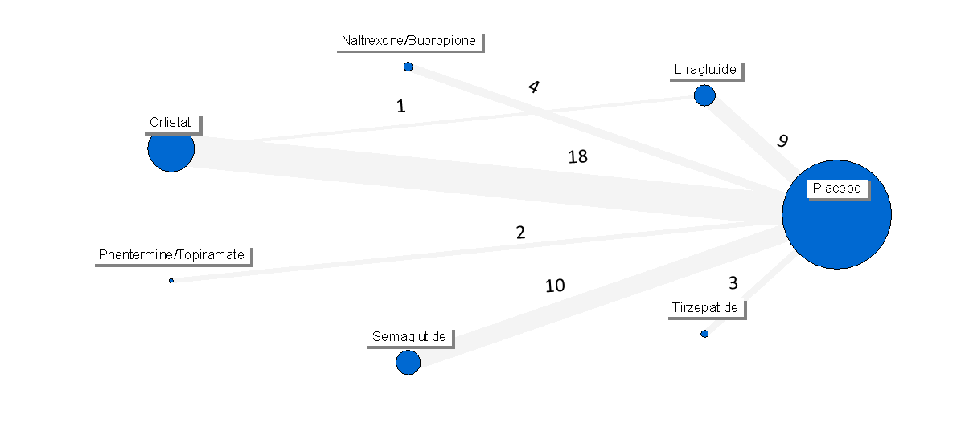
C
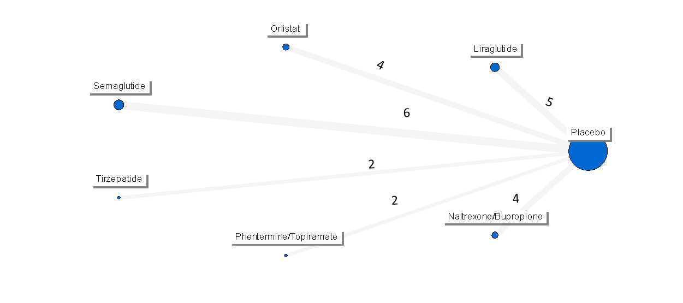
D
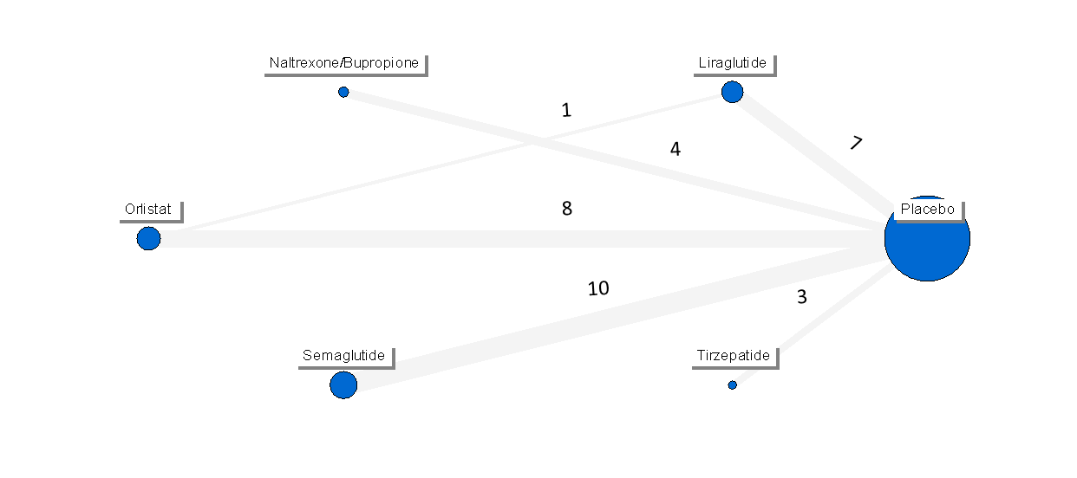

E
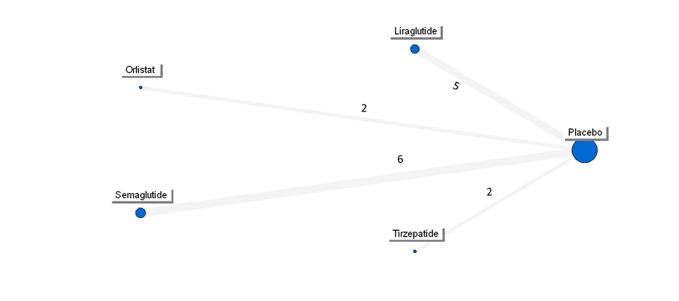

Figure 11S – Network forest plots showing the effects of each OMM on TBWL% at the endpoint (Panel A), 52 weeks (Panel B), and 53-104 weeks (Panel C), endpoint waist circumference (Panel D), and endpoint BMI (Panel E) in RCTs specifically designed for body weight reduction.
A
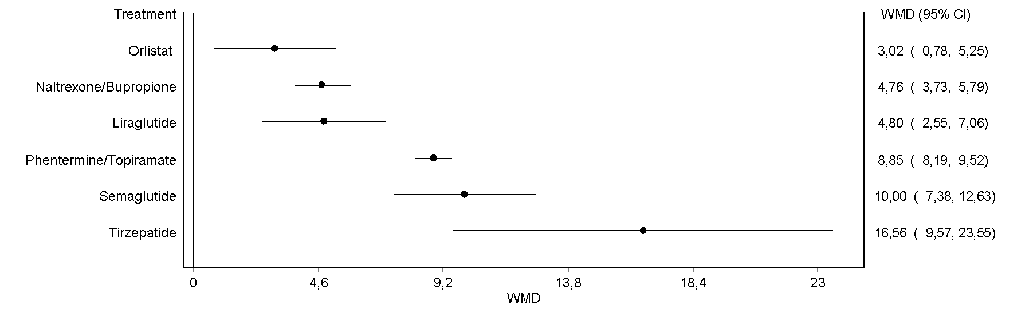
B
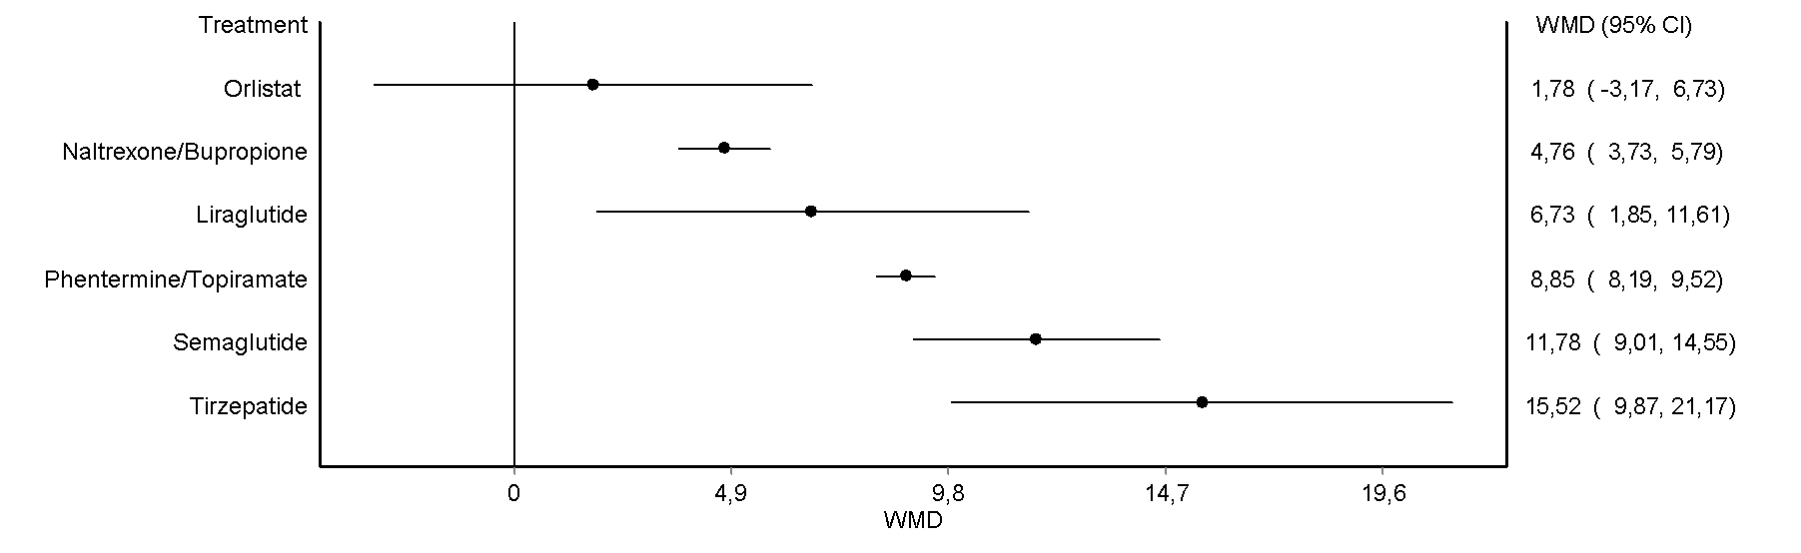
C
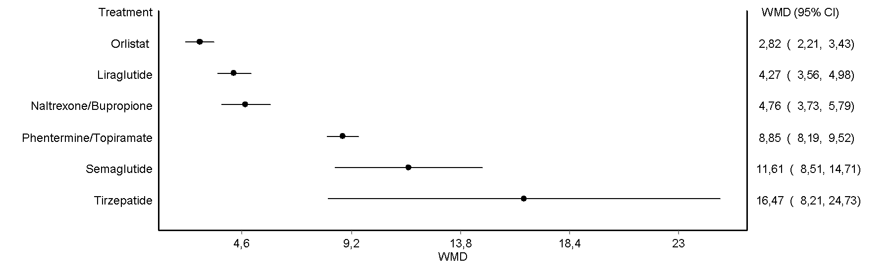
D
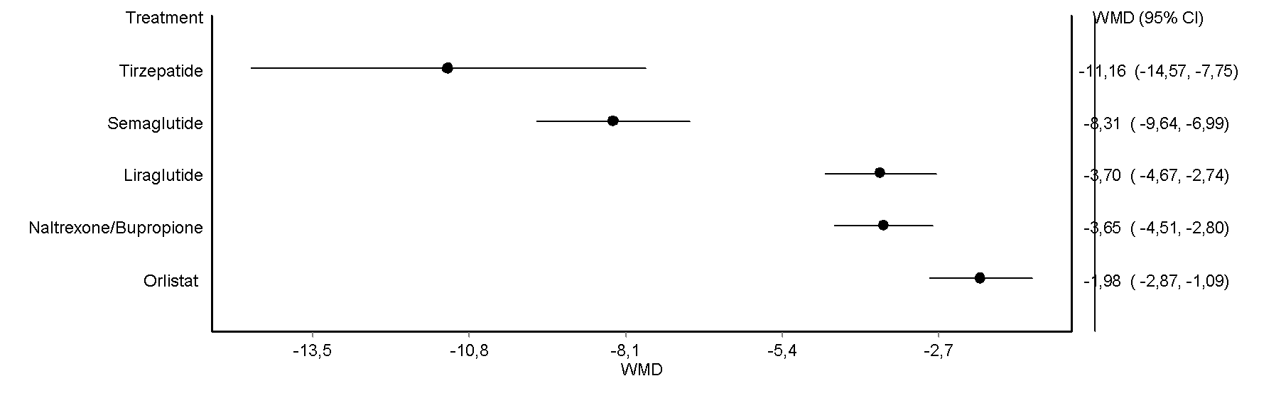
E
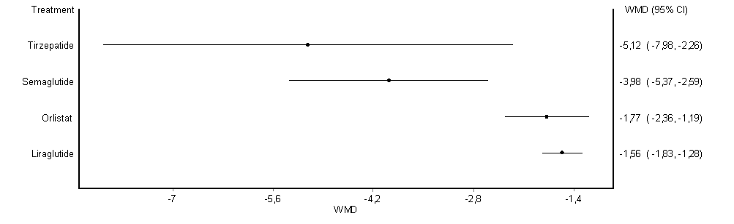

Figure 12S – Network plots for trials reporting information on the proportion of subjects achieving a body weight reduction of at least 5% (Panel A), 10% (Panel B), 15% (Panel C), 20% (Panel D), and 25% (n= 2 RCTs with tirzepatide^{1,2}) in RCTs specifically designed for body weight reduction. .
A

B

C

D

Figure 13S – Network forest plots for trials reporting information on the proportion of subjects achieving a body weight reduction of at least 5% (Panel A), 10% (Panel B), 15% (Panel C), 20% (Panel D), and 25% (Panel E) in RCTs specifically designed for body weight reduction. .
A
B

C

D

E

Figure 14S – Network plots for trials reporting information on HbA1c (Panel A) and FPG (Panel B).

A

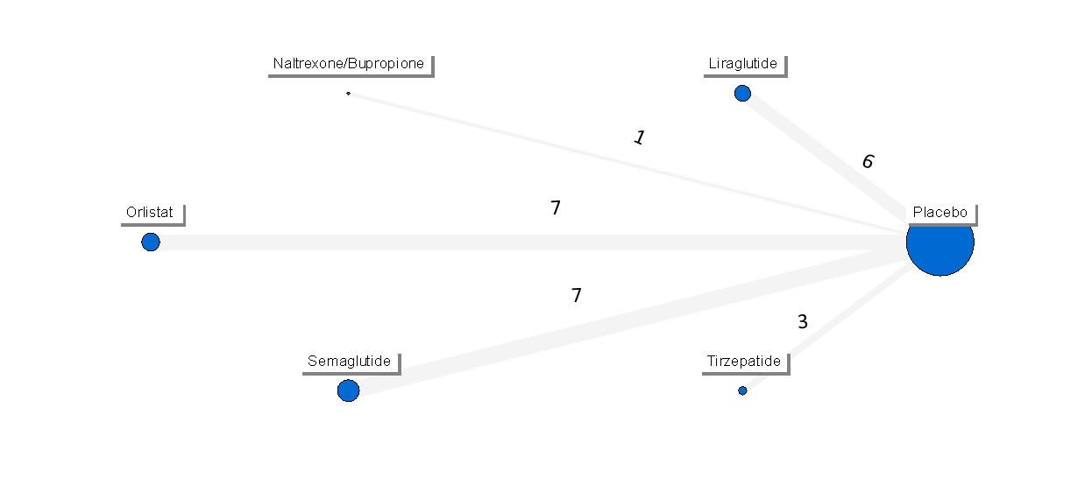
B
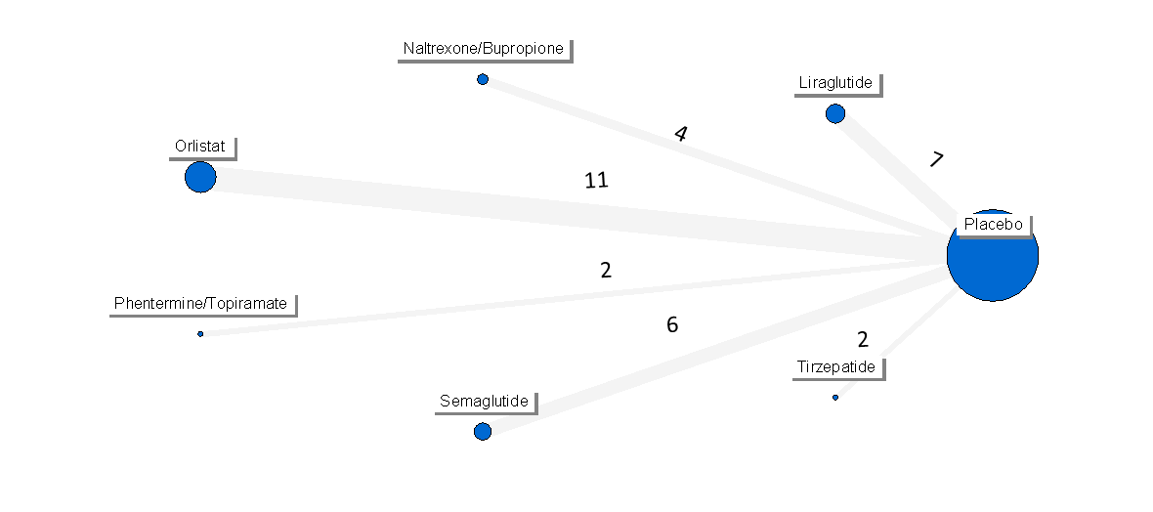

Figure 15S – Network forest plots for trials reporting information on HbA1c (Panel A) and FPG (Panel B).

A

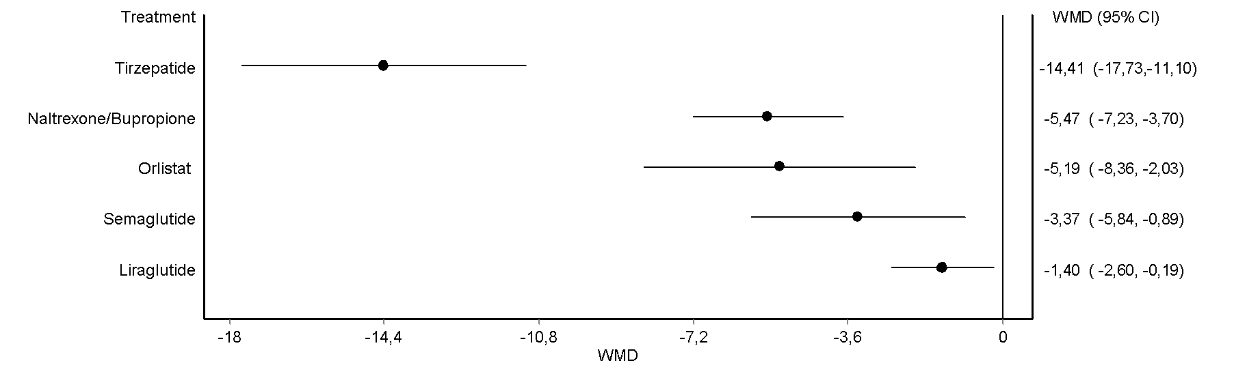
B

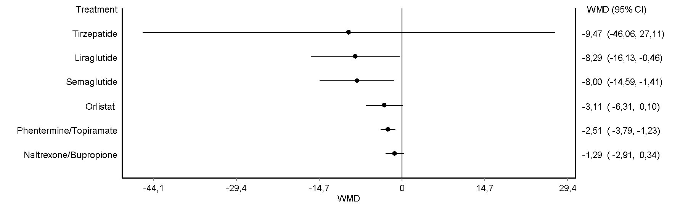

Figure 16S – Effects of OMM on complete diabetes remission rate.

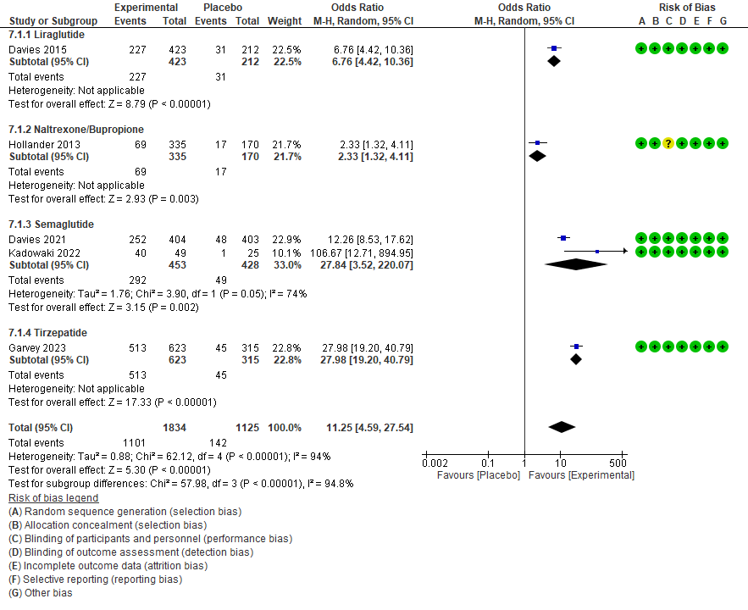

Figure 17S – Effects of OMM on partial diabetes remission rate.

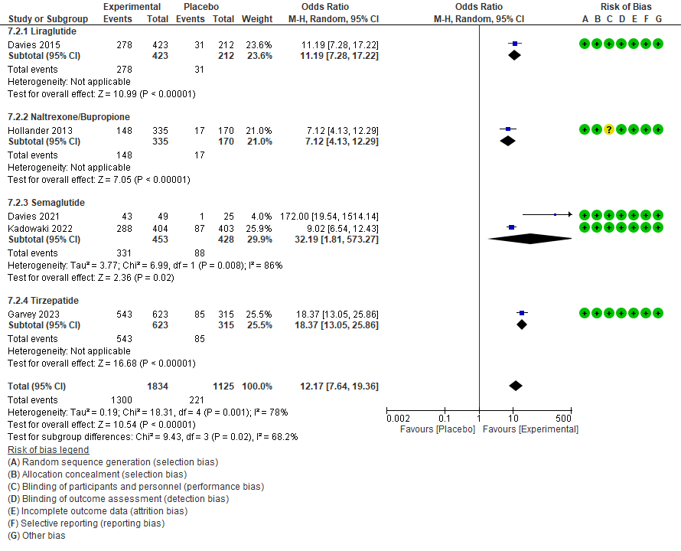

Figure 18S – Network plots for trials reporting information on total cholesterol (Panel A), HDL-cholesterol (Panel B), and triglycerides (Panel C).

A

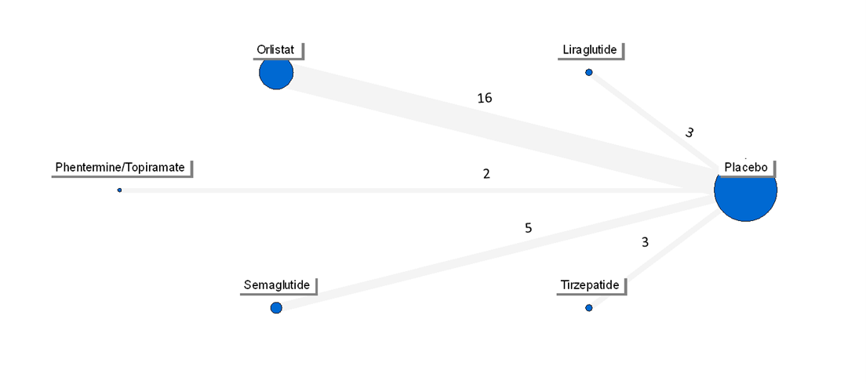
B
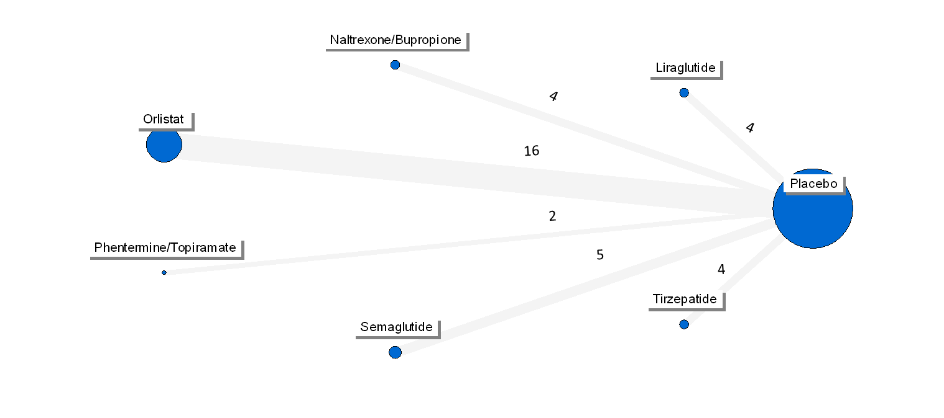
C

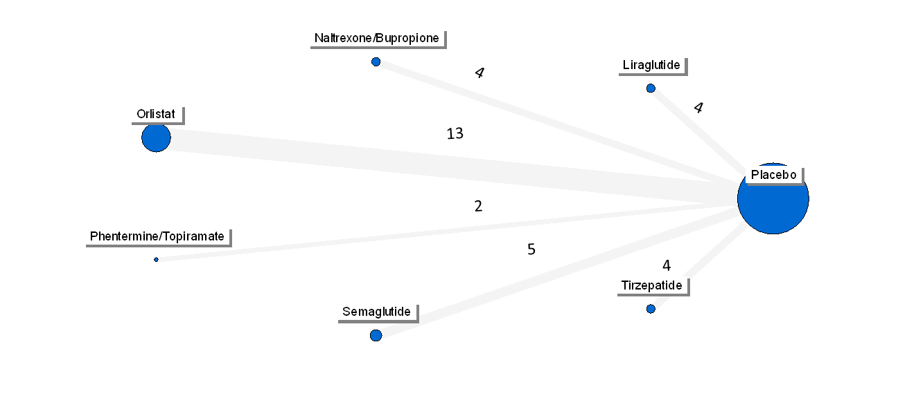

Figure 19S – Network forest plots for trials reporting information on total cholesterol (Panel A), HDL-cholesterol (Panel B), and triglycerides (Panel C).

A
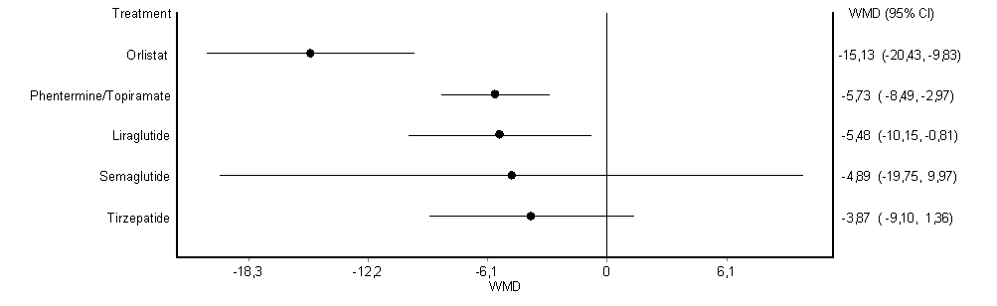

B

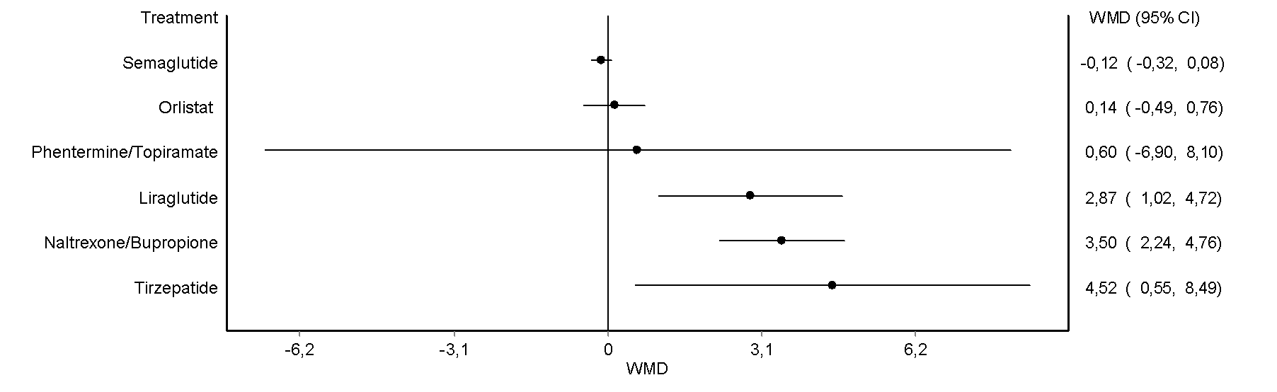

C
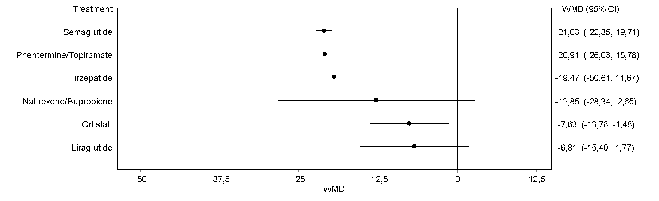

Figure 20S – Network plots for trials reporting information on systolic blood pressure (Panel A) and diastolic blood pressure (Panel B).

A

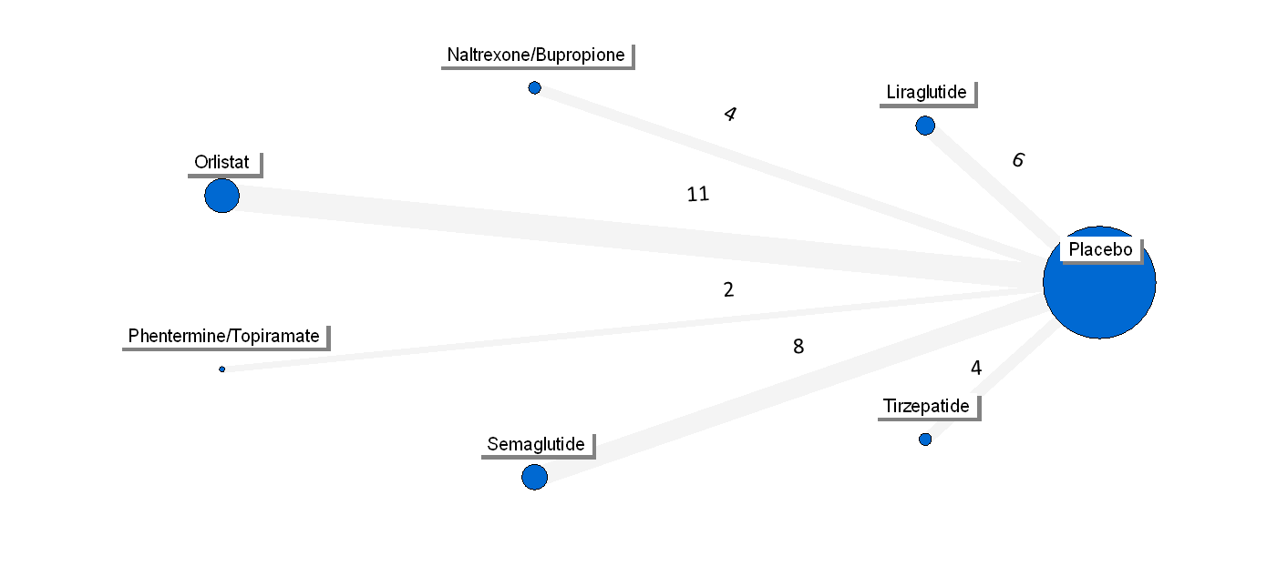

B

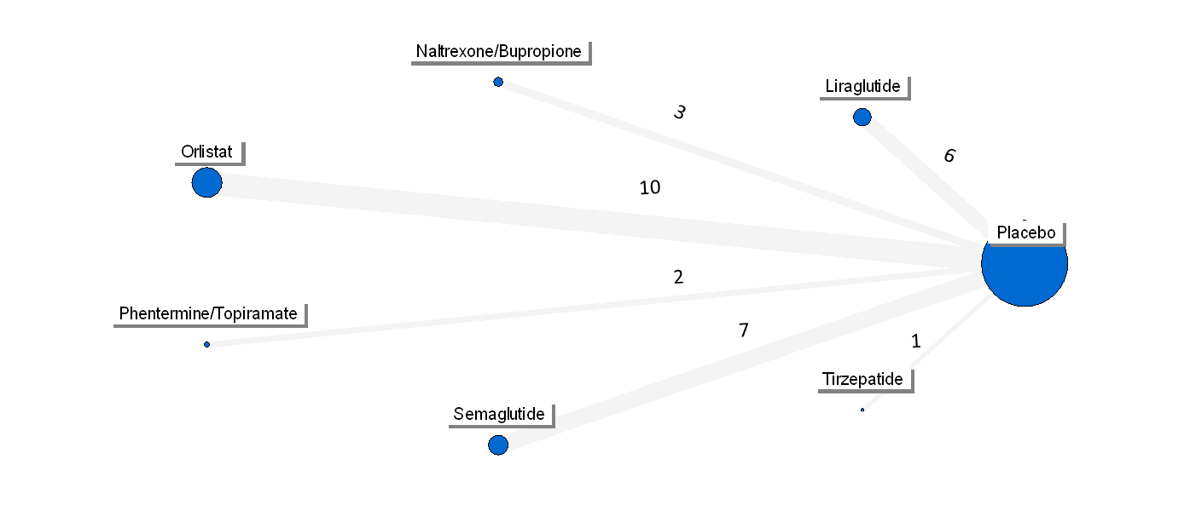

Figure 21S – Network forest plots for trials reporting information on systolic blood pressure (Panel A) and diastolic blood pressure (Panel B).

A

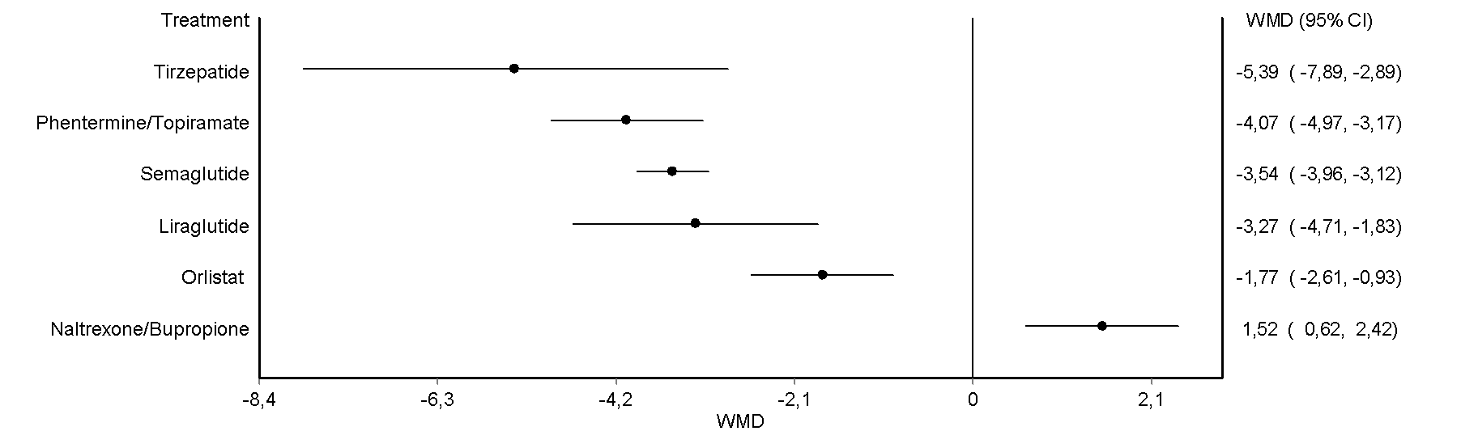

B

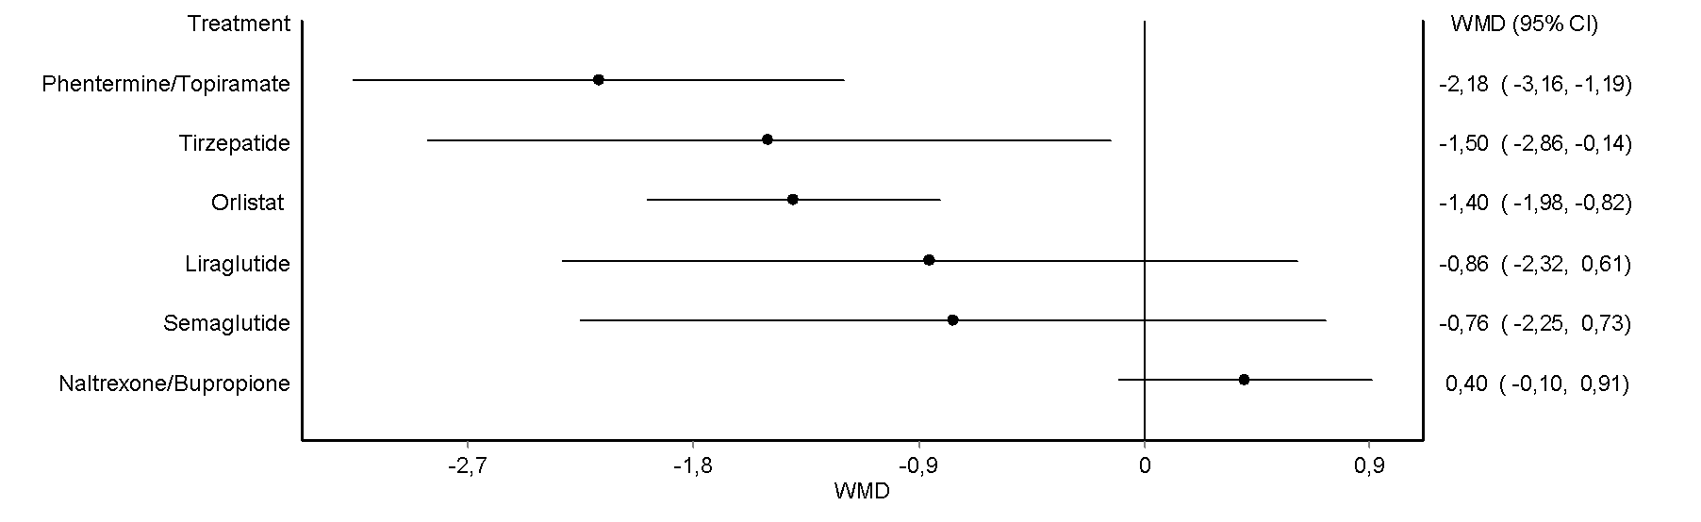

Figure 22S – Effects of OMM on hypertension remission rate.

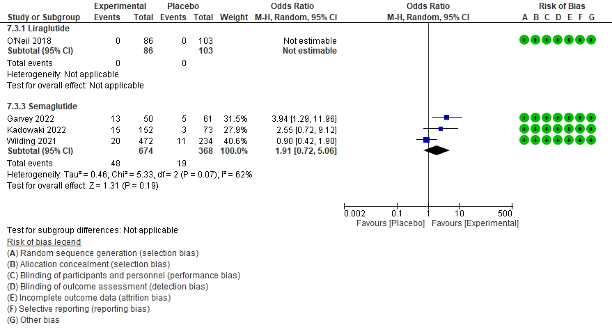

Figure 23S – Effects of OMM on dyslipidemia remission rate.

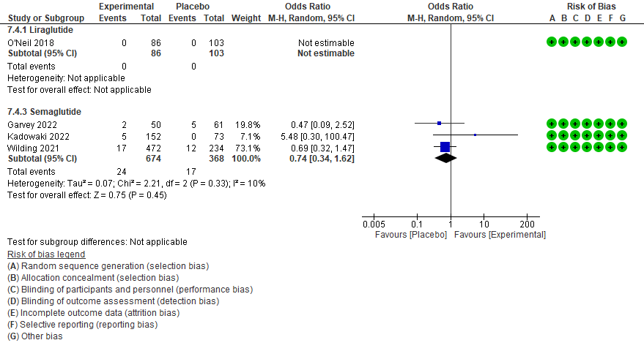

Figure 24S – Effects of OMM on MASLD resolution.

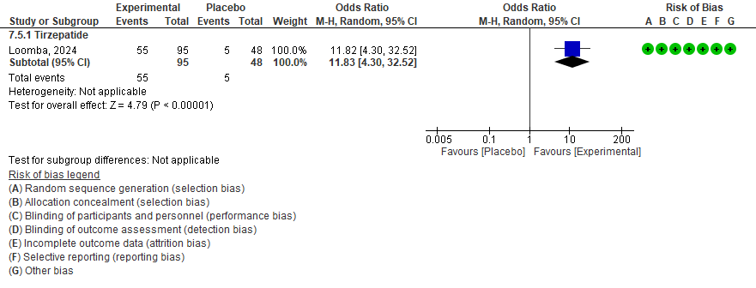

Figure 25S – Effects of OMM on the risk of incident diabetes.

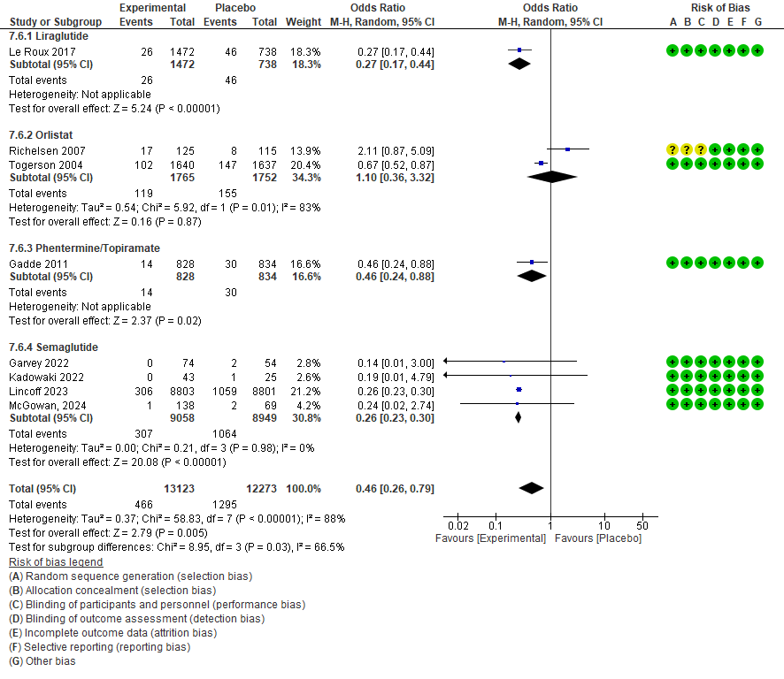

For SELECT trial³ data were retrieved for a subsequent publication⁴.

Figure 26S – Effects of OMM on restoring normoglycemia in placebo- (Panel A) and active- (Panel B) controlled trials.

A
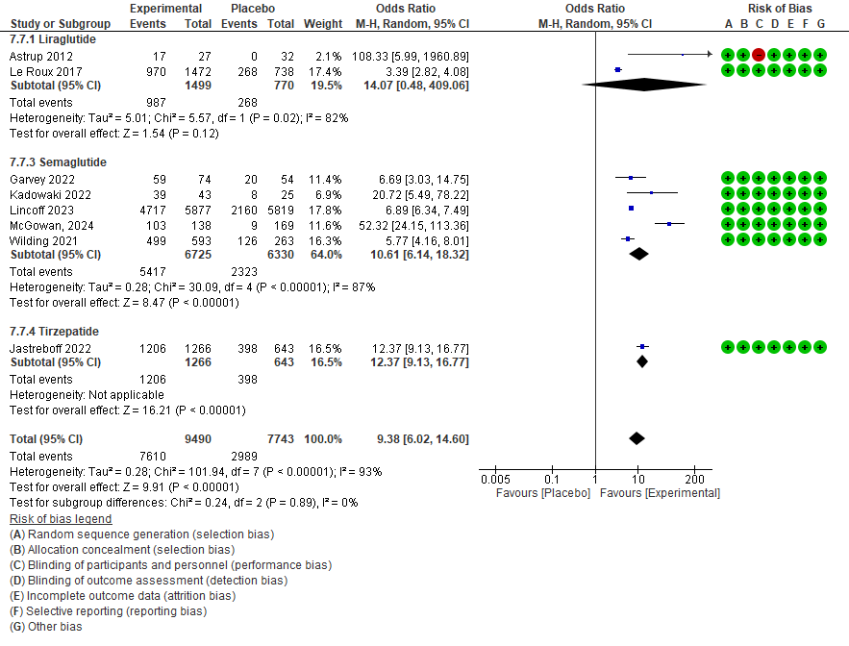
B

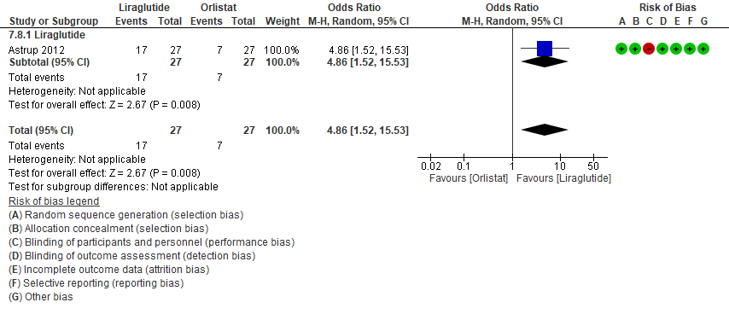

Figure 27S – Network plots for trials reporting information on all-cause mortality (Panel A), MACE (Panel B), and cardiovascular mortality (Panel C).

A
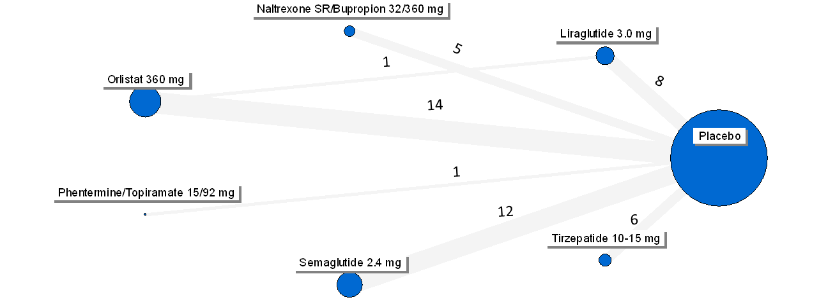

B

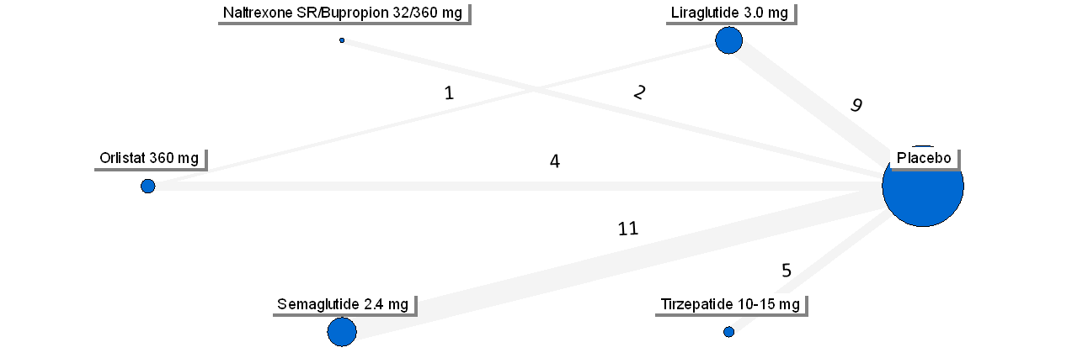

C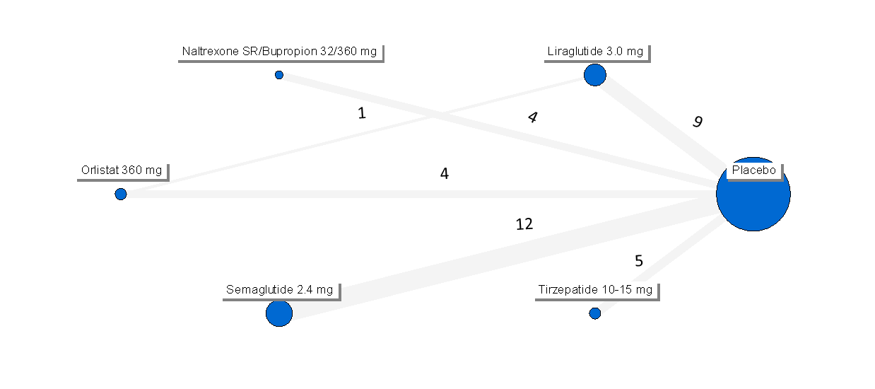

Figure 28S – Network forest plots for trials reporting information on all-cause mortality (Panel A), MACE (Panel B), and cardiovascular mortality (Panel C).
A
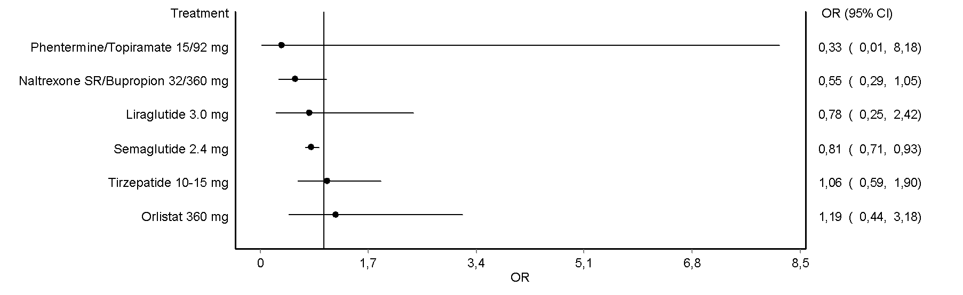
B
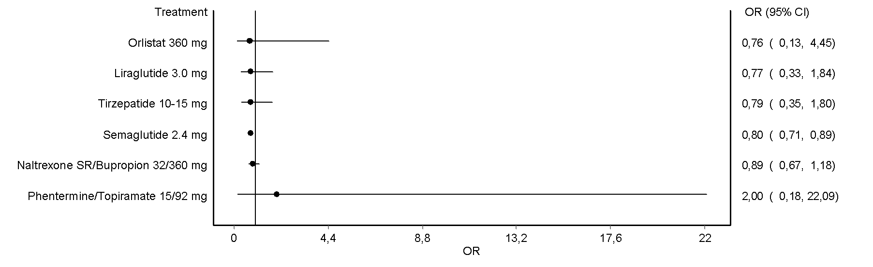
C

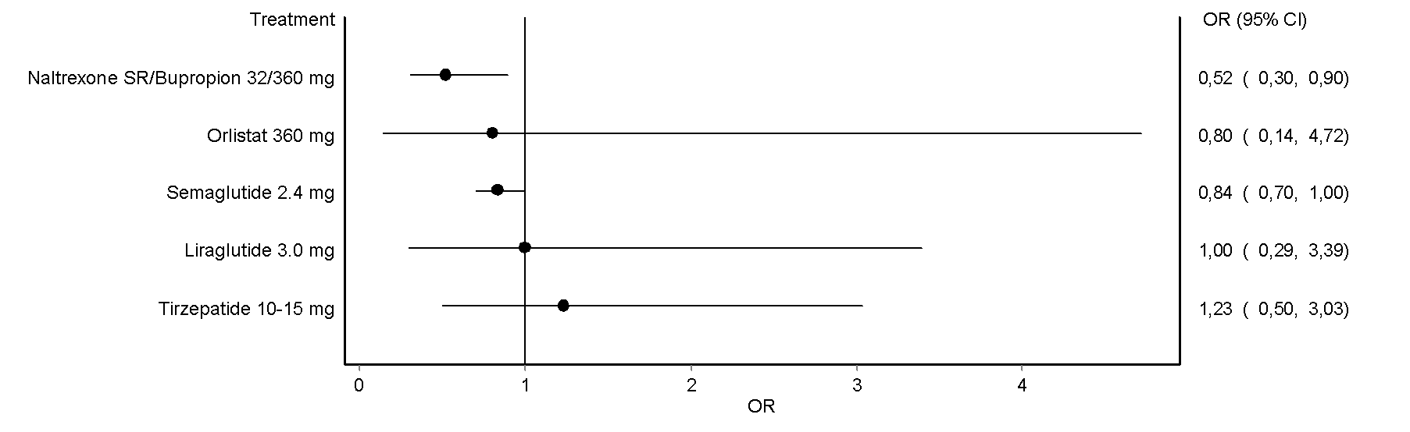

Figure 29S – Effects of OMM on the risk of heart failure hospitalization.

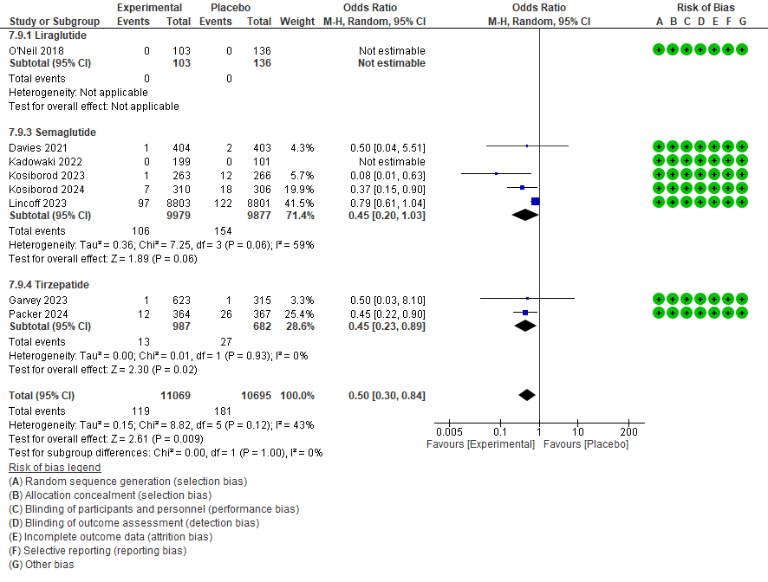

Figure 30S – Effects of OMM on quality of life (Panel A: The Impact of Weight on Quality of Life-Lite; Panel B: Short-Form General Health; Panel C: Short-Form-36 Physical Functioning; Panel D: Short-Form-36 Physical Component).

A

Placebo-controlled trials

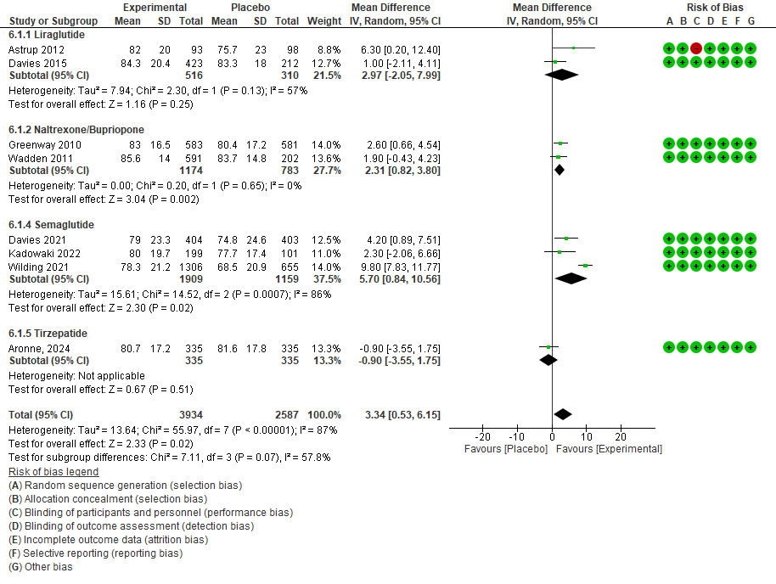

Active-controlled RCT

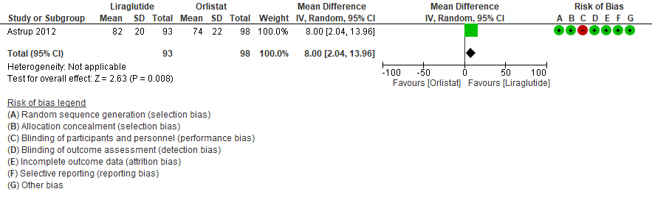

B Short-Form General Health

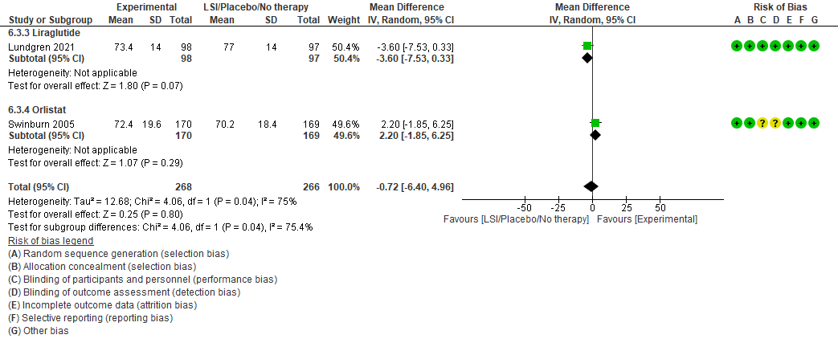

C Short-Form-36 Physical Functioning

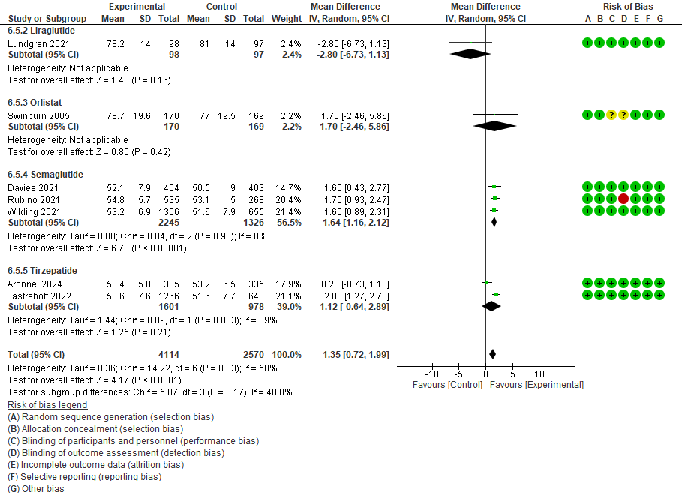

D Short-Form-36 Physical Component

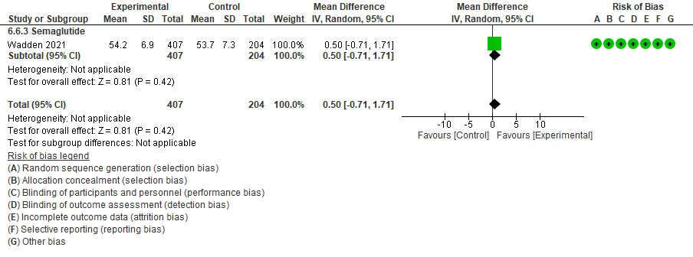

Figure 31S – Network plots for trials reporting information on serious adverse events (Panel A), treatment discontinuation (Panel B), suicide attempt (Panel C), and major depression (Panel D).
A

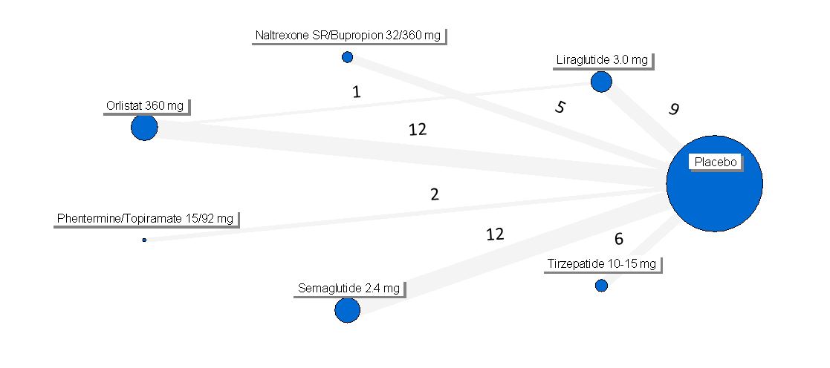
B

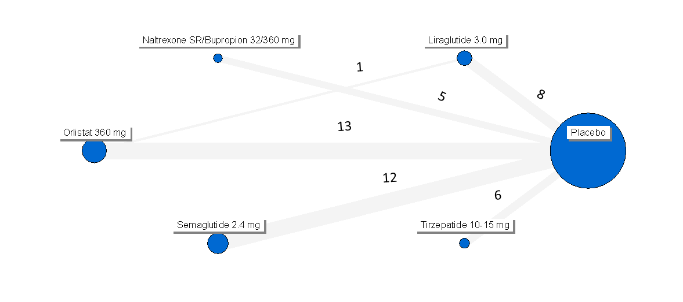
C
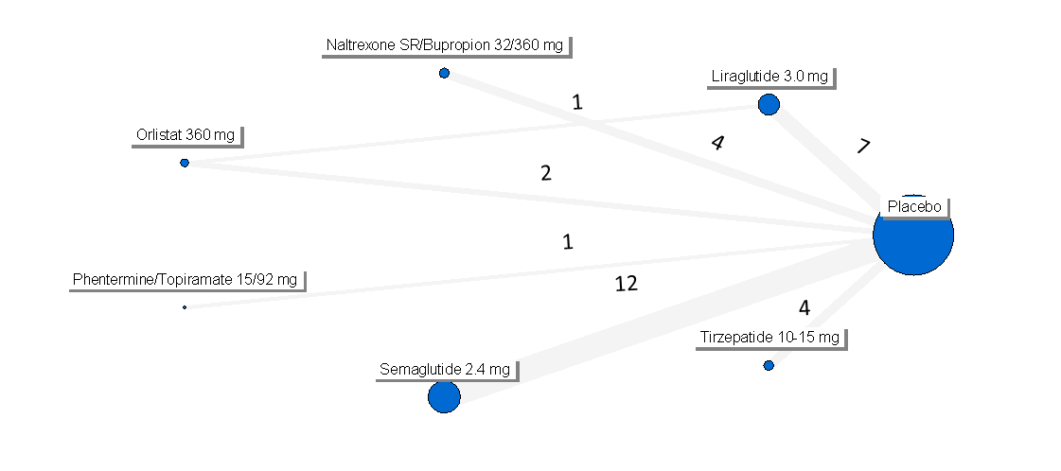
D
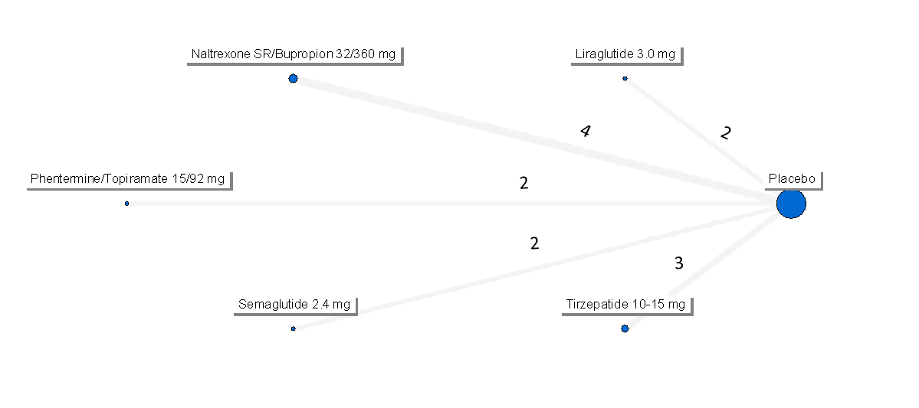

Figure 32S – Network forest plots for trials reporting information on serious adverse events (Panel A), treatment discontinuation (Panel B), suicide attempt (Panel C), and major depression (Panel D).
A

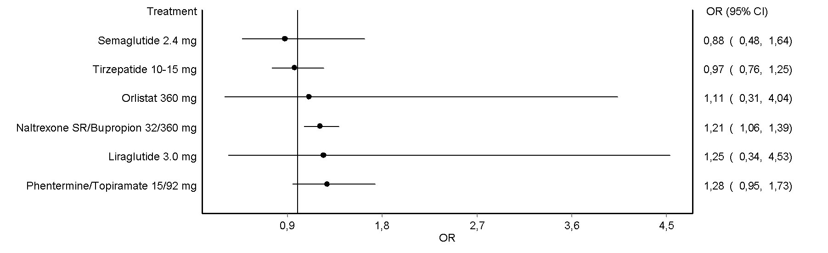
B

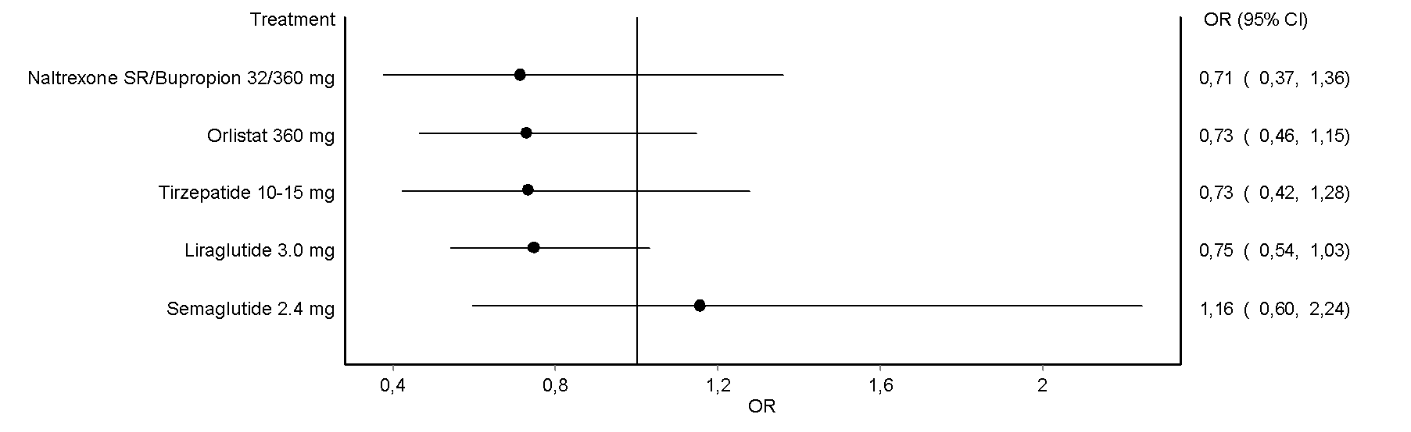
C
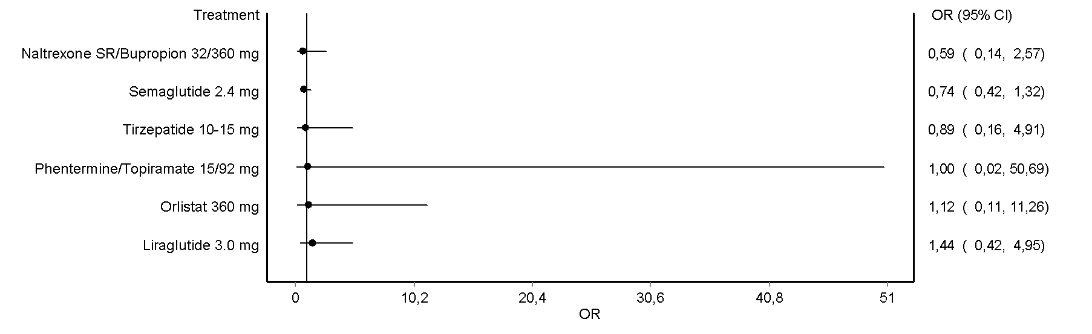
D
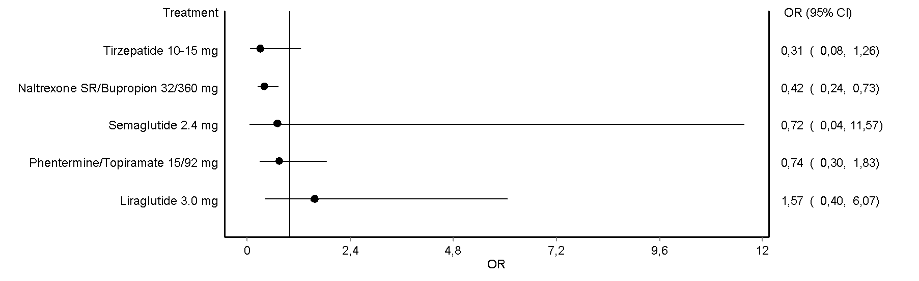

Figure 33S – Effects of OMM on the risk of incident anxiety.

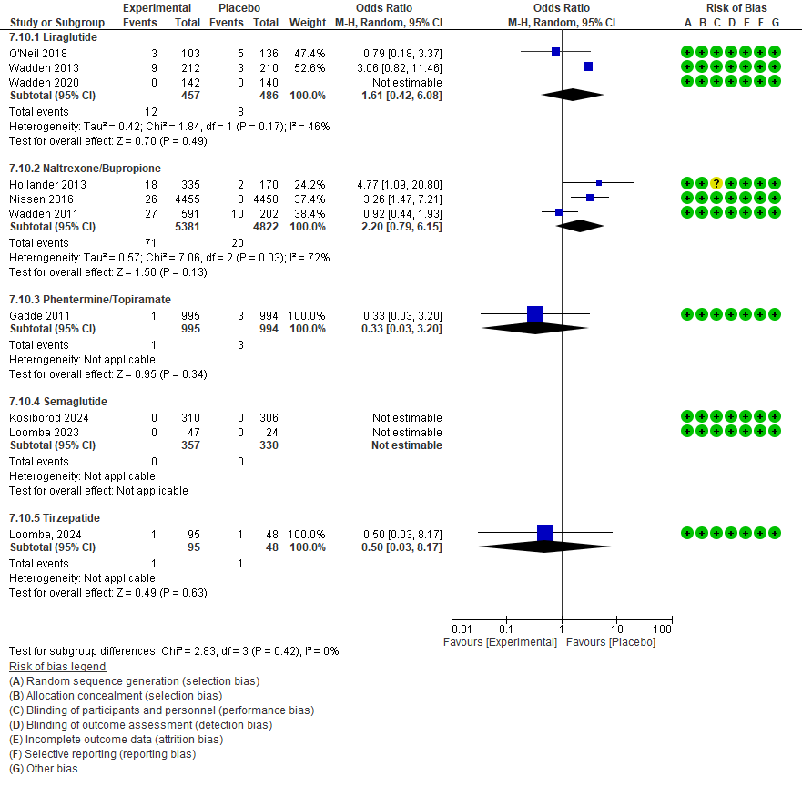

Figure 34S – Effects of OMM on WOMAC pain score (Panel A) and physical function (Panel B) score.

A

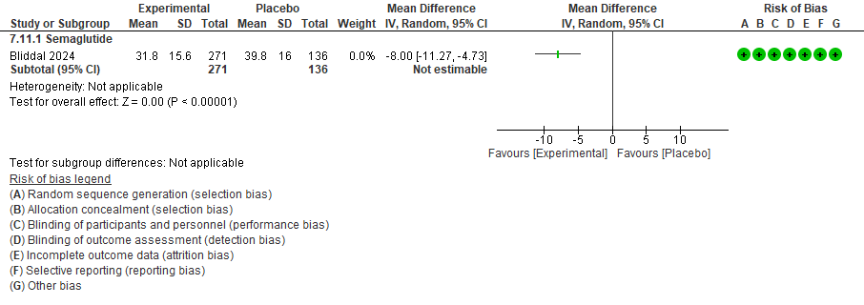

B

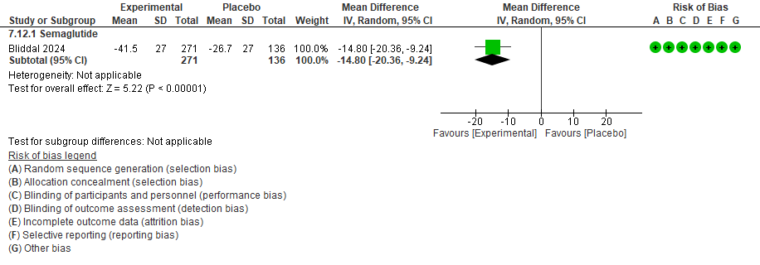

Figure 35S – Effects of OMM on TBWL% (Panel A), incident MACE (Panel B), acute myocardial infarction (Panel C), stroke (Panel D), cardiovascular mortality (Panel E) in RCTs performed on patients with established cardiovascular disease.
A
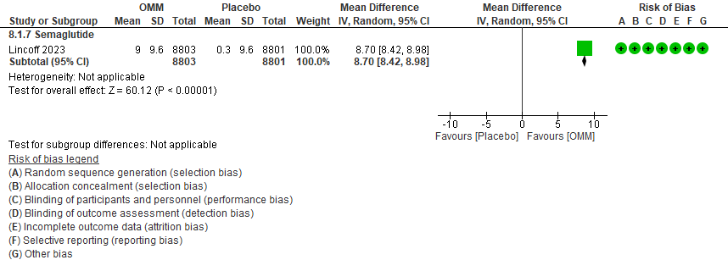
B
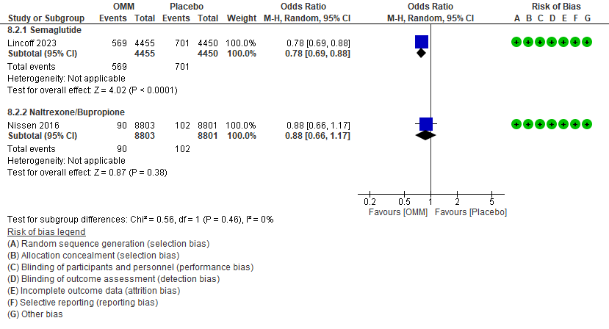
C
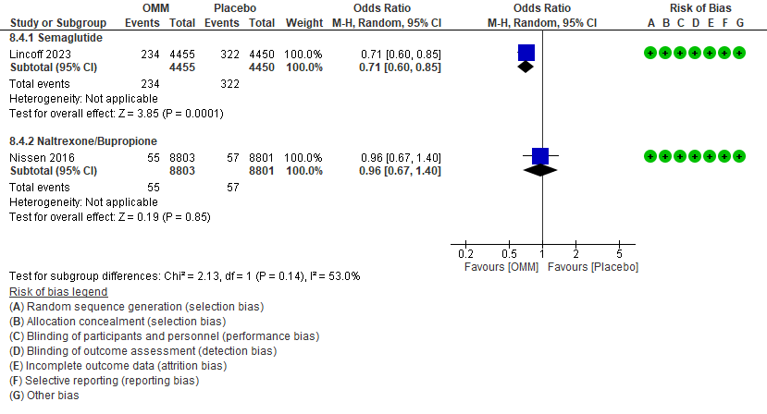
D
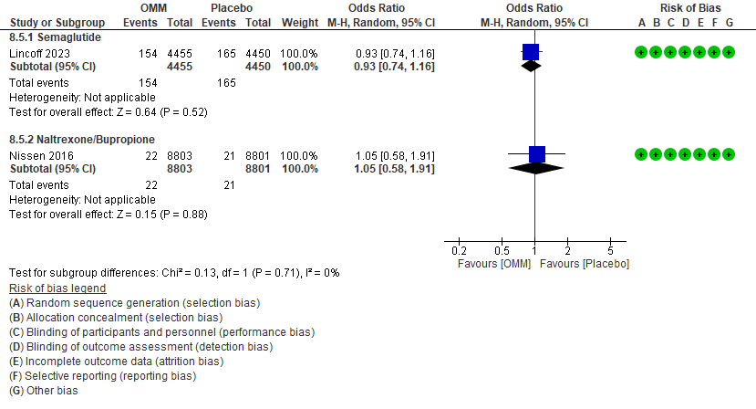
E
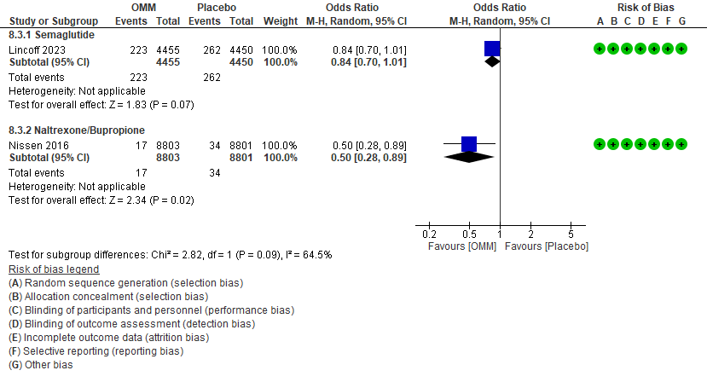
F
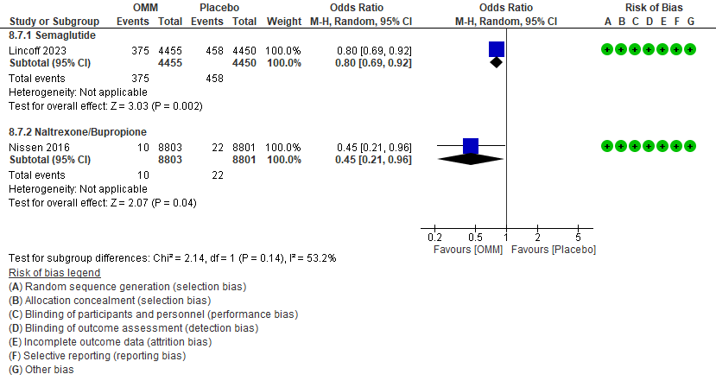

Figure 36S – Effects of OMM on TBWL% (Panel A), incident MACE (Panel B), cardiovascular mortality (Panel C), hospitalization for heart failure (Panel D), all-cause mortality (Panel E), change in Kansas City Cardiomyopathy Questionnaire clinical summary score (Panel F), change in 6-minute walking distance (Panel G) in RCTs performed on patients with previous heart failure.
A
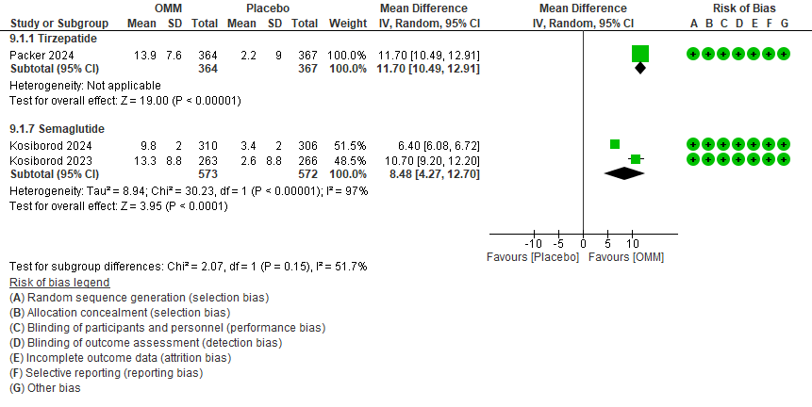
B
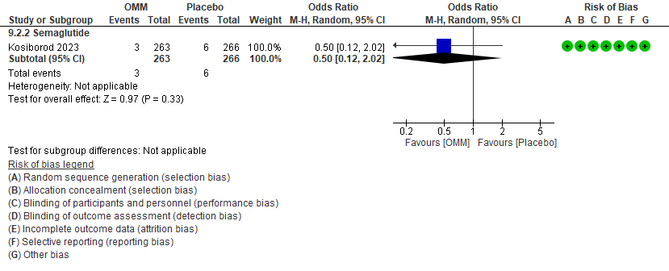
C
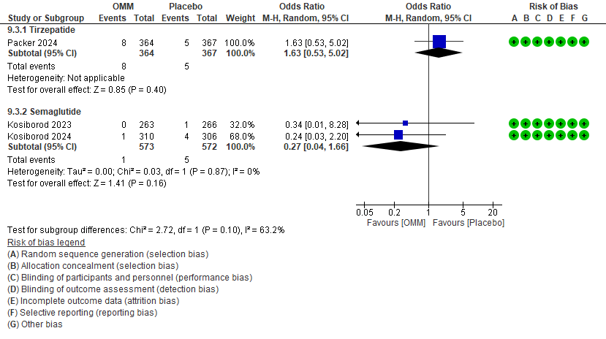

D
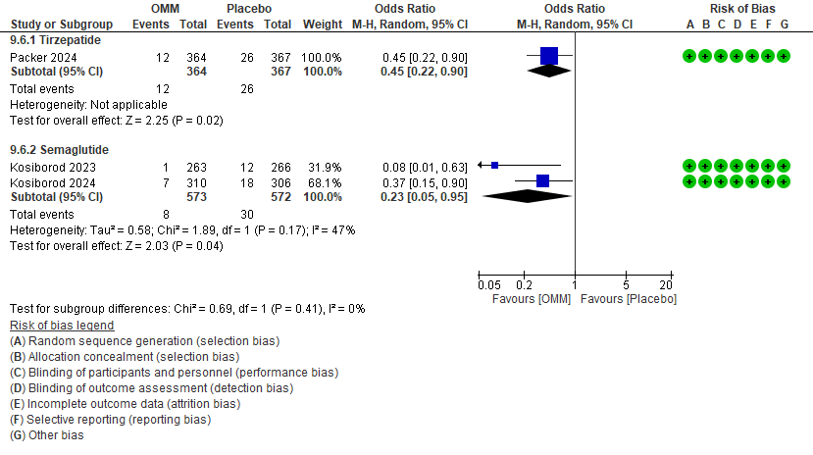
E
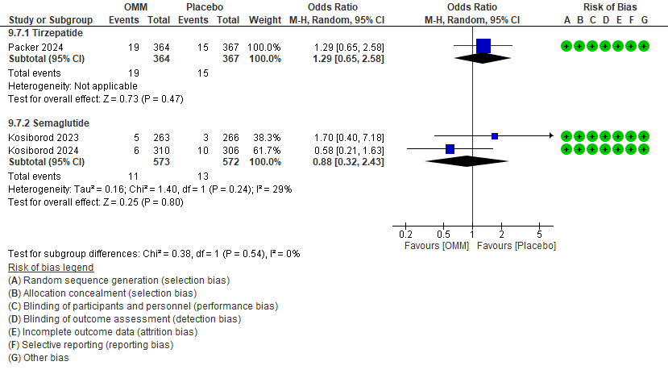
F
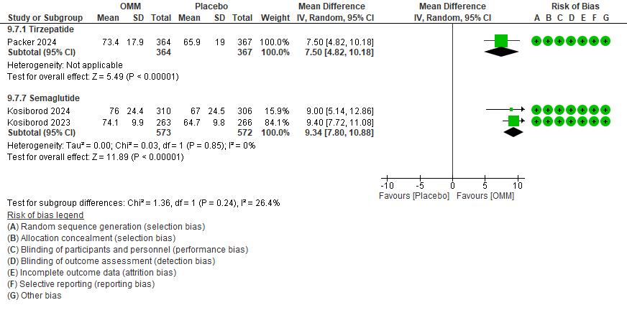
G
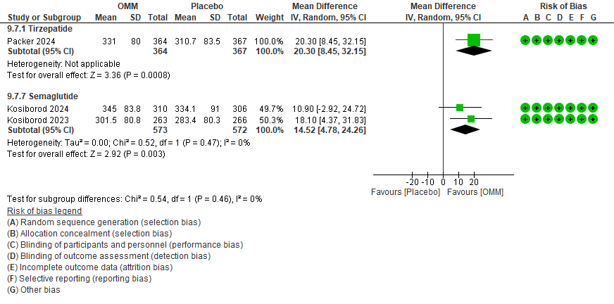

Figure 37S – Effects of OMM on TBWL% (Panel A), Hb1c (Panel B), FPG (Panel C), incident diabetes Panel D), and normoglycemia restoration (Panel E) in RCTs performed on patients with prediabetes.
A
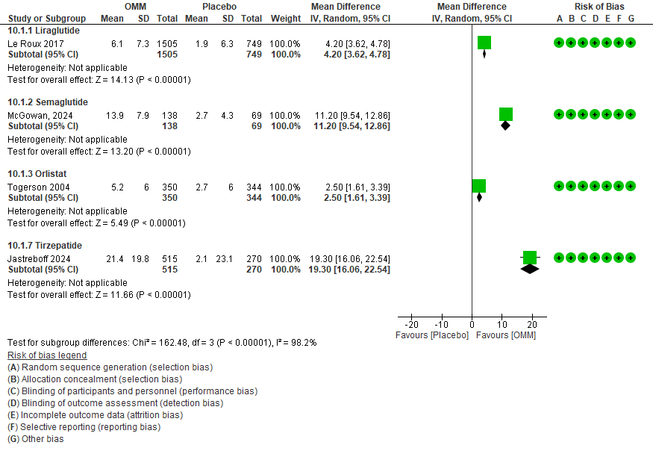
B
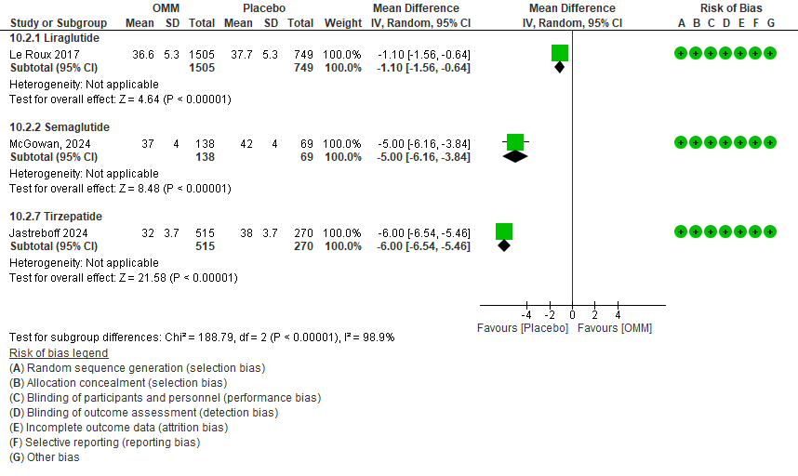
C
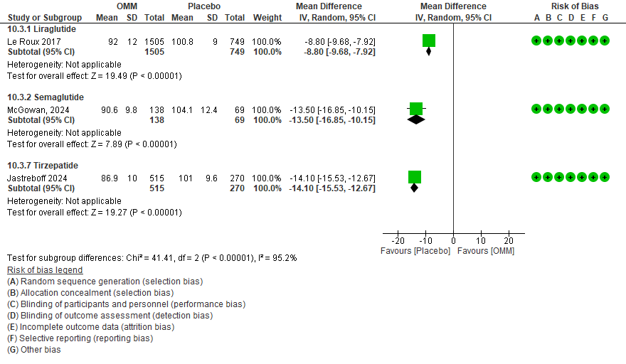
D
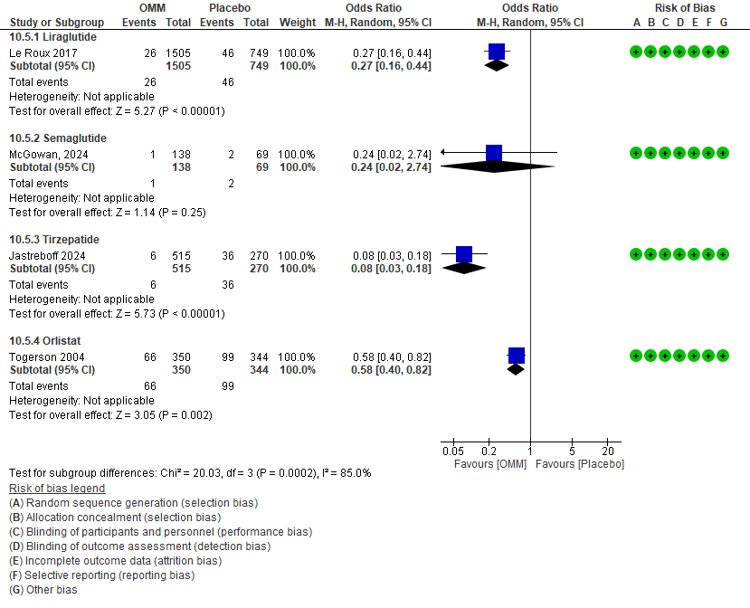
E
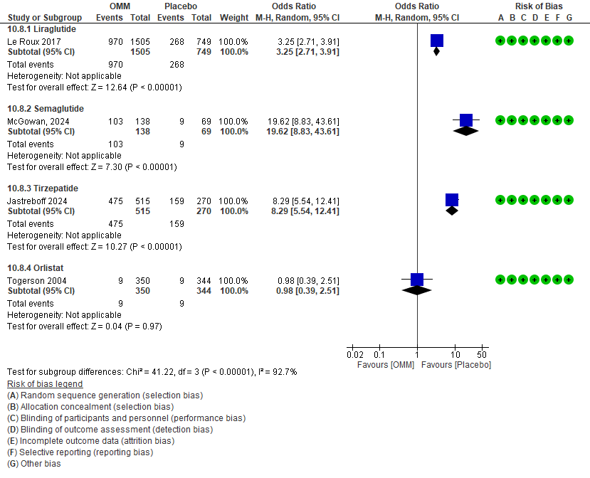

Figure 38S – Network plots for trials reporting information on TBWL% (Panel A), Hb1c (Panel B), FPG (Panel C), complete (Panel D) and partial (Panel E) diabetes remission in RCTs performed on patients with diabetes.
A
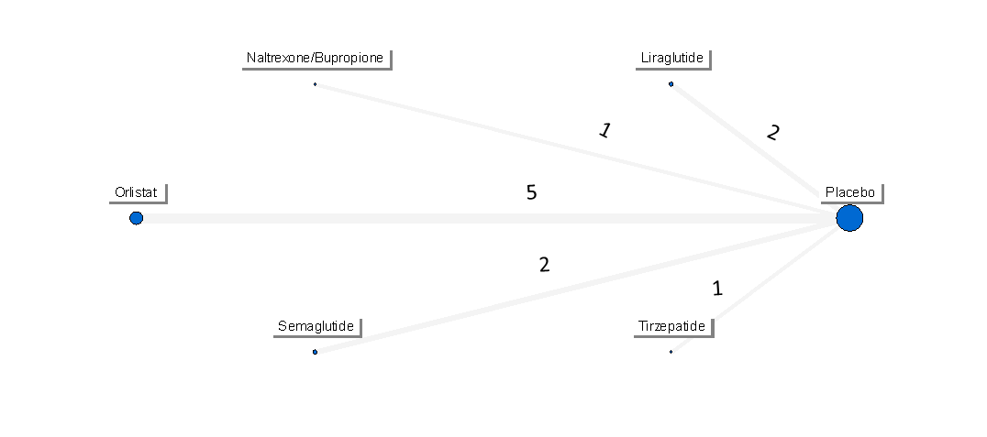
B
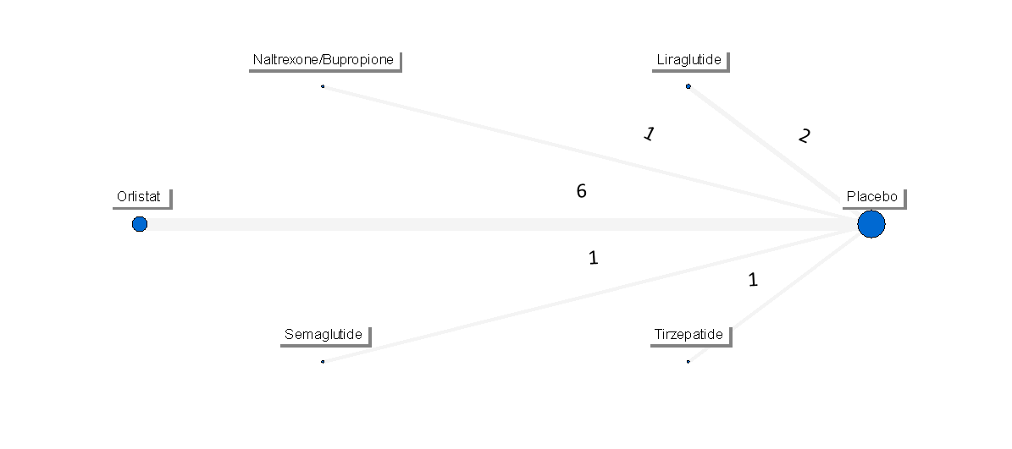
C
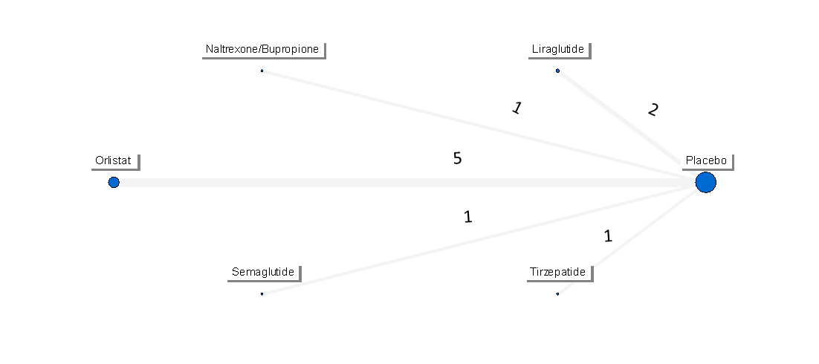

Figure 39S – Network forest plots for trials reporting information on TBWL% (Panel A), Hb1c (Panel B), and FPG (Panel C) in RCTs performed on patients with diabetes.
A

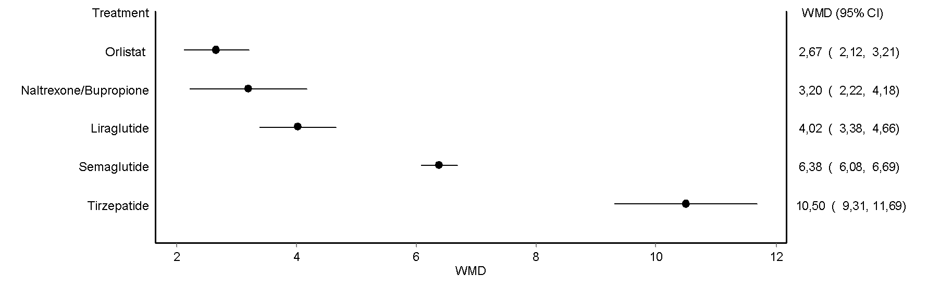
B
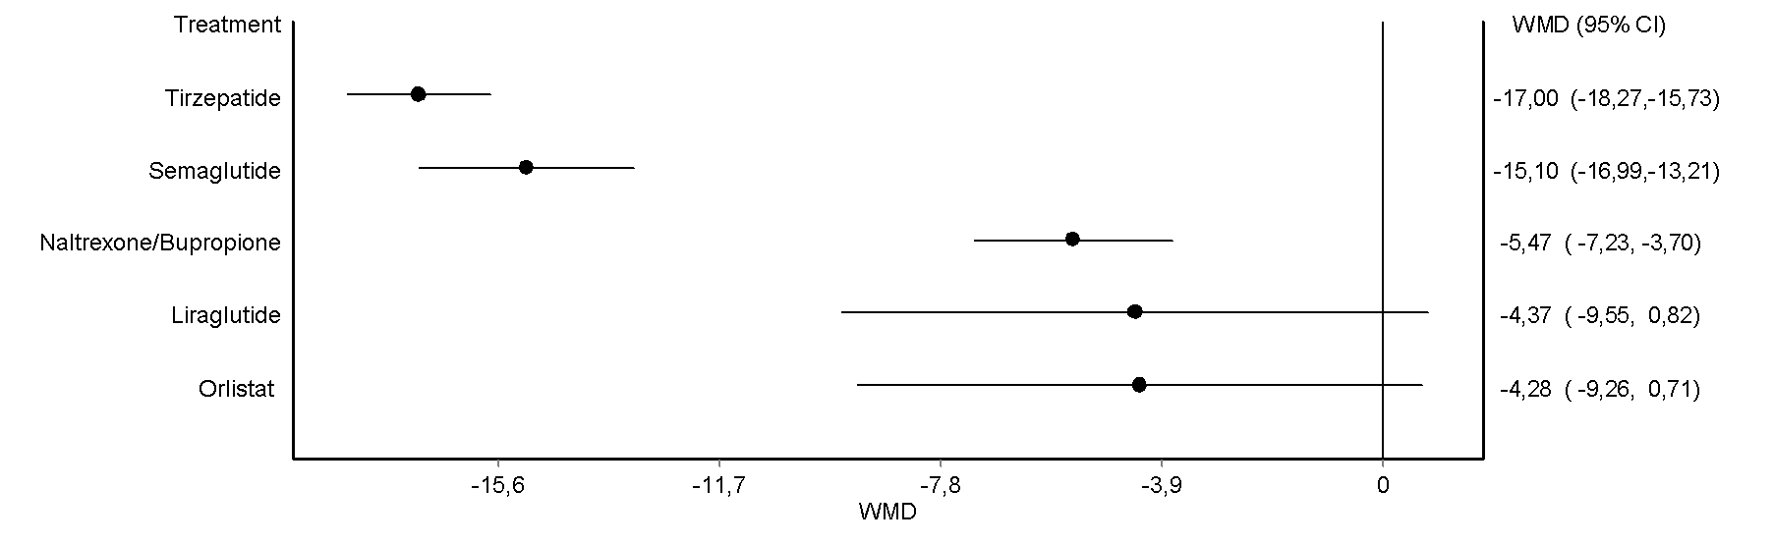
C
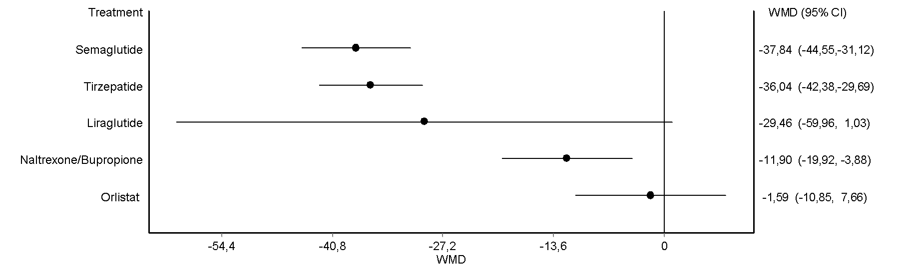

Figure 40S – Effects of OMM on complete (Panel A) and partial (Panel B) diabetes remission in RCTs performed on patients with diabetes.
A
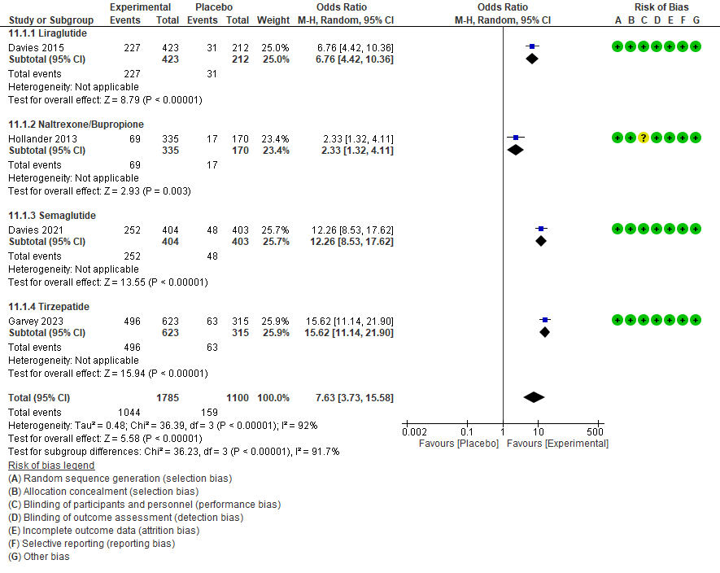
B
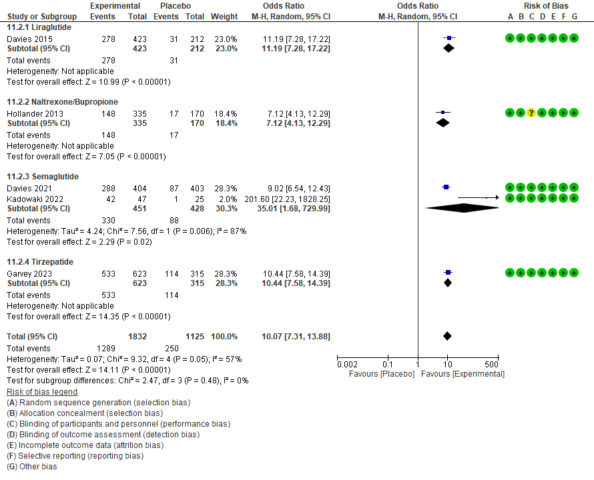

Figure 41S – Effects of OMM on MASLD resolution (Panel A), decrease of at least one fibrosis stage (Panel B), liver fat content (Panel C), liver stiffness (Panel D), AST (Panel E), and ALT (Panel F) in RCTs performed on patients with MASLD.
A
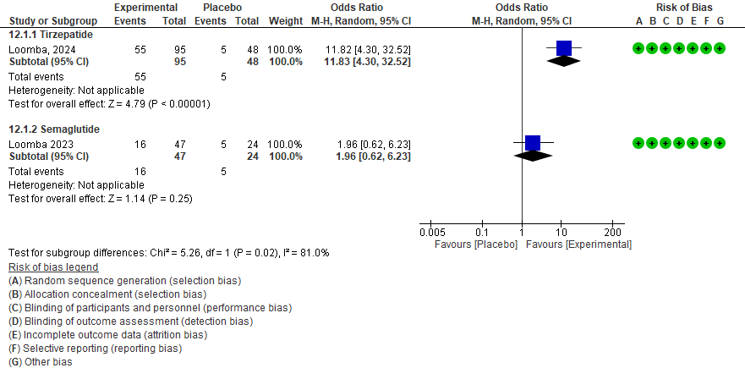
B
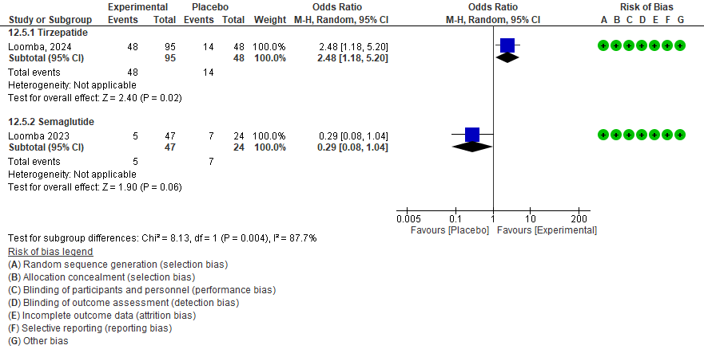
C
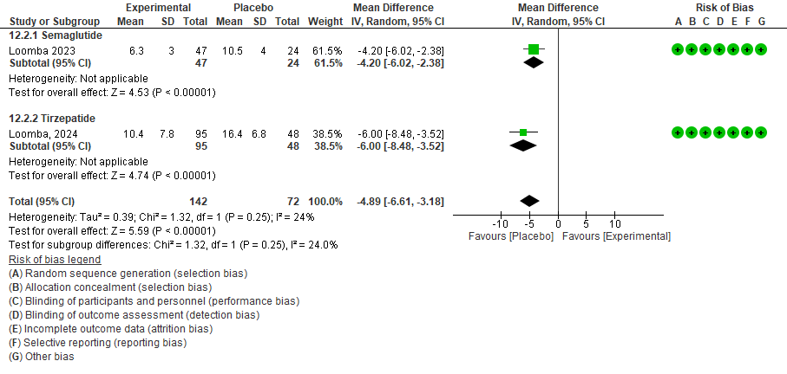
D
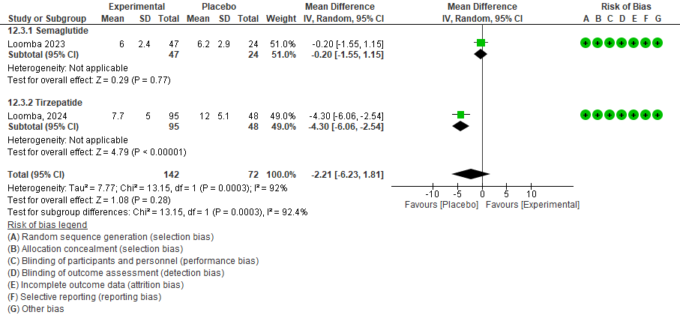

E

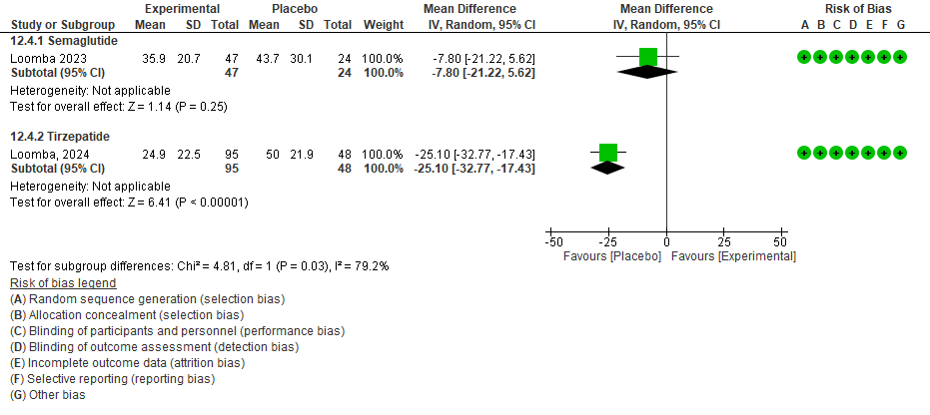
F

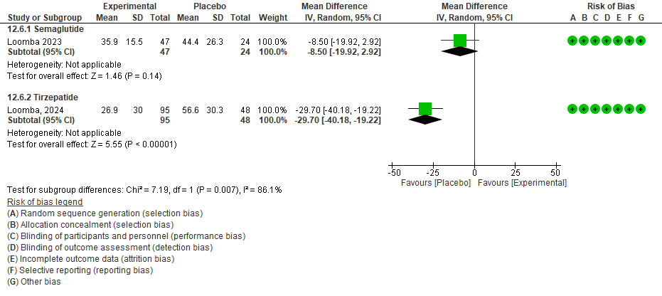

Figure 42S – Effects of OMM on the change in the apnea-hypopnea index (AHI: the number of apneas and hypopneas during an hour of sleep) from baseline (Panel A) and on the percent change in AHI (Panel B) in RCTs performed on patients with OSAS.

A

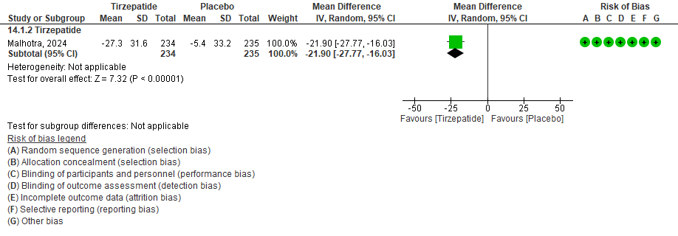

B

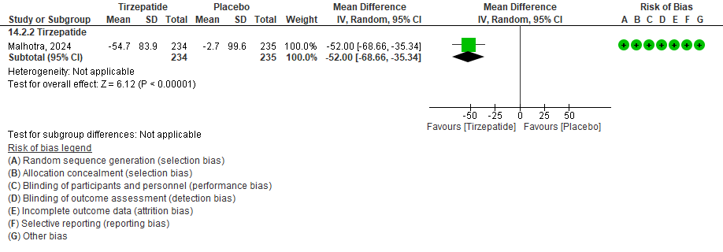

Figure 43S – Effects of OMM on opioid use (Panel A) and WOMAC pain scale (Panel B) for semaglutide and KOOS pain scale for liraglutide in RCTs performed on patients with Knee osteoarthritis.

A

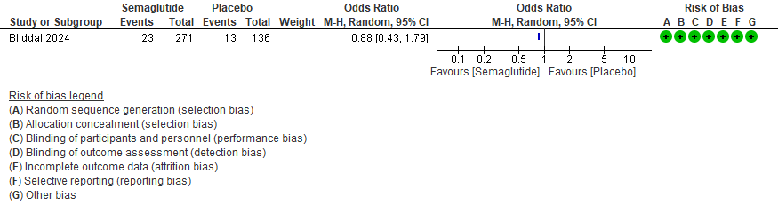
B

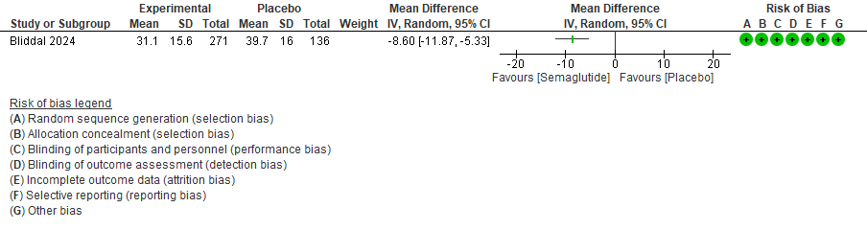
C
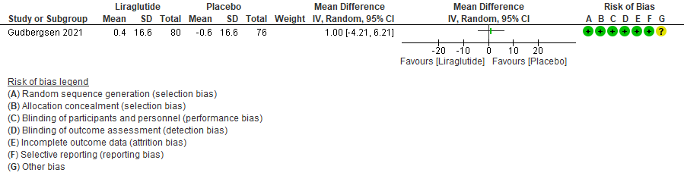

Figure 44S – Network plots for trials reporting information on TBWL% in RCT with baseline BMI 30-34.9 (Panel A) and 35.0-39.9 kg/m² (Panel B).

A

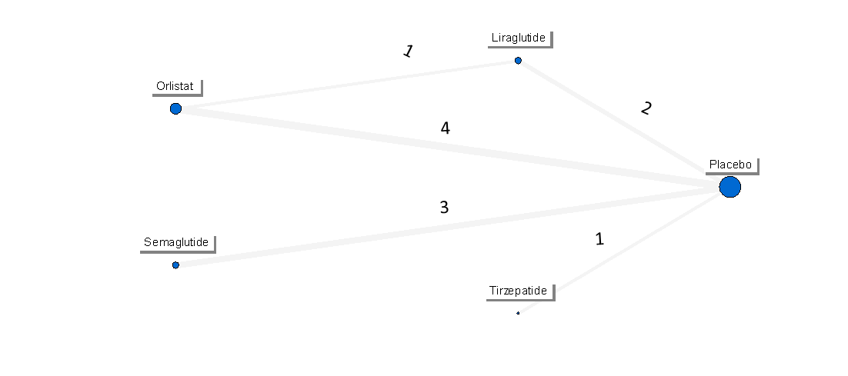
B

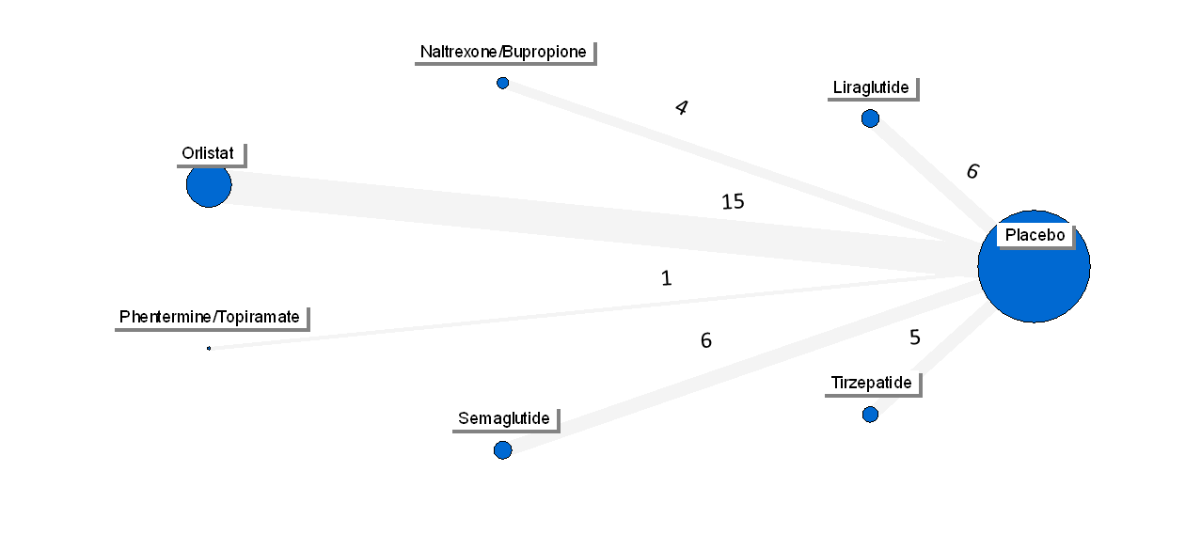

Figure 45S – Network forest plots for trials reporting information on TBWL% in RCT with baseline BMI 30-34.9 (Panel A) and 35.0-39.9 kg/m² (Panel B).

A
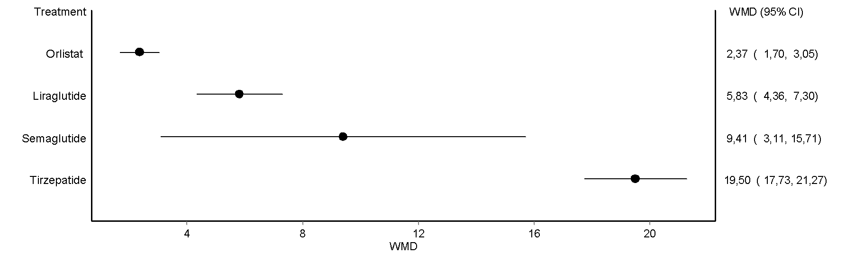

B

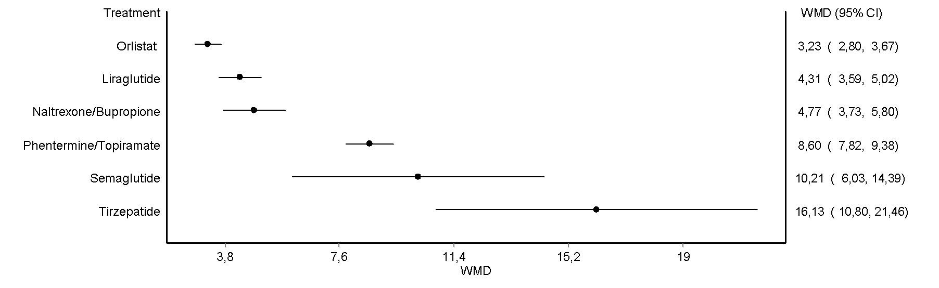

Figure 46S – Effects of OMM on TBWL% in RCTs with baseline BMI≥ 40 Kg/m².

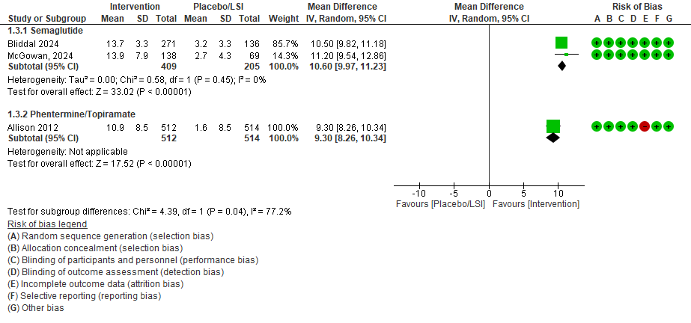

Tables

Table 1S – PRISMA checklist.

Section/topic | # | Checklist item | Reported on page #
TITLE
Title | 1 | Pharmacological treatment of obesity and overweight in adults: efficacy and safety of medications for obesity management. A comprehensive systematic review and network meta-analysis of randomized controlled trials. | -
ABSTRACT
Structured summary | 2 |  | 1
INTRODUCTION
Rationale | 3 | The European Association for the Study of Obesity (EASO) is developing a guideline on the pharmacological treatment of overweight and obesity, following the Grades of Recommendation, Assessment, Development and Evaluation (GRADE) methodology | 3
Objectives | 4 | The present network meta-analysis is aimed the assessment of the effectiveness and safety of OMM in subjects affected by overweight/obesity. | 3
METHODS
Protocol and registration | 5 | The study has been uploaded on the PROSPERO website (CRD42024625338). | 4
Eligibility criteria | 6 | All studies were included if they satisfied the following criteria: (i) randomized trials. (ii) duration ≥52 weeks, (iii) on obesity/overweight, and (iv) comparing OMM to placebo or other active treatments. | 4
Information sources | 7 | A MEDLINE and Embase database search were performed to identify all clinical trials (English only) up to Jan 1st, 2025. | 4
Search | 8 | See Table 2S. | 4 and SM
Study selection | 9 | The identification of relevant abstracts. the selection of studies and extraction were performed independently by two of the authors (B.R. and E.M.) and conflicts resolved by a third investigator (M.M.). | 5
Data collection process | 10 | The principal characteristics of the included trials included were reported in Table 5S. | 6 and SM
Data items | 11 | Information on the baseline characteristics of the samples enrolled (age, gender, proportion of people with diabetes, baseline Body Mass Index – BMI), Total Body Weight Loss (TBWL%), Quality of Life (QoL), Serious Adverse Events (SAE), and all-cause mortality were extracted from the principal publication, when available. | 6 and SM
Risk of bias in individual studies | 12 | The quality of trials was assessed using the parameters proposed by the Cochrane Collaboration. | 6
Summary measures | 13 | Mantel-Haenszel odds ratio (MH-OR) and Weighted Mean Difference (WMD) with 95% Confidence Interval (95%, CI) were calculated for all outcomes defined above on an intention-to-treat basis. | 5-6
Synthesis of results | 14 | Heterogeneity was assessed by using I² statistics. A random-effects model was applied in the primary analysis. We performed a Network Meta-Analysis (NMA) for all the outcomes listed above, to verify differences across individual anti-obesity strategies concerning their effects on primary and secondary endpoints. | 6
Section/topic | # | Checklist item | Reported on page #
Risk of bias across studies | 15 | The risk of bias was assessed using the Cochrane recommended tool to determine the risk of bias in RCTs | 5
Additional analyses | 16 | Several prespecified subgroup analyses were performed for the following baseline variables: different OMM, BMI categories (mean BMI at the enrolment <30, 30-34.9, 35-39.9, and >40 Kg/m2), prediabetes, type 2 diabetes mellitus, established cardiovascular disease, heart failure, MASLD, and OSAS. Traditional meta-analyses were performed for all the endpoints for placebo- and active-controlled trials with less than 10 RCTs. | 5-6
RESULTS
Study selection | 17 | The search of Medline and Embase database allowed the identification of 55 trials (i.e., 56 comparisons). | 7 and SM
Study characteristics | 18 | The principal characteristics of included trials were reported in Supplementary Materials (Table 5S). | 7 and SM
Risk of bias within studies | 19 | The quality of studies was heterogeneous. | 7 and SM
Results of individual studies | 20 | Forest plots for any primary and secondary endpoint are reported in the Results section and Supplementary Materials. | 8-10; SM
Synthesis of results | 21 | At the endpoint (mean follow-up duration 68 weeks), all OMM showed a significant effect versus placebo. The estimated endpoint TBWL was greater than 10% only for semaglutide and tirzepatide. SAE were reported in most included studies, with no OMM significantly associated with an increased risk of SAE compared to placebo, except for NB. Semaglutide was associated with a lower risk of mortality. | 8-10; SM
Risk of bias across studies | 22 | The quality of studies was heterogeneous (Figure 2S of Supporting Information). Trials were usually double-blind (66%), with a few trials with inadequate attrition and/or description of allocation or blinding of assessors (29.3%). | 7 and SM
Additional analysis | 23 | Subgroup analyses of trials are available at pg. 10-12. | 8-9 and SM
DISCUSSION
Summary of evidence | 24 | The GRADE profile classified the strength as moderate for the primary endpoint. | 14 and SM
Limitations | 25 | Limitations were reported in extenso in the Discussion section. | 17
Conclusions | 26 | In conclusion, this NMA reinforces the need of tailoring the therapy for obesity and obesity-related medical conditions, with some drugs exerting greater effects on body weight i.e., tirzepatide and, to a lesser extent, semaglutide), and others with proven cardiovascular protective effects (i.e., semaglutide for MACE, semaglutide and NB for cardiovascular mortality, and semaglutide and tirzepatide for HHF). In addition, some agents can have either detrimental or beneficial effects on specific cardiovascular risk factors (i.e., NB increases systolic blood pressure and orlistat reduces plasma cholesterol) or obesity-associated conditions (i.e., improvements of OSAS and MASLD with tirzepatide). These findings will be the basis for the upcoming first EASO guidelines. Both those guidelines and the present NMA will need to be constantly updated, considering the rapid development of pharmacological research and the accumulation of clinical evidence on weight-reducing agents. | 18
FUNDING
Funding | 27 | No funding. | 18

Table 2S – Detailed information on search strategy

Limits: Human studies; any date up to Jan 1st, 2025

Search string: (obesity or overweight) AND (orlistat OR phentermine OR topiramate OR naltrexone OR bupropion OR liraglutide OR semaglutide OR tirzepatide)
Pubmed
N= 620
Search: (obesity or overweight) AND (orlistat OR phentermine OR topiramate OR naltrexone OR bupropion OR liraglutide OR semaglutide OR tirzepatide) Filters: Randomized Controlled Trial
(("obeses"[All Fields] OR "obesity"[MeSH Terms] OR "obesity"[All Fields] OR "obese"[All Fields] OR "obesities"[All Fields] OR "obesity s"[All Fields] OR ("overweight"[MeSH Terms] OR "overweight"[All Fields] OR "overweighted"[All Fields] OR "overweightness"[All Fields] OR "overweights"[All Fields])) AND ("orlistat"[MeSH Terms] OR "orlistat"[All Fields] OR "orlistat s"[All Fields] OR ("phentermine"[MeSH Terms] OR "phentermine"[All Fields]) OR ("topiramate"[MeSH Terms] OR "topiramate"[All Fields] OR "topiramate s"[All Fields]) OR ("naltrexone"[MeSH Terms] OR "naltrexone"[All Fields] OR "naltrexon"[All Fields] OR "naltrexone s"[All Fields]) OR ("bupropion"[MeSH Terms] OR "bupropion"[All Fields] OR "amfebutamone"[All Fields] OR "bupropion s"[All Fields] OR "bupropione"[All Fields]) OR ("liraglutid"[All Fields] OR "liraglutide"[MeSH Terms] OR "liraglutide"[All Fields] OR "liraglutide s"[All Fields]) OR ("semaglutide"[Supplementary Concept] OR "semaglutide"[All Fields]) OR ("tirzepatide"[MeSH Terms] OR "tirzepatide"[All Fields]))) AND (randomizedcontrolledtrial[Filter])
Translations
obesity: "obeses"[All Fields] OR "obesity"[MeSH Terms] OR "obesity"[All Fields] OR "obese"[All Fields] OR "obesities"[All Fields] OR "obesity's"[All Fields]
overweight: "overweight"[MeSH Terms] OR "overweight"[All Fields] OR "overweighted"[All Fields] OR "overweightness"[All Fields] OR "overweights"[All Fields]
orlistat: "orlistat"[MeSH Terms] OR "orlistat"[All Fields] OR "orlistat's"[All Fields]
phentermine: "phentermine"[MeSH Terms] OR "phentermine"[All Fields]
topiramate: "topiramate"[MeSH Terms] OR "topiramate"[All Fields] OR "topiramate's"[All Fields]
naltrexone: "naltrexone"[MeSH Terms] OR "naltrexone"[All Fields] OR "naltrexon"[All Fields] OR "naltrexone's"[All Fields]
bupropion: "bupropion"[MeSH Terms] OR "bupropion"[All Fields] OR "amfebutamone"[All Fields] OR "bupropion's"[All Fields] OR "bupropione"[All Fields]
liraglutide: "liraglutid"[All Fields] OR "liraglutide"[MeSH Terms] OR "liraglutide"[All Fields] OR "liraglutide's"[All Fields]
semaglutide: "semaglutide"[Supplementary Concept] OR "semaglutide"[All Fields]
tirzepatide: "tirzepatide"[MeSH Terms] OR "tirzepatide"[All Fields]

EMBASE
N= 1,102
('obesity'/exp OR obesity OR 'overweight'/exp OR overweight) AND ('orlistat'/exp OR orlistat OR 'phentermine'/exp OR phentermine OR 'topiramate'/exp OR topiramate OR 'naltrexone'/exp OR naltrexone OR 'bupropion'/exp OR bupropion OR 'liraglutide'/exp OR liraglutide OR 'semaglutide'/exp OR semaglutide OR 'tirzepatide'/exp OR tirzepatide) AND [embase]/lim NOT ([embase]/lim AND [medline]/lim) AND ('phase 3 clinical trial'/de OR 'randomized controlled trial'/de OR 'randomized controlled trial topic'/de)
Additional search:
Additional manual search of the references of included trials and former meta-analyses was carried out to identify other newly published and unpublished studies. Completed but yet unpublished studies with the procedures specified above were searched in the www.clinicaltrials.gov register. using the same search string as above.

Table 3S – Critical outcomes for each subpopulation of patients with overweight/obesity.

Pre-existing comorbid condition
Type 2 diabetes mellitus
Primary endpoint: complete diabetes remission*
Other critical endpoints: Body weight reduction (total body weight loss % - TBWL%); lipid and blood pressure profile, and renal function), and improvement of metabolic control (glycosylated hemoglobin - HbA1c and fasting plasma glucose - FPG).
Pre-diabetes
Primary endpoint: normoglycemia restoration*
Other critical endpoints: Body weight reduction (total body weight loss % - TBWL%); lipid and blood pressure profile, and renal function), reduction of incident diabetes*, and improvement of metabolic control (glycosylated hemoglobin - HbA1c and fasting plasma glucose - FPG).
Established cardiovascular disease
Primary endpoint: Incidence reduction of Major Adverse Cardiovascular Events (MACE)*
Other critical endpoints: Body weight reduction (total body weight loss % - TBWL%), all-cause and cardiovascular mortality reduction.
Heart failure
Primary endpoint: Reduction of hospital admission for heart failure*
Other critical endpoints: Body weight reduction (total body weight loss % - TBWL%), incidence of Major Adverse Cardiovascular Events (MACE)*, improvement of Kansas City Cardiomyopathy Questionnaire clinical summary score, change in 6-minute walking test (6-m WT) distance. All-cause and cardiovascular mortality reduction
Obstructive sleep apnea syndrome
Primary endpoint: OSAS remission *
Other critical endpoints: Body weight reduction (total body weight loss % - TBWL%) and improvement of parameters evaluating apnea*
Metabolic dysfunction-associated steatotic liver disease
Primary endpoint: MASH remission*
Other critical endpoints: Body weight reduction (total body weight loss % - TBWL%) and improvement of fibrosis and liver indexes.
Knee osteoarthritis
Primary endpoint: KOA improvement assessed with scales evaluating osteoarthritis outcome scores (Western Ontario and McMaster Universities Osteoarthritis Index – pain and physical-function score),
Other critical endpoints: Body weight reduction (total body weight loss % - TBWL%), improvement of 6-m walking distance, and opioids use.

*Only adjudicated events will be considered. For PICO 1 all outcomes will be considered critical; for PICO 2-8 only underlined outcomes will be analyzed separately in RCTs specifically designed for that subpopulation of patients with overweight/obesity.

Table 4S. Excluded trials and reasons for the exclusion.

N | Study | Publication year | Reason for the exclusion
1 | Newsome⁵ | 2021 | Submaximal doses
2 | Inagaki⁶ | 2022 | On diabetes
3 | Butler⁷ | 2024 | Duplicate
4 | L. Beck-da-Silva⁸ | 2005 | Short treatment period
5 | Garvey⁹ | 2012 | Duplicate
6 | Grilo¹⁰ | 2023 | Short treatment period
7 | Greenway¹¹ | 2000 | Not EMA-approved

Table 5S. Principal baseline characteristics of the included studies
n | Study Name | Intervention | Comparator | N. pat.  Interv. | N. pat.  Comp. | Trial duration  (weeks) | BMI min.  (Kg/m²) | BMI max.  (Kg/m²) | Age max.  (years) | Average BMI  (Kg/m²) | Avergae Age  (years) | Women  (%) | T2DM  (%)
1 | Astrup¹² | Liraglutide | Orlistat | 93 | 95 | 52 | 30 | 40 | 65 | 34.4 | 46 | 75 | 3
 |  |  | Placebo | 93 | 98 | 52 | 30 | 40 | 65 | 34.8 | 46 | 75 | 4
2 | Gudbergsen¹³ | Liraglutide | Placebo | 80 | 76 | 52 | 27 | NR | 74 | 32.1 | 59 | 65 | NR
3 | Lundgren¹⁴ | Liraglutide | Placebo | 98 | 97 | 52 | 32 | 43 | 65 | 32.6 | 43 | 64 | 0
4 | O'Neil¹⁵ | Liraglutide | Placebo | 103 | 136 | 52 | 30 | NR | NR | 39.3 | 47 | 35 | 0
5 | Davies¹⁶ | Liraglutide | Placebo | 423 | 212 | 56 | 27 | NR | NR | 37.2 | 55 | 51 | 100
6 | Garvey¹⁷ | Liraglutide | Placebo | 195 | 197 | 56 | 27 | NR | NR | 35.5 | 57 | 53 | 100
7 | Wadden¹⁸ | Liraglutide | Placebo | 212 | 210 | 56 | 27 | NR | NR | 35.6 | 46 | 81 | 0
8 | Wadden¹⁹ | Liraglutide | Placebo | 142 | 140 | 56 | 30 | NR | NR | 39.0 | 47 | 84 | 0
9 | Le Roux²⁰ | Liraglutide | Placebo | 1505 | 749 | 156 | 27 | NR | NR | 38.9 | 47 | 76 | 0
10 | Apovian²¹ | Naltr./Bupr. | Placebo | 992 | 492 | 56 | 30 | 45 | 65 | 36.1 | 44 | 85 | 0
11 | Greenway²² | Naltr./Bupr. | Placebo | 583 | 581 | 56 | 27 | 45 | 65 | 36.1 | 44 | 85 | 0
12 | Hollander²³ | Naltr./Bupr. | Placebo | 335 | 170 | 56 | 27 | 45 | 70 | 36.4 | 54 | 55 | 100
13 | Wadden²⁴ | Naltr./Bupr. | Placebo | 591 | 202 | 56 | 27 | 45 | 65 | 36.5 | 46 | 90 | 0
14 | Nissen²⁵ | Naltr./Bupr. | Placebo | 4455 | 4450 | 156 | 27 | 50 | NR | 36.6 | 61 | 54 | 85
15 | Bakris²⁶ | Orlistat | Placebo | 267 | 265 | 52 | 28 | 43 | NR | 35.6 | 53 | 61 | 8
16 | Berne²⁷ | Orlistat | Placebo | 111 | 109 | 52 | 28 | 40 | 75 | 32.7 | 59 | 45 | 100
17 | Davidson²⁸ | Orlistat | Placebo | 657 | 223 | 52 | 30 | 43 | NR | 36.3 | 44 | 84 | 0
18 | Derosa²⁹ | Orlistat | Placebo | 126 | 128 | 52 | 30 | NR | NR | 32.8 | 52 | 50 | 100
19 | Derosa³⁰ | Orlistat | Placebo | 53 | 47 | 52 | 30 | NR | NR | 32.1 | 51 | 52 | 0
20 | Finer³¹ | Orlistat | Placebo | 110 | 108 | 52 | 30 | 43 | NR | 36.8 | 41 | 89 | 0
21 | Hill³² | Orlistat | Placebo | 179 | 184 | 52 | 28 | 34 | NR | 32.8 | 46 | 85 | 0
22 | James³³ | Orlistat | Placebo | 23 | 23 | 52 | 30 | 43 | NR | 37.5 | 43 | 85 | 0
23 | Karhunen³⁴ | Orlistat | Placebo | 36 | 36 | 52 | 30 | 43 | NR | 35.8 | 44 | 77 | 0
24 | Kelley³⁵ | Orlistat | Placebo | 266 | 269 | 52 | 28 | 40 | 65 | 35.7 | 58 | 56 | 100
25 | Miles³⁶ | Orlistat | Placebo | 250 | 254 | 52 | 28 | 43 | 65 | 35.4 | 53 | 48 | 100
26 | Poston³⁷ | Orlistat | Placebo | 37 | 35 | 52 | 27 | NR | 65 | 36.8 | 43 | 100 | 11
27 | Sjostrom³⁸ | Orlistat | Placebo | 343 | 340 | 52 | 28 | 47 | NR | 36.0 | 45 | 83 | NR
28 | Svendsen³⁹ | Orlistat | Placebo | 23 | 21 | 52 | 30 | NR | 63 | 37.5 | 48 | 55 | NR
29 | Swinburn⁴⁰ | Orlistat | Placebo | 170 | 169 | 52 | 30 | 50 | 70 | 37.8 | 52 | 57 | 8
30 | Hollander⁴¹ | Orlistat | Placebo | 162 | 159 | 57 | 28 | 40 | NR | 34.2 | 55 | 50 | 100
31 | Krempf⁴² | Orlistat | Placebo | 346 | 350 | 78 | 28 | NR | 65 | 36.1 | 41 | 86 | 0
32 | Hauptman⁴³ | Orlistat | Placebo | 210 | 212 | 104 | 30 | 44 | NR | 36.0 | 42 | 68 | NR
33 | Rossner⁴⁴ | Orlistat | Placebo | 244 | 243 | 104 | 28 | 43 | NR | 35.0 | 44 | 85 | NR
34 | Richelsen⁴⁵ | Orlistat | Placebo | 153 | 156 | 156 | 30 | 45 | 65 | 37.5 | 47 | 51 | 20
35 | Togerson⁴⁶ | Orlistat | Placebo | 1640 | 1637 | 208 | 30 | NR | 60 | 37.3 | 43 | 55 | 0
36 | Allison⁴⁷ | Phen./Topir. | Placebo | 512 | 514 | 56 | 35 | NR | 70 | 42.2 | 43 | 83 | NR
37 | Gadde⁴⁸ | Phen./Topir. | Placebo | 995 | 994 | 56 | 27 | 45 | 70 | 36.6 | 51 | 70 | 67
38 | Kosiborod⁴⁹ | Semaglutide | Placebo | 310 | 306 | 52 | 30 | NR | NR | 36.9 | 70 | 44 | 100
39 | Kosiborod⁵⁰ | Semaglutide | Placebo | 263 | 266 | 52 | 30 | NR | NR | 37.0 | 69 | 56 | 0
40 | McGowan⁵¹ | Semaglutide | Placebo | 138 | 69 | 52 | 30 | NR | NR | 40.1 | 53 | 71 | 0
41 | Bliddal⁵² | Semaglutide | Placebo | 271 | 136 | 68 | 30 | NR | NR | 40.3 | 56 | 82 | 0
42 | Davies⁵³ | Semaglutide | Placebo | 404 | 403 | 68 | 27 | NR | NR | 35.9 | 55 | 51 | 100
43 | Kadowaki⁵⁴ | Semaglutide | Placebo | 199 | 101 | 68 | 27 | NR | NR | 31.9 | 51 | 37 | 25
44 | Rubino⁵⁵ | Semaglutide | Placebo | 535 | 268 | 68 | 27 | NR | NR | 34.3 | 46 | 78 | 0
45 | Wadden⁵⁶ | Semaglutide | Placebo | 407 | 204 | 68 | 27 | NR | NR | 38.0 | 46 | 82 | 0
46 | Wilding⁵⁷ | Semaglutide | Placebo | 1306 | 655 | 68 | 27 | NR | NR | 37.9 | 46 | 75 | 0
47 | Garvey⁵⁸ | Semaglutide | Placebo | 152 | 152 | 104 | 27 | NR | NR | 38.5 | 47 | 77 | 0
48 | Lincoff³ | Semaglutide | Placebo | 8803 | 8801 | 104 | 27 | NR | NR | 33.3 | 62 | 28 | 0
49 | Loomba⁵⁹ | Semaglutide | Placebo | 47 | 24 | 48 | 27 | NR | 75 | 35.0 | 59 | 70 | 75
50 | Aronne⁶⁰ | Tirzepatide | Placebo | 335 | 335 | 52 | 27 | NR | NR | 30.5 | 49 | 70 | 0
51 | Loomba ⁶¹ | Tirzepatide | Placebo | 95 | 48 | 52 | 27 | 50 | 80 | 36.1 | 54 | 57 | 58
52 | Malhotra⁶² | Tirzepatide | Placebo | 234 | 235 | 52 | 30 | NR | NR | 39.0 | 50 | 30 | 0
53 | Garvey¹ | Tirzepatide | Placebo | 623 | 315 | 72 | 27 | NR | NR | 36.1 | 54 | 51 | 100
54 | Jastreboff² | Tirzepatide | Placebo | 1266 | 643 | 72 | 27 | NR | NR | 38.0 | 45 | 67 | 0
55 | Packer⁶³ | Tirzepatide | Placebo | 364 | 367 | 52 | 30 | NR | NR | 38.2 | 65 | 53 | 48
Total (mean value) in trials on OMM |  |  |  | 33,986 | 28,804 | 66 | 29 | 44 | 68 | 36.0 | 51 | 64 | 34

N.: Number; Min.; Minimum; Max.: Maximum; BMI: Body Mass Index; DM: Proportion of subjects with diabetes enrolled; Naltr./Bupr.: Naltrexone/Bupropione; Phen./Topir.: Phentermine/Topiramate. NR: Not reported
Table 6S – Direct and estimates of effects of different OMM on endpoint TBWL%.

ID | Comparison | Active | Control | WMD | LCI 95% | UCI 95%
 | Direct estimates
1 | Liraglutide vs Placebo | Liraglutide 3.0 mg | Placebo | 4.53 | 3.40 | 5.66
2 | Nalt/Bup vs Placebo | Naltrexone SR/Bupropion | Placebo | 4.76 | 3.73 | 5.79
3 | Orlistat vs Placebo | Orlistat 360 mg | Placebo | 3.14 | 2.71 | 3.56
4 | Phen/Topir vs Placebo | Phentermine/Topiramate (15/92) | Placebo | 8.85 | 8.18 | 9.51
5 | Semaglutide vs Placebo | Semaglutide 2.4 mg | Placebo | 10.00 | 7.38 | 12.62
6 | Tirzepatide vs Placebo | Tirzepatide 10-15 mg | Placebo | 16.48 | 11.39 | 21.57
7 | Liraglutide vs Placebo | Orlistat 360 mg | Orlistat | 3.80 | 0.72 | 6.87
 | Indirect estimates (source IDs)
1 | Liraglutide vs Placebo | Liraglutide 3.0 mg | Placebo | 6.94 | 3.83 | 10.04
2 | Orlistat vs Placebo | Orlistat 360 mg | Placebo | 0.73 | -2.54 | 4.01

Naltr./Bupr.: Naltrexone/Bupropione; Phen./Topir.: Phentermine/Topiramate. WMD: Weighted Mean Difference; LCI and UCI: Lower and Upper Confidence Intervals.

Table 7S – Direct and estimates of effects of different OMM on 52-week TBWL%.

ID | Comparison | Active | Control | WMD | LCI 95% | UCI 95%
 | Direct estimates
1 | Liraglutide vs Placebo | Liraglutide 3.0 mg | Placebo | 4.51 | 3.51 | 5.51
2 | Nalt/Bup vs Placebo | Naltrexone SR/Bupropion | Placebo | 4.76 | 3.73 | 5.79
3 | Orlistat vs Placebo | Orlistat 360 mg | Placebo | 3.68 | 2.89 | 4.47
4 | Phen/Topir vs Placebo | Phentermine/Topiramate (15/92) | Placebo | 8.85 | 8.18 | 9.51
5 | Semaglutide vs Placebo | Semaglutide 2.4 mg | Placebo | 10.73 | 8.19 | 13.27
6 | Tirzepatide vs Placebo | Tirzepatide 10-15 mg | Placebo | 14.77 | 11.68 | 17.86
7 | Liraglutide vs Placebo | Orlistat 360 mg | Orlistat | 5.70 | 5.11 | 6.28
 | Indirect estimates (source IDs)
1 | Liraglutide vs Placebo | Liraglutide 3.0 mg | Placebo | 9.38 | 8.40 | 10.37
2 | Orlistat vs Placebo | Orlistat 360 mg | Placebo | -1.18 | -2.34 | -0.029

Naltr./Bupr.: Naltrexone/Bupropione; Phen./Topir.: Phentermine/Topiramate. WMD: Weighted Mean Difference; LCI and UCI: Lower and Upper Confidence Intervals.

Table 8S – Direct and estimates of effects of different OMM on 53-104-week TBWL%.

ID | Comparison | Active | Control | WMD | LCI 95% | UCI 95%
 | Direct estimates
1 | Liraglutide vs Placebo | Liraglutide 3.0 mg | Placebo | 4.27 | 3.60 | 5.00
2 | Orlistat vs Placebo | Orlistat 360 mg | Placebo | 2.82 | 2.21 | 3.43
3 | Semaglutide vs Placebo | Semaglutide 2.4 mg | Placebo | 10.14 | 7.21 | 13.06
4 | Tirzepatide vs Placebo | Tirzepatide 10-15 mg | Placebo | 16.47 | 8.20 | 24.73
5 | Phen./Topir. vs Placebo | Phen./Topir. | Placebo | 8.85 | 8.18 | 9.51
6 | Naltr./Bupr.vs Placebo | Naltr./Bupr. | Placebo | 4.76 | 3.73 | 5.79
 | Indirect estimates (source IDs)
- | - | - | - | - | - | -

Naltr./Bupr.: Naltrexone/Bupropione; Phen./Topir.: Phentermine/Topiramate. WMD: Weighted Mean Difference; LCI and UCI: Lower and Upper Confidence Intervals.
Table 9S – GRADE evaluation of the retrieved evidence for each OMM for endpoint-TBWL%.
Certainty assessment |  |  |  |  |  |  | Summary of findings
Participants  (studies)  Follow-up | Risk of bias | Inconsistency | Indirectness | Imprecision | Publication bias | Overall certainty of evidence | Study event rates (%) |  | Relative effect  (95% CI) | Anticipated absolute effects
 |  |  |  |  |  |  | With PBO | With ID | Relative effect  (95% CI) | Risk with PBO | Risk difference with TBWL%
Endpoint TBWL%
Orlistat
9923  (18 RCTs) | seriousª | not serious | not serious | not serious | strong association | ⨁⨁⨁⨁  Highª | 4659 | 5264 | - | 4659 | MD 3.03 higher  (2.65 higher to 3.41 higher)
Naltrexone/Bupoprione
3251  (4 RCTs) | not serious | serious^{b} | not serious | not serious | strong association | ⨁⨁⨁⨁  High^{b} | 1372 | 1879 | - | 1372 | MD 3.99 higher  (2.62 higher to 5.37 higher)
Phentermine/Topiramate
3015  (2 RCTs) | not serious | not serious | not serious | not serious | strong association | ⨁⨁⨁⨁  High | 1508 | 1507 | - | 1508 | MD 8.86 higher  (8.2 higher to 9.53 higher)
Liraglutide
5394  (8 RCTs) | not serious | serious^{b} | not serious | not serious | strong association | ⨁⨁⨁⨁  High^{b} | 2041 | 3353 | - | 2041 | MD 7.15 higher  (3.68 higher to 10.63 higher)
Semaglutide
24422  (11 RCTs) | not serious | serious^{b} | not serious | not serious | very strong association | ⨁⨁⨁⨁  High^{b} | 11339 | 13083 | - | 11339 | MD 9.7 higher  (7.84 higher to 11.55 higher)
Tirzepatide
4314  (6 RCTs) | not serious | serious^{b} | not serious | not serious | very strong association | ⨁⨁⨁⨁  High^{b} | 1825 | 2489 | - | 1825 | MD 14.09 higher  (11.16 higher to 17.02 higher)
MACE
Semaglutide
8905  (1 RCT) | not serious | not serious | not serious | serious^{c} | very strong association | ⨁⨁⨁⨁  High^{c} | 701/4450 (15.8%) | 569/4455 (12.8%) | OR 0.78  (0.69 to 0.88) | 701/4450 (15.8%) | 30 fewer per 1.000  (from 43 fewer to 16 fewer)
Naltrexone/Bupropione
17604  (1 RCT) | not serious | not serious | not serious | serious^{c} | none | ⨁⨁⨁◯  Moderate^{c} | 102/8801 (1.2%) | 90/8803 (1.0%) | OR 0.88  (0.66 to 1.17) | 102/8801 (1.2%) | 1 fewer per 1.000  (from 4 fewer to 2 more)
HHF
Tirzepatide
731  (1 RCT) | not serious | not serious | not serious | serious^{c} | very strong association | ⨁⨁⨁⨁  High^{c} | 26/367 (7.1%) | 12/364 (3.3%) | OR 0.45  (0.22 to 0.90) | 26/367 (7.1%) | 38 fewer per 1.000  (from 54 fewer to 7 fewer)
Semaglutide
1145  (2 RCTs) | not serious | not serious | not serious | not serious | very strong association | ⨁⨁⨁⨁  High | 30/572 (5.2%) | 8/573 (1.4%) | OR 0.23  (0.05 to 0.95) | 30/572 (5.2%) | 40 fewer per 1.000  (from 50 fewer to 2 fewer)
Complete diabetes remission
Liraglutide
635  (1 RCT) | not serious | not serious | not serious | serious^{c} | very strong association | ⨁⨁⨁⨁  High^{c} | 31/212 (14.6%) | 227/423 (53.7%) | OR 6.76  (4.42 to 10.36) | 31/212 (14.6%) | 390 more per 1.000  (from 285 more to 493 more)
Naltrexone/Bupropione
505  (1 RCT) | not serious | not serious | not serious | serious^{c} | strong association | ⨁⨁⨁⨁  High^{c} | 17/170 (10.0%) | 69/335 (20.6%) | OR 2.33  (1.32 to 4.11) | 17/170 (10.0%) | 106 more per 1.000  (from 28 more to 214 more)
Semaglutide
807  (1 RCT) | not serious | not serious | not serious | serious^{c} | very strong association | ⨁⨁⨁⨁  High^{c} | 48/403 (11.9%) | 252/404 (62.4%) | OR 12.26  (8.53 to 17.62) | 48/403 (11.9%) | 505 more per 1.000  (from 417 more to 585 more)
Tirzepatide
938  (1 RCT) | not serious | not serious | not serious | serious^{c} | very strong association | ⨁⨁⨁⨁  High^{c} | 63/315 (20.0%) | 496/623 (79.6%) | OR 15.62  (11.14 to 21.90) | 63/315 (20.0%) | 596 more per 1.000  (from 536 more to 646 more)

Normoglycemia restoration
Liraglutide
 | 2254  (1 RCT) |  | not serious |  | not serious | not serious | serious^{c} | strong association | ⨁⨁⨁⨁  High^{c} | 268/749 (35.8%) |  | 970/1505 (64.5%) |  | OR 3.25  (2.71 to 3.91) |  | 268/749 (35.8%) |  | 286 more per 1.000  (from 244 more to 328 more)
 | Semaglutide
 | 207  (1 RCT) |  | not serious |  | not serious | not serious | very serious^{c,d} | very strong association | ⨁⨁⨁⨁  High^{c,d} | 9/69 (13.0%) |  | 103/138 (74.6%) |  | OR 19.62  (8.83 to 43.61) |  | 9/69 (13.0%) |  | 616 more per 1.000  (from 439 more to 737 more)
Tirzepatide
785  (1 RCT) |  | not serious |  | not serious |  | not serious | very serious^{c,d} | very strong association | ⨁⨁⨁⨁  High^{c,d} |  | 159/270 (58.9%) |  | 475/515 (92.2%) |  | OR 8.29  (5.54 to 12.41) |  | 159/270 (58.9%) |  | 333 more per 1.000  (from 299 more to 358 more)
Orlistat
694  (1 RCT) |  | not serious |  | not serious |  | not serious | very serious^{c,d} | none | ⨁⨁◯◯  Low^{c,d} |  | 9/344 (2.6%) |  | 9/350 (2.6%) |  | OR 0.98  (0.39 to 2.51) |  | 9/344 (2.6%) |  | 1 fewer per 1.000  (from 16 fewer to 37 more)
MASLD resolution
Tirzepatide
143  (1 RCT) |  | not serious |  | not serious |  | not serious | very serious^{c,d} | very strong association | ⨁⨁⨁⨁  High^{c,d} |  | 5/48 (10.4%) |  | 55/95 (57.9%) |  | OR 11.83  (4.30 to 32.52) |  | 5/48 (10.4%) |  | 475 more per 1.000  (from 229 more to 687 more)
Semaglutide
71  (1 RCT) |  | not serious |  | not serious |  | not serious | very serious^{c,d} | none | ⨁⨁◯◯  Low^{c,d} |  | 5/24 (20.8%) |  | 16/47 (34.0%) |  | OR 1.96  (0.62 to 6.23) |  | 5/24 (20.8%) |  | 132 more per 1.000  (from 68 fewer to 413 more)
AHI (episodes) reduction
Tirzepatide
469  (1 RCT) |  | not serious |  | not serious |  | not serious | very serious^{c,d} | strong association | ⨁⨁⨁◯  Moderate^{c,d} |  | 235 |  | 234 |  | - |  | 235 |  | MD 21.9 lower  (27.77 lower to 16.03 lower)
AHI (proportion of AIH) reduction
Tirzepatide
469  (1 RCT) |  | not serious |  | not serious |  | not serious | very serious^{c,d} | strong association | ⨁⨁⨁◯  Moderate^{c,d} |  | 235 |  | 234 |  | - |  | 235 |  | MD 52 lower  (68.66 lower to 35.34 lower)
WOMAC pain
Semaglutide
407  (1 RCT) |  | not serious |  | not serious |  | not serious | very serious^{c,d} | strong association | ⨁⨁⨁◯  Moderate^{c,d} |  | 136 |  | 271 |  | - |  | 136 |  | MD 8 lower  (11.27 lower to 4.73 lower)
CI: confidence interval; MD: mean difference; OR: odds ratio; ID: Investigational Drugs
Explanations
a. Several low-quality studies
b. I2> 50% (high heterogeneity)
c. Data coming from one single study.
d. Small sample size.

References

1. Garvey WT, Frias JP, Jastreboff AM, le Roux CW, Sattar N, Aizenberg D, et al. Tirzepatide once weekly for the treatment of obesity in people with type 2 diabetes (SURMOUNT-2): a double-blind, randomised, multicentre, placebo-controlled, phase 3 trial. Lancet 2023;402(10402):613-626. (In eng). DOI: 10.1016/s0140-6736(23)01200-x.
2. Jastreboff AM, Aronne LJ, Ahmad NN, Wharton S, Connery L, Alves B, et al. Tirzepatide Once Weekly for the Treatment of Obesity. N Engl J Med 2022;387(3):205-216. (In eng). DOI: 10.1056/NEJMoa2206038.
3. Lincoff AM, Brown-Frandsen K, Colhoun HM, Deanfield J, Emerson SS, Esbjerg S, et al. Semaglutide and Cardiovascular Outcomes in Obesity without Diabetes. N Engl J Med 2023;389(24):2221-2232. (In eng). DOI: 10.1056/NEJMoa2307563.
4. Kahn SE, Deanfield JE, Jeppesen OK, Emerson SS, Boesgaard TW, Colhoun HM, et al. Effect of Semaglutide on Regression and Progression of Glycemia in People With Overweight or Obesity but Without Diabetes in the SELECT Trial. Diabetes Care 2024;47(8):1350-1359. (In eng). DOI: 10.2337/dc24-0491.
5. Newsome PN, Buchholtz K, Cusi K, Linder M, Okanoue T, Ratziu V, et al. A Placebo-Controlled Trial of Subcutaneous Semaglutide in Nonalcoholic Steatohepatitis. N Engl J Med 2021;384(12):1113-1124. (In eng). DOI: 10.1056/NEJMoa2028395.
6. Inagaki N, Takeuchi M, Oura T, Imaoka T, Seino Y. Efficacy and safety of tirzepatide monotherapy compared with dulaglutide in Japanese patients with type 2 diabetes (SURPASS J-mono): a double-blind, multicentre, randomised, phase 3 trial. Lancet Diabetes Endocrinol 2022;10(9):623-633. (In eng). DOI: 10.1016/s2213-8587(22)00188-7.
7. Butler J, Shah SJ, Petrie MC, Borlaug BA, Abildstrøm SZ, Davies MJ, et al. Semaglutide versus placebo in people with obesity-related heart failure with preserved ejection fraction: a pooled analysis of the STEP-HFpEF and STEP-HFpEF DM randomised trials. Lancet 2024;403(10437):1635-1648. (In eng). DOI: 10.1016/s0140-6736(24)00469-0.
8. Beck-da-Silva L, Higginson L, Fraser M, Williams K, Haddad H. Effect of Orlistat in obese patients with heart failure: a pilot study. Congestive heart failure (Greenwich, Conn) 2005;11(3):118-23. (In eng). DOI: 10.1111/j.1527-5299.2005.03827.x.
9. Garvey WT, Ryan DH, Look M, Gadde KM, Allison DB, Peterson CA, et al. Two-year sustained weight loss and metabolic benefits with controlled-release phentermine/topiramate in obese and overweight adults (SEQUEL): a randomized, placebo-controlled, phase 3 extension study. Am J Clin Nutr 2012;95(2):297-308. (In eng). DOI: 10.3945/ajcn.111.024927.
10. Grilo CM, Lydecker JA, Gueorguieva R. Cognitive-behavioral therapy for binge-eating disorder for non-responders to initial acute treatments: Randomized controlled trial. Int J Eat Disord 2023;56(8):1544-1553. (In eng). DOI: 10.1002/eat.23975.
11. Greenway FL, Raum WJ, DeLany JP. The effect of an herbal dietary supplement containing ephedrine and caffeine on oxygen consumption in humans. J Altern Complement Med 2000;6(6):553-5. (In eng). DOI: 10.1089/acm.2000.6.553.
12. Astrup A, Carraro R, Finer N, Harper A, Kunesova M, Lean ME, et al. Safety, tolerability and sustained weight loss over 2 years with the once-daily human GLP-1 analog, liraglutide. Int J Obes (Lond) 2012;36(6):843-54. (In eng). DOI: 10.1038/ijo.2011.158.
13. Gudbergsen H, Overgaard A, Henriksen M, Wæhrens EE, Bliddal H, Christensen R, et al. Liraglutide after diet-induced weight loss for pain and weight control in knee osteoarthritis: a randomized controlled trial. Am J Clin Nutr 2021;113(2):314-323. (In eng). DOI: 10.1093/ajcn/nqaa328.
14. Lundgren JR, Janus C, Jensen SBK, Juhl CR, Olsen LM, Christensen RM, et al. Healthy Weight Loss Maintenance with Exercise, Liraglutide, or Both Combined. N Engl J Med 2021;384(18):1719-1730. (In eng). DOI: 10.1056/NEJMoa2028198.
15. O'Neil PM, Birkenfeld AL, McGowan B, Mosenzon O, Pedersen SD, Wharton S, et al. Efficacy and safety of semaglutide compared with liraglutide and placebo for weight loss in patients with obesity: a randomised, double-blind, placebo and active controlled, dose-ranging, phase 2 trial. Lancet 2018;392(10148):637-649. (In eng). DOI: 10.1016/s0140-6736(18)31773-2.
16. Davies MJ, Bergenstal R, Bode B, Kushner RF, Lewin A, Skjøth TV, et al. Efficacy of Liraglutide for Weight Loss Among Patients With Type 2 Diabetes: The SCALE Diabetes Randomized Clinical Trial. Jama 2015;314(7):687-99. (In eng). DOI: 10.1001/jama.2015.9676.
17. Garvey WT, Birkenfeld AL, Dicker D, Mingrone G, Pedersen SD, Satylganova A, et al. Efficacy and Safety of Liraglutide 3.0 mg in Individuals With Overweight or Obesity and Type 2 Diabetes Treated With Basal Insulin: The SCALE Insulin Randomized Controlled Trial. Diabetes Care 2020;43(5):1085-1093. (In eng). DOI: 10.2337/dc19-1745.
18. Wadden TA, Hollander P, Klein S, Niswender K, Woo V, Hale PM, et al. Weight maintenance and additional weight loss with liraglutide after low-calorie-diet-induced weight loss: the SCALE Maintenance randomized study. Int J Obes (Lond) 2013;37(11):1443-51. (In eng). DOI: 10.1038/ijo.2013.120.
19. Wadden TA, Tronieri JS, Sugimoto D, Lund MT, Auerbach P, Jensen C, et al. Liraglutide 3.0 mg and Intensive Behavioral Therapy (IBT) for Obesity in Primary Care: The SCALE IBT Randomized Controlled Trial. Obesity (Silver Spring) 2020;28(3):529-536. (In eng). DOI: 10.1002/oby.22726.
20. le Roux CW, Astrup A, Fujioka K, Greenway F, Lau DCW, Van Gaal L, et al. 3 years of liraglutide versus placebo for type 2 diabetes risk reduction and weight management in individuals with prediabetes: a randomised, double-blind trial. Lancet 2017;389(10077):1399-1409. (In eng). DOI: 10.1016/s0140-6736(17)30069-7.
21. Apovian CM, Aronne L, Rubino D, Still C, Wyatt H, Burns C, et al. A randomized, phase 3 trial of naltrexone SR/bupropion SR on weight and obesity-related risk factors (COR-II). Obesity (Silver Spring) 2013;21(5):935-43. (In eng). DOI: 10.1002/oby.20309.
22. Greenway FL, Fujioka K, Plodkowski RA, Mudaliar S, Guttadauria M, Erickson J, et al. Effect of naltrexone plus bupropion on weight loss in overweight and obese adults (COR-I): a multicentre, randomised, double-blind, placebo-controlled, phase 3 trial. Lancet 2010;376(9741):595-605. (In eng). DOI: 10.1016/s0140-6736(10)60888-4.
23. Hollander P, Gupta AK, Plodkowski R, Greenway F, Bays H, Burns C, et al. Effects of naltrexone sustained-release/bupropion sustained-release combination therapy on body weight and glycemic parameters in overweight and obese patients with type 2 diabetes. Diabetes Care 2013;36(12):4022-9. (In eng). DOI: 10.2337/dc13-0234.
24. Wadden TA, Foreyt JP, Foster GD, Hill JO, Klein S, O'Neil PM, et al. Weight loss with naltrexone SR/bupropion SR combination therapy as an adjunct to behavior modification: the COR-BMOD trial. Obesity (Silver Spring) 2011;19(1):110-20. (In eng). DOI: 10.1038/oby.2010.147.
25. Nissen SE, Wolski KE, Prcela L, Wadden T, Buse JB, Bakris G, et al. Effect of Naltrexone-Bupropion on Major Adverse Cardiovascular Events in Overweight and Obese Patients With Cardiovascular Risk Factors: A Randomized Clinical Trial. Jama 2016;315(10):990-1004. (In eng). DOI: 10.1001/jama.2016.1558.
26. Bakris G, Calhoun D, Egan B, Hellmann C, Dolker M, Kingma I. Orlistat improves blood pressure control in obese subjects with treated but inadequately controlled hypertension. J Hypertens 2002;20(11):2257-67. (In eng). DOI: 10.1097/00004872-200211000-00026.
27. Berne C. A randomized study of orlistat in combination with a weight management programme in obese patients with Type 2 diabetes treated with metformin. Diabet Med 2005;22(5):612-8. (In eng). DOI: 10.1111/j.1464-5491.2004.01474.x.
28. Davidson MH, Hauptman J, DiGirolamo M, Foreyt JP, Halsted CH, Heber D, et al. Weight control and risk factor reduction in obese subjects treated for 2 years with orlistat: a randomized controlled trial. Jama 1999;281(3):235-42. (In eng). DOI: 10.1001/jama.281.3.235.
29. Derosa G, Cicero AF, D'Angelo A, Fogari E, Maffioli P. Effects of 1-year orlistat treatment compared to placebo on insulin resistance parameters in patients with type 2 diabetes. J Clin Pharm Ther 2012;37(2):187-95. (In eng). DOI: 10.1111/j.1365-2710.2011.01280.x.
30. Derosa G, Mugellini A, Ciccarelli L, Fogari R. Randomized, double-blind, placebo-controlled comparison of the action of orlistat, fluvastatin, or both an anthropometric measurements, blood pressure, and lipid profile in obese patients with hypercholesterolemia prescribed a standardized diet. Clin Ther 2003;25(4):1107-22. (In eng). DOI: 10.1016/s0149-2918(03)80070-x.
31. Finer N, James WP, Kopelman PG, Lean ME, Williams G. One-year treatment of obesity: a randomized, double-blind, placebo-controlled, multicentre study of orlistat, a gastrointestinal lipase inhibitor. Int J Obes Relat Metab Disord 2000;24(3):306-13. (In eng). DOI: 10.1038/sj.ijo.0801128.
32. Hill JO, Hauptman J, Anderson JW, Fujioka K, O'Neil PM, Smith DK, et al. Orlistat, a lipase inhibitor, for weight maintenance after conventional dieting: a 1-y study. Am J Clin Nutr 1999;69(6):1108-16. (In eng). DOI: 10.1093/ajcn/69.6.1108.
33. James WP, Avenell A, Broom J, Whitehead J. A one-year trial to assess the value of orlistat in the management of obesity. Int J Obes Relat Metab Disord 1997;21 Suppl 3:S24-30. (In eng).
34. Karhunen L, Franssila-Kallunki A, Rissanen P, Valve R, Kolehmainen M, Rissanen A, et al. Effect of orlistat treatment on body composition and resting energy expenditure during a two-year weight-reduction programme in obese Finns. Int J Obes Relat Metab Disord 2000;24(12):1567-72. (In eng). DOI: 10.1038/sj.ijo.0801443.
35. Kelley DE, Bray GA, Pi-Sunyer FX, Klein S, Hill J, Miles J, et al. Clinical efficacy of orlistat therapy in overweight and obese patients with insulin-treated type 2 diabetes: A 1-year randomized controlled trial. Diabetes Care 2002;25(6):1033-41. (In eng). DOI: 10.2337/diacare.25.6.1033.
36. Miles JM, Leiter L, Hollander P, Wadden T, Anderson JW, Doyle M, et al. Effect of orlistat in overweight and obese patients with type 2 diabetes treated with metformin. Diabetes Care 2002;25(7):1123-8. (In eng). DOI: 10.2337/diacare.25.7.1123.
37. Poston WS, Reeves RS, Haddock CK, Stormer S, Balasubramanyam A, Satterwhite O, et al. Weight loss in obese Mexican Americans treated for 1-year with orlistat and lifestyle modification. Int J Obes Relat Metab Disord 2003;27(12):1486-93. (In eng). DOI: 10.1038/sj.ijo.0802439.
38. Sjöström L, Rissanen A, Andersen T, Boldrin M, Golay A, Koppeschaar HP, et al. Randomised placebo-controlled trial of orlistat for weight loss and prevention of weight regain in obese patients. European Multicentre Orlistat Study Group. Lancet 1998;352(9123):167-72. (In eng). DOI: 10.1016/s0140-6736(97)11509-4.
39. Svendsen M, Helgeland M, Tonstad S. The long-term influence of orlistat on dietary intake in obese subjects with components of metabolic syndrome. J Hum Nutr Diet 2009;22(1):55-63. (In eng). DOI: 10.1111/j.1365-277X.2008.00920.x.
40. Swinburn BA, Carey D, Hills AP, Hooper M, Marks S, Proietto J, et al. Effect of orlistat on cardiovascular disease risk in obese adults. Diabetes, obesity & metabolism 2005;7(3):254-62. (In eng). DOI: 10.1111/j.1463-1326.2004.00467.x.
41. Hollander PA, Elbein SC, Hirsch IB, Kelley D, McGill J, Taylor T, et al. Role of orlistat in the treatment of obese patients with type 2 diabetes. A 1-year randomized double-blind study. Diabetes Care 1998;21(8):1288-94. (In eng). DOI: 10.2337/diacare.21.8.1288.
42. Krempf M, Louvet JP, Allanic H, Miloradovich T, Joubert JM, Attali JR. Weight reduction and long-term maintenance after 18 months treatment with orlistat for obesity. Int J Obes Relat Metab Disord 2003;27(5):591-7. (In eng). DOI: 10.1038/sj.ijo.0802281.
43. Hauptman J, Lucas C, Boldrin MN, Collins H, Segal KR. Orlistat in the long-term treatment of obesity in primary care settings. Arch Fam Med 2000;9(2):160-7. (In eng). DOI: 10.1001/archfami.9.2.160.
44. Rössner S, Sjöström L, Noack R, Meinders AE, Noseda G. Weight loss, weight maintenance, and improved cardiovascular risk factors after 2 years treatment with orlistat for obesity. European Orlistat Obesity Study Group. Obes Res 2000;8(1):49-61. (In eng). DOI: 10.1038/oby.2000.8.
45. Richelsen B, Tonstad S, Rössner S, Toubro S, Niskanen L, Madsbad S, et al. Effect of orlistat on weight regain and cardiovascular risk factors following a very-low-energy diet in abdominally obese patients: a 3-year randomized, placebo-controlled study. Diabetes Care 2007;30(1):27-32. (In eng). DOI: 10.2337/dc06-0210.
46. Torgerson JS, Hauptman J, Boldrin MN, Sjöström L. XENical in the prevention of diabetes in obese subjects (XENDOS) study: a randomized study of orlistat as an adjunct to lifestyle changes for the prevention of type 2 diabetes in obese patients. Diabetes Care 2004;27(1):155-61. (In eng). DOI: 10.2337/diacare.27.1.155.
47. Allison DB, Gadde KM, Garvey WT, Peterson CA, Schwiers ML, Najarian T, et al. Controlled-release phentermine/topiramate in severely obese adults: a randomized controlled trial (EQUIP). Obesity (Silver Spring) 2012;20(2):330-42. (In eng). DOI: 10.1038/oby.2011.330.
48. Gadde KM, Allison DB, Ryan DH, Peterson CA, Troupin B, Schwiers ML, et al. Effects of low-dose, controlled-release, phentermine plus topiramate combination on weight and associated comorbidities in overweight and obese adults (CONQUER): a randomised, placebo-controlled, phase 3 trial. Lancet 2011;377(9774):1341-52. (In eng). DOI: 10.1016/s0140-6736(11)60205-5.
49. Kosiborod MN, Petrie MC, Borlaug BA, Butler J, Davies MJ, Hovingh GK, et al. Semaglutide in Patients with Obesity-Related Heart Failure and Type 2 Diabetes. N Engl J Med 2024;390(15):1394-1407. (In eng). DOI: 10.1056/NEJMoa2313917.
50. Kosiborod MN, Abildstrøm SZ, Borlaug BA, Butler J, Rasmussen S, Davies M, et al. Semaglutide in Patients with Heart Failure with Preserved Ejection Fraction and Obesity. N Engl J Med 2023;389(12):1069-1084. (In eng). DOI: 10.1056/NEJMoa2306963.
51. McGowan BM, Bruun JM, Capehorn M, Pedersen SD, Pietiläinen KH, Muniraju HAK, et al. Efficacy and safety of once-weekly semaglutide 2·4 mg versus placebo in people with obesity and prediabetes (STEP 10): a randomised, double-blind, placebo-controlled, multicentre phase 3 trial. Lancet Diabetes Endocrinol 2024;12(9):631-642. (In eng). DOI: 10.1016/s2213-8587(24)00182-7.
52. Bliddal H, Bays H, Czernichow S, Uddén Hemmingsson J, Hjelmesæth J, Hoffmann Morville T, et al. Once-Weekly Semaglutide in Persons with Obesity and Knee Osteoarthritis. N Engl J Med 2024;391(17):1573-1583. (In eng). DOI: 10.1056/NEJMoa2403664.
53. Davies M, Færch L, Jeppesen OK, Pakseresht A, Pedersen SD, Perreault L, et al. Semaglutide 2·4 mg once a week in adults with overweight or obesity, and type 2 diabetes (STEP 2): a randomised, double-blind, double-dummy, placebo-controlled, phase 3 trial. Lancet 2021;397(10278):971-984. (In eng). DOI: 10.1016/s0140-6736(21)00213-0.
54. Kadowaki T, Isendahl J, Khalid U, Lee SY, Nishida T, Ogawa W, et al. Semaglutide once a week in adults with overweight or obesity, with or without type 2 diabetes in an east Asian population (STEP 6): a randomised, double-blind, double-dummy, placebo-controlled, phase 3a trial. Lancet Diabetes Endocrinol 2022;10(3):193-206. (In eng). DOI: 10.1016/s2213-8587(22)00008-0.
55. Rubino D, Abrahamsson N, Davies M, Hesse D, Greenway FL, Jensen C, et al. Effect of Continued Weekly Subcutaneous Semaglutide vs Placebo on Weight Loss Maintenance in Adults With Overweight or Obesity: The STEP 4 Randomized Clinical Trial. Jama 2021;325(14):1414-1425. (In eng). DOI: 10.1001/jama.2021.3224.
56. Wadden TA, Bailey TS, Billings LK, Davies M, Frias JP, Koroleva A, et al. Effect of Subcutaneous Semaglutide vs Placebo as an Adjunct to Intensive Behavioral Therapy on Body Weight in Adults With Overweight or Obesity: The STEP 3 Randomized Clinical Trial. Jama 2021;325(14):1403-1413. (In eng). DOI: 10.1001/jama.2021.1831.
57. Wilding JPH, Batterham RL, Calanna S, Davies M, Van Gaal LF, Lingvay I, et al. Once-Weekly Semaglutide in Adults with Overweight or Obesity. N Engl J Med 2021;384(11):989-1002. (In eng). DOI: 10.1056/NEJMoa2032183.
58. Garvey WT, Batterham RL, Bhatta M, Buscemi S, Christensen LN, Frias JP, et al. Two-year effects of semaglutide in adults with overweight or obesity: the STEP 5 trial. Nat Med 2022;28(10):2083-2091. (In eng). DOI: 10.1038/s41591-022-02026-4.
59. Loomba R, Abdelmalek MF, Armstrong MJ, Jara M, Kjær MS, Krarup N, et al. Semaglutide 2·4 mg once weekly in patients with non-alcoholic steatohepatitis-related cirrhosis: a randomised, placebo-controlled phase 2 trial. Lancet Gastroenterol Hepatol 2023;8(6):511-522. (In eng). DOI: 10.1016/s2468-1253(23)00068-7.
60. Aronne LJ, Sattar N, Horn DB, Bays HE, Wharton S, Lin WY, et al. Continued Treatment With Tirzepatide for Maintenance of Weight Reduction in Adults With Obesity: The SURMOUNT-4 Randomized Clinical Trial. Jama 2024;331(1):38-48. (In eng). DOI: 10.1001/jama.2023.24945.
61. Loomba R, Hartman ML, Lawitz EJ, Vuppalanchi R, Boursier J, Bugianesi E, et al. Tirzepatide for Metabolic Dysfunction-Associated Steatohepatitis with Liver Fibrosis. N Engl J Med 2024;391(4):299-310. (In eng). DOI: 10.1056/NEJMoa2401943.
62. Malhotra A, Grunstein RR, Fietze I, Weaver TE, Redline S, Azarbarzin A, et al. Tirzepatide for the Treatment of Obstructive Sleep Apnea and Obesity. N Engl J Med 2024 (In eng). DOI: 10.1056/NEJMoa2404881.
63. Packer M, Zile MR, Kramer CM, Baum SJ, Litwin SE, Menon V, et al. Tirzepatide for Heart Failure with Preserved Ejection Fraction and Obesity. N Engl J Med 2024 (In eng). DOI: 10.1056/NEJMoa2410027.

