Supplementary Methods

Sensitivity analyses of GAMLSS
The resulting models were evaluated using several sensitivity analyses and validation approaches:
1.Leave-one-site-out: We performed a series of leave-one-site-out analyses to test whether our model's reliability was skewed toward any study. Specifically, we iteratively excluded the dataset from a single site (e.g., UESTC) from the primary studies, refitted the GAMLSS model, re-estimated all model parameters, and then extracted developmental trajectories. These alternative trajectories were then compared to those derived from the full dataset for all brain morphometry measures. Our results showed remarkable consistency (Figure S1), with a high degree of similarity between the trajectories derived from the full dataset and those from the subsets.
2.Bootstrap analysis: To further assess the reliability of the GAMLSS-fitted trajectories and obtain their confidence intervals, we conducted a bootstrap resampling analysis. Specifically, we performed 1,000 bootstrap iterations with stratified sampling and replacement. The bootstrap replicates were stratified by site and sex, preserving the relative proportions of the original datasets. For each brain morphometry measure, we refitted 1,000 trajectories and computed 95% confidence intervals (CIs) for the 50th centile curve. Supplementary Figure S2 depicts the CIs for the developmental trajectories, underscoring the stability of our modeling framework.
3.Adjusted Lifespan Brain Chart Consortium (LBCC) brain chart: Based on the lifespan trajectory from the LBCC's seminal work, an online tool has been developed for the lifespan development of human brain morphology (https://brainchart.shinyapps.io/brainchart/). ASD and TDC samples were employed separately to update the LBCC charts.
4.Longitudinal variability: Due to the lack of longitudinal imaging data, normative models were estimated from cross-sectional data collected at a single time point. However, with the available longitudinal data from 28 TDCs from BJN (three follow-ups) and 17 autistic children from YZU (two follow-ups), we further tested the generalizability of different models to capture within-subject variation in centile scores over time, quantified as the interquartile range (IQR). Our findings revealed that the IQR for centile scores was consistently low (all median IQR < 0.05 centile points), indicating highly stable centile scoring across multiple repeated scans. In addition to the possibility of constructing own brain growth curves using our large-sample data, the LBCC provided an online tool (https://github.com/brainchart/lifespan) for uploading local data to update and enhance the LBCC normative brain growth charts. Here, we employed CABIC samples into this procedure to obtain an adjusted LBCC brain growth chart. We found that across all the morphometric phenotypes, the IQR of our CABIC brain growth chart was significantly decreased compared to the IQR of the upgraded LBCC brain growth chart (Two-sample T-test, P < 0.05) (Figure S3). These results indicated that our CABIC-generated brain growth charts show reliable stability and align more closely with the growth and developmental trajectories of Chinese children.

Quality control
Initially, T1 images were visually inspected for quality by two experienced raters, and participants with lower-quality data were excluded. All remaining images passed this quality control process. Subsequently, any scan that could not be fully processed through the data pipeline was excluded, resulting in the removal of 66 participants. Finally, we assessed the impact of image quality on estimated brain phenotypes and the parameterization of the GAMLSS model using the Euler Index (EI), an automated and quantitative measure of data quality in scans processed by FreeSurfer.
The EI metric was defined as the sum across hemispheres of the number of surface "holes" or topological defects in the cortical surface reconstruction before the topological correction performed by the FreeSurfer pipeline. Significant differences in EI were observed across sites (Figure S4a, ANOVA, p < 0.0001) and between ASD and TDC groups (Figure S4b, two-sample t-test, p < 0.0001). We also examined the relationship between image quality, as measured by EI, and individual deviation centile scores of GMV using Spearman correlation analysis. No significant associations were found between EI and individual centile scores (Figure S4c). Notably, although there were significant between-group differences between ASD and TDC groups within CABIC, no significant differences were observed between the two large databases, ABIDE and CABIC (Figure S4d, ANOVA, p = 0.65).

Sexual variability in trajectories
In the GAMLSS modeling process, the sex effect was incorporated as a critical feature to establish sex-stratified growth curves for children. Male predominance is a well-documented characteristic of ASD, with a reported male-to-female ratio of approximately 4:1. The data distribution in our study similarly exhibited a male preponderance among autistic children. Consequently, the primary results focus on the growth curves for males, which are presented in the main text, while those for females are provided in Supplementary Figures S7-S8. Furthermore, the regional sex-stratified growth curves for ASD are illustrated in Figure S9, while for TDC are illustrated in Figure S10, offering valuable insights into the differential effects of sex on ASD development.

Intelligence groupings
To characterize intelligence-specific growth charts, we categorized all autistic children in the CABIC dataset into subgroups based on intelligence quotient (IQ) cutoff scores. It is important to note that IQ assessment methods vary across different sites, leading to potential inconsistencies. An IQ assessment was considered valid if it employed one of the following standardized measures: the Wechsler Intelligence Scale for Children (WISC), Gesell Developmental Schedules (GDS), or the Peabody Picture Vocabulary Test (PPVT).
To standardize groupings across these different scales, specific cutoff scores were applied. For the WISC, children with a Full-Scale Intelligence Quotient (FIQ) score below 90 were classified into the intellectual disability group, while those with scores of 90 or above were classified into the average intelligence group; For the GDS, children with a Developmental Quotient (DQ) score below 85 were placed in the intellectual disability group, while those with scores of 85 or above were classified into the average intelligence group; For the PPVT, children with standardized scores below 90 were categorized into the intellectual disability group, and those with scores of 90 or above were classified into the average intelligence group.

Reference multi-sites database details
Site-specific details for further information on ethics, diagnostics and assessments. are available at https://php.bdnilab.com/sites/. The detailed acquisition parameters of each site are presented following:

UESTC
STUDY1: 3.0-T GE Discovery MR750 scanner: High-resolution MR data of the whole brain were acquired using a 3D T1 sequence with the following parameters: repetition time (TR) = 6.02 ms, echo time (TE) = 1.96 ms, matrix size = 256 x 256, flip angle (FA) = 9°, field of view (FOV) = 256 x 256 mm², voxel size = 1 x 1 x 1 mm³, and 156 axial slices.
STUDY2: 3.0-T Siemens Skyra MRI scanner: High-resolution MR data of the whole brain were acquired using a 3DT1 sequence with the following parameters: TR = 1570ms, TE = 2.4ms; matrix size = 256 x 256; FA = 8°; FOV = 256 x 256 mm²; voxel size = 1 x 1 x 1 mm³, slice number=160.
STUDY3: 3.0-T Siemens Skyra MRI scanner: High-resolution MR data of the whole brain were acquired using a 3DT1 sequence with the following parameters: TR = 1570ms, TE = 2.4ms; matrix size = 256 x 256; FA = 8°; FOV = 256 x 256 mm²; voxel size = 1 x 1 x 1 mm³, slice number=160.
STUDY4: 3.0-T UNITED IMAGING uMR780：High-resolution MR data of the whole brain were acquired using a 3DT1 sequence with the following parameters: TR = 6.9ms, TE = 3ms; matrix size = 256 x 256; FA = 10°; FOV = 256 x 256 mm²; voxel size = 1 x 1 x 1 mm³, slice number=176.

SYSU
3.0-T Siemens Skyra MRI scanner: High-resolution MR data of the whole brain were acquired using a 3DT1 sequence with the following parameters: TR = 1800ms, TE = 2.19ms; matrix size = 256 x 256; FA = 9°; FOV = 256 x 256 mm²; voxel size = 1 x 1 x 1 mm³, slice number=176.

WXCH
Siemens Magnetom Aera scanner: High-resolution MR data of the whole brain were acquired using a 3D T1W1 sequence with the following parameters: TR = 2200ms, TE = 3.06ms; FOV = 192 x 192 mm²; slice thickness =1mm.

PKU
3.0-T GE Discovery MR750 scanner: High-resolution MR data of the whole brain were acquired using Ax FSPGER BRAVO sequence with the following parameters: TR = 8.2ms, TE = 3.2ms; matrix size = 256 x 256; FA = 9°; FOV = 256 x 256 mm²; voxel size = 1 x 1 x 1 mm³, slice number=192, prep time = 600.

HMU
3.0-T Philips Achieva MRI scanner: High-resolution MR data of the whole brain were acquired using a 3DT1 sequence with the following parameters: TR = 8.4ms, TE = 3.87ms; matrix size = 256 x 256; FA = 9°; FOV = 256 x 256 mm²; slice thickness = 1mm, voxel size = 1 x 1 x 1 mm³, slice number=176.

YZU
3.0-T GE Discovery MR750 scanner: High-resolution MR data of the whole brain were acquired using a 3DT1 sequence with the following parameters: TR = 7.2ms, TE = 3.06ms; matrix size = 256 x 256; FA = 12°; FOV = 256 x 256 mm²; slice thickness = 1mm, voxel size = 1 x 1 x 1 mm³, slice number=166.

JLU
3.0-T Philips Ingenia Elition scanner: High-resolution MR data of the whole brain were acquired using a 3DT1 sequence with the following parameters: TR = 6.7ms, TE = 3.06ms; matrix size = 240 x 240; FA = 8°; FOV = 240 x 240 mm²; slice thickness = 1mm, voxel size = 1 x 1 x 1 mm³, slice number=152.

CHCMU
3.0-T Philips Achieva MRI scanner: High-resolution MR data of the whole brain were acquired using a 3DT1 sequence with the following parameters: TR = 7.7ms, TE = 3.8ms; matrix size = 256 x 256; FA = 12°; FOV = 256 x 256 mm²; slice thickness = 1mm, voxel size = 1 x 1 x 1 mm³, slice number=164.
3.0-T Siemens Trio MRI scanner: High-resolution MR data of the whole brain were acquired using a 3DT1 sequence with the following parameters: TR = 8.22ms, TE = 3.19ms; matrix size = 256 x 256; FA = 12°; FOV = 256 x 256 mm²; slice thickness = 1mm, voxel size = 1 x 1 x 1 mm³, slice number=164.

PLAGH
3.0-T GE Discovery MR750 scanner: High-resolution MR data of the whole brain were acquired using a 3DT1 sequence with the following parameters: TR = 7.9ms, TE = MIN FULL; matrix size = 256 x 256; FA = 12°; FOV = 256 x 256 mm²; slice thickness = 1mm, voxel size = 1 x 1 x 1 mm³, slice number=156.

CMCMC
3.0-T Philips Healthcare scanner: High-resolution MR data of the whole brain were acquired using a 3DT1 sequence with the following parameters: TR = 8.1ms, TE = 3,7ms; matrix size = 256 x 240; FA = 8°; FOV = 256 x 240 mm²; slice thickness = 1mm, voxel size = 1 x 1 x 1 mm³, slice number=160.

BNU
STUDY1:3.0-T Siemens Trio MRI scanner: High-resolution MR data of the whole brain were acquired using 3D MPRAGE sequence with the following parameters: TR = 2600 ms, TE = 3.02ms; matrix size = 256 x 256; FA = 8°; FOV = 256 x 256 mm²; slice thickness = 1mm, voxel size = 1 x 1 x 1 mm³, slice number=176.
STUDY2:3.0-T GE Discovery MR750 scanner: High-resolution MR data of the whole brain were acquired using 3D SPGR sequence with the following parameters: TR = 6.7 ms, TE = 2.9 ms; matrix size = 256 x 256; FA = 12°; FOV = 256 x 256 mm2; slice thickness = 1mm, voxel size = 1 x 1 x 1 mm3, slice number=176.

Supplementary Figures
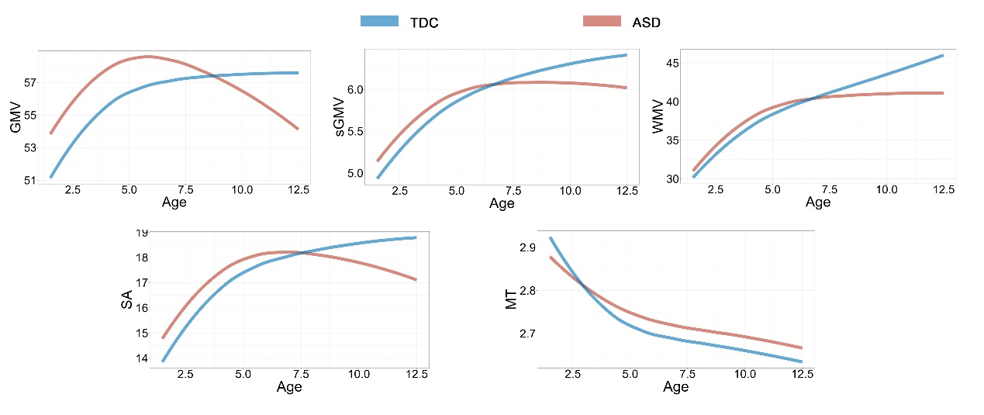
Figure S1. Leave-one-site-out (LOSO) analyses of typical and atypical trajectories in males for global morphometric phenotypes. The solid lines represent the 95% confidence intervals, computed from the mean and standard deviation of normative trajectories, repeatedly estimated after systematically excluding data from each contributing site in turn.

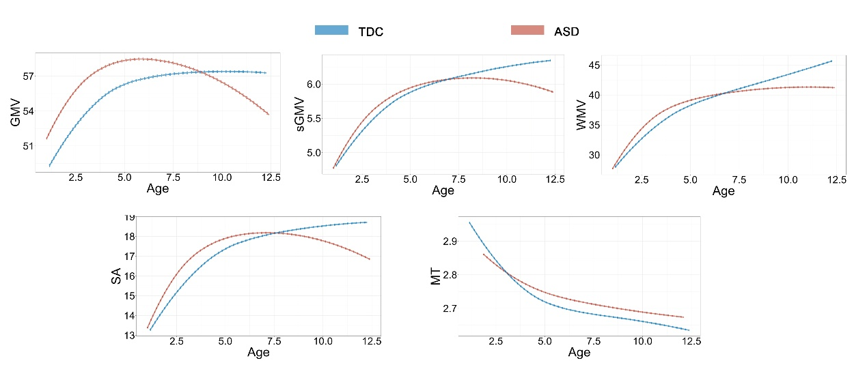
Figure S2. Bootstrap resampling of confidence intervals on typical and atypical trajectories in males for global morphometric phenotypes. The median (50% centile) is represented by a solid line, while the 95% centiles are indicated by dotted lines. 95% confidence intervals (estimated across random bootstrap iterations resampling with replacement) were computed from the mean and standard deviation of trajectories after 1000 iterations of a bootstrapping procedure designed to conserve the relative proportion of primary sites in each resampling with replacement from the representative dataset.

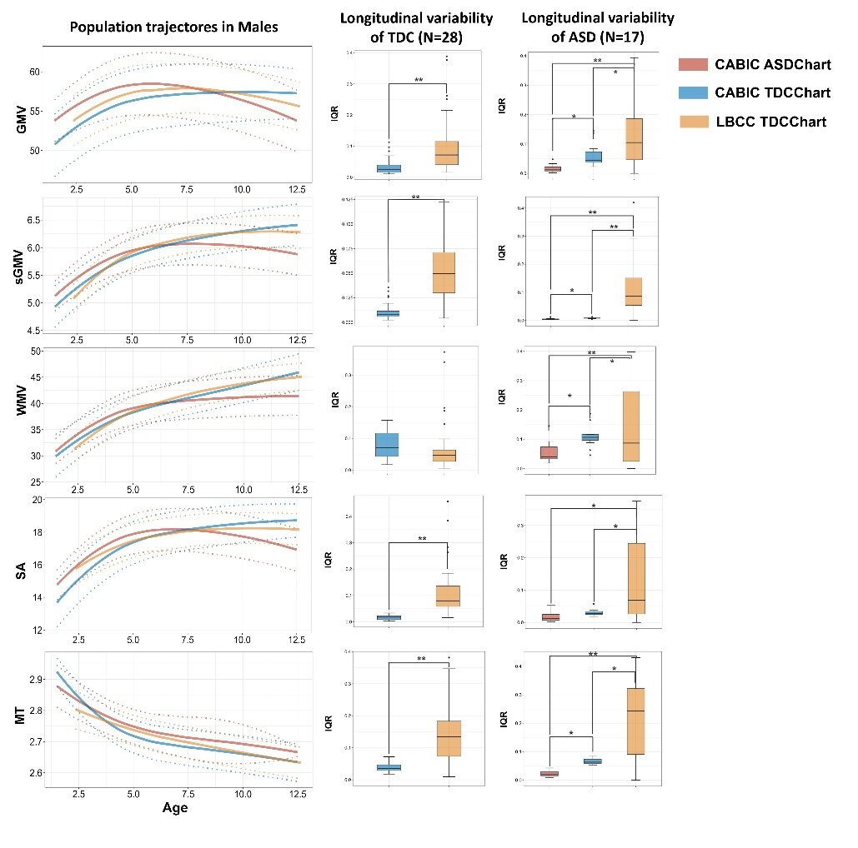
Figure S3. Comparison of brain charts independently estimated from the CABIC dataset with previously published brain charts from the Lifespan Brain Chart Consortium (LBCC). Left: Trajectories of global morphometric phenotypes. Right: Within-subject variation, quantified as the interquartile range (IQR) in longitudinal centile scores for global morphometric phenotypes, comparing different brain chart curves.
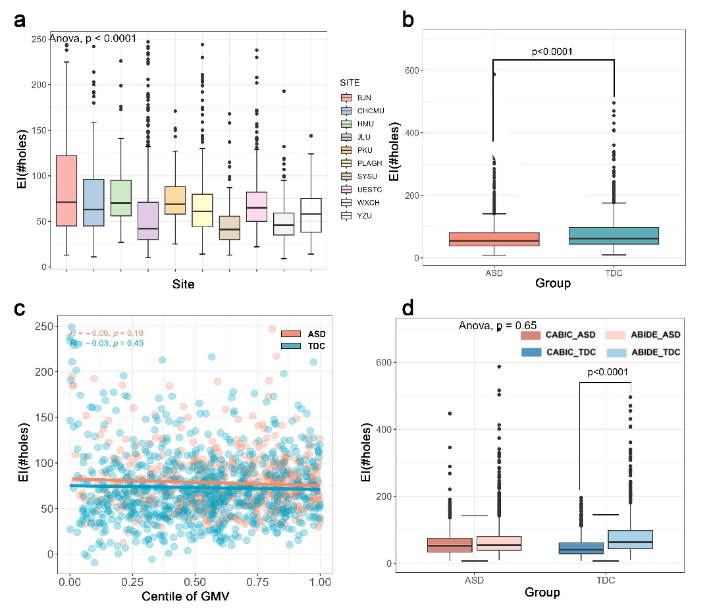
Figure S4. Complementary analyses of quality control metrics defined by the Euler Index (EI). (a) Bar plots showing the distribution of EI across all sites. (b) Significant between-group differences in EI between ASD and TDC groups. (c) Associations between individual deviation centile scores of GMV and MRI scan quality, as defined by EI. The Spearman correlations between EI and individual centile scores of GMV were negligible (ASD, p = 0.18; TDC, p = 0.45). (d) Differences in EI between the ABIDE and CABIC databases.

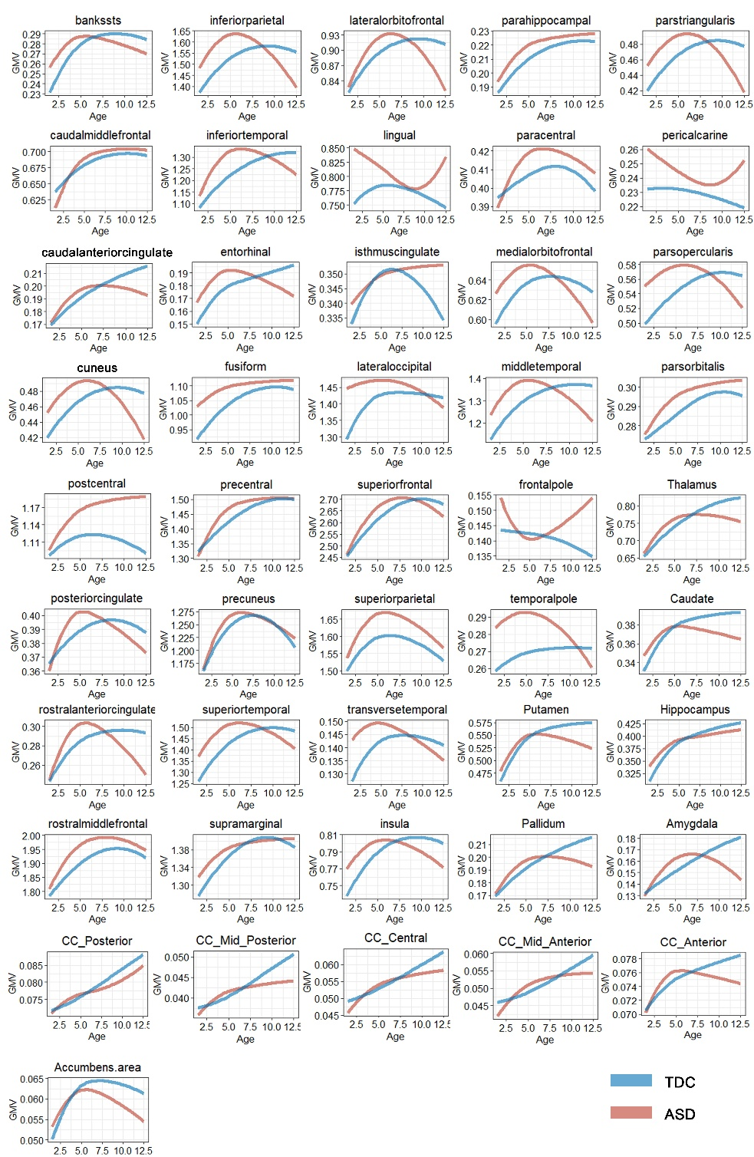
Figure S5. Typical and atypical trajectories of median regional volumes in males for 34 bilateral brain regions as defined by the Desikan-Killiany parcellation and 12 subcortical regions (with volumes normalized to 10,000 mm³). These trajectories were fitted to the raw data using the same GAMLSS model applied to estimate the global morphometric phenotype trajectories, as illustrated in Figure 2.
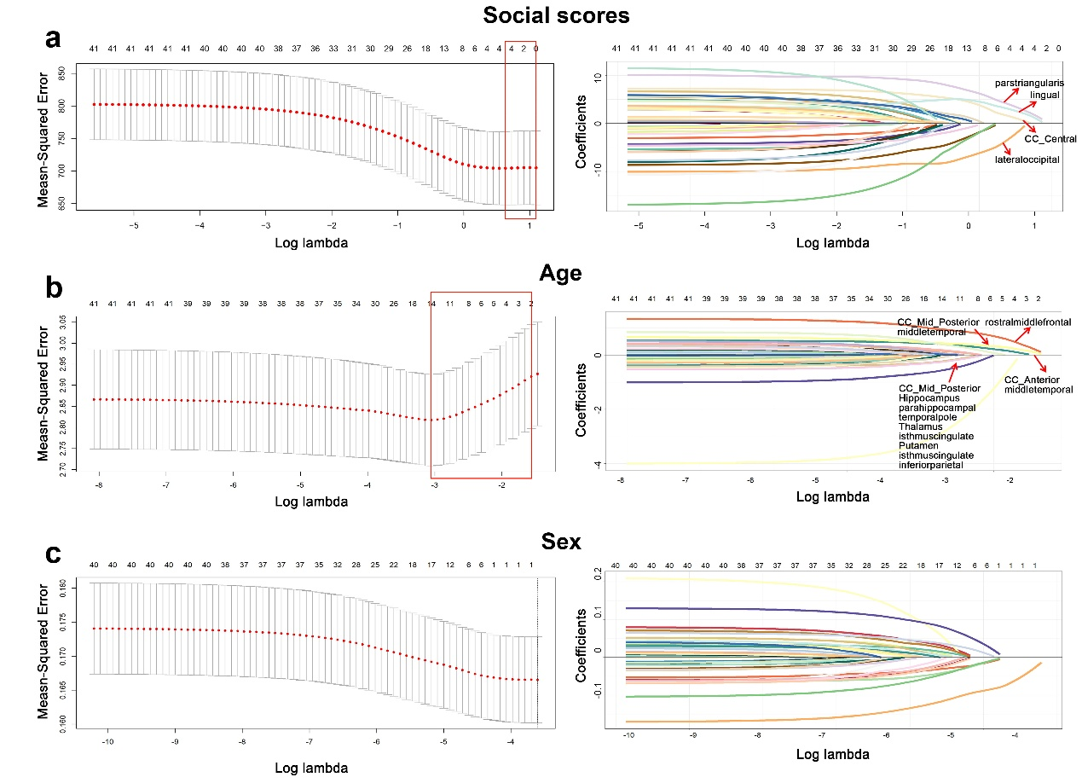
Figure S6. Brain areas that contributed significantly to social cognition deficit scores (a), age(b) and sex(c), based on Glmnet regression analysis. Left: Solution paths from the penalized regression with a lasso penalty were used to select the optimal model for the relationship between individualized deviation scores and social cognition deficit scores. The red box highlights the optimal lambda, as determined by cross-validation. Right: The complete solution path for all coefficients is shown as a function of the logarithmic tuning parameter, lambda, for the lasso penalty.

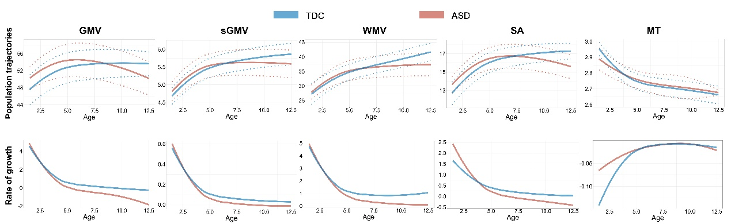
Figure S7. Typical and atypical brain growth chart of females. Top, typical and atypical trajectories of global morphometric phenotype. The median (50% centile) is represented by a solid line, while the 2.5% and 97.5% centiles are indicated by dotted lines. Bottom, rate of growth (the first derivatives of the median trajectory). y axes are scaled in units of the corresponding MRI metrics (10,000 mm³ for volume value, 10,000 mm² for surface area and mm for cortical thickness).

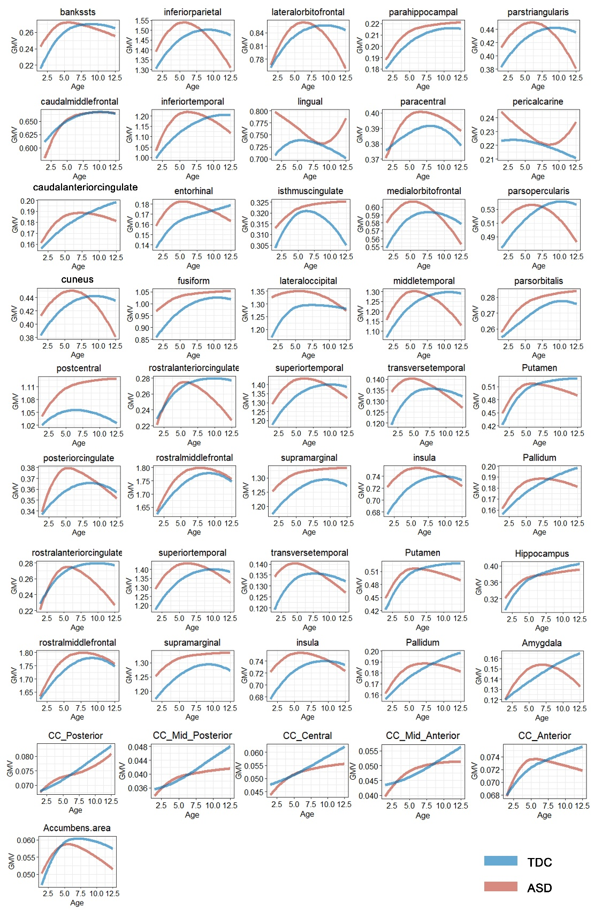
Figure S8. Typical and atypical trajectories of median regional volumes in females for 34 bilateral brain regions as defined in the Desikan-Killiany parcellation and 12 subcortical regions (10,000 mm³). These trajectories were fitted to the raw data using the same GAMLSS model used for estimation of global morphometric phenotype trajectories, as shown in Figure S7.

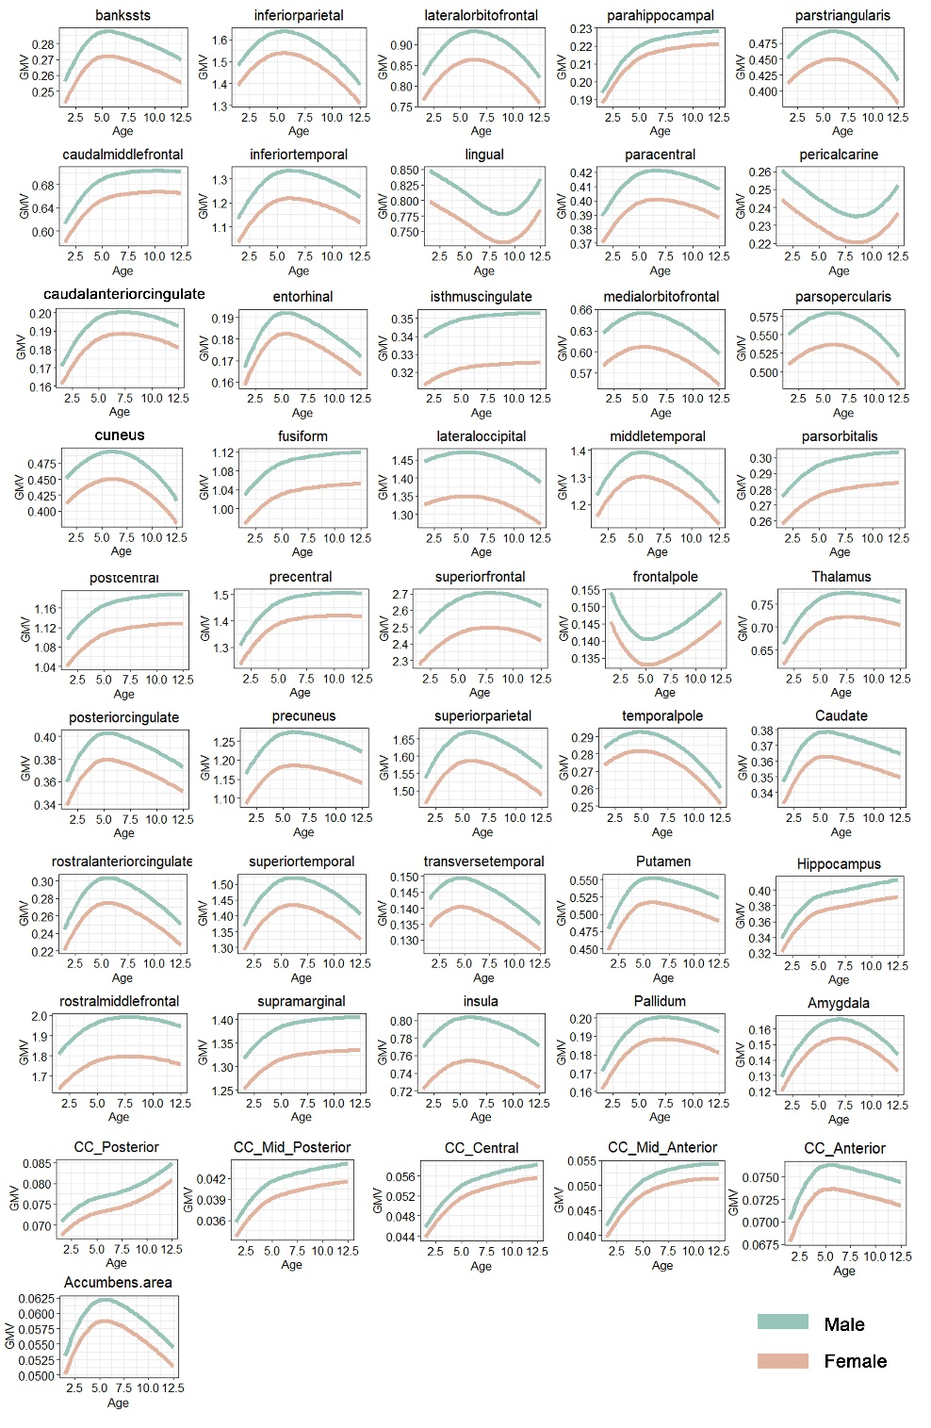
Figure S9. Sex-stratified atypical trajectories of median regional volumes in ASD (10,000 mm³).

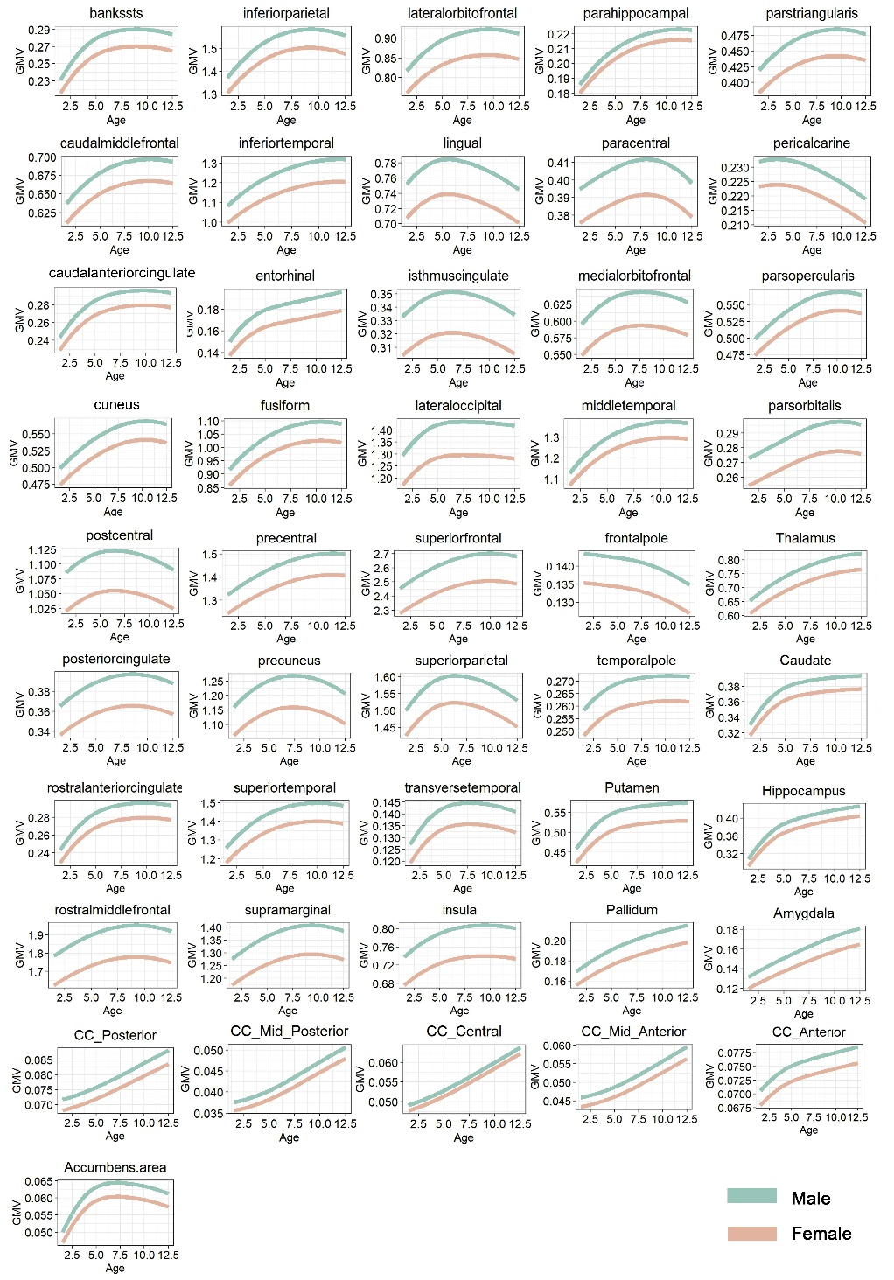
Figure S10. Sex-stratified atypical trajectories of median regional volumes in TDC (10,000 mm³).

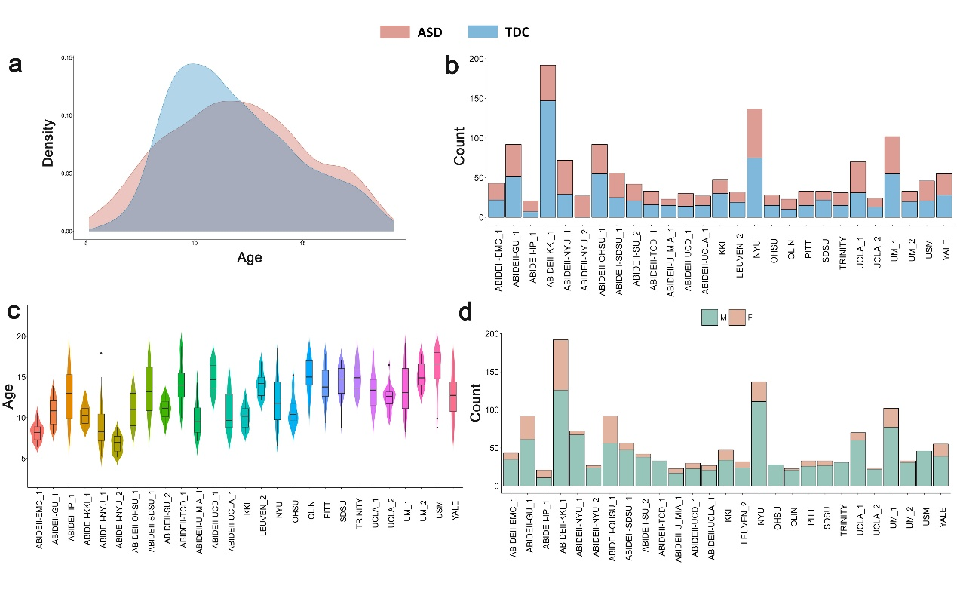
Figure S11. ABIDE Sample Characteristics (a) The distributions of age in ASD and TDC group (b) Total number of participants per group for each site. (c) Age (in years) for all individuals per site irrespective of diagnostic group. (d) Number of males and females for each site irrespective of diagnostic group.

Supplementary Tables
Table S1 Demographics and clinical characteristics of all participants in CABIC.
 |  | N | AGE  (year) | SEX  （M/F） | HANDEDNESS  (L/R/M) | IQ  (N) | DIGNOSIS  (N)
TOTAL | ASD | 1451 | 1.00~12.41 | 1150/301 | 30/837/46 | 286 | 727
TOTAL | TDC | 1119 | 1.00~12.92 | 692/427 | 18/763/35 | 259 | /
UESTC | ASD | 293 | 1.99~11.00 | 224/69 | 11/272/10 | 37 | 124
UESTC | TDC | 172 | 1.00~12.07 | 115/57 | 3/158/10 | 127 | /
JLU | ASD | 312 | 1.00~8.00 | 229/83 | / | 201 | 208
JLU | TDC | 48 | 1.00~12.9 | 31/17 | / | / | /
CHCMU | ASD | 146 | 2.00~6.92 | 407/31 | / | / | /
CHCMU | TDC | 100 | 1.25~10.25 | 32/68 | / | / | /
PLAGH | ASD | 135 | 1.52~12.40 | 108/27 | 0/135/0 | / | /
PLAGH | TDC | 79 | 3.96~11.00 | 52/27 | 0/135/0 | / | /
WXCH | ASD | 111 | 1.82~10.01 | 83/28 | 0/111/0 | 106 | 92
WXCH | TDC | 89 | 1.14~12.80 | 47/42 | 0/45/0 | / | /
SYSU | ASD | 109 | 2.15~11.69 | 94/15 | 9/74/26 | 106 | 109
SYSU | TDC | 81 | 5.26~12.64 | 47/34 | 6/68/7 | 81 | /
GWCMC | ASD | 79 | 3.05~12.00 | 63/16 | / | / | /
GWCMC | TDC | 95 | 2.8~9.00 | 59/36 | / | / | /
PKU | ASD | 98 | 3.00~5.81 | 87/11 | 3/82/10 | / | 96
PKU | TDC | 30 | 3.94~5.57 | 24/6 | 0/23/7 | / | /
YZU | ASD | 125 | 3.05~12.25 | 111/14 | 0/125/0 | / | 55
YZU | TDC | / | / | / | / | / | /
HMU | ASD | 43 | 2.92~7.94 | 36/7 | 7/36/0 | 37 | 43
HMU | TDC | 58 | 3.18~8.04 | 48/10 | 3/55/0 | 51 | /
BNU | ASD | / | / | / | / | / | /
BNU | TDC | 367 | 4.5~12.9 | 207/160 | 6/355/11 | / | /
Note: An assessment is considered to include an intelligence quotient (IQ) score if it involves one of the following measures: the Wechsler Intelligence Scale for Children (WISC), Gesell Developmental Schedules (GDS), or the Peabody Picture Vocabulary Test (PPVT). A clinical symptom score is recorded if the assessment includes one of the following: The Autism Diagnostic Interview-Revised (ADI-R), Autism Diagnostic Observation Schedule (ADOS), Childhood Autism Rating Scale (CARS), or Autism Behavior Checklist (ABC).

