Supporting Information
Towards the Direct Detection of Viral Materials at the Surface of Protective Face Masks via Infrared Spectroscopy

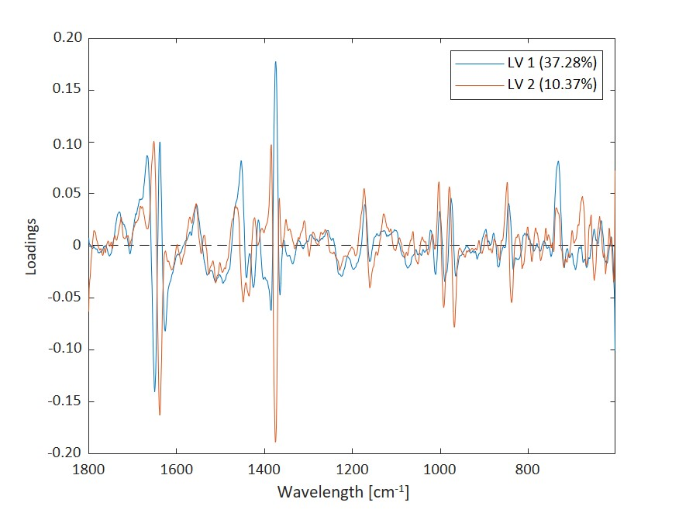
Vanessa Schorer, ª Julian Haas, ^{b} Robert Stach, ^{b} Vjekoslav Kokoric, ^{b} Jan Münch, ^{c} Rüdiger Groß, ^{c} Tim Hummel, ^{d, e} Harald Sobek, ^{d} Jan Mennig, ^{d} and Boris Mizaikoff ^{a, b, *}
Figure SI 1 Loadings of the PLS-DA model of differently treated face masks (H₂O and BSA). The loadings on LV 1 and LV 2 depict the characteristic H₂O bending around 1640-1670 cm⁻¹.

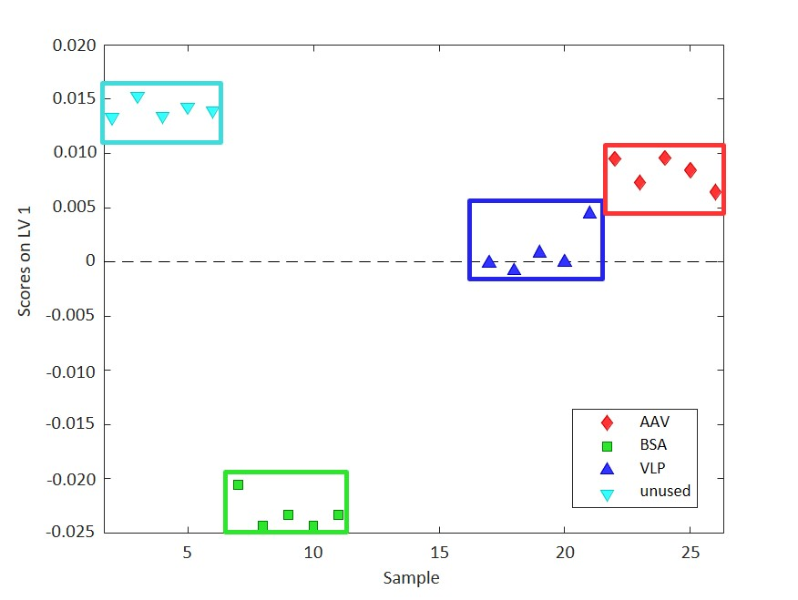  A | 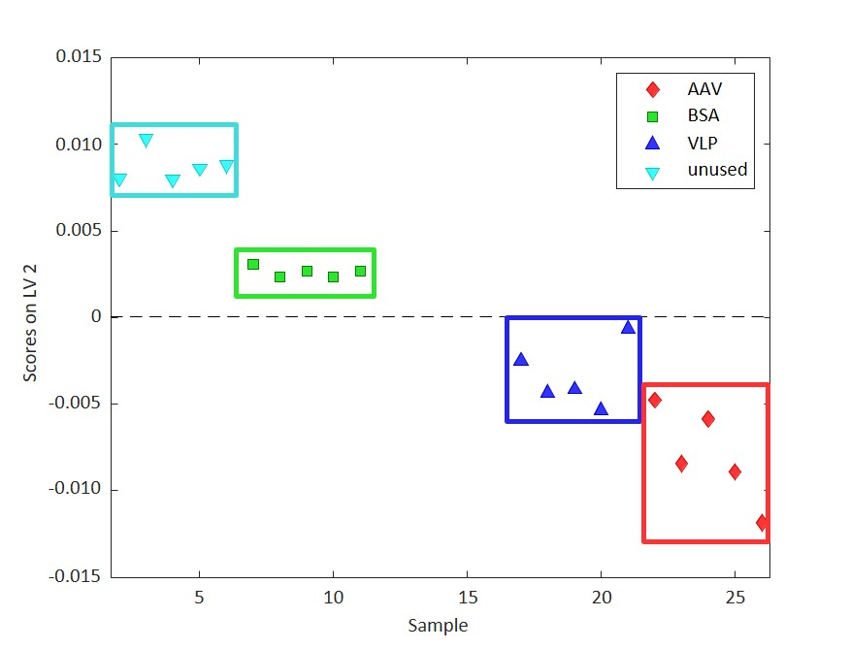  B
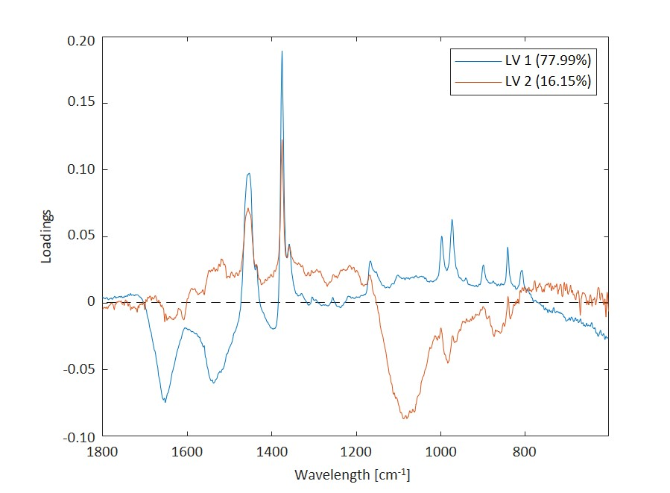
Figure SI 2 Comparison of the scores on LV 1 and LV 2 for the PLS-DA model of face masks comparing four different classes using ATR FT-IR spectral data. (A) Especially, the BSA class (green) segregates on LV 1. (B) According to the scores of LV 2 a differentiation of the classes unused/BSA versus AAV/VLP was achieved.

Figure SI 3 Loadings of LV 1 and LV 2 of the PLS-DA model evaluating different treated face masks (unused/BSA/VLP/AAV). Intensive peaks around 1375 cm⁻¹ indicate the sprayed-on proteins lead to changes in polymer matrix of polypropylene.

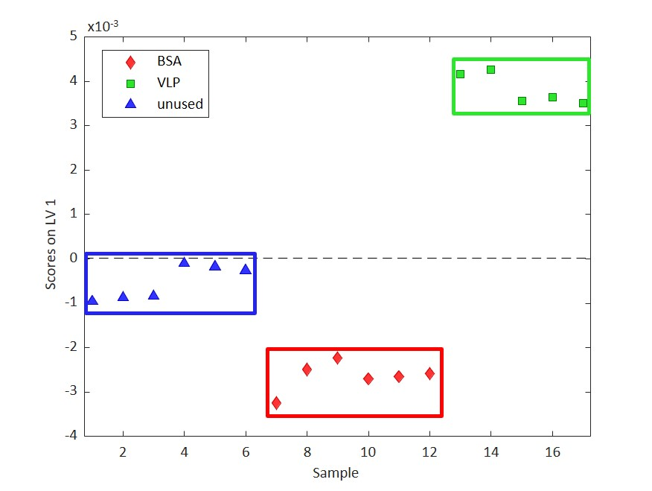  A | 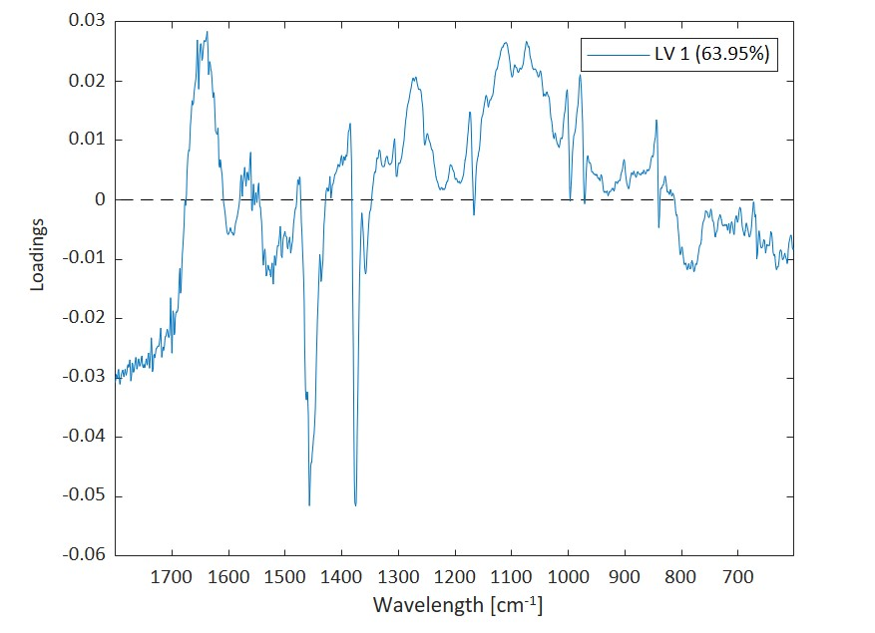  B
Figure SI 4 PLS-DA of ER FT-IR measurements analysing unused face masks with face masks on which BSA and VLPs were applied. The clear discrimination between VLPs and BSA shows that even two proteins can be classified

