Supplemental Table 1. Absolute number of sepsis and DM-related deaths stratified by sex and race in the United States, 1999-2020.

Year | Overall | Females | Males | White | Black or African American |  | Asian or Pacific Islander | American Indian or Alaskan Native | Hispanic or Latino
1999 | 15670 | 8958 | 6712 | 11642 |  | 3534 | 330 | 164 | 1397
2000 | 15601 | 8855 | 6746 | 11560 |  | 3563 | 334 | 144 | 1492
2001 | 16194 | 9153 | 7041 | 12076 |  | 3622 | 351 | 145 | 1656
2002 | 16679 | 9354 | 7325 | 12410 |  | 3699 | 403 | 167 | 1671
2003 | 17131 | 9513 | 7618 | 12818 |  | 3674 | 467 | 172 | 1786
2004 | 17248 | 9426 | 7822 | 12883 |  | 3727 | 446 | 192 | 1817
2005 | 18236 | 9879 | 8357 | 13531 |  | 4001 | 525 | 179 | 2013
2006 | 17511 | 9468 | 8043 | 13086 |  | 3701 | 535 | 189 | 1963
2007 | 17283 | 9136 | 8147 | 12884 |  | 3714 | 497 | 188 | 2020
2008 | 17082 | 9062 | 8020 | 12880 |  | 3475 | 541 | 186 | 1924
2009 | 16467 | 8562 | 7905 | 12484 |  | 3232 | 556 | 195 | 1927
2010 | 16591 | 8646 | 7945 | 12611 |  | 3239 | 543 | 198 | 2013
2011 | 16960 | 8863 | 8097 | 12928 |  | 3231 | 570 | 231 | 2139
2012 | 16509 | 8504 | 8005 | 12703 |  | 3011 | 559 | 236 | 2035
2013 | 17045 | 8738 | 8307 | 13142 |  | 3044 | 620 | 239 | 2208
2014 | 17375 | 8650 | 8725 | 13470 |  | 3034 | 640 | 231 | 2284
2015 | 18527 | 9251 | 9276 | 14439 |  | 3144 | 692 | 252 | 2405
2016 | 19390 | 9384 | 10006 | 15096 |  | 3350 | 689 | 255 | 2576
2017 | 19867 | 9557 | 10310 | 15555 |  | 3184 | 851 | 277 | 2744
2018 | 20217 | 9578 | 10639 | 15674 |  | 3446 | 801 | 296 | 2683
2019 | 20257 | 9513 | 10744 | 15767 |  | 3352 | 850 | 288 | 2754
2020 | 28663 | 13132 | 15531 | 21858 |  | 5081 | 1299 | 425 | 5056
Total | 396503 | 205182 | 191321 | 301497 |  | 77058 | 13099 | 4849 | 48563

Supplemental Table 2. Overall and sex-stratified sepsis and DM-related age-adjusted mortality rates per 100,000 among adults in the United States, 1999 to 2020.

Year | Overall | Male | Female
1999 | 8.88 | 9.24 | 8.64
2000 | 8.73 | 9.19 | 8.45
2001 | 8.9 | 9.34 | 8.65
2002 | 8.99 | 9.53 | 8.71
2003 | 9.09 | 9.67 | 8.75
2004 | 9.02 | 9.77 | 8.52
2005 | 9.35 | 10.15 | 8.81
2006 | 8.81 | 9.56 | 8.31
2007 | 8.53 | 9.47 | 7.88
2008 | 8.27 | 9.11 | 7.68
2009 | 7.86 | 8.76 | 7.14
2010 | 7.76 | 8.66 | 7.12
2011 | 7.72 | 8.51 | 7.14
2012 | 7.3 | 8.22 | 6.67
2013 | 7.43 | 8.29 | 6.75
2014 | 7.35 | 8.42 | 6.55
2015 | 7.67 | 8.77 | 6.84
2016 | 7.88 | 9.28 | 6.82
2017 | 7.82 | 9.25 | 6.77
2018 | 7.85 | 9.38 | 6.68
2019 | 7.7 | 9.22 | 6.5
2020 | 10.68 | 12.96 | 8.88
Total | 8.3 | 9.3 | 7.58
Supplemental Table 3. Sepsis and DM-related age-adjusted mortality rates per 100,000 among adults stratified by race/ethnicity in the United States, 1999 to 2020.

Year | White | Black or African American | Asian or Pacific Islander | American Indian or Alaskan Native | Hispanic or Latino
1999 | 7.43 | 22.73 | 8.13 | 18.10 | 15.25
2000 | 7.31 | 22.79 | 7.62 | 14.85 | 15.77
2001 | 7.53 | 22.5 | 7.63 | 14.25 | 16.47
2002 | 7.62 | 22.68 | 7.9 | 15.52 | 15.7
2003 | 7.78 | 21.98 | 8.78 | 14.38 | 15.63
2004 | 7.71 | 21.91 | 8.02 | 15.48 | 15.34
2005 | 7.98 | 22.79 | 8.72 | 13.69 | 16.04
2006 | 7.58 | 20.45 | 8.43 | 14.06 | 14.84
2007 | 7.36 | 20.19 | 7.59 | 13.44 | 14.77
2008 | 7.2 | 18.34 | 7.83 | 13.34 | 13.07
2009 | 6.89 | 16.5 | 7.55 | 13.13 | 12.64
2010 | 6.85 | 16.26 | 7.05 | 11.88 | 12.71
2011 | 6.86 | 15.72 | 6.75 | 14.11 | 12.43
2012 | 6.56 | 14.03 | 6.3 | 13.27 | 11.25
2013 | 6.69 | 13.73 | 6.58 | 12.36 | 11.65
2014 | 6.69 | 13.1 | 6.38 | 11.66 | 11.3
2015 | 7.06 | 13.14 | 6.41 | 12.56 | 11.27
2016 | 7.26 | 13.57 | 5.99 | 11.82 | 11.51
2017 | 7.26 | 12.41 | 7.05 | 12.35 | 11.71
2018 | 7.28 | 13.06 | 6.21 | 12.44 | 10.99
2019 | 7.13 | 12.4 | 6.35 | 11.94 | 10.75
2020 | 9.78 | 18.1 | 9.15 | 16.11 | 18.5
Total | 7.34 | 16.99 | 7.2 | 13.33 | 13.22

Supplemental Table 4. Sepsis and DM related age-adjusted mortality rates per 100,000 among adults in the United States, 1999-2020.

Census Region | Year | Age Adjusted Rate
Northeast | 1999 | 9.1
Northeast | 2000 | 8.99
Northeast | 2001 | 9.43
Northeast | 2002 | 8.98
Northeast | 2003 | 8.73
Northeast | 2004 | 8.8
Northeast | 2005 | 9.2
Northeast | 2006 | 8.63
Northeast | 2007 | 8.24
Northeast | 2008 | 7.61
Northeast | 2009 | 6.85
Northeast | 2010 | 6.99
Northeast | 2011 | 7.04
Northeast | 2012 | 6.6
Northeast | 2013 | 6.81
Northeast | 2014 | 6.74
Northeast | 2015 | 6.74
Northeast | 2016 | 6.52
Northeast | 2017 | 6.27
Northeast | 2018 | 6.14
Northeast | 2019 | 6.08
Northeast | 2020 | 7.78
Northeast | Total | 7.55
Midwest | 1999 | 7.92
Midwest | 2000 | 7.72
Midwest | 2001 | 7.63
Midwest | 2002 | 7.72
Midwest | 2003 | 8.17
Midwest | 2004 | 8.08
Midwest | 2005 | 8.29
Midwest | 2006 | 7.77
Midwest | 2007 | 7.73
Midwest | 2008 | 7.39
Midwest | 2009 | 7.19
Midwest | 2010 | 6.79
Midwest | 2011 | 7.06
Midwest | 2012 | 6.49
Midwest | 2013 | 6.56
Midwest | 2014 | 6.64
Midwest | 2015 | 6.8
Midwest | 2016 | 6.65
Midwest | 2017 | 6.65
Midwest | 2018 | 6.8
Midwest | 2019 | 6.7
Midwest | 2020 | 9.21
Midwest | Total | 7.31
South | 1999 | 9.75
South | 2000 | 9.66
South | 2001 | 9.9
South | 2002 | 10.2
South | 2003 | 10.14
South | 2004 | 9.94
South | 2005 | 10.23
South | 2006 | 9.53
South | 2007 | 9.13
South | 2008 | 9
South | 2009 | 8.52
South | 2010 | 8.35
South | 2011 | 7.98
South | 2012 | 7.8
South | 2013 | 7.84
South | 2014 | 7.75
South | 2015 | 8.16
South | 2016 | 8.65
South | 2017 | 8.57
South | 2018 | 8.81
South | 2019 | 8.56
South | 2020 | 12.13
South | Total | 9.08
West | 1999 | 8.14
West | 2000 | 7.84
West | 2001 | 7.98
West | 2002 | 8.44
West | 2003 | 8.66
West | 2004 | 8.65
West | 2005 | 9.13
West | 2006 | 8.83
West | 2007 | 8.63
West | 2008 | 8.53
West | 2009 | 8.12
West | 2010 | 8.41
West | 2011 | 8.53
West | 2012 | 7.95
West | 2013 | 8.04
West | 2014 | 7.91
West | 2015 | 8.45
West | 2016 | 8.8
West | 2017 | 9.07
West | 2018 | 8.67
West | 2019 | 8.47
West | 2020 | 11.96
West | Total | 8.63

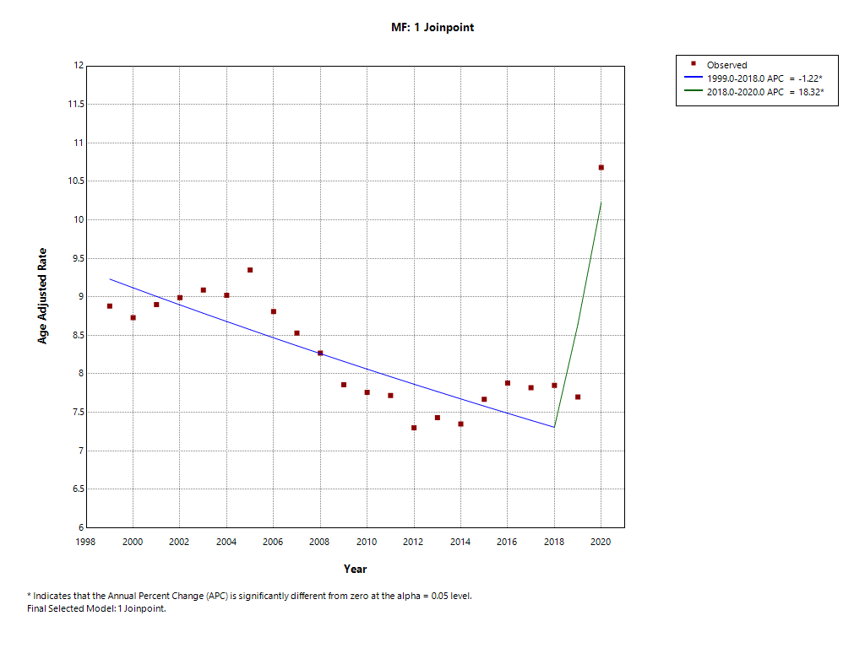

Supplemental Figure 1: Annual trends in overall sepsis and DM related mortality

