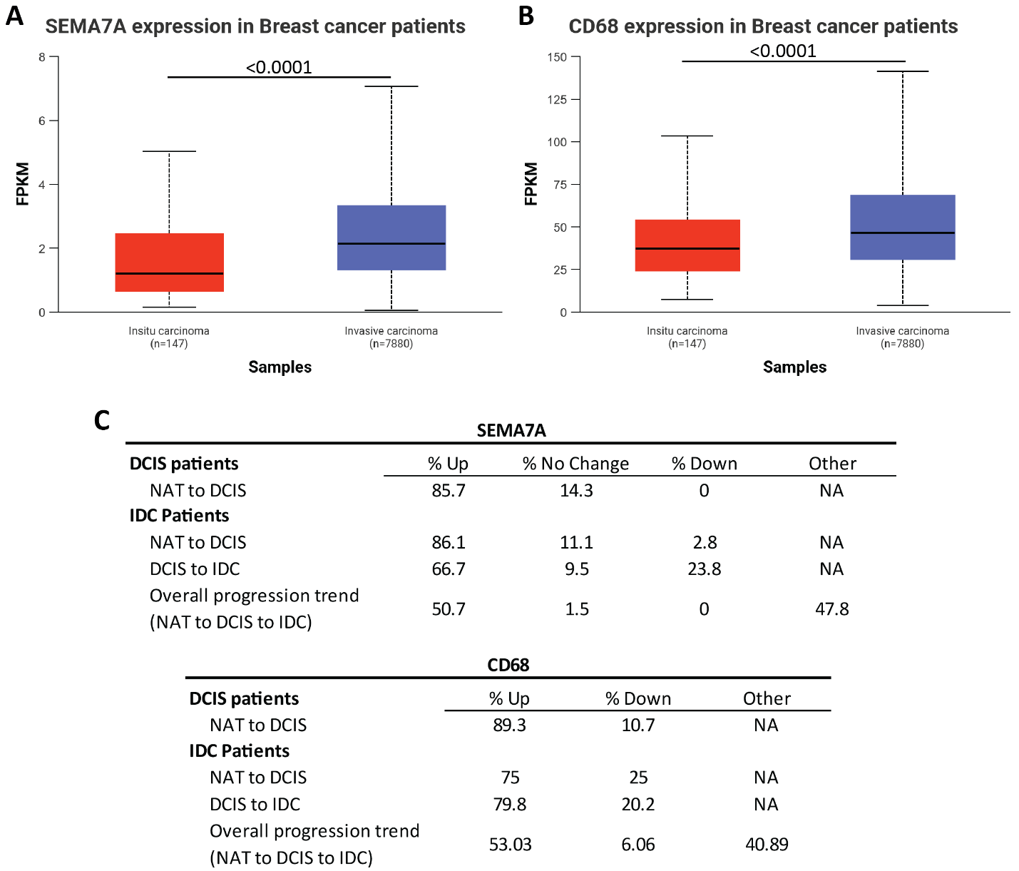
Supplement Figure 1: (A-B) TCGA data for SEMA7A (A) and CD68 (B) in in situ breast cancer (n=147) and invasive breast cancer (n=7880). (C) Percent changes in quantitative IHC for SEMA7A and CD68 in tumor microarrays for NAT, DCIS and IDC tissues from patients with DCIS or DCIS+IDC. Pattern of decreasing, increasing, or no change in expression for SEMA7A or CD68 as a percentage of total paired tissues in TMA2. Overall progression defined as invasion progression from NAT to DCIS to IDC.
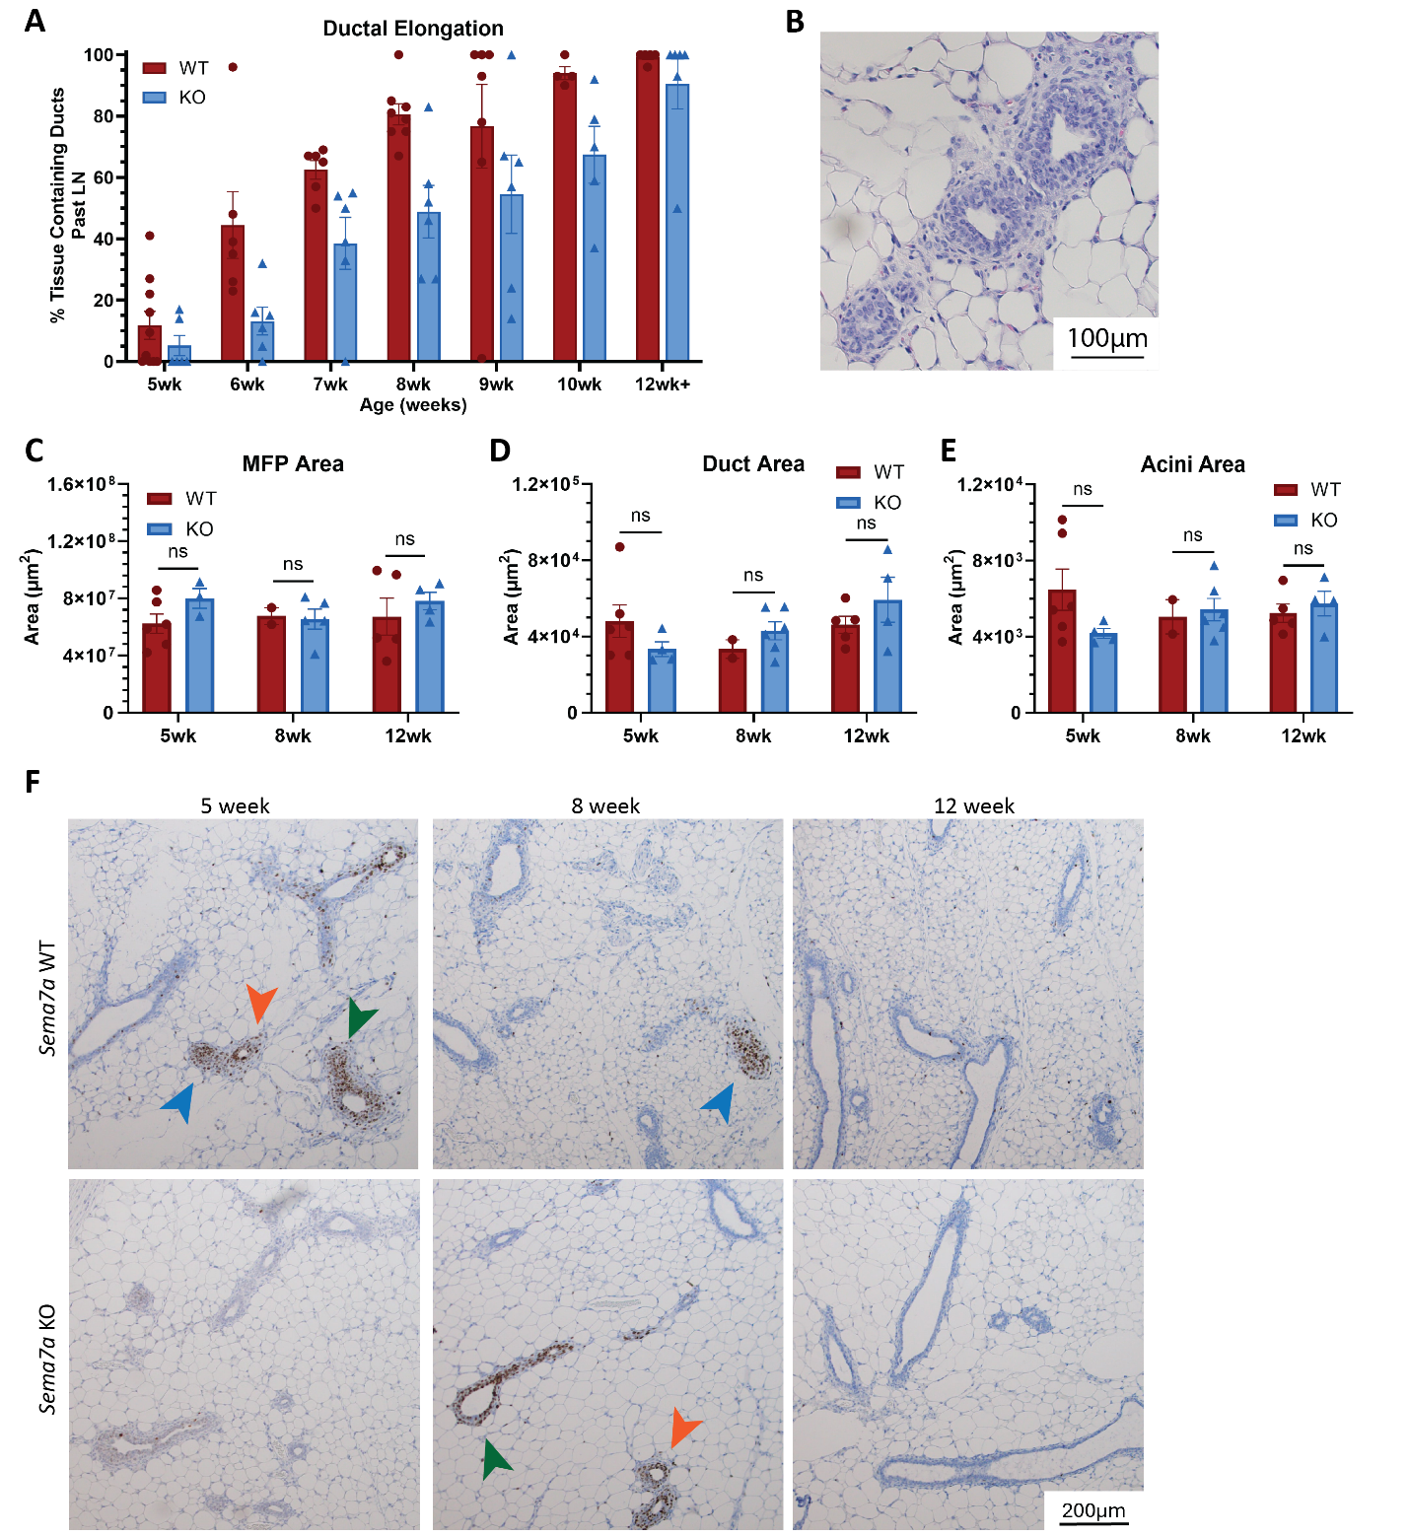
Supplement Figure 2: (A) Quantification of ductal elongation in WT and KO as a percent of tissue invasion past the lymph node during pubertal development at 5 weeks to 12-13 weeks. (B) Representative H&E image of TEB structures at 5 weeks in the Sema7a KO mouse. (C) Quantification of MFP area. (D) Quantification of duct area. (E) Quantification of acini area. P-values determined by two-tailed t-test (B-D). (F) Representative images of Ki67+ mammary gland epithelial structures during pubertal development timepoints. Arrows pointing at proliferative structures (TEBs, blue; ducts, green; acini, orange).
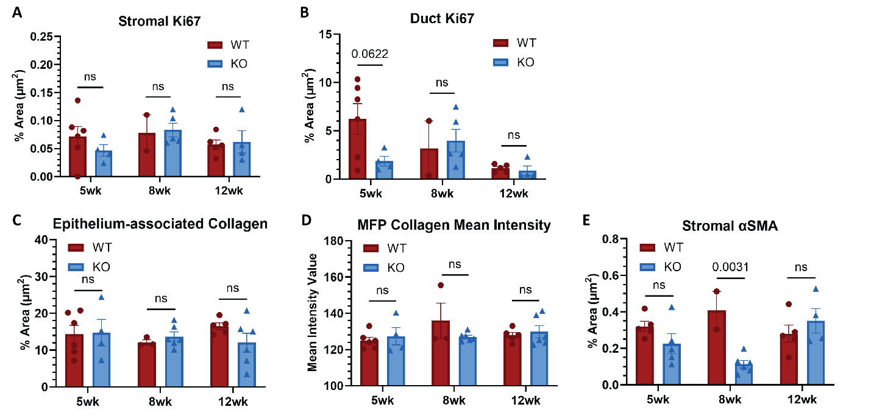
Supplement Figure 3: (A) Quantification of stromal Ki67 IHC as a percent area of the stroma. Two-way ANOVA, p_{timepoint}=0.4317, p_{strain}=0.7219, p_{interaction}=0.5475. (B) Quantification of Ki67 IHC in ducts as a percent area of ducts. Two-way ANOVA, p_{timepoint}=0.0403, p_{strain}=0.2369, p_{interaction}=0.01109. (C) Quantification of epithelium-associated collagen as a percent area of epithelial structures. Two-way ANOVA, p_{timepoint}=0.7236, p_{strain}=0.9216, p_{interaction}=0.7436. (D) Quantification of collagen mean intensity. Two-way ANOVA, p_{timepoint}=0.3506, p_{strain}=0.5985, p_{interaction}=0.2292. (E) Quantification of stromal αSMA as a percent area of stroma. Two-way ANOVA, p_{timepoint}=0.5239, p_{strain}=0.0164, p_{interaction}=0.0084. (A-E) p values determined by two-tailed t-test.
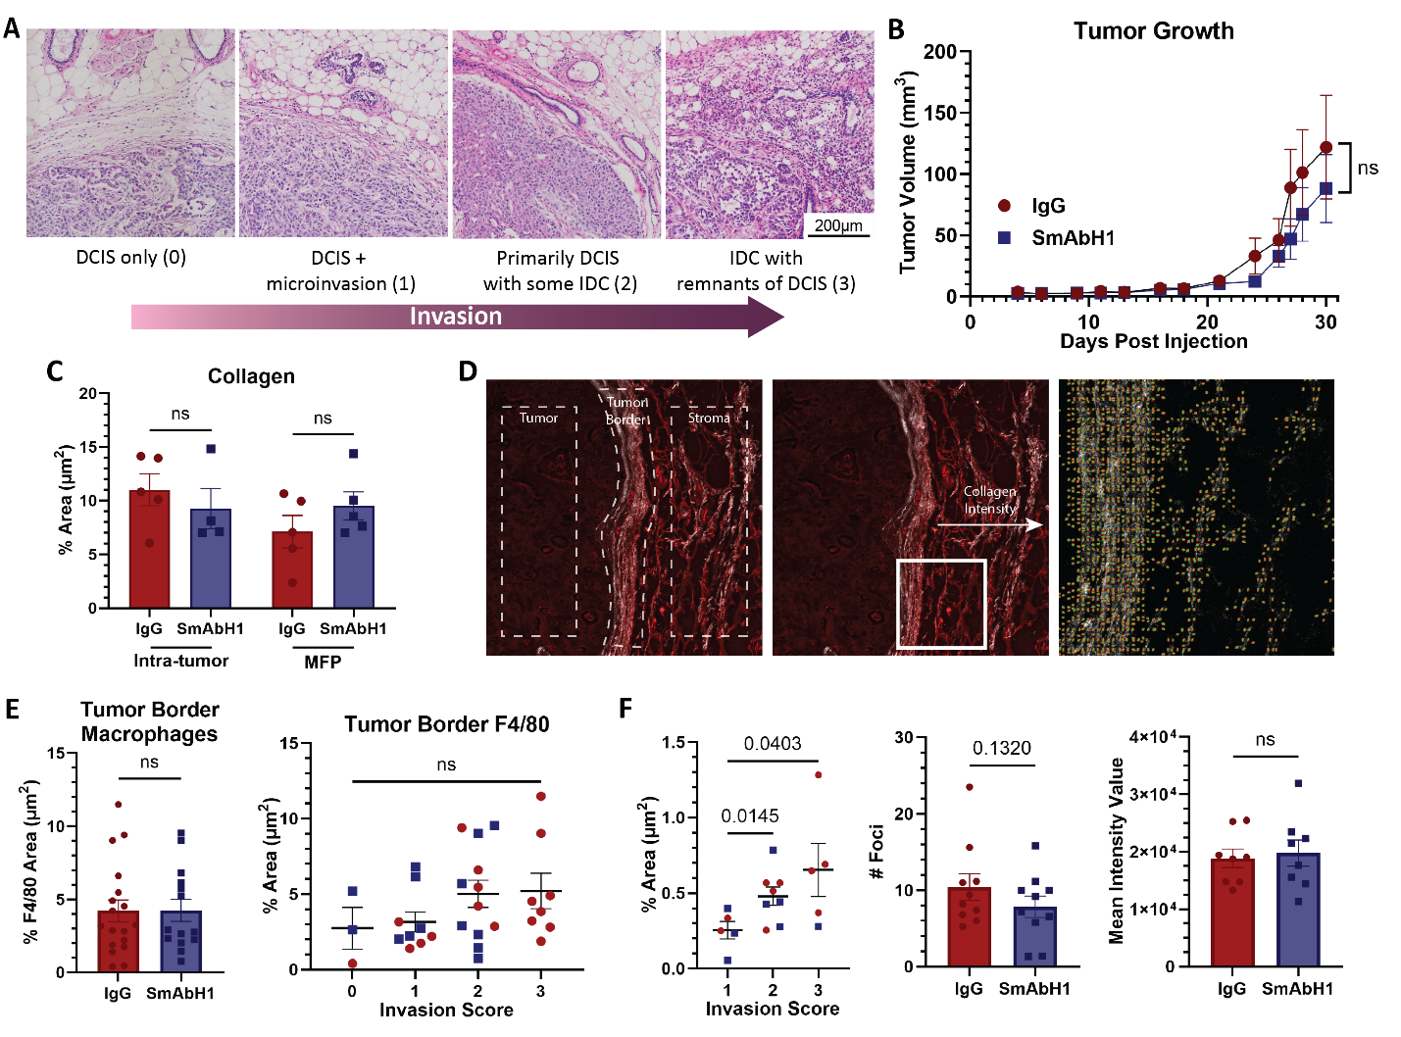
Supplement Figure 4: (A) Representative images demonstrating invasion scoring system. (B) Quantification of tumor volume per treatment group. IgG, SmAbH1, n=10. (C) Quantification of collagen expression as a percent area in the tumor or MFP by treatment group. (D) Representative images of collagen analysis. (left) Designation of regions for tumor, tumor border, and stroma analysis. (middle) Arrow depicting direction and location of SHG collagen intensity analysis, from tumor border through stroma. (right) Zoomed image of white box region showing fiber analysis for alignment and orientation (green lines) with middle focal point (red lines). (E) Quantification of F4/80 positive macrophages as a percent of the tumor border by treatment group (left) and invasion score (right). (F) Quantification of DQ-gelatin assay percent area by treatment group, number of positive foci, and mean intensity. (C, E-F) P values determined by one-tailed t-test.
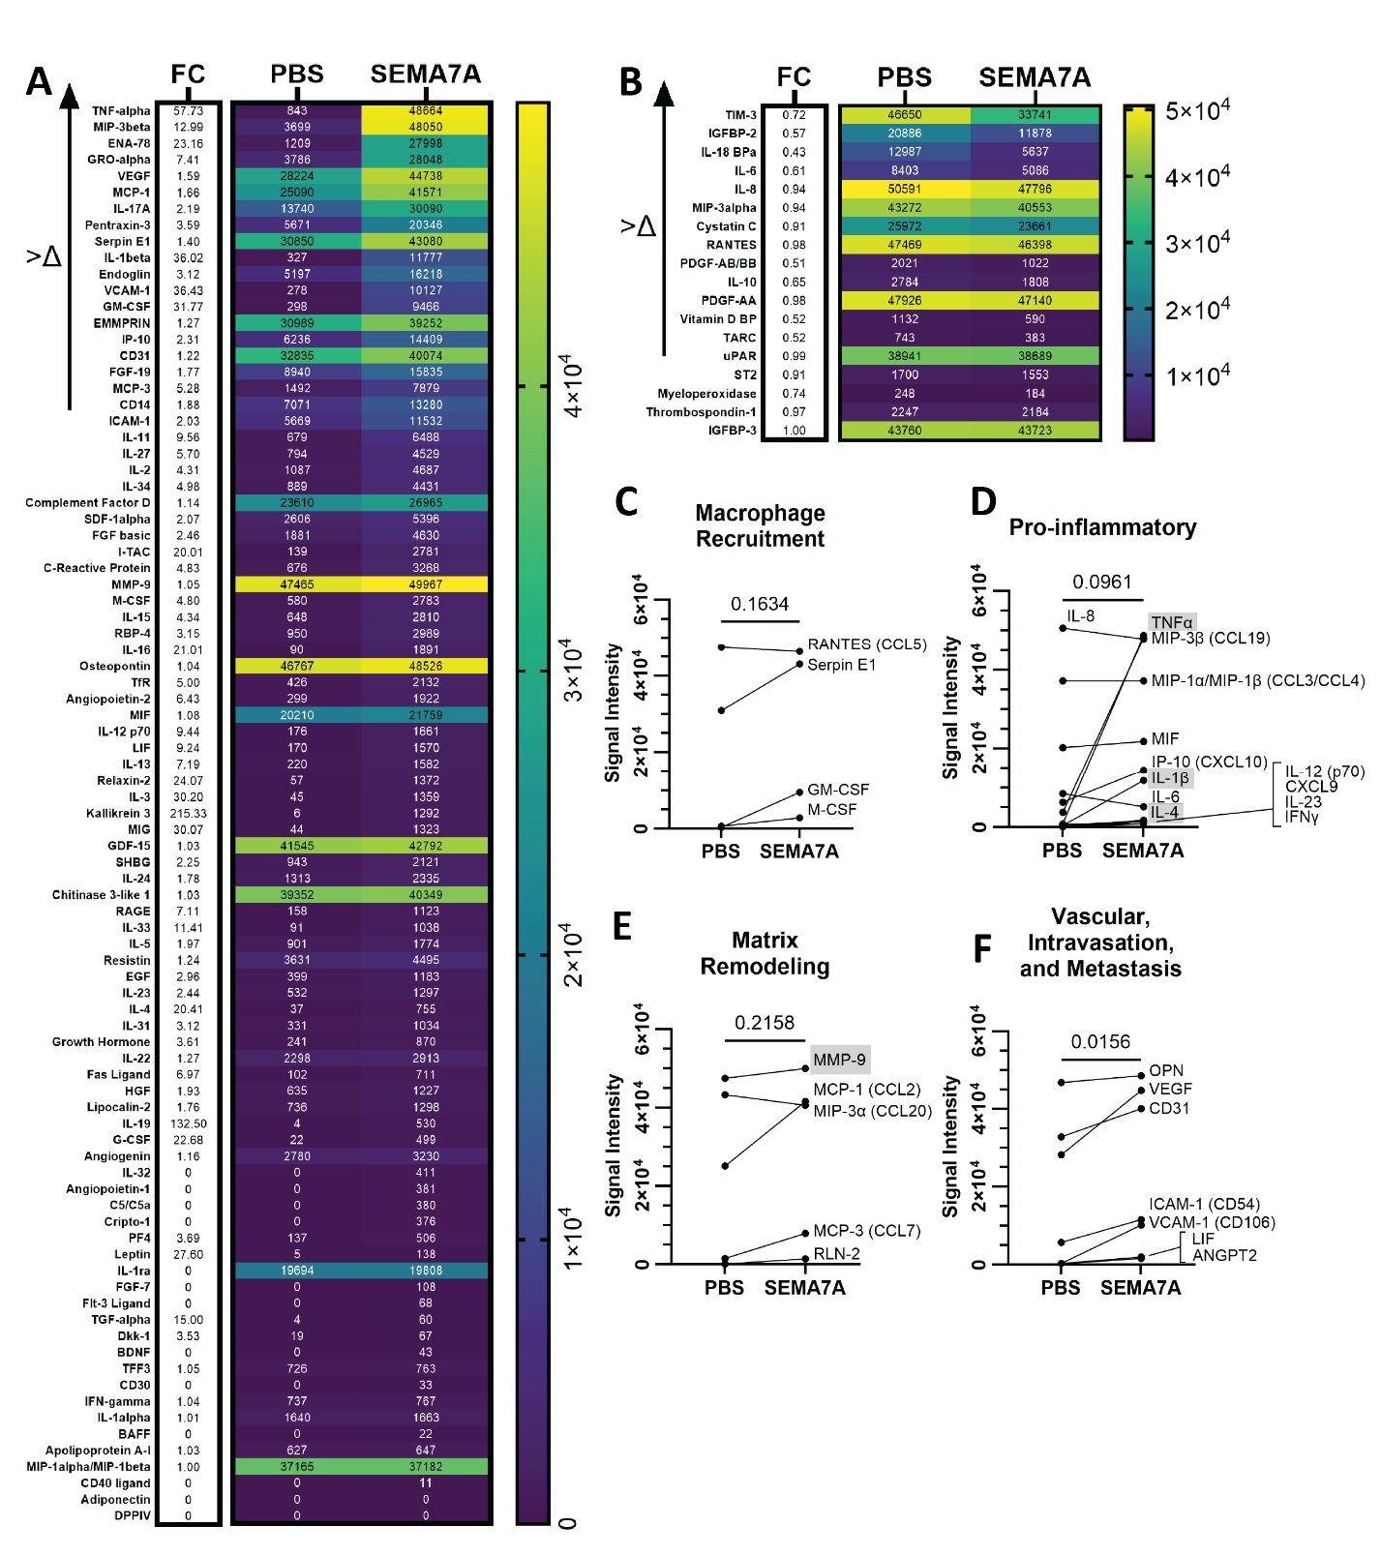
Supplement Figure 5: (A-B) Cytokine array of conditioned media from THP-1 macrophages treated with SEMA7A. Cytokines organized as those that increased (A) or decreased (B) with SEMA7A treatment. Raw signal values are depicted on the right with fold-change (FC) compared to PBS on the left. (C-F) Specific cytokines of interest by functional groups.
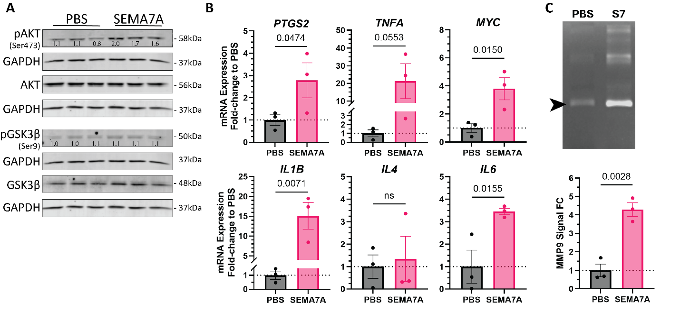
Supplement Figure 6: (A) Western blot of cell lysates from THP-1 macrophages treated with PBS or 40ug/mL SEMA7A. Phosphorylated protein signal values were normalized to GAPDH and total protein then fold change to average PBS. (B) qPCR analysis of β-catenin target genes in THP-1 macrophages as relative mRNA expression fold-change (FC) to PBS: Ptgs2, Tnfa, Myc, Il1b, Il4, and Il6. (C) MMP gel zymography of conditioned media from THP-1 macrophages treated with PBS or SEMA7A. (top) Representative image of zymography gel showing white signal bands for MMP activity, including MMP9 (black arrow, 82kDa). (bottom) Quantification of MMP9 signal intensity as fold change to average PBS. P values determined by one-tailed (B) or two-tailed (C) t-test.

