Table S1 Description of the geographic and restoration information for the sampling sites
Sites | Restoration dynamics (in years) | Location | Altitude (m) | Supply water | Main plant species
CK | Degraded wetland (0) | 37°43′24″N, 119°01′05″E | 0 | Tides and precipitation | None
Y4 | Habitat island (4) | 37°45′15″N, 119°01′09″′E | 1 | Precipitation and freshwater from the Yellow River | Phragmites australis, Sonchus brachyotus
Y8 | Habitat island (8) | 37°43′38″N, 119°01′25″′E | 1 | Precipitation and freshwater from the Yellow River | Utricularia australis, Glycine soja
Y11 | Conservation area (11) | 37°45′36″N, 118°58′50″E | 3 | Precipitation | Phragmites australis, Imperata cylindrica
Y20 | Habitat island (20) | 37°45′21″N, 119°01′24″E | 2.1 | Precipitation and freshwater from the Yellow River | Phragmites australis, Imperata cylindrica

Table S2 Variations in vegetation and soil characteristics with vegetation restoration age.
Environmental variables | vegetation restoration age (in years) |  |  |  |  | F | P
Environmental variables | CK | Y4 | Y8 | Y11 | Y20 | F | P
Coverage | 0.00±0.00c | 40.67±11.68ab | 64±11.83a | 40±7.81ab | 26±3.06b | 7.32 | **
AGB (g·m⁻²) | 0.00±0.00b | 498±78.29a | 458.24±141.15a | 354.11±53.48a | 590.55±98.53a | 5.33 | **
BGB (g·m⁻²) | 0.00±0.00c | 94.90±5.52b | 107.01±19.62b | 426.50±135.55a | 559.87±26.84a | 8.51 | ***
Shannon index | 0.00±0.00b | 0.62±0.13a | 0.68±0.19a | 0.92±0.14a | 0.51±0.13a | 5.51 | **
Pielou index | 0.00±0.00b | 0.67±0.06a | 0.54±0.11a | 0.71±0.11a | 0.54±0.08a | 8.84 | ***
Richeness index | 0.00±0.00c | 2±0.58b | 3.4±0.4a | 3.8±0.37a | 2±0.58b | 14.55 | ***
pH | 8.59±0.93a | 7.78±0.05b | 7.83±0.04b | 8.03±0.16b | 7.77±0.02b | 10.46 | ***
TC (g kg⁻¹) | 14.48±0.32b | 15.75±0.58b | 14.59±0.82b | 18.84±0.85a | 14.69±1.00b | 6.43 | **
SOC (g kg⁻¹) | 1.86±0.22b | 3.79±0.53ab | 3.26±0.84b | 6.02±0.85a | 3.13±0.23b | 5.11 | **
TN (g kg⁻¹) | 0.24±0.03c | 0.40±0.03bc | 0.49±0.04b | 0.74±0.08a | 0.38±0.09bc | 9.42 | ***
C/N (g kg⁻¹) | 64.39±8.97a | 39.34±1.80b | 29.95±1.73b | 26.39±2.11b | 41.67±7.32b | 9.81 | ***
EC (mS·cm⁻¹) | 2.26±0.17a | 1.91±0.12a | 1.18±1.77b | 0.88±0.19b | 0.85±0.11b | 12.38 | ***
SWC (%) | 25.22±0.81b | 19.08±0.75c | 14.16±1.01d | 21.02±0.34c | 29.75±1.77a | 38.96 | ***
MBC (mg·kg⁻¹) | 21.56±7.73b | 107.98±3.63a | 119.28±18.53a | 174.83±27.82a | 116.96±19.32a | 7.81 | ***
AGB, plant above-ground biomass; BGB, plant underground biomass; SOC, soil organic carbon; TC, total carbon; TN, total nitrogen; C/N, the ratio of TC to TN; SWC, soil water content; MBC, microbial biomass carbon, nitrogen. Values are means ± standard error. Different letters indicate significant differences among vegetation restoration ages (p < 0.05). F and P values are from one-way ANOVA. **, p < 0.01; ***, p < 0.001

Table S3 Variations in plant lignin phenolic monomers and soil amino sugars with vegetation restoration age.
Lignin monomers and anmino sugars | vegetation restoration age (in years) |  |  |  |  | F | P
Lignin monomers and anmino sugars | CK | Y4 | Y8 | Y11 | Y20 | F | P
Vanilin | 9.75±3.12b | 30.12±9.78b | 104.65±39.26a | 68.43±39.26a | 69.79±39.26a | 1.83 | 0.18
Acetovaillone | 2.31±0.3b | 9.45±0.22ab | 24.3±7.26a | 19.79±6.4ab | 12.03±0.73ab | 3.61 | *
Vanllic acid | 3.23±0.76b | 15.69±1.3a | 38.38±12.99a | 34.68±10.11a | 26.94±6.12a | 2.34 | 0.10
Syringaldehyde | 9.6±3.06a | 29.91±9.46a | 94.66±35.43a | 65.7±27.24a | 42.52±13a | 1.71 | 0.20
Acetosyrngone | 2.4±0.73a | 8.28±2.46a | 21.05±7.41a | 20.16±8.75a | 11.86±2.79a | 1.50 | 0.25
Syring acid | 2.36±0.48c | 11.57±1.12bc | 27.91±8.87a | 30.01±8.67a | 16.44±2.58ab | 2.75 | *
p-Coumaric acid | 0.95±0.3a | 12.43±1.73a | 21.62±7.49a | 35.51±17.48a | 21.64±8.42a | 1.39 | 0.29
Ferulic acid | 0.51±0.17a | 6.49±1.04a | 10.3±3.12a | 18.03±8.3a | 11.48±3.19a | 1.70 | 0.21
GluN (mg kg⁻¹) | 32.5±7.40c | 87.4±12.7abc | 153.10±34.06a | 123.60±24.6ab | 61.10±15.27bc | 3.91 | *
ManN (mg kg⁻¹) | 1.90±0.86a | 5.30±3.39a | 11.70±3.78a | 13.20±3.50a | 8.90±6.82a | 1.55 | 0.24
GalN (mg kg⁻¹) | 20.20±3.51c | 45.5±6.03bc | 59.6±9.09ab | 85.7±14.67a | 36.4±9.24bc | 5.96 | **
MurA (mg kg⁻¹) | 3.80±1.65a | 8.10±5.01a | 8.60±2.68a | 10.6±4.39a | 6.80±4.90a | 0.49 | 0.74
GluN, glucosamine; ManN, mannosamine; GalN, galactosamine; MurA, muramic acid. Values are means ± standard error (n = 4). Different letters indicate significant differences amongvegetation restoration ages (P < 0.05). F and P values are from one-way ANOVA. *, P < 0.05; **, P < 0.01.

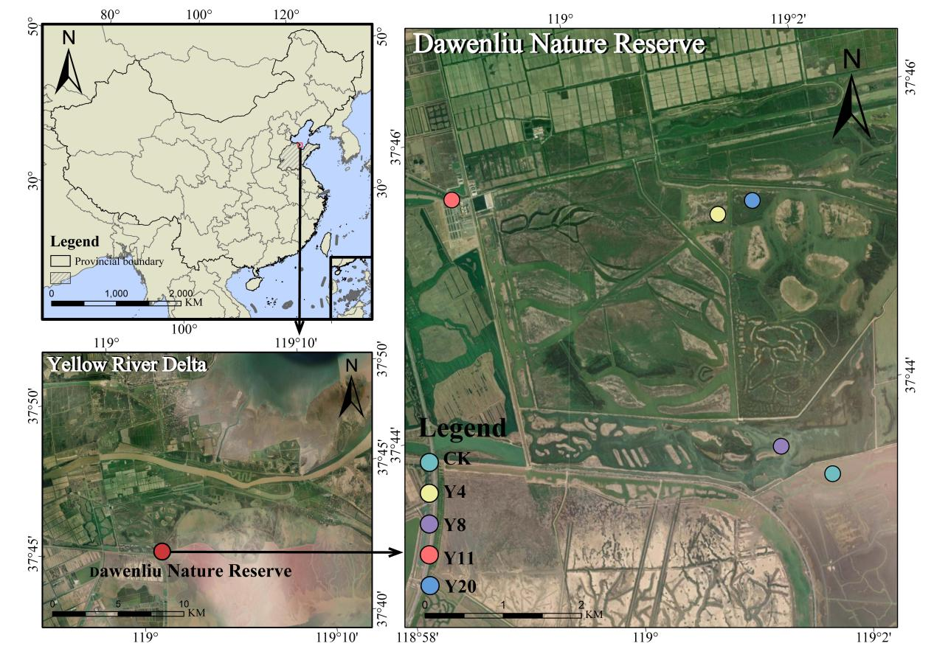
Fig. S1 Location of the study area and sampling sites in the Yellow River Delta, China.

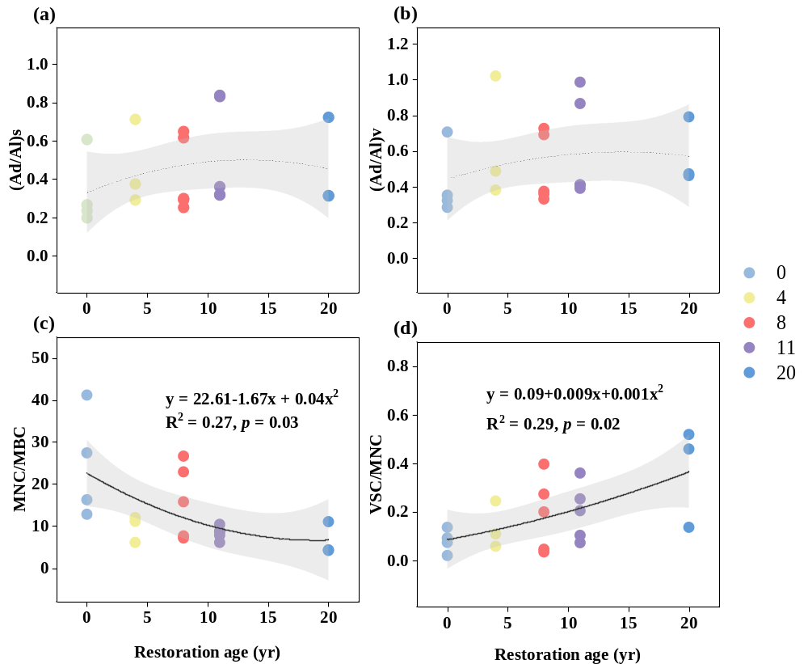
Fig. S2 Effects of restoration age on lignin degradation (a-b), MNC/MBC (c) and VSC/MNC (d). The grey shaded areas represent the 95 % confidence interval. (Ad/Al)s and (Ad/Al)v represent the acid-aldehyde ratios for syringyl and vanillyl phenols, respectively; MNC/MBC, the ratio of microbial necromass carbon to microbial biomass carbon; the ratio of total plant lignin phenols to microbial necromass carbon.

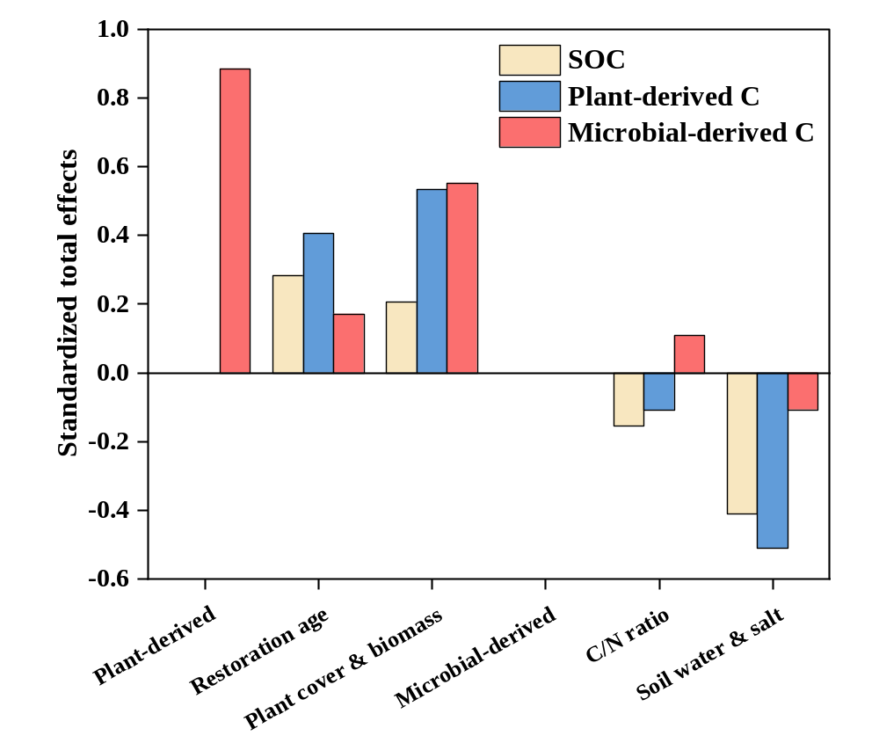
Fig. S3 Results of standardized total effects of individual variables on soil organic carbon, plant- and microbial-derived C. SOC, soil organic carbon; C/N, the ratio of soil total carbon to total nitrogen.

