Supporting Information for

Atmospheric Dynamical Amplification Intensifies Future Extreme Precipitation Risks

Ping Chang^{1,2*}, Dan Fu^{2*}, Xue Liu¹, Frederic S. Castruccio³, Andreas F. Prein^{3,4}, Gokhan Danabasoglu³, Xiaoqi Wang¹, Julio Bacmeister³, Qiuying Zhang¹, Nan Rosenbloom³, Teagan King³, Susan C. Bates^{3,5}

Corresponding author: ping@tamu.edu; fudan1991@tamu.edu

The PDF file includes:

Figures. S1 to S9
Tables S1 to S2

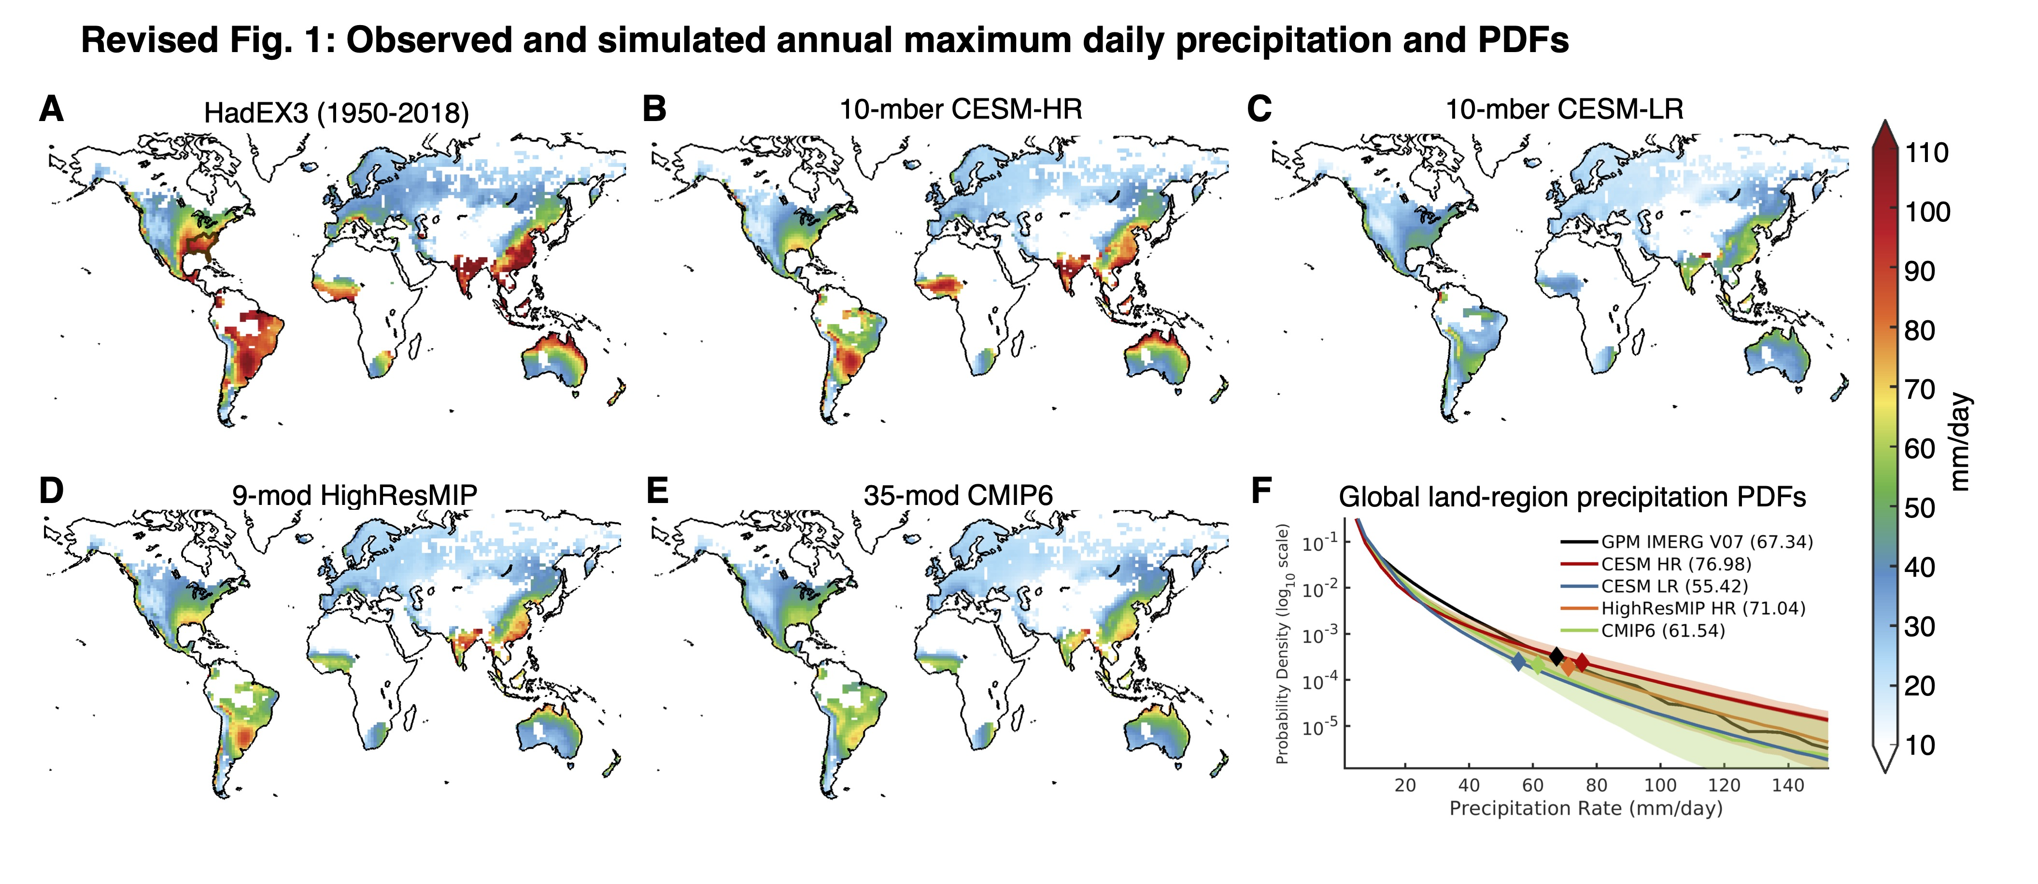
Fig. S1: Comparison of observed and simulated Rx1day using conservative interpolation method. Similar to Figure 1, but using conservative interpolation method to remap all data to a common HadEX3 1.875° longitude × 1.25° latitude grid (or 1° × 1°) before computing Rx1day (or PDFs). Global mean Rx1day for HadEX3, CESM-HR, CESM-LR, HighResMIP, and CMIP6 is 61.3 mm/day, 48.9 mm/day, 34.8 mm/day, 45.3 mm/day, and 41.2 mm/day, respectively.

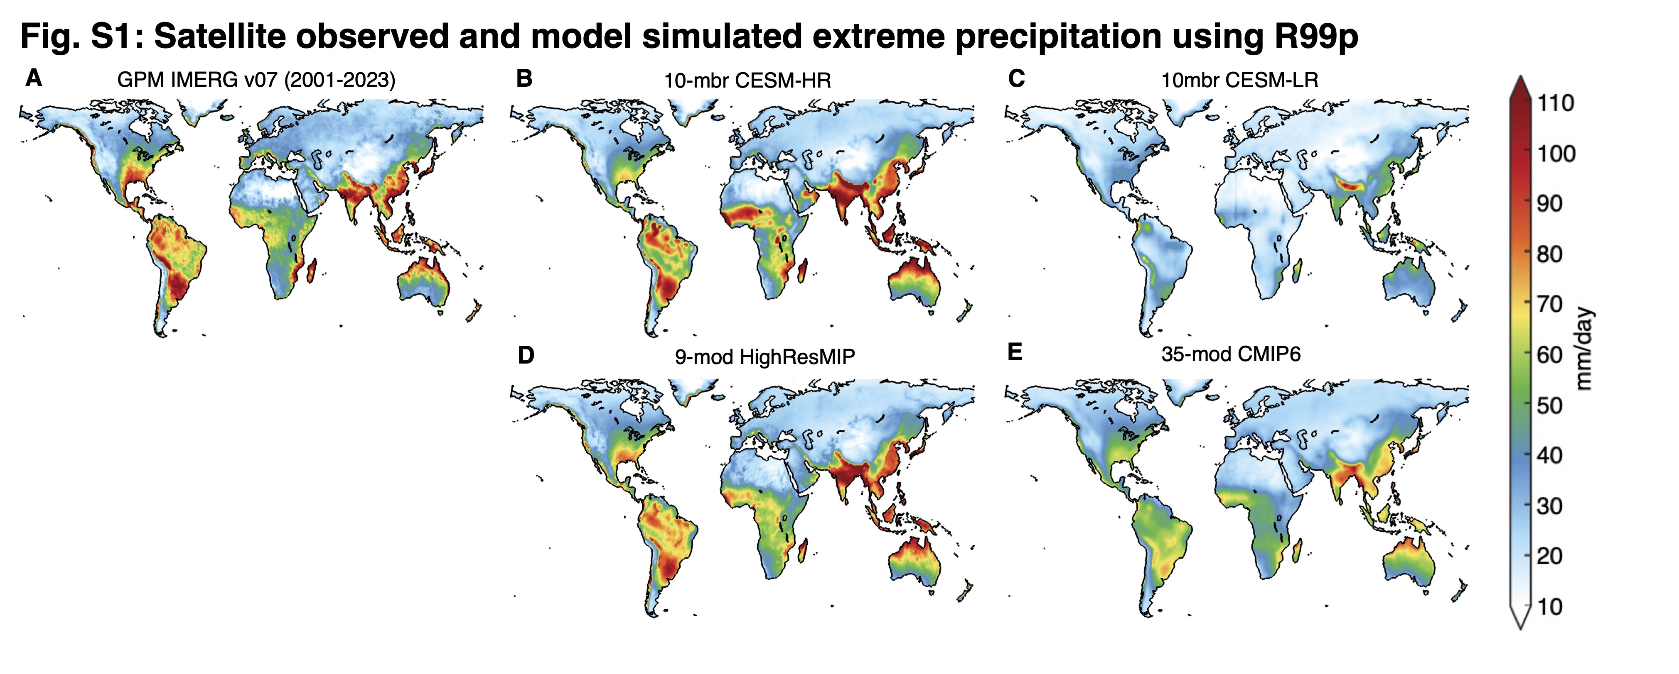
Fig. S2: Comparison of observed and simulated R99p using bilinear interpolation method. (A) Observed R99p, derived from IMERG V07 [35] for the 2001-2023 period. (B, C) As in (A), but for the 10-member ensemble mean of CESM-HR and CESM-LR, respectively. (D) (E) As in (A), but for the multi-model ensemble mean of 9 HighResMIP models and 35 CMIP6 models, respectively. The global mean R99p is 46.6 mm/day, 46.5 mm/day, 25.9 mm/day, 46.4 mm/day, and 39.5 mm/day, for IMERG V07, CESM-HR, CESM-LR, HighResMIP, and CMIP6, respectively. R99p is firstly computed on the native grid first and then interpolated to a common 1° × 1°.

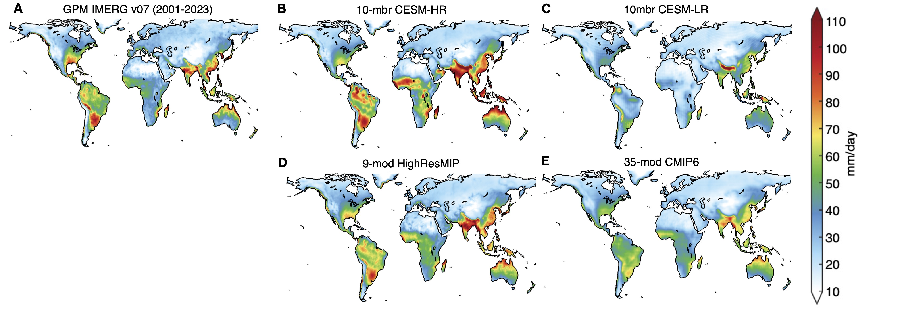
Fig. S3: Comparison of observed and simulated R99p using conservative interpolation method. Similar to Figure S2, but using conservative interpolation method to remap all data to a common 1° × 1° grid before computing R99p. The global mean R99p is 37.3 mm/day, 41.3 mm/day, 28.1 mm/day, 38.8 mm/day, and 34.2 mm/day, for IMERG V07, CESM-HR, CESM-LR, HighResMIP, and CMIP6, respectively.

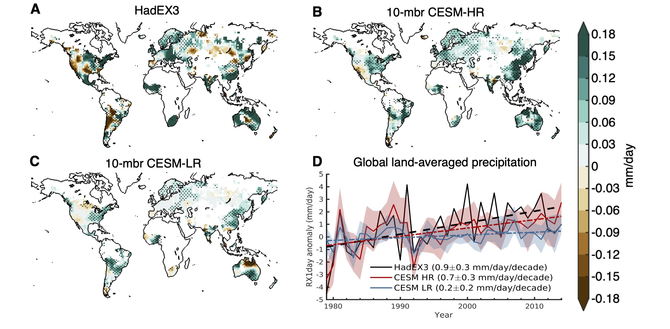
Fig. S4: Observed and simulated Rx1day trends. (A) Rx1day trend from HadEX3, with stippling indicating regions where the trend is statistically significant at the 95% confidence level based on a Mann-Kendall test. (B) As in (A), but for the ensemble-mean of CESM-HR. (C) As in (A), but for ensemble-mean of CESM-LR. (D) Rx1day anomalies averaged over global land relative to the 1950-2014 mean (solid) and the corresponding trends (dashed) from HadEX3 (black), CESM-HR (red), CESM-LR (blue), with shading representing inter-ensemble spread. The numbers show the trend value for HadEX3 (0.9±0.3 mm/day/decade), CESM-HR (0.7±0.3 mm/day/decade), and CESM-LR (0.2±0.2 mm/day/decade), respectively, calculated for the 1979-2014 period. Observed trend uncertainty is estimated using R-squared, while model trend uncertainties are based on the standard deviation of ensemble spread.

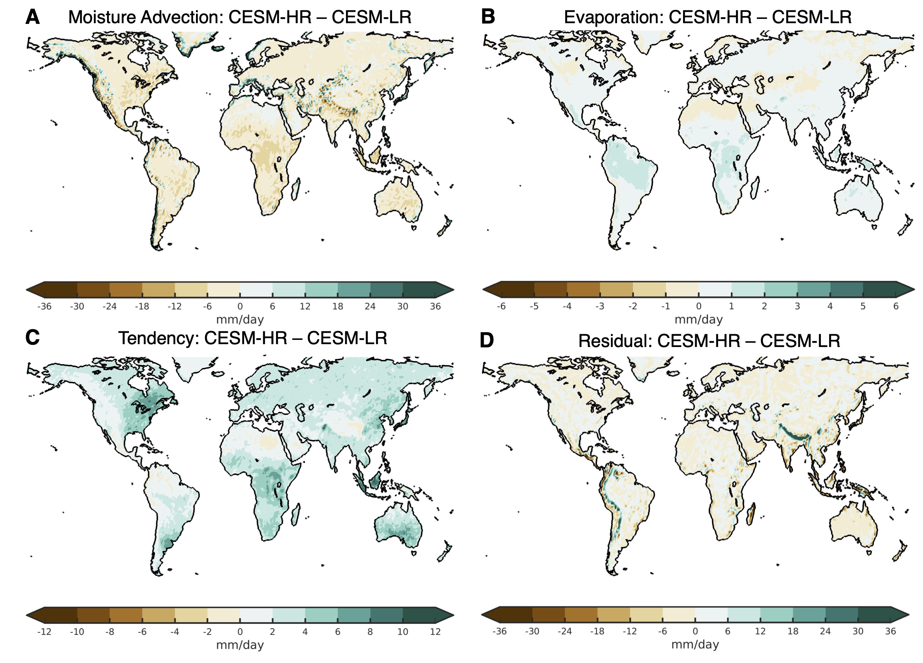
Fig. S5: Remaining moisture budget terms for Rx1day difference between CESM-HR and CESM-LR. (A) Contribution to the Rx1day difference between CESM-HR and CESM-LR from differences in moisture advection (M_{a}; -{u⋅∇q}). (B) As in (A), but showing the contribution from differences in evaporation (E). (C) As in (A), but showing the contribution from differences in moisture tendency (M_{t}; ∂/∂t{q}). (D) As in (A), but showing the contribution from the residual term. Note that different color scales are used for each term. Together with the dynamical tendency $M_{∆C}$ shown in Fig.2E and the thermodynamical tendency $M_{∆q}$ shown in Fig. 2F, these terms collectively describe the moisture budget contributing to the Rx1day difference between CESM-HR and CESM-LR. Among these terms, the dynamical tendency $M_{∆C}$ is clearly the most dominant process.

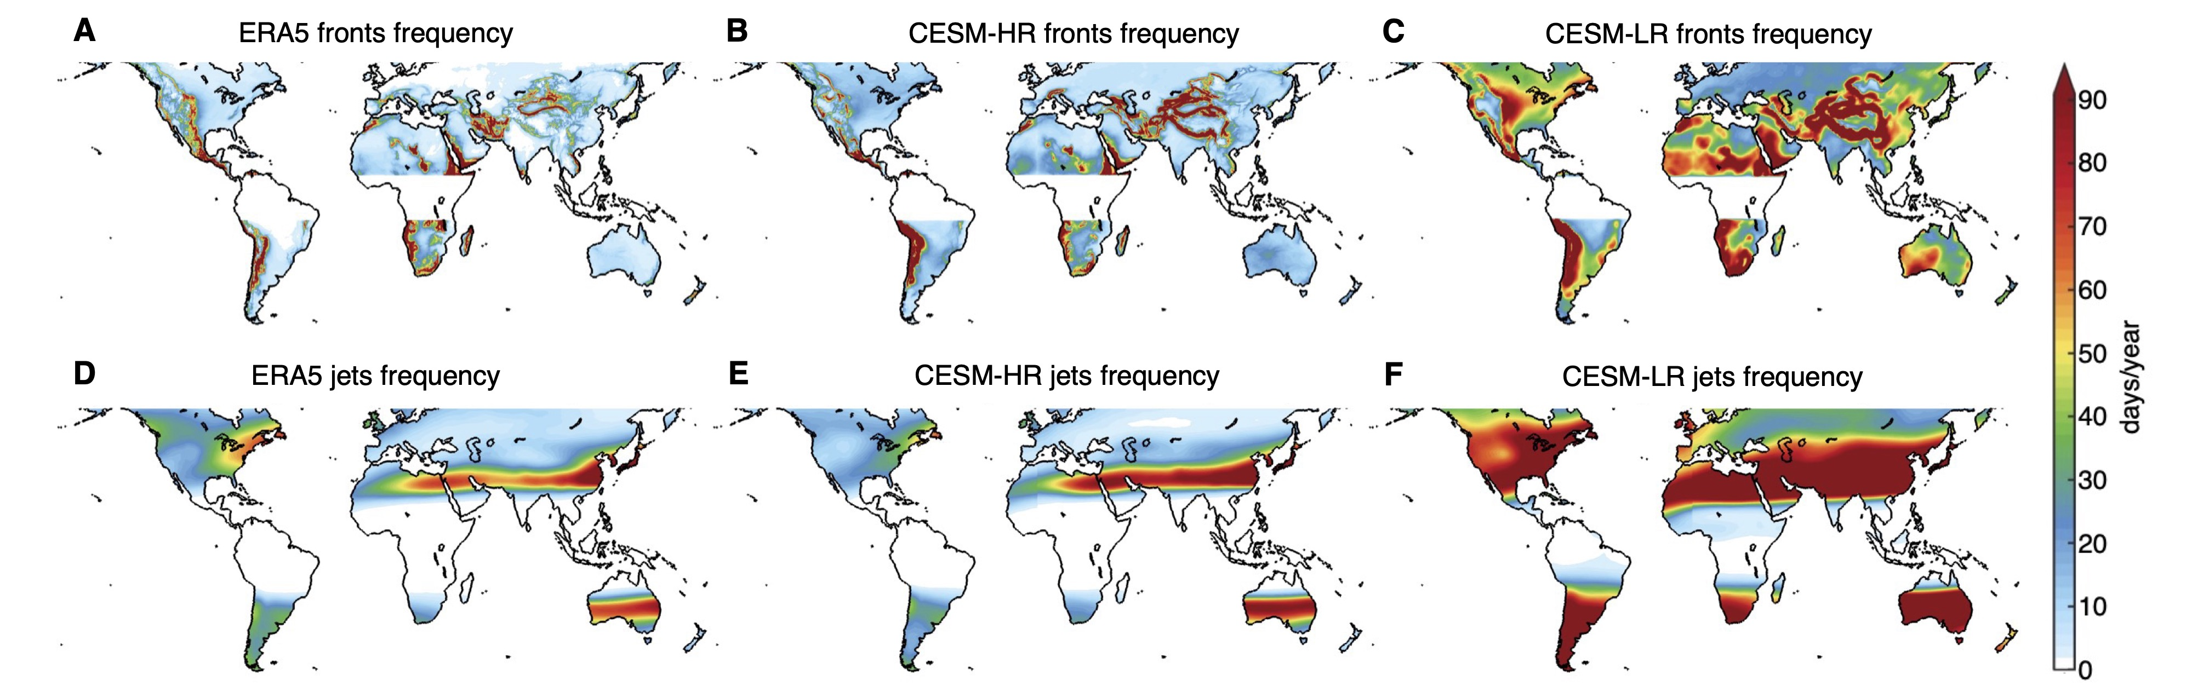
Fig. S6: MOAAP-tracked fronts and jets occurrence frequency. (A) Occurrence frequency (days/year) for MOAAP-tracked fronts from ERA5. (B), As in (A), but for tracked fronts from CESM-HR. (C) As in (A), but for tracked fronts from CESM-LR. (D), Occurrence frequency (days/year) for MOAAP-tracked jets from ERA5. (E) As in (D), but for tracked jets from CESM-HR. (F) As in (D), but for tracked jets from CESM-LR. To be consistent with tracked MCSs shown in Fig. 3, the spatial maps are shown between 60°S and 60°N.

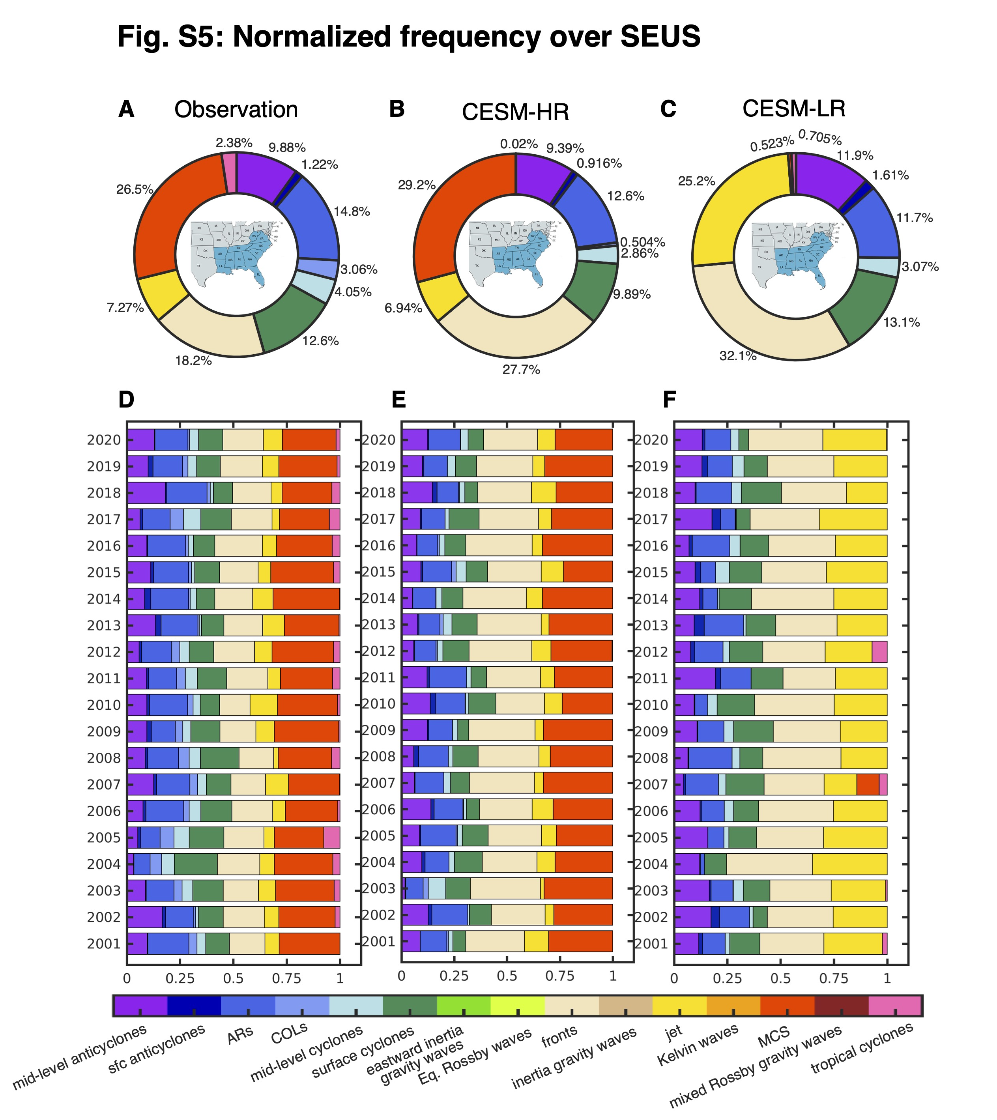
Fig. S7: Normalized frequency over SEUS. (A) Normalized occurrence frequency (%) of tracked atmospheric phenomena averaged over 2001-2020 for SEUS in observations, (B) As in (A), but for CESM-HR. (C) As in (A), but for CESM-LR. (D) Stacked bar plot of normalized occurrence frequency (%) of tracked phenomena over SEUS within the 24-hour window for each annual Rx1day event from 2001 to 2020 in observations. (E), As in (D), but for CESM-HR. (F) As in (D), but for CESM-LR. SEUS is shaded in blue on the map in (A-C).

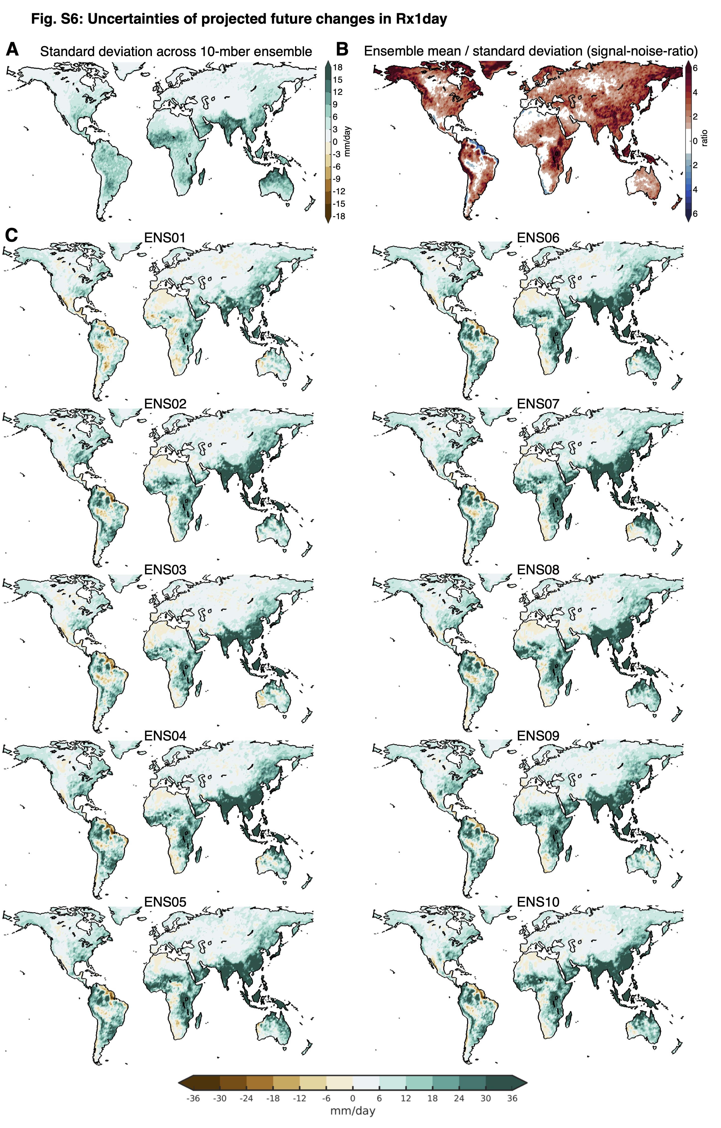
Fig. S8: Uncertainty quantification for projected Rx1day changes in CESM-HR. (A) Ensemble spread meansured by standard deviation (mm/day) of the 10 CESM-HR ensemble members, (B) Signal-to-noise ratio, defined as the ratio of the CESM-HR ensemble mean to its ensemble standard deviation, (C) Projected Rx1day changes (mm/day) calculated as the difference the future (2071-2100) and present (1981-2010) periods for each of the 10 CESM-HR ensemble members.
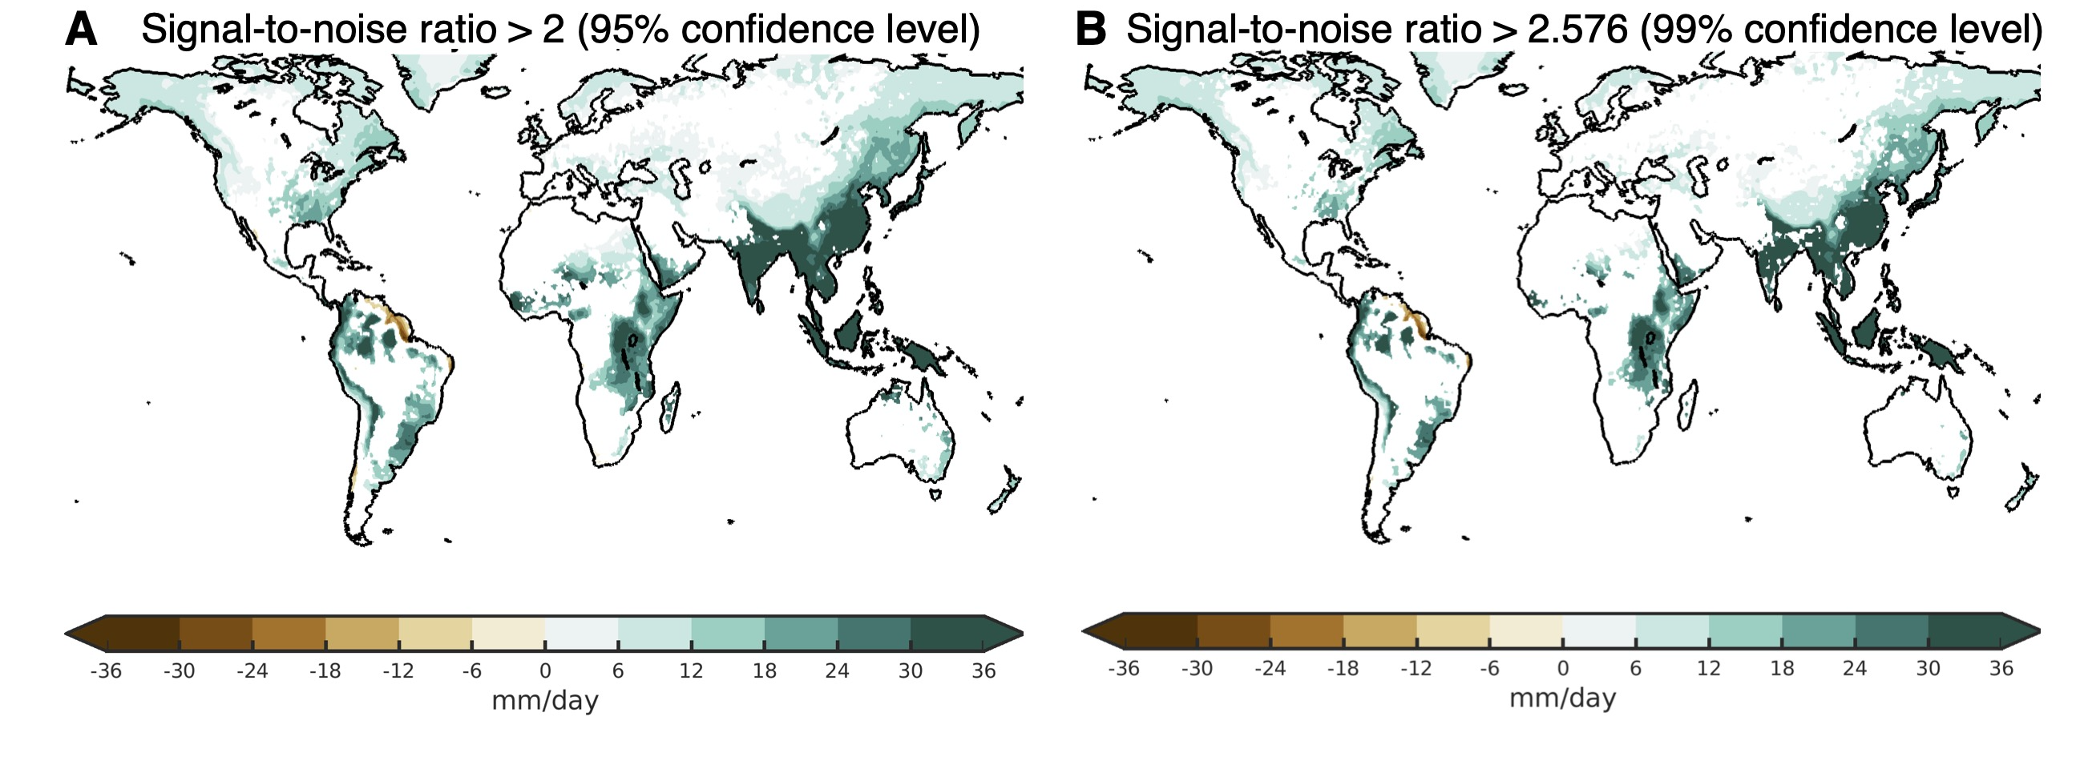
Fig. S9 Projected Rx1 changes exceeding signal-to-noise thresholds. (A) Projected Rx1day changes (mm/day) for the future period (2071-2100) relative to the present period (1981-2010) over regions where the signal-to-noise ratio exceeds the 95% confidence level (SNR > 2), (B) As in a, but for regions where the signal-to-noise ratio exceeds the 99% confidence level (SNR > 2.576).

Model Name | Horizontal Resolution (lon. by lat. in degrees) | Institution
ACCESS-CM2 | 1.9° × 1.3° | Commonwealth Scientific and Industrial Research Organisation (CSIRO), Australia
ACCESS-ESM1-5 | 1.9° × 1.2°
BCC-CSM2-MR | 1.1° × 1.1° | Beijing Climate Center, China
BCC-ESM1 | 2.8° × 2.8° | Beijing Climate Center, China
CanESM5 | 2.8° × 2.8° | Canadian Centre for Climate Modelling and Analysis, Canada
CESM2-FV2 | 1.3° × 0.9° | National Science Foundation National Center for Atmospheric Research, USA
CESM2 | 1.3° × 0.9°
CESM2-WACCM-FV2 | 1.3° × 0.9°
CESM2-WACCM | 1.3° × 0.9°
CNRM-CM6-1 | 1.4° × 1.4° | National Center for Meteorological Research, Météo-France and CNRS laboratory, France
CNRM-CM6-1-HR | 0.5° × 0.5°
CNRM-ESM2-1 | 1.4° × 1.4°
EC-Earth3 | 0.7° × 0.7° | European Earth System Model, EU
EC-Earth3-Veg | 0.7° × 0.7° | European Earth System Model, EU
FGOALS-f3-L | 1.3° × 1° | Chinese Academy of Sciences, China
FGOALS-g3 | 2° × 2.3° | Chinese Academy of Sciences, China
GFDL-CM4 | 1° × 1° | U.S. Department of Commerce/National Oceanic and Atmospheric Administration (NOAA)/ Geophysical Fluid Dynamics Laboratory (GFDL), USA
GFDL-ESM4 | 1.3° × 1°
HadGEM3-GC31-LL | 1.9° × 1.3° | Met Office Hadley Centre, United Kingdom
HadGEM3-GC31-MM | 0.8° × 0.6° | Met Office Hadley Centre, United Kingdom
INM-CM4-8 | 2° × 1.5° | Institute for Numerical Mathematics, Russia
INM-CM5-0 | 2° × 1.5° | Institute for Numerical Mathematics, Russia
IPSL-CM6A-LR | 2.5° × 1.3° | Institut Pierre-Simon Laplace, France
MIROC6 | 1.4° × 1.4° | Japan Agency for Marine-Earth Science and Technology (JAMSTEC), University of Tokyo (UT), National Institute for Environmental Studies (NIES) and RIKEN Center for Computational Science (R-CCS), Japan
MIROC-ES2L | 2.8° × 2.8°
MPI-ESM-1-2-HAM | 1.9° × 1.9° | Max Planck Institute for Meteorology, Germany
MPI-ESM1-2-HR | 0.9° × 0.9° | Max Planck Institute for Meteorology, Germany
MPI-ESM1-2-LR | 1.9° × 1.9° | Max Planck Institute for Meteorology, Germany
MRI-ESM2-0 | 1.1° × 1.1° | Meteorological Research Institute, Japan
NESM3 | 1.9° × 1.9° | Nanjing University of Information Science and Technology, China
NorESM2-LM | 2.5° × 1.9° | Norwegian Meteorological Institute, Norway
NorESM2-MM | 1.1° × 0.9° | Norwegian Meteorological Institute, Norway
SAM0-UNICON | 1.3° × 0.9° | Seoul National University, South Korea
TaiESM1 | 1.3° × 0.9° | Research Center for Environmental Changes, Academia Sinica, Taiwan,
UKESM1-0-LL | 1.9° × 1.3° | Met Office Hadley Center, United Kingdom
Table S1: 35 CMIP6 models used for extreme precipitation computation

Table S2: 9 HighResMIP models used for extreme precipitation computation
Model Name | Horizontal Resolution (lon. by lat. in degrees) | Institution
CESM-HR | 0.25° × 0.25° | National Science Foundation National Center for Atmospheric Research, USA
CMCC-CM2-VHR4 | 0.31° ×0.23° | Euro-Mediterranean Centre on Climate Change, Italy
CNRM-CM6-1-HR | 0.5° × 0.5° | National Center for Meteorological Research, Météo-France and CNRS laboratory, France
EC-Earth3P-HR | 0.5° × 0.5° | European Earth System Model, EU
ECMWF-IFS-HR | 0.23° ×0.23° | European Centre for Medium-Range Weather Forecasts (ECMWF)
FGOALS-f3-H | 0.25° × 0.25° | Chinese Academy of Sciences, China
GFDL-CM4-HR | 0.5° × 0.5° | U.S. Department of Commerce/National Oceanic and Atmospheric Administration (NOAA)/ Geophysical Fluid Dynamics Laboratory (GFDL), USA
HadGEM3-GC31-HM | 0.35° × 0.23° | Met Office Hadley Center, United Kingdom
MPI-ESM1-2-XR | 0.47° ×0.47° | Max Planck Institute for Meteorology, Germany

