Supporting Information

Optimized Stress Transfer Interfaces Enabled Wearable Nano-Electronics for Fatigue Driving Monitoring
Hao Lei^{1,2,3,†}, Lingjie Xie^{4,†}, Xuan Qin^{2,†}, Guoxuan Sun¹, Peihao Huang¹, Weinuo Wang¹, Bohan Lu⁴, Jiawei Yan¹, Yuxi Wang¹,Yina Liu⁴, Eng Gee Lim¹, Xin Tu³, Chun Zhao^{1,3,*}, Xuhui Sun^{2,*}, Zhen Wen^{2,*}

¹ Department of Electrical and Electronic Engineering, School of Advanced Technology, Xi'an Jiaotong-Liverpool University, Suzhou 215123, P.R. China.
² Institute of Functional Nano and Soft Materials (FUNSOM), Joint International Research Laboratory of Carbon-Based Functional Materials and Devices, Soochow University, Suzhou 215123, P.R. China.
³ Department of Electrical and Electronic Engineering, University of Liverpool, Liverpool L693GJ, United Kingdom.
⁴ Department of Applied Mathematics, School of Mathematics and Physics, Xi'an Jiaotong-Liverpool University, Suzhou 215123, P.R. China.
*E-mail: chun.zhao@xjtlu.edu.cn (C. Zhao); xhsun@ suda.edu.cn (X. Sun); wenzhen2011@suda.edu.cn (Z. Wen)
†These authors contributed equally to this work.

Supplementary Note 1
At a macro level, the flow of blood causes the artery to dilate, leading to the transmission of pressure onto the sensor. It brings the upper electrode of silver in contact with silicone rubber, as shown in Fig. S4. Due to the difference in electronegativity, charges transfer from the silver layer to the surface of the silicone rubber layer. The transferred charges quickly compensate for each other, resulting in no current flow through the external circuit. As the blood vessels contract, the pressure applied on the sensor by the artery decreases accordingly. The upper electrode and silicone rubber separate, leading to an electric potential between two electrodes by electrostatic induction. This potential drives the flow of current through the external circuit. When the applied pressure on the sensor reaches 0, the upper electrode and the dielectric layer fully separate, with no current flowing between the two electrodes. At this point, the electric potential difference between two electrodes remains constant, representing the initial state of the open-circuit voltage measurement.
The process of triboelectrification is explained by a model that takes into account of atomic-scale electron cloud potential wells operating between the silver and silicone rubber layers, as depicted in Fig. S3. Under normal atomic distance, the electron clouds of silicone rubber and silver are separated due to their different charge affinity. However, when mechanical pressure is applied on the silver electrode, the distances between the atoms of the two materials decrease and eventually reach the repulsive force region. This leads to a strong overlap of the electron clouds, causing a significant reduction in the inter atomic potential barrier. Consequently, electrons from the higher energy levels in silver can easily cross the lowered potential barrier and transfer to the silicone rubber layer to achieve an equilibrium. After the release of pressure, the silicone rubber and silver layers separate, while the transferred electrons and holes remain as static charges on the surfaces.
The electromechanical coupling model of the triboelectric sensor with cone microstructures can be demonstrated in Fig. S4A. According to the previous studies, it is obtained that
$V_{(F)}=\frac{{\text{σ}d}_{(F)}}{ε}$ (1)
where σ is the charge density on the upper electrode and d_((F)) is the distance from the upper electrode to the bottom electrode.
Assuming the gap distance of initial status is d and the change distance is ∆d, as demonstrated in Fig. S4A, the gap distance d_((F)) under the pressure F can be calculated by
$d_{(F)}=d-∆d$ (2)
Meanwhile, d_((F)), F and the compression modulus Y of gap layer can be expressed as
$Y=\frac{P}{∆d/d}$ (3)
that is, the $V_{(F)}$ under the pressure F can be calculated by
$V_{(F)}=\frac{σ}{ε}\left(d-\frac{d}{Y}∙P\right)$ (4)
Therefore, the output voltage is expected to illustrate a direct linear relationship with the external pressure F. The sensitivity of the self-powered triboelectric sensor is
$S= \frac{{∂V}_{(F)}}{∂F}=\frac{σ}{ε}\frac{d}{Y}$ (5)
According to the output voltage and sensitivity formula, the compression modulus and distance of the triboelectric layer play essential roles in improving the sensing performance. More specifically, the higher initial gap and the lower compression modulus contribute to the higher sensitivity.
However, as the initial height increases to a certain extent, the electrostatic induction effect of triboelectricity will be greatly weakened, resulting in a decrease in the output voltage of the sensor and adversely impacting the signal-to-noise ratio of the device. Simultaneously, the triboelectric sensor can be construed as two capacitors connected in series, where the variable capacitance constituted between the top electrode and the triboelectric layer plays an important role in the sensitivity of the sensor. As depicted in Supplementary Fig. 4b，the capacitance $C_{1}$ and voltage $V_{1}$ between top electrode and the bottom of microstructure layer are given by:
$C_{1}=\frac{εA}{d}$ (6)
$V_{1}=\frac{\text{Q}\text{1}}{C_{1}}$ (7)
The change of voltage can be calculated by:
${∆V}_{1}=V-V_{0}=\frac{\text{Q}\text{1}}{C_{F}}-\frac{\text{Q}\text{1}}{C_{1}}$ (8)
The capacitance under a pressure $F$is:
$C_{F}=\frac{εA}{d-∆d}$ (9)
Thus, the voltage change ${∆V}_{1}$ under the pressure F can be calculated by:
${∆V}_{1}=\text{Q}\text{1}\left(\frac{\text{1- }\frac{∆d}{d}}{C_{1}}-\frac{\text{1}}{C_{1}}\right)$ (10)
The sensitivity of the sensor is:
$S=\left|\frac{{∆V}_{1}}{V_{1}}\right|$=$\frac{\text{∆}\text{d}}{d}$ (11)
In this case, the higher the initial height, the lower the sensitivity. Taking the two situations mentioned above into account, it is found that the initial height of the microstructure also affects the sensitivity of the sensor. Generally, the higher the initial height, the higher the sensitivity of the triboelectric sensor. However, when the height exceeds a certain level, the sensitivity will decrease as a result of weakened electrostatic induction and capacitance effect of the TENG.
Supplementary Note 2
In order to understand the mechanism of constructing microstructure templates in PMMA substrate by CO2 laser, analysis can be carried out from the perspective of laser energy distribution. The physical formula for the Gaussian distribution of laser energy is:
$I\left(r\right)=I_{0}e^{\frac{-2r^{2}}{ω^{2}}}$ (12)

where I(r) is the laser intensity at position r, I0 is the maximum laser intensity at the center of the optical axis, ω is the laser beam radius or half height and half width, representing the degree of laser focusing. The smaller ω is, the higher the focusing is. r is the distance from the center of the optical axis to position r.
This formula describes that the laser intensity decreases exponentially along the radial direction and the decay coefficient is proportional to the beam radius ω. That is, the farther away from the optical axis, the lower the light intensity. When the beam radius decreases, the light intensity at the same radial position also decreases.
The Gaussian distribution shows that the energy of the laser beam is continuous and the light intensity decreases continuously from the center outward. This is closely related to the significant thermal effect produced by the laser on the material surface. The shape of the thermal effect zone has a typical Gaussian curve distribution.
Based on the characteristics of the Gaussian distribution, when ω is relatively large, the peripheral light intensity is also higher and the entire thermal effect zone is relatively wide. The holes or melt pools are also wider. When ω is smaller, the light intensity attenuates very quickly, the thermal effect zone is focused in a relatively small area. The holes and melt pools are also relatively deep and narrow.
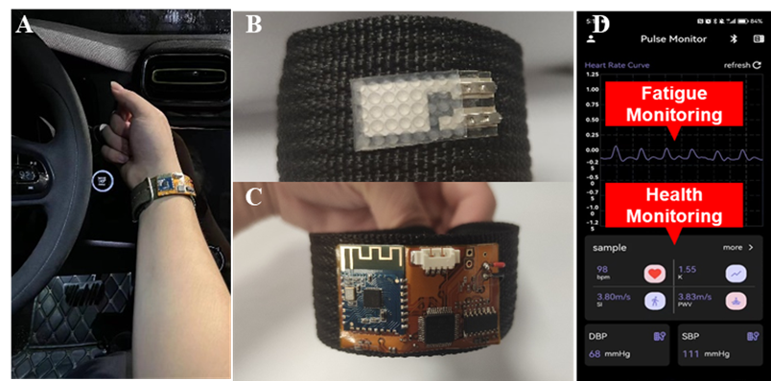
Fig. S1. A wearable wireless system for precise pulse wave monitoring. a Photograph of real testing scenario based on IETS. b Reverse side of smart strip: picture of flexible sensor. c The obverse side of smart strip: photograph of flexible data acquisition and a wireless transmission module. d Photograph of the customized App for fatigue monitoring and health state detection.
By installing the flexible sensor on a smart wristband, the system can obtain the pulse wave characteristics of the volunteer (Supplementary Fig. 1a). By integrating the flexible sensor on the back of a wristband and applying a pre-tension to tighten the band, the sensor is pressed firmly against the skin, effectively capturing the waveform of the pulse beats (Supplementary Fig. 1b). The front side of the wristband is equipped with a flexible circuit board that integrates signal amplification, filtering and wireless transmission modules, ensuring reliable operation across a range of arm girths and curvatures (Supplementary Fig. 1c). Combined with a deep learning network, the system can realize multiple functions, including fatigue state detection and cardiovascular health monitoring as shown in Supplementary Fig. 1d.

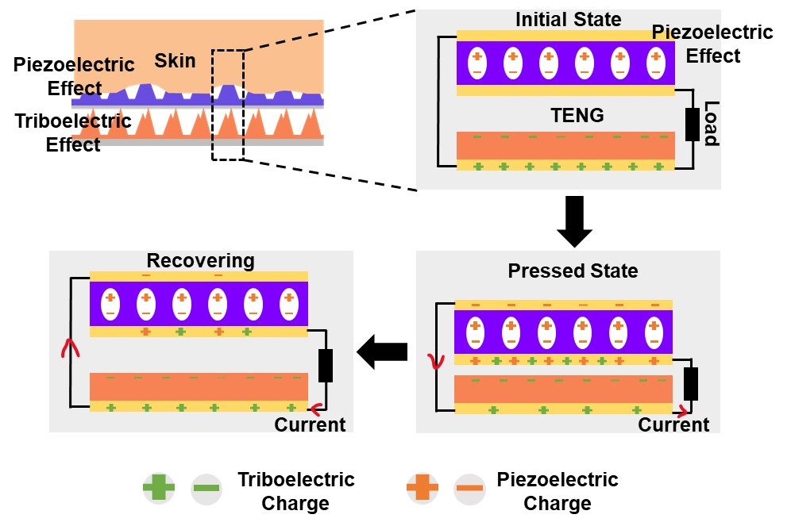
Fig. S2. The working mechanism of the IETS. The fabricated sensor consists of a piezoelectric nanogenerator-based sensor (PENG) and a triboelectric nanogenerator-based sensor (TENG). The PENG is connected with PENG in parallel to amplify the charge output. When the mechanical force from pulse wave applied on the sensor, the bottom electrode of the PENG induces positive charges due to the piezoelectric effect, while the upper electrode of the TENG also generates positive charges due to the triboelectric effect. The same type of charges produced by these two different effects accumulate on the common electrode and output to the backend charge amplification circuit, where they are transformed into voltage.
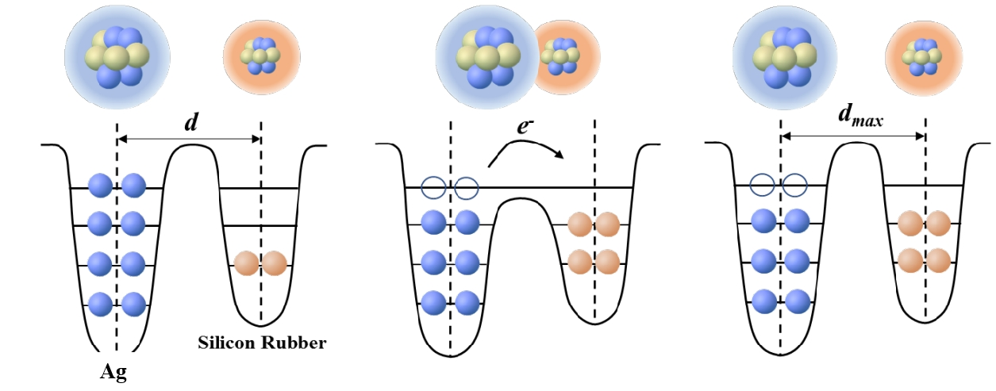
Fig. S3. Atomic-scale-electron-cloud potential-well model to describe the mechanism of triboelectrification. Within the interface between the silicone rubber and the silver electrode, a quantum-scale electron potential well model effectively explains the dynamics of contact electrification. This model illustrates a potential well that securely retains electrons within a specific path before the silver and silicone rubber make contact, preventing electron departure. When the two materials are in proximity and touch, an electron transfer is facilitated from the silver to the silicone rubber, which diminishes the energy threshold between them. After the separation of the silver and rubber, the transferred electrons persist as static charges on the silicone rubber's surface.

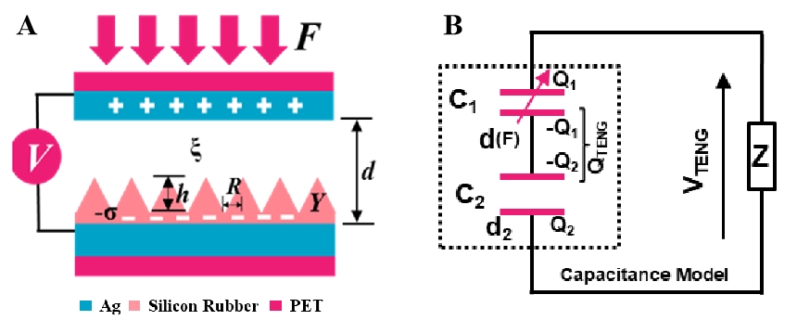
Fig. S4. The physical models of the triboelectric sensor part. a The electromechanical coupling model of the triboelectric sensor with cone microstructures. b The capacitance model of the triboelectric sensor.

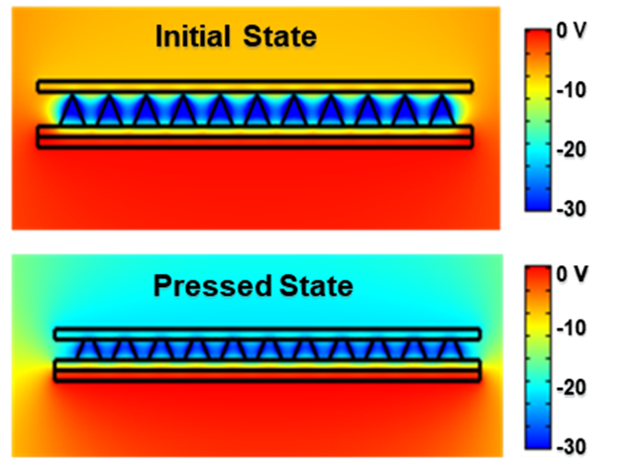
Fig. S5. The simulation results of triboelectric sensor part under an applied pressure. Under a certain pressure, the microstructures are compressed. Due to the decrease of distance between the upper electrode and the bottom electrode, the potential difference of the device changes accordingly.

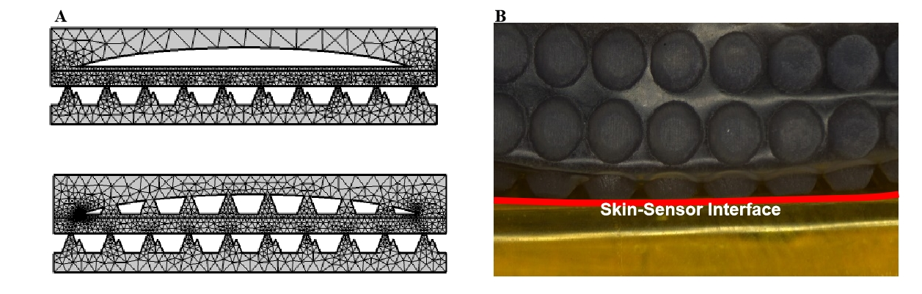
Fig. S6. The interface between skin and IETS.

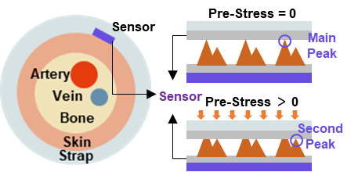
Fig. S7. The working mechanism of the mountain-like microstructures. The blood flow in the artery generates a pulsatile mechanical energy. The sensor in close contact with the skin detects this mechanical energy and converts it into an electrical signal output. When there is no pre-stress applied to the sensor, the microstructure of the triboelectric interface does not undergo a compression deformation and the sensor exhibits high sensitivity due to the large deformation ability of the main peak. However, the sensor needs to be fixed in a specific location by tightening a strap. The pre-stress provided by the strap causes deformation of the main peak of the triboelectric interface, reducing the sensitivity of the device. The mountain-like microstructures designed in this work allow the device to maintain high sensitivity under pre-stress by providing a large deformation from the second peak when the main peak is compressed.

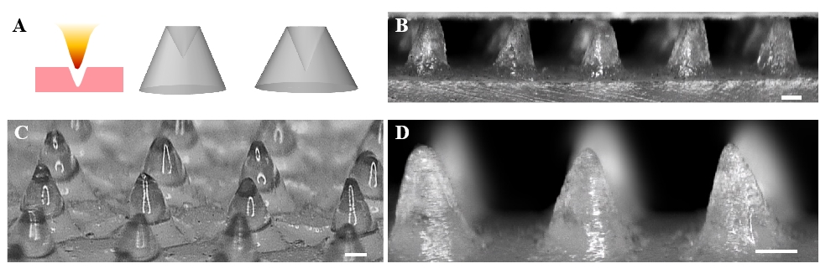
Fig. S8. The large-area fabrication for cone microstructures. The figures show that the conical microstructures made by laser point etching have high consistency. Our experiments also found that the holes created by laser heat on the PMMA substrate have high consistency as long as the substrate is placed flatly and the laser-substrate spacing is fixed. The scale bar is 200 μm.

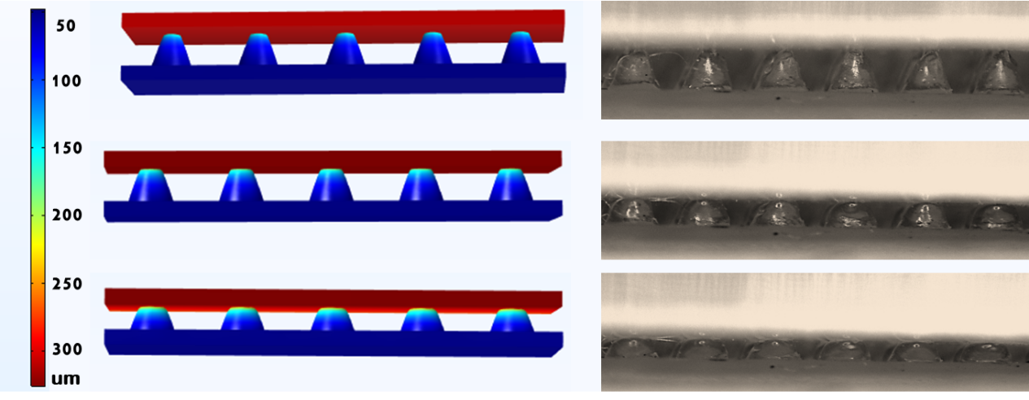
Fig. S9. The deformation of cone microstructures under an increasing pressure. The simulation results are consistent with the phenomena observed under a microscope.

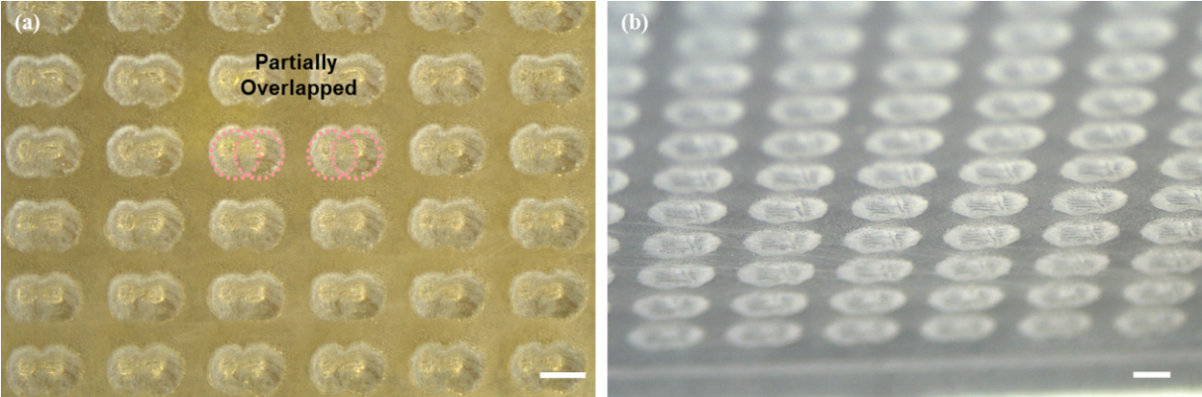
Fig. S10. Optical images of the mountain-shaped microstructure templates. By controlling the etching pattern and laser power, mountain-shaped microstructures of different dimensions are obtained. The scale bar is 300 μm.

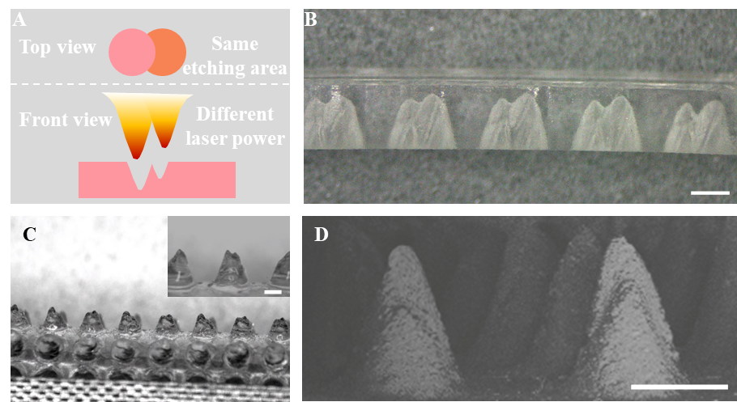
Fig. S11. The large-area fabrication for mountain-shaped microstructures. The figures show that the mountain-shaped microstructures made by cutting mode of the laser also have high consistency. By designing the etching pattern as shown in Fig. Supplementary 11a and setting different etching powers, the cavity template as shown in Supplementary Fig. 11b can be obtained. Through the demolding process, the mountain-shaped microstructures as shown in Supplementary Fig. 11c, can be attained. Supplementary Fig. 11d is the SEM image of the mountain-shaped microstructures. The scale bar is 500 μm. This process results in unequal heights of the two peaks in the microstructure, forming a mountain-shaped microstructure.
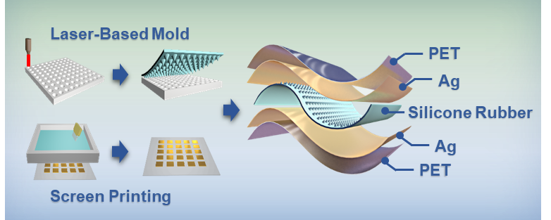
Fig. S12. The fabrication process of the triboelectric sensor. Supplementary Fig. 12 shows the main preparation process flows and the device structures of triboelectric sensor. The PMMA mold uses the Gaussian distribution of laser energy to form a microstructure pattern inside the PMMA. By adjusting the power and motion modes of the laser machine, microstructures with different sizes and shapes can be obtained. The triboelectric sensor is composed of upper and lower electrodes and a microstructured triboelectric layer. The electrodes are formed by screen printing silver paste (01 L-2211D, Sryed Paste) on a polyethylene terephthalate (PET) substrate. Importantly, this processing flow has the potential for large-scale production.

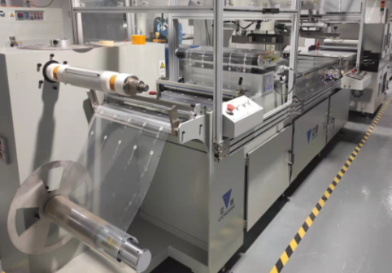
Fig. S13. The large-scale production for the triboelectric sensors. As shown in Supplementary Fig. 13, a roll-to-roll screen printing process is introduced in this work. The printing, curing and cutting processes of the upper and lower electrodes can be completed with one production line. With the high temperature generated by a CO2 laser, patterned groove microstructures can be formed on a polymethyl methacrylate (PMMA) plate. Adjusting the laser process parameters will control the shapes and sizes of the microstructures in the PMMA template. Then the triboelectric layer with surface microstructures can be obtained by coating and curing the silicone solution.

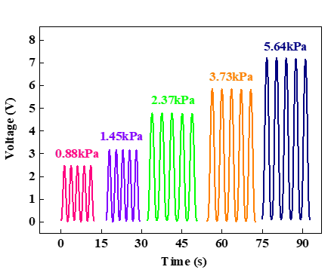
Fig. S14. Output curves of triboelectric sensors with conical microstructures under different pressures. It can be seen that the output voltage is positively correlated with the pressure.

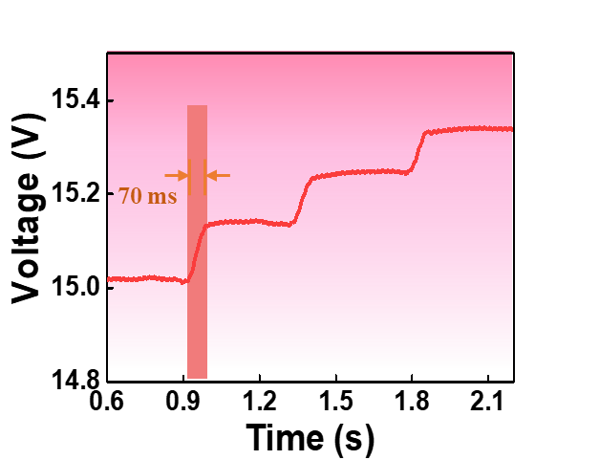
Fig. S15. The response time testing of IETS. It can be clearly seen that the sensor has the fast response time within 70 ms.

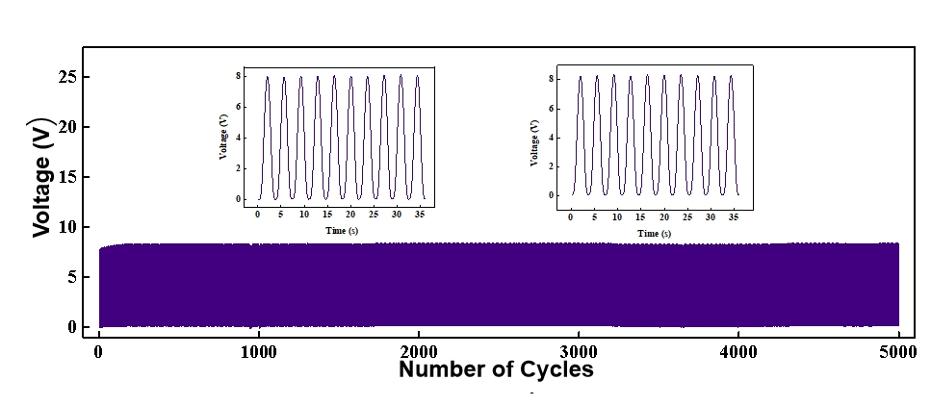
Fig. S16. Cyclic stability testing of the device over 5000 cycles.

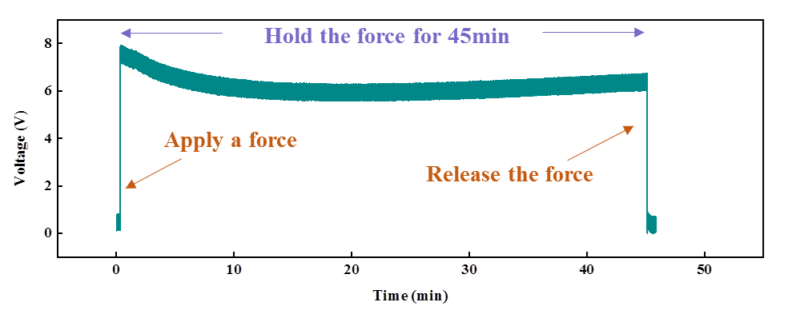
Fig. S17. Creep testing of the IETS under a static pressure. It is clearly seen that the sensor has the ability to monitor static pressure in real time and the static drift within 45 minutes is less than 15%.

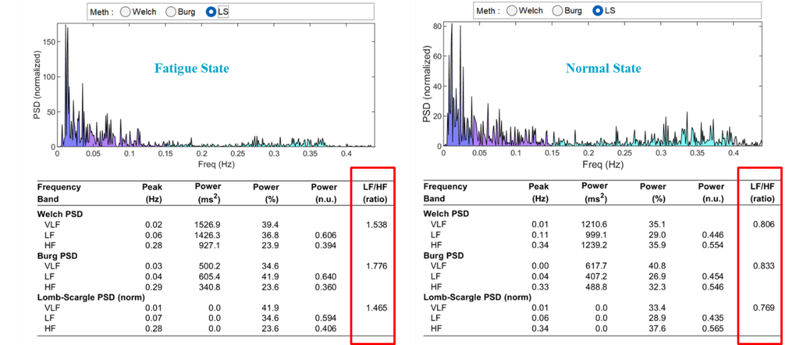
Fig. S18. The pulse wave’s frequency-domain information of the same user during normal state and fatigue state. After Fourier transform, the pulse wave waveform can be converted into the frequency domain as shown in the figure above. The ratio of low frequency signals (LF) to high frequency signals (HF) serves as the major basis for determining the fatigue state of the human body. It can be clearly seen that the ration at fatigue state is obvious higher than that at normal state.

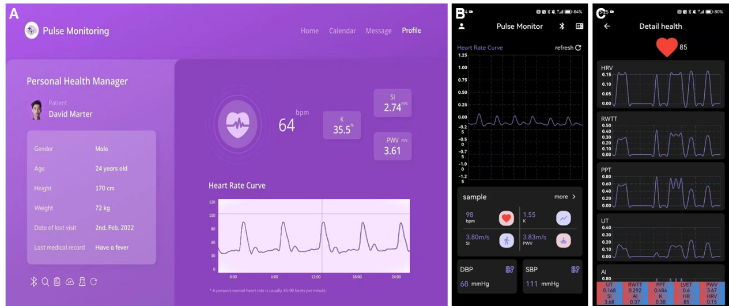
Fig. S19. The PC and APP interface of the fatigue driving and health state monitoring system. In addition to determining the degree of fatigue based on frequency domain information, the backend algorithm also calculates cardiovascular health-related parameters based on the characteristic information of the pulse wave, such as Heart Rate (HR), Pulse Wave Velocity (PWV), Vascular Stiffness Index (SI) and Blood Pressure (BP).

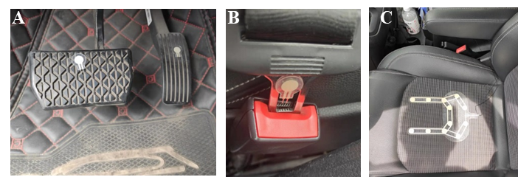
Fig. S20. IETSs are installed at different locations in the cockpit to monitor the driver's behavior information in real time.

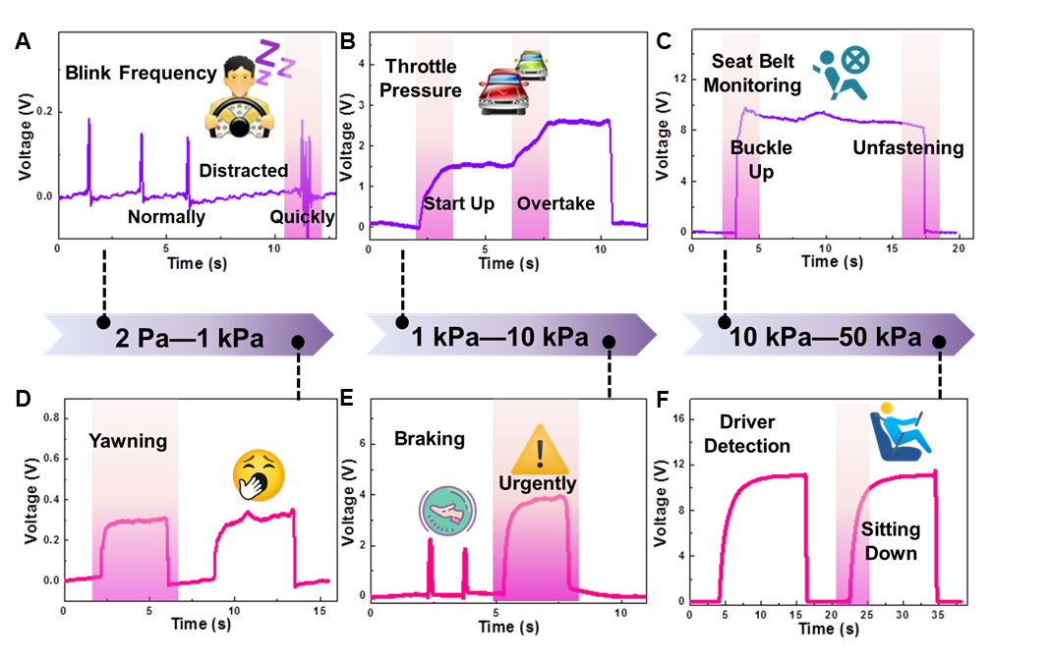
Fig. S21. Driving behavior monitoring system based on the IETS and its applications in a smart cockpit. a Frequency of normal blinking by the driver and frequency of blinking during fatigue. b Recognition of specific behaviors, such as yawning. c Real-time collection of the pressure applied to the accelerator pedal by the sensor. d Real-time collection of the pressure applied to the brake pedal by the sensor. Identification of specific behaviors, such as normal braking and sudden braking. e Sensor installed at the seatbelt buckle position to detect seatbelt usage. f Sensor installed beneath the seat to identify the driver seating status.

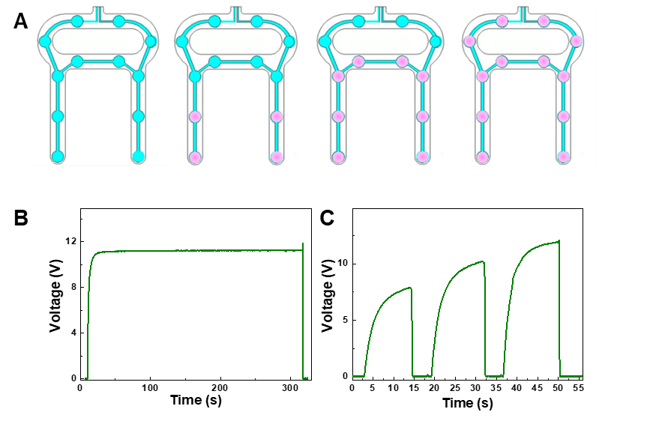
Fig. S22. Schematic of sensors for monitoring the driver's sitting posture. a Illustrations of the physical sensor for seat occupancy detection. b Sensor utilized to gather driving time, enabling prolonged sitting reminders. c Sensor employed to detect the driver sitting posture.
The driver's different sitting postures correspond to different numbers of detection points on the sensor as shown in Supplementary Fig. 22a. The further back the driver's sitting posture, the more the number of monitoring points pressed on the sensor, resulting in a higher total output voltage. Supplementary Fig. 22b illustrates real-time monitoring of the driving time by the sensor. Notably, the sensor signal exhibits nearly no attenuation even after continuous pressure lasting 5 min, showing its feasibility for tracking sitting duration. In addition, the sensor can be integrated into a seat cushion to determine the driver sitting posture by the number of sensors triggered, thus monitoring the driver sitting posture, as shown in Supplementary Fig. 22c. When the driver occupies the front half of the seat, few units within the sensor are triggered, thereby reducing the overall contact area between the electrodes and the triboelectric layer and reducing the voltage output. Similarly, when the entire seat is occupied, all sensitive units of the sensor are triggered, achieving the maximum contact area. This phenomenon increases the voltage output from the sensor.

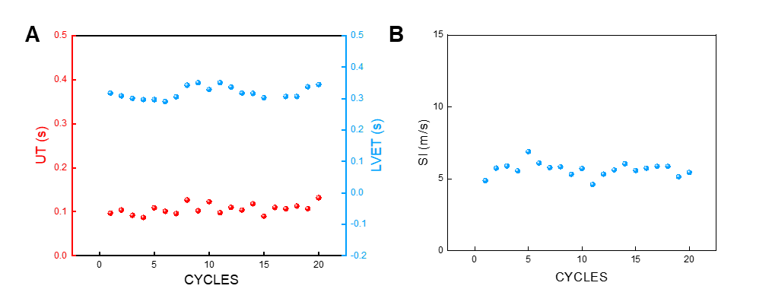
Fig. S23. Upstroke time (UT), left ventricular ejection time (LVET) and stiffness index (SI) acquired from continuous pulse signal during 20 cycles.

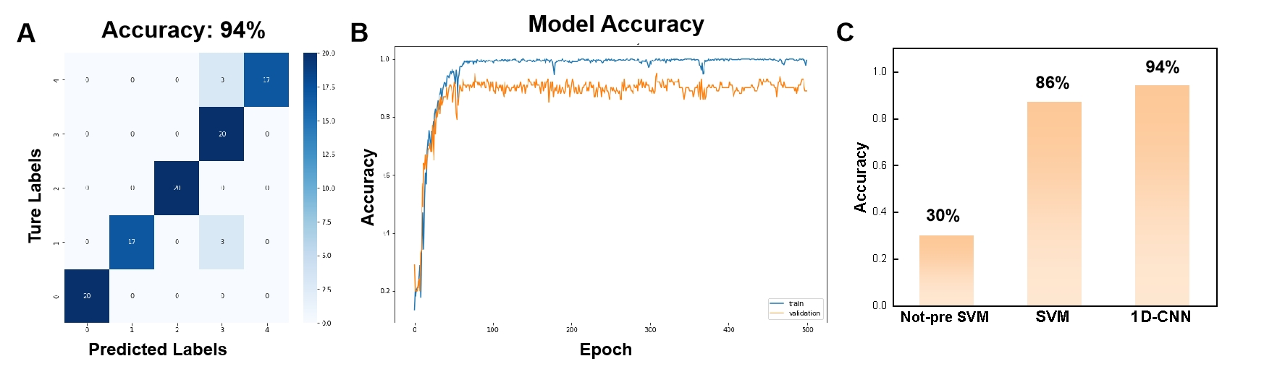
Fig. S24. a The confusion map for 1D-CNN outcome of 5 subjects. b The learning curve of training set and test set in data set 1. c Classification accuracy by random division without pre-processing SVM model, SVM with pre-processing and 1D-CNN model of full features (750 features).

Table 1 The detailed framework and parameters of 1D-CNN analytic
Layer (type) | Output shape | Number of parameters
Conv1d (Conv1D) | (None, 750, 4) | 88
Max_polling1d | (None, 375, 4) | 0
Conv1d_1 (Conv1D) | (None, 375, 16) | 1488
Max_polling1d_1 | (None, 188, 16) | 0
Conv1d_2 (Conv1D) | (None, 188, 32) | 12832
Average_polling1d_1 (AveragePooling1D) | (None, 94, 32) | 0
Conv1d_3 (Conv1D) | (None, 94, 64) | 55360
Flatten (Flatten) | (None, 6016) | 0
Dense (Dense) | (None, 128) | 770176
Dropout (Dropout) | (None, 128) | 0
Dense_1 (Dense) | (None, 5) | 645

Movie S1.
Simulation of the microstructures fabrication.
Movie S2.
Fatigue driving and health state warning system based on IETS.
Movie S3.
Driver behavior monitoring system based on IETS.

