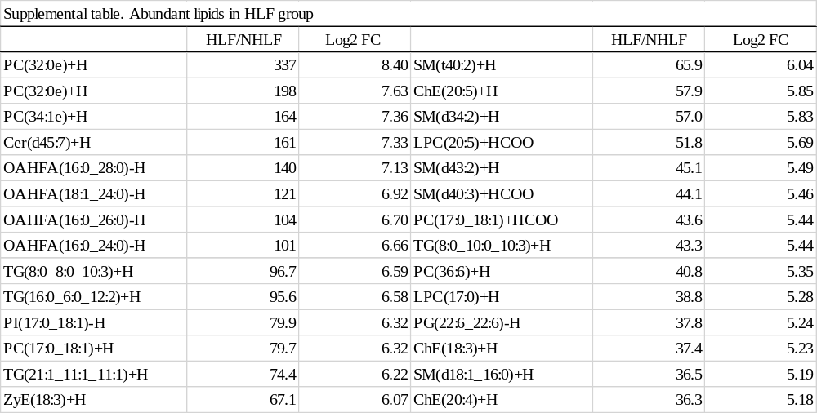

HLF: hypertrophied ligamentum flavum, NHLF: non-hypertrophied ligamentum flavum, FC: fold change
PC: phosphatidylcholine, Cer: ceramide, OAFHA: O-acyl-ω-hydroxy fatty acids, TG: triglyceride, PI: phosphatidylinositol, ZyE: zymosteryl, LPC: lysophosphatidylcholine, SM: sphingomyelin, ChE: cholesteryl ester, PG: phosphatidylgrycerol.

