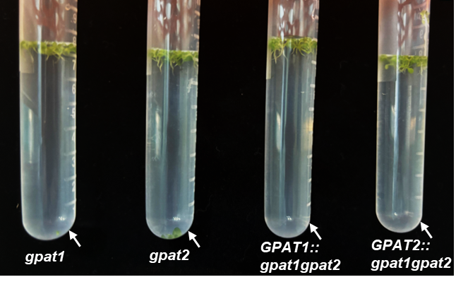
Fig. S1. Six-day-old cotyledons of gpat1, gpat2, GPAT1::gpat1 gpat2 and GPAT2::gpat1 gpat2 were placed on the surface of water. Most of their cotyledons floated.

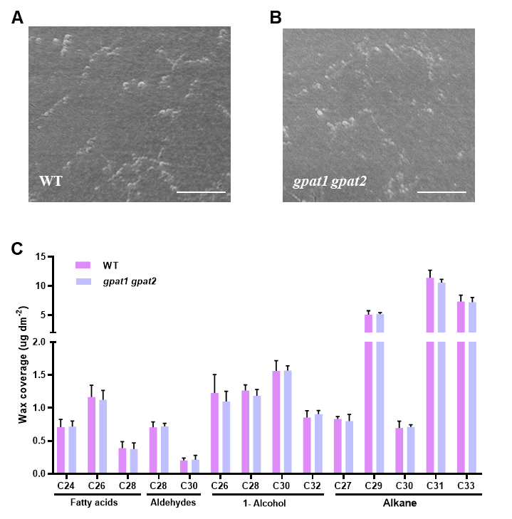
Fig. S2. Wax detection. 20-day-old rosette leaves of WT (A) and gpat1 gpat2 (B) wax crystal observed by TEM. Scale bars=1 μm. (C) Quantitative analysis of leaf wax coverage using GC-MS.

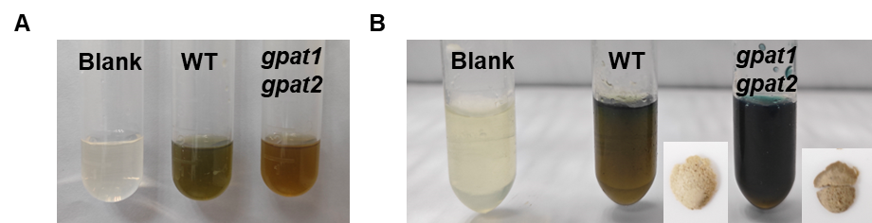
Fig. S3. Lignin and cellulose assay. (A) The lignin content measurement solution of WT and gpat1 gpat2. The darker the color of the solution, the higher the lignin content (B) The cellulose content measurement solution of WT and gpat1 gpat2. The darker the color of the solution, the higher the cellulose content. The image at the bottom right of each centrifuge tube represents the corresponding cellulose precipitation of WT and gpat1 gpat2. The blank was set as the negative control.

