Appendix S1
Beyond Dispersal Limitation: Drivers of Fine-Scale Population Structure in Two Common Solitary Wild Bees

Table S1 Overview of sampled Andrena haemorrhoa and Andrena nigroaenea at kettle-holes grouped by spatial cluster in the Agroscapelab research area in northeastern Germany (see Methods), including spatial cluster, kettle-hole ID, coordinates (WGS84), and individual count (n).
Andrena haemorrhoa |  |  |  |  | Andrena nigroaenea
Spatial Cluster | Ketlle-hole | x | y | n | Spatial Cluster | Kettle-hole | x | y | n
1 | 149 | 13.758482 | 53.349858 | 8 | 1 | 149 | 13.758482 | 53.349858 | 5
2 | 190 | 13.727117 | 53.362444 | 9 | 1 | 190 | 13.727117 | 53.362444 | 1
2 | 187 | 13.742511 | 53.363995 | 20 | 1 | 187 | 13.742511 | 53.363995 | 20
2 | 183 | 13.742717 | 53.367470 | 10 | 1 | 183 | 13.742717 | 53.367470 | 2
3 | 235 | 13.721543 | 53.327811 | 8 | 1 | 269 | 13.701001 | 53.376962 | 3
3 | 236 | 13.721488 | 53.328479 | 2 | 1 | 265 | 13.704492 | 53.378195 | 16
4 | 269 | 13.701001 | 53.376962 | 3 | 1 | 319 | 13.670430 | 53.378829 | 9
4 | 265 | 13.704492 | 53.378195 | 13 | 1 | 258 | 13.707032 | 53.382468 | 2
4 | 258 | 13.707032 | 53.382468 | 6 | 1 | 275 | 13.709487 | 53.385975 | 1
4 | 259 | 13.706979 | 53.384092 | 9 | 1 | 312 | 13.686318 | 53.386734 | 2
4 | 287 | 13.699214 | 53.385843 | 2 | 1 | 808 | 13.667568 | 53.396518 | 3
4 | 275 | 13.709487 | 53.385975 | 8 | 1 | 807 | 13.665798 | 53.397377 | 2
4 | 312 | 13.686318 | 53.386734 | 7 | 1 | 908 | 13.639553 | 53.405256 | 10
5 | 805 | 13.662017 | 53.394665 | 18 | 1 | 910 | 13.641936 | 53.407186 | 2
5 | 808 | 13.667568 | 53.396518 | 9 | 1 | 911 | 13.640171 | 53.408547 | 3
5 | 807 | 13.665798 | 53.397377 | 12 | 2 | 606 | 13.629944 | 53.347328 | 4
6 | 907 | 13.638137 | 53.405524 | 1 | 2 | 607 | 13.631487 | 53.347977 | 4
6 | 892 | 13.651345 | 53.406355 | 7 | 2 | 2489 | 13.623681 | 53.352275 | 12
6 | 910 | 13.641936 | 53.407186 | 7 | 2 | 1229 | 13.597662 | 53.363931 | 1
6 | 893 | 13.652892 | 53.408342 | 1 | 2 | 1228 | 13.598962 | 53.364171 | 5
6 | 911 | 13.640171 | 53.408547 | 1 | 3 | 1590 | 13.541943 | 53.303302 | 1
7 | 606 | 13.629944 | 53.347328 | 3 | 3 | 1604 | 13.551442 | 53.306172 | 1
7 | 607 | 13.631487 | 53.347977 | 1 | 3 | 1598 | 13.553018 | 53.308537 | 12
7 | 2484 | 13.623681 | 53.352275 | 2 | 3 | 1599 | 13.551857 | 53.308914 | 9
7 | 1189 | 13.618345 | 53.353518 | 4 | 3 | 40 | 13.537215 | 53.317315 | 7
8 | 1229 | 13.597662 | 53.363931 | 4
8 | 1228 | 13.598962 | 53.364171 | 7
9 | 1590 | 13.541943 | 53.303302 | 2
9 | 1604 | 13.551442 | 53.306172 | 3
9 | 2565 | 13.558765 | 53.306179 | 3
9 | 1598 | 13.553018 | 53.308537 | 10
9 | 1599 | 13.551857 | 53.308914 | 6
10 | 40 | 13.537215 | 53.317315 | 5
10 | 28 | 13.528872 | 53.317754 | 3

Table S2 Details of primers used for microsatellite analyses of Andrena haemorrhoa and Andrena nigroaenea with name, fragment size, core repeat, primer sequence, annealing temperature (mean_{ForRev}) and the literature reference. Note: Loci with more than 5 % missing data, high null allele frequency > 0.3 as well as monomorphic loci were excluded from the analysis.
Name | Fragment Size (bp) | Core Repeat | Forward Primer Sequence | Reverse Primer Sequence | T_{m} (°C) | Ref.
AJ-01 | 99 | GA₁₂ | CTTTTACCC | GAACGAGAG | 60.95 | Paxton et al., 1996
AJ-25 | 149 | CT₂₃ | GATCAAACG | CTTCGTTAC | 56.45 | Paxton et al., 1996
AJ-26 | 147 | CT₁₅ | AGCCCTTCC | GATTCCGTG | 57.4 | Paxton et al., 1996
vaga01 | 186 | CT₂₀ | GTGCCAAGT | GAAACACG | 58.25 | Mohra et al., 2000
vaga03 | 107 | CT₁₇ | GATTCGGGA | CGTTTATAG | 58.35 | Mohra et al., 2000
vaga04 | 228 | CT₁₇ | TTCTACGTT | CTTAGTCCG | 57.3 | Mohra et al., 2000
vaga05 | 318 | CT₁₆ | GGAAGGTTG | TGTCCGAAG | 56.3 | Mohra et al., 2000
vaga06 | 194 | CT₁₅ | GCTTTGGTT | CCACTGAAA | 60.9 | Mohra et al., 2000
vaga08 | 171 | CT₂₉ | GATCCGAAA | CTACGTGAC | 57.55 | Mohra et al., 2000
vaga09 | 117 | CT₂₁ | CCGTTGTAA | GATGGAGGA | 55.65 | Mohra et al., 2000
vaga13 | 153 | CT₁₈ | CTTAGTCCG | GGAACGAAA | 58.15 | Mohra et al., 2000
vaga18 | 135 | CT₂₀ | CGACTTTGC | CGACTTGGA | 57.75 | Mohra et al., 2000
vaga19 | 160 | CT₂₃ | GGGTAACGA | TGTTACGTG | 58.5 | Mohra et al., 2000
vaga20 | 183 | CT₁₇ | GATCTTCTT | CTTCCTTTT | 58.05 | Mohra et al., 2000
vaga21 | 149 | CT₁₉ | CCTTGTTAC | TCGGAAACT | 56.7 | Mohra et al., 2000
vaga23 | 219 | CT₃₃ | CTGTGTGGA | GAAGGGAAC | 58.15 | Mohra et al., 2000
vaga25 | 126 | CT₁₈ | GTCGCTACA | CATGGATTC | 58.25 | Mohra et al., 2000
vaga26 | 166 | CT₂₀ | CGAGGGCAA | TTCACGTAG | 57.45 | Mohra et al., 2000
vaga27 | 100 | CT₁₄ | GACGGACTC | CGAGTTGCC | 58.85 | Mohra et al., 2000

Reagent | Volume [µl]
5x My-Taq buffer | 5.0
Forward-Primer [10µM] | 0.34 - 0.5*
Reverse-Primer [10µM] | 0.34 - 0.5*
My-Taq | 0.12
HPLC-H₂O | 16.88-17.52*
DNA | 1
Table S3 a) Polymerase chain reaction protocol. Volumes marked with an asterisk were adjusted according to the primer volume added.

Table S3 b) Multiplex mixes for Andrena haemorrhoa with primers, annealing temperature and the primer volume used in (two separate) Polymerase Chain Reactions (PCR).
Mix | Primer | A1 T [°C] | Amount of Primer [µl] | A2 T [°C] | Amount of Primer [µl]
A | vaga27 | 57 | 0.34 | AJ26 | 52
 | vaga01 | 57 | 0.34 | AJ25 | 52

Mix | Primer | B1 T [°C] | Amount of Primer [µl] | B2 T [°C] | Amount of Primer [µl]
B | vaga03 | 52 | 0.34 | vaga08 | 52
 | vaga23 | 52 | 0.5 | vaga26 | 52

Mix | Primer | C1 T [°C] | Amount of Primer [µl] | C2 T [°C] | Amount of Primer [µl]
C | AJ01 | 57 | 0.34 | vaga19 | 57
 | vaga20 | 57 | 0.34 | vaga06 | 57

Table S3 c) Multiplex mixes for Andrena nigroaenea with primers, annealing temperature and the primer volume used in (two separate) Polymerase Chain Reactions (PCR).
Mix | Primer | A1 T [°C] | Amount of Primer [µl] | A2 T [°C] | Amount of Primer [µl]
A | vaga27 | 57 | 0.5 | vaga04 | 57
 | vaga18 | 57 | 0.34

Mix | Primer | B1 T [°C] | Amount of Primer [µl] | B2 T [°C] | Amount of Primer [µl]
B | AJ26 | 57 | 0.34 | vaga03 | 57
 | AJ01 | 57 | 0.34 | vaga21 | 57

Mix | Primer | C1 T [°C] | Amount of Primer [µl] | C2 T [°C] | Amount of Primer [µl]
C | vaga09 | 57 | 0.34
 | vaga13 | 57 | 0.34
 | vaga08 | 57 | 0.25

Mix | Primer | D1 T [°C] | Amount of Primer [µl] | D2 T [°C] | Amount of Primer [µl]
D | vaga25 | 57 | 0.34 | AJ25 | 52
 | vaga05 | 57 | 0.34 | vaga06 | 52

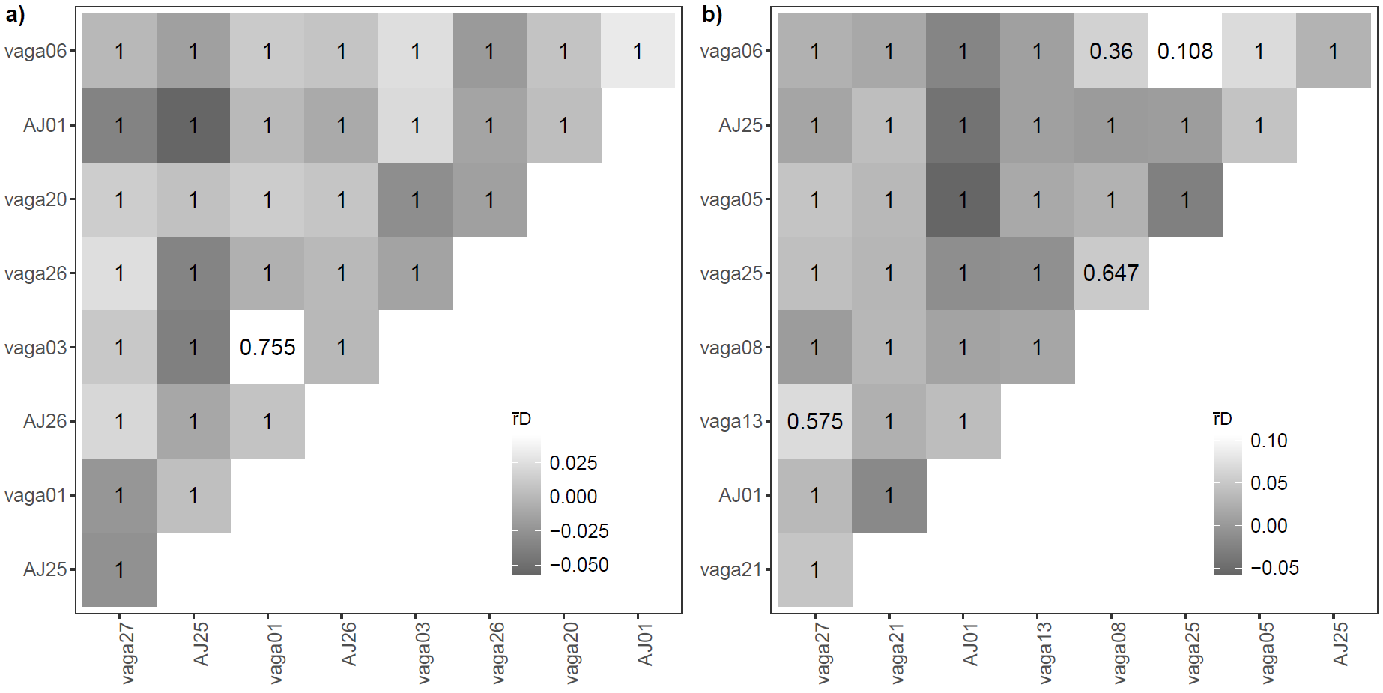
Figure S1 Heatmaps showing pairwise linkage disequilibrium (LD) for (a) Andrena haemorrhoa and (b) Andrena nigroaenea, measured as r̄D. The shading represents LD strength, with lower values (weaker LD) in darker grey and higher values (stronger LD) in white (grayscale). Numbers in cells indicate significance (p-values), with an alpha threshold of 0.05.
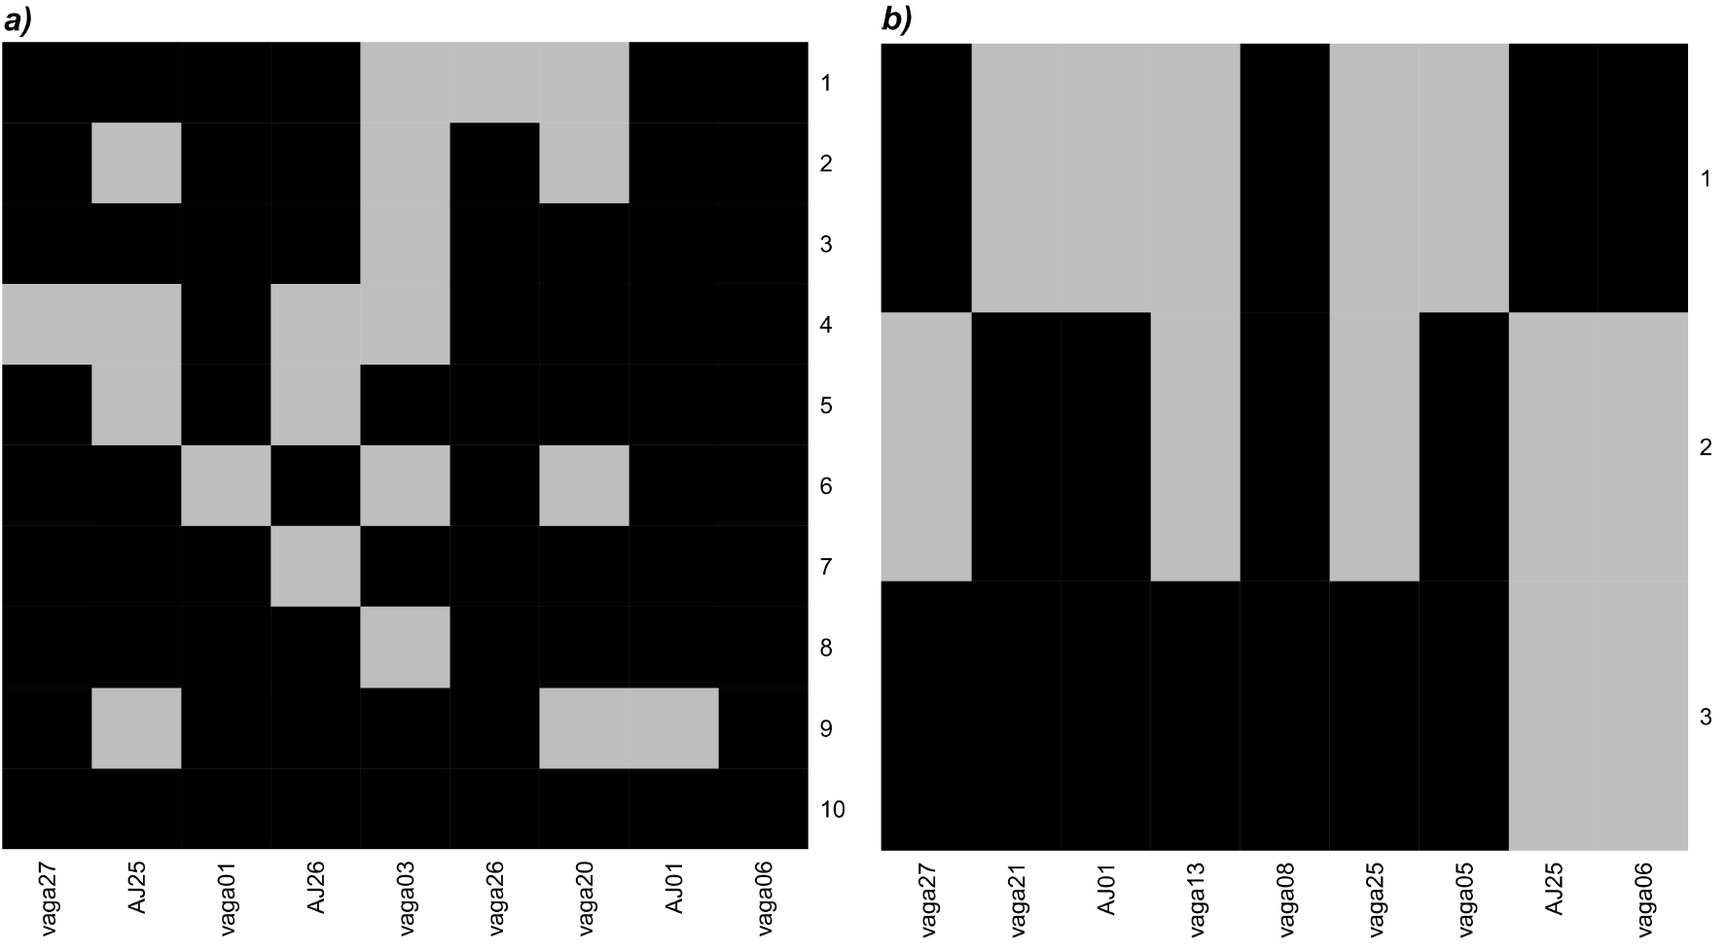
Figure S2 Heat maps illustrate significant departures from Hardy-Weinberg-Equilibrium (HWE) in (a) Andrena haemorrhoa and (b) Andrena nigroaenea sample sets, with single loci in columns and spatial clusters in rows; grey indicates loci presumed of not being in HWE with p ≤ 0.05 in the cluster.

Table S4: Genetic diversity metrics estimated for each locus, pooled across kettle-holes, for 214 Andrena haemorrhoa and 137 Andrena nigroaenea individuals. Metrics include observed Heterozygozity (Ho), expected heterozygosity (He), inbreeding coefficient (Fis)
Locus | Ho | He | Fis
A. haemorrhoa
vaga27 | 0.5954 | 0.6743 | 0.1171
AJ25 | 0.3739 | 0.5260 | 0.2892
vaga01 | 0.8291 | 0.8711 | 0.0481
AJ26 | 0.5880 | 0.6704 | 0.1229
vaga03 | 0.8466 | 0.9484 | 0.1074
vaga26 | 0.6913 | 0.6830 | -0.0121
vaga20 | 0.6484 | 0.8304 | 0.2192
AJ01 | 0.3551 | 0.3899 | 0.0892
vaga06 | 0.8834 | 0.8682 | -0.0175
A. nigroaenea
vaga27 | 0.5551 | 0.5950 | 0.0670
vaga21 | 0.4414 | 0.5711 | 0.2270
AJ01 | 0.4387 | 0.6082 | 0.2788
vaga13 | 0.5812 | 0.6820 | 0.1478
vaga08 | 0.6832 | 0.7655 | 0.1074
vaga25 | 0.5439 | 0.5874 | 0.0740
vaga05 | 0.7620 | 0.8980 | 0.1515
AJ25 | 0.6126 | 0.7755 | 0.2100
vaga06 | 0.6858 | 0.8392 | 0.1828

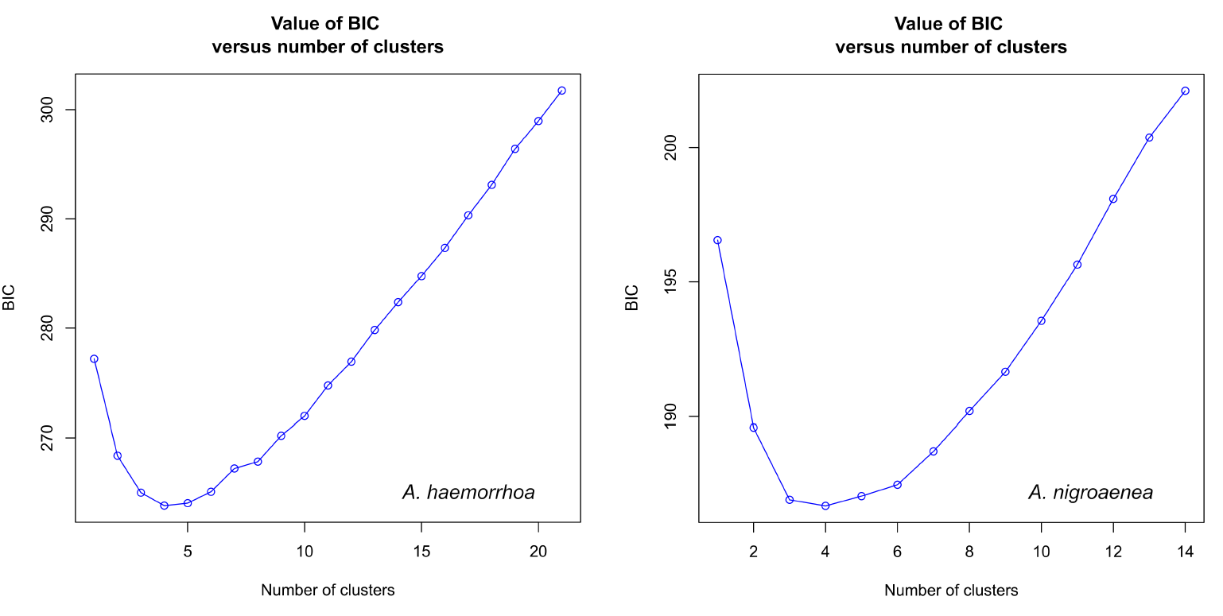

Figure S3 Optimal number of clusters (K=4) as determined by ‘k-means’ with Bayesian information criterion (BIC) for Andrena haemorrhoa and Andrena nigroaenea.

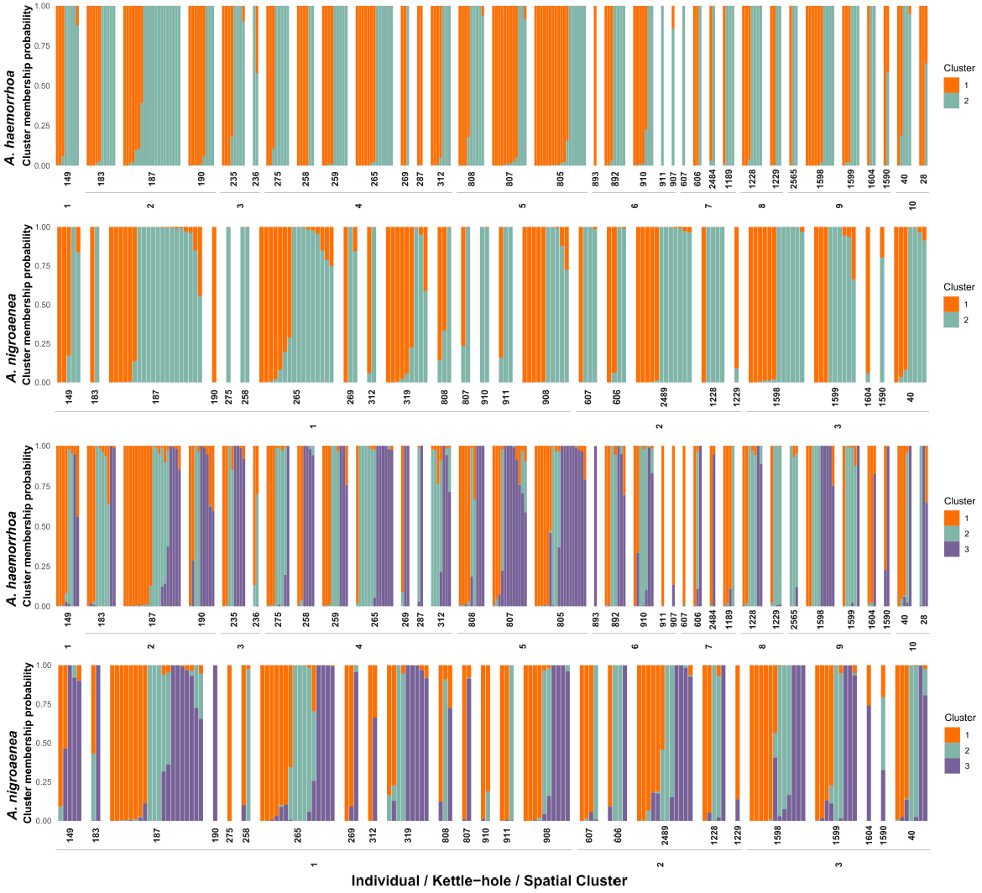
Figure S4 Results of additional DAPC analyses (upper, K=2 and lower K,=3) for Andrena haemorrhoa and Andrena nigroaenea. Single bars represent cluster membership probability of individual genotypes illustrated by distinct colors, and ordered them by sampling site (local kettle-hole ID by ZALF- Leibniz Centre for Agricultural Landscape Research) and spatial cluster arranged in decreasing longitudinal order.

