Supplementary Information

Hourly-resolution analysis of a mussel shell: Influence of normal tide and the great tsunami
Yuji Sano^{1,2}, Tomoyo Okumura¹, Naoko Murakami-Sugihara², Kentaro Tanaka², Takanori Kagoshima³, Akizumi Ishida⁴, Masako Hori⁵, Glen, T. Snyder², Naoto Takahata² and Kotaro Shirai²

¹Center for Advanced Marine Core Research, Kochi University, Kochi, Japan
²Atmosphere and Ocean Research Institute, University of Tokyo, Chiba, Japan.
³Graduate School of Science and Engineering, University of Toyama, Toyama, Japan.
⁴Graduate School of Science, Tohoku University, Sendai, Japan.
⁵Natural Sciences, Osaka Kyoiku University, Osaka, Japan.

*Correspondence should be addressed to T.O. (e-mail: tomoyook@kochi-u.ac.jp)

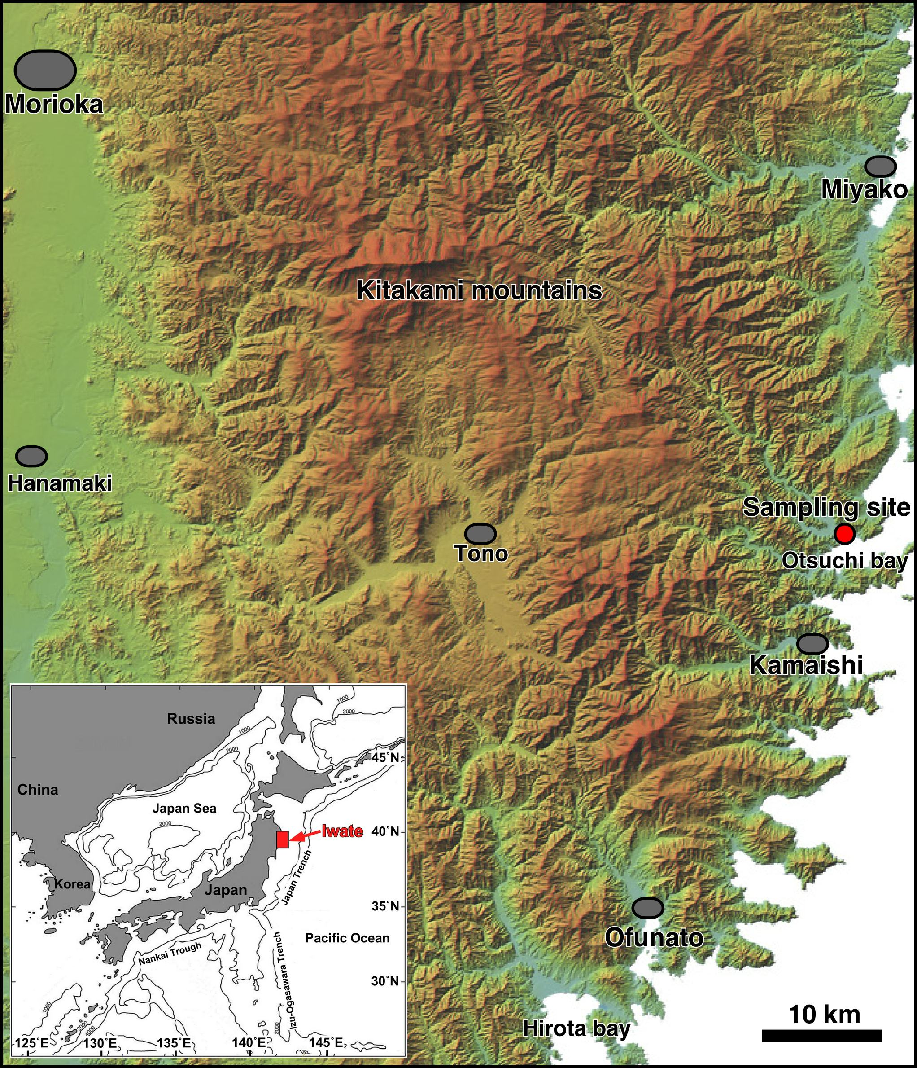

Supplementary Figure 1. Location of mussel shells sampling site in Otsuchi Bay, Iwate prefecture, northeast Japan. Environmental data are taken from Miyako Bay (precipitation), Morioka city (insolation), Hirota Bay (surface seawater temperature), and Kamaishi Bay (sea level change). The inset map shows the location of the Iwate prefecture.

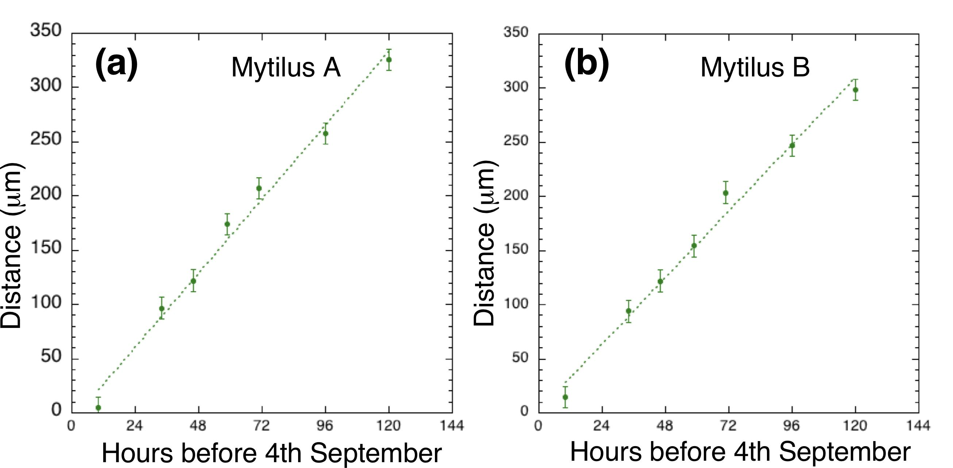

Supplementary Figure 2. Correlation diagram between the time before 4th September 2011 and the distance from the inner edge of a mussel shell. (a) Growth data of Mytilus A. Dotted line shows the best fit of y = -7±19 + (2.84±0.28) x where the error is 2σ, R²=0.988, and MSWD=1.59. (b) Growth data of Mytilus B. Dotted line shows the best fit of y = +2±15 + (2.56±0.22) x where the error is 2σ, R²=0.987, and MSWD=1.41.

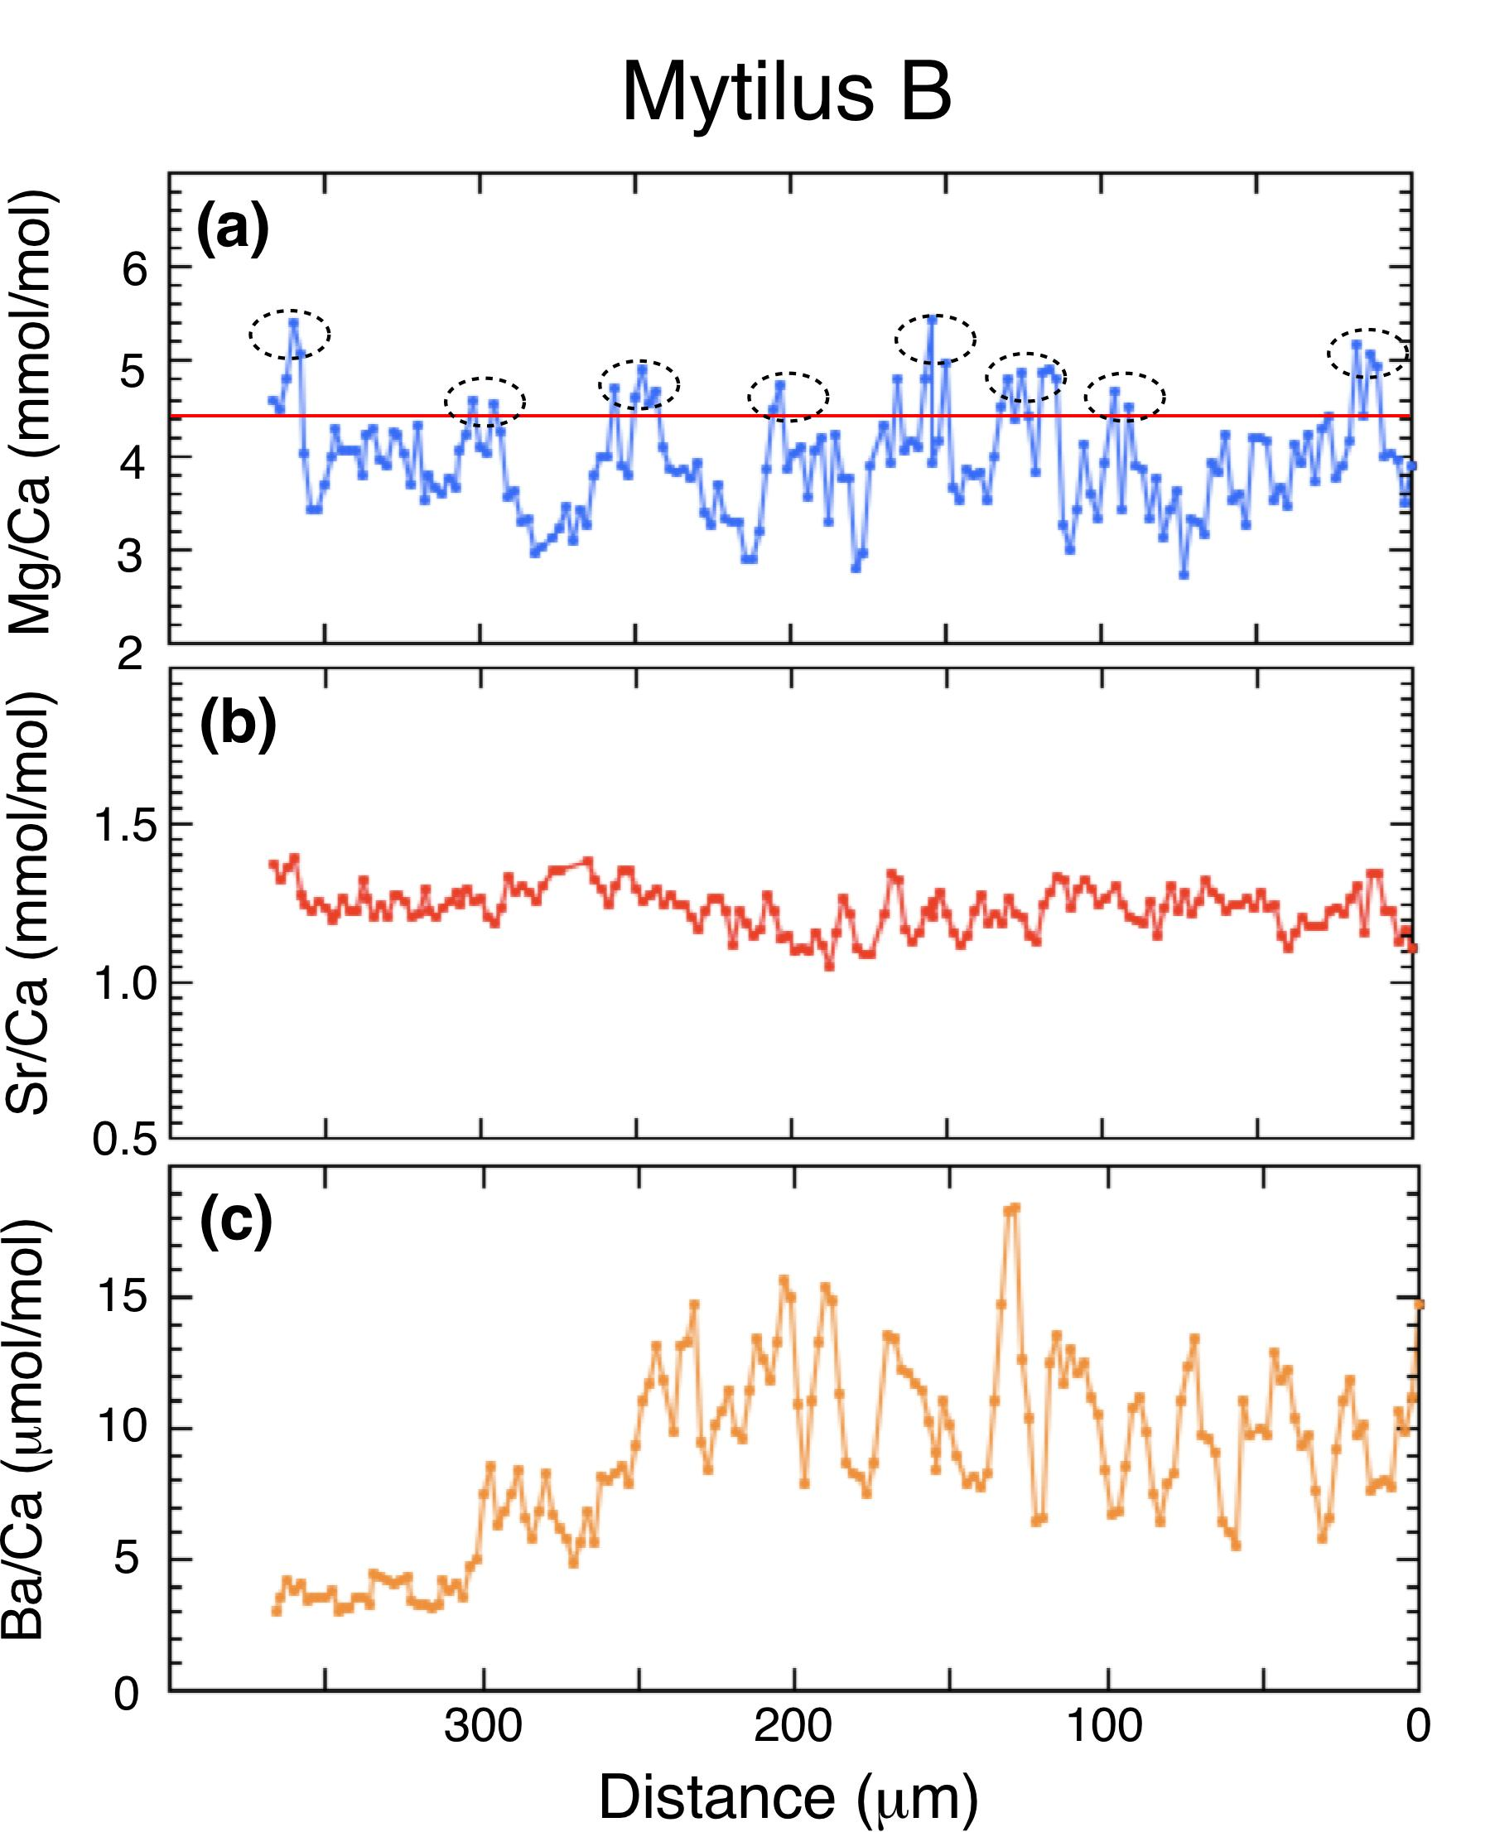

Supplementary Figure 3. High-resolution profile of Mg/Ca, Sr/Ca and Ba/Ca ratios of Mytilus B. (a) High-resolution profile of Mg/Ca ratios along the growth line in the inner edge. A red line shows a threshold value. Ovals indicate values higher than the threshold. (b) High-resolution profile of Sr/Ca ratios along the growth line in the inner edge. (c) High-resolution profile of Ba/Ca ratios along the growth line in the inner edge.

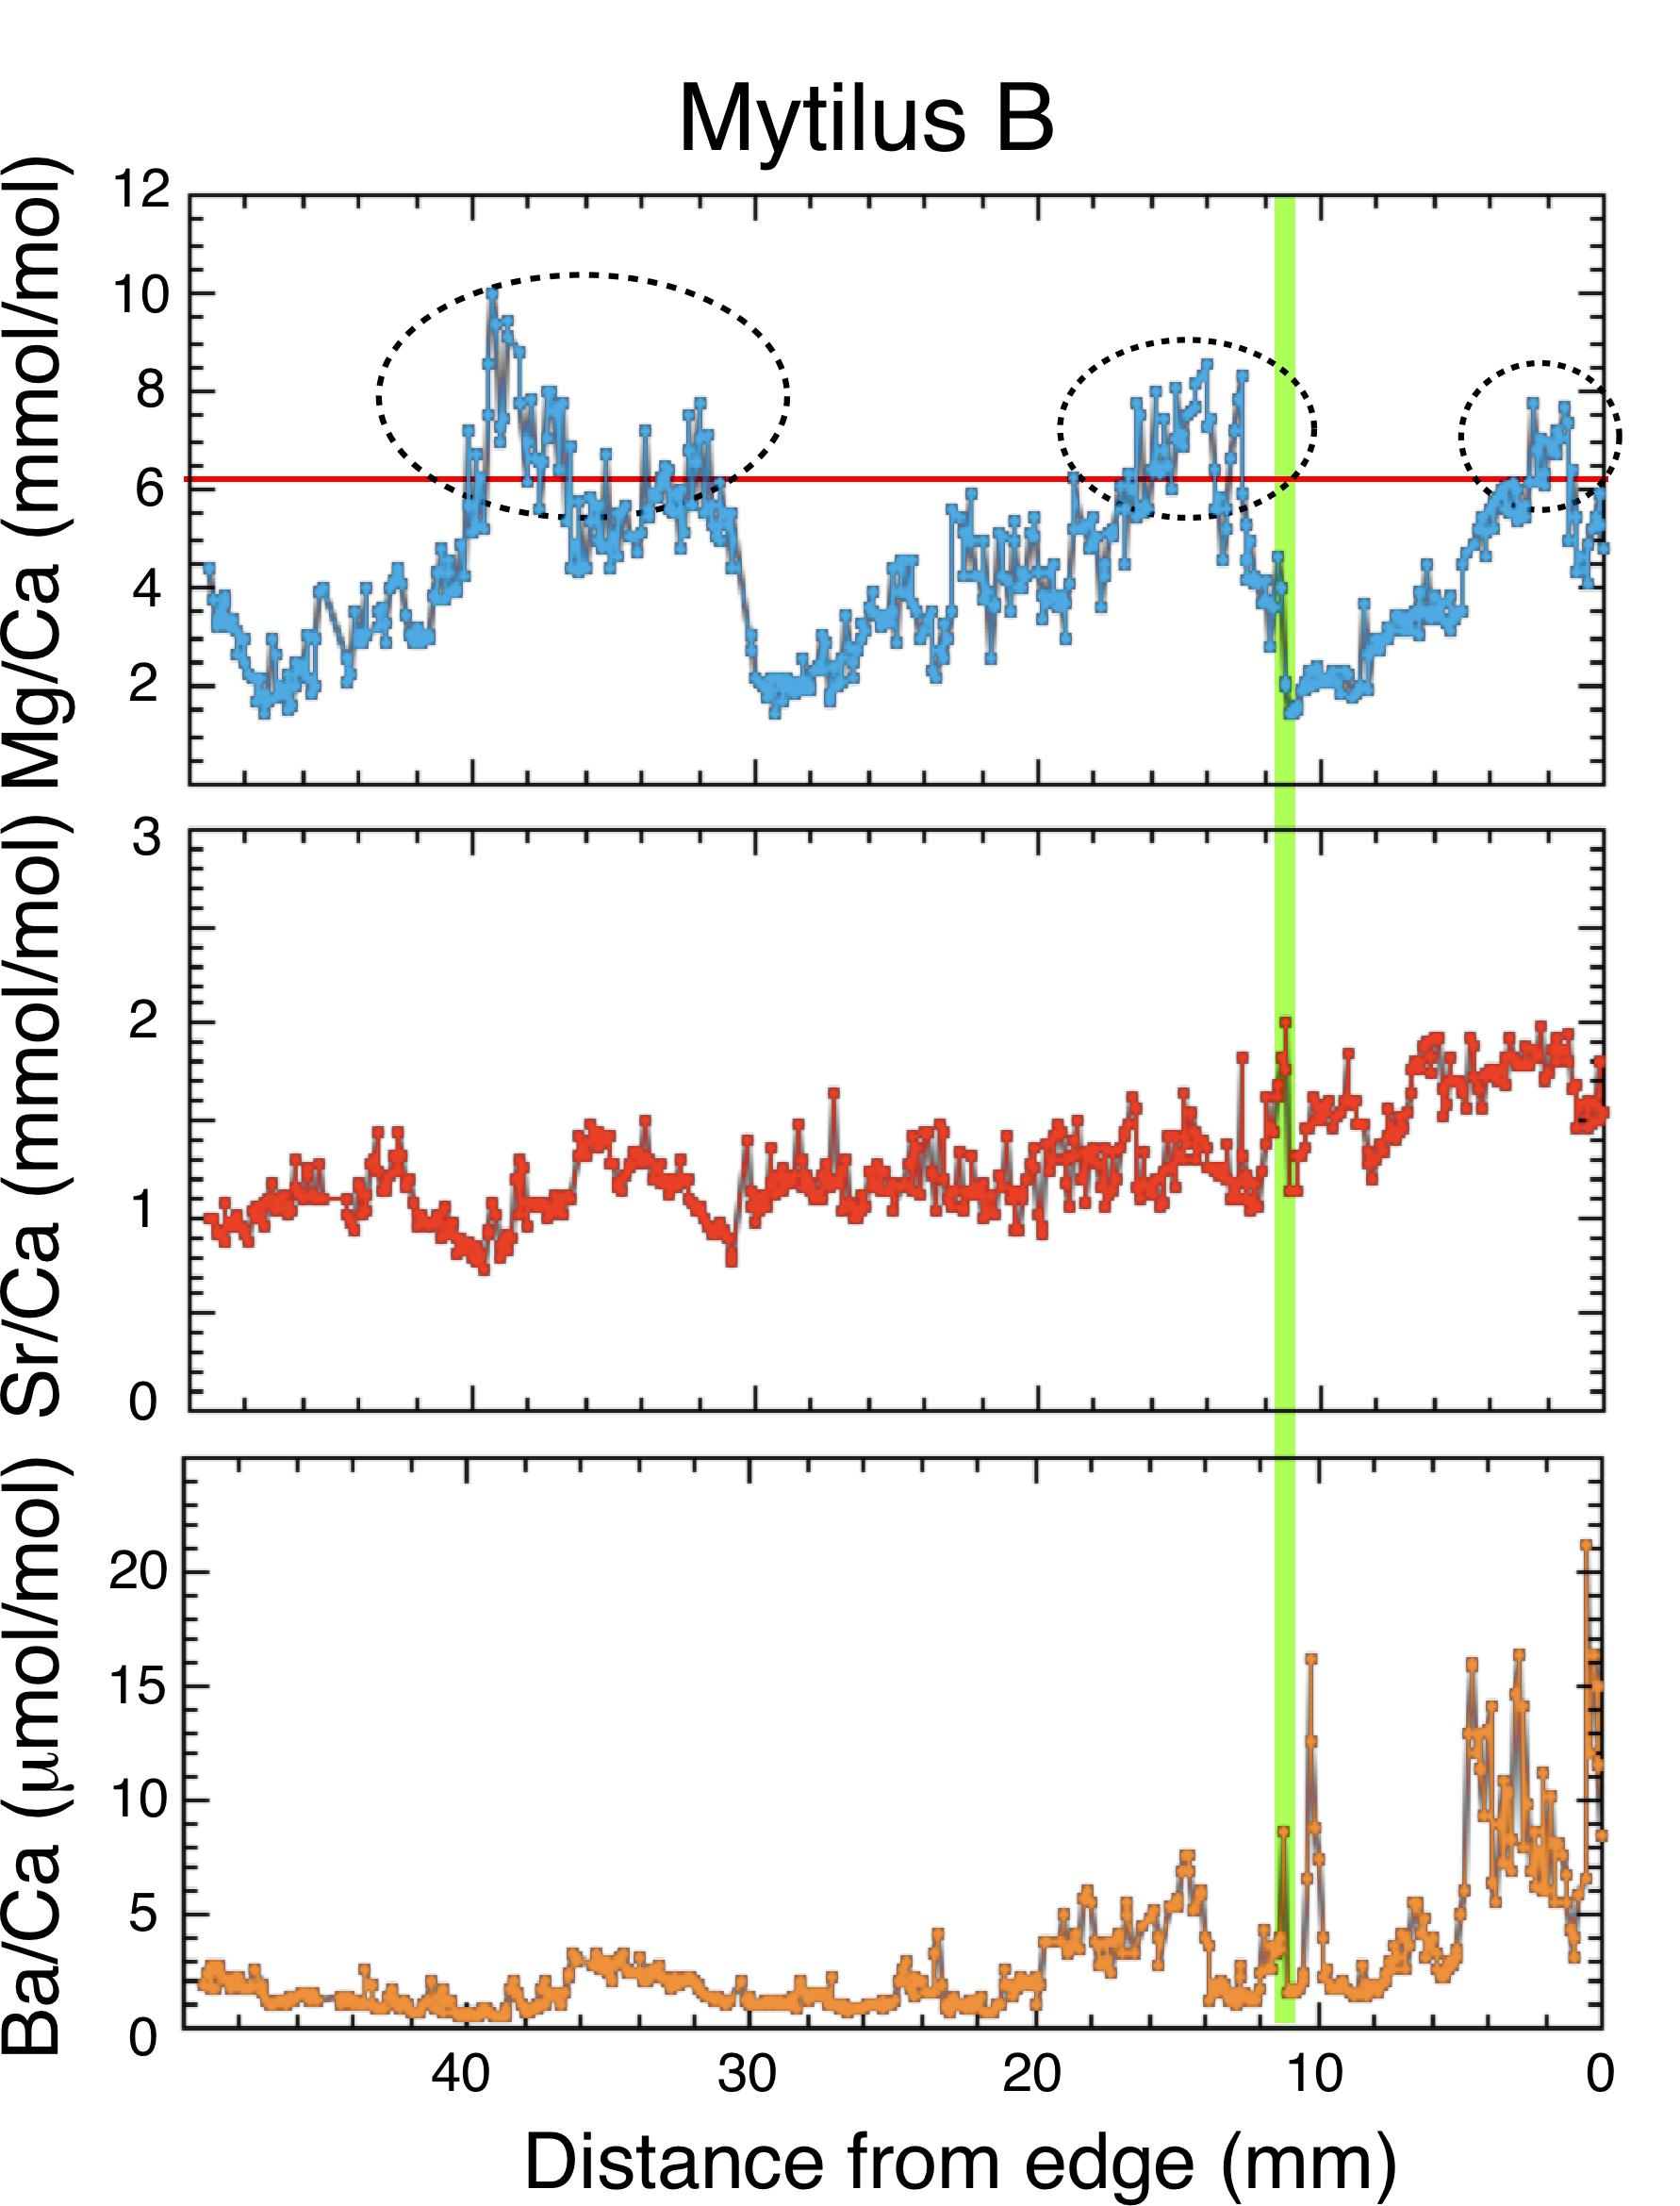

Supplementary Figure 4. Low-resolution profiles of Mg/Ca, Sr/Ca and Ba/Ca ratios of Mytilus B. (a) Low-resolution profile of Mg/Ca ratios along the maximum growth line. Horizontal red line and vertical green line show a threshold value and the date of the great tsunami, respectively. Ovals show the data higher than the threshold. (b) Low-resolution profile of Sr/Ca ratios along the growth line. (c) Low-resolution profile of Ba/Ca ratios along the growth line.

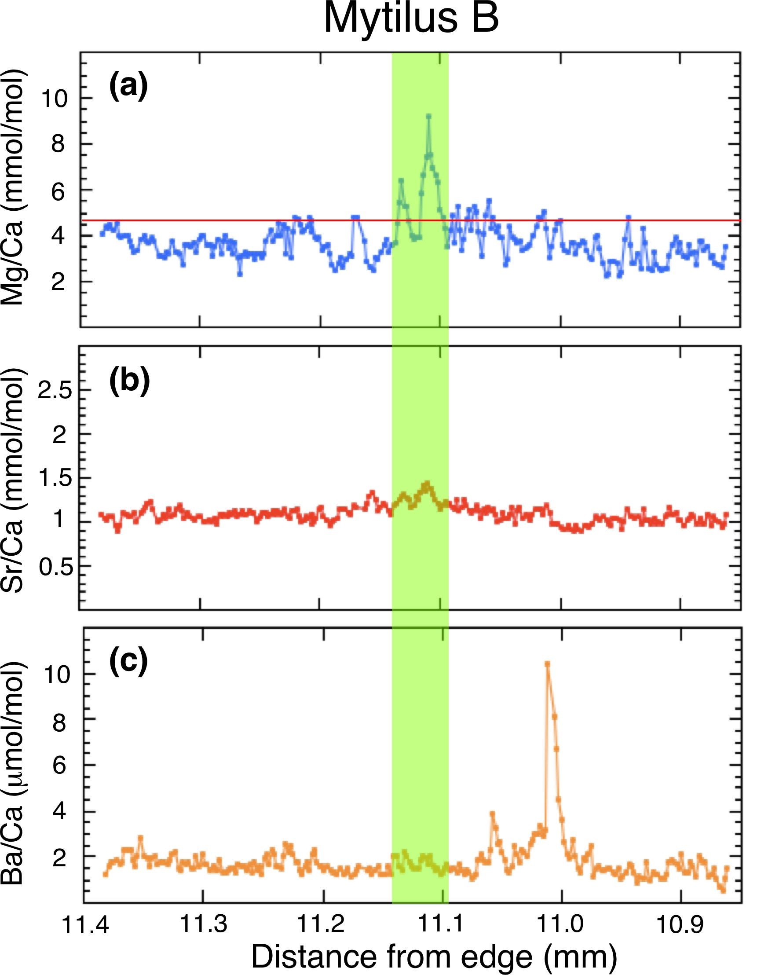

Supplementary Figure 5. High-resolution profiles of Mg/Ca, Sr/Ca and Ba/Ca ratios of Mytilus B in tsunami part. (a) High-resolution profile of Mg/Ca ratios across the tsunami part. A red line shows a threshold value. (b) High-resolution profile of Sr/Ca ratios across the tsunami part. (c) High-resolution profile of Ba/Ca ratios across the tsunami part.

