Supplemental Tables – Main text
Supplemental Table 1 (relates to Figure 1). Estimated marginal means of accuracy in the learning phase for humans and rats. All are significantly above chance level (0.5). Note that accuracy the learning phase for rats is calculated in the unrewarded “probe” trials (see Methods)
 |  | Humans |  | Rats
 |  | Average | Slope | Average | Slope
AB | E1 | 0.978 [0.959 , 0.988] z=11.6, p<0.001 | 0.068 [0.048, 0.089]  z=6.54, p<0.001 | 0.714, [0.660 , 0.761]  z=7.22, p<0.001 | 0.036 [0.011, 0.061] z=2.79, p=0.005
AB | E2 | 0.948 [0.91 , 0.971]  z=9.66, p<0.001 | 0.066 [0.048, 0.085]  z=7.10, p<0.001 | 0.676, [0.628 , 0.721]  z=6.75, p<0.001 | 0.042 [0.020, 0.064] z=3.80, p<0.001
AB | E3 | 0.918 [0.863 , 0.953] z=8.16, p<0.001 | 0.065 [0.047, 0.083]  z=7.13, p<0.001 | 0.675, [0.627 , 0.720]  z=6.73, p<0.001 | 0.046 [0.024 , 0.068] z=4.17, p<0.001
CD | E1 | 0.985 [0.971 , 0.992] z=12.3, p<0.001 | 0.103 [0.082, 0.124]  z=9.64, p<0.001 | 0.784, [0.738 , 0.824]  z=10.1, p<0.001 | 0.079 [0.053 , 0.105] z=5.86, p<0.001
CD | E2 | 0.919 [0.864, 0.953]  z=8.22, p<0.001 | 0.049 [0.031, 0.067]  z=5.37, p<0.001 | 0.746, [0.703 , 0.785]  z=9.74, p<0.001 | 0.123 [0.101 , 0.146] z=10.7, p<0.001
CD | E3 | 0.962 [0.932 , 0.979] z=10.5, p<0.001 | 0.060 [0.041, 0.079] z=6.25, p<0.001 | 0.688, [0.64 , 0.732] z=7.22, p<0.001 | 0.066 [0.045 , 0.088] z=5.98, p<0.001

Supplemental Table 2 (relates to Figure 2A, 2C). Estimated marginal means of the accuracy in the transfer phase for humans in the first trial and across all trials, and the estimated increase in accuracy (slope) per trial. Slope estimates were backtransformed from the logarithmic scale. Statistically significant estimates in bold.
 |  | Humans
 |  | First Trial | All trials | Slope
AB | E1 | 0.890 [0.804, 0.941]  z=6.07, p<0.001 | 0.866, [0.815 0.904]  z=9.57, p<0.001 | -0.027 [-0.099, 0.044]  z=-0.743, p=0.457
AB | E2 | 0.848 [0.754, 0.911]  z=5.6, p<0.001 | 0.824, [0.765 0.871]  z=8.27, p<0.001 | -0.021 [-0.086, 0.043]  z=-0.642, p=0.521
AB | E3 | 0.827 [0.729, 0.895]  z=5.31, p<0.001 | 0.793, [0.728 0.846]  z=7.34, p<0.001 | -0.027 [-0.088, 0.035]  z=-0.848, p=0.397
CD | E1 | 0.887 [0.804, 0.937]  z=6.22, p<0.001 | 0.823, [0.764 0.871]  z=8.22, p<0.001 | -0.062 [-0.130, 0.005]  z=-1.81, p=0.071
CD | E2 | 0.705 [0.591, 0.799]  z=3.39, p<0.001 | 0.695, [0.617 0.763]  z=4.67, p<0.001 | -0.006 [-0.061, 0.049]  z=-0.208, p=0.835
CD | E3 | 0.787 [0.683, 0.864]  z=4.73, p<0.001 | 0.74, [0.667 0.801]  z=5.85, p<0.001 | -0.032 [-0.090, 0.026]  z=-1.07, p=0.284
AD | E1 | 0.859 [0.763, 0.92]  z=5.56, p<0.001 | 0.871, [0.821, 0.908]  z=9.76, p<0.001 | 0.012 [-0.057, 0.082]  z=0.352, p=0.725
AD | E2 | 0.844 [0.748, 0.908]  z=5.5, p<0.001 | 0.832, [0.774, 0.878]  z=8.52, p<0.001 | -0.010 [-0.075, 0.054]  z=-0.312, p=0.755
AD | E3 | 0.763 [0.65, 0.849]  z=4.14, p<0.001 | 0.846, [0.791, 0.889]  z=8.94, p<0.001 | 0.064 [0.002, 0.127]  z=2.02, p=0.043
AC | E1 | 0.607 [0.488, 0.715]  z=1.77, p=0.077 | 0.693, [0.616, 0.761]  z=4.64, p<0.001 | 0.046, [-0.007, 0.099]  z=1.69, p=0.092
AC | E2 | 0.635 [0.515, 0.74]  z=2.2, p=0.028 | 0.723, [0.648, 0.787]  z=5.38, p<0.001 | 0.049, [-0.006, 0.103]  z=1.76, p=0.078
AC | E3 | 0.532 [0.413, 0.647]  z=0.525, p=0.600 | 0.705, [0.628, 0.772]  z=4.92, p<0.001 | 0.090 [0.036, 0.143]  z=3.29, p=0.001
BD | E1 | 0.477 [0.363, 0.594]  z=-0.381, p=0.703 | 0.61, [0.527, 0.687]  z=2.57, p=0.010 | 0.065 [0.013, 0.116]  z=2.46, p=0.014
BD | E2 | 0.473 [0.358, 0.591]  z=-0.449, p=0.65 | 0.605, [0.521, 0.683]  z=2.44, p=0.015 | 0.065 [0.012, 0.117]  z=2.42, p=0.015
BD | E3 | 0.621 [0.502, 0.726]  z=1.99, p=0.046 | 0.661, [0.58, 0.733]  z=3.82, p<0.001 | 0.021 [-0.032, 0.074]  z=0.785, p=0.433
BC | E1 | 0.173 [0.106, 0.269]  z=-5.43, p<0.001 | 0.282, [0.217, 0.358]  z=-5.23, p<0.001 | 0.076 [0.017, 0.136]  z=2.51, p=0.012
BC | E2 | 0.272 [0.184, 0.382]  z=-3.82, p<0.001 | 0.463, [0.38, 0.548]  z=-0.846, p=0.398 | 0.101 [0.046, 0.155]  z=3.63, p<0.001
BC | E3 | 0.299 [0.206, 0.411]  z=-3.38, p<0.001 | 0.439, [0.358, 0.524]  z=-1.41, p=0.159 | 0.073, [0.020,0.127]  z=2.71, p=0.007

Supplemental Table 3 (relates to Figure 2B, 2D). Estimated marginal means of the accuracy in the transfer phase for rats in the first session and across all session, and the estimated increase in accuracy (slope) per session. Statistically significant estimates in bold.

 |  | Rats
 |  | First Session | All Sessions | Slope
AB | E1 | 0.754 [0.692 , 0.806]  z=7.12, p<0.001 | 0.779, [0.725 0.824]  z=8.6, p<0.001 | 0.031 [-0.009 , 0.071]  z=1.52, p=0.130
AB | E2 | 0.662 [0.602 , 0.717]  z=5.1, p<0.001 | 0.719, [0.667 0.766]  z=7.51, p<0.001 | 0.060, [0.027, 0.092]  z=3.6, p<0.001
AB | E3 | 0.694 [0.637, 0.746,  z=6.21, p<0.001 | 0.704, [0.65 0.752]  z=6.91, p<0.001 | 0.010 [-0.02, 0.042]  z=0.606, p=0.545
CD | E1 | 0.815 [0.763, 0.858]  z=9.23, p<0.001 | 0.778, [0.725 0.824]  z=8.58, p<0.001 | -0.051 [-0.091, -0.011]  z=-2.51, p=0.012
CD | E2 | 0.809 [0.764, 0.848]  z=10.4, p<0.001 | 0.774, [0.727 0.814]  z=9.72, p<0.001 | -0.048 [-0.082, -0.014]  z=-2.73, p=0.006
CD | E3 | 0.720 [0.665, 0.769]  z=7.14, p<0.001 | 0.687, [0.632 0.737]  z=6.3, p<0.001 | -0.035 [-0.067, -0.004]  z=-2.2, p=0.028
AD | E1 | 0.836 [0.786, 0.876]  z=9.79, p<0.001 | 0.841, [0.798, 0.876]  z=11.2, p<0.001 | 0.008, [-0.036, 0.052]  z=0.348, p=0.728
AD | E2 | 0.843 [0.802, 0.878]  z=11.5, p<0.001 | 0.866, [0.834, 0.893]  z=14.3, p<0.001 | 0.041, [0.002, 0.081]  z=1.97, p=0.049
AD | E3 | 0.771 [0.72, 0.815]  z=8.87, p<0.001 | 0.783, [0.738, 0.822]  z=10.1, p<0.001 | 0.016, [-0.019, 0.050]  z=0.887, p=0.375
AC | E1 | 0.481 [0.408, 0.553]  z=-0.523, p=0.601 | 0.584, [0.514, 0.65]  z=2.36, p=0.018 | 0.093, [0.057, 0.128]  z=5.15, p<0.001
AC | E2 | 0.498 [0.435, 0.561]  z=-0.0645, p=0.949 | 0.616, [0.557, 0.672]  z=3.8, p<0.001 | 0.107, [0.076, 0.138]  z=6.77, p<0.001
AC | E3 | 0.544 [0.482, 0.606]  z=1.39, p=0.166 | 0.575, [0.515, 0.633]  z=2.43, p=0.015 | 0.027 [-0.003, 0.057]  z=1.79, p=0.073
BD | E1 | 0.675 [0.607, 0.736]  z=4.82, p<0.001 | 0.628, [0.56, 0.691]  z=3.65, p<0.001 | -0.046 [-0.081, -0.010]  z=-2.52, p=0.012
BD | E2 | 0.693 [0.635, 0.745]  z=6.16, p<0.001 | 0.681, [0.626, 0.732]  z=6.08, p<0.001 | -0.012 [-0.043, 0.020]  z=-0.743, p=0.458
BD | E3 | 0.571 [0.508, 0.631]  z=2.21, p=0.027 | 0.577, [0.517, 0.635]  z=2.5, p=0.012 | 0.006 [-0.024, 0.036]  z=0.376, p=0.707
BC | E1 | 0.304 [0.244, 0.371]  z=-5.42, p<0.001 | 0.302, [0.245, 0.364]  z=-5.81, p<0.001 | -0.002 [-0.039, 0.037]  z=-0.122, p=0.903
BC | E2 | 0.332 [0.278, 0.392]  z=-5.33, p<0.001 | 0.387, [0.331, 0.446]  z=-3.7, p<0.001 | 0.053, [0.022, 0.083]  z=3.36, p<0.001
BC | E3 | 0.358 [0.301, 0.418]  z=-4.51, p<0.001 | 0.374 [0.319, 0.433]  z=-4.14, p<0.001 | 0.016 [-0.015, 0.046]  z=1.01, p=0.312

Supplemental Table 4 (relates to Methods). Demographic data. Mean and standard deviation of sex, age, bonus payment and completion time across all experiments.
 | n | Sex |  | Age | Bonus Payment | Time
 | n | M | F | Age | Bonus Payment | Time
E1 | 24 | 12 | 12 | 26.5 ± 6.80 | 2.10 ± 0.128 | 23.9 ± 8.85
E2 | 24 | 12 | 12 | 30.1 ± 10.7 | 1.91 ± 0.199 | 24.1 ± 7.75
E3 | 24 | 12 | 12 | 33.0 ± 12.9 | 1.94 ± 0.154 | 23.2 ± 7.17

Supplemental Table 5 (relates to Methods). Stimulus features
Stimulus | Orientation | Frequency | Background Colour (RGB) | Subjects
 | 0 | 0.2 | 153, 0, 153 | Humans & Rats
 | 45 | 0.15 | 0, 51, 255 | Humans & Rats
 | 90 | 0.1 | 0, 255, 204 | Humans & Rats
 | 135 | 0.05 | 153, 255, 0 | Humans & Rats
 | 22.5 | 0.25 | 255, 113, 91 | Humans
 | 67.5 | 0.075 | 56, 102, 65 | Humans
 | 112.5 | 0.125 | 200, 153, 51 | Humans
 | 157.5 | 0.175 | 200, 121, 255 | Humans

Supplemental Figures – Main text
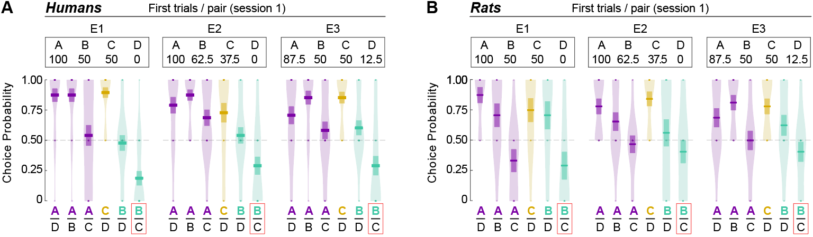
Supplemental Figure 1. Initial transfer phase trials for humans and rats (relates to Figure 2). The plots show choice probability for all possible option combinations during the first two presentations of each pair during the transfer phase in humans (A) and rats (B) for all three experiments (E1, E2, and E3). Individual data points represent the average performance per subject (2 trials/pair). Each pair in the plot is represented by two choices, as humans saw two sets of symbols representing each choice pair (e.g., AD and A’D’) and in rats, this corresponds to the counterbalanced side presentation (e.g., one AD trial with A on the left, and one trial with A on the right).
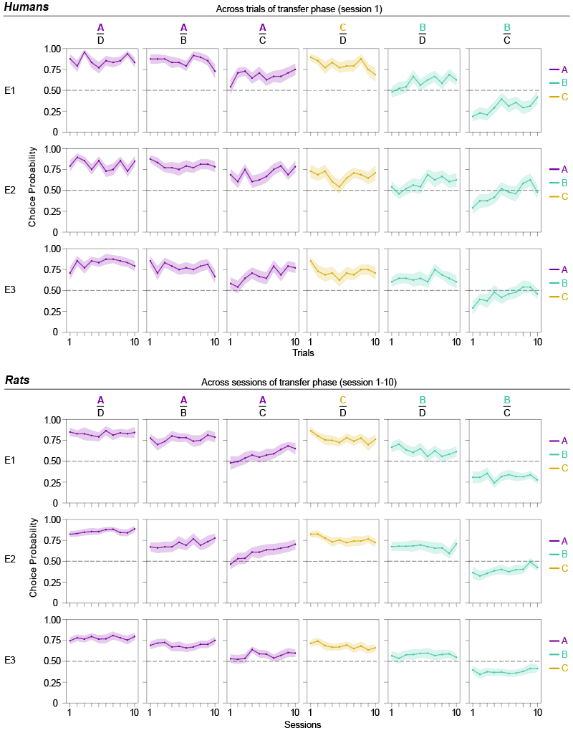
Supplemental Figure 2. Evolution of transfer phase choices across all trials (humans) and all sessions (rats) (relates to Figure 2). Each point represents the average choice probability for a given trial or session, color represents the option chosen, and the shading represents the standard error of the mean. Note that economically suboptimal preferences get corrected over time (e.g., in E2, BC and BD for humans, and AC and BC for rats).
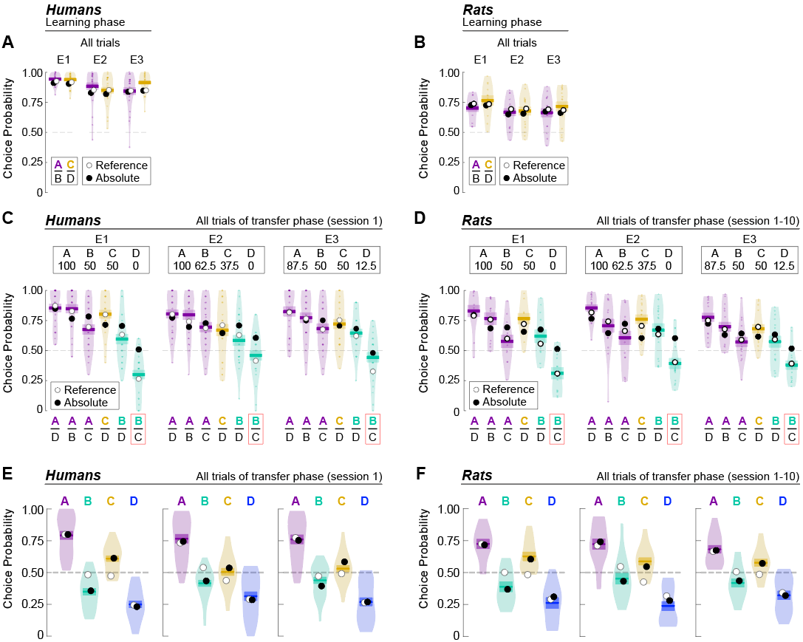

Supplemental Figure 3. Behavioural results and model simulations for each experiment (relates to Figure 4). Crossbars and violin plots represent subject’s responses, while black and white dots represent predictions of the “Absolute” and “Reference” models, respectively. (A, B) Choice rates in the learning phase in humans and rats. (C, D) Choice rates in each choice pair of the transfer phase in humans and rats. (E, F) Choice rate per option in the transfer phase in humans and rats.
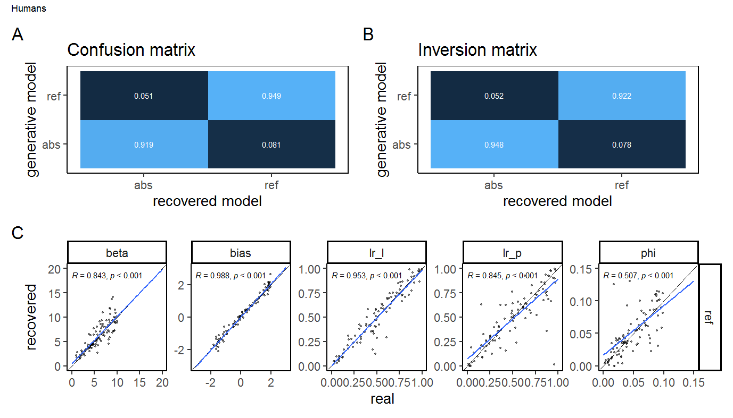
Supplemental Figure 4. Model and parameter recovery – humans (relates to Methods). “abs” refers to the “Absolute” model, while “ref” refers to the “Reference” model. Parameters lr_l and lr_p refer to the learning rates for the learning and transfer phase respectively, while bias reflects motor bias for options presented on the left and phi is the decay parameter governing the rate of forgetting.
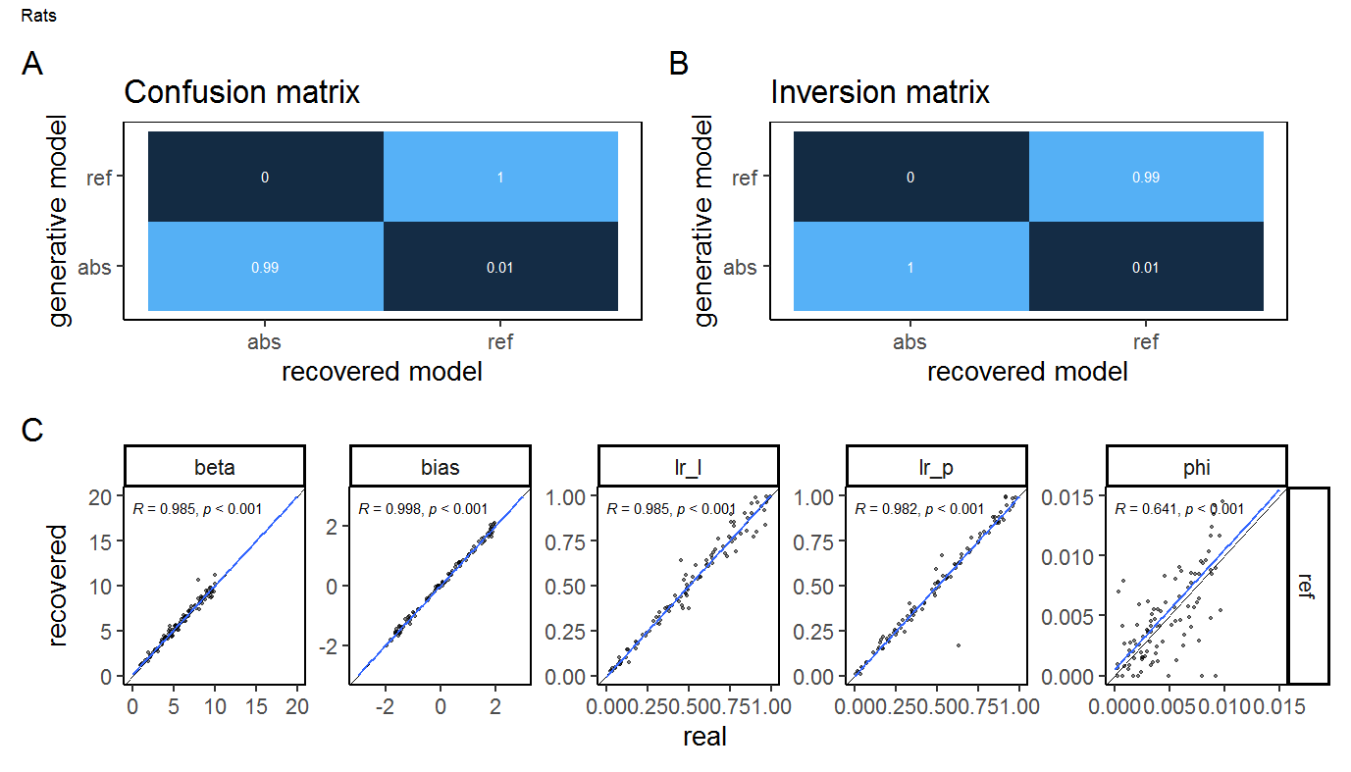
Supplemental Figure 5. Model and parameter recovery – rats (relates to Methods). “abs” refers to the “Absolute” model, while “ref” refers to the “Reference” model. Parameters lr_l and lr_p refer to the learning rates for the learning and transfer phase respectively, while bias reflects motor bias for options presented on the left and phi is the decay parameter governing the rate of forgetting.

Supplemental Material

Response times
We analysed subjects’ reaction times as such analysis can provide further insight into the underlying cognitive processes. Notably, longer reaction times are linked with decision conflict or option values (Fontanesi et al., 2019). After assessing that we could observe the expected modulation of reaction times as a function of the progression in the learning phase (Supplemental Figure 6), we focussed on analysing the reaction times as a function of the option pair, after averaging across trials. To do so, we first excluded any trials with response times under 100ms as the former were too short to represent a genuine response to the presented stimuli. We also excluded reaction times over 5s (humans) or 10s (rats) as those were likely result of task-unrelated events. The learning phase was analysed using the following linear mixed model (LMM):
log(respRT) ~ expID*context *blockTrial+ expID*context *repetition +(1+blockTrial + repetition |partID)
Where respRT was the response time in ms, context was the presented pair of options, e.g. AB or CD, blockTrial represented a trial within the miniblock (humans) or session (rats), and repetition referred to the session (rats) or to the miniblock (humans). Both blockTrial and repetition variables were centred. The interaction between context and repetition was omitted due to collinearity issues.
In the learning phase (Supplemental Table 6), rats had significantly longer reaction times in the “poor” (CD) context, compared to the “rich” (AB) context even though the objective choice difficulty, proxied by the probability difference between the presented options, was the same in both contexts (E1: contrast_{CD/AB} = 1.12, z= 13.5, p< 0.001; E2: contrast_{CD/AB} = 1.17, z= 20.7, p< 0.001; E3: contrast_{CD/AB} = 1.07, z= 9.29, p< 0.001). However, this was not the case for humans (E1: contrast_{CD/AB} = 0.973, z= -1.77, p= 0.076; E2: contrast_{CD/AB} = 0.997, z= -0.193, p=.847; E3: contrast_{CD/AB} = 0.958, z = -2.84, p= .005). One possible explanation is that rats viewed the poor contexts as more punishing than humans as response times are known to be slower in such conditions (Fontanesi et al., 2019; Palminteri et al., 2016). The transfer phase was analysed using the following linear mixed model (LMM):
log(respRT) ~ expID*context * repeat +(1+repeat |partID)
Where respRT was the response time in ms, context was the presented pair of options, e.g. AB or CD, and repeat represented a trial within the context (humans, log-transformed) or a session (rats), and was centred.
In the transfer phase, both species responded slowest in the BD context, where they had to decide between two previously unfavourable options (Supplemental Table 7). This is notable as the objective difficulty (again proxied by the probability difference between the options) was the same as in the AC context, where subjects encountered two previously advantageous options and where the response times were significantly faster (Humans: E1: contrast_{BD/AC} = 1.25, z= 7.86, p< 0.001; E2: contrast_{BD/AC} = 1.21, z=6.63, p< 0.001; E3: contrast_{BD/AC} = 1.11,z= 3.68, p< 0.001, Rats: E1: contrast_{BD/AC} = 1.04, z3.55, p< 0.001; E2: contrast_{BD/AC} = 1.05, z=5.22, p< 0.001; E3: contrast_{BD/AC} = 1.06, z= 6.51, p< 0.001)
Notably, these results cannot be explained by a difference in information sampling, since both human and rat subjects were provided with complete feedback in the learning phase and these effects are present from the first trial of the transfer phase and confirm that in reinforcement learning, option valence is a strong modulator of reaction times (of note, similar findings were recently reported by Tohidi-Moghaddam & Tsetsos (2024))
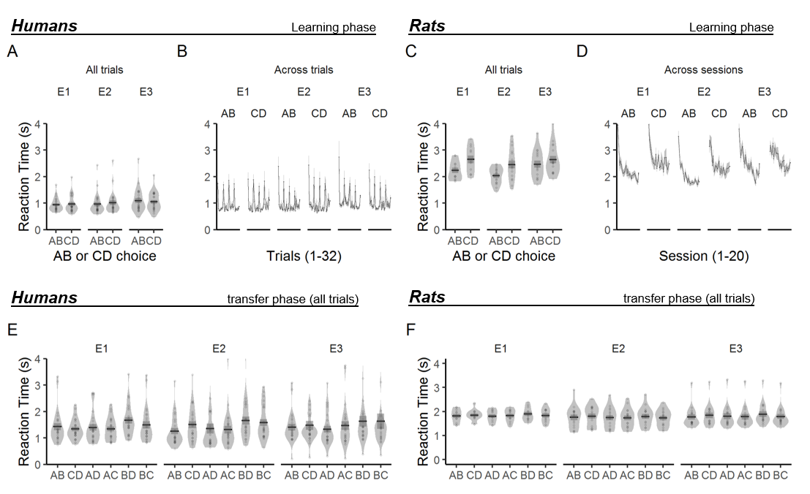
Supplemental Figure 6. Reaction times during free choice trials. (A-B) Human reaction times in the learning phase. The spikes in B represent start of miniblocks (i.e., AB/A’B’ or CD/C’D’ with the same choice pair. (C-D) Rat reaction times in the learning phase. (E, F) Reaction times in the transfer phase for humans and rats, respectively.

Supplemental Table 6. Estimated marginal means of reaction times for free choice trials in the learning phase.
 |  | Humans | Rats
AB | E1 | M=787, CI=[712;871], | M=2030, CI=[1830;2250],
AB | E2 | M=769, CI=[696;851], | M=1810, CI=[1650;1980],
AB | E3 | M=875, CI=[791;968], | M=2160, CI=[1970;2360],
CD | E1 | M=762, CI=[689;843], | M=2270, CI=[2050;2520],
CD | E2 | M=767, CI=[693;848], | M=2110, CI=[1930;2310],
CD | E3 | M=839, CI=[758;928], | M=2320, CI=[2120;2530],
Supplemental Table 7. Estimated marginal means of reaction times in the transfer phase.
 |  | Humans | Rats
AB | E1 | M=1040, CI=[906;1180] | AB M=1660, CI=[1490;1840]
AB | E2 | M=1000, CI=[876;1150] | AB M=1560, CI=[1430;1710]
AB | E3 | M=1080, CI=[947;1240] | AB M=1630, CI=[1490;1780]
CD | E1 | M=1070, CI=[939;1230] | CD M=1680, CI=[1510;1860]
CD | E2 | M=1130, CI=[991;1300] | CD M=1590, CI=[1450;1740]
CD | E3 | M=1160, CI=[1010;1330] | M=1680, CI=[1540;1840]
AD | E1 | M=1020, CI=[894;1170] | M=1670, CI=[1500;1850]
AD | E2 | M=1010, CI=[887;1160] | M=1570, CI=[1430;1710]
AD | E3 | M=1040, CI=[909;1190] | M=1630, CI=[1490;1790]
AC | E1 | M=1050, CI=[921;1200] | M=1670, CI=[1510;1860]
AC | E2 | M=1030, CI=[899;1180] | M=1560, CI=[1420;1700]
AC | E3 | M=1120, CI=[980;1280] | M=1620, CI=[1480;1780]
BD | E1 | M=1310, CI=[1150;1500] | M=1730, CI=[1560;1920]
BD | E2 | M=1240, CI=[1080;1420] | M=1630, CI=[1490;1780]
BD | E3 | M=1250, CI=[1090;1430] | M=1720, CI=[1570;1880]
BC | E1 | M=1130, CI=[990;1290] | M=1700, CI=[1530;1890]
BC | E2 | M=1240, CI=[1080;1410] | M=1560, CI=[1430;1710]
BC | E3 | M=1150, CI=[1010;1320] | M=1660, CI=[1520;1820]

Finally, we also compared the response times for B and C across both the learning phase and transfer phase as faster reaction times when selecting C compared to B might suggest that the context effects are modulated by processing speed. In the learning phase, humans tended to respond faster when selecting C than when selecting B (Supplemental Table 8, E1: contrast_{C/B} = 0.830, z= -3.19, p= 0.004; E2: contrast_{C/B} = 0.906, z= -2.48, p= 0.031; E3: contrast_{C/B} = 0.912, z= -2.65, p= 0.02). Rats on the other hand, responded faster when selecting B both in choice trials and sampling trials (Supplemental Table 8, Choice trials: E1: contrast_{C/B} = 1.05, z= 3.79, p< 0.001; E2: contrast_{C/B} = 1.13, z= 10.4, p< 0.001; E3: contrast_{C/B} = 1.03, z= 2.54, p= 0.031; Sampling trials: E1: contrast_{C/B} = 1.02, z= 3.70, p< 0.001; E2: contrast_{C/B} = 1.13, z= 28.2, p< 0.001; E3: contrast_{C/B} = 1.03, z= 7.22, p< 0.001).
In the transfer phase, we compared the reaction times for selecting option C in the BC context to selecting option B. We did not find any significant statistical difference in the reaction times of the human participants (Supplemental Table 9, E1: contrast_{C/B} = 0.978, z= -0.445, p= 0.656; E2: contrast_{C/B} = 0.973, z= -6.09, p= 0.543; E3: contrast_{C/B} = 1.03, z= 0.545, p= 0.586). Similarly, we did not find any evidence in support of rats being faster when choosing C rather than B (Supplemental Table 9, E1: contrast_{C/B} = 1.011, z= 0.678, p= 0.499; E2: contrast_{C/B} = 0.985, z= -1.17, p= 0.241; E3: contrast_{C/B} = 1.028, z= 2.145, p= 0.032). Thus, we believe that the observed context effects are not due to response speed errors.

Supplemental Table 8. Estimated marginal means of reaction times for selecting options B and C in the learning phase
 |  | Humans | Rats  (choice trials) | Rats  (sampling trials)
B | E1 | M=909, CI=[782;1060] | M=2130, CI=[1910;2370] | M=2040, CI=[1840;2270]
B | E2 | M=833, CI=[735;944] | M=1850, CI=[1690;2040] | M=1810, CI=[1650;1980]
B | E3 | M=912, CI=[809;1030] | M=2210, CI=[2010;2430] | M=2110, CI=[1920;2320]
C | E1 | M=755, CI=[681;837] | M=2240, CI=[2010;2490] | M=2080, CI=[1870;2320]
C | E2 | M=755, CI=[681;837] | M=2090, CI=[1900;2290] | M=2040, CI=[1860;2240]
C | E3 | M=831, CI=[750;922] | M=2270, CI=[2070;2500] | M=2180, CI=[1980;2390]

Supplemental Table 9. Estimated marginal means of reaction times for selecting options B and C in the transfer phase
 |  | Humans | Rats
B | E1 | M=1150, CI=[983;1345] | M=1690, CI=[1518;1882]
B | E2 | M=1256, CI=[1082;1459] | M=1578, CI=[1439;1732]
B | E3 | M=1132, CI=[972;1318] | M=1636, CI=[1491; 1795]
C | E1 | M=1125, CI=[974;1301] | M=1709, CI=[1537;1900]
C | E2 | M=1222, CI=[1054;1417] | M=1554, CI=[1418;1704]
C | E3 | M=1161, CI=[1000;1347] | M=1682, CI=[1535;1844]

Explicit ratings
The probability recollection task, specific to the human participants, was designed to assess to what extent participants were able to retrieve the probability of reward associated with each option (“how frequently the option won”). Each option was presented three times in a pseudorandom manner, and participants were required to estimate its reward probability using a slider scale from 0 to 100%.
In general, participants had a tendency to assign higher reward probabilities to the best possible option (A) and the lower probability to the worst possible option (D), indicating that participants were able to retrieve sensible numbers. However, interestingly, the intermediate value options B and C were encoded in a way that did not follow their objective values (Supplemental Figure 7A). To quantify this effect, we analysed to what extent the recalled rating differed from the real reward probability for the mid options B and C using a linear mixed model (LMM) with response error and experiment as the independent variables:
resp_diff~symID*expID+(1|partID)
Symbols A and D were excluded from the analysis as they were the extreme options in experiments E1 and E2 and therefore their error was always one directional.
We found that option B, which was disadvantageous in the original learning context, tended to be remembered significantly worse compared to option C, which was advantageous in the original learning context (E1: contrast_B-C = -0.190, t(856)=-7.34, p<0.001; E2: contrast_B-C = -0.269, t(856)=-10.4, p<0.001; E3: contrast_B-C = -0.04, t(856)=-1.64, p=0.101, Supplemental Figure 7B). This is even more striking if we take into account that the explicit rating task was performed after the transfer phase, giving participants the opportunity to correct possible context-dependent biases.
In addition, a significant proportion of participants’ choices in the last round of the transfer phase, was consistent with the average option ratings in the probability recollection task, which followed immediately after (E1: M=74.8%, t(23)=7.04, p<0.001; E2: 69.8%, t(23)=3.48, p=0.002; E3:73.6%, t(23)=5.83, p<0.001; two-sided one-sample t-test all compared to the chance level of 0.5). We can thus conclude that context in which options were presented affected not only participants’ choices but also their recollection of the reward probabilities. These results corroborate previous findings on this topic (Bavard & Palminteri, 2023; Juechems et al., 2022; Soukupova et al., 2024).

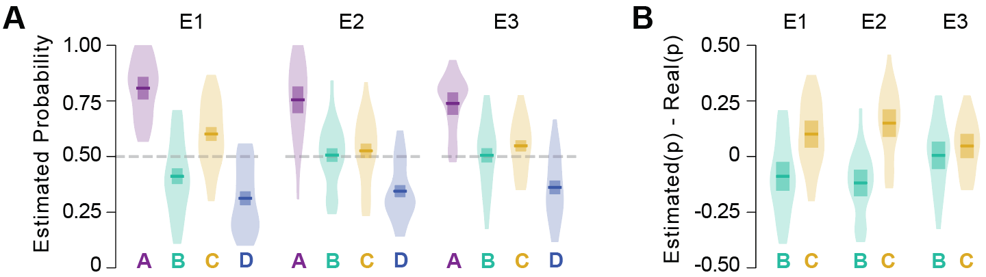
Supplemental Figure 7. Human participant’s explicit rating of reward probability. (A) Explicit rating of reward probability for each option. (B) Explicit rating of reward probability for critical BC choice options, minus their true probability. Plots illustrate participants’ propensity to overestimate the reward probability of C, which had a higher relative value in the learning phase compared to B. Note that these ratings were taken after the end of the transfer phase. The crossbar represents mean and standard error.

Experiments 4-6: Humans
In Experiments 1-3 (see Main Text), the learning phase differed between humans and rats. Humans executed free choices from two options, with both factual and counterfactual outcomes presented, whereas rats experienced forced-choice trials (presentation of only one stimulus), interleaved with free-choice trials without outcome feedback. To examine the impact of these design differences, we conducted an additional version of the human task using the same learning task as that used for rats. Specifically, the learning phase was arranged into 9-trial blocks: eight forced sampling trials (single-stimulus presentations with partial feedback) followed by one probe choice trial (two-stimuli) without feedback. Each block included four presentations of the high-value stimulus and four of the low-value stimulus in an alternating order (e.g., A, B, A). Instructions were also shortened and made neutral, with no references to reward maximization to reduce the potential impact of verbal instruction on the participants’ choice of behavioural strategy (see Appendix).

Methods

Participants
Participants were recruited via the online platform Prolific. In total, 144 participants completed the experiment, i.e., 48 per experiment. Participants were paid £3.50 plus a bonus payment up to £3.50 (M=£3.18, SD=0.209) based on the number of points they won during the experiment. See Supplemental Table 10 for mean age, sex, completion time and bonus payment. The study was approved by a local ethical committee (INSERM Institutional Review Board) and all participants gave informed consent before taking part in the experiment.
Supplemental Table 10. Demographics of the new experiment
 | Men | Women | n | Age | Bonus | Time
E4 | 24 | 24 | 48 | 34.4±6.73 | 3.25±0.219 | 29.8±5.38
E5 | 24 | 24 | 48 | 32.5±7.31 | 3.23±0.193 | 29.6±5.31
E6 | 24 | 24 | 48 | 32.0±7.16 | 3.04±0.144 | 30.6±8.01

Behavioural procedure
The learning phase of Experiments 4-6 was arranged into 9-trial blocks. Within each block, 8 forced sampling trials (single stimulus presentations) with partial feedback preceded a probe choice trial with no feedback. Sampling trials included 4 presentations of the high value stimulus and 4 presentations of the low value stimulus in an interleaved manner (e.g. A, B, A, ...). Each stimulus was presented an equal number of times on the left and right of the screen (during sampling trials) and the order of presentation within a block was also counterbalanced. The reward probabilities associated with each option are shown in Figure 1C (Main text). Two stimuli were associated with each probability (8 options in total) to ensure that the task remained sufficiently challenging. Each option was shown 32 times with feedback, yielding 256 sampling trials and 32 choice trials (288 trials in total). Thus, participants received the same amount of information as in Experiments 1-3.
The learning phase was preceded by a pre-training phase consisting of a single block during which the participants could familiarize themselves with the task structure. The pre-training phase used a different set of stimuli (the letters A, B) with different outcome probabilities (25% and 75%). The learning and transfer phase were identical to those described in the main text (Methods – Main text).

Results
As the learning phase consisted primarily of sampling trials, we focused our analyses on the transfer phase. In Experiment 4 (E4), options B and C had equivalent reward probabilities (50:50), but differed in relative value (B = low; C = high) within their respective “rich” and “poor” learning contexts. As in Experiment 1 (E1), which had identical reward probabilities, option B was chosen significantly less often than chance in the early transfer trials, indicating a clear preference for the higher relative value option C (Supplemental Figure 8, Supplemental Table 11; M=0.242, CI=[0.174;0.325], z=-5.44, p<0.001). This bias diminished across trials (Supplemental Figure 9, Supplemental Table 11; slope=0.087, CI=[0.048;0.126], z=4.40, p<0.001).
In Experiment 5 (E5), options B and C had both opposing reward probability (B = 62.5%; C = 37.5%) and relative value (B = low; C = high). In the initial transfer trials, no significant preference was observed for B or C (M = 0.514, CI = [0.416, 0.610], z = 0.272, p = 0.785). This is despite participants otherwise preferring the options with higher reward probabilities (Supplemental Figure 8, Supplemental Table 9; all p < 0.001). As in previous experiments, preference for option B increased significantly over time (Supplemental Figure 9, Supplemental Table 9, slope=0.063, CI=[0.026; 0.101], z=3.31, p<0.001) indicating that participants were able to distinguish between the options.
Finally, in Experiment 6 (E6), options A and D were non-deterministic, while B and C had equal reward probabilities (A = 87.5%; B = 50%; C = 50%; D = 12.5%). Participants preferred C over B (Supplemental Figure 8, Supplemental Table 11; M = 0.398, CI = [0.310, 0.492], z = –2.12, p = 0.034), as well as C over D, A over D, and A over C (all p < 0.004). No significant differences were observed between A and B (p = 0.29) or between B and D (p = 0.717). As in previous experiments, preference for option B increased significantly over time (Supplemental Figure 9, Supplemental Table 11, slope=0.038, CI=[0.002;0.074], z=2.08, p=0.037).
We then compared the accuracy in the AC context (previously favourable options) to the BD context (previously unfavourable options). Consistent with Experiments 1-3, accuracy was significantly higher in the AC than the BD context (E4: contrast_{AC/BD} = 1.89, z= 5.63, p<0.001, E5: contrast_{AC/BD} = 1.59, z= 3.93, p<0.001, E6: contrast_{AC/BD} = 1.38, z= 3.33, p=0.002). However, a closer examination revealed that, at the start of the transfer phase, participants in Experiments 4-6 were less biased towards recalling favourable outcomes compared to unfavourable outcomes than participants in Experiments 1-3 (E4: contrast_{AC.BD.New/AC.BC.Old} = 0.377, z= -2.36, p=0.036, E5: contrast_{AC/BD} = 0.335, z= -2.61, p=0.018, E6: contrast_{AC/BD} = 2.39, z= 2.169, p= 0.0593). This appears to be driven by higher accuracy in the BD context (Supplemental Table 11), suggesting that forced sampling might render participants more sensitive to the negative outcomes associated with an option.

Caution is needed when interpreting the results, however, as the accuracy in the learning task was significantly lower in Experiments 4-6 than in Experiments 1-3 (E1 vs E4: contrast_{New-Old} = -0.112, t(210)= -2.84, p=0.005, E2 vs E5: contrast_{New-Old} = -0.032, t(210)= -0.821, p=0.412, E3 vs E6: contrast_{New-Old} =-0.164, t(210)= -4.19, p<0.001). Importantly, participants had the same information in all experiments; full feedback was provided in Experiments 1-3 and sampling trials that unambiguously identify the more rewarding option in Experiments 4-6. The diminished accuracy in Experiments 4-6 may reflect lower engagement with the task. In a post experiment debriefing, the participants’ most common complaint was that the learning phase was too long, boring or “soporific”.

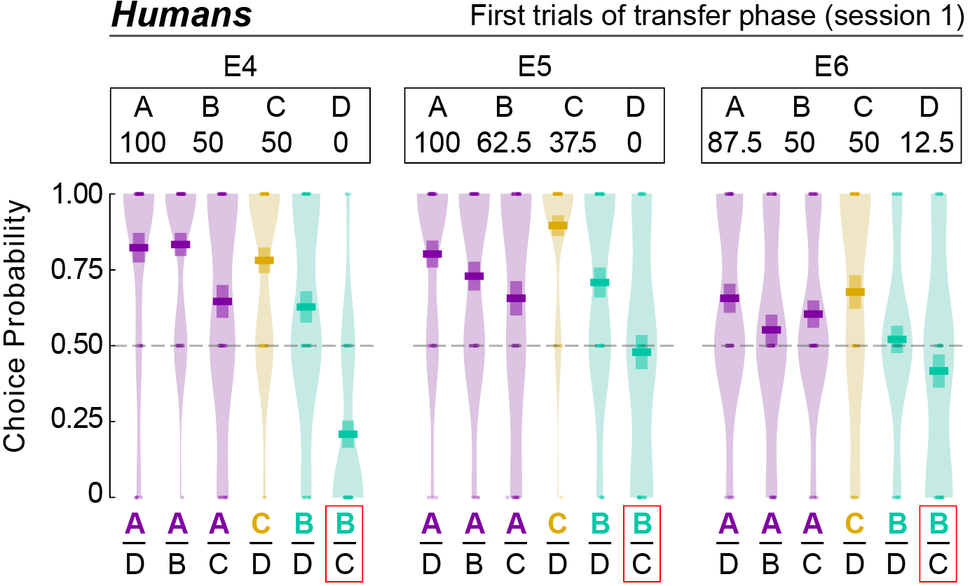
Supplemental Figure 8. Initial transfer phase trials in Experiments 4-6 (humans only). The plots show choice probability for all possible option combinations during the first two presentations of each pair during the transfer phase for Experiments 4-6 (E4, E5, and E6). Individual data points represent the average performance per subject (2 trials/pair). Each pair in the plot is represented by two choices, as humans saw two sets of symbols representing each choice pair (e.g., AD and A’D’).

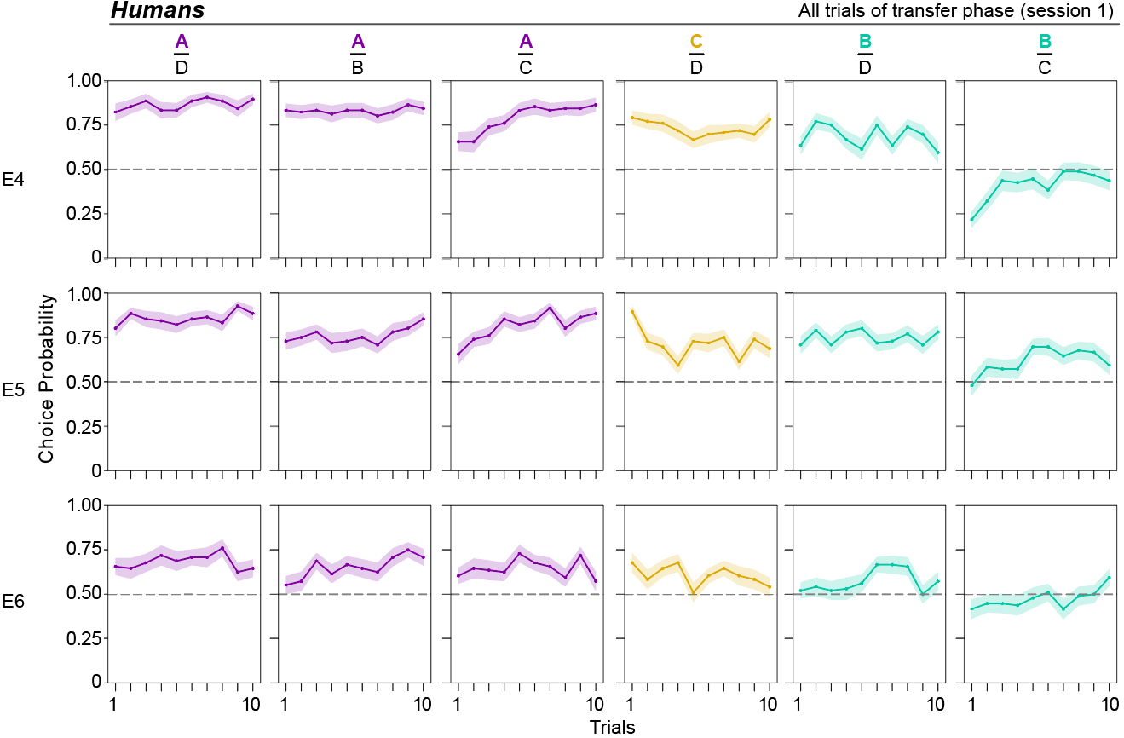
Supplemental Figure 9. Evolution of transfer phase choices across all trials for Experiments 4-6 (humans only). Each point represents the average choice probability for a given trial, color represents the option chosen, and the shading represents the standard error of the mean.

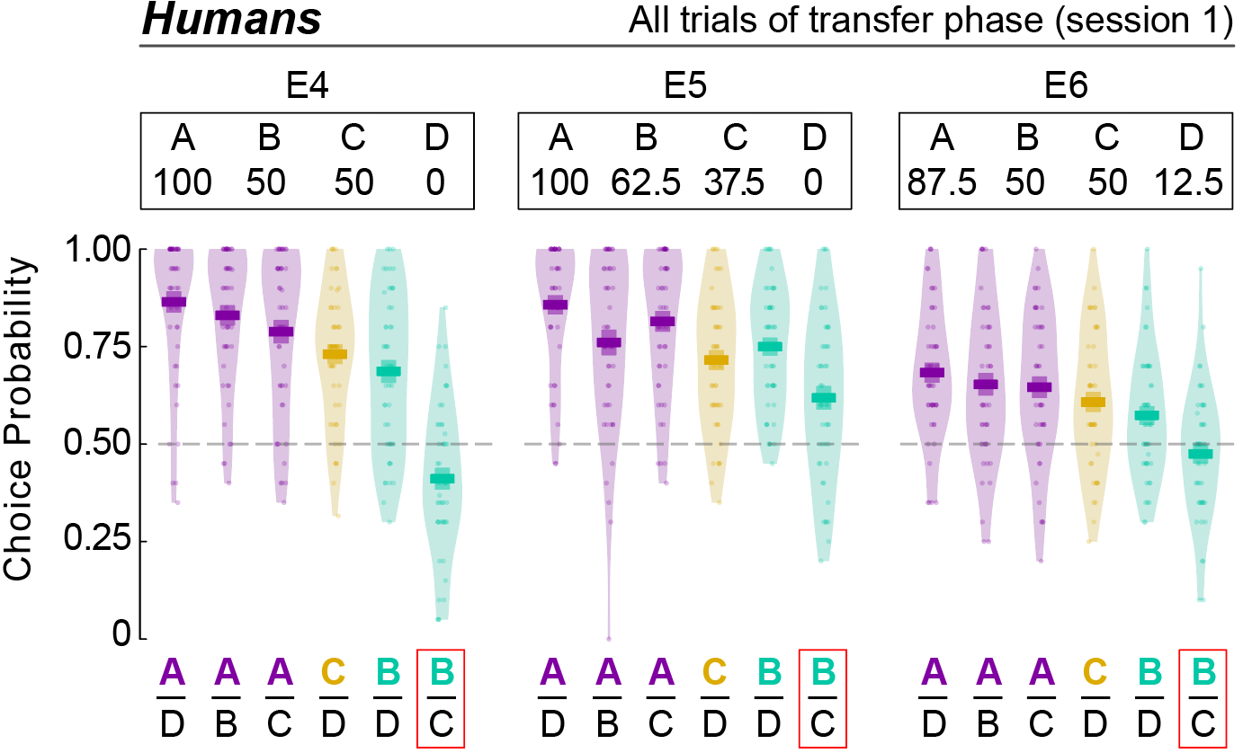
Supplemental Figure 10. Transfer phase results, averaged across all trials. Choice probability for all possible option combinations in the transfer phase, averaged across all trials in humans for Experiments 4-6 (E4, E5, and E6). Individual data points represent the average performance per subject (10 trials/pair).

Supplemental Table 11. Estimated marginal means of the accuracy in the transfer phase in the first trial and across all trials, and the estimated increase in accuracy (slope) per trial. Slope estimates were backtransformed from the logarithmic scale.
 |  | Humans
 |  | First Trial | All trials | Slope
AB | E4 | M=0.849, CI=[0.778;0.900],  z=7.19, p<0.001 | M=0.854, CI=[0.817;0.884], z=12.8, p<0.001 | M=0.005,  CI=[-0.042;0.051], z=0.189, p=0.85
AB | E5 | M=0.746, CI=[0.658;0.817],  z=5.00, p<0.001 | M=0.791, CI=[0.745;0.83], z=10.1, p<0.001 | M=0.031,  CI=[-0.011;0.072], z=1.45, p=0.146
AB | E6 | M=0.552, CI=[0.456;0.644], z=1.06, p=0.290 | M=0.666, CI=[0.61;0.719], z=5.52, p<0.001 | M=0.058, CI=[0.022;0.095], z=3.12, p=0.002
CD | E4 | M=0.804, CI=[0.727;0.864], z=6.38, p<0.001 | M=0.754, CI=[0.704;0.798], z=8.66, p<0.001 | M=-0.035,  CI=[-0.077;0.007],  z=-1.64, p=0.100
CD | E5 | M=0.837, CI=[0.767;0.889], z=7.23, p<0.001 | M=0.747, CI=[0.696;0.792], z=8.35, p<0.001 | M=-0.067,  CI=[-0.109;-0.024],  z=-3.1, p=0.002
CD | E6 | M=0.673, CI=[0.582;0.752], z=3.62, p<0.001 | M=0.618, CI=[0.559;0.674], z=3.87, p<0.001 | M=-0.029,  CI=[-0.066;0.008],  z=-1.54, p=0.123
AD | E4 | M=0.854, CI=[0.783;0.905], z=7.16, p<0.001 | M=0.887, CI=[0.855;0.912], z=14.3, p<0.001 | M=0.035,  CI=[-0.015;0.085], z=1.39, p=0.166
AD | E5 | M=0.847, CI=[0.775;0.899], z=7.07, p<0.001 | M=0.883, CI=[0.851;0.909], z=14.2, p<0.001 | M=0.037,  CI=[-0.011;0.086], z=1.51, p=0.131
AD | E6 | M=0.676, CI=[0.585;0.756], z=3.65, p<0.001 | M=0.696, CI=[0.642;0.746], z=6.59, p<0.001 | M=0.011,  CI=[-0.026;0.049], z=0.589, p=0.556
AC | E4 | M=0.635, CI=[0.536;0.724], z=2.65, p=0.008 | M=0.820, CI=[0.777;0.856], z=11.2, p<0.001 | M=0.116, CI=[0.074;0.157], z=5.4, p<0.001
AC | E5 | M=0.686, CI=[0.589;0.769], z=3.65, p<0.001 | M=0.850, CI=[0.812;0.881], z=12.5, p<0.001 | M=0.114, CI=[0.071;0.158], z=5.16, p<0.001
AC | E6 | M=0.640, CI=[0.546;0.724], z=2.90, p=0.004 | M=0.658, CI=[0.600;0.710],  z=5.22, p<0.001 | M=0.009,  CI=[-0.027;0.046], z=0.496, p=0.620
BD | E4 | M=0.727, CI=[0.639;0.801], z=4.68, p<0.001 | M=0.706, CI=[0.652;0.755], z=6.89, p<0.001 | M=-0.013,  CI=[-0.052;0.027],  z=-0.625, p=0.532
BD | E5 | M=0.768, CI=[0.684;0.835], z=5.52, p<0.001 | M=0.780, CI=[0.733;0.821], z=9.66, p<0.001 | M=0.008,  CI=[-0.033;0.049], z=0.381, p=0.703
BD | E6 | M=0.518, CI=[0.423;0.611], z=0.362, p=0.717 | M=0.582, CI=[0.522;0.639], z=2.66, p=0.00781 | M=0.031,  CI=[-0.005;0.067],  z=1.71, p=0.087
BC | E4 | M=0.242, CI=[0.174;0.325],  z=-5.44, p<0.001 | M=0.397, CI=[0.340;0.457],  z=-3.33, p<0.001 | M=0.087, CI=[0.048;0.126], z=4.4, p<0.001
BC | E5 | M=0.514, CI=[0.416;0.610], z=0.272, p=0.785 | M=0.641, CI=[0.582;0.696], z=4.59, p<0.001 | M=0.063, CI=[0.026;0.101], z=3.31, p<0.001
BC | E6 | M=0.398, CI=[0.310;0.492],  z=-2.12, p=0.034 | M=0.475, CI=[0.416;0.536],  z=-0.793, p=0.428 | M=0.038, CI=[0.002;0.074], z=2.08, p=0.037

Instructions: Experiments 1-3 (E1-E3)

[General Instructions]
Page 1:
The study consists of three games. You will see the same eight lottery tickets in each game. In the first game, you will be presented with two lottery tickets each trial and you will have to select one of them. After each choice, you will see the outcome of both the chosen lottery ticket (highlighted) and the unchosen one. There are only two possible outcomes: you can either win 1 point or get nothing (0 points). As you will find out throughout the study, some of the lottery tickets win more often than others. Your goal is to collect as many points as possible.
Page 2:
At the end of the study, we will convert all collected points into pounds and add them to the fixed bonus provided by Prolific. The conversion rate is 1 point = 1.2 pence.
This means that you can double your earnings if you perform well. "],
Page 3:
Here are some key points to remember: You will see the same eight lottery tickets in all three games. Some lottery tickets are more likely to win than the others. The winning probability does not change across games. Lottery tickets that won frequently in one game will win with the same frequency also in the other games. Only the outcomes of the chosen option will count towards your final payoff. The position of the lottery tickets on the screen (left/right) has no impact on their outcome.
Page 4:
Here is an animated example of the first game:

As you can see, in this case, lottery C wins (gets 1p) more frequently than D and therefore it is the better option.

[Instructions - Training]
Let's start with a few practice trials!
Note: Points collected during the practice won't be added to your total payoff. However, you will see your score at the end of the training.
Click the button below to start.

[Instructions - Learning]
You are about to start the first game.
Note From now on, any points you earn will be added to your final payoff.
There will be a lot more trials than in the training. The lottery tickets will differ from those used during training. However, the logic will remain the same
Click the button below to start.

[Instruction Transfer]
In the second game, you will see the same lottery tickets again. However, this time they will be presented in different combinations and you will only be able to see the outcome of your chosen option. Feel free to select whichever lottery you think is more likely to win.
Click the button below to start.

[Instructions Explicit Recollection]
In the third game, you will see one of the lottery tickets and a slider each round.
Your goal is to estimate how frequently each ticket won. For example, if you think a particular lottery ticket won (got 1p) in 3 out of 4 trials, you should set the slider to 75%.
If you do not remember the exact number, give your best guess. You will get 1 point for each correct response.
Click the button below to start.

Instructions: Experiments 4-6 (E4-E6)

[General Instructions]
Page 1:
The study consists of three games. In each game, you will see the same eight symbols. Each symbol has a specific probability of winning 1 point, which remains constant throughout the study.
Page 2:
At the end of the study, we will convert all points you earned into pounds and add them to the fixed compensation provided by Prolific. The conversion rate is: 1 point = 1.35 pence. This means that you can win up to £3.50, i.e. double your final payoff.
Click the button below to view the instructions for the first game.

[Learning Phase - General Instructions]
In the first game, you will need to select (i.e. click on) one of the symbols presented on the screen in each trial. In some trials, only one symbol will be presented. Once you click on it, you will see whether you won (1p) or received nothing (0p). In other trials, two symbols will be shown. You may choose either one, but we will not show you whether you won or not.

[Learning Phase - Training]
Let’s start with a few practice trials!
Note: Points collected during the practice won’t be added to your total payoff. However, you will see your score at the end of the training.
Click the button below to start.

[Learning Phase – Post-Training]
You are about to start the first game.
Note: From now on, any points you earn will be added to your final payoff. The symbols will differ from those used during training. However, the logic will remain the same.
There will be a lot more trials than in the training.
Click the button below to start.

[Instructions Transfer]
In this game, you will see the same 8 symbols again.
Each trial, two symbols will be presented on the screen. You will be free to select whichever symbol you prefer. Once you select a symbol, you will see the outcome of the chosen symbol. That is, whether you won 1p or gained nothing (0p).
Click the button below to start.
[Explicit Recollection]
This is the final game. On each trial, one symbol will appear along with a slider.
Your task is to estimate how often each symbol won points.
For example, if you think a particular symbol won a point in 3 out of 4 trials, you should set the slider to 75%. If you do not remember the exact number, please provide your best guess.
You will get 1 point for each correct response.
Click the button below to start.

References
Bavard, S., & Palminteri, S. (2023). The functional form of value normalization in human reinforcement learning. eLife, 12, e83891. https://doi.org/10.7554/eLife.83891
Fontanesi, L., Gluth, S., Spektor, M. S., & Rieskamp, J. (2019). A reinforcement learning diffusion decision model for value-based decisions. Psychonomic Bulletin & Review, 26(4), 1099–1121. https://doi.org/10.3758/s13423-018-1554-2
Juechems, K., Altun, T., Hira, R., & Jarvstad, A. (2022). Human value learning and representation reflect rational adaptation to task demands. Nature Human Behaviour, 6(9), 1268–1279. https://doi.org/10.1038/S41562-022-01360-4
Palminteri, S., Kilford, E. J., Coricelli, G., & Blakemore, S.-J. (2016). The Computational Development of Reinforcement Learning during Adolescence. PLOS Computational Biology, 12(6), e1004953. https://doi.org/10.1371/journal.pcbi.1004953
Soukupova, M., Garcia, B., & Palminteri, S. (2024, September 10). Context induces distortions in value representations: A test across multiple elicitation methods and learning modalities | PsyArXiv Preprints. https://osf.io/preprints/psyarxiv/yrjfa
Tohidi-Moghaddam, M., & Tsetsos, K. (2024). The timescale and functional form of context-dependence during human value-learning (p. 2024.02.01.578398). bioRxiv. https://doi.org/10.1101/2024.02.01.578398

