Near-Infrared-Responsive Single-Component Hybrid Lead Halides for Photocatalytic C₂ Hydrocarbon Production from CO₂

Yukong Li, Ziyi Wang, Chen Sun, Qikai Zheng, Yilin Jiang and Honghan Fei*

School of Chemical Science and Engineering, Shanghai Key Laboratory of Chemical Assessment and Sustainability, Tongji University, Shanghai 200092, P. R. China

Corresponding Author: fei@tongji.edu.cn

Table of Contents
1. Experimental Procedures 3
1.1. Chemicals. 3
1.2 Single-crystal X-ray crystallography 3
1.3. Ultrafast transient absorption (TA) spectroscopy 4
1.4. Time-resolved photoluminescence 4
1.5. In situ DRIFTS 4
1.6. Photoelectrochemical measurement 5
1.7. Chemical and thermal stability 5
1.8. Photothermal properties of the materials 6
2. CO₂ Reduction Products Selectivity Calculation 6
3. Computational Methods 7
4. Supplementary Figures 1-42 7
5. Supplementary Table 1-5 49
6. Reference 54

1. Experimental Procedures

1.1. Chemicals.
All reagents and solvents were purchased from commercial suppliers and used without further purification, lead chloride (PbCl₂, 99.0%, Aladdin), lead bromide (PbBr₂, 99.9%, Aladdin), 4-[2,2':6',2''-terpyridin]-4'-ylbenzoic acid (Hcptpy, >98.0%, Adamas), Fe(BF₄)₂·6H₂O (>99.0%, Adamas), Co(OAc)₂·4H₂O (>99.0%, Adamas), Ni(OAc)₂·4H₂O (>99.0%, Adamas), hydrochloric acid (48% in water), hydrobromic acid (48% in water), perchloric acid (70.0% in H₂O, SCR), Trolamine (>99.0%, Adamas), N, N’-dimethylformamide (DMF), acetonitrile (CH₃CN, >99.0%, Greagent), dichloromethane (DCM, >99.5%, Greagent), methanol (MeOH, >99.5%, Greagent). Deionized water was obtained from a BARNSTEAD PACIFIC RO water purification system.

1.2 Single-crystal X-ray crystallography
A single crystal of suitable size is carefully mounted on the glass fiber. Single crystal X-ray diffraction was carried out with graphite monochromated Mo/Cu radiation (λ = 0.71073/1.54178 Å) on a Rigaku Oxford Diffract/Oxford Diffraction Gemini E Ultra diffractometer. Data-sets were collected by using CrysAlisPro software. The program Olex2 was employed as an interface to invoke program SHELXS97 and SHELXL97 executables. The crystal structures were solved by direct methods with SHELXS97 and refined by full-matrix least squares on F² with anisotropic atomic displacement parameters for all non-hydrogen atoms using SHELXL97. All H atoms were located from molecular geometric calculations and refined with isotropic temperature parameters. Further details of crystallographic data and structural refinement are summarized in Supplementary Table 1-3. The crystallographic information on the crystal structures of for TJU-59(Cl)-Fe(tpy)₂, TJU-59(Cl)-Co(tpy)₂, TJU-59(Cl)-Ni(tpy)₂, TJU-59(Br)-Fe(tpy)₂, TJU-59(Br)-Co(tpy)₂, TJU-59(Br)-Ni(tpy)₂, TJU-60(I)-Fe(tpy)₂, TJU-60(I)-Co(tpy)₂ and TJU-60(I)-Ni(tpy)₂ determined at 298 K have been deposited in the CIF format in the Cambridge Crystallographic Database Centre as Supporting Information, (CCDC: 2435159, 2435160, 2435161, 2435162, 2435163, 2435164, 2435165, 2435166, 2435167).

1.3. Ultrafast transient absorption (TA) spectroscopy
The solid samples were dispersed in ethylene glycol by sonication. TA spectroscopy was performed at room temperature by a regenerative amplified Ti:sapphire laser system (Coherent; 800 nm, 35 fs, 6 mJ/pulse, and 1 kHz repetition rate), nonlinear frequency mixing techniques and the Helios spectrometer (Ultrafast Systems LLC). The 800 nm output pulse from the regenerative amplifier was split into two parts using a 50% beam splitter. The transmission part was used to pump the TOPAS optical parametric amplifier, producing a 420 nm pump beam. The reflecting part was attenuated by a neutral density filter and focused into a 2 mm thick CaF₂ window, producing a continuous white light of 500 nm to 800 nm as the probe beam. The probe beam was then focused onto the sample with a parabolic reflector. Then, the probe beam was collimated and focused into a fiber-coupled spectrometer and detected at a frequency of 1 KHz. The delay between the pump and probe pulses was controlled by a motorized delay stage. The pump pulses were chopped by a synchronized chopper at 500 Hz and the absorbance change was calculated with two adjacent probe pulses (pump-blocked and pump-unblocked).

1.4. Time-resolved photoluminescence
Time-resolved PL data were collected at room temperature using an FLS980 spectrophotometer. The average lifetime was obtained from the tri-exponential decay according to the following equation (eq.1):
$τ_{ave}=\frac{\sum{α_{i}τ_{i}^{2}}}{\sum{α_{i}τ_{i}}} i=1, 2, 3$ (1)
where 𝑎_{𝑖} represents the amplitude of each component and 𝜏_{𝑖} represents the decay time.

1.5. In situ DRIFTS
In situ DRIFTS was performed on a Thermo Scientific Nicolet 6700FT spectrometer. Before the measurements, the sample was purged with argon (Ar) gas for a duration of 30 minutes to remove any residual gases. Subsequently, water/TEOA-passed CO₂ was introduced into the reactor for a period of 30 minutes under dark conditions, followed by sealing the reactor. Finally, the Xenon lamp was activated. For clarification reasons, the data was plotted with an interval of 10 min.

1.6. Photoelectrochemical measurement
The working electrodes were prepared as follows: 10 mg of catalyst was firstly dispersed in a mixture containing ethanol (2 mL) and 5 wt.% Nafion solution (10 µL) under ultrasonic condition for 30 min to obtain a mixture. and 60 µL of the above mixtures was coated on one side of ITO electrode followed by drying at room temperature. The photocurrent responses and electrochemical impedance spectroscopy measurements were carried out on a CHI 760E electrochemical workstation (Shanghai Chenhua) equipped with a standard three-electrode system, including an indium tin oxide (ITO) deposited with samples as the working electrode, an Ag/AgCl (KCl saturated) reference electrode and a Pt counter electrode. A 0.5 M Na₂SO₄ aqueous solution was used as the electrolyte. The frequency range was measured from 1 Hz to 1MHz. In the photocurrent measurements, a 300 W Xenon lamp with the AM 1.5G filter was served as the incident light and no bias voltage was used.

1.7. Chemical and thermal stability
First, approximately 150 mg as-synthesized single crystals of TJU-60(I)-Fe(tpy)₂, TJU-60(I)-Co(tpy)₂ and TJU-60(I)-Ni(tpy)₂ were incubated in various organic solvents (CH₃CN, MeOH, and CH₂Cl₂) and aqueous conditions (a HCl solution of pH=4 and a NaOH solution of pH=11) for 24 hours. After incubation, the solids were isolated by filtration, washed with EtOH for three times, and dried in an oven at 80 ºC. Thermal stability experiments were carried out by as-synthesized materials in oven at the corresponding temperature in air for 24 h. PXRD characterization were performed after cooling to the room temperature.

1.8. Photothermal properties of the materials
1.5 mL of various samples (TJU-60(I)-Fe(tpy)₂ and TJU-60(I)-Co(tpy)₂) with 200 ppm concentrations was irradiated with 808 nm laser for 10 min. The power density is set at 2 W·cm². The temperature changes and corresponding photothermal images were also recorded at 30 s intervals during irradiation. DI water was used as the control group.

2. CO₂ Reduction Products Selectivity Calculation
The electron-based selectivity was calculated based on the following formula:
$$CO\left(selectivity\%\right)=\frac{CO yield×2}{CO yield ×2+CH_{4} yield ×8+C_{2}H_{4} yield ×12+C_{2}H_{6} yield ×14}×100\%$$
$$CH_{4}(selectivity\%)=\frac{CH_{4} yield×8}{CO yield ×2+CH_{4} yield ×8+C_{2}H_{4} yield ×12+C_{2}H_{6} yield ×14}×100\%$$
$$C_{2}H_{4}\left(selectivity\%\right)=\frac{C_{2}H_{4} yield×12}{CO yield ×2+CH_{4} yield ×8+C_{2}H_{4} yield ×12+C_{2}H_{6} yield ×14}×100\%$$
$$C_{2}H_{6}(selectivity\%)=\frac{C_{2}H_{6} yield×14}{CO yield ×2+CH_{4} yield ×8+C_{2}H_{4} yield ×12+C_{2}H_{6} yield ×14}×100\%$$
The product-based selectivity was calculated based on the following formula:
$$CO\left(selectivity\%\right)=\frac{CO yield}{CO yield+CH_{4} yield+C_{2}H_{4} yield+C_{2}H_{6} yield}×100\%$$
$$CH_{4}(selectivity\%)=\frac{CH_{4} yield}{CO yield+CH_{4} yield+C_{2}H_{4} yield+C_{2}H_{6} yield}×100\%$$
$$C_{2}H_{4}\left(selectivity\%\right)=\frac{C_{2}H_{4} yield}{CO yield+CH_{4} yield+C_{2}H_{4} yield+C_{2}H_{6} yield}×100\%$$
$$C_{2}H_{6}(selectivity\%)=\frac{C_{2}H_{6} yield}{CO yield+CH_{4} yield+C_{2}H_{4} yield+C_{2}H_{6} yield}×100\%$$

3. Computational Methods
We have employed the first-principles ^{[4-5]} to perform density functional theory (DFT) calculations within the generalized gradient approximation (GGA) using the Perdew-Burke-Ernzerhof (PBE) formulation ^{[6]}. We have chosen the projected augmented wave (PAW) potentials to describe the ionic cores and take valence electrons into account using a plane wave basis set with a kinetic energy cutoff of 500 eV. Partial occupancies of the Kohn-Sham orbitals were allowed using the Gaussian smearing method and a width of 0.05 eV. The electronic energy was considered self-consistent when the energy change was smaller than 10⁻⁵ eV. A geometry optimization was considered convergent when the energy change was smaller than 0.05 eV Å⁻¹. The vacuum spacing in a direction perpendicular to the plane of the structure is 18 Å. The Brillouin zone integration is performed using 1×1×1 Monkhorst-Pack k-point sampling for a structure. Finally, the adsorption energies (E_{ads}) were calculated as:
E_{ads}= E_{ad/sub} - E_{ad} - E_{sub} (3)
where E_{ad/sub}, E_{ad}, and E_{sub} are the total energies of the optimized adsorbate/substrate system, the adsorbate in the gas phase, and the clean substrate, respectively. The free energy (ΔG) for elemental reaction step were calculated as:
ΔG = ΔE + ΔEZPE - TΔS (4)
where ΔE is the difference between the total energy, ΔEZPE and ΔS are the differences in the zero-point energy and the change of entropy, T is the temperature (T =300 K in this work), respectively.

4. Supplementary Figures
Supplementary Figure 1. Synthetic route for [M(Hcptpy)₂] (M = Fe²⁺/Co²⁺/Ni²⁺) ligands and lead halide frameworks.

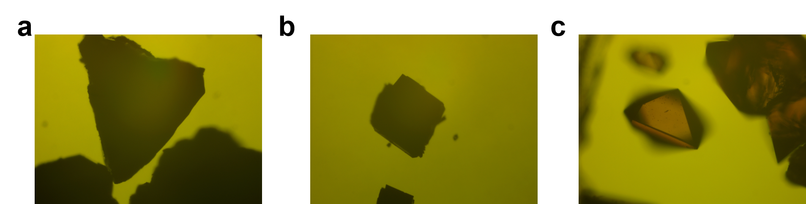
Supplementary Figure 2. Optical microscope image of (a) TJU-60(I)-Fe(tpy)₂, (b) TJU-60(I)-Co(tpy)₂ and (c) TJU-60(I)-Ni(tpy)₂.

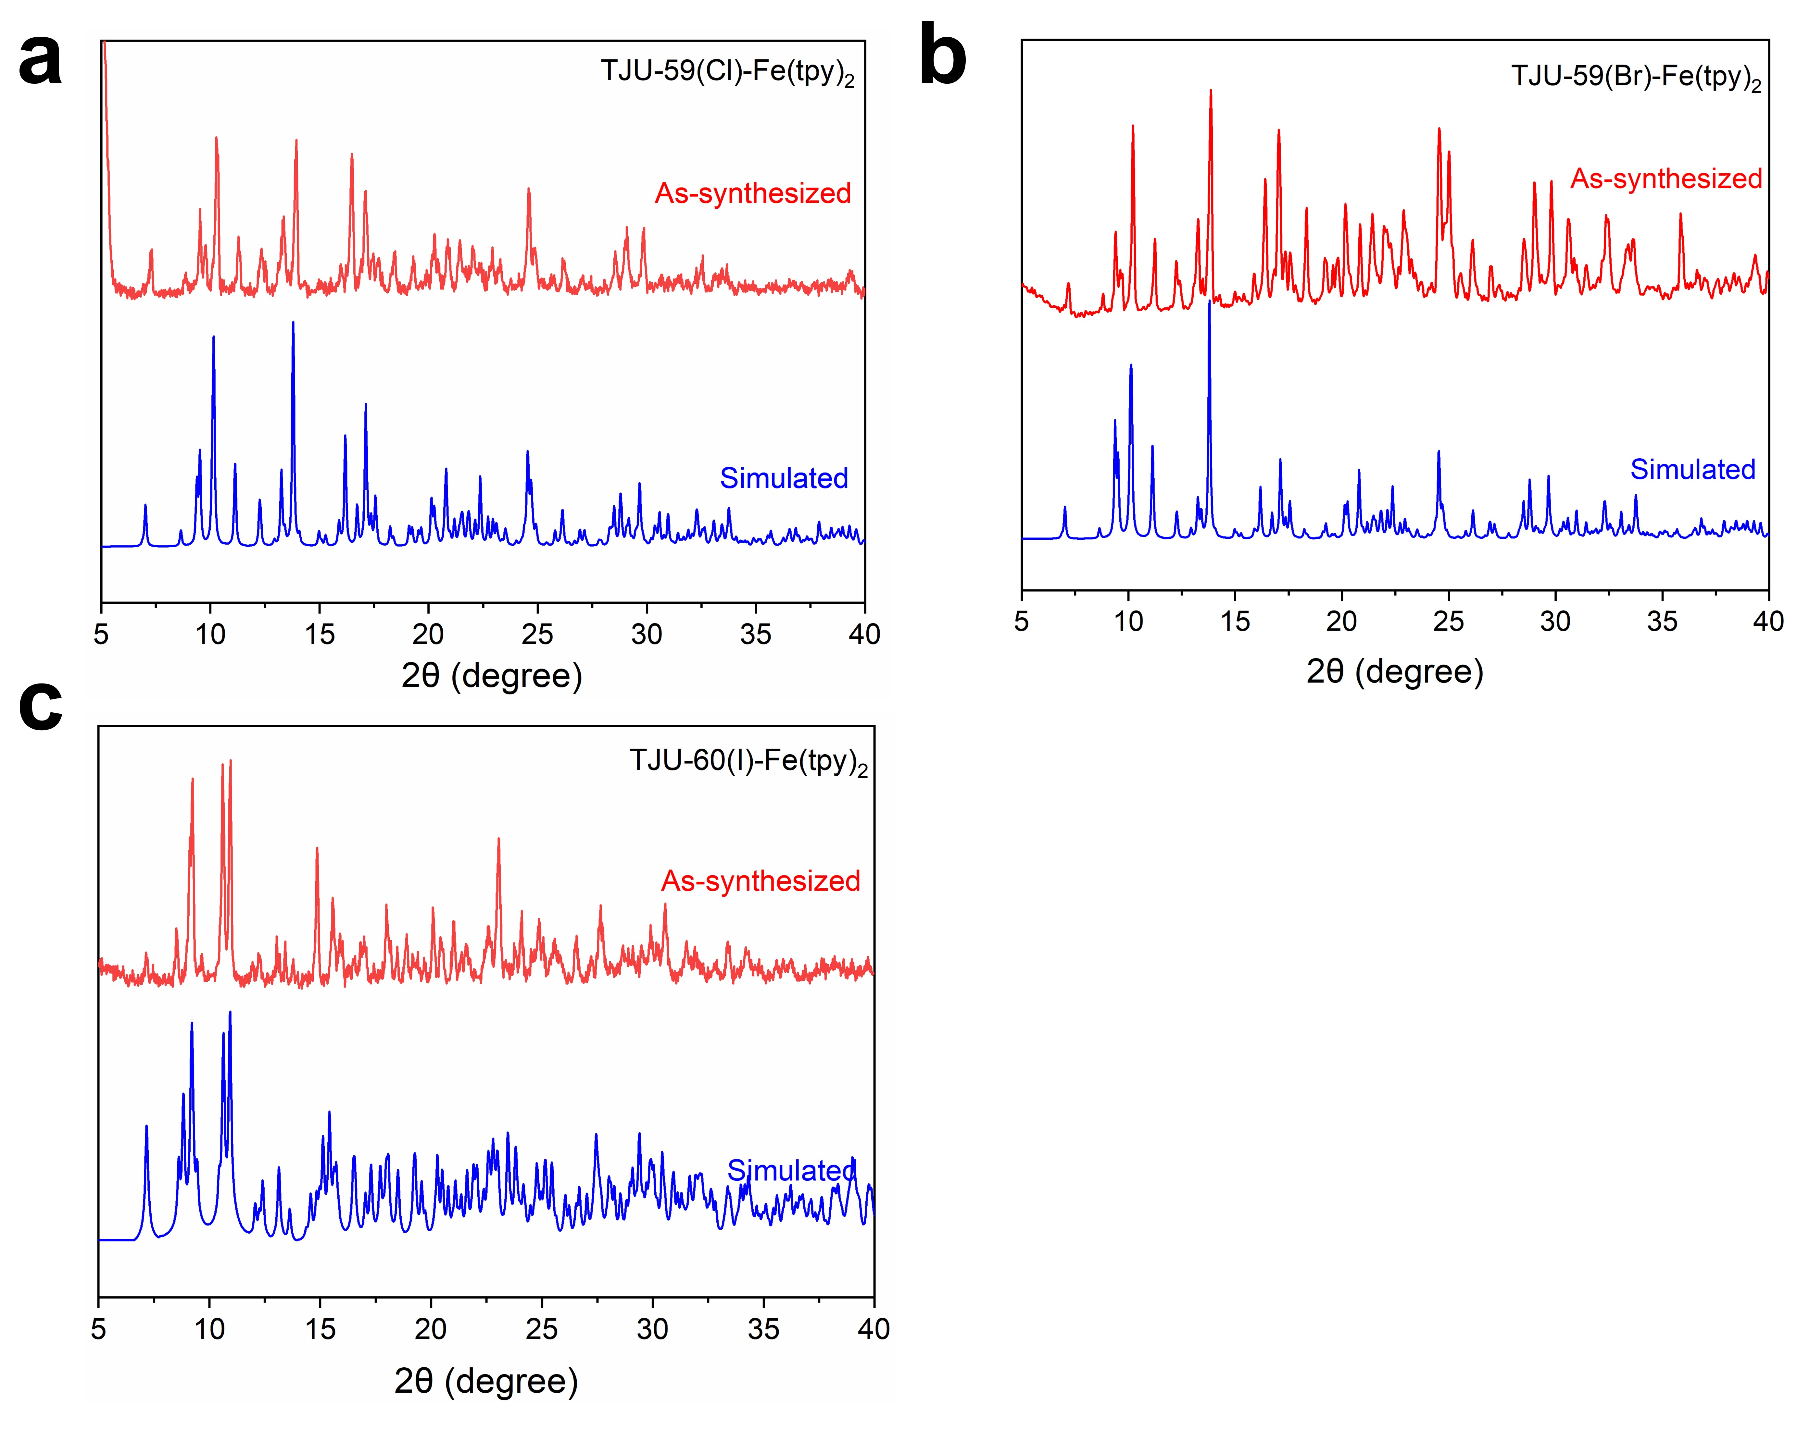
Supplementary Figure 3. (a) Simulated and experimental PXRD of TJU-59(Cl)-Fe(tpy)₂. (b) Simulated and experimental PXRD of TJU-59(Br)-Fe(tpy)₂. (c) Simulated and experimental PXRD of TJU-60(I)-Fe(tpy)₂.

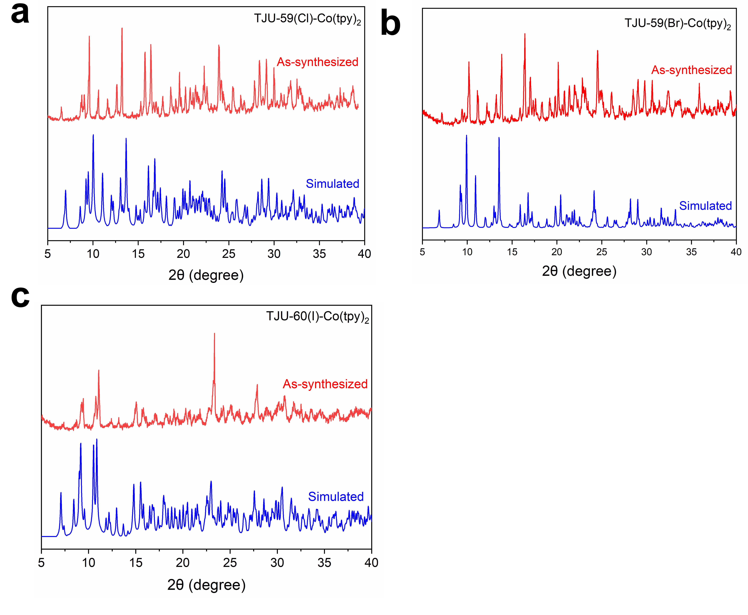
Supplementary Figure 4. (a) Simulated and experimental PXRD of TJU-59(Cl)-Co(tpy)₂. (b) Simulated and experimental PXRD of TJU-59(Br)-Co(tpy)₂. (c) Simulated and experimental PXRD of TJU-60(I)-Co(tpy)₂.

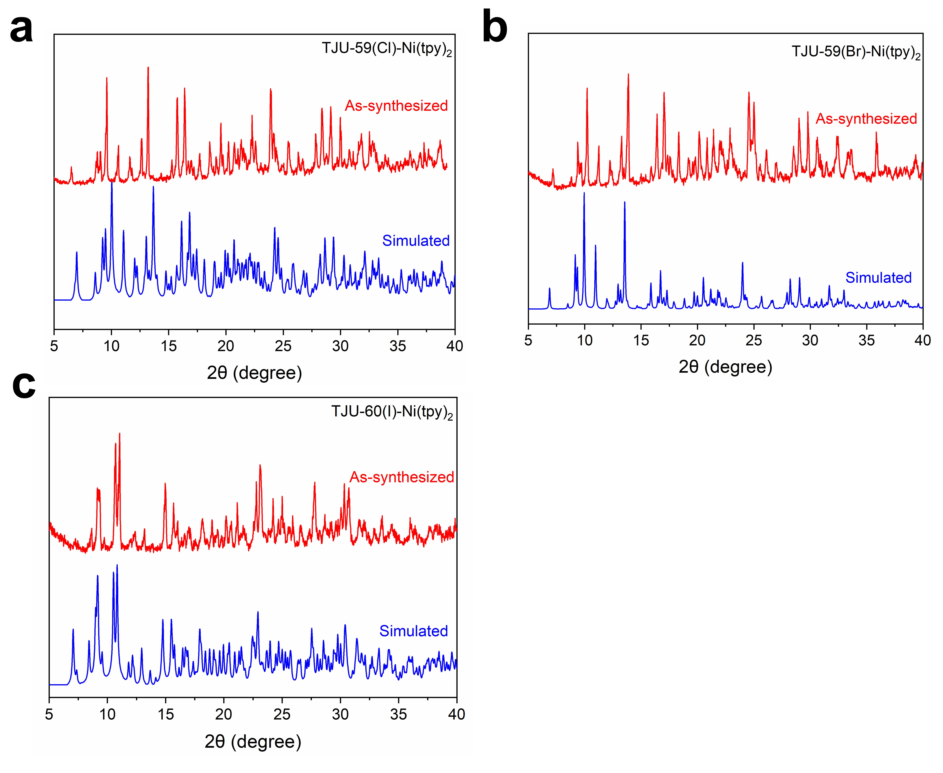
Supplementary Figure 5. (a) Simulated and experimental PXRD of TJU-59(Cl)-Ni(tpy)₂. (b) Simulated and experimental PXRD of TJU-59(Br)-Ni(tpy)₂. (c) Simulated and experimental PXRD of TJU-60(I)-Ni(tpy)₂.
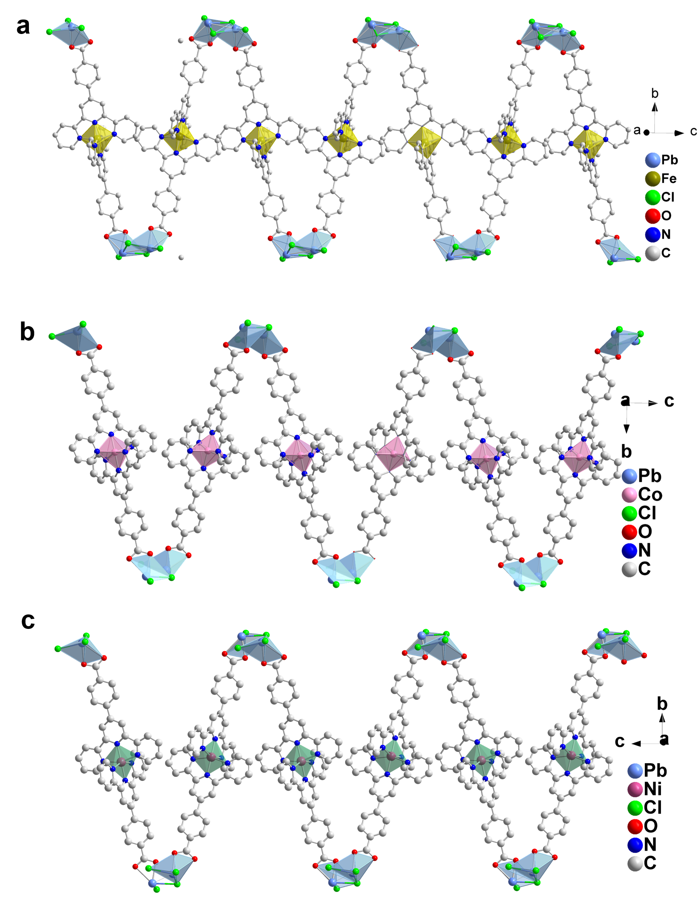
Supplementary Figure 6. Crystallographic view of a single 1D S-shaped zigzag chain of (a) TJU-59(Cl)-Fe(tpy)₂, (b) TJU-59(Cl)-Co(tpy)₂ and (c) TJU-59(Cl)-Ni(tpy)₂.

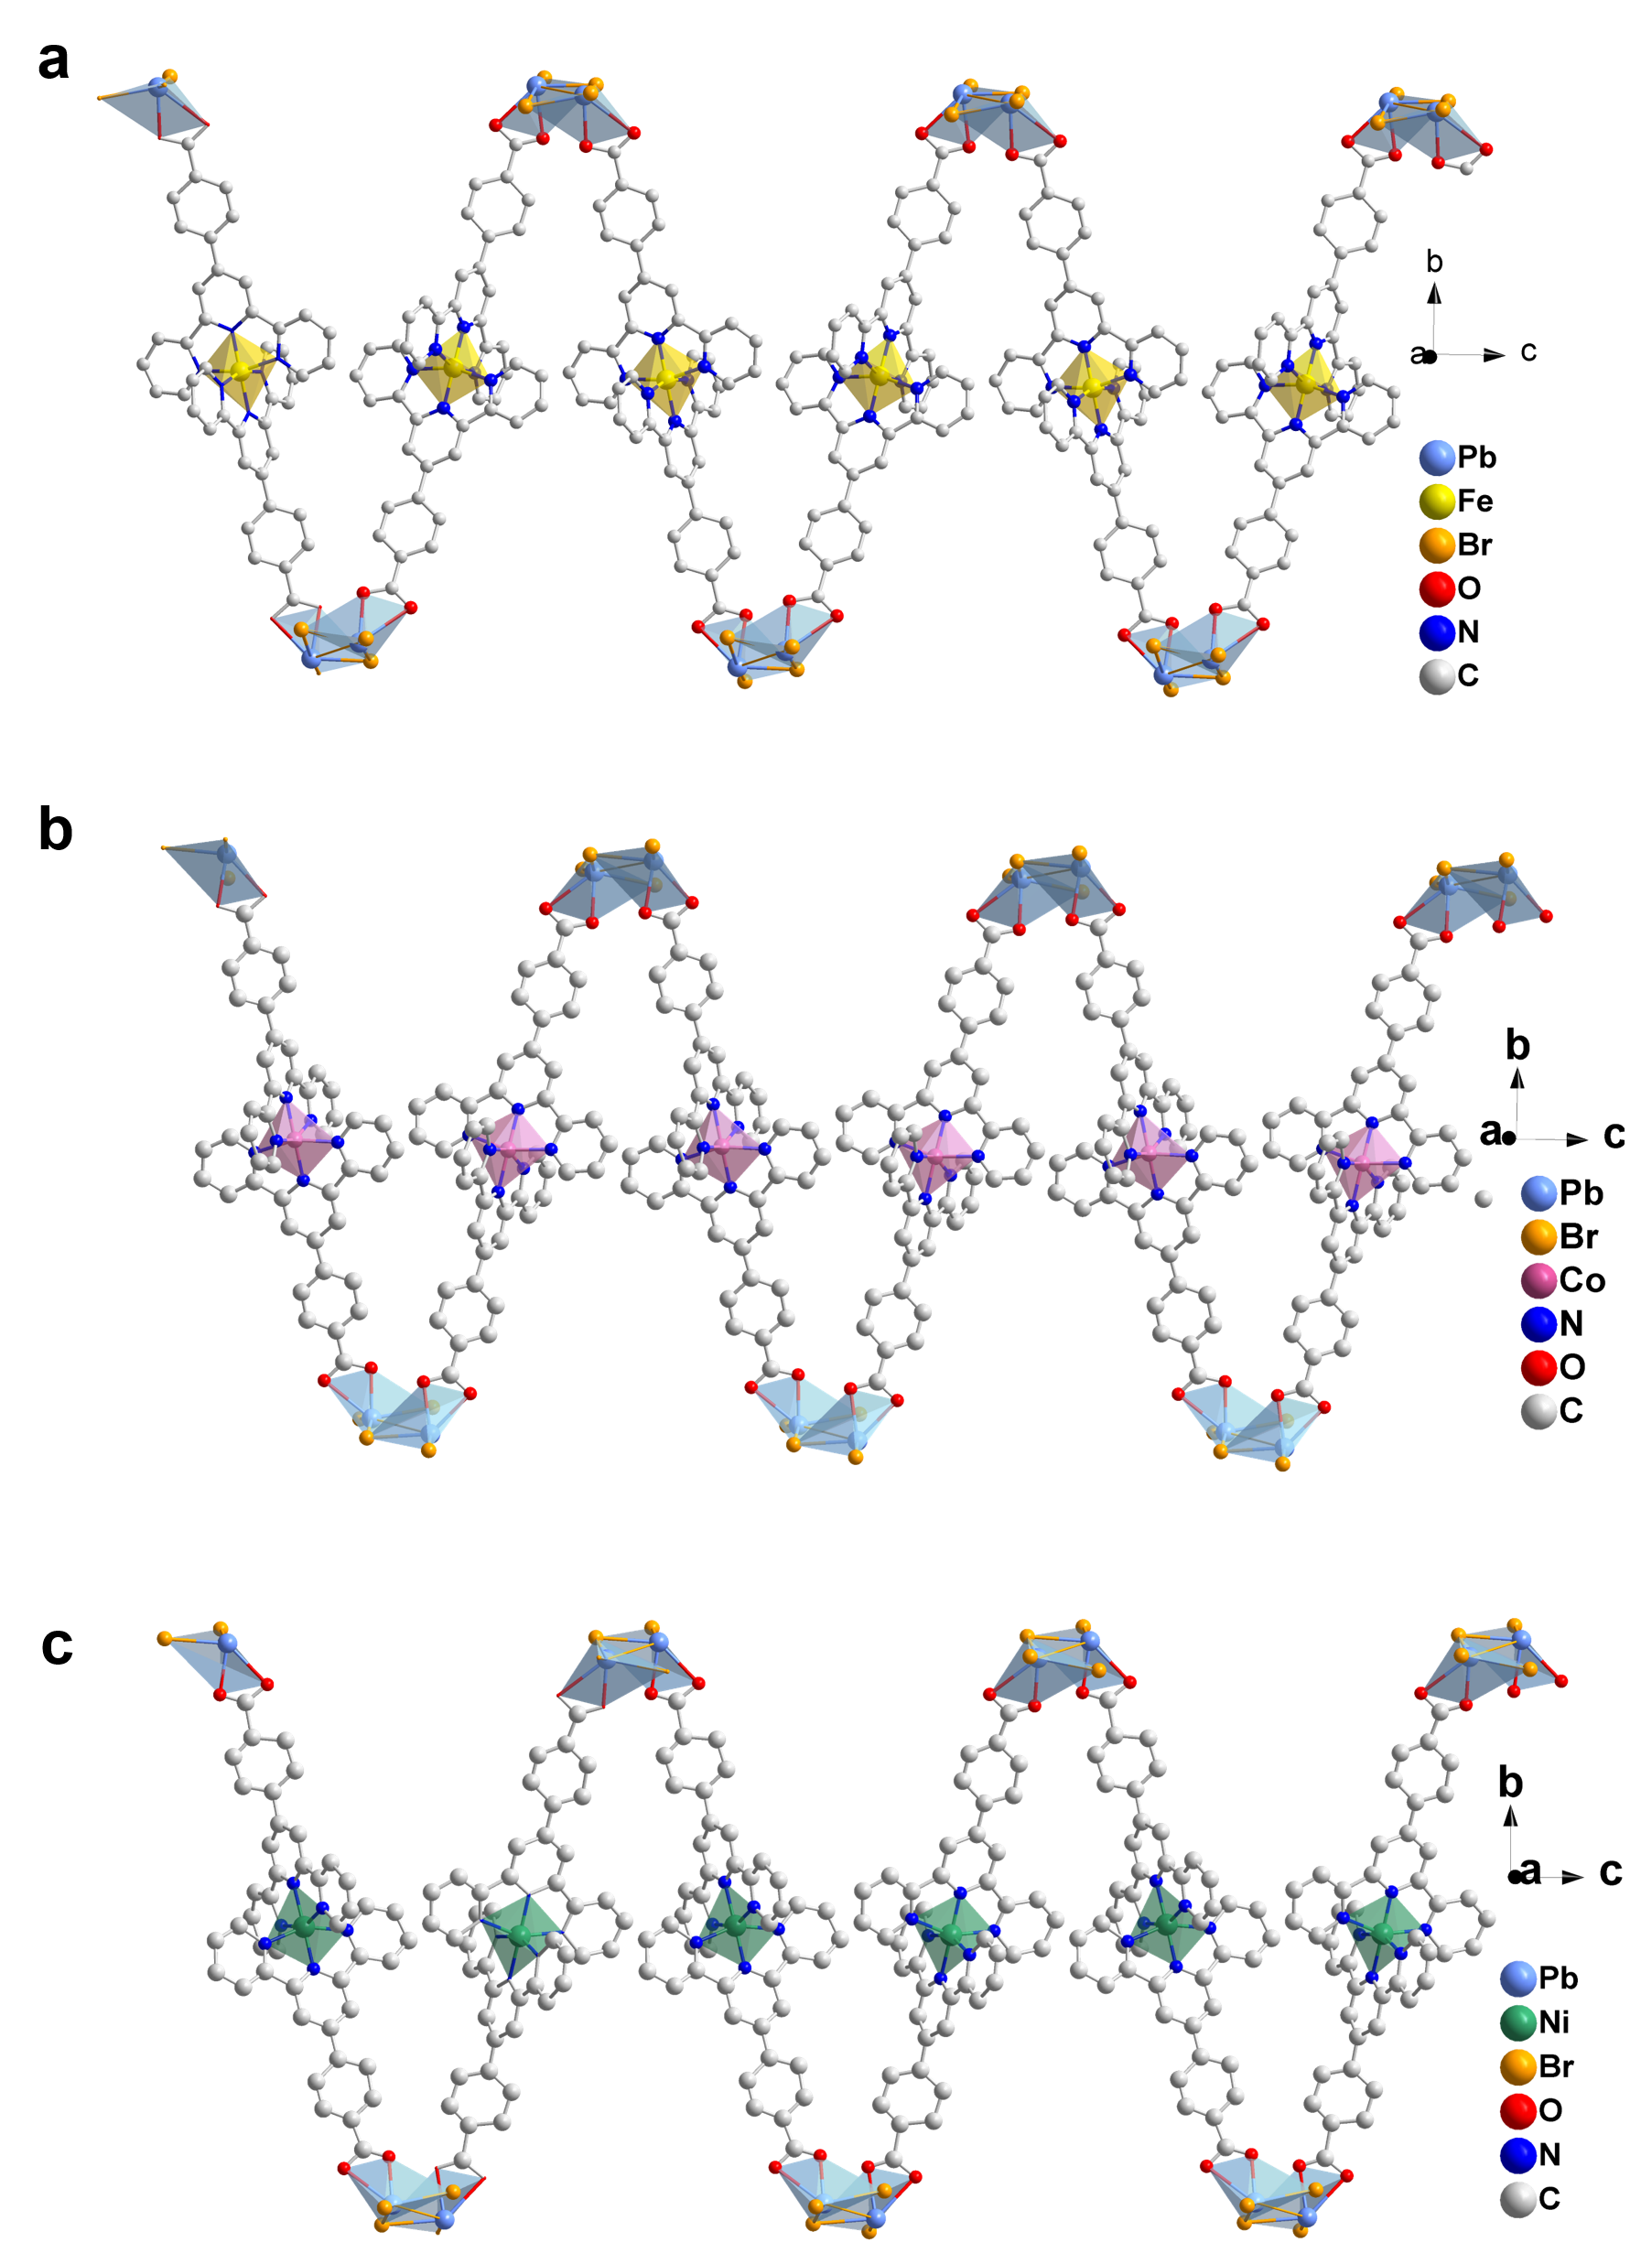
Supplementary Figure 7. Crystallographic view of a single 1D S-shaped zigzag chain of (a) TJU-59(Br)-Fe(tpy)₂, (b) TJU-59(Br)-Co(tpy)₂ and (c) TJU-59(Br)-Ni(tpy)₂.
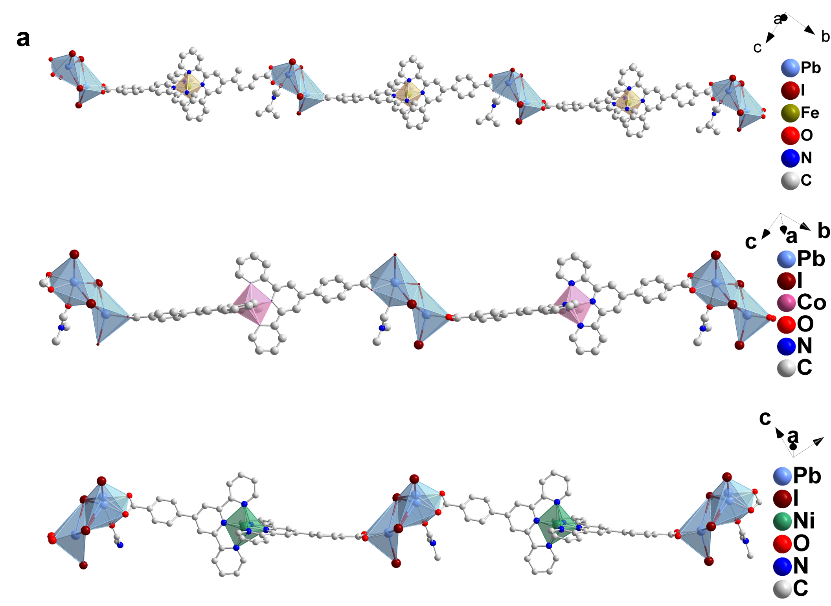
Supplementary Figure 8. Crystallographic view of a single 1D linear chain of (a) TJU-60(I)-Fe(tpy)₂, (b) TJU-60(I)-Co(tpy)₂ and (c) TJU-60(I)-Ni(tpy)₂.

Supplementary Figure 9. Two 1D zigzag chains and their π−π interactions of TJU-59(Cl)-Fe(tpy)₂.
Supplementary Figure 10. Two 1D linear chains and their π−π interactions of TJU-60(I)-Fe(tpy)₂.
Supplementary Figure 11. The 3D Van der Walls framework of TJU-59(Br)-Fe(tpy)₂ showing 1D pore channels.
Supplementary Figure 12. The 3D Van der Walls framework of TJU-60(I)-Fe(tpy)₂ with 1D pore channels.

Supplementary Figure 13. Crystal structure of [Fe(Hcptpy)₂] ligands.
Supplementary Figure 14. Tauc plots of TJU-59(Cl)-Fe(tpy)₂, TJU-59(Cl)-Co(tpy)₂, TJU-59(Cl)-Ni(tpy)₂, TJU-59(Br)-Fe(tpy)₂, TJU-59(Br)-Co(tpy)₂, TJU-59(Br)-Ni(tpy)₂, TJU-60(I)-Fe(tpy)₂, TJU-60(I)-Co(tpy)₂ and TJU-60(I)-Ni(tpy)₂.
Supplementary Figure 15. UV-vis-NIR diffuse reflectance spectra of Fe(Hcptpy)₂ and Co(Hcptpy)₂.
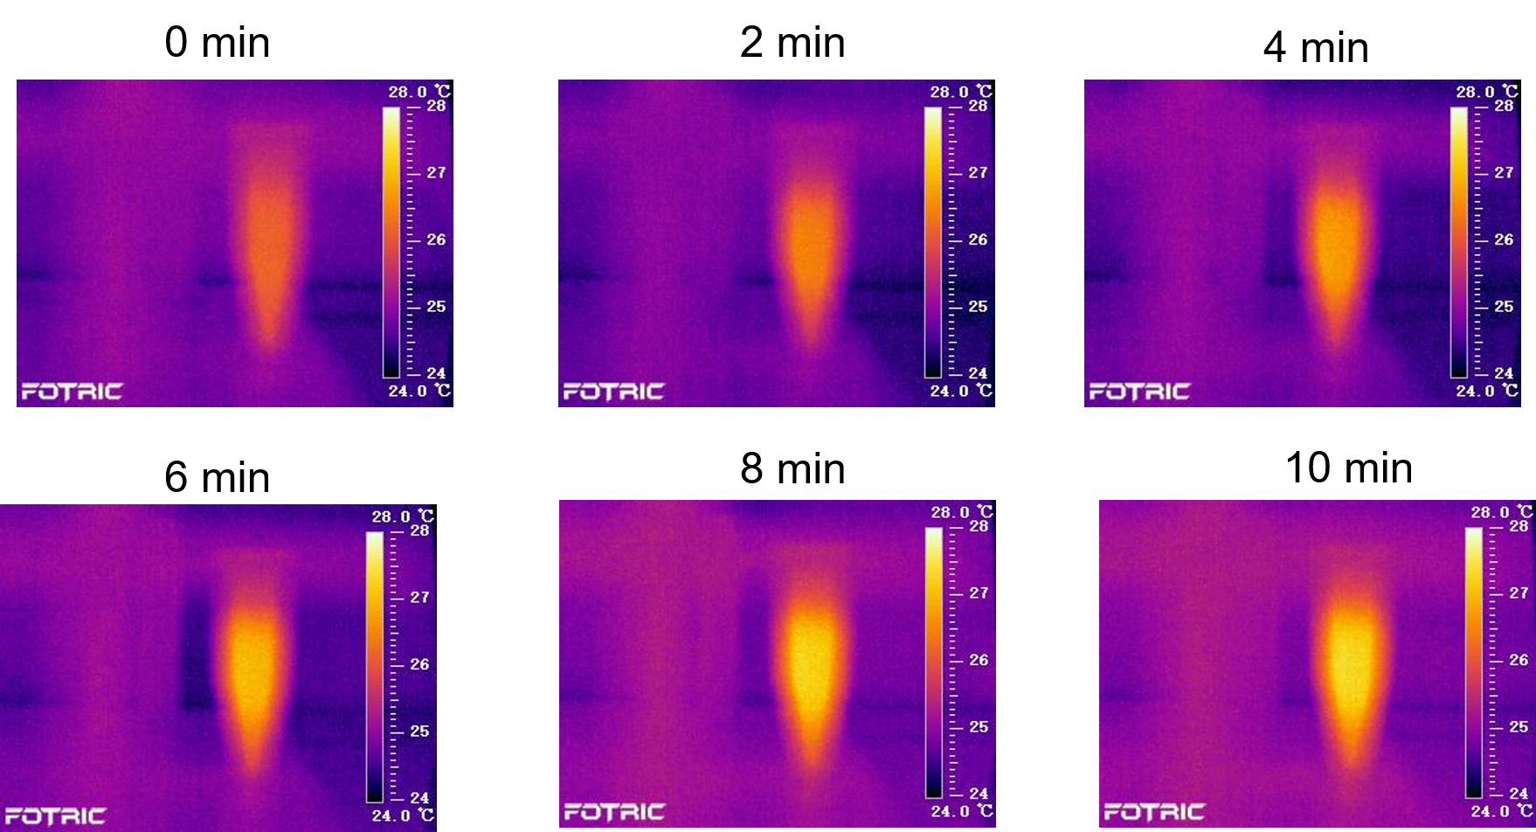
Supplementary Figure 16. Temperature changes of TJU-60(I)-Fe(tpy)₂ under 808 nm laser (2 W/cm²) at different time intervals.
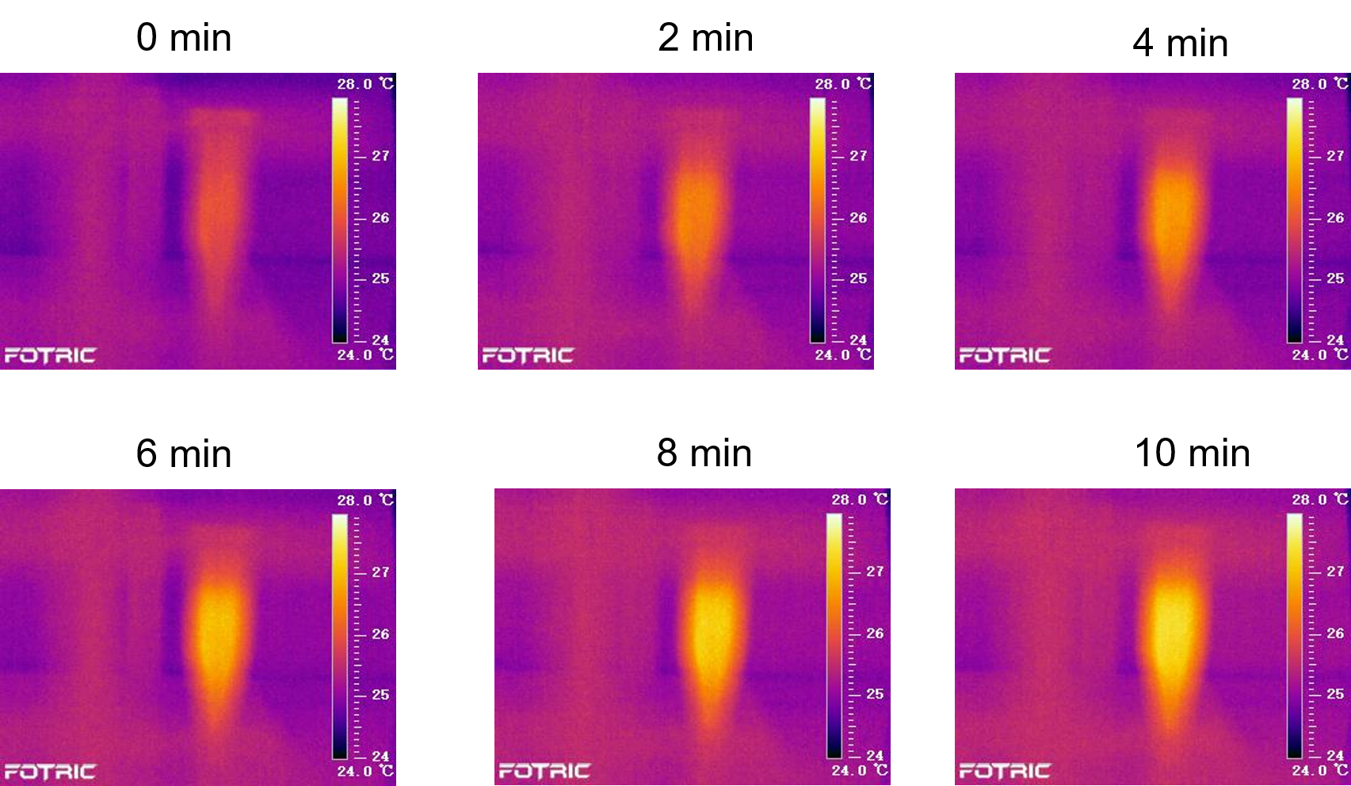
Supplementary Figure 17. Temperature changes of TJU-60(I)-Ni(tpy)₂ under 808 nm laser (2 W/cm²) at different time intervals.
Supplementary Figure 18. PXRD of TJU-59(Cl)-Fe(tpy)₂ before and after thermal and chemical treatment.

Supplementary Figure 19. PXRD of TJU-60(I)-Ni(tpy)₂ before and after thermal and chemical treatment.
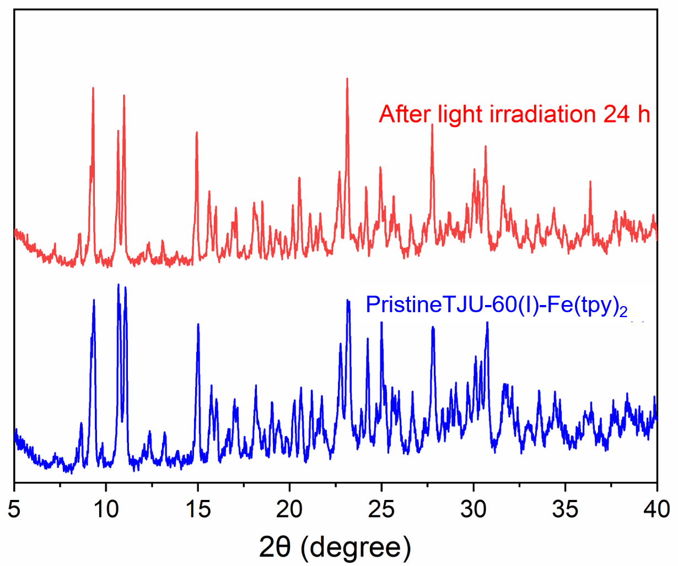
Supplementary Figure 20. PXRD spectra of TJU-60(I)-Fe(tpy)₂ before and after light irradiation.
Supplementary Figure 21. PXRD spectra of TJU-60(I)-Fe(tpy)₂ before and after light irradiation.
Supplementary Figure 22. Thermogravimetric analysis of TJU-60(I)-Fe(tpy)₂.

Supplementary Figure 23. Thermogravimetric analysis of TJU-60(I)-Co(tpy)₂.
Supplementary Figure 24. Thermogravimetric analysis of TJU-60(I)-Ni(tpy)₂.
Supplementary Figure 25. Solid-state PL spectra of TJU-60(I)-Fe(tpy)₂ and Fe(Hctpy)₂.
Supplementary Figure 26. Solid-state PL spectra of TJU-59(Cl)-Fe(tpy)₂ TJU-59(Br)-Fe(tpy)₂ and TJU-60(I)-Fe(tpy)₂.
Supplementary Figure 27. Mott-Schottky plots of TJU-60(I)-Fe(tpy)₂, TJU-60(I)-Co(tpy)₂ and TJU-60(I)-Ni(tpy)₂. The plot of 1/C² versus V at all frequencies were positively sloped, indicating that the TJU-60(I)-Fe(tpy)₂, TJU-60(I)-Co(tpy)₂ and TJU-60(I)-Ni(tpy)₂ are n-type semiconductors.
Supplementary Figure 28. 2D fs-TA spectra of Fe(Hctpy)₂ (excited at 420 nm).
Supplementary Figure 29. XPS spectra of Fe 2p in TJU-60(I)-Fe(tpy)₂ with and without light irradiation.
Supplementary Figure 30. CV curve of Fe(Hcptpy)₂.
Supplementary Figure 31. The evolution rates for CO₂ reduction to C₂ hydrocarbons over different photocatalysts.

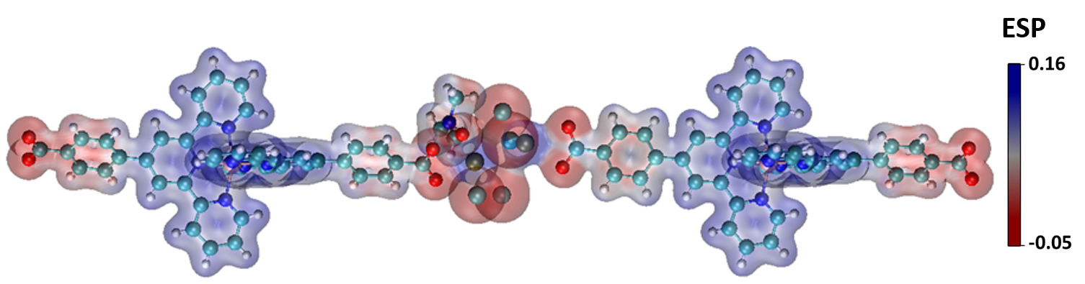
Supplementary Figure32. The calculated surface electrostatic potential of TJU-60(I)-Fe(tpy)₂.

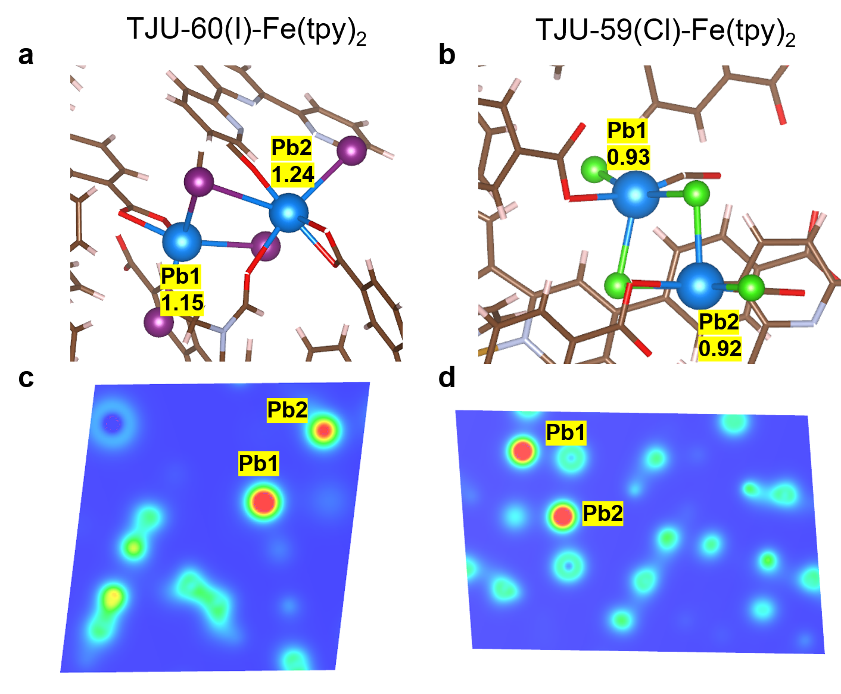
Supplementary Figure 33. Bader charge values of crystallographic independent Pb²⁺ centers in TJU-59(Cl)-Fe(tpy)₂ and TJU-60(I)-Fe(tpy)₂.
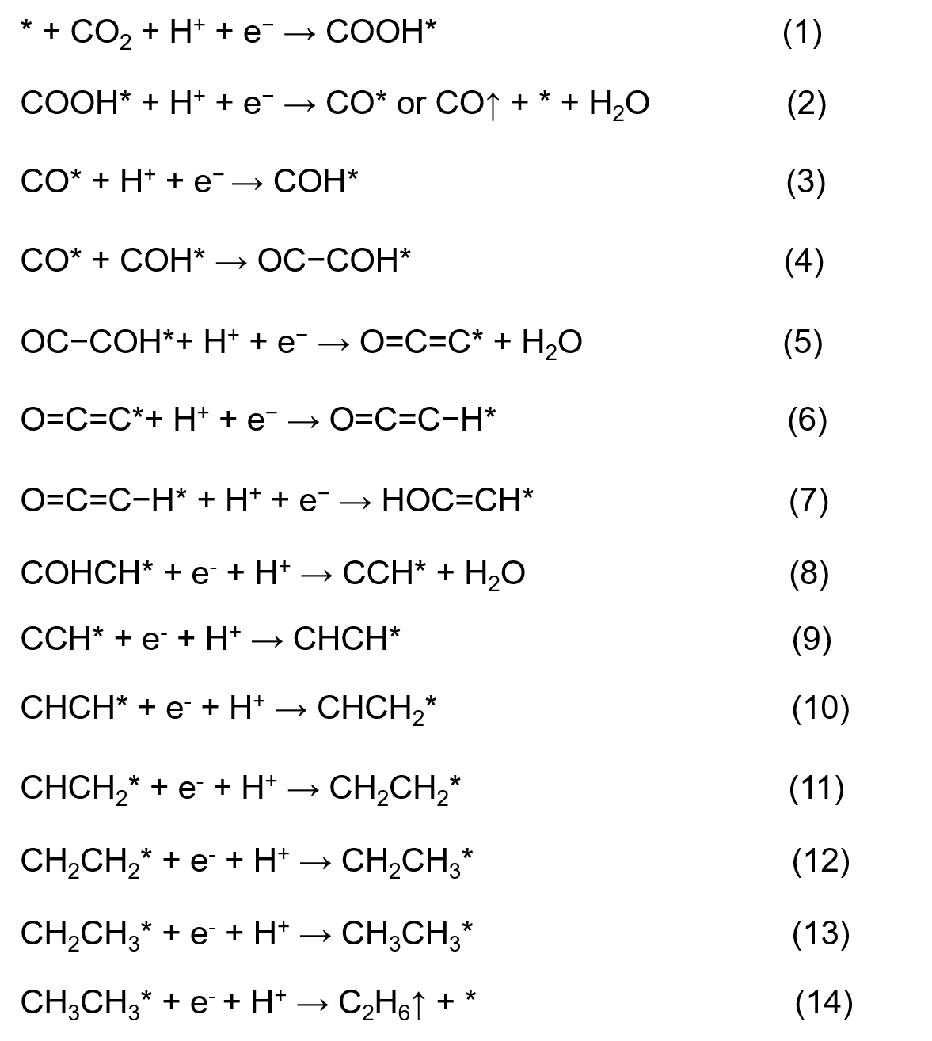
Supplementary Figure 34. The proposed CO₂-to-C₂H₆ mechanistic pathways over TJU-60(I)-Fe(tpy)₂.

Supplementary Figure 35. Time-dependent CO and CH₄ evolution rates under UV-vis-NIR light within 4 h using TJU-59(Cl)-Fe(tpy)₂.
Supplementary Figure 36. Time-dependent CO and CH₄ evolution rates under UV-vis-NIR light within 4 h using TJU-59(Br)-Fe(tpy)₂.
Supplementary Figure 37. Time-dependent CO, CH₄, C₂H₄ and C₂H₆ evolution rates under UV-vis-NIR light within 4 h using TJU-60(I)-Ni(tpy)₂.
Supplementary Figure 38. Control experiments of the photocatalytic CO₂ reduction performance under different reaction conditions.
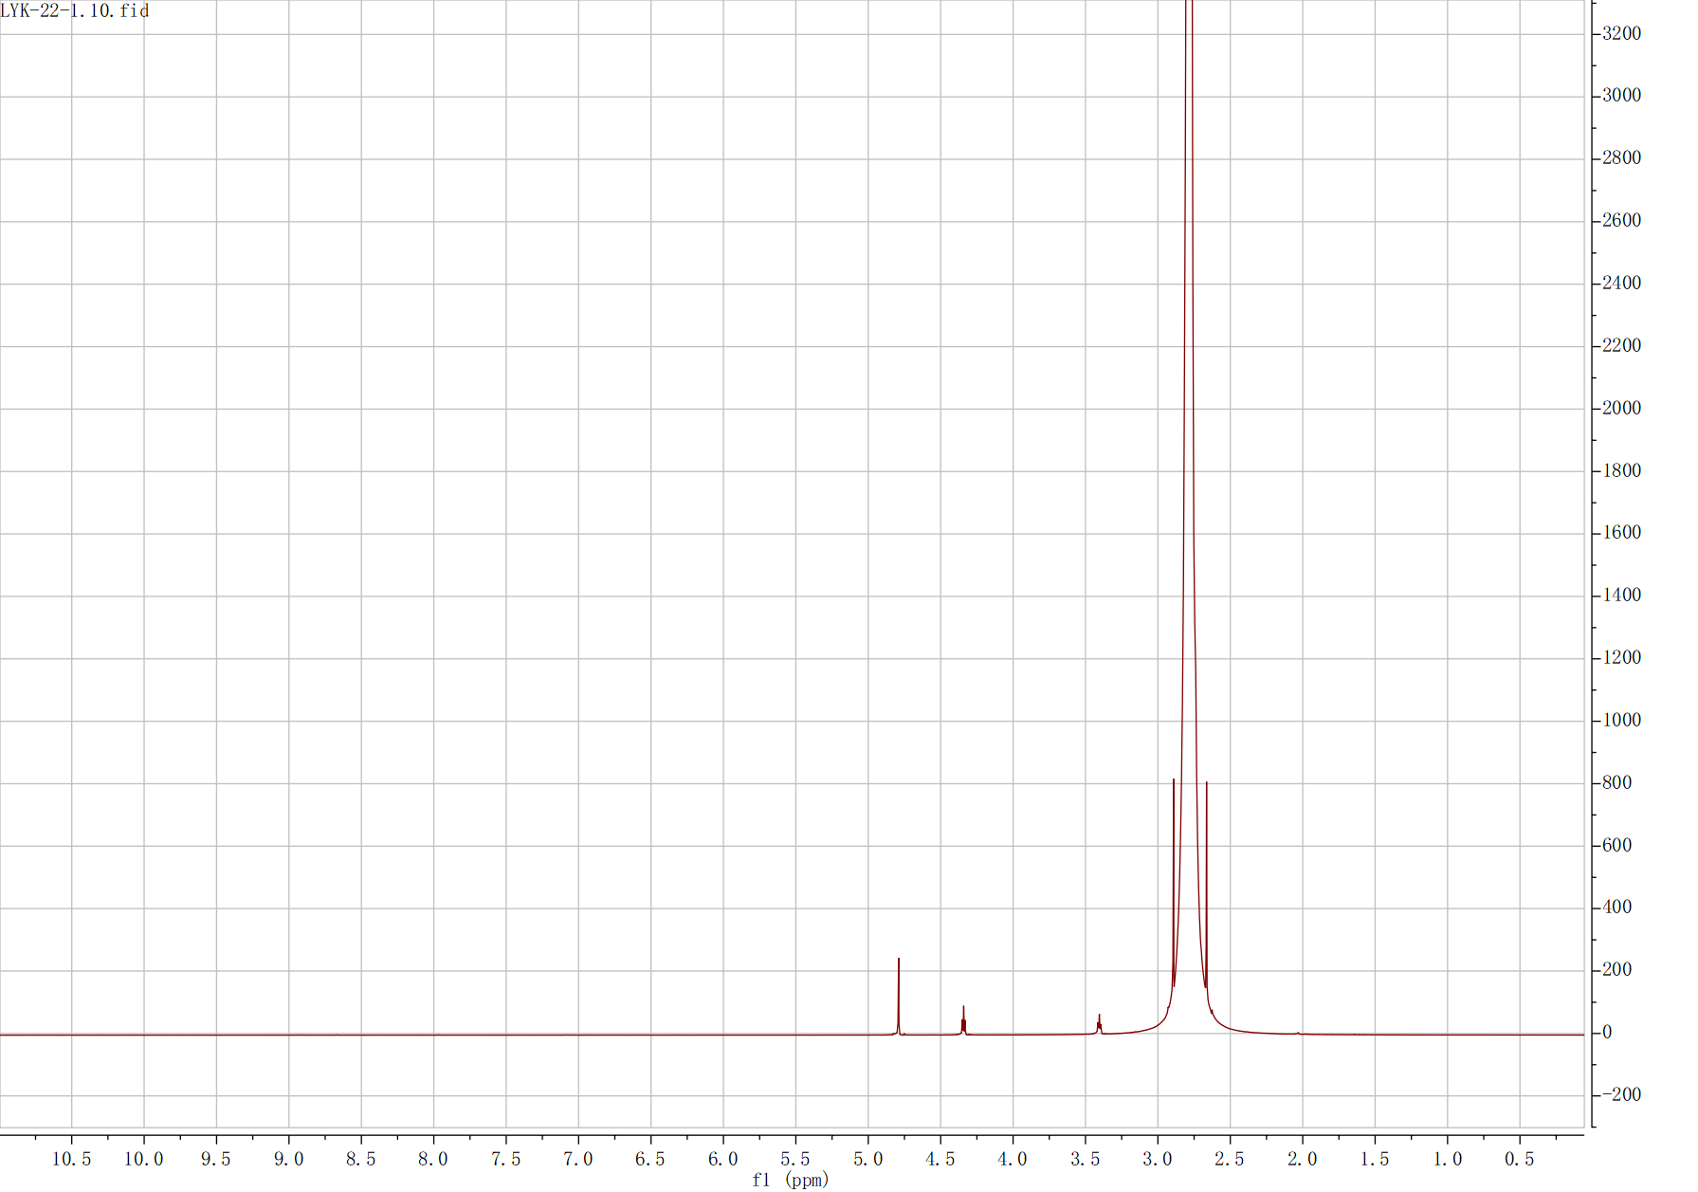
Supplementary Figure 39. ¹H NMR of the liquid products obtained from CO₂ photoreduction catalyzed by TJU-60(I)-Fe(tpy)₂.
Supplementary Figure 40. XPS spectra of TJU-60(I)-Co(tpy)₂ for before and after three-cycle photocatalysis.

Supplementary Figure 41. PXRD spectra of TJU-60(I)-Fe(tpy)₂ before and after three-cycle photocatalysis.

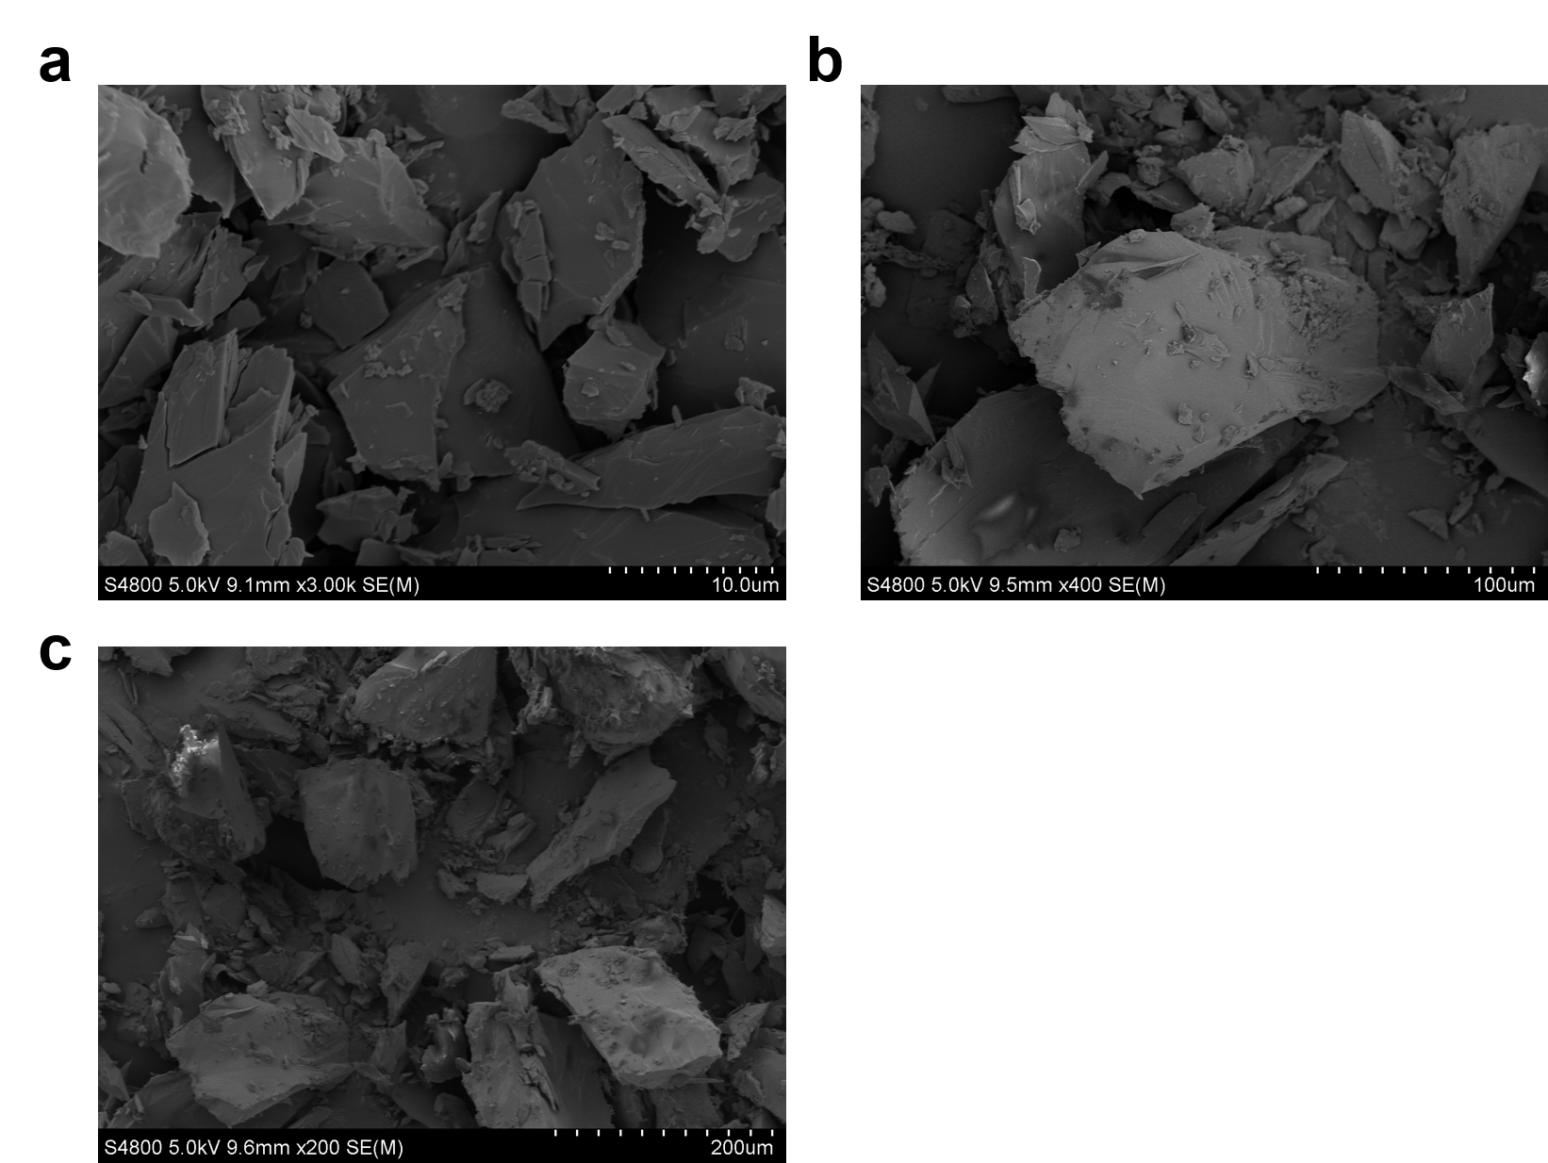
Supplementary Figure 42. SEM of (a) TJU-59(Cl)-Fe(tpy)₂, (b) TJU-59(Br)-Fe(tpy)₂, (c) TJU-60(I)-Fe(tpy)₂ after photocatalysis.

5. Supplementary Table
Supplementary Table 1 Crystal data and structure refinement of TJU-59(Cl)-Fe(tpy)₂, TJU-59(Br)-Fe(tpy)₂ and TJU-60(I)-Fe(tpy)₂.
Identification code | TJU-59(Cl)-Fe(tpy)₂ | TJU-59(Br)-Fe(tpy)₂ | TJU-60(I)-Fe(tpy)₂
Empirical formula | C₄₄H₃₂Cl₄FeN₆O₆Pb₂ | C₄₄H₂₈Br₄FeN₆O₄Pb₂ | C₄₇H₃₅FeI₄N₇O₅Pb₂
Formula weight | 1352.78 | 1494.59 | 1755.65
Temperature (K) | 286.00 | 273 K | 278.00
Crystal system | monoclinic | monoclinic | triclinic
Space group | P2₁/c | P2₁/c | P-1
a (Å) | 12.629(3) | 12.8594(19) | 12.295(3)
b (Å) | 17.519(4) | 17.715(2) | 12.487(3)
c (Å) | 18.925(4) | 19.123(3) | 16.692(4)
α/° | 90 | 90 | 85.561(8)
β/° | 95.414(8) | 96.048(4) | 87.022(9)
γ/° | 90 | 90 | 81.497(9)
V (Å³) | 4168.3(16) | 4332.0(10) | 2524.8(11)
Z | 4 | 4 | 2
ρ_{calc}g/cm³ | 2.156 | 2.292 | 2.309
Index ranges | -14 ≤ h ≤ 14 | -15 ≤ h ≤15 | -14 ≤ h ≤14
Index ranges | -20 ≤ k ≤20 | -21 ≤ k ≤ 21 | -14 ≤ h ≤14
Index ranges | -22≤ l ≤22 | -22 ≤ l ≤ 22 | -19 ≤ l ≤ 19
Data/restraints/parameters | 6713/595/550 | 7596/609/458 | 8602/631/597
Goodness-of-fit on F² | 1.091 | 1.017 | 1.071
Final R indexes [I>=2σ(I)] | R₁ = 0.0526 | R₁ = 0.0948 | R₁ = 0.0573
Final R indexes [I>=2σ(I)] | wR₂ = 0.1084 | wR₂ = 0.1780 | wR₂ = 0.1171
Final R indexes [all data] | R₁ = 0.0616 | R₁ = 0.1379 | R₁ = 0.0923
Final R indexes [all data] | wR₂ = 0.1130 | wR₂ = 0.2003 | wR₂ = 0.1326
Largest diff. peak/hole (e Å⁻³ ) | 1.88/-2.25 | 1.99/-2.19 | 1.43/-2.07
R₁=∑(||F₀|-|F_{c}||) / ∑|F₀|; wR₂={∑[w(F₀²-F_{c}²)²]/∑[w(F₀²)]²}

Supplementary Table 2 Crystal data and structure refinement of TJU-59(Cl)-Co(tpy)₂, TJU-59(Br)-Co(tpy)₂ and TJU-60(I)-Co(tpy)₂.
Identification code | TJU-59(Cl)-Co(tpy)₂ | TJU-59(Br)-Co(tpy)₂ | TJU-60(I)-Co(tpy)₂
Empirical formula | C₄₄H₂₈Cl₄CoN₆O₄Pb₂ | C₄₄H₂₈Br₄CoN₆O₄Pb₂ | C₄₇H₃₅CoI₄N₇O₅Pb₂
Formula weight | 1319.83 | 1497.67 | 1758.73
Temperature (K) | 283.00 | 296 K | 289.00
Crystal system | monoclinic | monoclinic | triclinic
Space group | P2₁/c | P2₁/c | P-1
a (Å) | 12.706(6) | 12.862(5) | 12.0479(12)
b (Å) | 17.590(8) | 17.754(7) | 12.6442(10)
c (Å) | 19.196(9) | 19.260(7) | 16.8631(15)
α/° | 90 | 90 | 84.801(4)
β/° | 94.703(18) | 94.926(11) | 88.484(2)
γ/° | 90 | 90 | 82.612(2)
V (Å³) | 4276(3) | 4382(3) | 2536.8(4)
Z | 4 | 4 | 2
ρ_{calc}g/cm³ | 2.050 | 2.270 | 2.302
Index ranges | -14 ≤ h ≤ 14 | -14 ≤ h ≤14 | -14 ≤ h ≤14
Index ranges | -20 ≤ k ≤20 | -20 ≤ k ≤ 20 | -14 ≤ h ≤14
Index ranges | -22≤ l ≤22 | -22 ≤ l ≤ 22 | -19 ≤ l ≤ 19
Data/restraints/parameters | 7195/0/550 | 7098/570/454 | 8656/606/597
Goodness-of-fit on F² | 1.042 | 1.062 | 1.030
Final R indexes [I>=2σ(I)] | R₁ = 0. 0667 | R₁ = 0.0849 | R₁ = 0.0338
Final R indexes [I>=2σ(I)] | wR₂ = 0.2056 | wR₂ = 0.1538 | wR₂ = 0.0671
Final R indexes [all data] | R₁ = 0.0813 | R₁ = 0.1365 | R₁ = 0.0432
Final R indexes [all data] | wR₂ = 0.2173 | wR₂ = 0.1767 | wR₂ = 0.0711
Largest diff. peak/hole (e Å⁻³ ) | 2.92/-4.87 | 2.03/-2.07 | 1.53/-2.24
R₁=∑(||F₀|-|F_{c}||) / ∑|F₀|; wR₂={∑[w(F₀²-F_{c}²)²]/∑[w(F₀²)]²}^{1/2}
Supplementary Table 3 Crystal data and structure refinement of TJU-59(Cl)-Ni(tpy)₂, TJU-59(Br)-Ni(tpy)₂ and TJU-60(I)-Ni(tpy)₂.
Identification code | TJU-59(Cl)-Ni(tpy)₂ | TJU-59(Br)- Ni (tpy)₂ | TJU-60(I)- Ni (tpy)₂
Empirical formula | C₄₄H₂₈Cl₄N₆NiO₄Pb₂ | C₄₄H₂₈Br₄N₆NiO₄Pb₂ | C₄₇H₃₅I₄N₇NiO₅Pb₂
Formula weight | 1333.12 | 1497.45 | 1758.51
Temperature (K) | 293 K | 296 K | 289.00
Crystal system | monoclinic | monoclinic | triclinic
Space group | P2₁/c | P2₁/c | P-1
a (Å) | 12.4027(10) | 12.882(8) | 12.094(3)
b (Å) | 17.5860(9) | 17.747(12) | 12.656(3)
c (Å) | 19.0115(14) | 19.366(11) | 16.868(4)
α/° | 90 | 90 | 84.788(7)
β/° | 94.761(3) | 84.80(3) | 88.519(7)
γ/° | 90 | 90 | 82.676(7)
V (Å³) | 4132.4(5) | 4409(5) | 2549.9(9)
Z | 4 | 4 | 2
ρ_{calc}g/cm³ | 2.143 | 2.256 | 2.290
Index ranges | -14 ≤ h ≤ 14 | -14 ≤ h ≤ 14 | -13 ≤ h ≤13
Index ranges | -20 ≤ k ≤20 | -19 ≤ k ≤ 18 | -14 ≤ h ≤14
Index ranges | -22≤ l ≤22 | -21≤ l ≤ 21 | -18 ≤ l ≤ 18
Data/restraints/parameters | 6689/0/550 | 6112/571/454 | 7348/615/601
Goodness-of-fit on F² | 1.089 | 1.090 | 1.037
Final R indexes [I>=2σ(I)] | R₁ = 0.0516 | R₁ = 0.1078 | R₁ = 0.0481
Final R indexes [I>=2σ(I)] | wR₂ = 0.1095 | wR₂ = 0.1885 | wR₂ = 0.1055
Final R indexes [all data] | R₁ = 0.0555 | R₁ = 0.2703 | R₁ = 0.0619
Final R indexes [all data] | wR₂ = 0.1116 | wR₂ = 0.2403 | wR₂ = 0.1128
Largest diff. peak/hole (e Å⁻³ ) | 1.53/-2.76 | 1.75/-2.23 | 1.63/-2.27
R₁=∑(||F₀|-|F_{c}||) / ∑|F₀|; wR₂={∑[w(F₀²-F_{c}²)²]/∑[w(F₀²)]²}^{1/2}

Supplementary Table 4. Comparison of electron selectivity and evolution rates of different photocatalysts for C₂₊ production from CO₂.
Photocatalyst | Condition | C₂₊ product | Photocatalytic  reactivity | Selectivity | Ref
Cu/PCN | DMF/H₂O | C₂H₅OH | 11.8 μmol g⁻¹ h⁻¹ (full  spectrum) | 89.6% | [7]
STO/Cu@Ni/TiN | H₂O | C₂H₅OH | 21.3 μmol g⁻¹ h⁻¹ (full  spectrum) | 79.0% | [8]
DMASnI₃(O) | H₂O | C₂H₄ | 11.2 μmol g⁻¹ h⁻¹ (full  spectrum) | 94% | [9]
NiCo-TiO₂ | H₂O+Na₂SO₃+ CsOH | CH₃COOH | 22.6 μmol g⁻¹ h⁻¹ (full  spectrum) | 71% | [10]
WO₃·0.33H₂O | H₂O | CH₃COOH | 9.4 μmol g⁻¹ h⁻¹ (full  spectrum) | 85.0% | [11]
G-TiO₂ | H₂O vapor | C₂H₆ | 16.8 μmol g⁻¹ h⁻¹ (full  spectrum) | 78.6% | [12]
Mo-COF | H₂O | C₂H₄ | 3.57μmol g⁻¹ h⁻¹ (λ>420nm) | 4.8% | [13]
F-TotPp(Co) | H₂O | C₂H₄ | 0.06 μmol g⁻¹ h⁻¹ (full  spectrum) | 42.5% | [14]
DTB-PCT | H₂O+TEOA | C₂H₄ | 0.017 μmol g⁻¹ h⁻¹ (λ>420nm) | 5.12% | [15]
CuO_{X}/p-ZnO | H₂O+TEA | C₂H₄ | 22.3μmol g⁻¹ h⁻¹ (full  spectrum) | 32% | [16]
Au-CeO₂ | H₂O | C₂H₆ | 11.07 μmol g⁻¹ h⁻¹ (full  spectrum) | 65.3% | [17]
Au/TiO_{2-x} | H₂O | C₂H₆ | 0.66 μmol g⁻¹ h⁻¹ (full  spectrum) | 30.4% | [18]
CN-g-C₃N₄ | H₂O | C₂H₄ | 1.38 μmol g⁻¹ h⁻¹ (full  spectrum) | 70.9% | [19]
NH₂-CuBDC-2L | H₂O | C₂H₄ | 1.74 μmol g⁻¹ h⁻¹ (λ>420nm) | -- | [20]
Cu/3DOM-In₂O₃ | H₂O | C₂H₄ | 24.31μmol g⁻¹ h⁻¹(full  spectrum) | -- | [21]
CuInP₂S₆ | H₂O | C₂H₄ | 20.89 μmol g⁻¹ h⁻¹(full  spectrum) | 74.6% | [22]
MoSx/Fe₂O₃ | H₂O | C₂H₄ | 10.60 μmol g⁻¹ h⁻¹(full  spectrum) | 51% | [23]
Aun/Au₁-CMS | H₂O | CH₃COOH | 26.9 μmol g⁻¹ h⁻¹ (UV-Vis) | 95.1% | [24]
TJU-60(I)-Fe(tpy)₂ | H₂O+MeCN+TEOA | C₂H₄ / C₂H₆ | 35.1 μmol g⁻¹ h⁻¹ (full  spectrum)  14.3 μmol g⁻¹ h⁻¹ (NIR) | 86% | This work

Supplementary Table 5. Comparison of electron consumption rates (R_{electron}) for NIR-driven CO₂ reduction on different photocatalysts.
Photocatalyst | R_{electron}  for CO(μmol/g/h) | R_{electron}  for CH₄(μmol/g/h) | R_{electron}  for C₂₊ product (μmol/g/h) | Ref
Au_{N}/Au₁-CMS | 4.2 | 0 | 75.11 | [25]
Bi₁₉S₂₇Br₃ | 1.2 |  | 10.0 | [26]
UCNPs/ZIS | 3 | 0 | 0 | [27]
CQDs/Bi₂WO₆ | 3.5 | 0 | 0 | [28]
Cu-Cu₂O | 4 | 0 | 0 | [29]
Bi₁₂O₁₇Cl₂/NiAl-LDH | 4.4 | 0 | 0 | [30]
O_{V}-WO₃ | 4.4 | 0 | 0 | [31]
V_{o}-Rich WO₃ | 5.6 | 0 | 0 | [31]
Cu_{2-x}S/Ni-Al-LDH | 5.9 | 0 | 0 | [32]
BiOBr/Bi₂S₃ | 8 | 0 | 0 | [33]
Ag₂O/Bi₂O₂S | 14.8 | 0 | 0 | [34]
V_{S}-AgInS₂ | 16.1 | 0 | 0 | [35]
Bi₂O_{3−x} | 16.2 | 0 | 0 | [36]
Cs₄CuSb₂Cl₁₂ | 2.7 | 0.2 | 0 | [37]
10-BP/WO | 8.6 | 2.4 | 0 | [38]
bismuthene | 4.3 | 7.7 | 0 | [40]
Ag₆Si₂O₇/Bi₁₉Br₃S₂₇ | 9.6 | 12 | 0 | [41]
15% Cu_{2–x}S/LDH | 11.6 | 39.2 | 0 | [32]
Bi₂O₂S | 14.8 | 49.4 | 0 | [43]
Ru@H-MoO₃₋x | 4 | 80 | 0 | [44]
TJU-60(I)-Fe(tpy)₂ | 11.4 | 20 | 185.6 | This work

6. Reference
- Zhang X, et al. Coordination Polymers with 2,2′:6′,2″-Terpyridine Earth-Abundant Metal Complex Units for Selective CO₂ Photoreduction. Inorg. Chem. 61, 1590-1596(2022).
- Wang X, et al. Dual-Function Precious-Metal-Free Metal-Organic Framework for Photocatalytic Conversion and Chemical Fixation of Carbon Dioxide. Inorg. Chem. 62, 19015-19024(2023).
- Kresse G, Furthmüller J. Efficiency of ab-initio total energy calculations for metals and semiconductors using a plane-wave basis set. Comput. Mater. Sci. 6, 15-50(1996).
- Perdew J P, Burke K, Ernzerhof M, Generalized Gradient Approximation Made Simple. Phys. Rev. Lett. 77, 3865(1996).
- Monkhorst H J, Pack J D. Special points for Brillouin-zone integrations. Phys. Rev. B. 13, 5188(1976).
- Blöchl P E, Projector augmented-wave method. Phys. Rev. B. 50, 17953(1994).
- Shi H, et al. Atomically Dispersed Indium-Copper Dual-Metal Active Sites Promoting C−C Coupling for CO₂ Photoreduction to Ethanol. Angew. Chem. Int. Ed. 61, e202208904(2022).
- Yu H, et al. Full solar spectrum driven plasmonic-assisted efficient photocatalytic CO₂ reduction to ethanol Chem. Eng. J. 430, 132940(2022).
- Li L, et al. Modulation of active center distance of hybrid perovskite for boosting photocatalytic reduction of carbon dioxide to ethylene. Proc. Natl. Acad. Sci. 121, e2318970121(2024).
- Jia G, et al. Asymmetric coupled dual-atom sites for selective photoreduction of carbon dioxide to acetic acid. Adv. Funct. Mater. 32, 2206817(2022).
- Sun S, et al. Ultrathin WO₃·0.33H₂O nanotubes for CO₂ photoreduction to acetate with high selectivity. J. Am. Chem. Soc. 140, 6474-6482(2018).
- Tu W, et al. An In Situ Simultaneous Reduction-Hydrolysis Technique for Fabrication of TiO₂-Graphene 2D Sandwich-Like Hybrid Nanosheets: Graphene-Promoted Selectivity of Photocatalytic-Driven Hydrogenation and Coupling of CO₂
into Methane and Ethane. Adv. Funct. Mater. 23, 1743-1749(2013).
- Kou M, et al. Photocatalytic CO₂ conversion over single-atom MoN₂ sites of covalent organic framework. Appl. Catal. B Environ. Energy. 291, 120146(2021).
- Wang K, et al. Porous organic polymers with shiftable active Co(II) sites for photocatalytic reduction of CO₂ to C₂H₄. Appl. Catal. B Environ. Energy. 362, 124765(2025).
- Tang G, et al. Alkyne Bridge Engineering of Donor-π-Acceptor Polymers for Efficient CO₂ Reduction to CH₄ and C₂H₄ under Visible Light Illumination, Appl. Catal. B Environ. Energy. 342, 123392(2024).
- Wang W, et al. Photocatalytic C–C Coupling from Carbon Dioxide Reduction on Copper Oxide with Mixed-Valence Copper(I)/Copper(II). J. Am. Chem. Soc. 143, 2984-2993(2021).
- Ji J, et al. Highly selective photocatalytic reduction of CO₂ to ethane over Au-O-Ce sites at micro-interface. Appl. Catal. B Environ. Energy. 321, 122020(2023).
- Wang K, et al. Unravelling the C-C coupling in CO₂ photocatalytic reduction with H₂O on Au/TiO₂-x: Combination of plasmonic excitation and oxygen vacancy. Appl. Catal. B Environ. Energy. 292, 120147(2021).
- Gao Q, et al. Regulating Local Electron Density of Cyano Sites in Graphitic Nitride Carbon by Giant Internal Electric Field for Eﬃcient CO₂ Photoreduction to Hydrocarbons. Small. 20, 2404822(2024).
- Guo F, et al. Construction of N-doped copper metal–organic frameworks for promoting photocatalytic carbon dioxide reduction to ethylene. Sci. China Chem. 68, 601-609(2025).
- Xu M, et al. Engineering Heteronuclear Dual-Metal Active Sites in Ordered Macroporous Architectures for Enhanced C₂H₄ Production from CO₂ Photoreduction. Angew. Chem. Int. Ed. e202506072(2025).
- Gao W, et al. Tandem Synergistic Effect of Cu‐In Dual Sites Confined on the Edge of Monolayer CuInP₂S₆ toward Selective Photoreduction of CO₂ into Multi Carbon Solar Fuels. Angew. Chem. Int. Ed. 63, e202317852(2023).
- Song W, et al. Unlocking Copper-Free Interfacial Asymmetric C–C Coupling for Ethylene Photosynthesis from CO₂ and H₂O'. J. Am. Chem. Soc. 146, 29028-
29039(2024).
- Chen C, et al. Supported Au single atoms and nanoparticles on MoS₂ for highly selective CO₂-to-CH₃COOH photoreduction. Nat Commun. 15, 7825(2024).
- Chen C, et al. Supported Au single atoms and nanoparticles on MoS2 for highly selective CO₂-to-CH₃COOH photoreduction. Nat Commun. 15, 7825(2024).
- Zhao J, et al. Sulfur-vacancy induced asymmetric active site for Bi19S27Br3 nanorods photocatalyzes CO₂ conversion to ethylene. Appl. Catal. B Environ. Energy. 361, 124647(2025).
- Yu M, et al. Upconversion nanoparticles coupled with hierarchical ZnIn₂S₄ nanorods as a near-infrared responsive photocatalyst for photocatalytic CO₂ reduction. J. Colloid Interface Sci. 612, 782-791(2022).
- Di J, et al. Novel visible-light-driven CQDs/Bi₂WO₆ hybrid materials with enhanced photocatalytic activity toward organic pollutants degradation and mechanism insight. Appl. Catal. B Environ. Energy. 168-169, 51-61(2015).
- Bai S, et al. Near-Infrared-Responsive Photocatalytic CO₂ Conversion via In Situ Generated Co₃O₄/Cu₂O. ACS Nano. 17, 10976-10986(2023).
- GuoR, et al. Carbon quantum dots-modified Z-scheme Bi₁₂O₁₇Cl₂/NiAl-LDH for significantly boosting photocatalytic CO₂ reduction. J. Colloid Interface Sci. 627, 343-354(2022).
- Lei B, et al. C-Doping Induced Oxygen-Vacancy in WO₃ Nanosheets for CO₂ Activation and Photoreduction. ACS Catal. 12, 9670-9678(2022).
- Ji X, et al. Construction of Full Solar-Spectrum-Driven Cu_{2-x}S/Ni-Al-LDH Heterostructures for Efficient Photocatalytic CO₂ Reduction. ACS Appl. Energy Mater. 5, 286-2872(2022).
- Miao Z, et al. BiOBr/Bi₂S₃ heterojunction with S-scheme structure and oxygen defects: In-situ construction and photocatalytic behavior for reduction of CO₂ with H₂O. J. Colloid Interface Sci. 620, 407-418(2022).
- Jiang L, et al. In-situ growth of p-type Ag₂O on n-type Bi₂O₂S with intimate interfacial contact for NIR light-driven photocatalytic CO₂ reduction. Appl. Surf. Sci. 601, 154185(2022).
- Wang K, et al. Metallic AgInS₂ nanocrystals with sulfur vacancies boost atmospheric CO₂ photoreduction under near-infrared light illumination. Appl. Catal. B Environ. Energy. 332, 122763(2023).
- Li Y, et al. Plasmonic Hot Electrons from Oxygen Vacancies for Infrared Light-Driven Catalytic CO₂ Reduction on Bi₂O_{3−x}. Angew. Chem. Int. Ed. 60, 910-916(2021).
- Cai T, Lead-Free Cs₄CuSb₂Cl₁₂ Layered Double Perovskite Nanocrystals. J. Am. Chem. Soc. 142, 11927-11936(2020).
- Lu C, et al. Nonmetallic surface plasmon resonance coupling with pyroelectric effect for enhanced near-infrared-driven CO₂ reduction. Chem. Eng. J. 445, 136739(2022).
- Zhou L, et al. Recent advances and future perspectives of bismuthene: From preparation to applications. Materials Today. 80, 1369-7021(2024).
- Wang K, Near-infrared-responsive sea-urchin-like Ag₆Si₂O₇/Bi₁₉Br₃S₂₇ S-scheme heterojunction for efficient CO₂ photoreduction. Appl. Catal. B Environ. Energy. 361, 124560(2025).
- Chitara B, Limbu, T B, Orlando J D, Tang Y, Yan F. Ultrathin Bi₂O₂S nanosheet near-infrared photodetectors. Nanoscale, 12, 16285-16291(2020).
- Li J, Selective CO₂ Photoreduction into CH₄ Triggered by the Synergy between Oxygen Vacancy and Ru Substitution under Near-Infrared Light Irradiation. Adv. Sci. 11, 2405668(2024).

