Contact toxicity, Electrophysiology, Anti-mating and Repellent effects of Piper guineense against Spodoptera frugiperda

Mobolade Dele Akinbuluma^{1,2} ,Jacques A. Deere¹, Peter Roessingh¹ and Astrid T. Groot¹

- Department of Evolutionary and Population Biology, Institute for Biodiversity and Ecosystem Dynamics, Amsterdam, Netherlands

- Department of Crop Protection & Environmental Biology, University of Ibadan, Ibadan, Nigeria

Corresponding author: Email: m.d.akinbuluma@uva.nl; Phone: +31686279835

ORCID: https://orcid.org/0000-0002-5473-9703

Supplementary Information

Table S1a. Statistical comparison of LC₅₀ values of Piper guineense extract on Spodoptera frugiperda larvae tested by topical application between days

Comparison  across days | Estimate | Std. Error | t-value | p-value
1-2 | 3.69989 | 9.8652 | 0.3750 | 0.7109
1-7 | 3.88432 | 9.8759 | 0.3933 | 0.6976
2-7 | 0.18443 | 0.9821 | 0.1878 | 0.8526
LC₅₀ values were not significantly different (p > 0.05) across pairs of days.

Table S1b. LC₅₀ values of Piper guineense extract across days against Spodoptera frugiperda larvae tested by topical application

Time (Days) | LC₅₀ | 95% CI
1 | 3.46 | -15.22-25.43
2 | 0.86 | 0.14- 2.67
7 | 0.36 | -0.36- 2.80

LC₅₀ values were not significantly different (p > 0.05) due to overlapping respective 95% CI. LC₅₀ = median lethal concentration; CI = confidence interval.

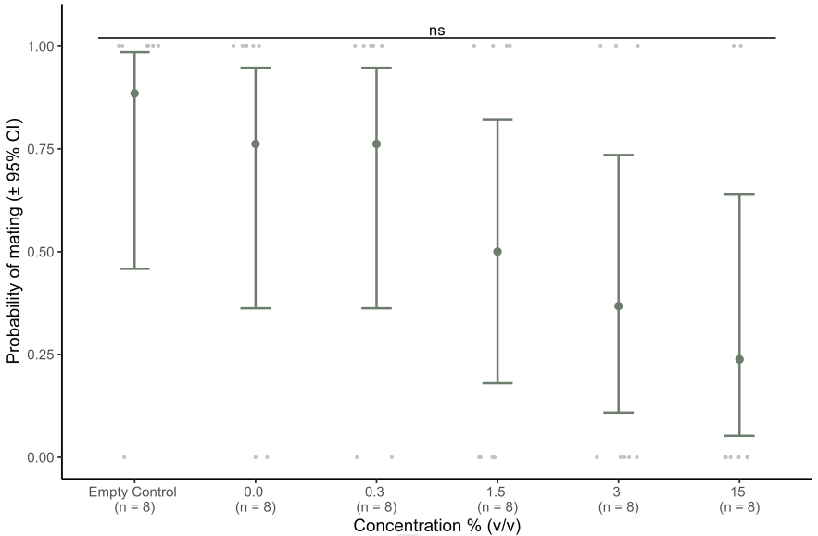

Fig S1: Probability of mating of Spodoptera frugiperda exposed to extract concentrations of Piper guineense extract. ns = mating probability not significant (p > 0.05). Grey dots indicate raw data.

Table S2. Contrast effects of extract concentration and population on oviposition. Contrasts are Tukey p-value adjustments after a significant interaction between population and extract concentration was found (GLMM: estimate = -2.43±0.83se, z-value. = -2.93, p = 0.003). Values are given on a log scale as the initial model was fitted with a Poisson distribution.

Contrast | estimate | s.e | z-ratio | p-value
SFK population
Empty Control - 0.0% | 0.41 | 0.41 | 0.99 | 1.00
Empty Control - 0.3% | 2.01 | 0.75 | 2.68 | 0.24
Empty Control - 1.5% | 0.31 | 0.40 | 0.78 | 1.00
Empty Control - 3% | 1.10 | 0.52 | 2.13 | 0.60
Empty Control - 15% | 1.32 | 0.53 | 2.35 | 0.44
0.0% - 0.3% | 1.61 | 0.77 | 2.08 | 0.64
0.0% - 1.5% | -0.09 | 0.44 | -0.22 | 1.00
0.0% - 3% | 0.69 | 0.55 | 1.27 | 0.98
0.0% - 15% | 0.92 | 0.59 | 1.55 | 0.93
0.3% -1.5% | -1.70 | 0.77 | -2.22 | 0.53
0.3% - 3% | -0.92 | 0.84 | -1.10 | 0.99
0.3% -15% | -0.69 | 0.87 | -0.80 | 1.00
1.5% - 3% | 0.79 | 0.54 | 1.46 | 0.95
1.5% - 15% | 1.01 | 0.58 | 1.74 | 0.85
3% - 15% | 0.22 | 0.67 | 0.33 | 1.00
SFN population
Empty Control - 0.0% | 0.66 | 0.31 | 2.15 | 0.59
Empty Control - 0.3% | 3.43 | 1.02 | 3.38 | 0.03
Empty Control - 1.5% | 2.74 | 0.73 | 3.76 | 0.009
Empty Control - 3% | 1.04 | 0.35 | 2.96 | 0.12
Empty Control - 15% | 2.34 | 0.60 | 3.87 | 0.006
0.0% - 0.3% | 2.77 | 1.03 | 2.69 | 0.23
0.0% - 1.5% | 2.08 | 0.75 | 2.78 | 0.19
0.0% - 3% | 0.37 | 0.39 | 0.96 | 0.99
0.0% - 15% | 1.67 | 0.63 | 2.66 | 0.24
0.3% -1.5% | -0.69 | 1.22 | -0.57 | 1.00
0.3% - 3% | -2.40 | 1.04 | -2.30 | 0.48
0.3% -15% | -1.10 | 1.15 | -0.95 | 1.00
1.5% - 3% | -1.70 | 0.77 | -2.22 | 0.53
1.5% - 15% | -0.41 | 0.91 | -0.45 | 1.00
3% - 15% | 1.30 | 0.65 | 2.00 | 0.70

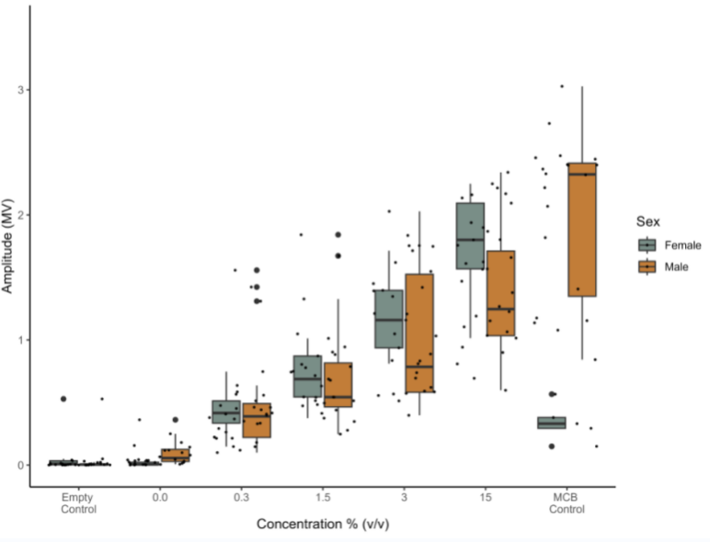

Fig S2: EAG responses of Spodoptera frugiperda males and female for combined SFK and SFK populations to extract concentration of Piper guineense. Box and whisker plots indicate amplitude response (in millivolts (MV)) of females (light grey) and males (orange). Extract concentrations of P. guineense are in percentage volume to volume (% (v/v)). The empty control represents negative control and the MCB (multiple component blends of the five pheromone compounds from a S. frugiperda female) represents a positive control. Sample sizes per sex: Female – Empty control and all concentrations (0.0% (v/v) - 15% (v/v)) = 13, MCB control = 5; Male – Empty control, all concentrations and MCB control = 18). Black dots indicate raw data.

