Water-Based Synthesis of CsPbBr₃ Perovskite Nanocrystals Under Ambient Conditions
Zhaoyi Duª, Jiewen Wei^{b}, Ding Ding^{b}, Martina Rimmele^{b}, Yueyao Dong^{c}, Davide Nodari^{b}, Francesco Furlan^{b}, George Morgan^{a,d}, Peter Akinshin^{a,d}, William Rodriguez Kazeemª, Gwilherm Kerherve^{e}, Martin Heeney^{b,f}, Thomas J. Macdonald^{c}, Saif A. Haque^{b}, Nicola Gasparini^{b}, David J. Payne and Martyn A. McLachlanª*
ª Department of Materials, Molecular Sciences Research Hub, Imperial College London, London, W12 0BZ, UK
^{b} Department of Chemistry, Molecular Sciences Research Hub, Imperial College London, London, W12 0BZ, UK
^{c} Department of Electronic and Electrical Engineering, Reynolds Building, University College London, London, WC1E 6BT, UK
^{d} Now at Clarendon Laboratory, Department of Physics, University of Oxford, Oxford OX1 3PU, UK
^{e} Department of Materials, Imperial College London, Exhibition Road, London SW7 2AZ, UK
^{f} King Abdullah University of Science & Technology (KAUST), Thuwal, 23955-6900, Saudi Arabia
^{g} NEOM Education, Research, and Innovation Foundation, Al Khuraybah, Tabuk 49643-9136, Saudi Arabia

Table S1 Compositional details of aqueous solvents containing malic acid (MA) and beta-alanine (βA), their measured pH and conductivity values.
Solvent | Moles of MA | Moles of βA | Moles of H₂O | MA mole Fraction (Χ_{MA}) | βA mole fraction (Χ_{βA}) | H₂O mole fraction  (Χ_{H2O}) | pH | Conductivity  (mS / cm)
0 | 0 | 1 | 10 | 0.000 | 0.091 | 0.909 | 7.48 ± 0.1 | 0.1 ± 0.01
1 | 0.17 | 1 | 10 | 0.015 | 0.090 | 0.895 | 4.46 ± 0.1 | 15.5 ± 0.56
2 | 0.33 | 1 | 10 | 0.029 | 0.088 | 0.883 | 4.18 ± 0.1 | 18.2 ± 1.05
3 | 0.5 | 1 | 10 | 0.043 | 0.087 | 0.87 | 3.91 ± 0.1 | 18.2 ± 1.15
4 | 0.67 | 1 | 10 | 0.057 | 0.086 | 0.857 | 3.61 ± 0.1 | 17.1 ± 1.21
5 | 0.83 | 1 | 10 | 0.070 | 0.085 | 0.845 | 3.42 ± 0.1 | 16.7 ± 1.21
6 | 1 | 1 | 10 | 0.083 | 0.083 | 0.834 | 3.24 ± 0.1 | 13.8 ± 0.85
7 | 1 | 0.83 | 10 | 0.085 | 0.070 | 0.845 | 3.08 ± 0.1 | 14.2 ± 0.90
8 | 1 | 0.67 | 10 | 0.086 | 0.057 | 0.857 | 2.98 ± 0.1 | 14.3 ± 0.91
9 | 1 | 0.5 | 10 | 0.087 | 0.043 | 0.87 | 2.75 ± 0.1 | 14.1 ± 0.85
10 | 1 | 0.33 | 10 | 0.088 | 0.029 | 0.883 | 2.42 ± 0.1 | 12.3 ± 0.65
11 | 1 | 0.17 | 10 | 0.090 | 0.015 | 0.895 | 2.22 ± 0.1 | 8.6 ± 0.30
12 | 1 | 0 | 10 | 0.091 | 0.000 | 0.909 | 1.32 ± 0.1 | 5.7 ± 1.18

Table S2 Measured PNC size and dispersity data obtained from transmission electron microscopy (TEM) images and measured photoluminescence (PL) emission wavelength (λ_{max}) and peak full width at half maximum (FWHM) for samples prepared from 75 μL of aqueous precursor solution.
Solvent | 75 uL HBr-Acetone
Solvent | Size (nm) | Dispersity  (nm) | l_{max}  (nm) | FWHM  (nm)
A₇₅ | 9.5 | ± 4.7 | 511.9 | 42.4
B₇₅ | 8.5 | ± 4.1 | 510 | 24.0
C₇₅ | 9.9 | ± 6.4 | 511.9 | 29.0
D₇₅ | 32.3 | ± 18.7 | 518.1 | 23.0
N/A | N/A | N/A | N/A | N/A

Table S3 Calculated A₁, τ₁, A₂, τ₂, τ_{ave}, k_{r} and k_{nr} of PNCs made with varying concentrations of HBr with 0-hour (unaged) HBr-acetone.
Non-aged | 1.5% HBr | 2.3% HBr | 3.0% HBr | 3.7% HBr
A₁ | 0.816817 | 0.811209 | 0.820725 | 0.777083
τ₁ (ns) | 5.42 | 5.52 | 5.32 | 8.02
A₂ | 0.183183 | 0.188791 | 0.179275 | 0.222917
τ₂ (ns) | 37.53 | 42.64 | 46.42 | 74.78
τ_{ave} (ns) | 11.30201 | 12.52791 | 12.68819 | 22.90192
k_{r} (MHz) | 22.41194 | 13.07481 | 13.18549 | 1.536989
k_{nr} (MHz) | 66.06788 | 66.74699 | 65.62798 | 42.12748

Table S4 Calculated A₁, τ₁, A₂, τ₂, τ_{ave}, k_{r} and k_{nr} of PNCs made with varying concentrations of HBr with 1-hour aged HBr-acetone.
Aged 1h | 1.5% HBr | 2.3% HBr | 3.0% HBr | 3.7% HBr
A₁ | 0.988401 | 0.857113 | 0.82824 | 0.825139
τ₁ (ns) | 4.00 | 4.455 | 3.81 | 3.03
A₂ | 0.011599 | 0.142887 | 0.171760 | 0.174861
τ₂ (ns) | 22.92 | 28.30 | 23.61 | 20.36
τ_{ave} (ns) | 4.22 | 7.94 | 7.21 | 6.06
k_{r} (MHz) | 144.5024 | 41.78841 | 29.97226 | 19.53795
k_{nr} (MHz) | 92.46445 | 84.15617 | 108.724 | 145.4785

$$\begin{aligned}A\left(t\right)= A_{1}\exp\left(\frac{-t}{τ_{1}}\right)+A_{2}\exp\left(\frac{-t}{τ_{2}}\right) \#\#Eq.S1\end{aligned}$$
Biexponential function used for fitting TRPL data. A₁ and A₂ are the relative ratio of ratios of the two recombination modes, τ₁ and τ₂ are PL lifetime of the charge carriers.

The average radiative and non-radiative rates of the charge carriers can be calculated as [20]:
$$\begin{aligned}τ_{ave}= \frac{1}{k_{r}+k_{nr}}\# Eq.S2\end{aligned}$$
$$\begin{aligned}PLQY= \frac{k_{r}}{k_{r}+k_{nr}}\# Eq.S3\end{aligned}$$
Where k_{r} and k_{nr} are radiative and non-radiative recombination rate constants, respectively. The values of k_{r} and k_{nr} of the PNCs synthesised with different concentrations of HBr are shown in the rate of radiative recombination decreases with increase of HBr concentration, which is consistent with PLQY results.

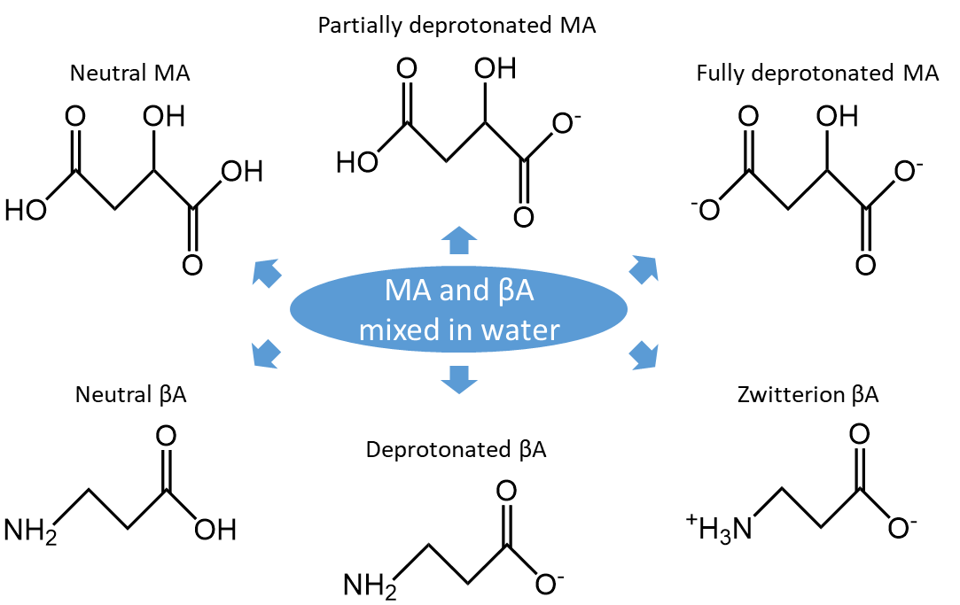
Figure S1 Possible molecular states of malic acid and beta-alanine aqueous solution.

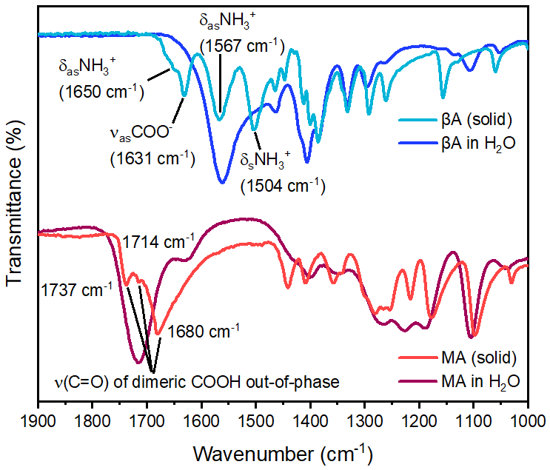
Figure S2 FTIR spectra of βA and MA solids (in powder form) and their respective aqueous solutions.

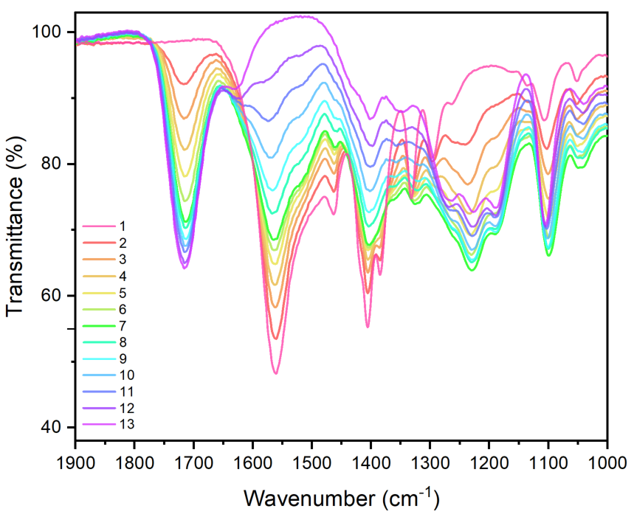
Figure S3 FTIR spectra of the aqueous solutions of MA and βA mixtures indicated in Table S1.

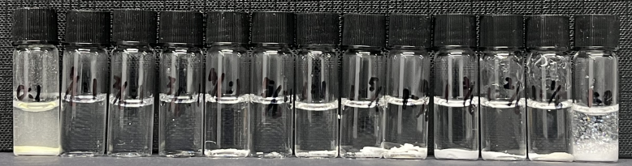
0 1 2 3 4 5 6 7 8 9 10 11 12
Figure S4 Photograph showing the solubility of 0.2M CsBr and PbBr₂ in our aqueous solvents 0-12, red box indicates solvents in which solubility of both precursors was achieved.

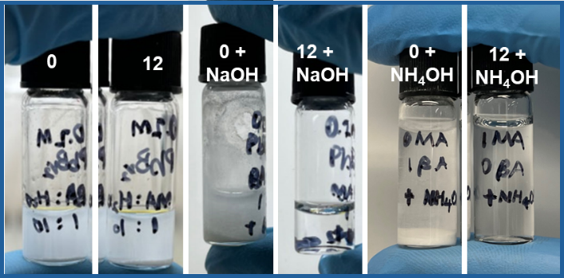
Figure S5 Solubility test of 0.2M CsBr and PbBr₂ in solvents 0 and 12 and following the addition of NaOH or NH₃·H₂O.

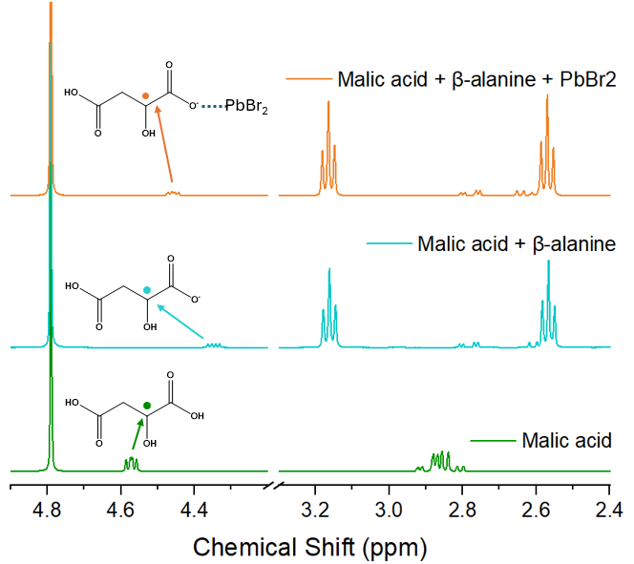
Figure S6 ¹H NMR of malic acid, mixture malic acid and beta-alanine, mixture of malic acid and beta-alanine and PbBr₂ in D₂O. The signal originating from the proton of -CH₂ in βA does not shift on addition of PbBr₂, indicating that there is not interaction between the βA and PbBr₂. This is reasonable since βA is in zwitterion form in the solution, the positively charged -NH₃⁺ group does not form an adduct with PbBr₂. In contrast, the peak of the H in -CH- of MA shifts considerably after the addition of PbBr₂. More specifically, the peak of the H in -CH- in pure MA in D₂O is at 4.56 ppm. But after the addition of βA, the peak shifted down filed to 4.33 ppm. This shift indicates that the -CH- is shielded by more electrons around. This is reasonable because the amino groups added with the addition of βA deprotonated the carboxyl groups of MA, making them more electron-rich and therefore stronger shielding effect. But after the addition of PbBr₂, the -CH- peak shifted downfield again, indicating that the electrons of the carboxylate groups adducted with PbBr₂, reducing the density of the electrons near the -CH-.

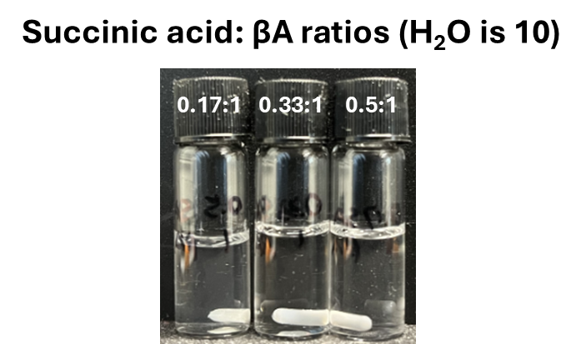
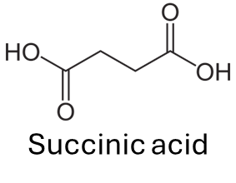
Solvent system equivalent
1. 2 3

Figure S7 Photograph showing the solubility of 0.2M CsBr and PbBr₂ in the aqueous mixture of succinic acid (SA) and βA, the SA quantity mimics that of Solvents 1-3 in Table S1. Succinic acid has similar structure to malic acid, lacking a -OH group adjacent to one of the -COOH groups. This aqueous solvent was capable of dissolving 0.2 mol dm⁻³ of CsBr and PbBr₂, less that the MA equivalent

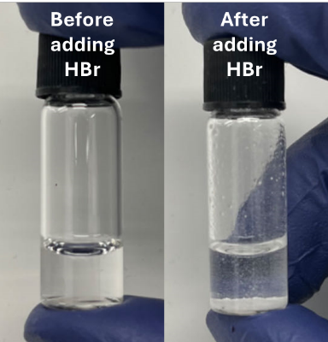
Figure S8 Images showing CsBr, PbBr₂ dissolved in our aqueous before (left) and after (right) the addition of conc. HBr showing the precipitation of PbBr₂ not the desired CsPbBr₃.

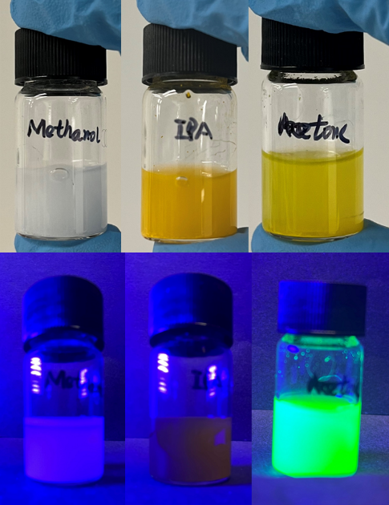
Figure S9 Images of the solutions resulting from the synthesis carried out with different water-miscible co-solvents (methanol, IPA and acetone) under ambient light (top) and UV light (bottom).
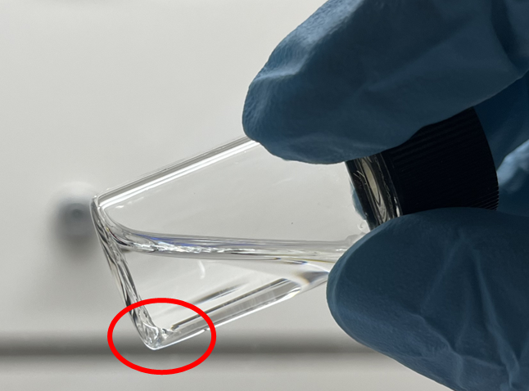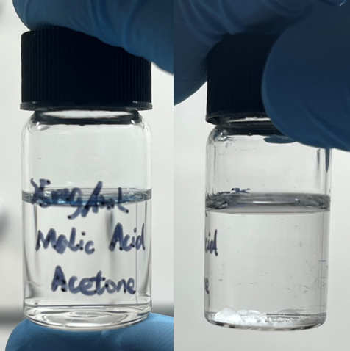
Figure S10 Images showing the insolubility of our aqueous solvent and precursor mixture in acetone (left), protonated MA (centre) and deprotonated MA (right) in acetone.

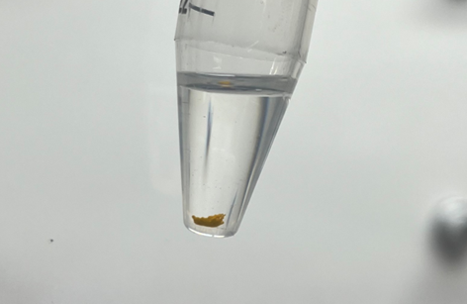
Figure S11 Image showing the product of synthesis carried out without the addition of OAm following centrifugation.

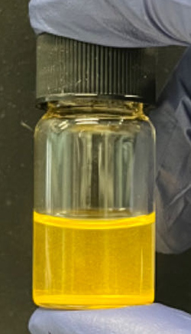
Figure S12 Image showing precipitate obtained when using the highest (4.4 % v/v) HBr-acetone precipitating solution.
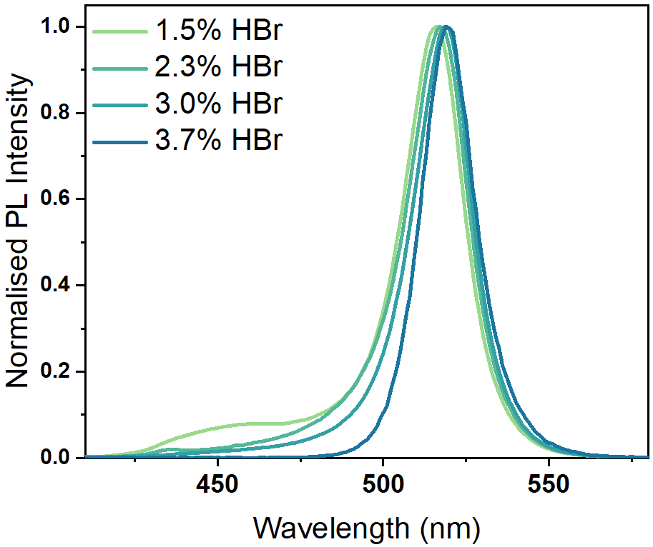
Figure S13 Photoluminescence (PL) spectra of PNCs prepared using varying concentrations of HBr in acetone.
(a (b (c (d
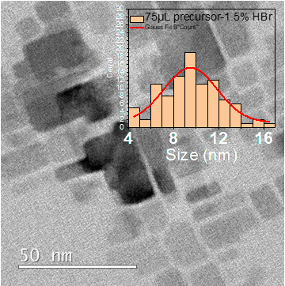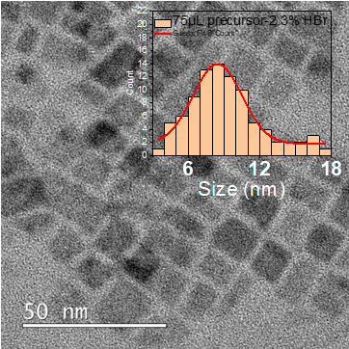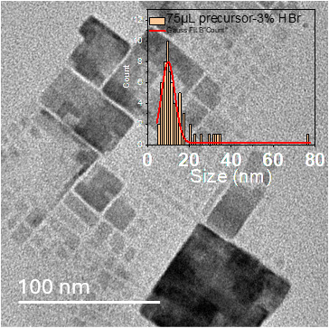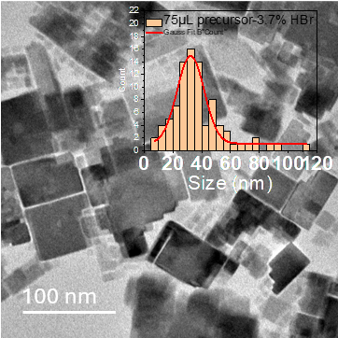
Figure S14 Representative TEM images of PNCs prepared using 75μL aqueous perovskite precursor solutions and different concentrations of HBr, a) 1.5%, b) 2.3%, c) 3.0% and d) 3.7% v/v.

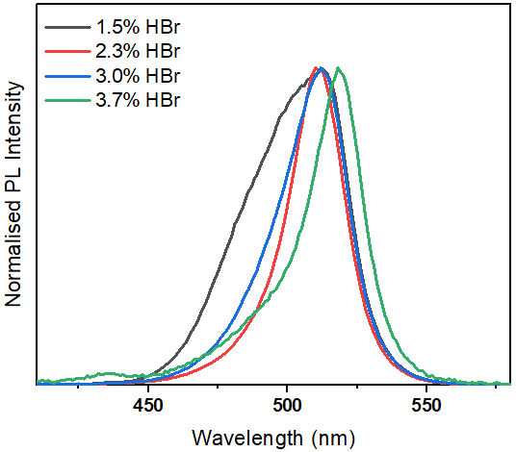
Figure S15 of PNCs prepared using 75μL aqueous perovskite precursor solutions and varying concentrations of HBr.
(a
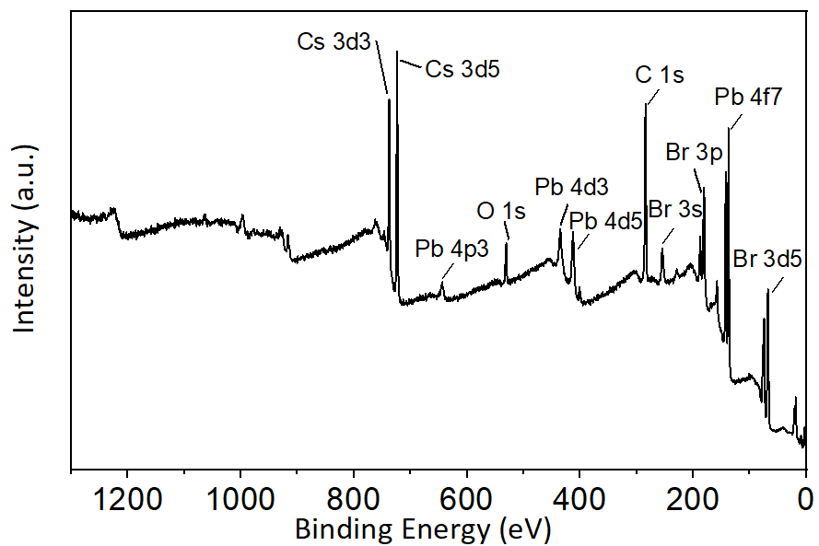
(b (c
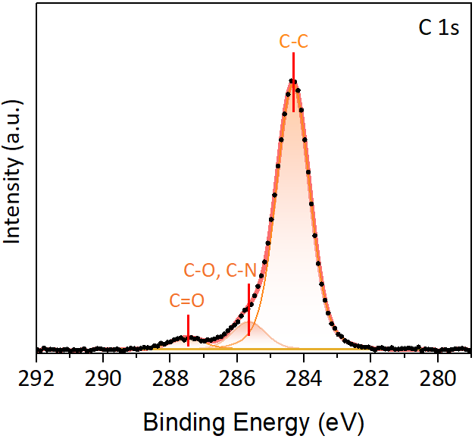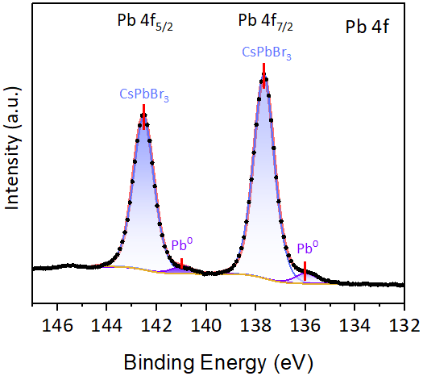
(d (e
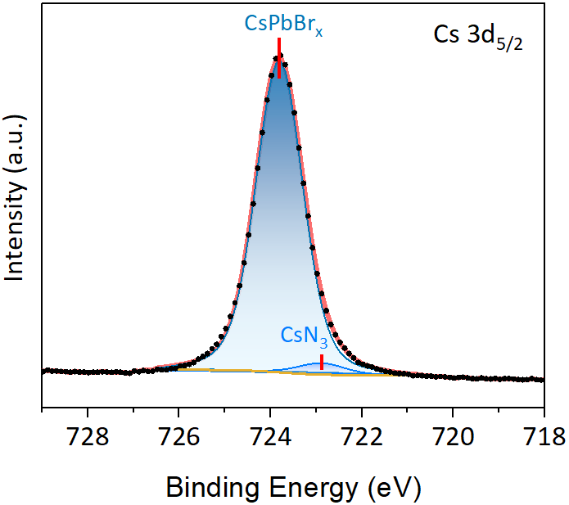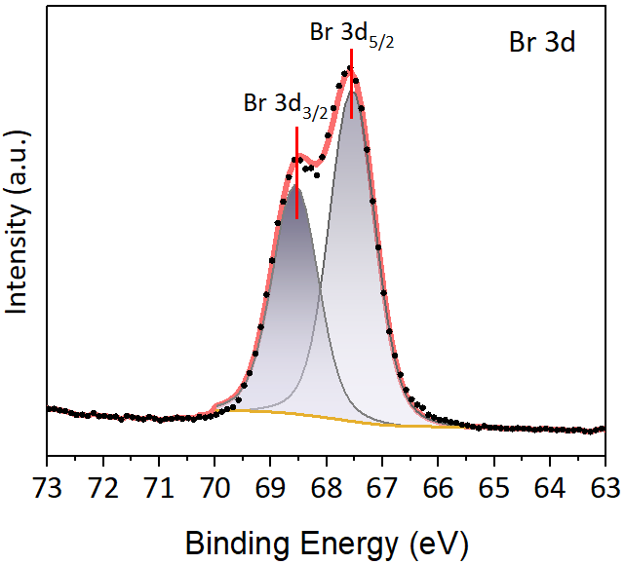
Figure S16 XPS spectra obtained from CsPbBr₃ PNCs, a) survey, b) C 1s, c) Pb 4f, d) Cs 3d_{5/2} and e) Br 3d.

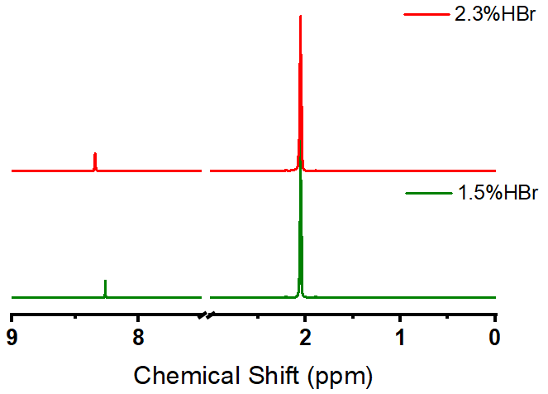
Figure S17 ¹H NMR of HBr-d₆-acetone with at different HBr concentrations

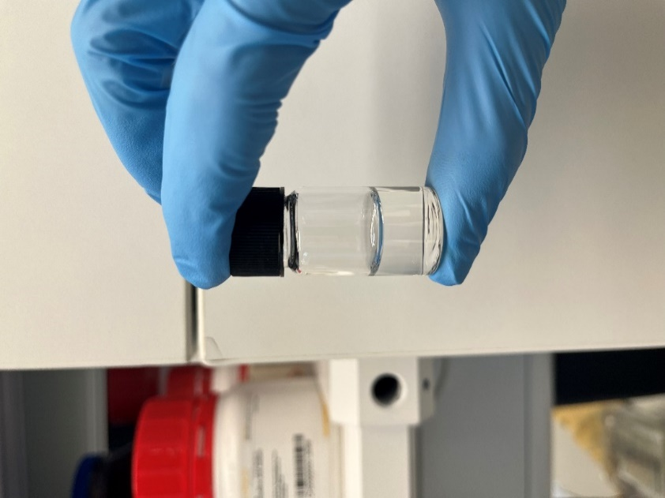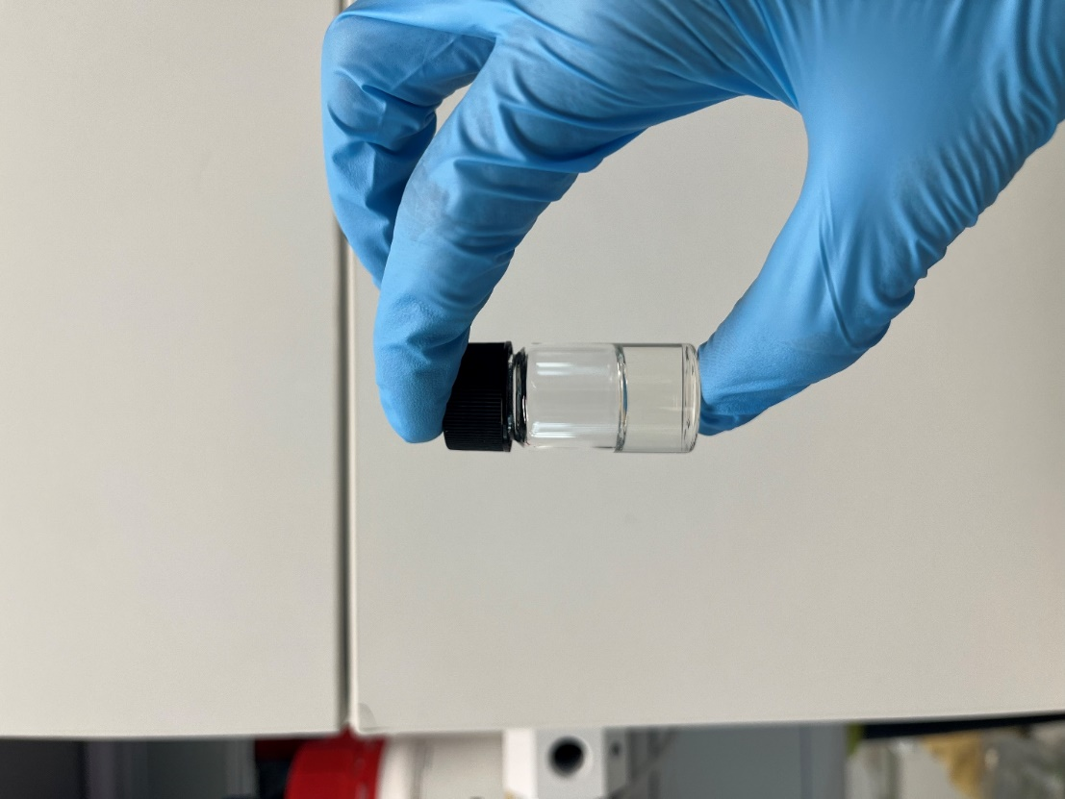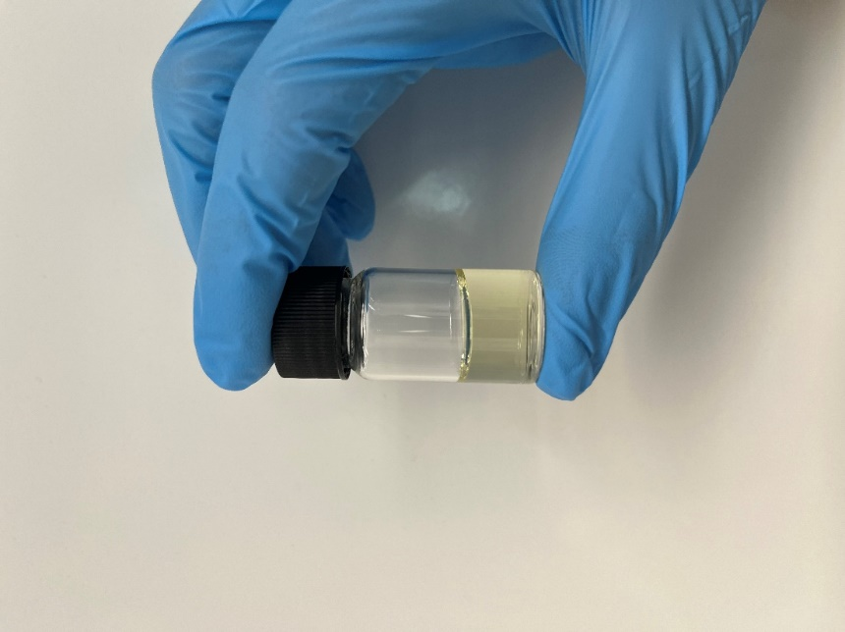
Figure S18 Images of HBr-acetone solutions immediately after preparation (left), 1-hour after preparation (centre) and 5-hours after preparation (right), note the characteristic brown colour of the solution at this time.

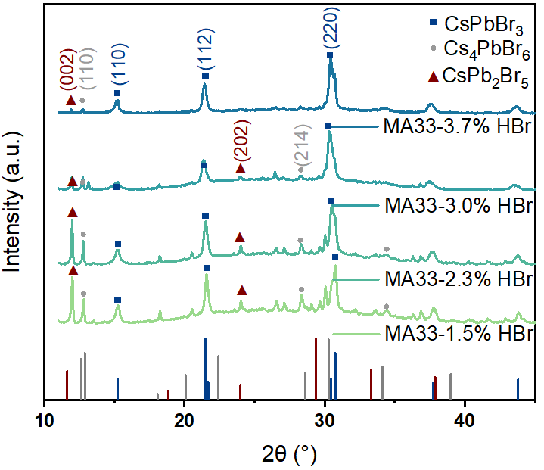
Figure S19 XRD pattern of PNCs prepared using 1h-aged 1.5%, 2.3%, 3% and 3.7% v/v HBr (reference patterns ICDD 01-090-2544 (blue), ICDD 04-014-8071 (grey) and ICDD 01-090-0382 (red) are also shown).

