Table 1. Summary of microplastic particles sampled across different locations with a 0.10mm sieve employed.
Location | Weather | Collected water | Colour | Plastic identified^{b} | Microscope image
Matilda Bay (Crawley) | Sunny | 230 L | Blue | PP | 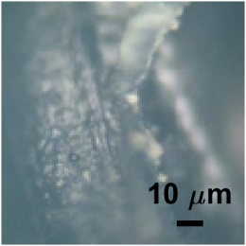
Matilda Bay (Crawley) | Sunny | 1500 L | Blue | Blend of PE and HDPE | 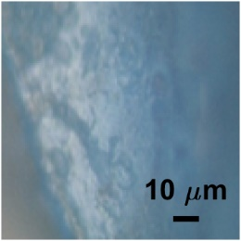
Matilda Bay (Crawley) | Sunny | 1500 L | Grey | PLA | 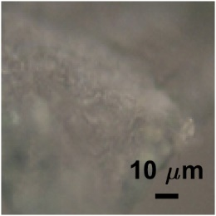
Matilda Bay (Crawley) | Sunny | 1200 L | Blue | Blend of PP and PE | 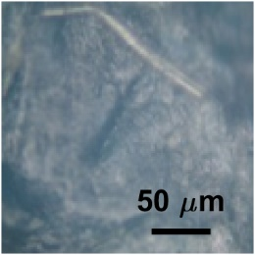
Matilda Bay (Crawley) | Sunny | 1200 L | Green | PP | 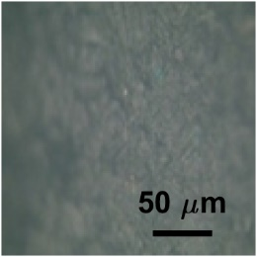
Matilda Bay (Crawley) | Sunny | 2000 L | Blue (1) | Blend of PP and PE | 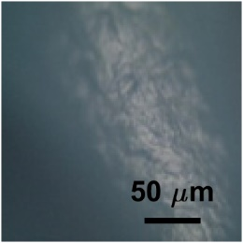
Matilda Bay (Crawley) | Sunny | 2000 L | Blue (2) | PP | 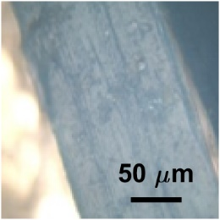
Matilda Bay (Crawley) | Sunny | 2000 L | Green | Blend of PP and PE | 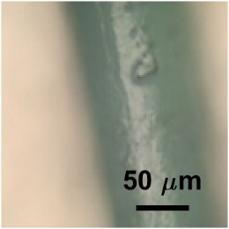
Matilda Bay (Crawley) | Sunny | 1500 L | Blue (1) | PP | 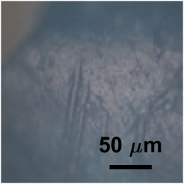
Matilda Bay (Crawley) | Sunny | 1500 L | Blue (2) | PP | 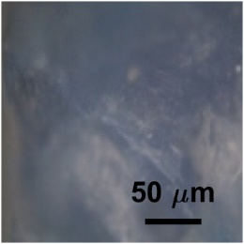
Matilda Bay (Crawley) | Sunny | 1500 L | Blue (3) | Blend of PE and HDPE with a small fraction of PP | 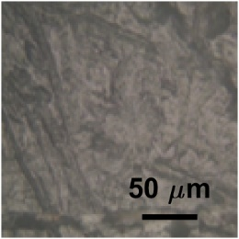
Matilda Bay (Crawley) | Sunny | 1500 L | Blue (4) | Blend of PP and PE | 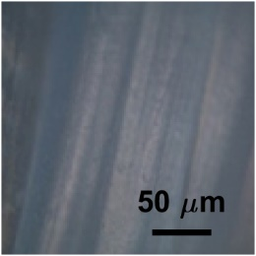
Matilda Bay (Crawley) | Sunny | 1500 L | Blue (5) | Predominantly PP with traces of PE | 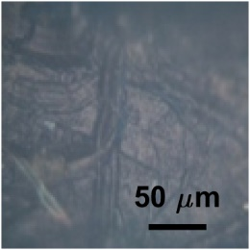
Matilda Bay (Crawley) | Sunny | 1500 L | Turquoise (1) | Blend of PP and PE with traces of PVC | 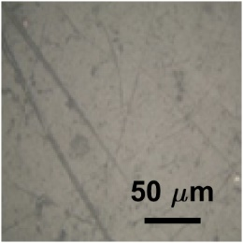
Matilda Bay (Crawley) | Sunny | 1500 L | Turquoise (2) | PP | 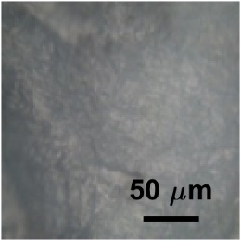
Matilda Bay (Crawley) | Sunny | 1500 L | Turquoise (3) | PP | 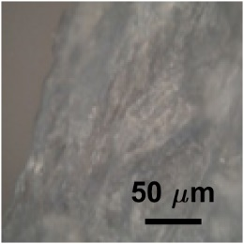
Matilda Bay (Crawley) | Sunny | 1500 L | Turquoise (4) | PP | 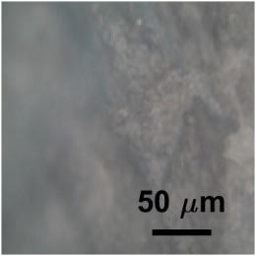
Matilda Bay (Crawley) | Sunny | 1500 L | Turquoise (5) | Blend of PP, PE, and HDPE | 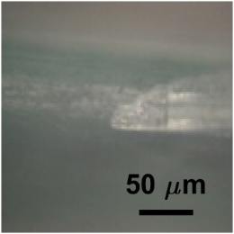
Matilda Bay (Crawley) | Sunny | 1500 L | Turquoise (6) | Blend of PP, PE, and HDPE | 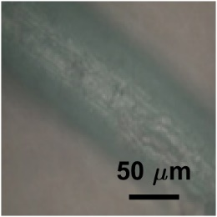
Matilda Bay (Crawley) | Sunny | 1500 L | Turquoise (7) | Blend of PP, PE, and HDPE | 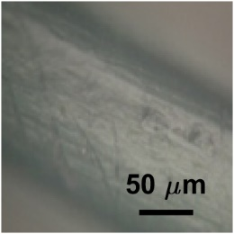
Matilda Bay (Crawley) | Sunny | 1500 L | Turquoise (8) | Blend of PP and PE | 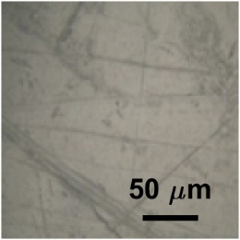
Deep Water Point Reserve (Mount Pleasant) | Rainy | 2000 L | Blue | Blend of PE, PP, HDPE | 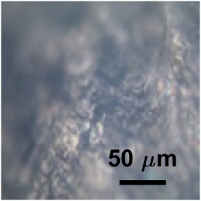
Bardon Park (Maylands)ª | Rainy | 2000 L | Blue | PP | 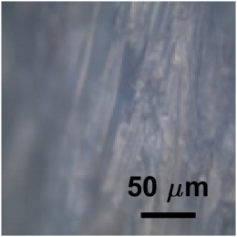  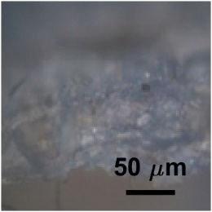
ªA 0.074 mm (200 mesh) sieve was used instead of a 0.10 mm (150 mesh).
^{b}Abbreviations: polypropylene: PP; polyethylene: PE; high-density polyethylene: HDPE; polylactic acid: PLA; polyvinyl chloride: PVC.

