Supplementary data
Fig. S1. Transmission electron micrograph of strains (a) BT553^{T} and (b) BT552^{T} from cultures grown on R2A agar for three days at 25°C. Bars are 500 nm.
(a)
(b)
Fig. S2. Polar lipid profile of strain BT553^{T} after two-dimensional chromatography.
(a) total lipids; (b) phospholipids; (c) aminolipids; (d) glycolipids.
Abbreviations: DPG; diphosphatidylglycerol (DPG), PE; phosphatidylethanolamine, PG; phosphatidylglycerol , PC; phosphatidylcholine, PL; phospholipids, SL; sphingolipid, AL; aminolipid, APL; aminophospholipid, L; lipids.

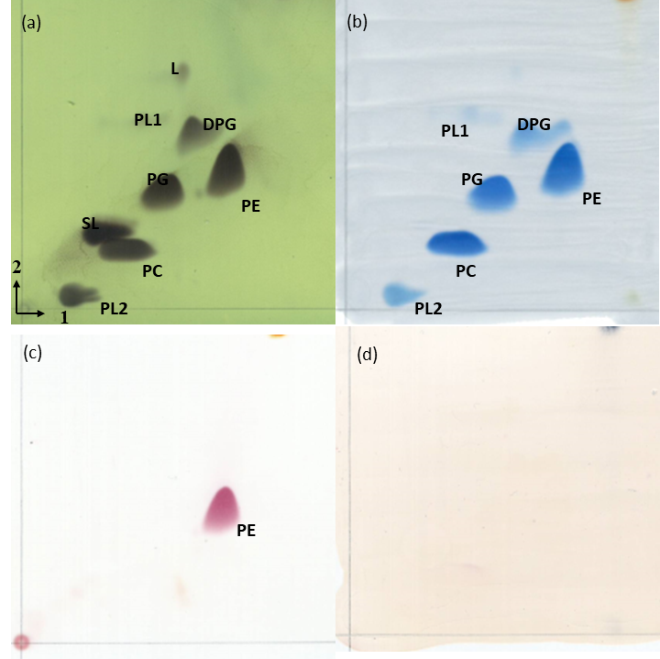
Fig. S3. Polar lipid profile of strain BT552^{T} after two-dimensional chromatography.
(a) total lipids; (b) phospholipids; (c) aminolipids; (d) glycolipids.
Abbreviations: DPG; diphosphatidylglycerol (DPG), PE; phosphatidylethanolamine, PG; phosphatidylglycerol , PC; phosphatidylcholine, PL; phospholipids, SL; sphingolipid, AL; aminolipid, APL; aminophospholipid, L; lipids.

