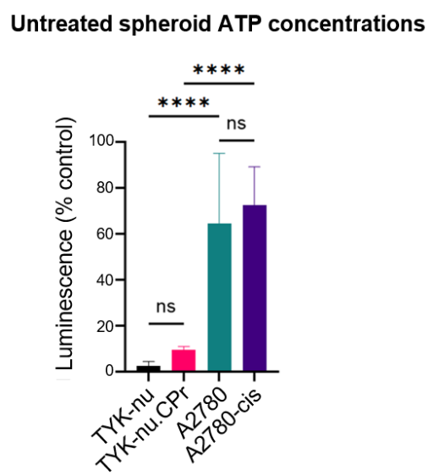
Supplementary Figure S1: The ATP concentrations of artificial spheroids generated from TYK-nu, TYK-nu.CPr, A2780, and A2780-cis cell lines. Values are mean ± SD; ****p<0.0001.
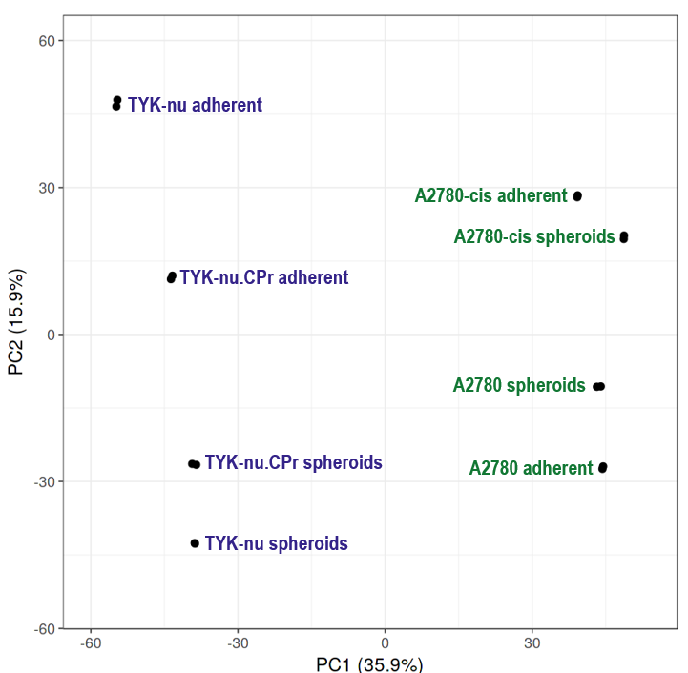
Supplementary Figure S2: PCA plot of the global proteomes of adherent cells and artificial spheroids generated from the TYK-nu and A2780 parental cell lines and their cisplatin-resistant counterparts. The A2780 and A2780-cis (green) cell lines separated from TYK-nu and TYK-nu.CPr (blue) cell lines along the first component (n=2). TYK-nu and TYK-nu.CPr adherent cells and spheroids separated along the second component based on their growth conditions, while A2780 and A2780-cis spheroids separated along the second component according to CBP sensitivity.
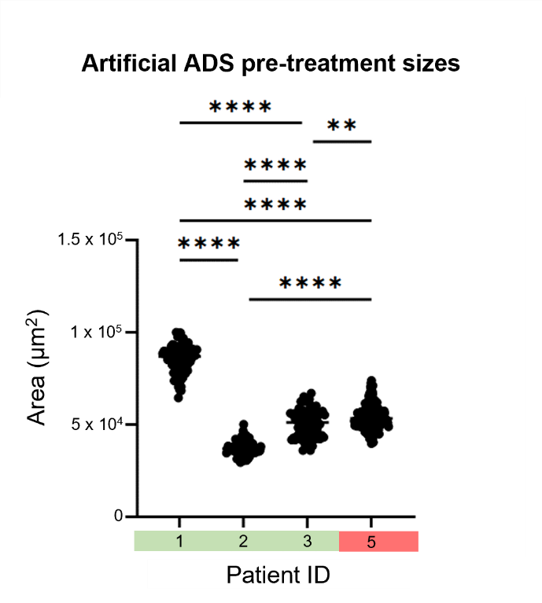
Supplementary Figure S3: The sizes of artificial ADS from a subset of patients that were imaged 72 hours after seeding. Artificial ADS from patient 4 could not be sized due to the presence of non-spheroidal matter. Green and red shading indicate ex vivo sensitivity and resistance to CBP, respectively.
Supplementary Table S1: Differentially abundant proteins between sensitive and resistant native ADS that are listed in the MatrixDB database. Proteins were considered significant when the q-value was less than 0.05 and the log 2-fold change (FC) was less than -1 or greater than 1. R= resistant native ADS; S= sensitive native ADS.
UniProt ID | Protein name | Log2 FC (R/S) | Q-val
P13727 | Bone marrow proteoglycan | 7.51 | 2.9E-10
P06731 | Carcinoembryonic antigen-related cell adhesion molecule 5 | 5.10 | 1.4E-03
P02452 | Collagen alpha-1(I) chain | 5.00 | 1.8E-03
P40199 | Carcinoembryonic antigen-related cell adhesion molecule 6 | 4.37 | 1.4E-03
Q14002 | Carcinoembryonic antigen-related cell adhesion molecule 7 | 3.99 | 3.2E-03
Q70J99 | Protein unc-13 homolog D | 3.68 | 2.2E-03
P17936 | Insulin-like growth factor-binding protein 3 | 3.65 | 2.6E-04
P15144 | Aminopeptidase N | 3.61 | 8.5E-08
P36952 | Serpin B5 | 3.59 | 2.4E-04
P08123 | Collagen alpha-2(I) chain | 3.59 | 6.0E-03
P35556 | Fibrillin-2 | 3.57 | 5.3E-03
P12110 | Collagen alpha-2(VI) chain | 3.47 | 7.7E-05
O43653 | Prostate stem cell antigen | 3.40 | 9.0E-04
P13726 | Tissue factor | 3.37 | 1.6E-03
P09668 | Pro-cathepsin H | 3.23 | 1.4E-05
P11678 | Eosinophil peroxidase | 3.10 | 1.8E-05
P00749 | Urokinase-type plasminogen activator | 3.08 | 4.7E-04
P01584 | Interleukin-1 beta | 2.92 | 1.4E-03
P09237 | Matrilysin | 2.87 | 3.4E-05
P18510 | Interleukin-1 receptor antagonist protein | 2.85 | 3.4E-07
Q6ZMP0 | Thrombospondin type-1 domain-containing protein 4 | 2.82 | 3.7E-04
P05120 | Plasminogen activator inhibitor 2 | 2.69 | 9.5E-04
P08572 | Collagen alpha-2(IV) chain | 2.69 | 9.7E-03
O00515 | Ladinin-1 | 2.54 | 7.1E-05
P52790 | Hexokinase-3 | 2.49 | 8.8E-03
Q6UX06 | Olfactomedin-4 | 2.44 | 4.2E-02
P15311 | Ezrin | 2.37 | 8.3E-04
P25774 | Cathepsin S | 2.28 | 7.3E-04
P31947 | 14-3-3 protein sigma | 2.23 | 9.2E-05
O95994 | Anterior gradient protein 2 homolog | 2.22 | 4.2E-07
P30740 | Leukocyte elastase inhibitor | 2.21 | 3.9E-09
P08582 | Melanotransferrin | 2.21 | 6.1E-03
Q9UM22 | Mammalian ependymin-related protein 1 | 2.16 | 1.8E-03
Q8N307 | Mucin-20 | 2.16 | 2.8E-08
P13796 | Plastin-2 | 2.14 | 1.4E-10
P06702 | Protein S100-A9 | 2.13 | 5.4E-03
P30530 | Tyrosine-protein kinase receptor UFO | 2.11 | 5.5E-08
P35555 | Fibrillin-1 | 2.02 | 6.5E-03
P16035 | Metalloproteinase inhibitor 2 | 1.99 | 6.8E-04
P00750 | Tissue-type plasminogen activator | 1.97 | 2.5E-02
Q96HE7 | ERO1-like protein alpha | 1.90 | 1.6E-10
P00488 | Coagulation factor XIII A chain | 1.87 | 4.8E-04
Q9UBR2 | Cathepsin Z | 1.85 | 2.7E-03
O95631 | Netrin-1 | 1.83 | 1.7E-06
P09917 | Polyunsaturated fatty acid 5-lipoxygenase | 1.78 | 2.4E-06
Q13753 | Laminin subunit gamma-2 | 1.77 | 7.7E-09
P62861 | Ubiquitin-like FUBI-ribosomal protein eS30 fusion protein | 1.77 | 4.2E-03
Q13751 | Laminin subunit beta-3 | 1.76 | 8.5E-09
P09382 | Galectin-1 | 1.75 | 3.0E-04
P16144 | Integrin beta-4 | 1.73 | 2.1E-07
Q6UWU2 | Beta-galactosidase-1-like protein | 1.71 | 1.2E-03
P41218 | Myeloid cell nuclear differentiation antigen | 1.70 | 3.2E-05
P32320 | Cytidine deaminase | 1.70 | 1.4E-03
P17213 | Bactericidal permeability-increasing protein | 1.70 | 6.5E-03
Q5JS37 | NHL repeat-containing protein 3 | 1.68 | 6.6E-04
Q16651 | Prostasin | 1.66 | 2.7E-10
Q01432 | AMP deaminase 3 | 1.65 | 3.7E-04
Q9Y5Z4 | Heme-binding protein 2 | 1.65 | 2.9E-10
P06396 | Gelsolin | 1.65 | 1.3E-05
P08571 | Monocyte differentiation antigen CD14 | 1.64 | 1.6E-03
P02751 | Fibronectin | 1.63 | 1.5E-03
P55210 | Caspase-7 | 1.62 | 1.9E-03
Q9BQE5 | Apolipoprotein L2 | 1.60 | 5.3E-03
P55058 | Phospholipid transfer protein | 1.59 | 5.1E-07
Q13442 | 28 kDa heat- and acid-stable phosphoprotein | 1.59 | 8.0E-03
Q14764 | Major vault protein | 1.59 | 4.4E-07
P16278 | Beta-galactosidase | 1.59 | 3.9E-03
P35237 | Serpin B6 | 1.57 | 6.2E-04
Q96MX0 | CKLF-like MARVEL transmembrane domain-containing protein 3 | 1.54 | 2.7E-02
P18428 | Lipopolysaccharide-binding protein | 1.52 | 1.2E-04
P11215 | Integrin alpha-M | 1.49 | 7.1E-06
Q86UX7 | Fermitin family homolog 3 | 1.48 | 4.1E-04
Q13510 | Acid ceramidase | 1.48 | 2.2E-03
O94964 | Protein SOGA1 | 1.48 | 4.3E-06
P06737 | Glycogen phosphorylase, liver form | 1.46 | 8.4E-07
P08174 | Complement decay-accelerating factor | 1.43 | 2.4E-04
P07355 | Annexin A2 | 1.43 | 6.3E-04
Q9GZN4 | Brain-specific serine protease 4 | 1.41 | 2.7E-05
P24071 | Immunoglobulin alpha Fc receptor | 1.41 | 3.5E-04
Q13214 | Semaphorin-3B | 1.40 | 1.1E-02
Q2PPJ7 | Ral GTPase-activating protein subunit alpha-2 | 1.40 | 1.2E-06
Q9NXH8 | Torsin-4A | 1.40 | 4.7E-05
Q92882 | Osteoclast-stimulating factor 1 | 1.38 | 5.5E-04
P21741 | Midkine | 1.37 | 1.8E-03
Q13443 | Disintegrin and metalloproteinase domain-containing protein 9 | 1.37 | 2.1E-05
P15289 | Arylsulfatase A | 1.36 | 1.0E-04
Q99536 | Synaptic vesicle membrane protein VAT-1 homolog | 1.36 | 4.2E-06
P07339 | Cathepsin D | 1.36 | 8.6E-03
Q8NHL6 | Leukocyte immunoglobulin-like receptor subfamily B member 1 | 1.34 | 2.6E-04
P78386 | Keratin, type II cuticular Hb5 | 1.33 | 3.3E-03
P12724 | Eosinophil cationic protein | 1.33 | 3.0E-03
P17813 | Endoglin | 1.32 | 4.9E-03
Q14116 | Interleukin-18 | 1.30 | 8.8E-07
Q5GFL6 | von Willebrand factor A domain-containing protein 2 | 1.30 | 6.7E-04
Q8N1N4 | Keratin, type II cytoskeletal 78 | 1.30 | 7.2E-06
P12830 | Cadherin-1 | 1.29 | 2.5E-05
P13987 | CD59 glycoprotein | 1.28 | 9.0E-05
Q9BRF8 | Serine/threonine-protein phosphatase CPPED1 | 1.26 | 5.4E-03
Q8N423 | Leukocyte immunoglobulin-like receptor subfamily B member 2 | 1.25 | 1.3E-03
P50395 | Rab GDP dissociation inhibitor beta | 1.24 | 1.7E-07
P63261 | Actin, cytoplasmic 2 | 1.23 | 2.4E-04
Q9UJU6 | Drebrin-like protein | 1.22 | 5.1E-04
P35030 | Trypsin-3 | 1.21 | 5.7E-03
P16284 | Platelet endothelial cell adhesion molecule | 1.21 | 1.4E-03
Q13444 | Disintegrin and metalloproteinase domain-containing protein 15 | 1.20 | 8.3E-05
Q9H4A4 | Aminopeptidase B | 1.20 | 4.1E-06
P31025 | Lipocalin-1 | 1.20 | 1.3E-02
P09104 | Gamma-enolase | 1.20 | 7.5E-06
P62937 | Peptidyl-prolyl cis-trans isomerase A | 1.19 | 1.0E-03
Q8TD55 | Pleckstrin homology domain-containing family O member 2 | 1.18 | 5.8E-04
O00391 | Sulfhydryl oxidase 1 | 1.18 | 2.2E-07
Q10472 | Polypeptide N-acetylgalactosaminyltransferase 1 | 1.17 | 4.6E-05
Q9Y376 | Calcium-binding protein 39 | 1.16 | 6.6E-03
O43240 | Kallikrein-10 | 1.16 | 7.5E-05
O00622 | CCN family member 1 | 1.14 | 3.3E-04
Q9NRV9 | Heme-binding protein 1 | 1.14 | 2.1E-06
O00602 | Ficolin-1 | 1.14 | 8.9E-06
P05156 | Complement factor I | 1.13 | 9.9E-03
P05204 | Non-histone chromosomal protein HMG-17 | 1.13 | 9.6E-03
Q9H5V8 | CUB domain-containing protein 1 | 1.12 | 1.8E-04
P29323 | Ephrin type-B receptor 2 | 1.12 | 2.6E-03
O43278 | Kunitz-type protease inhibitor 1 | 1.11 | 3.0E-04
P80188 | Neutrophil gelatinase-associated lipocalin | 1.11 | 6.5E-05
P17900 | Ganglioside GM2 activator | 1.11 | 1.3E-09
P09960 | Leukotriene A-4 hydrolase | 1.09 | 3.2E-05
O15455 | Toll-like receptor 3 | 1.09 | 7.3E-03
P20933 | N(4)-(beta-N-acetylglucosaminyl)-L-asparaginase | 1.09 | 4.6E-03
P17931 | Galectin-3 | 1.08 | 1.2E-05
P08581 | Hepatocyte growth factor receptor | 1.07 | 1.5E-04
Q14766 | Latent-transforming growth factor beta-binding protein 1 | 1.04 | 4.1E-04
P34059 | N-acetylgalactosamine-6-sulfatase | 1.03 | 6.6E-05
O00299 | Chloride intracellular channel protein 1 | 1.03 | 7.5E-04
O14727 | Apoptotic protease-activating factor 1 | 1.02 | 9.9E-06
Q15063 | Periostin | 1.01 | 7.1E-06
P50453 | Serpin B9 | 1.01 | 1.5E-08
Q96FZ5 | CKLF-like MARVEL transmembrane domain-containing protein 7 | 1.00 | 3.1E-07
P50452 | Serpin B8 | 1.00 | 8.6E-04
P46531 | Neurogenic locus notch homolog protein 1 | 1.00 | 2.4E-03
P10809 | 60 kDa heat shock protein, mitochondrial | -1.00 | 3.1E-08
Q9H2P0 | Activity-dependent neuroprotector homeobox protein | -1.01 | 2.8E-07
Q9H0U6 | Large ribosomal subunit protein uL18m | -1.04 | 3.4E-02
P55268 | Laminin subunit beta-2 | -1.04 | 3.2E-04
P02753 | Retinol-binding protein 4 | -1.06 | 2.2E-02
O00264 | Membrane-associated progesterone receptor component 1 | -1.12 | 8.2E-06
P43121 | Cell surface glycoprotein MUC18 | -1.13 | 2.2E-02
P00738 | Haptoglobin | -1.17 | 1.3E-03
Q9UNW1 | Multiple inositol polyphosphate phosphatase 1 | -1.17 | 1.3E-03
P02679 | Fibrinogen gamma chain | -1.20 | 2.0E-04
O00592 | Podocalyxin | -1.22 | 1.1E-03
P13995 | Bifunctional methylenetetrahydrofolate dehydrogenase/cyclohydrolase, mitochondrial | -1.22 | 2.1E-03
P18065 | Insulin-like growth factor-binding protein 2 | -1.22 | 3.2E-04
P01871 | Immunoglobulin heavy constant mu | -1.28 | 1.1E-03
Q9HCB6 | Spondin-1 | -1.30 | 8.9E-05
Q9H1B7 | Probable E3 ubiquitin-protein ligase IRF2BPL | -1.37 | 1.9E-04
Q9BY44 | Eukaryotic translation initiation factor 2A | -1.38 | 4.3E-05
P02766 | Transthyretin | -1.43 | 1.8E-04
P15907 | Beta-galactoside alpha-2,6-sialyltransferase 1 | -1.43 | 1.9E-04
Q9UHI8 | A disintegrin and metalloproteinase with thrombospondin motifs 1 | -1.45 | 8.6E-07
P01024 | Complement C3 | -1.48 | 5.0E-05
P20160 | Azurocidin | -1.52 | 4.0E-04
O75718 | Cartilage-associated protein | -1.55 | 1.2E-05
P01911 | HLA class II histocompatibility antigen, DRB1 beta chain | -1.56 | 6.0E-04
Q92563 | Testican-2 | -1.56 | 6.8E-04
O15230 | Laminin subunit alpha-5 | -1.61 | 1.2E-04
P09486 | SPARC | -1.63 | 8.0E-04
P04196 | Histidine-rich glycoprotein | -1.64 | 4.6E-03
P10909 | Clusterin | -1.66 | 1.7E-05
Q03169 | Tumor necrosis factor alpha-induced protein 2 | -1.70 | 9.0E-06
P19652 | Alpha-1-acid glycoprotein 2 | -1.71 | 9.3E-04
P02790 | Hemopexin | -1.72 | 1.7E-04
P05161 | Ubiquitin-like protein ISG15 | -1.72 | 2.9E-07
Q13228 | Methanethiol oxidase | -1.79 | 1.1E-06
P02787 | Serotransferrin | -1.79 | 4.3E-05
P02786 | Transferrin receptor protein 1 | -1.81 | 1.2E-05
P00450 | Ceruloplasmin | -1.82 | 7.7E-07
Q96SL4 | Glutathione peroxidase 7 | -1.83 | 1.7E-03
P02763 | Alpha-1-acid glycoprotein 1 | -1.85 | 1.1E-04
P30511 | HLA class I histocompatibility antigen, alpha chain F | -1.90 | 3.5E-02
P01857 | Immunoglobulin heavy constant gamma 1 | -1.92 | 8.4E-05
P50454 | Serpin H1 | -1.96 | 1.4E-05
Q92626 | Peroxidasin homolog | -2.11 | 2.7E-06
P01011 | Alpha-1-antichymotrypsin | -2.15 | 6.6E-05
P49746 | Thrombospondin-3 | -2.26 | 3.6E-07
P01009 | Alpha-1-antitrypsin | -2.29 | 2.1E-05
P01780 | Immunoglobulin heavy variable 3-7 | -2.30 | 3.8E-04
P01834 | Immunoglobulin kappa constant | -2.41 | 4.9E-06
A0A075B6H7 | Probable non-functional immunoglobulin kappa variable 3-7 | -3.62 | 7.8E-06
P01619 | Immunoglobulin kappa variable 3-20 | -3.64 | 9.5E-06

Supplementary Table S2: The significance of all identified keratins on the progression-free survival (PFS) and overall survival (OS) of stage III and IV high-grade (grade III) serous ovarian cancers. The average log 2 abundance ratios were shaded green when greater than 1, while the p-values of PFS and OS according to the log-rank test reported by the KM plotting tool³² were shaded green less than 0.05.
Protein name | UniProt ID | Average log 2 abundance ratio (resistant/sensitive native ADS) | Log-ranked values from KM Plotter
Protein name | UniProt ID |  | PFS | OS
KRT17 | Q04695 | 3.39 | 0.38 | 0.44
KRT8 | P05787 | 2.54 | 0.054 | 0.38
KRT18 | P05783 | 2.27 | 0.08 | 0.43
KRT19 | P08727 | 2.09 | 0.057 | 0.17
KRT7 | P08729 | 1.95 | .0028 | 0.064
KRT13 | P13646 | 1.87 | 0.00042 | 0.065
KRT5 | P13647 | 1.83 | 0.022 | 0.16
KRT32 | Q14532 | 1.82 | 0.15 | 0.22
KRT80 | Q6KB66 | 1.78 | 0.013 | 0.26
KRT16 | P08779 | 1.70 | 0.022 | 0.05
KRT6C | P48668 | 1.65 | 0.0094 | 0.044
KRT76 | Q01546 | 1.39 | 0.065 | 0.12
KRT14 | P02533 | 1.38 | 0.027 | 0.0092
KRT85 | P78386 | 1.33 | 0.0037 | 0.037
KRT78 | Q8N1N4 | 1.30 | 0.099 | 0.3
KRT23 | Q9C075 | 1.25 | 0.16 | 0.01
KRT15 | P19012 | 0.96 | 0.0038 | 0.028
KRT72 | Q14CN4 | 0.93 | 0.015 | 0.012
KRT84 | Q9NSB2 | 0.88 | 0.0029 | 0.1
KRT4 | P19013 | 0.85 | 0.045 | 0.17
KRT6A | P02538 | 0.57 | 0.0094 | 0.044
KRT9 | P35527 | 0.39 | 8.1e-05 | 0.065
KRT6B | P04259 | 0.23 | 0.036 | 0.12
KRT1 | P04264 | 0.20 | 0.081 | 0.38
KRT10 | P13645 | 0.07 | 0.39 | 0.085
KRT2 | P35908 | 0.05 | 0.0092 | 0.053
KRT74 | Q7RTS7 | -0.09 | 0.03 | 0.082
KRT77 | Q7Z794 | -0.28 | 0.0075 | 0.096

Supplementary Table S3: Clinicopathological details of patients from which tumour material was collected in this study.
Patient ID | Age at diagnosis | Diagnosis | Stage | Grade | Clinical chemoresponse
1 | 66 | Serous carcinoma of the peritoneum | 4 | 3 | Sensitive
2 | 50 | Serous carcinoma of the peritoneum | 3c | 3 | Sensitive
3 | 75 | Recurrent serous carcinoma of the ovary | 4 | 3 | Resistant
4 | 47 | Recurrent serous carcinoma of the ovary | 1c | 3 | Resistant
5 | 73 | Serous carcinoma of the peritoneum | 4 | 3 | Unknown
6 | 71 | Recurrent chemotherapy-resistant serous carcinoma of the ovary | - | - | Resistant

