Supporting Information

Replica Exchange Molecular Dynamics Simulations Reveal Self-association Sites in M-Crystallin Caused by Mutations Provide Insights of Cataract

Sunita Patel^{1*}, R. V. Hosur¹

¹UM-DAE Centre for Excellence in Basic Sciences, Vidyanagari, Mumbai, India

*Corresponding address:

Dr. Sunita Patel

Current address: UM-DAE Centre for Excellence in Basic Sciences, Mumbai University Campus, Mumbai 400098, India

Email: sunita.iitb@gmail.com

Tel.: 91-22-26532132

Fax: 91-22-26532134

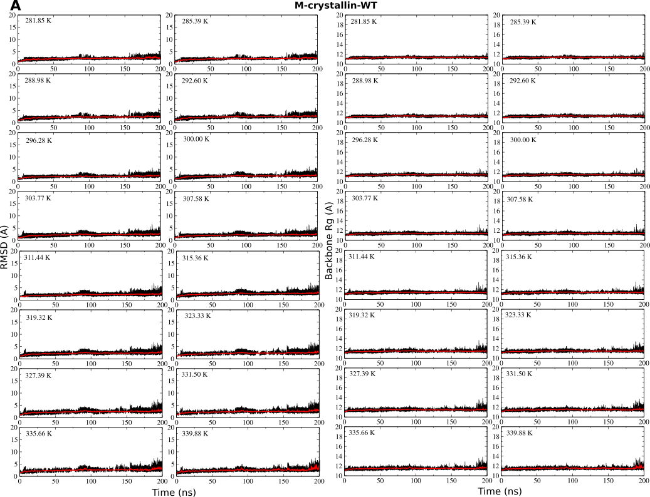
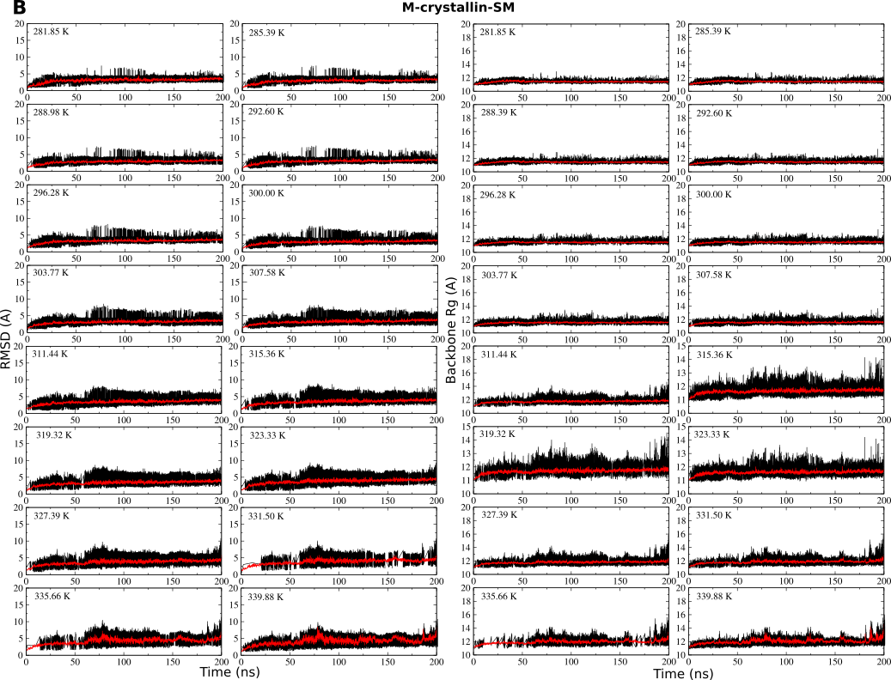
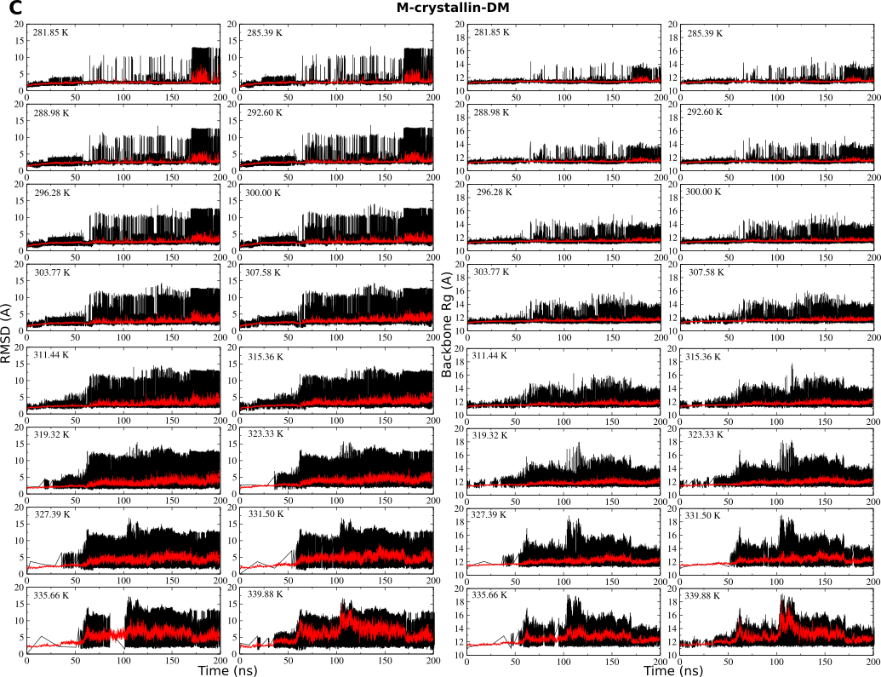
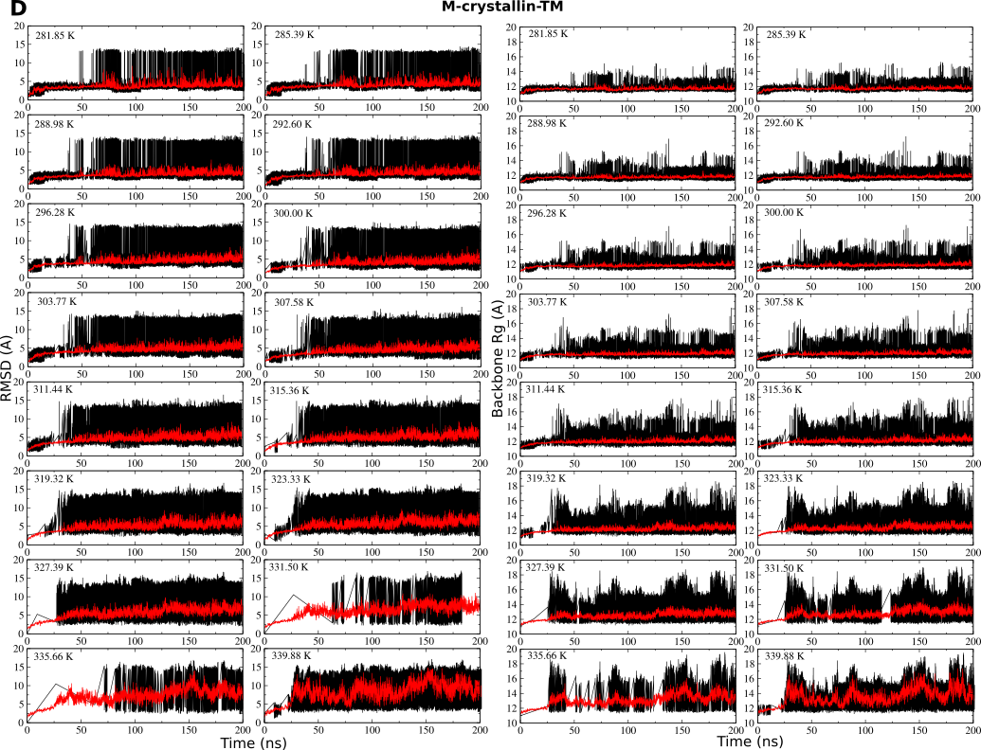
Figure S1. C^{α} RMSD and backbone Rg as a function of time are plotted for all the temperature filtered trajectories in (A) M-crystallin-WT, (B) M-crystallin-SM, (C) M-crystallin-DM and (D) M-crystallin-TM. Running averages over 50 data points are shown in red for each plot.

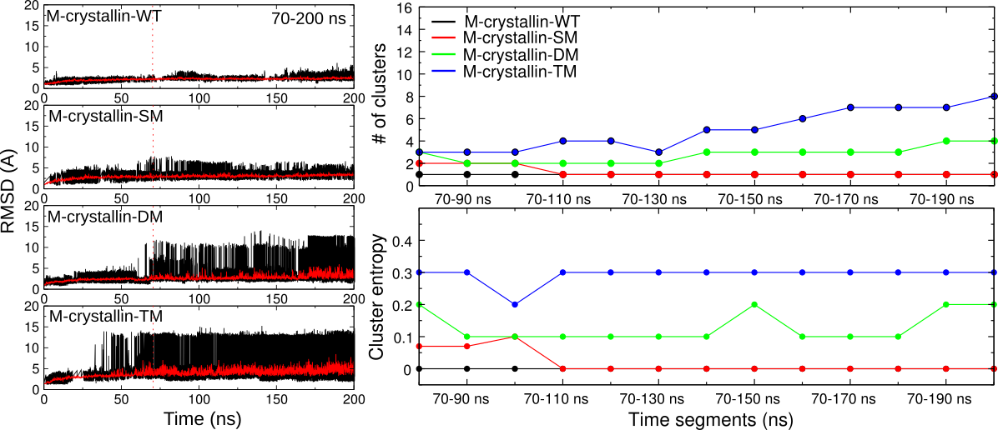

Figure S2. Number of clusters and cluster entropy as a function of time. For clustering the structure 5Å cut off was used.

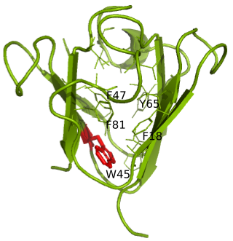

Figure S3. Trp corner surrounded by several aromatic and hydrophobic residues in the M-crystallin X-ray structure (3HZ2).

Large concerted motion observed in the N-terminal Greek key
Protein dynamics is associated with all kind of motions in the molecule. It is possible to isolate the concerted motion from the local fluctuations by doing principal component analysis. For this purpose covariance matrix was determined for all the C^{α} atoms which was then diagonalized to determine eigenvectors and corresponding eigenvalues. The first few eigenvectors possess higher eigenvalues and thus contribute significantly to the concerted motion. In Figure S2, we plotted only first 20 eigenvectors and their corresponding eigenvalues as in subsequent eigenvectors, the eigenvalues tend to zero therefore contribute least to the overall dynamics. It can be observed from Figure S2A that highest magnitude of concerted motion manifested from the eigenvalue of first eigenvector in all the simulations are 11.1, 4.5, 4 and 2.8 in M-crystallin-TM, M-crystallin-SM, M-crystallin-DM and M-crystallin-WT respectively suggesting M-crystallin-TM is showing significant concerted motion. The first three eigenvectors in all the simulations contribute more than 72% of overall motional dynamics. Therefore, RMSF are determined for the projected trajectory along the eigenvector 1, 2 and 3.
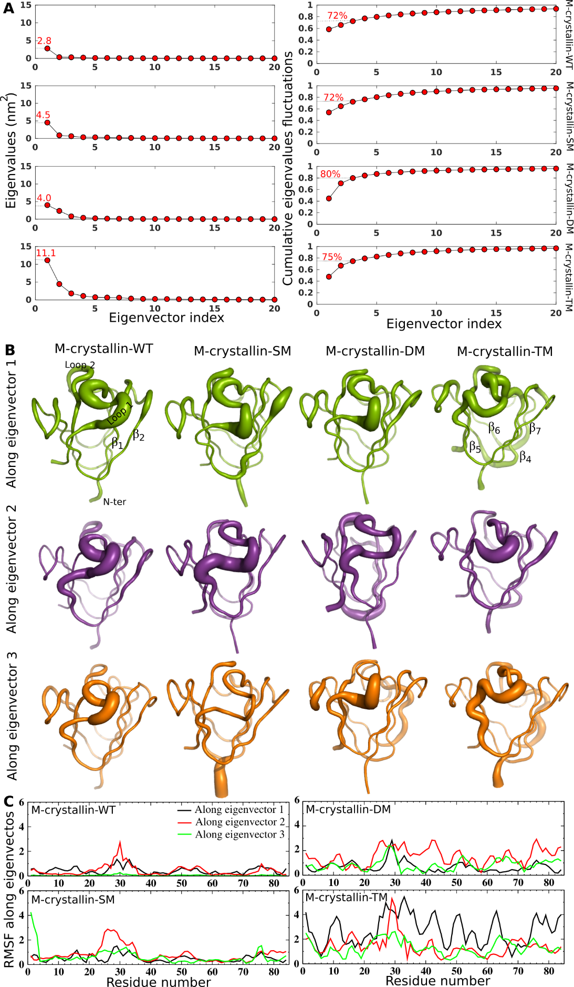

Figure S4. Eigenvectors and eigenvalues analysis on M-crystallin wild type and mutants. (A) Eigenvector index versus eigenvalues and cumulative eigenvalues functuations. (B) Sausage plots showing concerted motion along eigenvector 1, eigenvector 2 and eigenvector 3. (C) Residue number versus RMSF along eigenvector1, 2, and 3.
Flexibility are mostly observed in loop1 of N-terminal Greek key of M-crystallin-WT and M-crystallin-SM while in M-crystallin-DM and M-crystallin-TM additional regions such as loop2 and the hairpin loop between β₁ and β₂-strands, junction between β₄ and β₅-strands, between β₆ and β₇-strands and melted β₇-strand itself show flexibility (Figure S2B) suggesting large concerted motion in many parts of M-crystallin-DM and M-crystallin-TM which is more pronounce for the N-terminal Greek key.

Relatively increased spread of C^{α} RMSD is observed for the mutants
The distribution of C^{α} RMSD with respect to the crystal structure of M-crystallin in wild type simulation is less than 5 Å and has only one peak at 2.2 Å suggesting sampling of homogeneous conformational forms (Figure S3). Similarly, in M-crystallin-SM mutant, the spread of C^{α} RMSD is less than 7 Å and it shows two peaks, a major one at 2.5 Å and a minor one at 6 Å suggesting distribution in M-crystallin-SM is broader than M-crystallin-WT. On the other hand M-crystallin-DM shows relatively larger spread of about 12.5 Å which is much higher than M-crystallin-WT and M-crystallin-SM. The C^{α} RMSD distribution shows a major peak at 2.5 Å and three minor peaks at 5, 10 and 12.5 Å suggesting sampling of heterogeneous conformations having a major native-like distribution and minor non-native distributions. In M-crystallin-TM, a large variation in the C^{α} RMSD is seen which spreads up to 14 Å. The distribution shows one major peak at 3.5 Å and two minor peaks at 5.5 and 13 Å suggesting sampling of both native-like and non-native conformational forms (Figure S3). Overall, RMSD distributions suggest that all the three mutants sample heterogeneous mixture of native-like and non-native conformations in contrast to M-crystallin-WT which samples only homogeneous conformation.

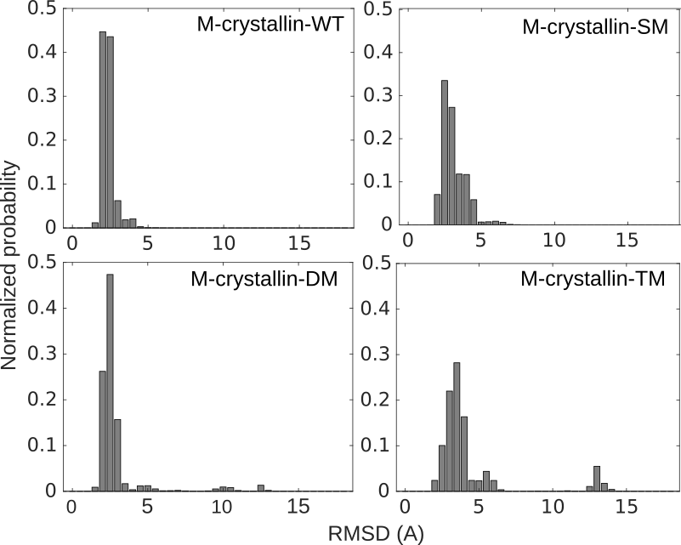

Figure S5. (A) Root mean square deviation of M-crystallin-WT, M-crystallin-SM, M-crystallin-DM and M-crystallin-TM as a function of time.

More distinct minima observed on the free energy landscape of M-crystallin mutants
Free energy landscapes are prepared for all REMD simulations by taking backbone radius of gyration (Rg) and C^{α} RMSD as the conformational coordinates. In M-crystallin-WT, there are two closely spaced minima having almost similar Rg. However, they differ in their RMSD values with one having 2.3 Å corresponding to lowest free energy minima while the other one having 4 Å is relatively higher in free energy (Figure S4). The centroid structures corresponding to these minima are structurally similar except the loop regions which differ suggesting M-crystallin-WT samples similar structures and have intact βγ-crystallin fold. In M-crystallin-SM, three minima are observed. The deepest minimum, M1, has 3 Å of RMSD and 11.4 Å of Rg, second minimum, M2, has 4.2 Å of RMSD and has similar Rg as that of M1 and the third minimum, M3, has 6 Å of RMSD and 12.3 Å of Rg (Figure S4). The minima M1 and M2 of M-crystallin-SM are akin to M1 and M2 of M-crystallin-WT. However, M3 differs largely in structure from both M1 and M2. The structure in M3 has partly unwound core and largely perturbed loops (Figure S4). The free energy landscape of M-crystallin-DM, shows five minima. The deepest minimum M1 has 2.2 Å of RMSD and 11.2 Å of Rg suggesting conformational ensemble observed in this region are well folded and have native-like conformations. The minima M2 and M5 have RMSD values of 4.7 and 6.7 Å, respectively, and have same Rg values of 12 Å. These conformational forms display similar topology however packing of the β-strands in the core is loose (Figure S4). The other two minima M3 and M4 show significantly large RMSD values of 10 and 12.5 Å and large Rg values of 13.6 and 13.3 Å, respectively, suggesting these conformations are largely unfolded and lack typical β-strands packing as observed in βγ-crystallin fold. (Figure S4). The free energy landscape of M-crystallin-TM also shows four minima. Out of these, M1 samples conformations similar to native-like βγ-crystallin, while M2 has partially unfolded conformation and has correspondingly higher RMSD and Rg values of 5.9 Å and 12.3 Å respectively. On the other hand M3 and M4 sample largely unfolded conformations which have higher RMSD values of 10.9 and 12.9 Å and higher Rg values of 14.9 and 13.5 Å respectively suggesting sampling of non-native conformations (Figure S4). Thus, overall, the analysis reveals that the wild type M-crystallin samples βγ-crystallin-like folded state while mutant proteins sample mixture of folded and partially unfolded conformations.

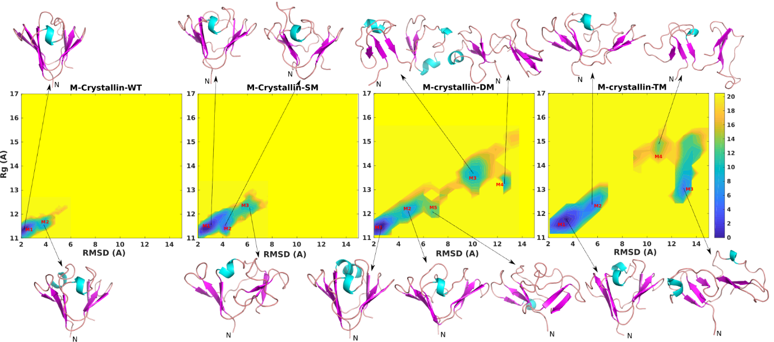

Figure S6. Free energy landscapes are constructed by taking backbone Rg and C^{α} RMSD as the conformational coordinates for M-crystallin wild type and its three mutants. The free energies expressed in kJ/mol are indicated on the color bar to the right. The minima on the free energy landscape are indicated by letters M1 to M5. The centroid structure corresponding to each minimum is shown by an arrow pointing to the structure.

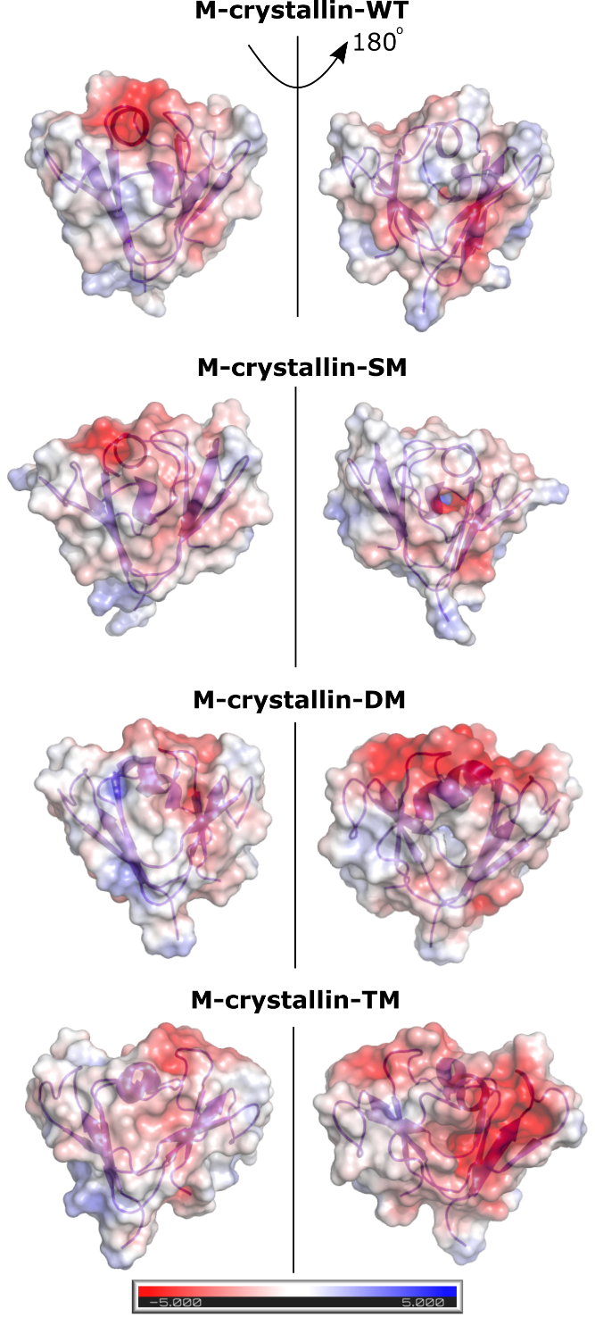

Figure S7. Surface charge potential shown on the centroid structure of M-crystallin-WT and the mutants. Red color indicates negative surface charge potential while blue color indicates positive charge potential while white color indicates non-charged potential.

Table S1. The hydrogen bonds and ionic interactions formed by the mutated residues in M-crystallin. Native interactions are shown in shaded cells.

Hydrogen bond/ ionic interaction | Percentage (%) | Hydrogen bond/ ionic interaction | Percentage (%) | Hydrogen bond/ ionic interaction | Percentage (%)
K34 → D34 |  | W45 → R45 |  | S77 → D77
 |  | M-crystallin-WT
K34:sc-E9:sc | 15.2±5.3 | W45:mc-L60:mc | 52.0±8.9 | S77:sc-P74:mc | 13.0±4.4
K34:sc-D29:sc | 38.0±9.3 |  |  | S77:sc-D75:mc | 22.4±7.0
K34:sc-D33:mc | 19.0±3.6
K34:sc-D75:sc | 11.2±6.1
 |  | M-crystallin-SM
K34:mc-D29:mc | 26.6±5.2 | R45:sc-D23:sc | 60.2±14.7 | S77:sc-D75:mc | 23.8±4.9
K34:sc-D29:sc | 63.2±10.9 | R45:mc-L60:mc | 52.4±11.5
K34:sc-D33:sc | 65.0±7.9 | R45:sc-Q83:sc | 17.8±7.3
 |  | M-crystallin-DM
 |  | W45:mc-L60:mc | 52.2±10.3 | D77:sc-R56:sc | 23.4±6.1
 |  | M-crystallin-TM
D34:sc-S36:sc | 35.4±9.0 | R45:sc-D34:sc | 18.6±8.6 | D77:sc-R56:sc | 35.8±5.3
 |  | R45:sc-L60:mc | 47.0±7.3
 |  | R45:sc-Q83:sc | 16.2±4.0

